Extended Data Fig. 1.
(a)Principal Component Analysis (PCA) for proteomic data from three cohorts.
(b)The distribution of proteomic age gaps.
(c-e)Performance of the trained proteomic aging models in the 200FG (c), 200HIV (d), and 2000HIV (e) cohort.
(f)The distribution of organ-specific protein counts.
(g)All-organ age model prediction in three cohorts.

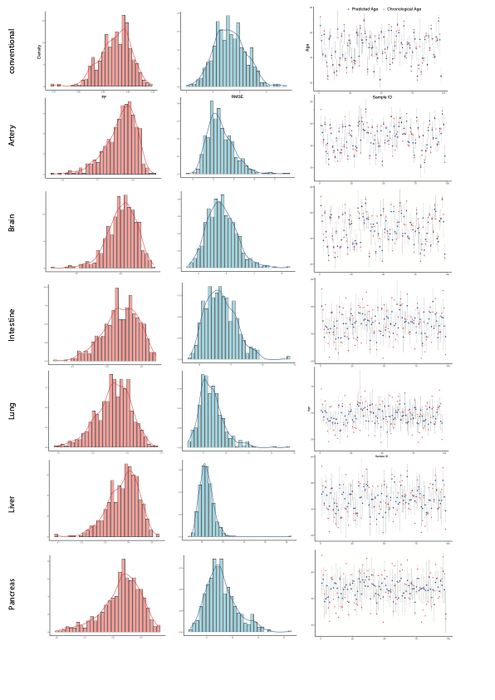

Extended Data Fig. 2.
The robustness test of all bootstrap aggregated LASSO aging models on 500 bootstrap iterations.

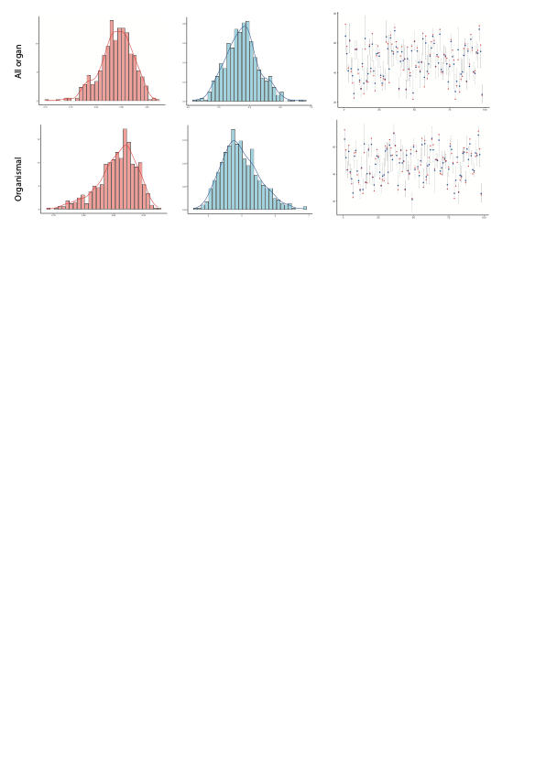

Extended Data Fig. 3.
The robustness test of all bootstrap aggregated LASSO models on organismal age and all-organ age model on 500 bootstrap iterations.

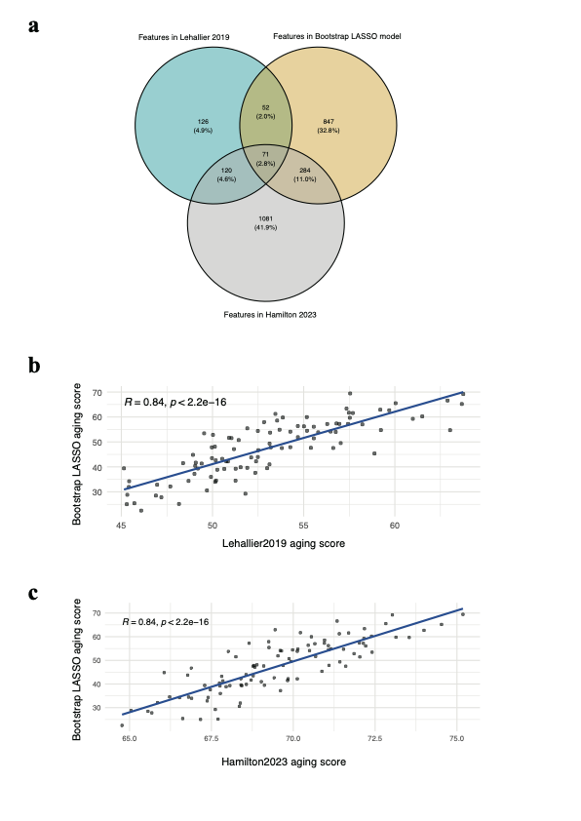

Extended Data Fig. 4.
(a) Venn diagram show the protein features used in our bootstrap-aggregated LASSO aging model with those employed in two previously published models: Lehallier et al. (2019) and Hamilton et al. (2023).
(b-c)The correlation between the predicted age of bootstrap-aggregated LASSO aging model and predicted age from Lehallier et al. (2019) and Hamilton et al. (2023).

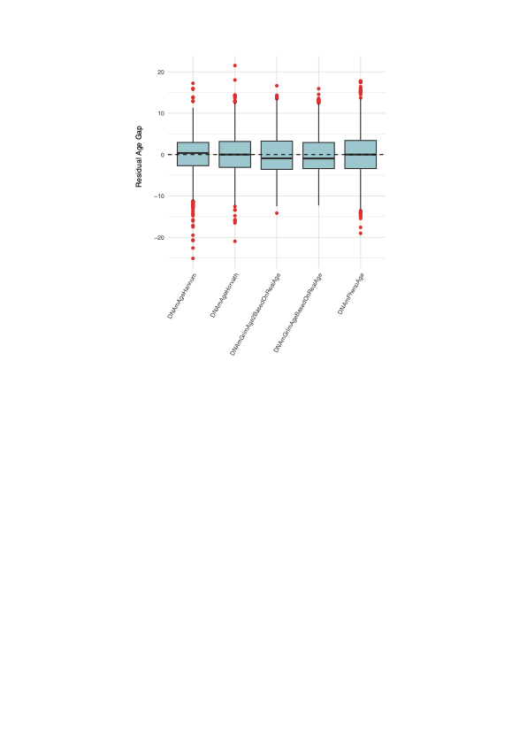

Extended Data Fig. 5.
Box plots show the distribution of Residual Age Gap calculated from 5 DNA methylation age score.

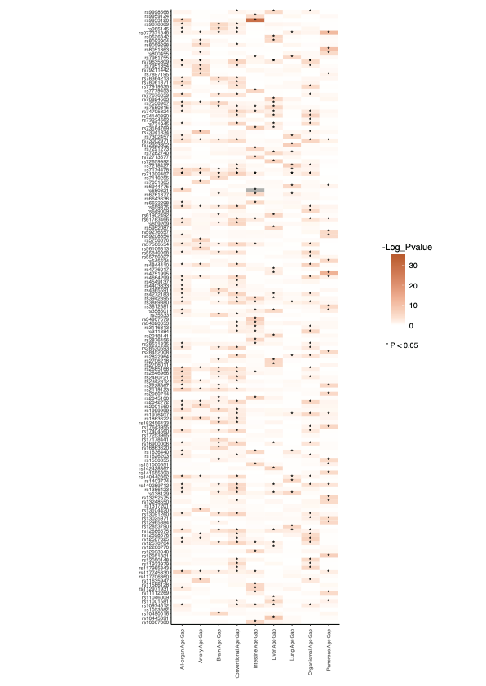

Extended Data Fig. 6.
Heatmap showing the pleiotropy of SNPs associated with all-organ, conventional, organismal and organ-specific age advancement (intestine, brain, artery, liver, lung and pancreas). The legend depicts the negative logarithm of P values of association with age advancement. * represents the associations with P < 0.05.

Extended Data Fig. 7.
Conventional age, Organismal age, and organ-specific age models prediction in three cohorts and feature importance, features over 75 percent of Bootstraps with nonzero coefficients were labeled.

Extended Data Fig. 8.
Proteomic age gaps and DNA methylation age gaps were plotted against chronological age, stratified into three age categories: 18–35 years (green), 36–60 years (orange), and ≥60 years (purple). Each dot represents an individual, and colored lines indicate age group–specific linear regression fits.

Extended Data Fig. 9.
(a) Box plots show the distribution of conventional age gap stratified by ethnicity (Asian, Black, Hispanic, Native American, Mixed, White) and chronological age groups (18–35, 36–60, and ≥60 years). Each dot represents an individual. Red dashed rectangles highlight the Asian group across all age brackets.
(b) Box plots illustrate the distribution of age gaps for four aging clocks—artery, intestine, liver, and organismal—stratified by sex (male, blue; female, orange) and chronological age group (18–35, 36–60, ≥60 years). Each dot represents an individual.

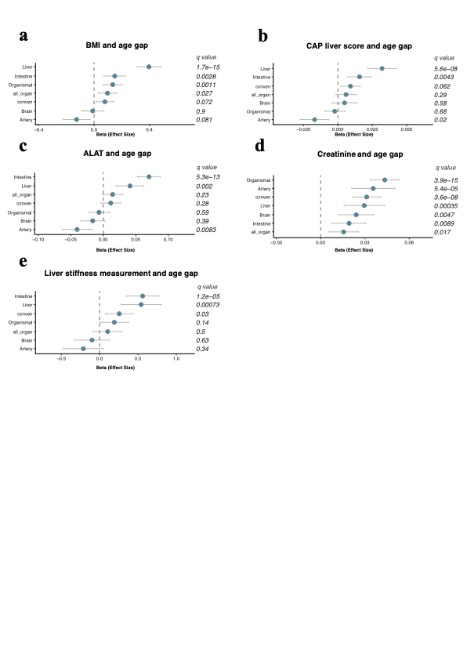

Extended Data Fig. 10.
Forest plot displaying the associations between age gaps and BMI (a), CAP liver score (b), ALAT (alanine aminotransferase) (c), Creatinine (d), and Liver stiffness measurement (e) in PWH. For each of the associations between age gap and clinical parameters, the beta and the confidence interval derived from linear models were plotted. The significant association is shown as q value.

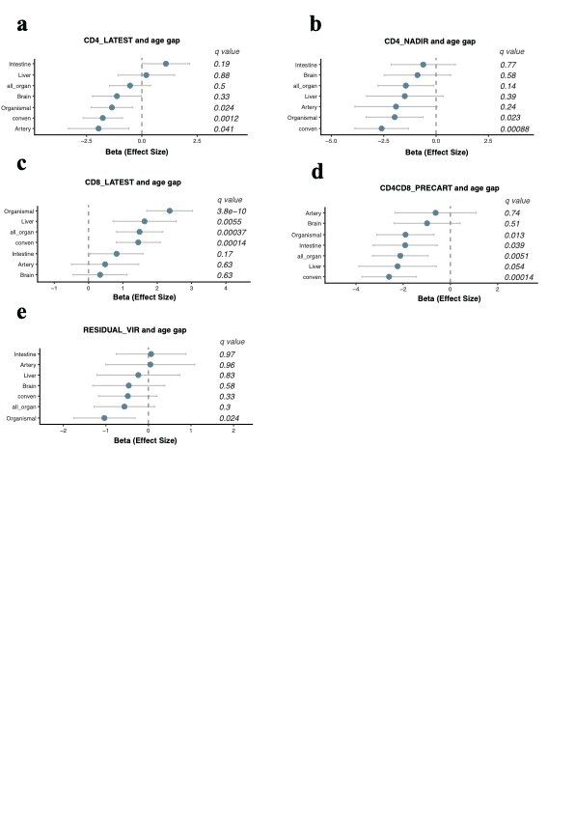

Extended Data Fig. 11.
Forest plot displaying the associations between age gaps and CD4_LATEST (a), CD4_NADIR (b), CD8_LATEST (c), CD4CD8_PRECART (d), and RESIDUAL_VIR (undetectable viral load over the past three years) (e) in PWH. The significant association (FDR) is shown.

Extended Data Fig. 12.
Box plots illustrate the distribution of age gaps between ART naive elite controllers and Normal progressors on ART stratified by chronological age group (18–35, 36–60, ≥60 years).

Table S1.
The Olink® Explore 3072 panels information.

Table S2.
OOB testing result of all proteomic aging models.

Table S3.
Detailed information on the genome-wide association studies extracted from the OpenGWAS database and used for Mendelian randomization analyses (n = 63 studies).

Table S4.
Harmonised summary data for SNPs used in Mendelian randomisation analyses of age advancement (exposure) and 63 GWAS diseases (outcomes). Also, results from the MR steiger test are presented.

Table S5.
Organ specific proteins used in this study and normalized expression in GTEX data

Table S6.
Death causes of 2000HIV participants.

Table S7.
Summary results from Mendelian randomization analyses using inverse variance weighted method (P-IVW < 0.05) of age advancement (exposure) on 63 disease outcomes. Results from the MR-IVW method and sensitivity analyses for heterogeneity (Cochran's Q test) and pleiotropy analyses (MR-PRESSO and Egger regression) are presented.

Table S8.
Reverse MR results of GWAS diseases (exposure) on age advancement (outcome). For the exposure/outcome pairs that 1cSNP remained as instrumental variable, MR statistics was not calculated using the IVW method. Sensitivity analyses were performed only for the pairs that showed a P value using forward-MR-IVW method < 0.05. REsults for which less than five SNPs were available as instrumental variables per exposure were excluded.

Table S9.
Full results of MR estimates (Age advancement on disease outcomes).

Table S10.
List of current co-administration ART in 2000HIV cohort.

Table S11.
List of accumulative co-administration ART in 2000HIV cohort.

