Supplementary Figure
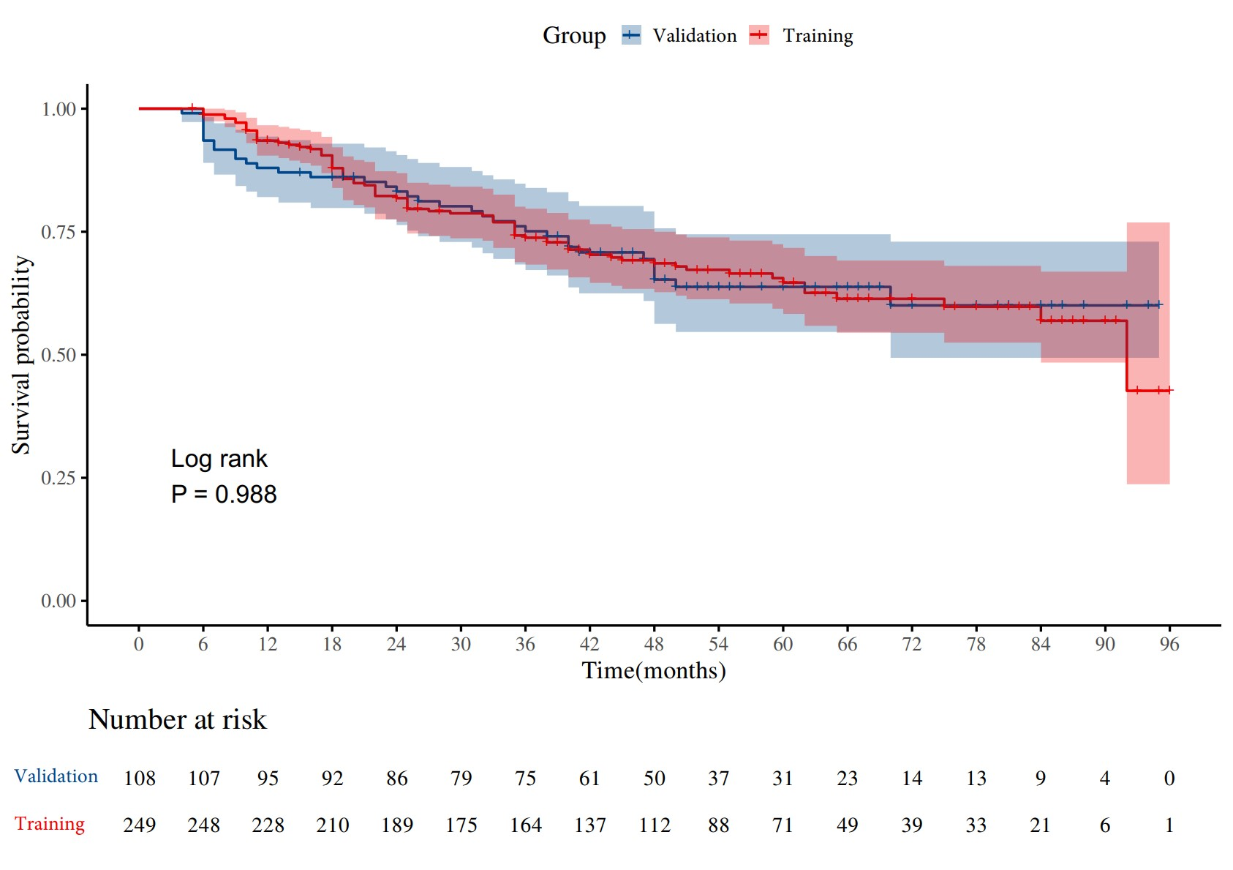
Supplementary Figure S1 The Kaplan-Meier survival curves for overall survival in rectal cancer patients from the training cohort and the validation cohort.

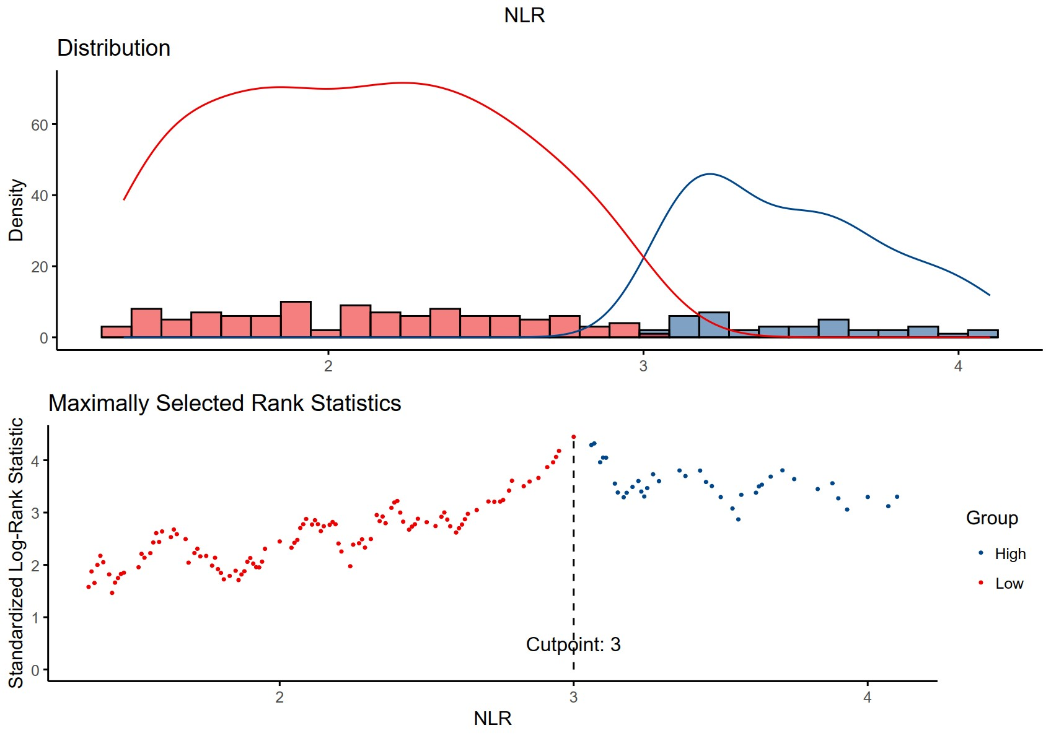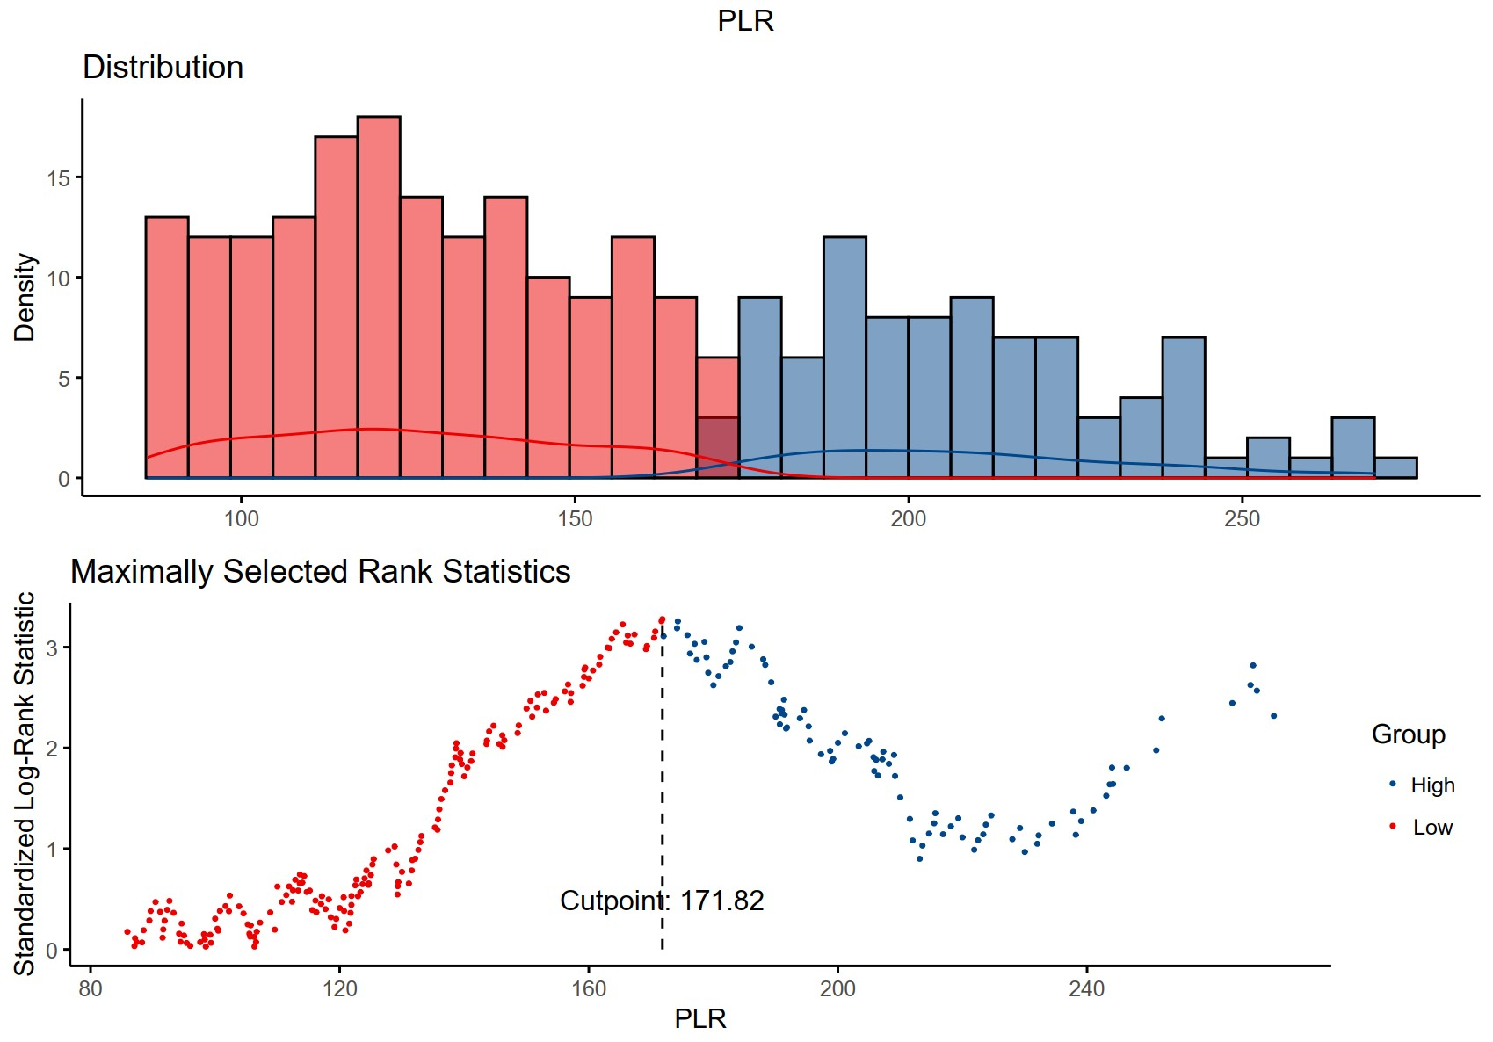
(A) (B)
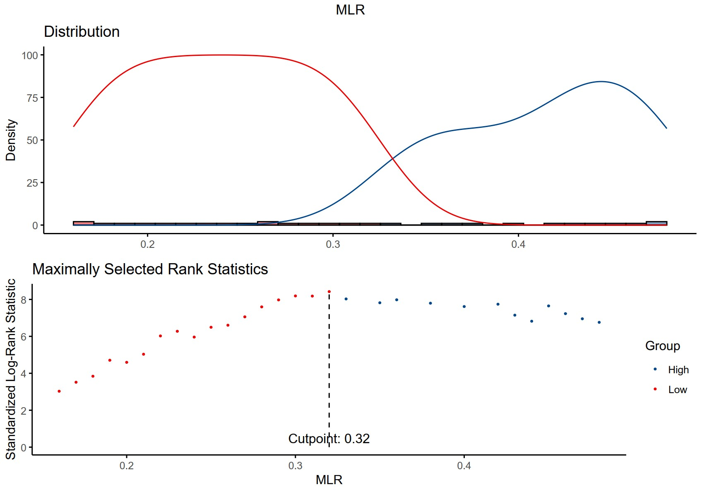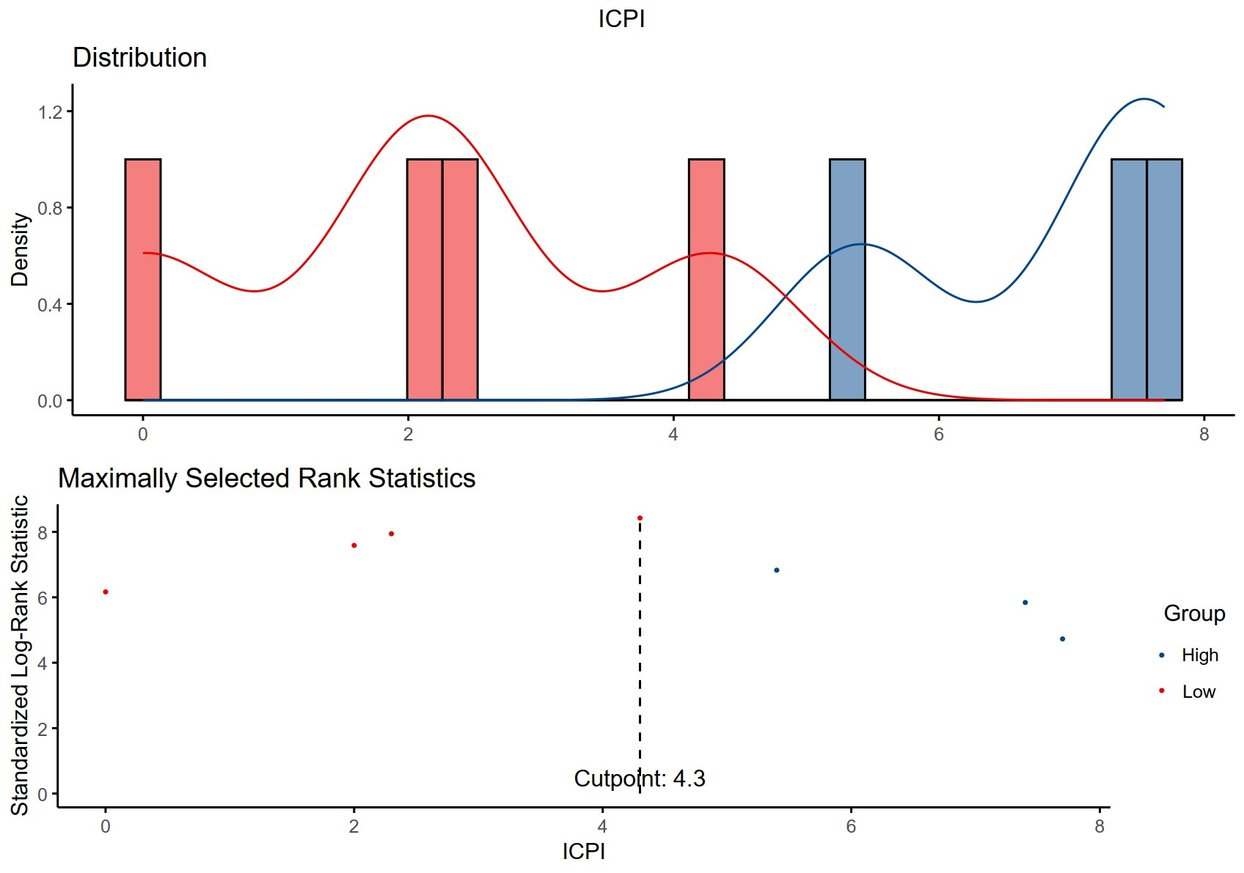
(C) (D)
Supplementary Figure S2 Cut-off of NLR (A), PLR (B), MLR(C) and ICPI(D) in patients with rectal cancer.

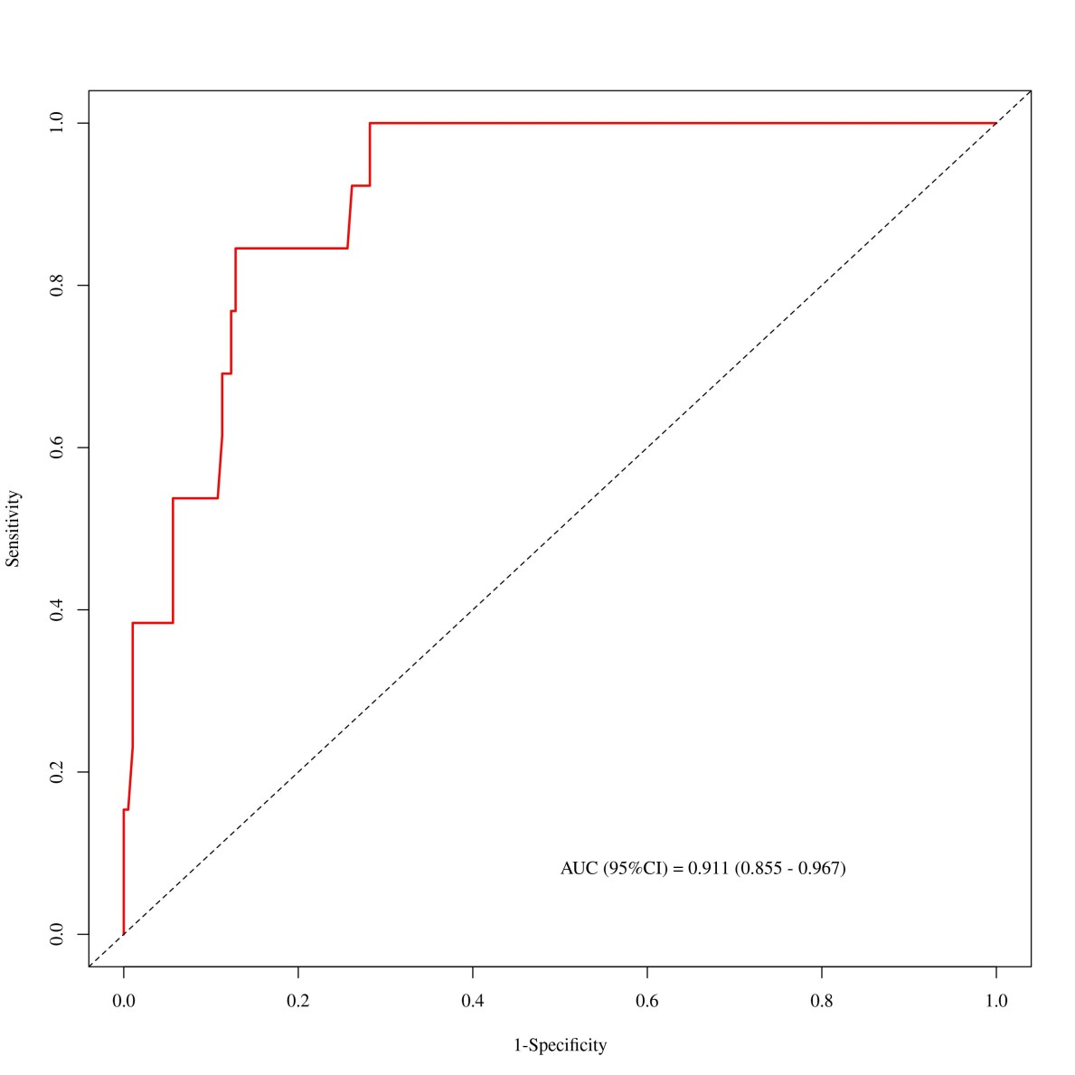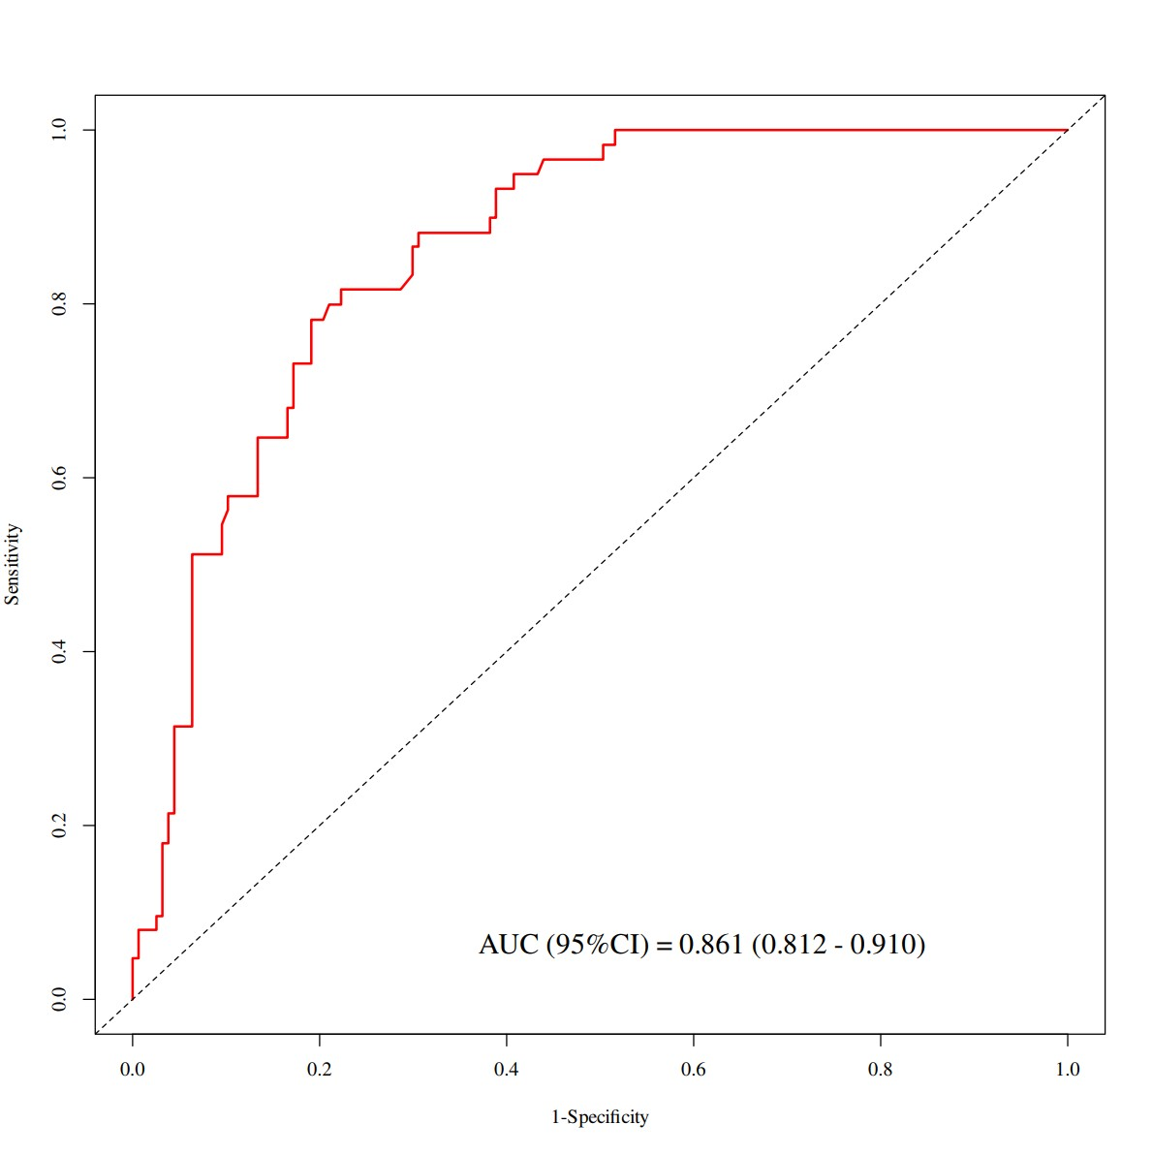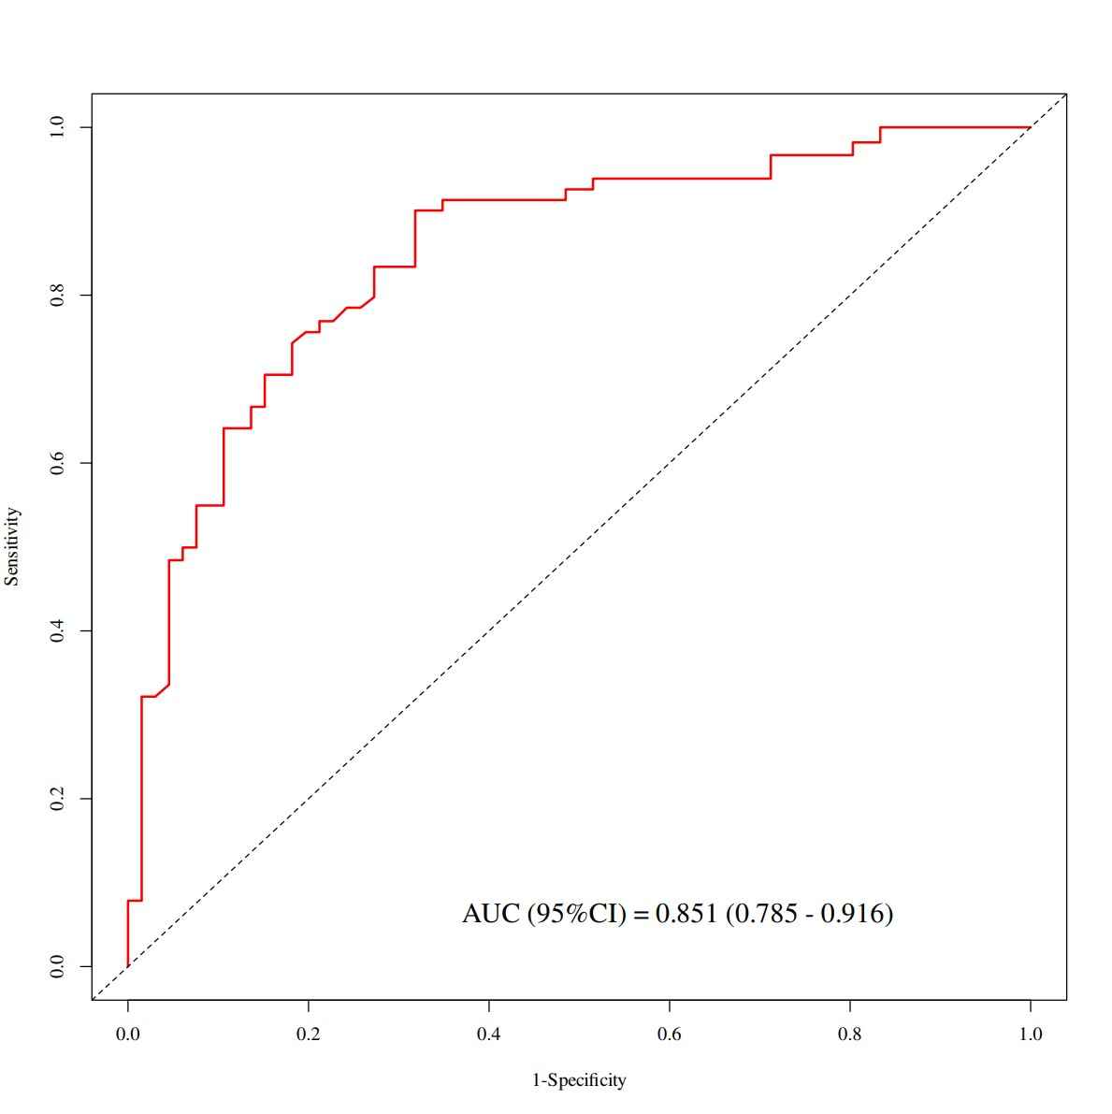
(A) (B) (C)
Supplementary Figure S3 The nomogram ROC curves for predicting 1- (A), 3- (B), and 5 (C) OS in patients with rectal cancer in the training cohort.

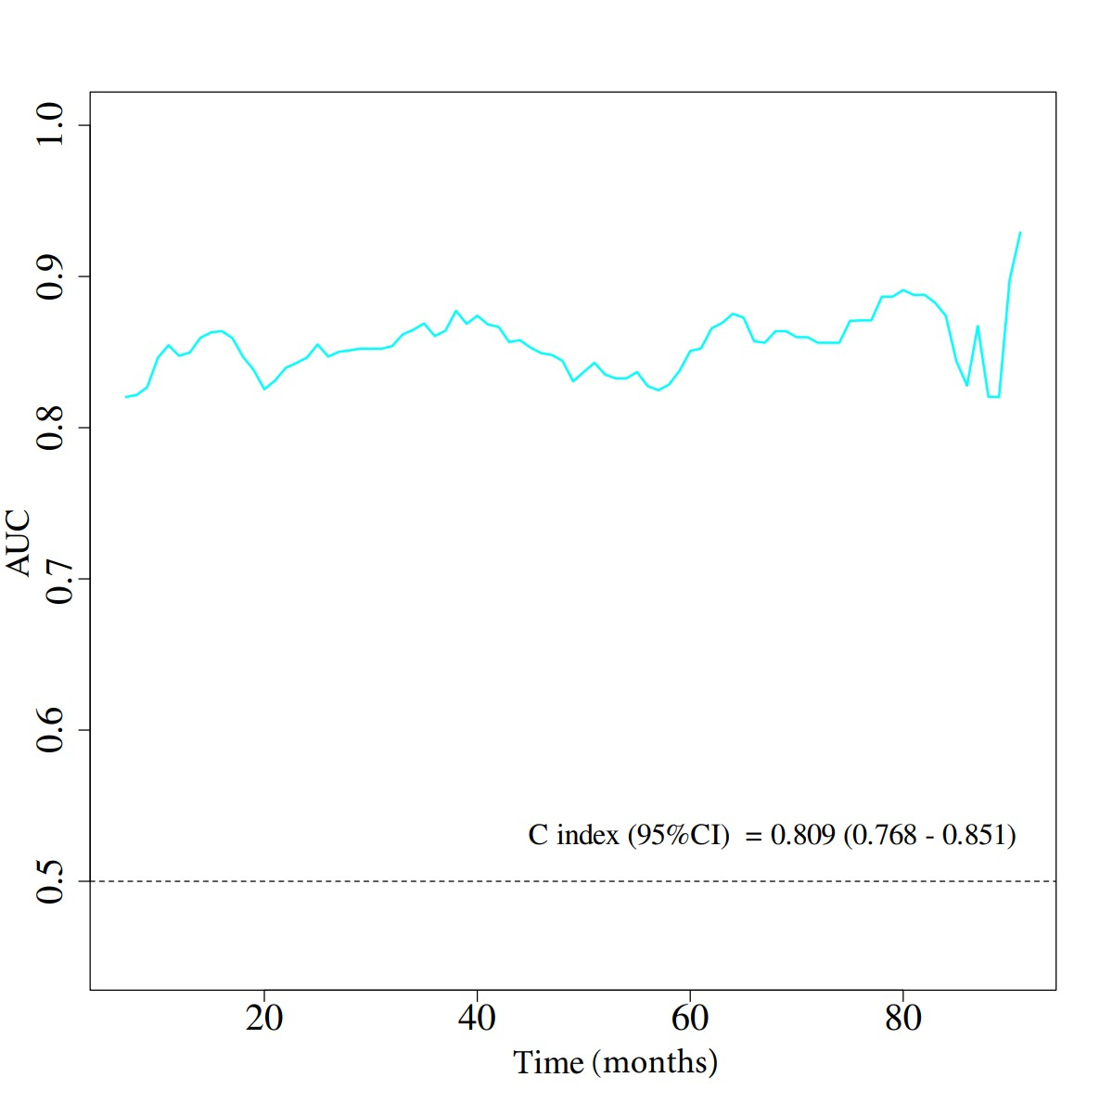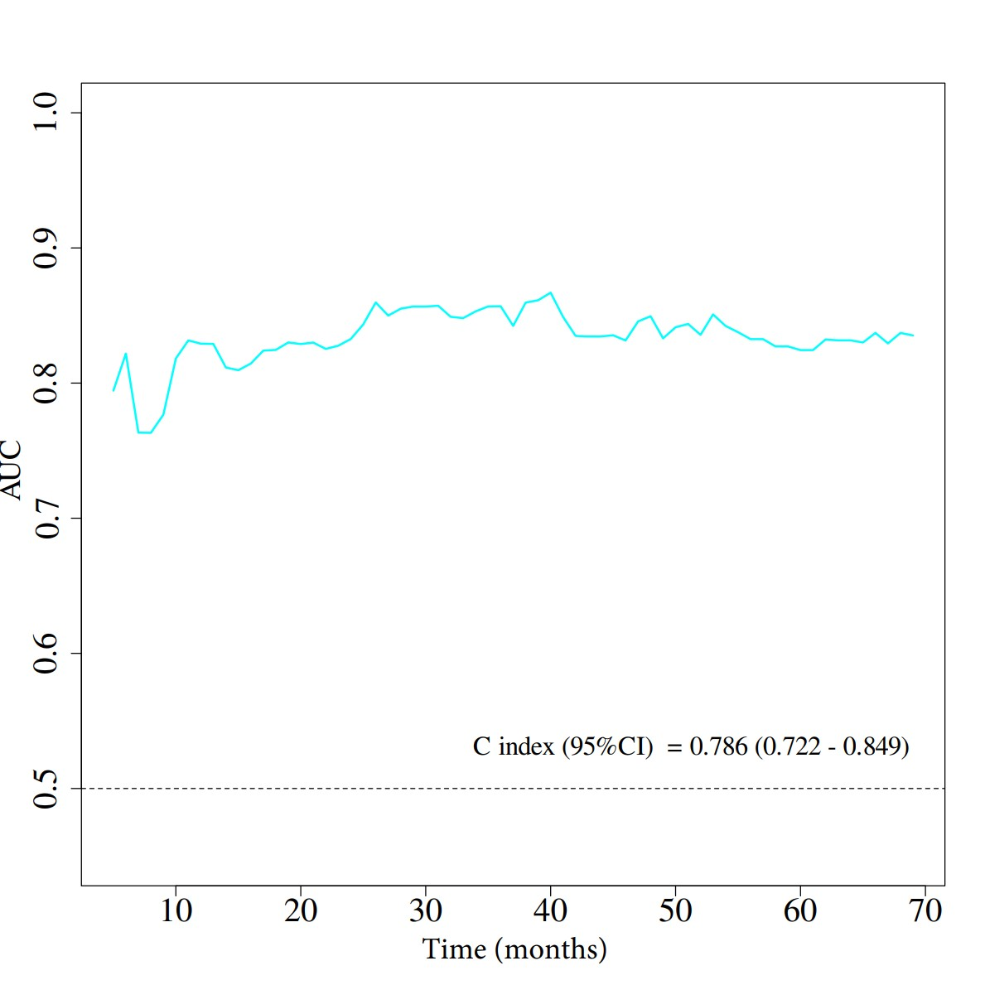
(A) (B)
Supplementary Figure S4 The time-dependent ROC curves in the training(A) and validation(B) cohorts.
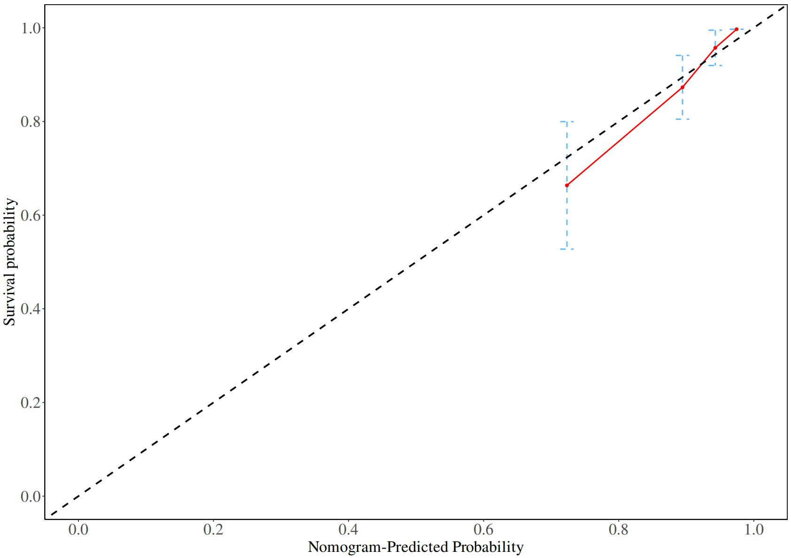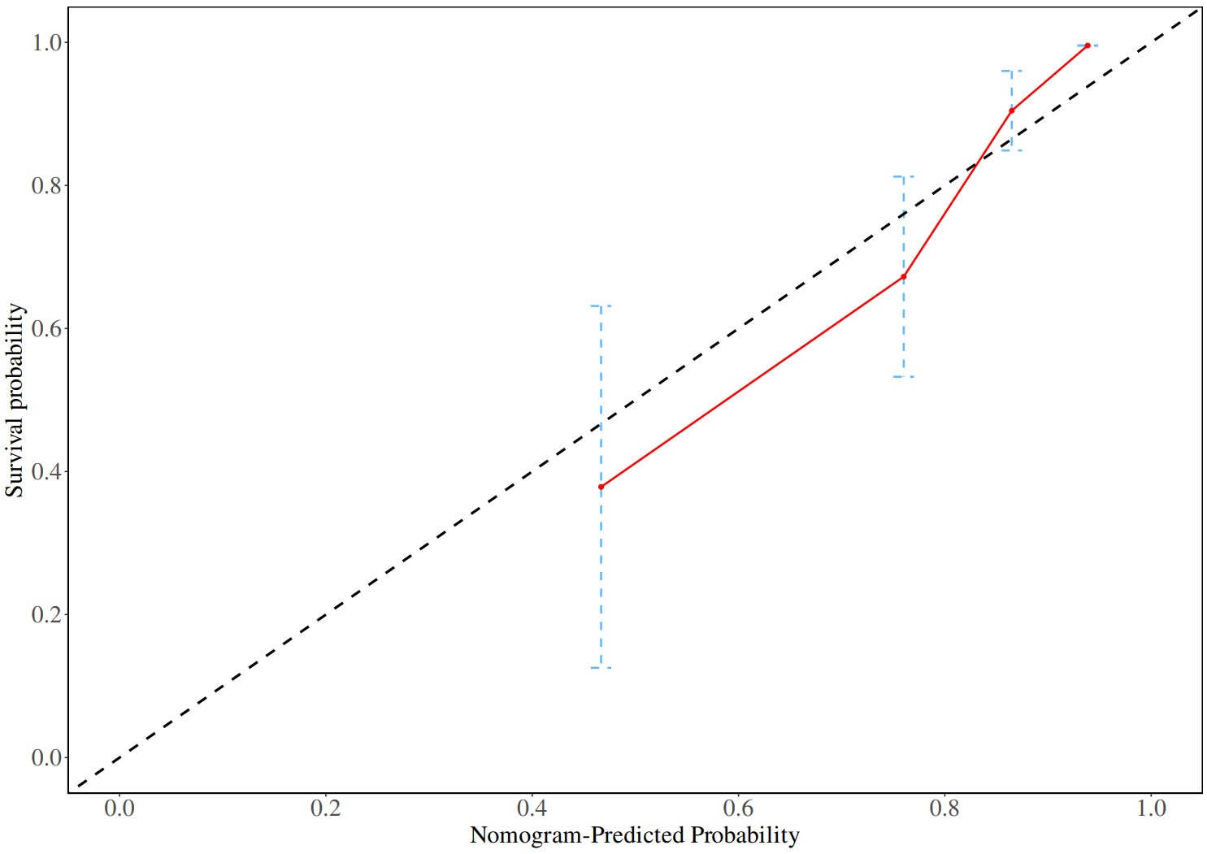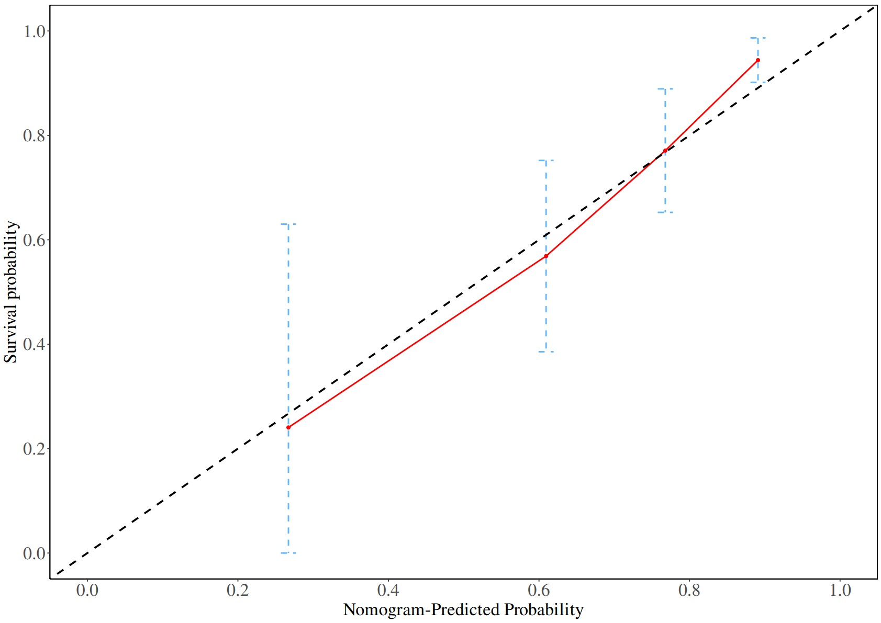
(A) (B) (C)
Supplementary Figure S5 The calibration curves for 1- (A), 3- (B), and 5-year (C) OS in the training cohort. The solid line indicates the performance of the prediction model, and the closer to the diagonal dashed line, the more accurate the prediction.

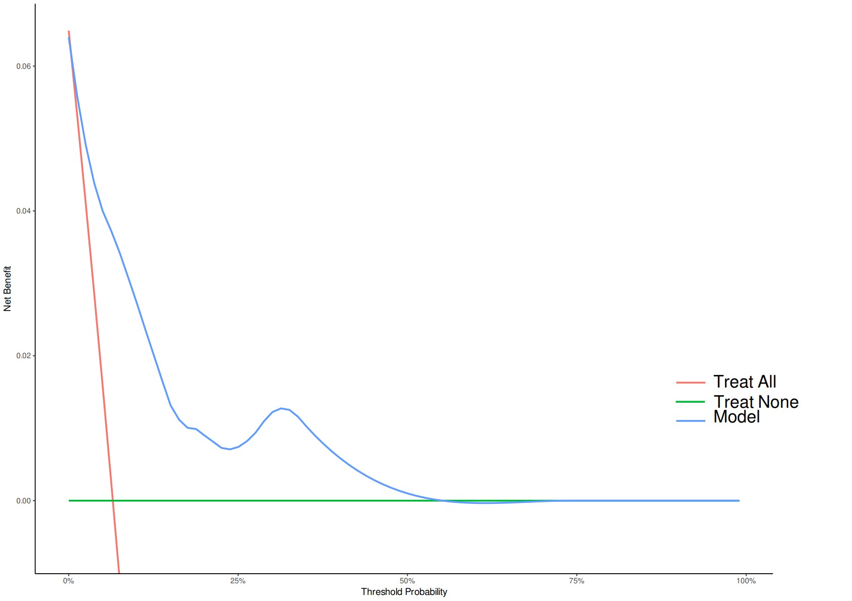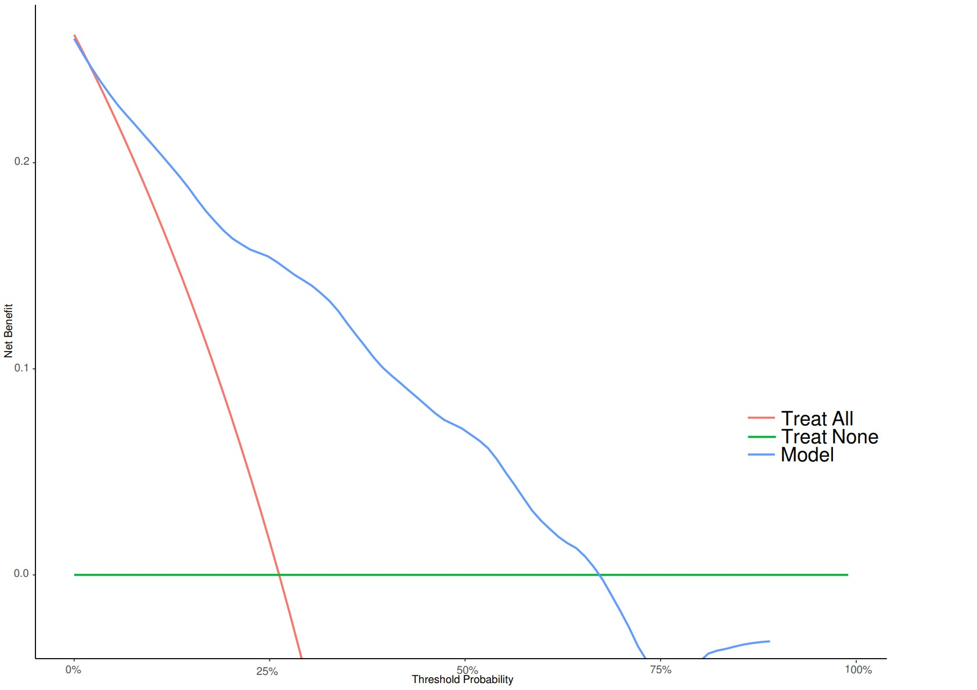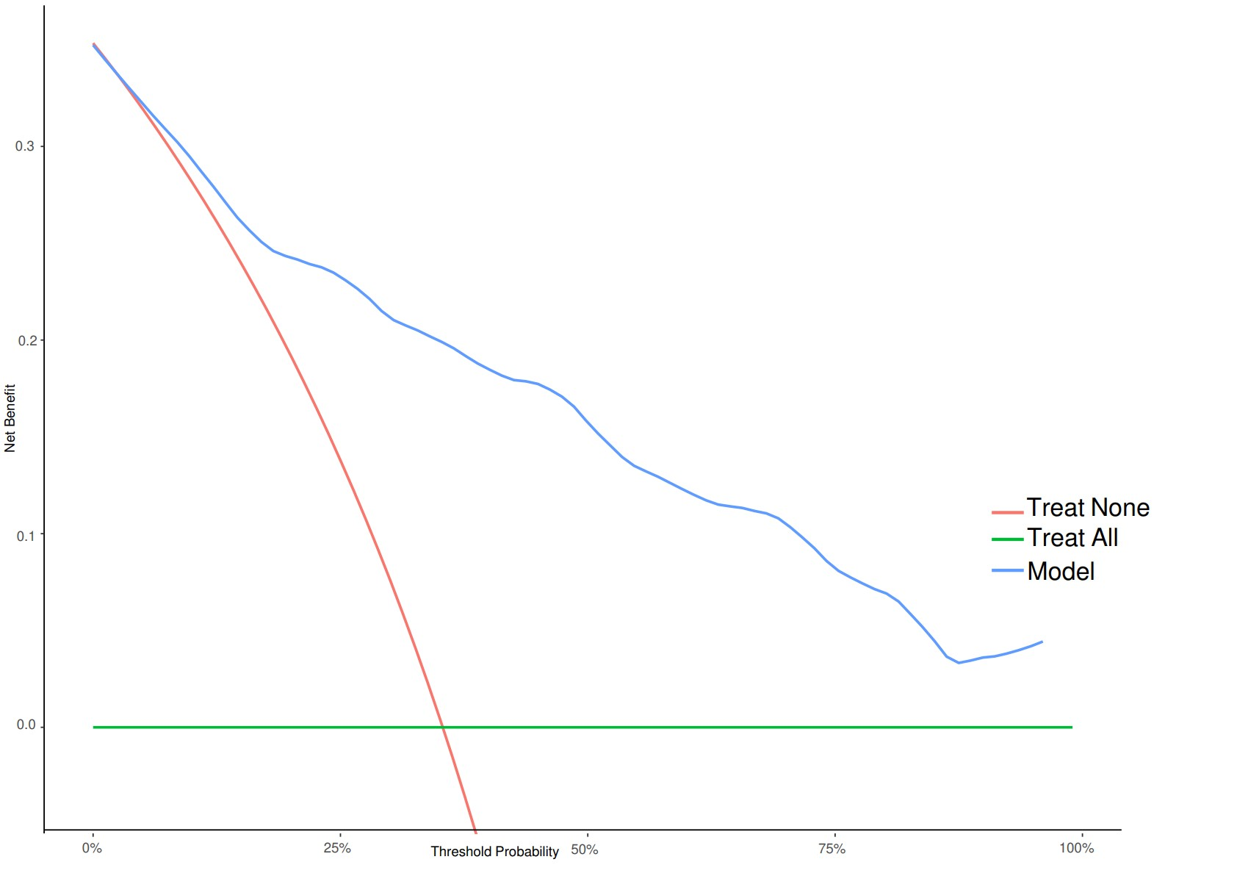
(A) (B) (C)
Supplementary Figure S6 The DCA curves for 1- (A), 3- (B), and 5-year (C) OS in the training cohort.

Supplementary Table S1 Baseline data comparison table for surviving and dying patients
Variables | Total (n = 357) | Survival (n = 239) | Dead (n = 118) | P
Age, Mean ± SD | 64.64 ± 11.59 | 63.20 ± 11.13 | 67.56 ± 12.01 | <.001
Sex, n(%) |  |  |  | 0.363
Female | 139 (38.94) | 97 (40.59) | 42 (35.59)
Male | 218 (61.06) | 142 (59.41) | 76 (64.41)
Hypertension, n(%) |  |  |  | 0.385
No | 232 (64.99) | 159 (66.53) | 73 (61.86)
Yes | 125 (35.01) | 80 (33.47) | 45 (38.14)
Diabetes, n(%) |  |  |  | 0.941
No | 314 (87.96) | 210 (87.87) | 104 (88.14)
Yes | 43 (12.04) | 29 (12.13) | 14 (11.86)
ASA grade, n(%) |  |  |  | 0.036
1 | 80 (22.41) | 55 (23.01) | 25 (21.19)
2 | 194 (54.34) | 138 (57.74) | 56 (47.46)
3 | 83 (23.25) | 46 (19.25) | 37 (31.36)
pT stage, n(%) |  |  |  | 0.068
1 | 210 (58.82) | 136 (56.90) | 74 (62.71)
2 | 81 (22.69) | 61 (25.52) | 20 (16.95)
3 | 50 (14.01) | 35 (14.64) | 15 (12.71)
4 | 16 (4.48) | 7 (2.93) | 9 (7.63)
pN stage, n(%) |  |  |  | 0.005
0 | 230 (64.43) | 166 (69.46) | 64 (54.24)
1 | 87 (24.37) | 54 (22.59) | 33 (27.97)
2 | 40 (11.20) | 19 (7.95) | 21 (17.80)
TNM stage, n(%) |  |  |  | 0.014
1 | 187 (52.38) | 137 (57.32) | 50 (42.37)
2 | 43 (12.04) | 29 (12.13) | 14 (11.86)
3 | 127 (35.57) | 73 (30.54) | 54 (45.76)
Differentiation type, n(%) |  |  |  | <.001
High | 18 (5.04) | 15 (6.28) | 3 (2.54)
Middle | 291 (81.51) | 204 (85.36) | 87 (73.73)
Low | 48 (13.45) | 20 (8.37) | 28 (23.73)
Nerve invasion, n(%) |  |  |  | <.001
No | 281 (78.71) | 201 (84.10) | 80 (67.80)
Yes | 76 (21.29) | 38 (15.90) | 38 (32.20)
Vascular invasion, n(%) |  |  |  | 0.001
No | 298 (83.47) | 210 (87.87) | 88 (74.58)
Yes | 59 (16.53) | 29 (12.13) | 30 (25.42)
Tumour size, n(%) |  |  |  | 0.154
≤3cm | 149 (41.74) | 106 (44.35) | 43 (36.44)
＞3cm | 208 (58.26) | 133 (55.65) | 75 (63.56)
CEA, n(%) |  |  |  | <.001
≤5 µg/L | 228 (63.87) | 180 (75.31) | 48 (40.68)
＞5 µg/L | 129 (36.13) | 59 (24.69) | 70 (59.32)
Surgical time, n(%) |  |  |  | <.001
≤240 min | 268 (75.07) | 203 (84.94) | 65 (55.08)
＞240 min | 89 (24.93) | 36 (15.06) | 53 (44.92)
Postoperative hospital stay, n(%) |  |  |  | 0.187
≤10 days | 169 (47.34) | 119 (49.79) | 50 (42.37)
＞10 days | 188 (52.66) | 120 (50.21) | 68 (57.63)
Chemotherapy, n(%) |  |  |  | 0.038
No | 164 (45.94) | 119 (49.79) | 45 (38.14)
Yes | 193 (54.06) | 120 (50.21) | 73 (61.86)
Radiotherapy, n(%) |  |  |  | 0.598
No | 287 (80.39) | 194 (81.17) | 93 (78.81)
Yes | 70 (19.61) | 45 (18.83) | 25 (21.19)
Platelet, Mean ± SD | 229.57 ± 71.91 | 225.64 ± 65.32 | 237.54 ± 83.44 | 0.176
Monocyte, Mean ± SD | 0.47 ± 0.19 | 0.43 ± 0.16 | 0.55 ± 0.22 | <.001
Neutrophile, Mean ± SD | 3.68 ± 1.30 | 3.48 ± 1.19 | 4.07 ± 1.42 | <.001
Lymphocyte, Mean ± SD | 1.61 ± 0.86 | 1.63 ± 0.92 | 1.56 ± 0.71 | 0.5
NLR, M (IQR) | 2.33 (1.75, 3.11) | 2.25 (1.67, 2.91) | 2.51 (1.91, 3.53) | 0.001
PLR, M (IQR) | 146.11 (110.00, 201.11) | 140.50 (110.00, 192.85) | 166.33 (111.12, 211.15) | 0.13
MLR, M(IQR) | 0.29 (0.22, 0.40) | 0.27 (0.20, 0.36) | 0.35 (0.27, 0.46) | <.001
ICPI, Mean ± SD | 2.96 ± 2.82 | 2.32 ± 2.60 | 4.27 ± 2.79 | <.001
ASA: American Society of Anesthesiologists; NLR: Neutrophil- to- Lymphocyte Ratio; PLR: Platelet-Lymphocyte Ratio; MLR: Monocyte Lymphocyte Ratio; ICPI: Inflammation-Combined Prognostic Index; TNM stage: The 8th edition of the American Joint Committee on Cancer (AJCC) staging system; CEA: carcinoembryonic antigen; IQR: InterQuartile Range;

