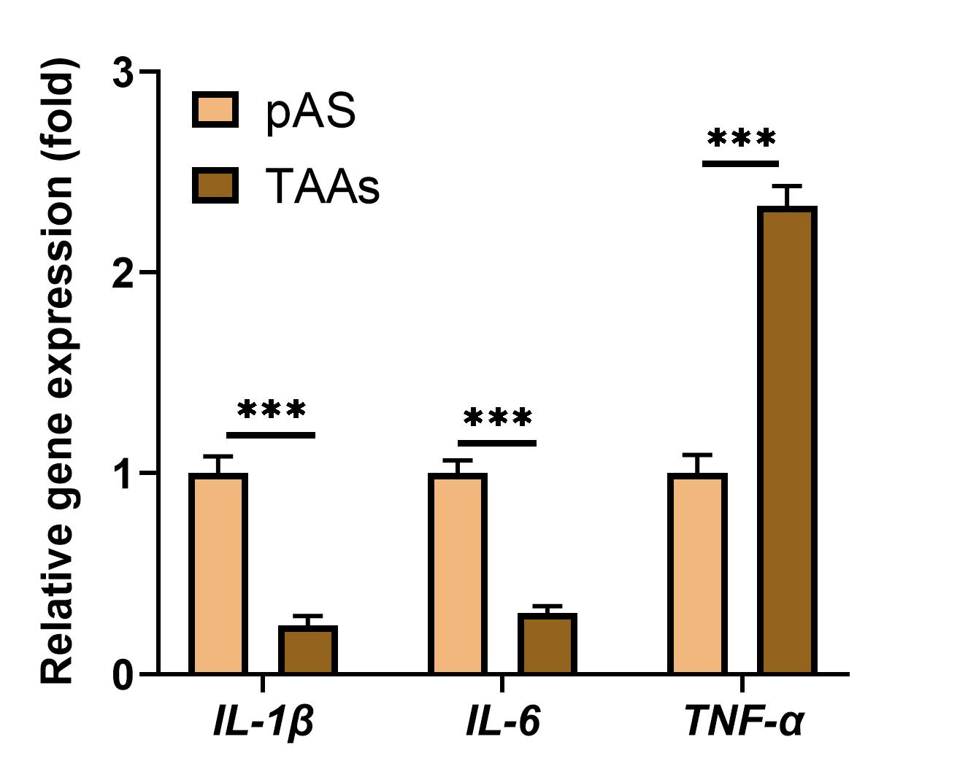
Supplementary Fig.1. The expression of TNF-ɑ is upregulated in tumor-associated astrocytes (TAAs). Primary astrocytes (pAS) and TAAs were isolated from normal mouse brain and mouse lung cancer brain metastasis tumors, respectively, and the gene expression levels of IL-1β, IL-6 and TNF-ɑ in these cells were determined using qPCR. *** p < 0.001.

