Supplementary file
Table S1. Wildlife-wise relief claimed and distributed amount in the last five years (2018/19 - 2022/23) in the buffer zone of Parsa National Park, Nepal.
Animal | Sum of claim amount (NPR in thousand) |  |  |  |  | Sum of relief received (NPR in thousand) |  |  |  |  | Total claim amount | Total relief received
Animal | 2019 | 2020 | 2021 | 2022 | 2023 | 2019 | 2020 | 2021 | 2022 | 2023 | Total claim amount | Total relief received
Elephant | 10.0 | 1280.0 | 373.0 | 769.7 | 2826.0 | 10.0 | 1280.0 | 368.0 | 496.0 | 2466.0 | 5258.7 | 4620.0
Leopard | 0.0 | 350.0 | 936.0 | 377.3 | 291.0 | 0.0 | 350.0 | 899.0 | 260.0 | 200.0 | 1954.3 | 1709.0
Rhino | 0.0 | 0.0 | 36.0 | 265.6 | 38.0 | 0.0 | 0.0 | 30.5 | 190.4 | 24.0 | 339.6 | 244.9
Tiger | 290.0 | 130.0 | 232.0 | 190.0 | 344.0 | 290.0 | 130.0 | 205.0 | 150.0 | 240.0 | 1186.0 | 1015.0
Wild boar | 10.0 | 0.0 | 339.0 | 205.9 | 179.0 | 10.0 | 0.0 | 339.0 | 177.6 | 152.0 | 733.9 | 678.6
Total | 310.0 | 1760.0 | 1916.0 | 1808.5 | 3678.0 | 310.0 | 1760.0 | 1841.5 | 1274.0 | 3082.0 | 9472.5 | 8267.5

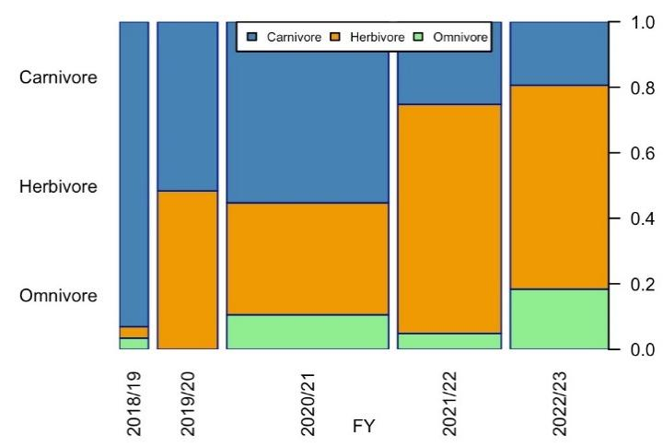 | 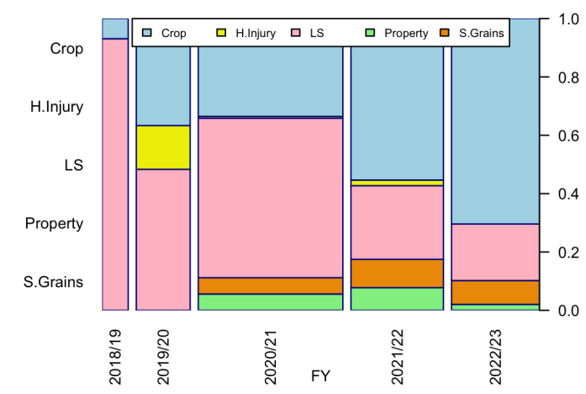
Figure S1: Yearly pattern of human-wildlife conflict (HWC) in the buffer zone of Parsa National Park, Nepal, from 2018/19 to 2022/23, based on (a) types of animals (Color code: Green – omnivores, Orange – herbivores, Blue – carnivores) and (b) damage types (Color code: Green – property damage, Orange – stored grain damage, Pink – livestock depredation, Yellow – human injury, Sky Blue – crop damage). The width of the bars represents the frequency of cases reported in each respective year.
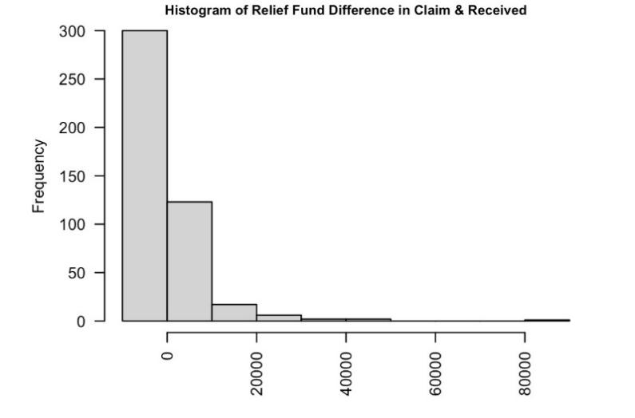
Figure S2. Frequency diagram for the difference of relief claimed vs. relief distributed amount in the buffer zone of Parsa National Park.

