SUPPLEMENTARY FIGURE 1 TP53 expression in patients with prostate cancer from TCGA database. (A) Pairwise analysis of TP53 expression between PRAD and normal tissues (n=52). (B) Comparing of TP53 expression between PRAD (n=498) and normal tissues (n=52). (C) Comparing of TP53 expression among different ages. (D) Comparing of TP53 expression among different TNM stages. (E) Comparing of TP53 expression among different histology grades. (F) Comparing of TP53 expression among different therapy outcomes. (G) Comparing of TP53 expression among biochemical recurrence. (H) Pearson correlation between TP53 expression and recurrence days. (I) Comparing of TP53 expression between patients with normal and abnormal bone scan results. (J) Comparing of TP53 expression among different lymphnodes examination results. (K) Comparing of TP53 expression among mutation, non-mutation and normal patients. (L) Comparing of TP53 expression among different mutation types.
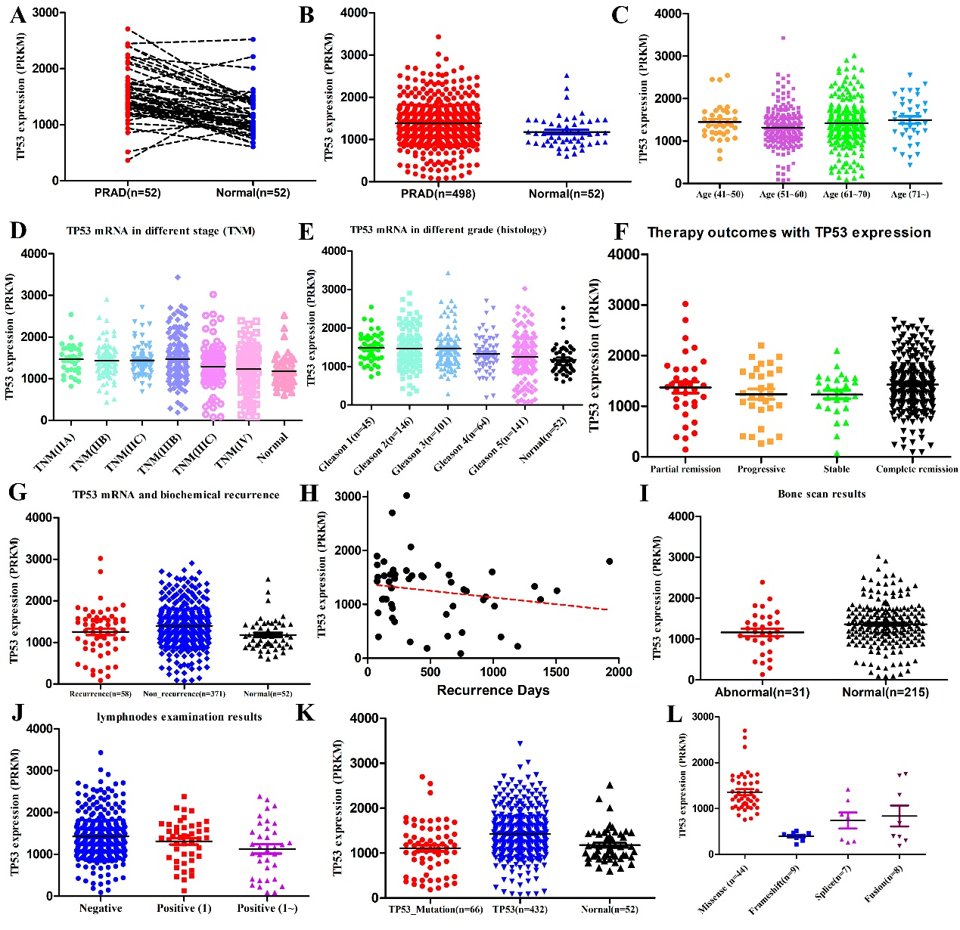

SUPPLEMENTARY FIGURE 2 AR expression in patients with prostate cancer from TCGA database. (A) Pairwise analysis of AR expression between PRAD and normal tissues (n=52). (B) Comparing of AR expression between PRAD (n=498) and normal tissues (n=52). (C) Comparing of AR expression among different ages. (D) Comparing of AR expression among different TNM stages. (E) Comparing of AR expression among different histology grades. (F) Comparing of AR expression among different therapy outcomes. (G) Comparing of AR expression among biochemical recurrence. (H) Pearson correlation between AR expression and recurrence days. (I) Comparing of AR expression between patients with normal and abnormal bone scan results. (J) Comparing of AR expression among different lymphnodes examination results. (K) Comparing of AR expression among different origin zones.
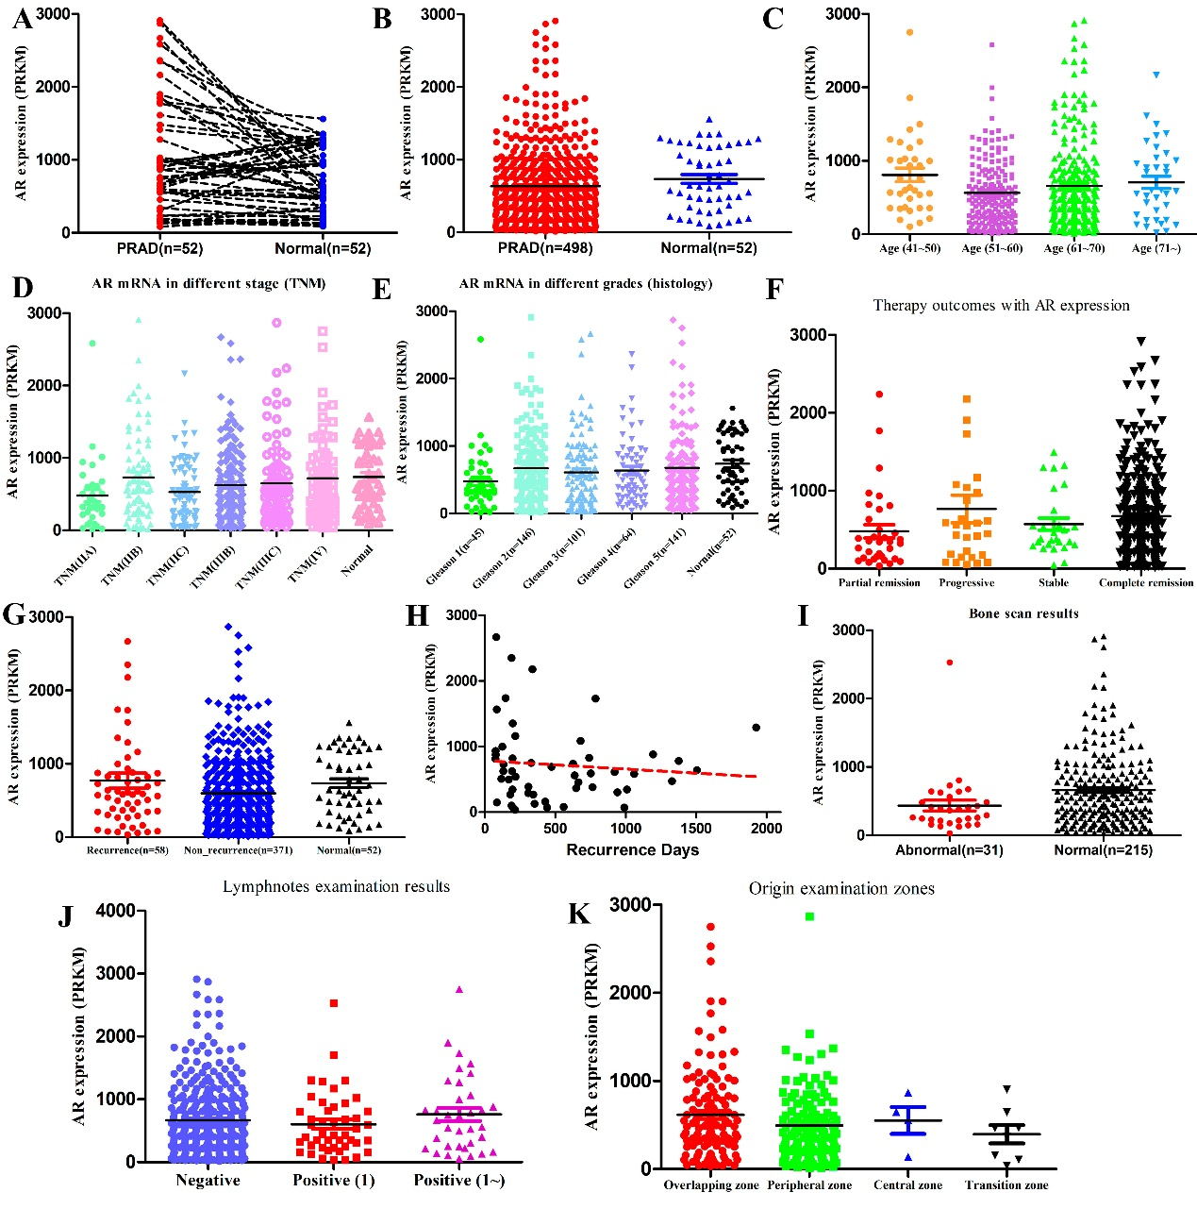

SUPPLEMENTARY TABLE 1 AR related pathway and genes
AR Signaling | AR and Steroid Synthesis Enzymes | Steroid inactivating genes | Down-regulated by androgen
SOX9 | AKR1C3 | AKR1C1 | BCHE
RAN | AR | AKR1C2 | CDK8
TNK2 | CYB5A | AKR1C4 | CTBP1
EP300 | CYP11A1 | CYP3A4 | ACKR3
PXN | CYP11B1 | CYP3A43 | DDC
NCOA2 | CYP11B2 | CYP3A5 | DPH1
AR | CYP17A1 | CYP3A7 | FN1
NRIP1 | CYP19A1 | UGT2B15 | HES6
NCOR1 | CYP21A2 | UGT2B17 | MMP16
NCOR2 | HSD17B1 | UGT2B7 | MYC
 | HSD17B10 |  | PEG3
 | HSD17B11 |  | PIK3R3
 | HSD17B12 |  | PRKD1
 | HSD17B13 |  | SCNN1A
 | HSD17B14 |  | SDC4
 | HSD17B2 |  | SERPINI1
 | HSD17B3 |  | SLC29A1
 | HSD17B4 |  | ST7
 | HSD17B6 |  | TULP4
 | HSD17B7
 | HSD17B8
 | HSD3B1
 | HSD3B2
 | HSD3B7
 | RDH5
 | SHBG
 | SRD5A1
 | SRD5A2
 | SRD5A3
 | STAR

Supplementary Figure to original western blot

Original western blot images to Figure 4B

TP53 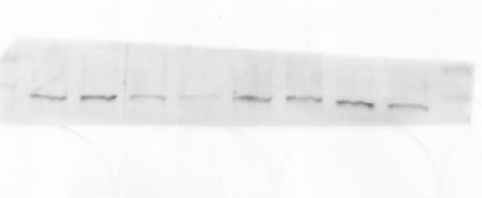
GAPDH 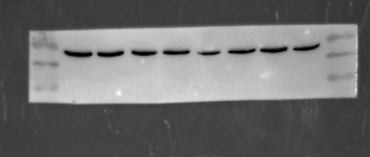

Original western blot images to Figure 3C
TP53 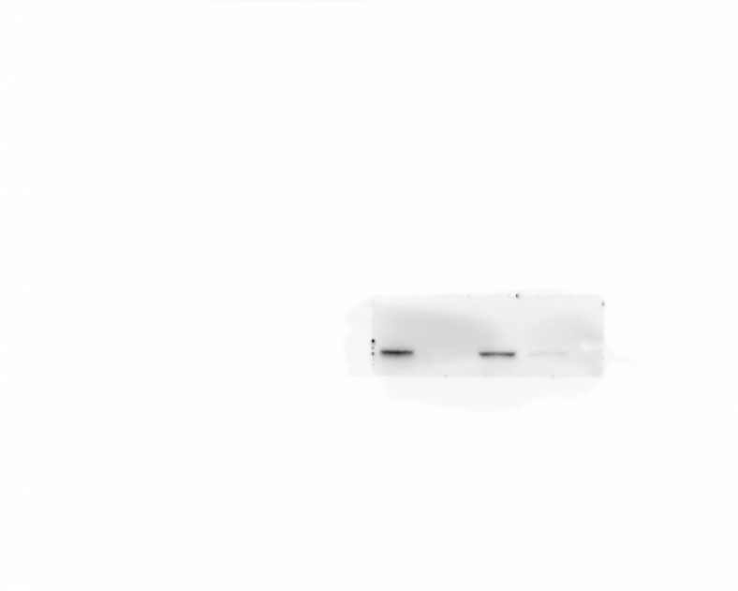

AR 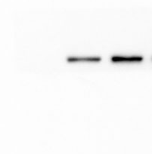
GAPDH 