Supplementary Information

Table S1. Descriptive Statistics of POL Variable per Country.
Country | Mean |  | Median |  | Max |  | Min |  |  | St.Dev
Eastern Europe
Bulgaria | 0.178 |  | 0.187 |  | 0.269 |  | 0.109 |  |  | 0.043
Czech Republic | 0.254 |  | 0.250 |  | 0.288 |  | 0.231 |  |  | 0.016
Hungary | 0.239 |  | 0.228 |  | 0.305 |  | 0.197 |  |  | 0.035
Poland | 0.242 |  | 0.245 |  | 0.300 |  | 0.198 |  |  | 0.025
Romania | 0.192 |  | 0.194 |  | 0.246 |  | 0.138 |  |  | 0.032
Slovakia | 0.212 |  | 0.200 |  | 0.238 |  | 0.200 |  |  | 0.016
Total | 0.220 |  | 0.217 |  | 0.305 |  | 0.109 |  |  | 0.028
Northern Europe
Denmark | 0.227 |  | 0.233 |  | 0.265 |  | 0.200 |  |  | 0.014
Estonia | 0.254 |  | 0.255 |  | 0.287 |  | 0.229 |  |  | 0.014
Finland | 0.223 |  | 0.237 |  | 0.252 |  | 0.166 |  |  | 0.030
Ireland | 0.207 |  | 0.205 |  | 0.223 |  | 0.189 |  |  | 0.013
Latvia | 0.252 |  | 0.252 |  | 0.264 |  | 0.246 |  |  | 0.006
Lithuania | 0.249 |  | 0.244 |  | 0.275 |  | 0.237 |  |  | 0.012
Sweden | 0.261 |  | 0.254 |  | 0.302 |  | 0.167 |  |  | 0.027
Total | 0.239 |  | 0.240 |  | 0.302 |  | 0.166 |  |  | 0.017
Southern Europe
Croatia | 0.223 |  | 0.228 |  | 0.283 |  | 0.185 |  |  | 0.022
Greece | 0.149 |  | 0.138 |  | 0.273 |  | 0.124 |  |  | 0.030
Italy | 0.165 |  | 0.172 |  | 0.268 |  | 0.108 |  |  | 0.030
Portugal | 0.201 |  | 0.197 |  | 0.246 |  | 0.158 |  |  | 0.018
Slovenia | 0.273 |  | 0.300 |  | 0.315 |  | 0.192 |  |  | 0.045
Spain | 0.139 |  | 0.135 |  | 0.223 |  | 0.113 |  |  | 0.025
Total | 0.192 |  | 0.195 |  | 0.315 |  | 0.108 |  |  | 0.028
Western & Central Europe
Austria | 0.302 |  | 0.308 |  | 0.325 |  | 0.276 |  |  | 0.017
Belgium | 0.256 |  | 0.251 |  | 0.309 |  | 0.202 |  |  | 0.029
France | 0.174 |  | 0.173 |  | 0.269 |  | 0.133 |  |  | 0.031
Germany | 0.237 |  | 0.241 |  | 0.303 |  | 0.157 |  |  | 0.034
Luxembourg | 0.211 |  | 0.211 |  | 0.211 |  | 0.211 |  |  | 0.000
Netherlands | 0.242 |  | 0.235 |  | 0.311 |  | 0.185 |  |  | 0.030
Total | 0.237 |  | 0.237 |  | 0.325 |  | 0.133 |  |  | 0.024

Table S2. Descriptive Statistics of NPC Variable per Country.
Country | Mean |  | Median |  |  | Max |  | Min |  |  | St.Dev
Eastern Europe
Bulgaria | 11.681 |  | 9.212 |  |  | 51.019 |  | 3.912 |  |  | 8.133
Czech Republic | 15.328 |  | 15.328 |  |  | 30.565 |  | 5.895 |  |  | 5.380
Hungary | 8.145 |  | 7.085 |  |  | 16.643 |  | 2.316 |  |  | 3.677
Poland | 13.737 |  | 12.372 |  |  | 36.330 |  | 7.568 |  |  | 4.718
Romania | 17.376 |  | 16.845 |  |  | 40.164 |  | 1.994 |  |  | 10.415
Slovakia | 10.481 |  | 4.762 |  |  | 25.926 |  | 4.762 |  |  | 7.962
Total | 12.791 |  | 10.934 |  |  | 51.019 |  | 1.994 |  |  | 6.714
Northern Europe
Denmark | 11.371 |  | 9.276 |  |  | 15.497 |  | 7.674 |  |  | 3.212
Estonia | 29.248 |  | 32.191 |  |  | 34.575 |  | 19.642 |  |  | 6.472
Finland | 35.153 |  | 33.664 |  |  | 47.514 |  | 28.282 |  |  | 5.431
Ireland | 10.522 |  | 10.173 |  |  | 13.457 |  | 8.154 |  |  | 1.856
Latvia | 36.961 |  | 36.944 |  |  | 41.128 |  | 35.381 |  |  | 2.023
Lithuania | 15.976 |  | 14.932 |  |  | 33.863 |  | 10.009 |  |  | 5.687
Sweden | 30.871 |  | 29.789 |  |  | 49.097 |  | 24.371 |  |  | 5.872
Total | 24.300 |  | 23.853 |  |  | 49.097 |  | 7.674 |  |  | 4.365
Southern Europe
Croatia | 17.914 |  | 13.743 |  |  | 59.660 |  | 6.311 |  |  | 11.394
Greece | 10.874 |  | 8.855 |  |  | 50.569 |  | 4.345 |  |  | 6.721
Italy | 22.969 |  | 22.135 |  |  | 57.400 |  | 6.147 |  |  | 9.828
Portugal | 26.936 |  | 20.944 |  |  | 45.928 |  | 15.108 |  |  | 10.810
Slovenia | 33.984 |  | 32.451 |  |  | 61.508 |  | 20.732 |  |  | 11.546
Spain | 10.695 |  | 9.724 |  |  | 31.684 |  | 2.221 |  |  | 7.035
Total | 20.562 |  | 17.975 |  |  | 61.508 |  | 2.221 |  |  | 9.556
Western & Central Europe
Austria | 17.689 |  | 8.938 |  |  | 50.367 |  | 4.632 |  |  | 13.574
Belgium | 15.722 |  | 14.427 |  |  | 37.757 |  | 3.118 |  |  | 7.328
France | 15.519 |  | 11.148 |  |  | 55.175 |  | 3.757 |  |  | 9.303
Germany | 13.450 |  | 12.689 |  |  | 38.658 |  | 1.857 |  |  | 6.179
Luxembourg | 26.614 |  | 26.614 |  |  | 26.614 |  | 26.614 |  |  | 0.000
Netherlands | 9.328 |  | 9.651 |  |  | 33.796 |  | 2.446 |  |  | 5.074
Total | 16.387 |  | 13.911 |  |  | 55.175 |  | 1.857 |  |  | 6.910

Table S3: Parameter Estimates of the First Stage Regression.
Parameter | Coefficient | St.Error | Parameter | Coefficient | St.Error
$$ζ_{0}$$ | 0.2272 | 0.1102*** | $$ζ_{c}$$ | 0.0066 | 0.0029**
$$ζ_{l}$$ | 0.0899 | 0.0161*** | $$ζ_{z}$$ | -0.1662 | 0.1002*
$$ζ_{h}$$ | -0.1045 | 0.0191*** | $$θ_{Ι}$$ | 0.4031 | 0.0730***
$$ζ_{f}$$ | -0.0062 | 0.0042 | $$θ_{ΙΖ}$$ | 0.0361 | 0.0225*
$${\overline{R}}^{2}$$ | 0.4000 |  | No of Obs | 19,347
Note: *, **, and *** indicate statistical significance at the 10%, 5%, and 1% level, respectively. Letter $l$ stands for labour, $h$ for land, $f$ for fertilizers, $c$ for capital, z for crop protection expenditures, and $I$ for the instrumental variable. Clustered robust standard errors at NUTS3 level are reported in the table.

Table S4. Output Elasticities of Productive Inputs (Mean Estimates Over Country).
Country | $$X_{l}$$ |  |  |  | $$X_{h}$$ |  | $$X_{f}$$ |  |  |  | $$X_{c}$$ |  | $$Z$$
Eastern Europe
Bulgaria | 0.3646 |  |  |  | 0.2295 |  | 0.1172 |  |  |  | 0.0480 |  | 0.2005
Czech Republic | 0.3603 |  |  |  | 0.2440 |  | 0.0955 |  |  |  | 0.0721 |  | 0.2713
Hungary | 0.3617 |  |  |  | 0.2402 |  | 0.1001 |  |  |  | 0.0678 |  | 0.3312
Poland | 0.3615 |  |  |  | 0.2408 |  | 0.0991 |  |  |  | 0.0688 |  | 0.2966
Romania | 0.3640 |  |  |  | 0.2322 |  | 0.1125 |  |  |  | 0.0536 |  | 0.2761
Slovakia | 0.3635 |  |  |  | 0.2352 |  | 0.1067 |  |  |  | 0.0609 |  | 0.2761
Mean | 0.3626 |  |  |  | 0.2370 |  | 0.1052 |  |  |  | 0.0619 |  | 0.2753
Northern Europe
Denmark | 0.3610 |  |  |  | 0.2407 |  | 0.1014 |  |  |  | 0.0651 |  | 0.3113
Estonia | 0.3591 |  |  |  | 0.2457 |  | 0.0948 |  |  |  | 0.0719 |  | 0.2970
Finland | 0.3616 |  |  |  | 0.2391 |  | 0.1032 |  |  |  | 0.0635 |  | 0.3409
Ireland | 0.3632 |  |  |  | 0.2352 |  | 0.1077 |  |  |  | 0.0592 |  | 0.3940
Latvia | 0.3590 |  |  |  | 0.2458 |  | 0.0949 |  |  |  | 0.0717 |  | 0.2767
Lithuania | 0.3598 |  |  |  | 0.2443 |  | 0.0962 |  |  |  | 0.0708 |  | 0.2855
Sweden | 0.3573 |  |  |  | 0.2492 |  | 0.0922 |  |  |  | 0.0735 |  | 0.3554
Mean | 0.3602 |  |  |  | 0.2429 |  | 0.0986 |  |  |  | 0.0679 |  | 0.3230
Southern Europe
Croatia | 0.3634 |  |  |  | 0.2363 |  | 0.1043 |  |  |  | 0.0639 |  | 0.3053
Greece | 0.3702 |  |  |  | 0.2172 |  | 0.1295 |  |  |  | 0.0378 |  | 0.2651
Italy | 0.3670 |  |  |  | 0.2243 |  | 0.1222 |  |  |  | 0.0441 |  | 0.2909
Portugal | 0.3642 |  |  |  | 0.2329 |  | 0.1100 |  |  |  | 0.0573 |  | 0.2508
Slovenia | 0.3585 |  |  |  | 0.2480 |  | 0.0913 |  |  |  | 0.0759 |  | 0.2397
Spain | 0.3699 |  |  |  | 0.2164 |  | 0.1323 |  |  |  | 0.0337 |  | 0.3269
Mean | 0.3655 |  |  |  | 0.2292 |  | 0.1149 |  |  |  | 0.0521 |  | 0.2798
Western & Central Europe
Austria | 0.3552 |  |  |  | 0.2556 |  | 0.0835 |  |  |  | 0.0827 |  | 0.3803
Belgium | 0.3581 |  |  |  | 0.2476 |  | 0.0939 |  |  |  | 0.0721 |  | 0.3714
France | 0.3668 |  |  |  | 0.2256 |  | 0.1194 |  |  |  | 0.0476 |  | 0.3516
Germany | 0.3603 |  |  |  | 0.2424 |  | 0.0994 |  |  |  | 0.0671 |  | 0.3423
Luxembourg | 0.3626 |  |  |  | 0.2365 |  | 0.1062 |  |  |  | 0.0606 |  | 0.4631
Netherlands | 0.3593 |  |  |  | 0.2444 |  | 0.0975 |  |  |  | 0.0686 |  | 0.2613
Mean | 0.3604 |  |  |  | 0.2420 |  | 0.1000 |  |  |  | 0.0664 |  | 0.3617
Note: All reported elasticities are statistically significant at the 1 per cent with their corresponding standard errors computed using the Delta Method. Subscript $l$ stands for labor, $h$ for land, $f$ for fertilizers, and $c$ for capital, while $Z$ denotes crop protection expenditures.

Table S5. Number of holdings and economic benefits in response to one unit increase of POL and NPC per country
Country | No of holdings_ General field cropping (GFC) (in 2016)* | No of holdings_Specialist cereals, oilseed and protein crops (COP) (in 2016)* | + 1 SD of POL _GFC (in 10^6 euros) | + 1 SD of POL_COP ((in 10^6 euros) | + 1 SD of NPC _GFC ((in 10^6 euros) | + 1 SD of NPC_COP ((in 10^6 euros)
Belgium | 8270 | 1920 | 31.6 | 7.3 | 56.4 | 13.1
Bulgaria | 28960 | 19030 | 110.6 | 72.7 | 197.4 | 129.7
Czechia | 2480 | 5520 | 9.5 | 21.1 | 16.9 | 37.6
Denmark | 4910 | 12060 | 18.8 | 46.1 | 33.5 | 82.2
Germany | 43720 | 40630 | 167.0 | 155.2 | 298.1 | 277.0
Estonia | 6450 | 2340 | 24.6 | 8.9 | 44.0 | 16.0
Ireland | 8690 | 4230 | 33.2 | 16.2 | 59.2 | 28.8
Greece | 71900 | 57530 | 274.6 | 219.7 | 490.2 | 392.2
Spain | 81780 | 134780 | 312.3 | 514.7 | 557.6 | 918.9
France | 44420 | 86440 | 169.6 | 330.1 | 302.9 | 589.3
Croatia | 10070 | 18310 | 38.5 | 69.9 | 68.7 | 124.8
Italy | 171430 | 173040 | 654.7 | 660.8 | 1168.8 | 1179.8
Cyprus | 1840 | 640 | 7.0 | 2.4 | 12.5 | 4.4
Latvia | 20420 | 8480 | 78.0 | 32.4 | 139.2 | 57.8
Lithuania | 15980 | 32360 | 61.0 | 123.6 | 109.0 | 220.6
Luxembourg | 90 | 60 | 0.3 | 0.2 | 0.6 | 0.4
Hungary | 30600 | 85480 | 116.9 | 326.4 | 208.6 | 582.8
Malta | 4000 |  | 15.3 | 0.0 | 27.3 | 0.0
Netherlands | 10050 | 760 | 38.4 | 2.9 | 68.5 | 5.2
Austria | 21220 | 12510 | 81.0 | 47.8 | 144.7 | 85.3
Poland | 403620 | 393740 | 1541.4 | 1503.7 | 2751.9 | 2684.5
Portugal | 17090 | 7310 | 65.3 | 27.9 | 116.5 | 49.8
Romania | 621850 | 441020 | 2374.8 | 1684.3 | 4239.8 | 3006.9
Slovenia | 9950 | 3460 | 38.0 | 13.2 | 67.8 | 23.6
Slovakia | 4780 | 7260 | 18.3 | 27.7 | 32.6 | 49.5
Finland | 13530 | 17520 | 51.7 | 66.9 | 92.2 | 119.5
Sweden | 19320 | 7780 | 73.8 | 29.7 | 131.7 | 53.0
European Union - 27 | 1677400 | 1574210 | 6406.0 | 6011.9 | 11436.5 | 10733.0
*Data source of number of holdings: Eurostat: https://doi.org/10.2908/EF_M_FARMLEG

Figure S1: Output elasticities of NPC on field crops production conditional on the level of the service.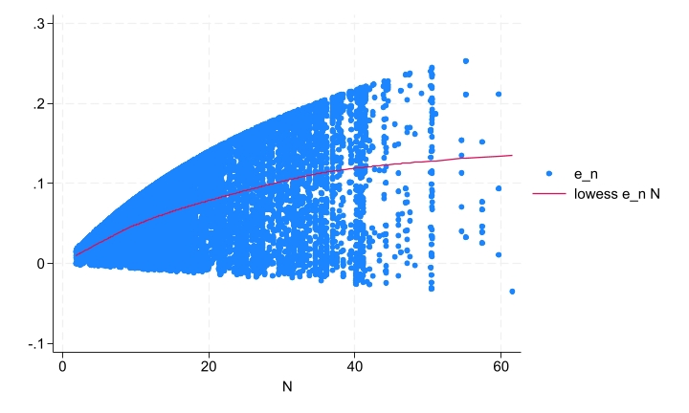
Note: LOWESS stands for locally weighted scatterplot smoothing. e_n stands for the output elasticity of natural pest control. N is the level of natural pest control service.
Figure S2: Output elasticities of POL (p0) on field crops production conditional on the level of the service
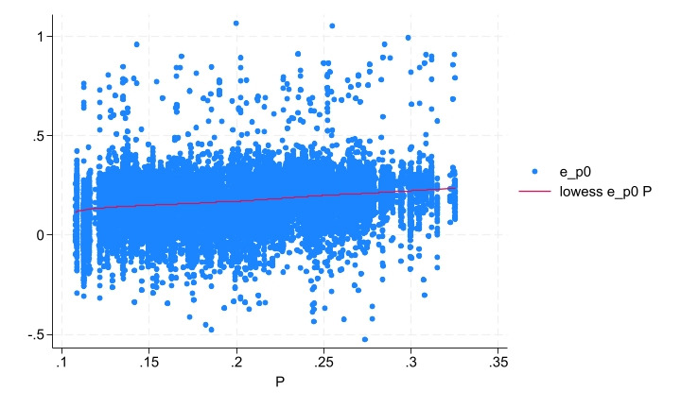
Note: LOWESS stands for locally weighted scatterplot smoothing. e_p0 stands for the output elasticity of pollination with the subscript 0 indicating predominantly non-dependent production. P is the level of wild pollination service.

Figure S3: Output elasticities of POL (p1) on field crops production conditional on the level of the service
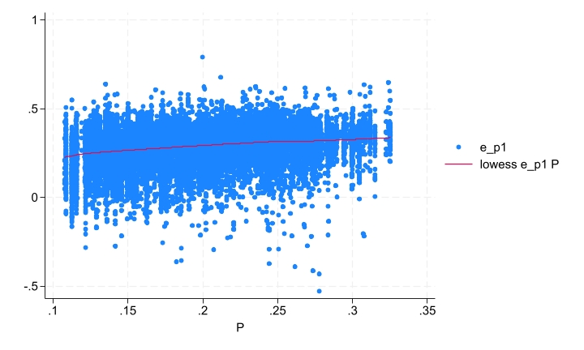
Note: LOWESS stands for locally weighted scatterplot smoothing. e_p1 stands for the output elasticity of pollination with the subscript 1 indicating predominantly pollination dependent production. P is the level of wild pollination service.

