Table S1 Overview of the feed types included and the main differences
Ingredient |  | Pro | Con
Core feed composition | Protein content(%)(SD ± 1.01) | 30 | 30
Core feed composition | Fat content(%)(SD ± 1.46) | 26 | 26
Core feed composition | Sargassum fusiforme content(%)(SD ± 1.22) | 14 | 14
Core feed composition | Ash content(%)(SD ± 0.81) | 35 | 35
Additives | Lactobacillus plantarum LPsca12(1× 1010 CFU/g) | + | -

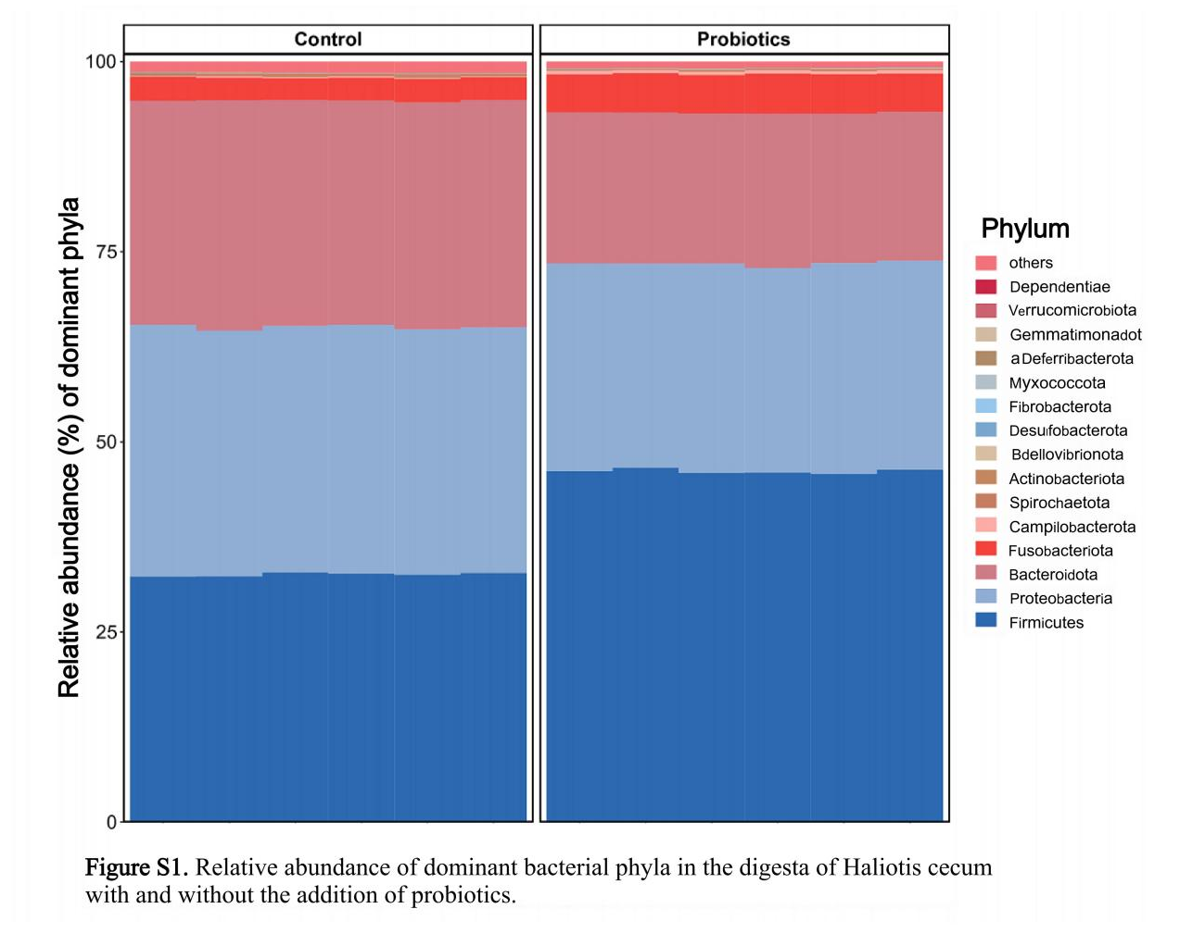
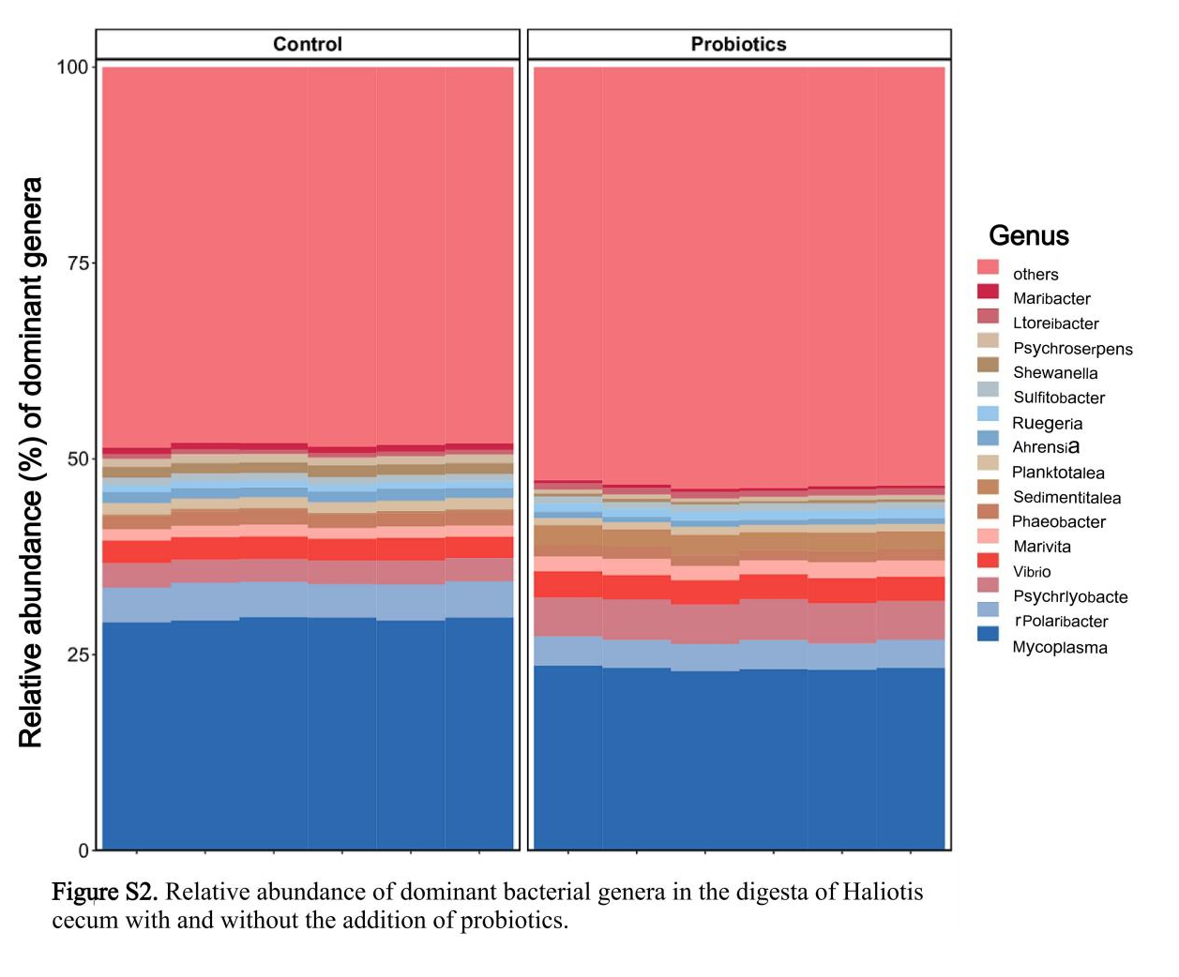
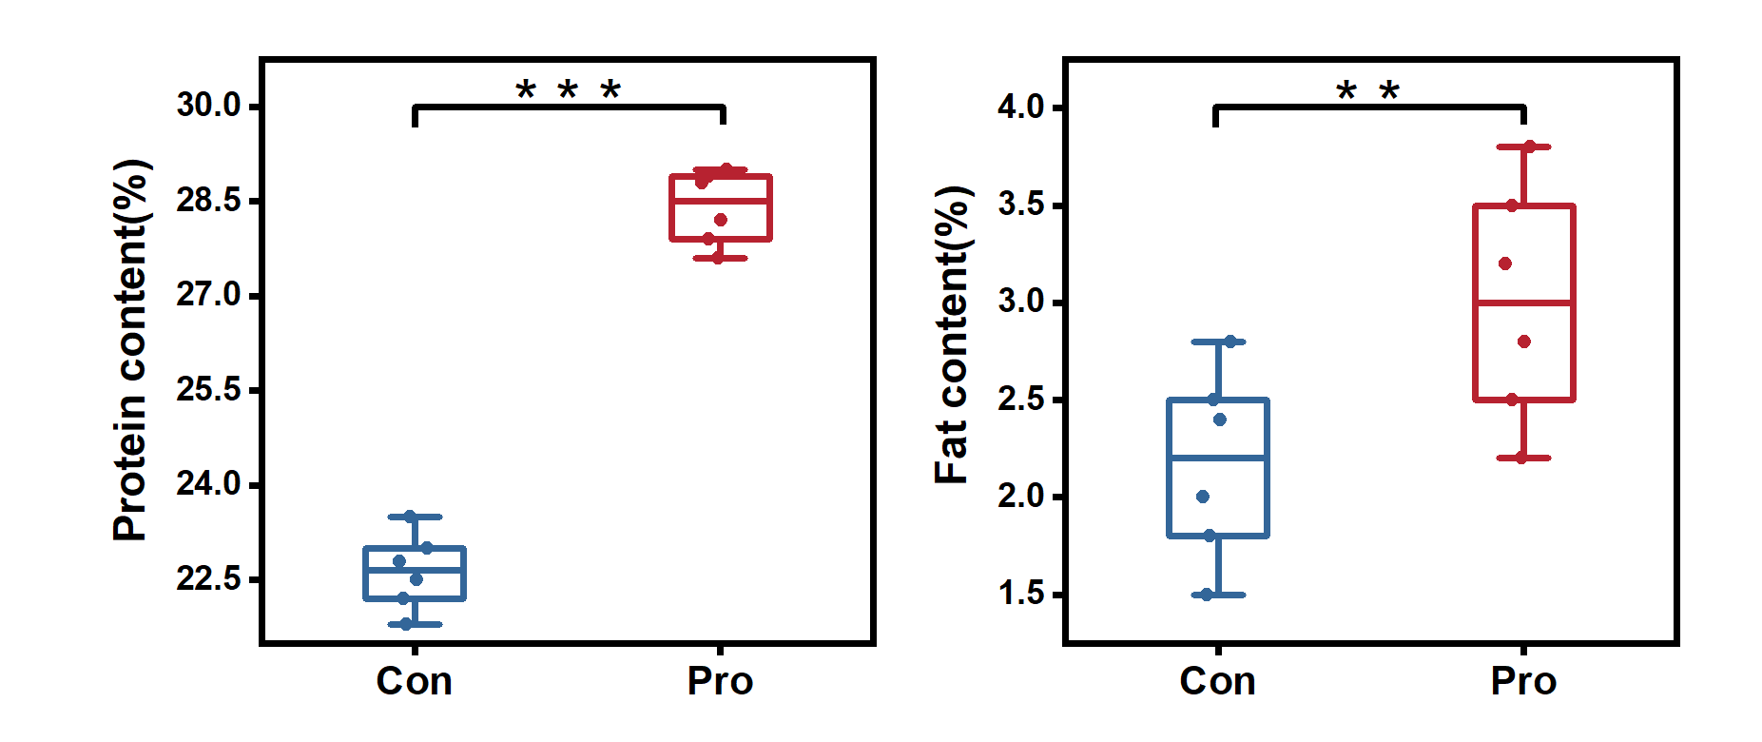
Figure S3. Content of protein and ether compounds in abalone muscle
Table S2 Compisitions of AAs in gut
Class | Count | Percent
5'-Deoxyribonucleosides | 1 | 1.02%
Benzene and Substituted Derivatives | 2 | 2.04%
Carboximidic Acids and Derivatives | 2 | 2.04%
Carboxylic Acids and Derivatives | 77 | 78.57%
Fatty Acyls | 1 | 1.02%
Indoles and Derivatives | 4 | 4.08%
Organonitrogen Compounds | 2 | 2.04%
Organooxygen Compounds | 2 | 2.04%
Peptidomimetics | 2 | 2.04%
Others | 5 | 5.1%

