Supplementary Information for

Regional electricity sector employment and skills under different European policy scenarios

Authors: Alison Maguire¹, Alexandre Torné^{1*}, Evelina Trutnevyte¹

¹ Renewable Energy Systems, Institute for Environmental Sciences (ISE), Section of Earth and Environmental Sciences, University of Geneva, Switzerland
* corresponding author (Uni Carl Vogt, Boulevard Carl Vogt 66, CH-1211 Geneva 4, Switzerland; alexandre.torne@unige.ch)

EXPANSE model
Unless otherwise stated, the assumptions of this model are the same as those listed in the Supplementary Information of (Sasse and Trutnevyte, 2023). The assumptions for the minimum load values of thermal electricity generators in EXPANSE are listed along with sources in the Supplementary Material of (Rubino et al., 2025).

Employment factors
Table A1. Regional and fuel employment factors for each technology
Technology | Regional Employment Factor (construction, operation & maintenance, decommissioning) (Job/MW) (Ram et al., 2020; Sasse and Trutnevyte, 2023) | Fuel Employment Factors (Job/MWh of fuel use) (Ram et al., 2020; Sasse and Trutnevyte, 2023)
Wind – onshore | 0.53
Wind – offshore | 1.07
Solar PV – open field | 1.25
Solar PV - rooftop | 1.27
Hydropower - large dams | 0.36
Hydropower - run of river | 0.42
Hydropower – small | 0.36
Nuclear | 1.75
Gas | 0.19 | 0.09
Hard Coal | 0.46 | 0.34
Lignite | 0.46 | 0.38
Geothermal | 0.63
Biogas | 2.22 | 0.26
Woody Biomass | 2.07 | 0.29
Waste | 2.07 | 0.30
Oil | 0.18 | 0.16
Pumped hydro storage | 1.15
Battery | 0.35
Hydrogen Storage | 0.63
Transmission | 180 (Jobs/TWkm)

Biomass calculations
Woody biomass extraction employment is assumed to be in the same NUTS 2 region as the woody biomass electricity generation due to short transport distances in the sector (Schnorf et al., 2021). The UK, Denmark and Italy are exceptions to this method since a large fraction of the wood pellet consumption in these countries are from imports (Sikkema et al., 2021). Trade data from these countries (UK (Piller, 2024), Italy (Bettini, 2017), Denmark (Tony Hansen, 2023)) reveal the countries from which wood pellets are imported and the corresponding quantities. The extraction jobs are allocated to the source countries proportional to the import quantities, while the jobs are allocated evenly across the regions in which woody biomass electricity is generated in these countries.

Peat calculations
Peat regions are accounted for in the model under lignite and are assumed to have the highest risk rating value (Alves Dias et al., 2018). The data for the peat regions are obtained from a European Commission report (Alves Dias et al., 2021).

Additional results
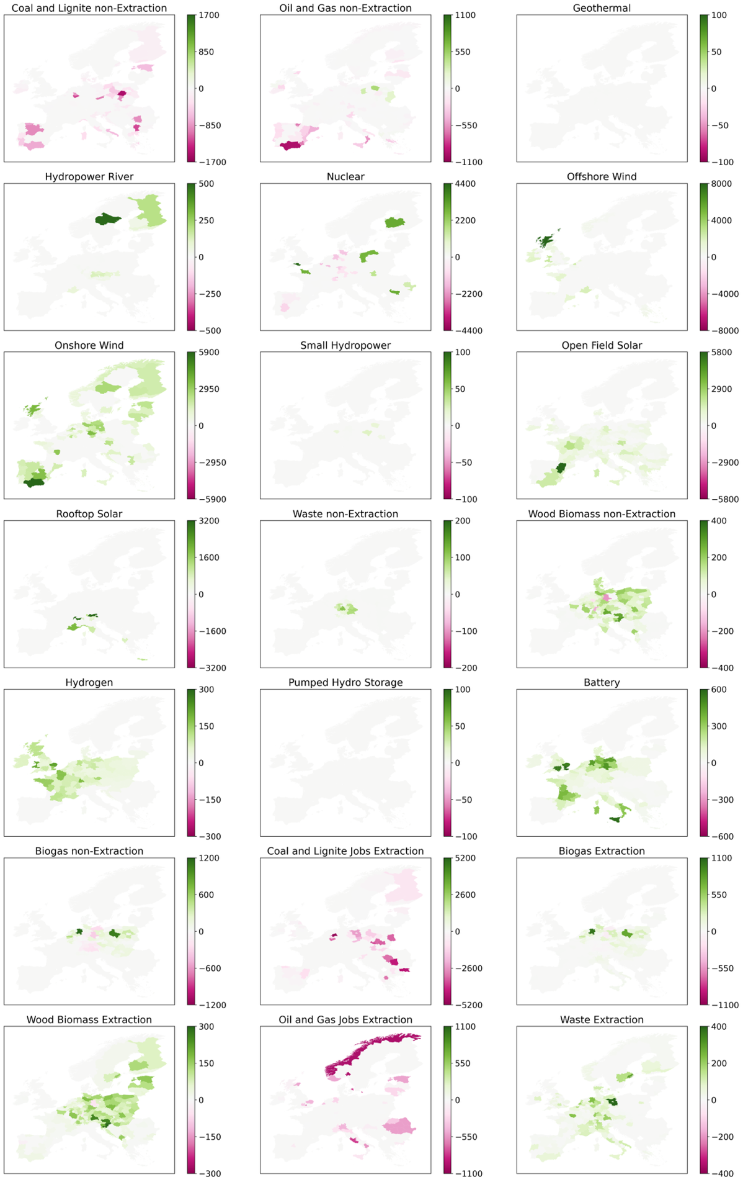
Figure A1. Maps with net changes in extraction and non-extraction jobs from generation and storage technologies in the case of ‘Fit for 55’ scenario.
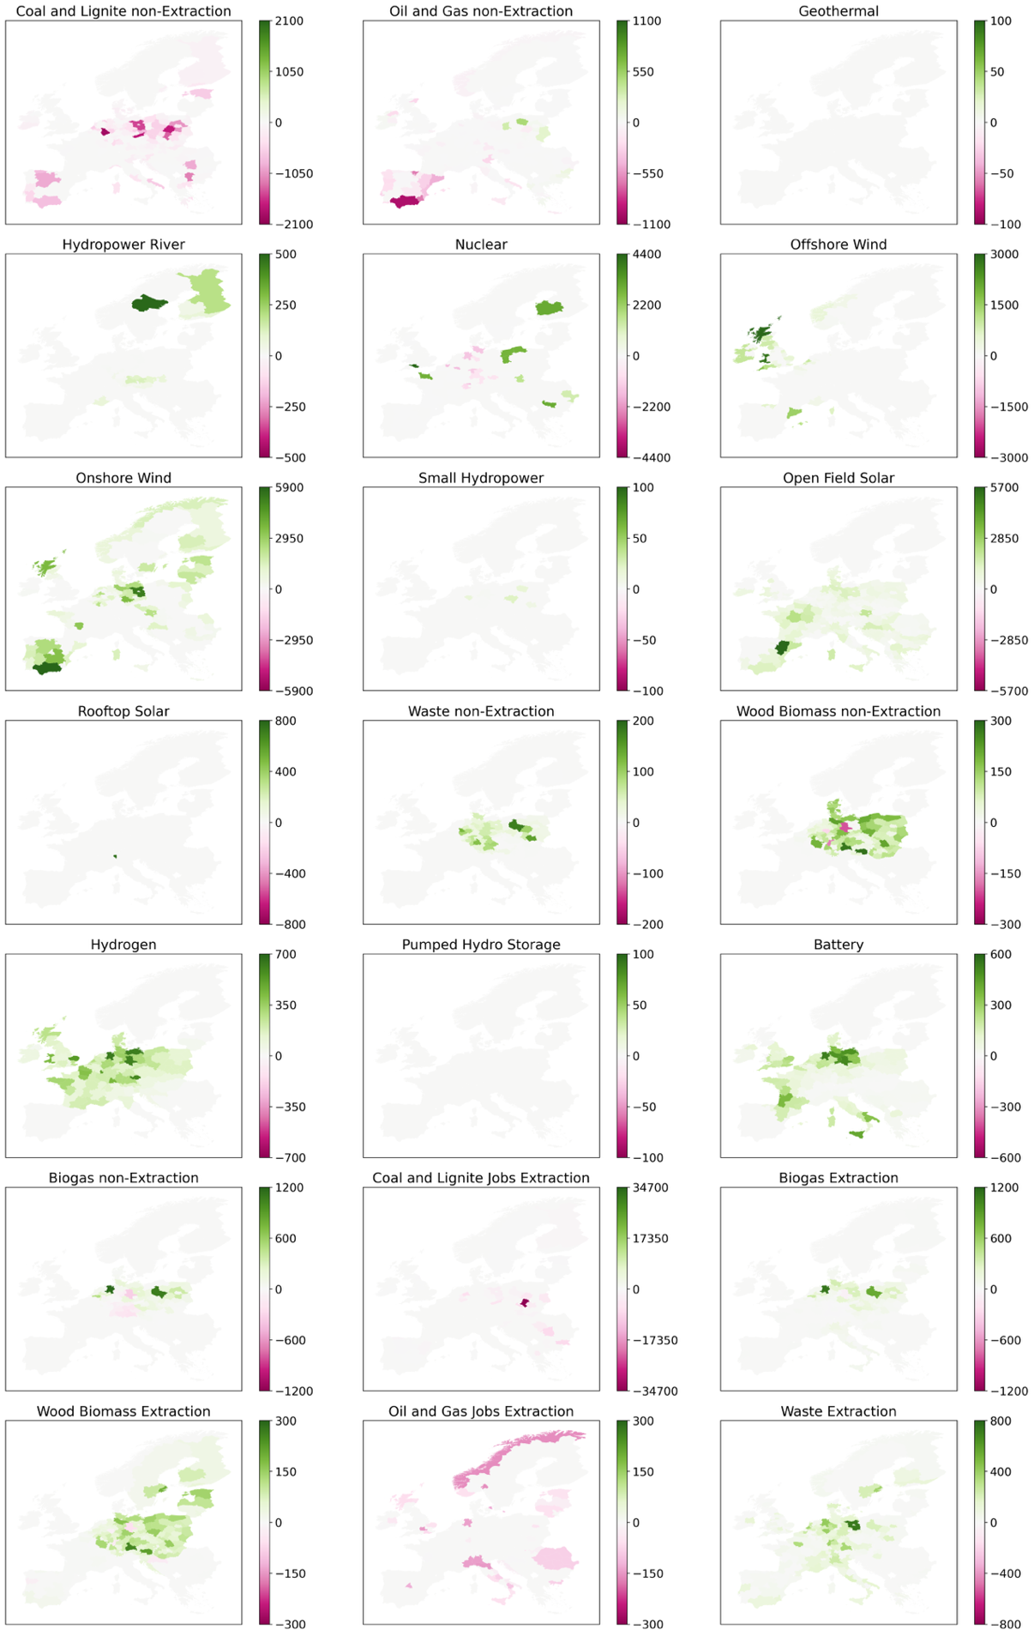
Figure A2. Maps with net changes in extraction jobs and non-extraction jobs from generation and storage technologies in the case of the EU-wide coal phaseout scenario.

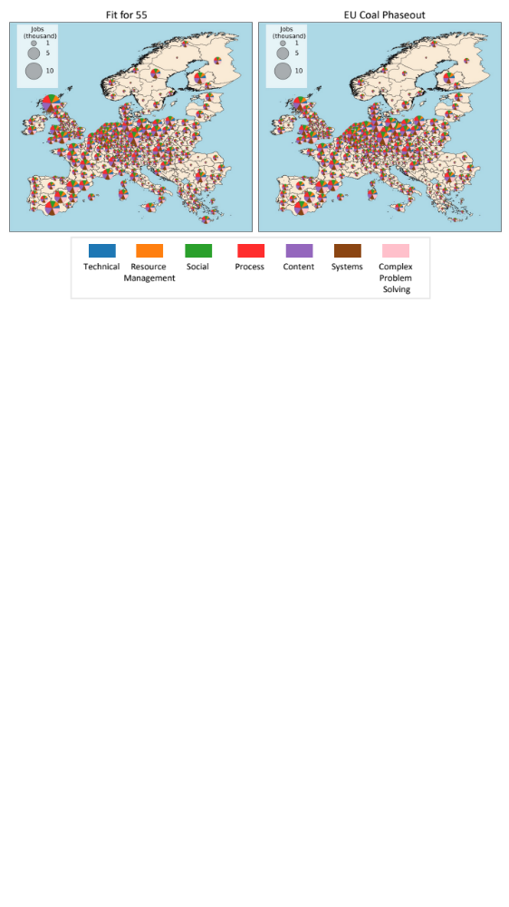

Figure A3. Regional skill needs of employment gains under both policy scenarios.

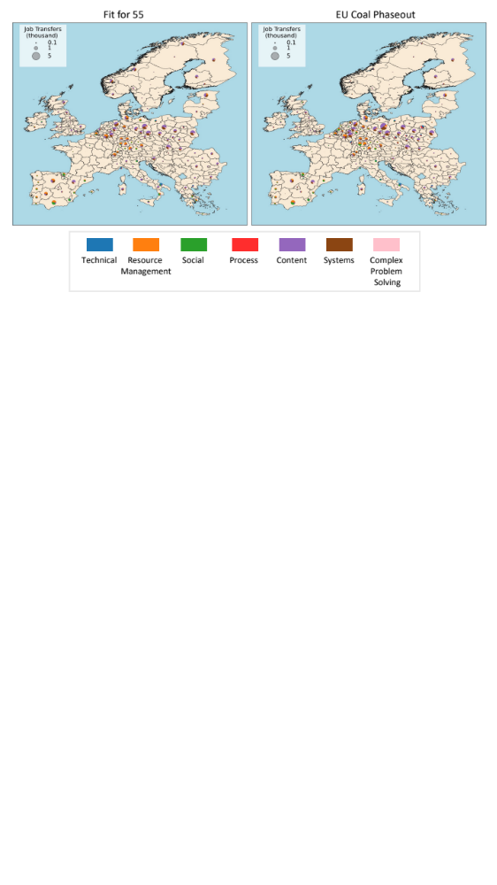
Figure A4. Regional re-skilling needs of potential employment transfers under both policy scenarios.

Skills Data

Table A2. Skills and their corresponding skill groups (O*NET and U.S. Department of Labor, Employment and Training Administration, 2024).

Skill Group | Individual Skills
Content | Reading Comprehension, Active Listening, Writing, Speaking, Mathematics, Science
Process | Critical Thinking, Active Learning, Learning Strategies, Monitoring
Social | Social Perceptiveness, Coordination, Persuasion, Negotiation, Instructing, Service Orientation
Technical | Operations Analysis, Technology Design, Equipment Selection, Installation, Programming, Operations Monitoring, Operations and Control, Equipment Maintenance, Troubleshooting, Repairing, Quality Control Analysis
Systems | Judgement and Decision Making, Systems Analysis, Systems Evaluation
Resource Management | Time Management, Management of Financial Resources, Management of Material Resources, Management of Personnel Resources
Complex Problem Solving | Complex Problem Solving

Table A3. A list of assumed jobs per technology that was used to create the skill data per technology. The job titles are obtained from O*NET (O*NET and U.S. Department of Labor, Employment and Training Administration, 2024). Each job is associated with a set of skills from Table A2. The skills have an importance and level value which are combined to create a score (Greenspon and Raimi, 2024; Lim et al., 2023; Soydan et al., 2024).

Technology | Construction | Operation and Maintenance | Decommissioning | Extraction
Coal and Lignite | Construction Laborers; Helpers--Installation, Maintenance, and Repair Workers; Riggers; Construction and Building Inspectors; Civil Engineers; | Power Plant Operators; Helpers--Installation, Maintenance, and Repair Workers; Electrical Engineers; Civil Engineers | Brownfield Redevelopment Specialists and Site Managers; Riggers; Construction Laborers; | Continuous Mining Machine Operators; Roof Bolters, Mining; Loading and Moving Machine Operators, Underground Mining; Helpers--Extraction Workers; Laborers and Freight, Stock, and Material Movers, Hand; Underground Mining Machine Operators, All Other; First-Line Supervisors of Construction Trades and Extraction Workers
Oil and Gas | Construction Laborers;Helpers--Installation, Maintenance, and Repair Workers; Riggers; Construction and Building Inspectors; Electrical Engineers; Chemical Engineers; Civil Engineers; | Power Plant Operators; Gas Plant Operators; Helpers--Installation, Maintenance, and Repair Workers; Electrical Engineers; Chemical Engineers; Civil Engineers | Brownfield Redevelopment Specialists and Site Managers; Riggers;Construction Laborers;Riggers; | Petroleum Engineers; Wellhead Pumpers; Helpers--Extraction Workers; Rotary Drill Operators, Oil and Gas; First-Line Supervisors of Construction Trades and Extraction Workers; Derrick Operators, Oil and Gas
Geothermal | Construction Laborers; Helpers--Installation, Maintenance, and Repair Workers; Riggers; Construction and Building Inspectors; Electrical Engineers; Civil Engineers; | Power Plant Operators; Geothermal Technicians; Geothermal Production Managers; Helpers--Installation, Maintenance, and Repair Workers; Electrical Engineers; Civil Engineers | Riggers; Construction Laborers;
Hydropower | Construction Laborers;Helpers--Installation, Maintenance, and Repair Workers; Riggers; Construction and Building Inspectors; Electrical Engineers; Civil Engineers | Power Plant Operators; Hydroelectric Plant Technicians; Helpers--Installation, Maintenance, and Repair Workers; Electrical Engineers; Civil Engineers; Hydroelectric Production Managers | Riggers; Construction Laborers;
Large Run of River | Construction Laborers;Helpers--Installation, Maintenance, and Repair Workers; Riggers; Construction and Building Inspectors; Electrical Engineers; Civil Engineers | Power Plant Operators; Hydroelectric Plant Technicians; Helpers--Installation, Maintenance, and Repair Workers; Electrical Engineers; Civil Engineers; Hydroelectric Production Managers | Riggers;Construction Laborers;
HVDC | Construction Laborers; Helpers--Installation, Maintenance, and Repair Workers; Electrical Power-Line Installers and Repairers; Construction and Building Inspectors; Electrical Engineers; Electrical and Electronic Equipment Assemblers | Electrical Power-Line Installers and Repairers; Power Distributors and Dispatchers; Electrical Engineers; Electrical and Electronic Engineering Technologists and Technicians | Telecommunications Line Installers and Repairers;Construction Laborers;Riggers;
HVAC | Construction Laborers;Helpers--Installation, Maintenance, and Repair Workers; Electrical Power-Line Installers and Repairers; Construction and Building Inspectors; Electrical Engineers; Electrical and Electronic Equipment Assemblers | Electrical Power-Line Installers and Repairers; Power Distributors and Dispatchers; Electrical Engineers; Electrical and Electronic Engineering Technologists and Technicians | Telecommunications Line Installers and Repairers; Construction Laborers;Riggers;
Nuclear | Construction Laborers; Helpers--Installation, Maintenance, and Repair Workers; Nuclear Engineers; Riggers; Construction and Building Inspectors; Electrical Engineers; Civil Engineers | Power Plant Operators; Nuclear Power Reactor Operators; Nuclear Technicians; Nuclear Monitoring Technicians; Nuclear Engineers; | Hazardous Materials Removal Workers; Construction Laborers; Riggers;
Onshore Wind | Construction Laborers;Helpers--Installation, Maintenance, and Repair Workers; Riggers; Construction and Building Inspectors; Electrical Engineers; Civil Engineers; Wind Energy Development Managers | Wind Energy Operations Managers; Wind Turbine Service Technicians; Electrical Engineers; Civil Engineers; Wind Energy Engineers; Wind Energy Development Managers | Construction Laborers;Riggers;
Offshore Wind | Construction Laborers;Helpers--Installation, Maintenance, and Repair Workers; Riggers; Construction and Building Inspectors; Electrical Engineers; Civil Engineers; Wind Energy Development Managers | Wind Energy Operations Managers; Wind Turbine Service Technicians; Electrical Engineers; Civil Engineers; Wind Energy Engineers; Wind Energy Development Managers | Construction Laborers;Riggers;
Small Hydropower | Construction Laborers;Helpers--Installation, Maintenance, and Repair Workers; Riggers; Construction and Building Inspectors; Electrical Engineers; Civil Engineers | Power Plant Operators; Hydroelectric Plant Technicians; Helpers--Installation, Maintenance, and Repair Workers; Electrical Engineers; Civil Engineers; Hydroelectric Production Managers | Construction Laborers;Riggers;
Open Field solar | Construction Laborers;Helpers--Installation, Maintenance, and Repair Workers; Riggers; Construction and Building Inspectors; Electrical Engineers; Solar Photovoltaic Installers; Solar Energy Installation Managers; Solar Thermal Installers and Technicians; Electrical and Electronics Installers and Repairers, Transportation Equipment; Electrical and Electronic Equipment Assemblers; Civil Engineers | Power Plant Operators; Helpers--Installation, Maintenance, and Repair Workers; Electrical Engineers; Solar Energy Systems Engineers; Electrical and Electronic Engineering Technologists and Technicians; Civil Engineers | Construction Laborers; Riggers;
Rooftop solar | Construction Laborers; Helpers--Installation, Maintenance, and Repair Workers; Construction and Building Inspectors; Electrical Engineers; Solar Photovoltaic Installers; Solar Energy Installation Managers; Solar Thermal Installers and Technicians; Electrical and Electronics Installers and Repairers, Transportation Equipment; Electrical and Electronic Equipment Assemblers | Power Plant Operators; Helpers--Installation, Maintenance, and Repair Workers; Electrical Engineers; Solar Energy Systems Engineers; Electrical and Electronic Engineering Technologists and Technicians | Construction Laborers;
Waste | Construction Laborers;Helpers--Installation, Maintenance, and Repair Workers; Riggers; Construction and Building Inspectors; Electrical Engineers; Civil Engineers | Biomass Power Plant Managers; Power Plant Operators; Electrical Engineers; | Hazardous Materials Removal Workers;Construction Laborers; Riggers; | Construction Laborers; Laborers and Freight, Stock, and Material Movers, Hand; First-Line Supervisors of Construction Trades and Extraction Workers
Woody Biomass | Construction Laborers; Helpers--Installation, Maintenance, and Repair Workers; Riggers; Construction and Building Inspectors; Electrical Engineers; Civil Engineers | Biomass Power Plant Managers; Power Plant Operators; Electrical Engineers; | Brownfield Redevelopment Specialists and Site Managers; Construction Laborers; Riggers; | Helpers--Extraction Workers; Laborers and Freight, Stock, and Material Movers, Hand; Log Graders and Scalers; First-Line Supervisors of Construction Trades and Extraction Workers
Hydrogen | Construction Laborers;Helpers--Installation, Maintenance, and Repair Workers; Riggers; Construction and Building Inspectors; Electrical Engineers; Chemical Engineers; Civil Engineers | Power Plant Operators; Gas Plant Operators; Chemical Equipment Operators and Tenders;Electrical Engineers; Chemical Engineers; | Brownfield Redevelopment Specialists and Site Managers; Construction Laborers; Riggers;
PHS | Construction Laborers; Helpers--Installation, Maintenance, and Repair Workers; Riggers; Construction and Building Inspectors; Electrical Engineers; Civil Engineers | Power Plant Operators; Helpers--Installation, Maintenance, and Repair Workers; Hydroelectric Plant Technicians;Electrical Engineers; Civil Engineers | Construction Laborers;Riggers;
Battery | Construction Laborers; Electrical and Electronic Equipment Assemblers; Helpers--Installation, Maintenance, and Repair Workers; Construction and Building Inspectors; Electrical Engineers; Electrical and Electronic Equipment Assemblers; Civil Engineers | Electrical Engineers; Electrical and Electronic Engineering Technologists and Technicians; Electrical and Electronics Installers and Repairers, Transportation Equipment; | Electrical and Electronics Installers and Repairers, Transportation Equipment; Construction Laborers;Riggers;
Biogas | Construction Laborers;Helpers--Installation, Maintenance, and Repair Workers; Riggers; Construction and Building Inspectors; Electrical Engineers;Chemical Engineers; Civil Engineers | Power Plant Operators; Gas Plant Operators; Chemical Equipment Operators and Tenders; Electrical Engineers; Chemical Engineers; | Hazardous Materials Removal Workers; Brownfield Redevelopment Specialists and Site Managers; Construction Laborers;Riggers; | Water and Wastewater Treatment Plant and System Operators; Chemical Engineers; Chemical Technicians;

References

Alves Dias, P., Kanellopoulos, K., Mandras, G., Medarac. H, Nijs, W., Ruiz, P., Somers, J., Tarvydas, D., Kapetaki, Z., 2021. Recent trends in EU coal, peat and oil shale regions. Publications Office of the European Union, Luxembourg.
Alves Dias, P., Trombetti, M., Vázquez Hernández, C., Gonzalez Aparicio, I., Kanellopoulos, K., Kapetaki, Z., Nijs, W., Shortall, R., Mandras, G., Czako, V., Trombetti, M., Telsnig, T., Medarac, H., Lacal Arántegui, R., Tzimas, E., 2018. EU coal regions: opportunities and challenges ahead (No. EUR 29292 EN). Publications Office of the European Union, Luxembourg.
Bettini, O., 2017. Italian Wood Pellets Overview (No. IT1728), USDA Foreign Agricultural Service. USDA Foreign Agricultural Service.
Greenspon, J., Raimi, D., 2024. Matching geographies and job skills in the energy transition. The Extractive Industries and Society 17, 101397. https://doi.org/10.1016/j.exis.2023.101397
Lim, J., Aklin, M., Frank, M.R., 2023. Location is a major barrier for transferring US fossil fuel employment to green jobs. Nat Commun 14, 5711. https://doi.org/10.1038/s41467-023-41133-9
Nielsen, P., 2024. Generation of Electricity and District heating. Danish Energy Agency.
O*NET, U.S. Department of Labor, Employment and Training Administration, 2024. O*NET 29.0 Database.
Piller, K., 2024. Forestry Statistics 2024, The Research Agency of the Forestry Commission. The Research Agency of the Forestry Commission.
Ram, M., Aghahosseini, A., Breyer, C., 2020. Job creation during the global energy transition towards 100% renewable power system by 2050. Technological Forecasting and Social Change 151, 119682. https://doi.org/10.1016/j.techfore.2019.06.008
Rubino, G., Killenberger, C., Sasse, J.-P., Wang, Z., Wen, X., Zielonka, N., Trutnevyte, E., 2025. Spatial strategies for siting variable renewable energy sources to ensure weather resilience in Switzerland. Renewable Energy 249, 123237. https://doi.org/10.1016/j.renene.2025.123237
Sasse, J.-P., Trutnevyte, E., 2023. A low-carbon electricity sector in Europe risks sustaining regional inequalities in benefits and vulnerabilities. Nat Commun 14, 2205. https://doi.org/10.1038/s41467-023-37946-3
Schnorf, V., Trutnevyte, E., Bowman, G., Burg, V., 2021. Biomass transport for energy: Cost, energy and CO2 performance of forest wood and manure transport chains in Switzerland. Journal of Cleaner Production 293, 125971. https://doi.org/10.1016/j.jclepro.2021.125971
Sikkema, R., Proskurina, S., Banja, M., Vakkilainen, E., 2021. How can solid biomass contribute to the EU’s renewable energy targets in 2020, 2030 and what are the GHG drivers and safeguards in energy- and forestry sectors? Renewable Energy 165, 758–772. https://doi.org/10.1016/j.renene.2020.11.047
Soydan, H., Düzgün, H.Ş., Brune, J., 2024. A Novel Job Similarity Index for Career Transition in the Mining Industry. Mining, Metallurgy & Exploration 41, 2257–2278. https://doi.org/10.1007/s42461-024-01017-y
Tony Hansen, M., 2023. Det danske træpille- marked 2022, Energistyrelsens træ pilleundersøgelse. Ea Energy Analyses.

