
Supporting Information

Emergent Superparamagnetism and Anomalous Hall Effect in Two-Dimensional Magnet Cr_{x}Pt_{1-x}Te₂
Xue Yang^{1,2†}, Ruihuan Duan^{3†}, Xin Zhou^{4†}, Yuqiao Zhou^{5†}, Lei Xu^{1,2}, Sicheng Zhou^{1,2}, Xinyi Zheng^{1,2}, Siyuan Zhou^{1,2}, Lihong Hu^{1,2}, Hua Ke⁶, Bingbing Tong^{1,7}, Jie Shen^{1,2,7}, Zhaozheng Lyu^{1,2,7}, Xiunian Jing¹, Fanming Qu^{1,2,7}, Peiling Li^{1,2,7}*, Zheng Liu^{3,8}*, Guangtong Liu^{1,2,7}*, and Li Lu^{1,2,7}

¹ Beijing National Laboratory for Condensed Matter Physics, Institute of Physics, Chinese Academy of Sciences, Beijing 100190, China.
² School of Physical Sciences, University of Chinese Academy of Sciences, Beijing 100049, China.
³ School of Materials Science and Engineering, Nanyang Technological University, 639798 Singapore.
⁴ Institute for Functional Intelligent Materials, National University of Singapore, 117544, Singapore.
⁵ Key Laboratory of Green Chemistry & Technology, Ministry of Education, College of Chemistry, Sichuan University, Chengdu 610064, China.
⁶ School of Materials Science and Engineering, Harbin Institute of Technology, Harbin 150001, China.
⁷ Hefei National Laboratory, Hefei, Anhui 230088, China.
⁸ CINTRA CNRS/NTU/THALES, Research Techno Plaza, Singapore, Singapore.

* Corresponding authors E-mail: cioran@iphy.ac.cn; z.liu@ntu.edu.sg; gtliu@iphy.ac.cn
†These authors contributed equally.

X-ray photoelectron spectroscopy (XPS)
X-ray photoelectron spectroscopy (XPS) measurements were conducted to investigate the chemical composition and valence states of the synthesized Cr_{x}Pt_{1−x}Te₂ single crystals. The XPS spectra for these crystals are presented in Fig. 1e and 1f. Energy calibration was carried out using the C 1s peak (284.6 eV) to eliminate the effects of charge accumulation and surface contamination during the analysis. The binding energy of Cr_{0.35}Pt_{0.65}Te₂ has been discussed in the main text, while those of other samples are listed in Table S1. However, relying only on XPS results presents challenges in accurately determining the stoichiometric ratio of the sample, as noted in previous report¹. Additionally, with the increasing Cr content, the observed shifts in peak positions can be attributed to the differences in electronegativity among Cr (1.66), Pt (2.28), and Te (2.1). When an atom with lower electronegativity replaces a bonded atom, the binding energy tends to decrease². Hence, it is inferred that the Cr elements in Cr_{x}Pt_{1−x}Te₂ are likely substituting for either Pt or Te, leading to the formation of Cr-Pt and Cr-Te bonds, which indicates a significant change of the local chemical environment surrounding the Pt and Te atoms.
Table S1: Specific binding energies of Pt 4f_{7/2}(Pt 4f_{5/2}), Cr 2p_{3/2}(Cr 2p_{1/2}) and Te 3d_{5/2}(Te 3d_{3/2}) in various oxidation states for the Cr_{x}Pt_{1−x}Te₂ (x=0.25, 0.3, and 0.35), together with values obtained from deconvoluted XPS spectra.
 | Pt 4f_{7/2}(Pt 4f_{5/2}) | Cr 2p_{3/2}(Cr 2p_{1/2}) | Te 3d_{5/2}(Te 3d_{3/2})
Cr_{0.25}Pt_{0.75}Te₂ | 72.61(75.96) eV | 576.46(586.66) eV | 573.41(583.76) eV
Cr0.3Pt0.7Te2 | 72.55(75.85) eV | 576.23(586.53) eV | 573.28(583.63) eV
Cr_{0.35}Pt_{0.65}Te₂ | 72.58(75.93) eV | 576.18(586.40) eV | 573.15(583.50) eV
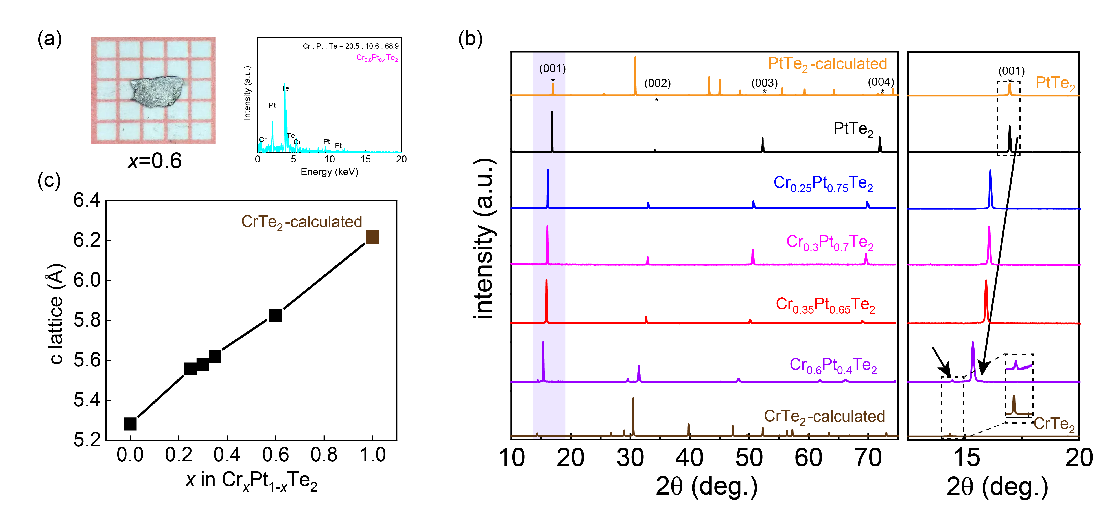Fig. S1. (a) Optical images and EDX spectra of as-grown Cr_{0.6}Pt_{0.4}Te₂ single crystals. (b) Left: XRD patterns for Cr_{x}Pt_{1−x}Te₂ samples with varying Cr concentration of (x=0, 0.25, 0.3, 0.35 and 0.6) alongside calculated patterns for PtTe₂ and CrTe₂. Right: Enlarged XRD patterns in the 12.5º to 20º range. (c) Changes in c-axis lattice constant with Cr concentration.

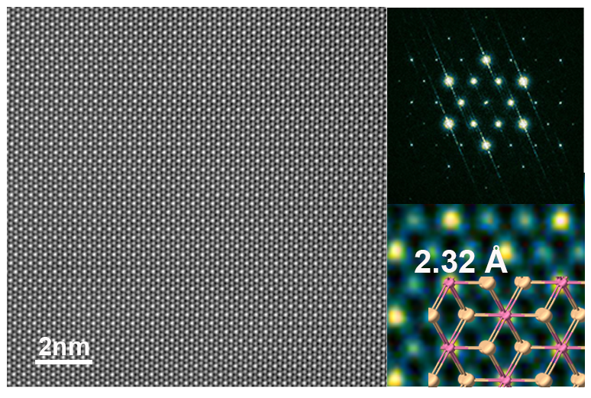
Fig. S2. STEM investigation of pristine PtTe₂. Left: HAADF image of the PtTe₂ material. Top-right: Fourier transform pattern of the STEM image. Bottom-right: Zoomed-in STEM image overlaid with the atomic model of PtTe₂, where pink spheres represent Pt atoms and yellow spheres represent Te atoms.
The STEM image of pristine PtTe₂ reveals the characteristic atomic arrangement displaying a honeycomb structure, which is further evidenced by the Fourier transform pattern. The metal-chalcogenide spacing, measured from the calibrated STEM image, is observed to be 2.32 Å. This measurement aligns precisely with the typical value for PtTe₂³.

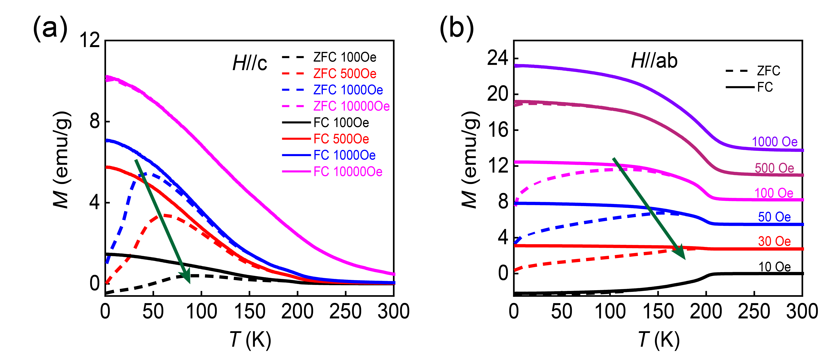
Fig. S3. Temperature-dependent magnetization of Cr_{0.35}Pt_{0.65}Te₂. (a) Out-of-plane (H∥c) magnetization of Cr_{0.35}Pt_{0.65}Te₂ measured under different magnetic fields. (b) In-plane magnetization of Cr_{0.35}Pt_{0.65}Te₂ under different magnetic fields. The green arrows in (a) and (b) indicate the shift in the blocking temperature T_{B} as the external applied magnetic field increases. For clarity, the zero-field-cooling (ZFC) and field-cooling (FC) curves for different fields have been shifted vertically. As the external magnetic field decreases, the blocking temperature T_{B} systematically shifts to higher temperatures for both H∥c and H∥ab directions, which aligns with the theoretical expectation of the superparamagnetism (SPM), confirming that Cr_{0.35}Pt_{0.65}Te₂ exhibits superparamagnetic properties in the intermediate temperature range.

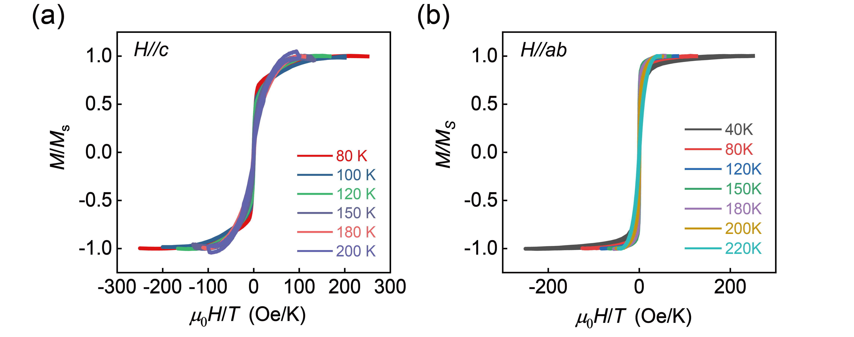
Fig. S4. Plots of reduced magnetization M/M_{s} versus H/T under out-of-plane (H∥c) (a) and in-plane (H∥ab) (b) magnetic fields of Cr_{0.35}Pt_{0.65}Te₂.
Analysis of the M(H) Curve with Modified Langevin Functions
We analyzed the magnetization data M(H) of Cr_{x}Pt_{1−x}Te₂ using the modified-Langevin function, expressed as,
$$\begin{aligned}M\left(H,T\right)=N\int_{0}^{∞}{μ}L\left(x\right)f\left(μ\right)dμ+χH\#\left(1\right)\end{aligned}$$
where $N=M_{0}(T)/〈μ〉$ represents the number density of clusters, $〈μ〉=M_{0}(T)ρ〈V〉$ is the mean cluster magnetic moment, $M_{0}(T)$ is the saturated magnetization, and $〈V〉$ is the mean cluster volume. The Langevin function is given by $L\left(x\right)=\coth\left(x\right)-\frac{1}{x}$, with $x={μH}/{k_{B}T}.$ The function $f\left(μ\right)=\frac{1}{μs\sqrt{2π}}\text{exp}\left\{-\frac{{\left[ln⁡(\frac{μ}{μ_{d}})\right]}^{2}}{2s^{2}}\right\}$ represents the log-normal distribution of the cluster magnetic moment, where s and µ_{d} are the median and the standard deviation of the log-normal distribution, respectively. We used Python to fit the data below 120 K with Eq. (1), adjusting the parameters N, µ_{d}, s and χ. According to refs.4 and 5, several factors can complicate parameter fitting, and the correlation among parameters may lead to over- or underestimation^{4,5}. To enhance the accuracy of our fitting, we selected the data below 120 K that exhibited a good overlap with the results presented in Fig. S4. The fitting parameters and the calculated mean volume diameter $〈D〉$ are summarized in Table S2. Notably, the mean magnetic moment $〈μ〉$ decreases with increasing temperature, indicating a reduction in the magnetic contributions from superparamagnetic clusters. Interestingly, the estimated average diameter at 120 K is larger than those at 80 K and 100 K, which could be attributed to factors such as anisotropy and reduced saturation magnetization, potentially leading to deviations in the Langevin fitting from the experimental data.

Next, we show how to derive the mean volume diameter $〈D〉$. The mean cluster volume $〈V〉$ is proportional to the cube of the mean diameter, $〈V〉∝{〈D〉}^{3}$. The magnetic cluster moment is given by,
$$\begin{aligned}μ=M_{0}m=M_{0}ρV\#\left(2\right)\end{aligned}$$
where $M_{0}=N〈μ〉$ is the saturation magnetization, ρ = 7.16 g/cm³ is the density of Cr, m is the mass of magnetic cluster, and V is the volume of magnetic cluster. Thus, mean cluster volume can be written as,
$$\begin{aligned}〈V〉=\int_{0}^{∞}{V\left(μ\right)f\left(μ\right)dμ}=\int_{0}^{∞}{\frac{μ}{M_{0}ρ}f\left(μ\right)dμ}=\frac{1}{M_{0}ρ}\int_{0}^{∞}{μf\left(μ\right)dμ}\#\left(3\right)\end{aligned}$$
From this, we can derive the mean volume diameter $〈D〉$,
$$\begin{aligned}〈D〉\sim \sqrt[3]{〈V〉}\sim \sqrt[3]{\frac{1}{M_{0}ρ}\int_{0}^{∞}{μf\left(μ\right)dμ}}\sim \sqrt[3]{\frac{1}{M_{0}ρ}〈μ〉}\sim \sqrt[3]{\frac{〈μ〉}{N〈μ〉ρ}}\sim \sqrt[3]{\frac{1}{Nρ}}\#\left(4\right)\end{aligned}$$

Table S2: Values of the fitting parameters N, s, $μ_{d}$, χ, and the mean volume diameter ⟨D⟩ for Cr_{0.35}Pt_{0.65}Te₂ at various temperatures.
T (K) | N (10¹⁷/g) | $$μ_{d}(μ_{B})$$ | s | $$χ ({10}^{-4}{emu}/gOe)$$ | $$〈D〉 (nm)$$ | $$〈μ〉(μ_{B})$$
80 K | 0.95 | 5070 | 0.52 | 2.46 | 8.79 | 5803
100 K | 0.82 | 4430 | 0.71 | 2.44 | 8.37 | 5700
120 K | 1.85 | 832 | 1.38 | 2.30 | 10.98 | 2156

Note:
To calculate the mean magnetic moment $〈μ〉=\int_{0}^{∞}{μf(μ)dμ}$, we let $x=μ$. Thus,
$$\begin{aligned}I=\int_{0}^{∞}{μ}f\left(μ\right)dμ=\frac{1}{s\sqrt{2π}}\int_{0}^{∞}{\text{exp}-\frac{{\left[\ln\left(\frac{x}{μ_{d}}\right)\right]}^{2}}{2s^{2}}}dx\#\left(5\right)\end{aligned}$$
Next, we perform a change of variables by setting $y=\frac{ln⁡(\frac{x}{μ_{d}})}{\sqrt{2}s}$. Then
$$\begin{aligned}x=μ_{d}e^{\sqrt{2}sy}, dx=\sqrt{2}sμ_{d}e^{\sqrt{2}sy}dy=\sqrt{2}sxdy\#\left(6\right)\end{aligned}$$
Substituting this into the integral yields:
$$I=\frac{1}{\sqrt{2π}s}\int_{-∞}^{∞}{e^{-y^{2}}}\sqrt{2}sxdy \\ \begin{aligned}=\frac{1}{\sqrt{π}}\int_{-∞}^{∞}{xe^{-y^{2}}dy} \\ =\frac{1}{\sqrt{π}}\int_{-∞}^{∞}{μ_{0}e^{\sqrt{2}sy}e^{-y^{2}}dy}\#\left(7\right)\end{aligned} \\ =\frac{μ_{d}}{\sqrt{π}}\int_{-∞}^{∞}{e^{-{(y-\frac{\sqrt{2}}{2}s)}^{2}}e^{\frac{s^{2}}{2}}}dy$$Letting $t=y-\frac{\sqrt{2}}{2}s$ gives $dt=dy$, and we can express the integral as,
$$\begin{aligned}I=\sqrt[3]{μ_{d}}e^{\frac{s^{2}}{2}}\int_{-∞}^{∞}{\frac{1}{\sqrt{π}}}e^{-t^{2}}dt\#\left(8\right)\end{aligned}$$
Since $\int_{-∞}^{∞}{e^{-t^{2}}dt=\sqrt{π}}$, we find,
$\begin{aligned}I=μ_{d}e^{\frac{s^{2}}{2}}\#\left(9\right)\end{aligned}$
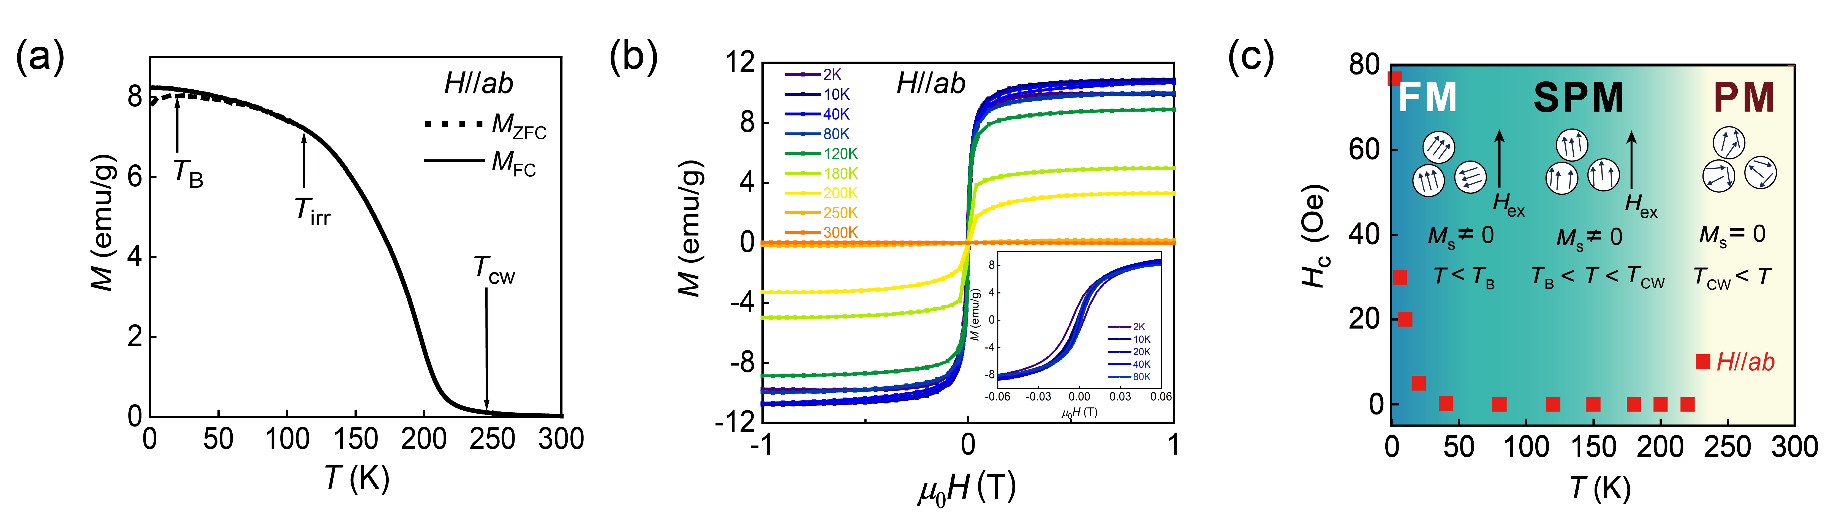
Fig. S5. In-plane superparamagnetism in Cr_{0.35}Pt_{0.65}Te₂. (a) Temperature dependence of the in-plane magnetization curves M(T) for Cr_{0.35}Pt_{0.65}Te₂ under an in-plane magnetic field (H∥ab) of 500 Oe. (b) In-plane isothermal magnetization M(H) curves at different temperatures. (c) Evolution of the temperature-dependent coercive field H_{ab} along with the magnetic phase diagram of Cr_{0.35}Pt_{0.65}Te₂. Schematic representations illustrate the orientation of the magnetic moment of superparamagnetic particles in ferromagnetic (FM), superparamagnetic (SPM), and paramagnetic states (PM).
The results of the in-plane magnetization measurements are presented in Fig. S5. As shown in Fig. S5a, the M_{ZFC}(T) and M_{FC}(T) exhibit a discernible difference up to 125 K, with M_{ZFC}(T) displaying a cusp at 23 K, indicating the presence of superparamagnetism (SPM). According the Curie–Weiss law ($1/χ=\frac{T-T_{\text{CW}}}{C}$), T_{cw} = 247 K can be obtained. Fig. S5b presents the in-plane magnetization M(H) curves collected at various temperatures. In contrast to the out-plane M(H) curves, the in-plane M(H) exhibits smaller coercivities and a sharper transition at zero magnetization, suggesting a strong magnetic anisotropy in Cr_{0.35}Pt_{0.65}Te₂, with the ab-plane being the easy magnetization plane. When T ≤ 20 K, small hysteresis loops are observed, and the coercive field drops to zero above 40 K, confirming the presence of in-plane SPM. The temperature-dependent coercivity H_{c}(T) is plotted in Fig. S5c. The pronounced decrease of H_{c} from 2 K to 40 K implies a transition from a ferromagnetic state to a superparamagnetic state. Similarly, we also establish the magnetic phase diagram of in-plane magnetization transition, as superimposed on Fig. S5c.

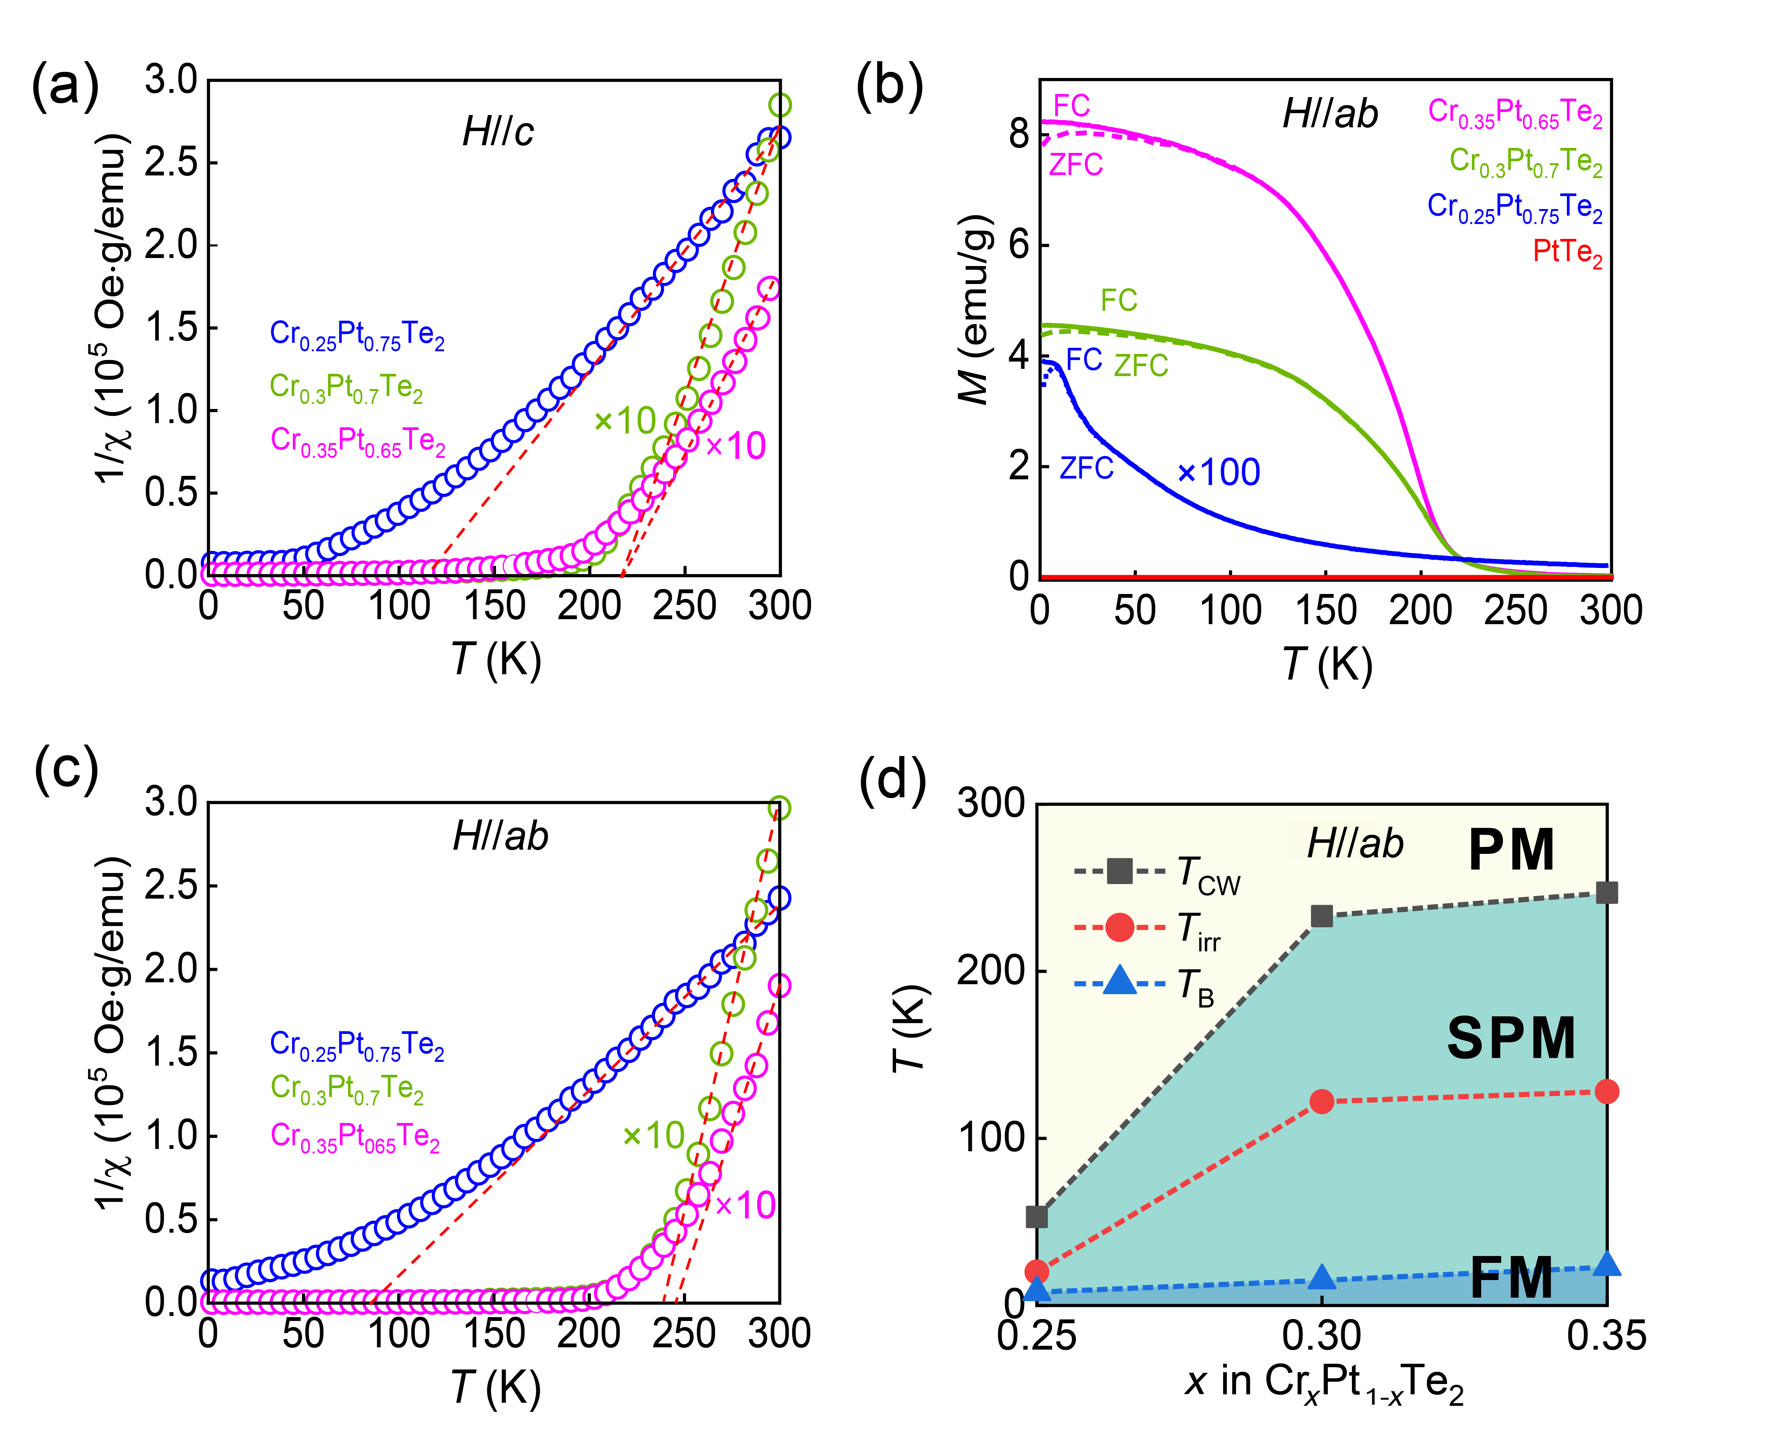
Fig. S6. (a) Inverse magnetic susceptibility ($1/χ=\frac{H}{M}$) of the out-of-plane magnetization of Cr_{x}Pt_{1−x}Te₂ (x=0.25, 0.3 and 0.35) under an external perpendicular magnetic field (H_{c}) of 500 Oe. The red dashed line represents the best fit to the experimental data with Curie-Weiss law ($1/χ=\frac{T-T_{\text{CW}}}{C}$). The mass values for the samples are as follows: Cr_{0.25}Pt_{0.75}Te₂ is 1.37 mg, Cr_{0.3}Pt_{0.7}Te₂ is 32.1 mg, and Cr_{0.35}Pt_{0.65}Te₂ is 7.3 mg. (b) Temperature dependence curves M(T). For clarity, the data for Cr_{0.25}Pt_{0.75}Te₂ is multiplied by 100. (c) Inverse magnetic susceptibility of the in-plane magnetization under a magnetic field (H∥ab) of 500 Oe. For clarity, the data for Cr_{0.3}Pt_{0.7}Te₂ and Cr_{0.35}Pt_{0.65}Te₂ are multiplied by 10 in (a) and (c). (d) Phase diagram of Cr_{x}Pt_{1−x}Te₂ as a function of Cr doping concentration x and temperature for the in-plane magnetization.
To verify the Cuire-Weiss temperature T_{cw} of these samples, we compare the temperature dependence of magnetic susceptibility χ⁻¹(T ) for the magnetic fields oriented parallel to the c-axis and the ab-plane, as shown in Fig. S6a and S6c. A linear relationship between χ⁻¹ and T is observed, consistent with the Curie–Weiss law, allowing for the determination of the corresponding Curie temperature T_{cw} and Curie constant C. Fig. S6b shows the ZFC and FC magnetization curves under an external field (µ₀H=500 Oe) parallel to the ab-plane for Cr_{x}Pt_{1−x}Te₂ samples with x= 0, 0.25, 0.3 and 0.35. Notably, the ZFC and FC curves diverge at the irreversible temperature T_{irr}, and the ZFC curve displays a peak at the temperature T_{B}. Further, Fig. S6d presents the magnetic phase diagrams for various Cr doping concentrations across different temperature ranges, incorporating T_{cw}, T_{B}, and T_{irr}. The corresponding values for the out-plane and in-plane magnetization are summarized in Tables S3 and Table S4.

Table S3: Curie constant C, Curie-Weiss temperature T_{cw}, Blocking temperature T_{B}, and Irreversible temperature T_{irr} for H∥c in Cr_{x}Pt_{1−x}Te₂ (x = 0.25, 0.3, and 0.35).
 | C  (10⁻⁴ Oe· K·g/emu) | T_{cw}(K) | T_{B}(K) | T_{irr}(K)
Cr_{0.25}Pt_{0.75}Te₂ | 6.92 | 114 | 15 | 33
Cr0.3Pt0.7Te2 | 22.78 | 220 | 53 | 194
Cr_{0.35}Pt_{0.65}Te₂ | 23.28 | 220 | 60 | 200

Table S4: Curie constant C, Curie-Weiss temperature T_{cw}, Blocking temperature T_{B}, and Irreversible temperature T_{irr} for H∥ab in Cr_{x}Pt_{1−x}Te₂ (x = 0.25, 0.3, and 0.35).
 | C  (10⁻⁴ Oe· K·g/emu) | T_{cw}(K) | T_{B} (K) | T_{irr}(K)
Cr_{0.25}Pt_{0.75}Te₂ | 9.01 | 85 | 8 | 20
Cr0.3Pt0.7Te2 | 20.63 | 239 | 17 | 120
Cr_{0.35}Pt_{0.65}Te₂ | 28.28 | 247 | 23 | 125

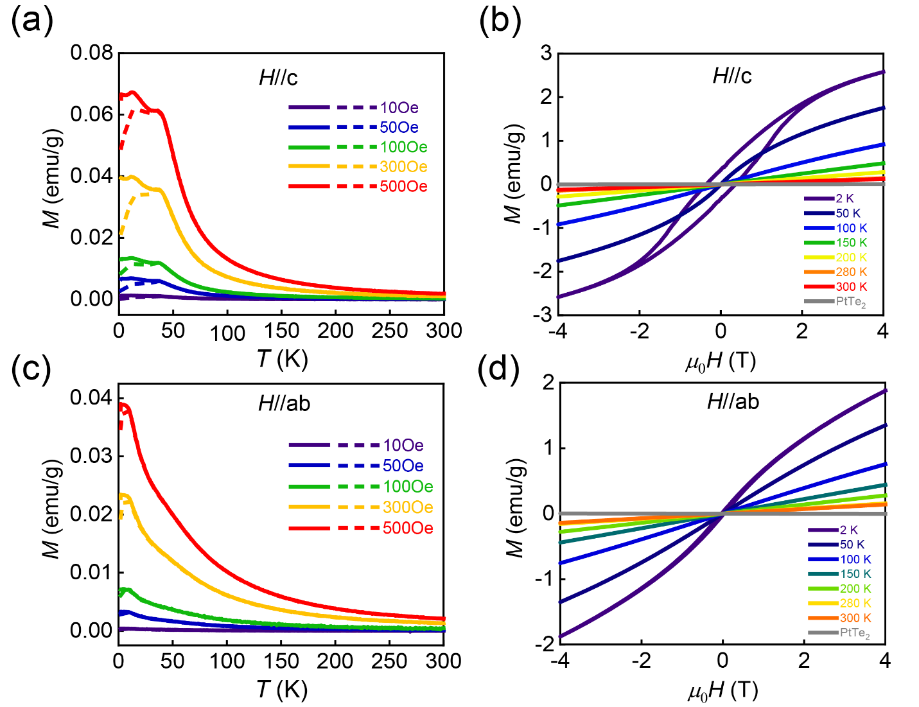
Fig. S7. Temperature-dependent in-plane magnetization (H∥ab) (a) and out-of-plane (H∥c) (c) of Cr_{0.25}Pt_{0.75}Te₂ sample under different magnetic fields. The solid and dashed lines represent the magnetization curves measured under the FC and ZFC conditions, respectively. Isothermal magnetization curves M(H) for in-plane (H∥ab) (b) and out-of-plane (H∥c) (d) taken at different temperatures.

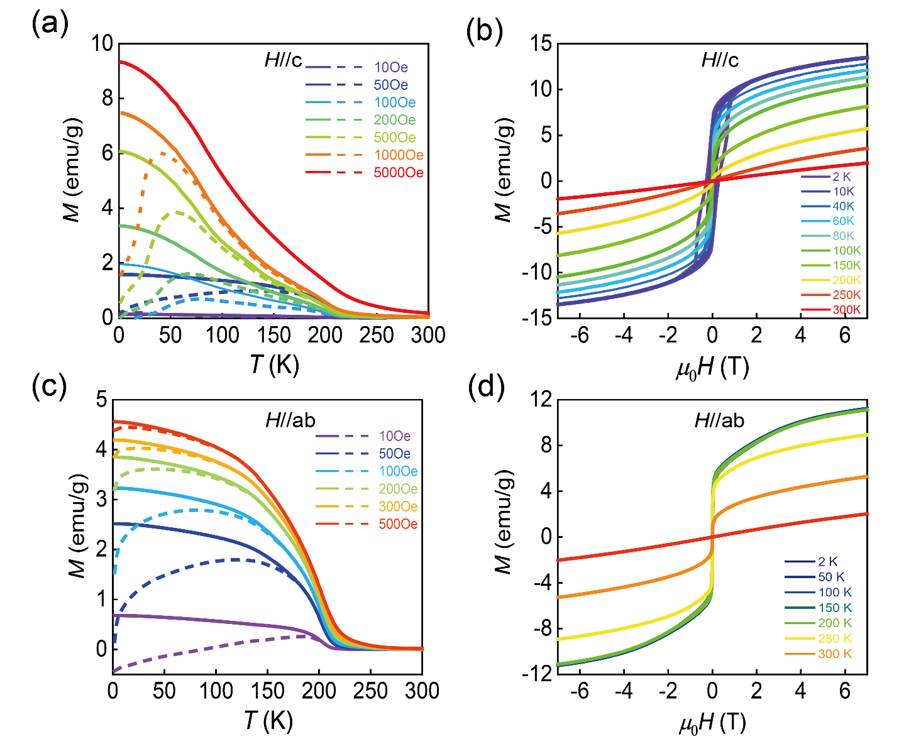
Fig. S8. Temperature-dependent in-plane magnetization (H∥ab) (a) and out-of-plane (H∥c) (c) of Cr_{0.3}Pt_{0.7}Te₂ sample under different magnetic fields. The solid and dashed lines represent magnetization curves measured under the FC and ZFC conditions, respectively. Isothermal magnetization curves M(H) for in-plane (H∥ab) (b) and out-of-plane (H∥c) (d) taken at different temperatures.

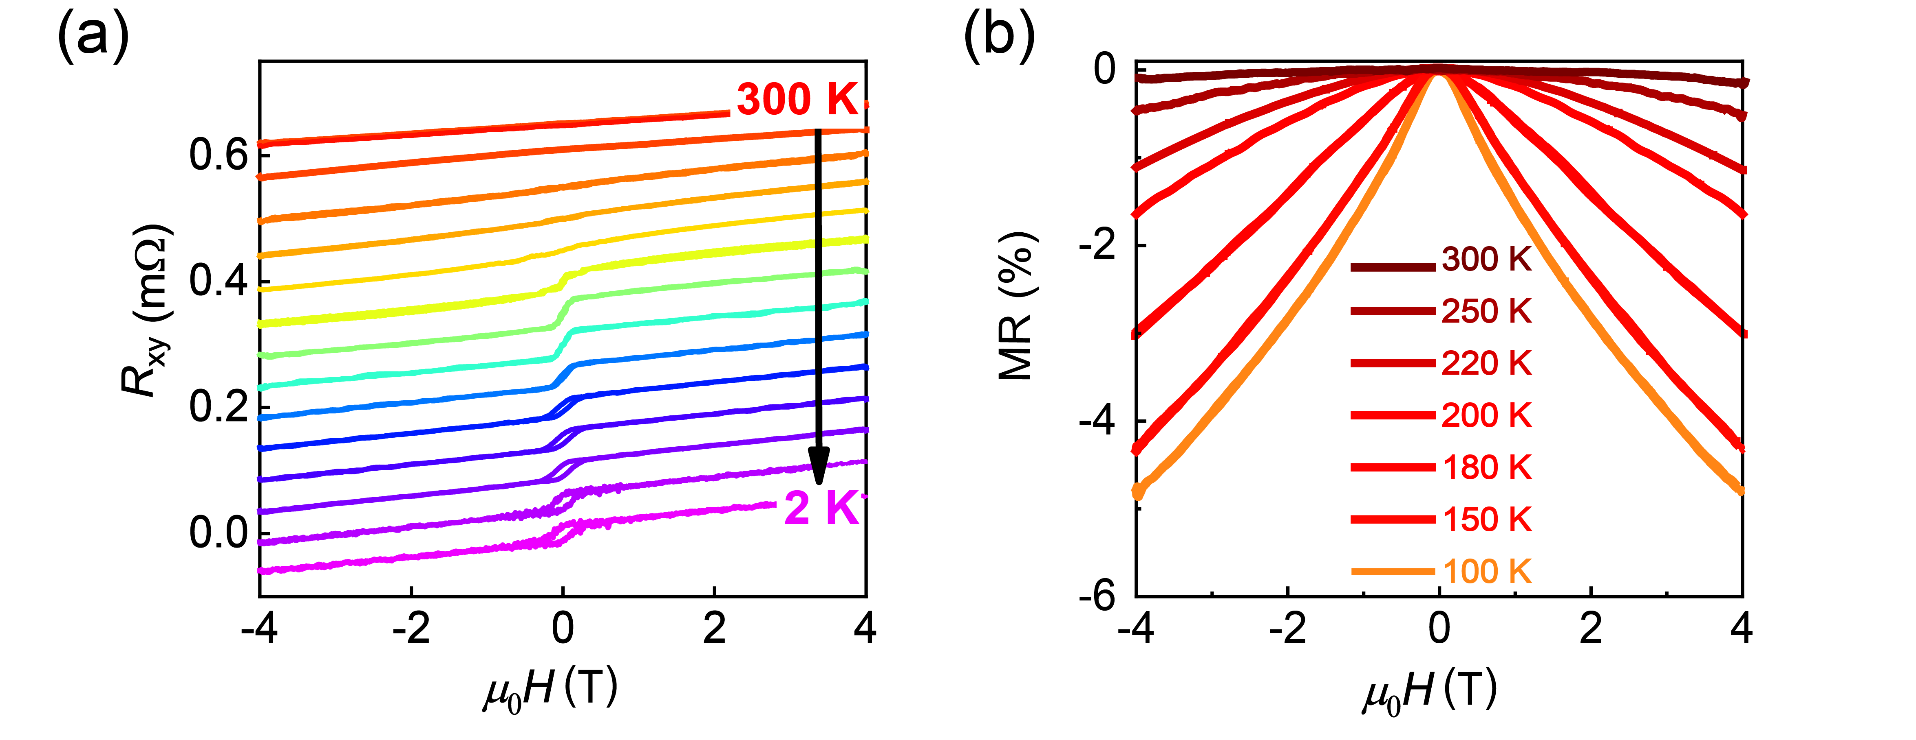
Fig. S9. (a) Hall measurement results at different temperatures ranging from 2 K to 300 K of Cr_{0.35}Pt_{0.65}Te₂. (b) High-temperature (T >100 K) magneto-resistance MR=(R_{xx}(µ₀H) − R_{xx}(0T))/R_{xx}(0T) of Cr_{0.35}Pt_{0.65}Te₂.
Fig. S9a plots the total Hall resistance R_{xy} as a function of the external perpendicular magnetic field µ₀H collected at various temperatures ranging from 2 K to 300 K. The total Hall resistance can be expressed as follows,
$$\begin{aligned}{\text{R}}_{\text{xy}}\text{=}{\text{R}}_{\text{xy}}^{\text{O}}\text{+}{\text{R}}_{\text{xy}}^{\text{A}}\#\left(10\right)\end{aligned}$$
Where ${\text{R}}_{\text{xy}}^{\text{O}}$ represents the ordinary Hall resistance and and ${\text{R}}_{\text{xy}}^{\text{A}}$ is the anomalous Hall resistance. Based on the positive slope of ${\text{R}}_{\text{xy}}^{\text{O}}$, the type of the charge carrier is determined to be p-type.
When T ≥ 200 K, the Hall traces exhibit a linear dependence on µ₀H, accompanied by negative magneto-resistance (MR=(R_{xx}(µ₀H) − R_{xx}(0T))/ R_{xx}(0T)) in the R_{xx} curve (Fig. S9b). The observed negative MR above 200 K may be associated with the spin fluctuations of the local electron^{6,7}. Below 200 K, the MR displays a remarkable increase from -1.62% at 200 K to -4.29% at 150 K, indicating that an external magnetic field can easily orient more magnetic moments. As T decreases, ${\text{R}}_{\text{xy}}^{\text{A}}$ gradually deviates from linearity at ∼ 200 K and develops into a well-defined S−shaped curve with zero coercivity until reaching 80 K. These behaviors further confirm the presence of superparamagnetism^{8,9}.
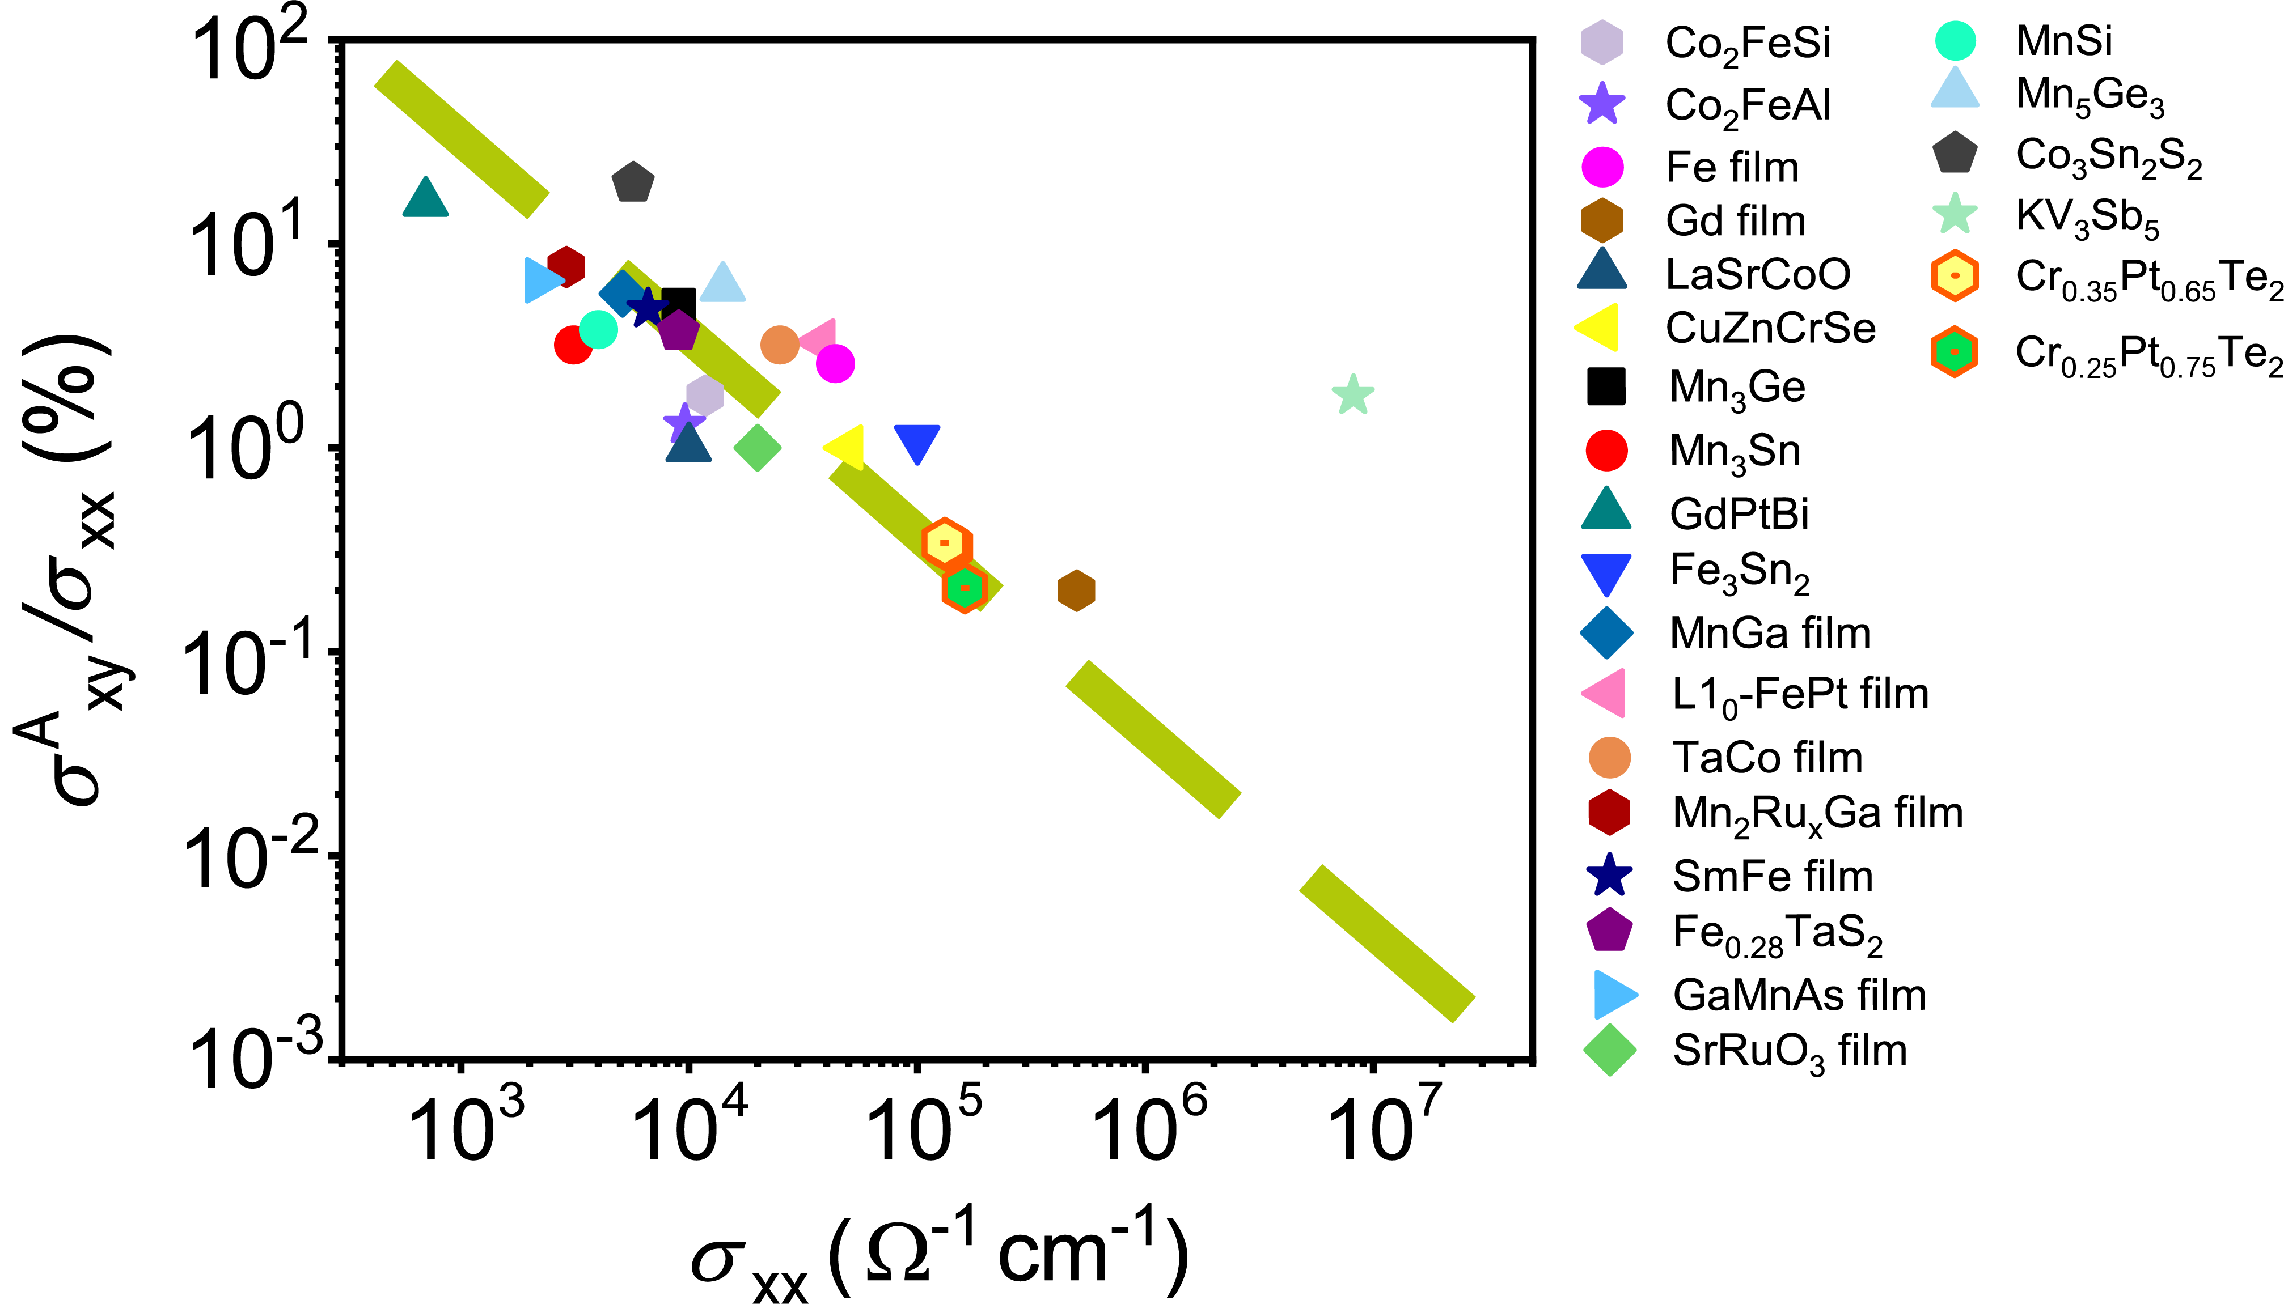
Fig. S10. Plot of Θ^{H} vs $σ_{\text{x}\text{x}}^{ }$ for Cr_{0.25}Pt_{0.75}Te₂, Cr_{0.35}Pt_{0.65}Te₂, and other reported anomalous Hall materials¹⁰⁻¹². For most anomalous Hall materials, the increase of Θ^{H} is typically accompanied by a decrease of $σ_{\text{x}\text{x}}^{ }$. The green dashed line guides the eye to illustrate the increasing tendency of Θ^{H} for Cr_{0.25}Pt_{0.75}Te₂, Cr_{0.35}Pt_{0.65}Te₂, and other reported anomalous Hall materials.

Fig. S11. The anomalous Hall conductivity ${\text{σ}}_{\text{xy}}^{\text{A}}$ as a function of the longitudinal conductivity $σ_{\text{x}\text{x}}^{ }$ (a) and the square of the longitudinal conductivity ${\text{σ}}_{\text{xx}}^{\text{2}}$ (b). The red dashed lines are linear fits to the experimental data.
Fig. S10 shows the anomalous Hall conductivity ${\text{σ}}_{\text{xy}}^{\text{A}}$ as a function of the longitudinal conductivity $σ_{\text{x}\text{x}}^{ }$ and its square ${\text{σ}}_{\text{xx}}^{\text{2}}$ from 2 K to 220 K. Clearly, the experimental data cannot be adequately fitted with either ${\text{σ}}_{\text{xy}}^{\text{A}}$ ∝ $σ_{\text{x}\text{x}}^{ }$ (red dashed line in Fig. S10a) or ${\text{σ}}_{\text{xy}}^{\text{A}}$ ∝${\text{σ}}_{\text{xx}}^{\text{2}}$ (red dashed line in Fig. S10b). These observations suggest that conventional scaling approaches, which typically consider only extrinsic or intrinsic mechanisms, are insufficient to interpret the experimental results.

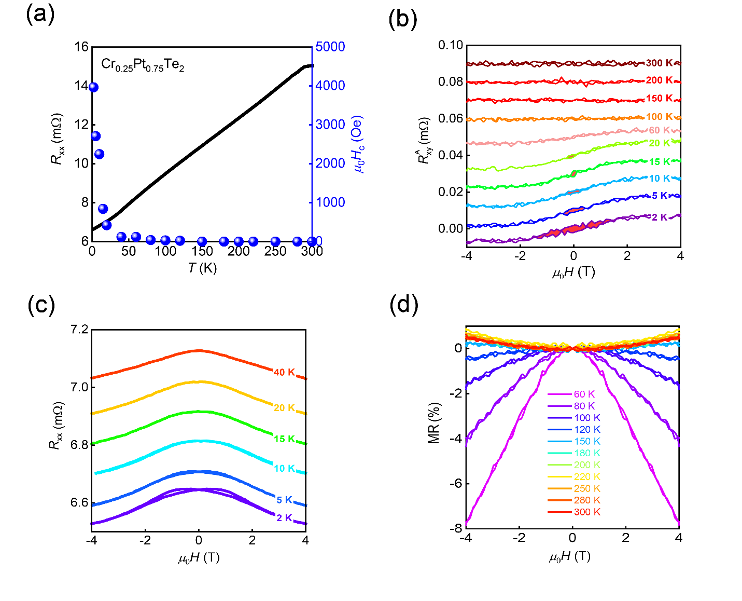
Fig. S12. (a) Temperature-dependent zero-field longitudinal resistance R_{xx} (left axis) and coercive field H_{c} (right axis) extracted from (b) of Cr_{0.25}Pt_{0.75}Te₂ single crystals. (b) Anomalous Hall resistance ${\text{R}}_{\text{xy}}^{\text{A}}$ measured at different temperatures ranging from 2 K to 300 K. The ${\text{R}}_{\text{xy}}^{\text{A}}$ hysteresis is highlighted by the shaded red region. Low-temperature longitudinal resistance R_{xx} (T < 40 K) (c) and high-temperature (T > 60 K) magneto-resistance MR=(R_{xx}(µ₀H) − R_{xx}(0T))/R_{xx}(0T) of Cr_{0.25}Pt_{0.75}Te₂. For clarity, each trace in (b) and (c) is vertically offset.

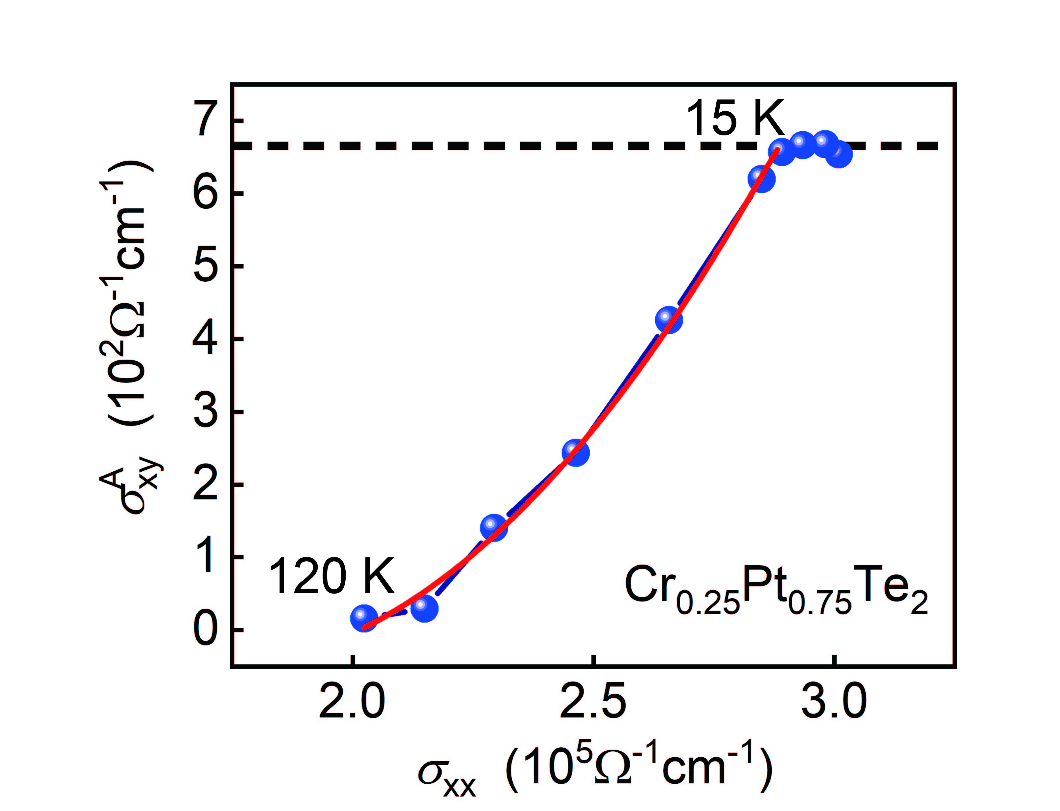
Fig. S13. The anomalous Hall conductivity ${\text{σ}}_{\text{xy}}^{\text{A}}$ as a function of $σ_{\text{x}\text{x}}^{ }$of Cr_{0.25}Pt_{0.75}Te₂. The red line is the best fit to the experimental data with the equation ${\text{σ}}_{\text{xy}}^{\text{A}}=α+βσ_{\text{x}\text{x}}^{ }+γ{\text{σ}}_{\text{xx}}^{\text{2}}$ for the SPM data from 15 K to 120 K.

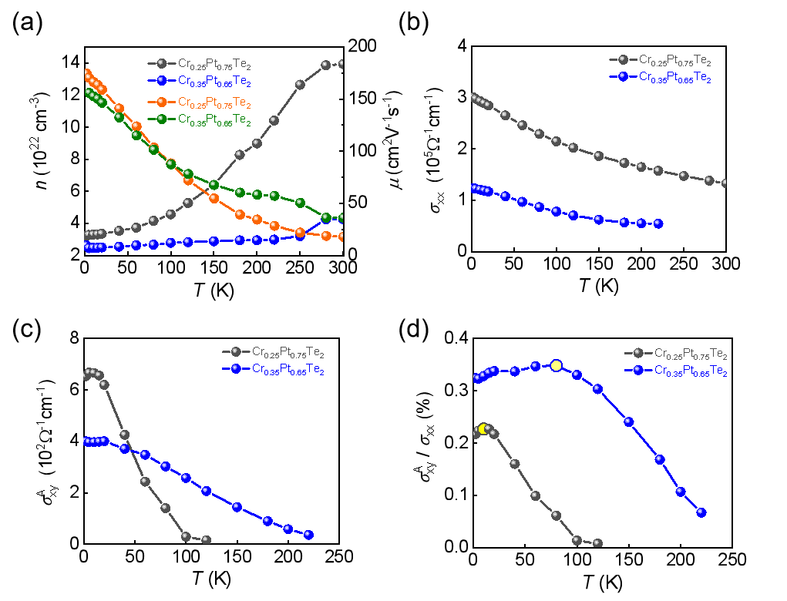
Fig. S14. (a) Carrier density n and mobility µ at different temperatures for Cr_{0.25}Pt_{0.75}Te₂ and Cr_{0.35}Pt_{0.65}Te₂. (b) Temperature-dependent curves of longitudinal conductivity (c) Anomalous Hall conductivity, and (d) Anomalous Hall angle for Cr_{0.25}Pt_{0.75}Te₂ and Cr_{0.35}Pt_{0.65}Te₂.
Accordingly, the density n and mobility µ can be calculated using the fundamental single- carrier Drude model, with the relations n = 1/eR₀d and µ=$σ_{\text{x}\text{x}}^{ }$/ne at different temperatures (Fig. S13a), where e is the elementary charge, d is the sample thickness, and R₀ is the ordinary Hall coefficient. The extracted n and µ are plotted as a function of temperature in Fig. S13. All the samples show p-type conducting behavior, with n (µ) found to be monotonically increasing (decreasing) upon cooling. In Fig. S13b and c, both $σ_{\text{x}\text{x}}^{ }$ and ${\text{σ}}_{\text{xy}}^{\text{A}}$ for Cr_{0.25}Pt_{0.75}Te₂ and Cr_{0.35}Pt_{0.65}Te₂ exhibit similar temperature-dependent trends, with ${\text{σ}}_{\text{xy}}^{\text{A}}$ saturating at low temperatures. This observation further confirms the presence of the AHE in the superparamagnetic system Cr_{x}Pt_{1−x}Te₂. The temperature dependence of the anomalous Hall angle, shown in Fig. S13d, reveals pronounced peaks around 15 K and 60 K for Cr_{0.25}Pt_{0.75}Te₂ and Cr_{0.35}Pt_{0.65}Te₂, respectively, corresponding to their blocking temperatures, as evidenced by magnetic measurements.

Fig. S15. Plot of ${\text{σ}}_{\text{xy}}^{\text{A}}$ vs $σ_{\text{x}\text{x}}^{ }$ for a variety of materials spanning the various AHE regimes, ranging from the impurity scattering to the intrinsic and skew scattering regimes¹³⁻¹⁸. Compared to other anomalous Hall materials, the smaller anomalous Hall conductivity of Cr_{0.25}Pt_{0.75}Te₂ (green symbol) and Cr_{0.35}Pt_{0.65}Te₂ (yellow symbol) may suggest the presence of disorder introduced by Cr doping.

References
1. Roy, A. et al. Perpendicular Magnetic Anisotropy and Spin Glass-like Behavior in Molecular Beam Epitaxy Grown Chromium Telluride Thin Films. ACS Nano 9, 3772-3779 (2015).
2. Hu, J. et al. Co-doping: An effective strategy for developing stable and high-speed Sb₂Te-based phase-change memory. Applied Physics Letters 122 (2023).
3. Furuseth, S. et al. Redetermined Crystal Structures of NiTe₂, PdTe₂, PtS₂, PtSe₂, and PtTe₂. Acta Chemica Scandinavica 19, 257-258 (1965).
4. Respaud, M. Magnetization process of noninteracting ferromagnetic cobalt nanoparticles in the superparamagnetic regime: Deviation from Langevin law. Journal of Applied Physics 86, 556-561 (1999).
5. Henrard, D. et al. Monitoring of Superparamagnetic Particle Sizes in the Langevin Law Regime. Journal of Nanomaterials 2019, 1-9 (2019).
6. Moriya, T. Spin fluctuations in itinerant electron magnetism. Vol. 56 (Springer Science & Business Media, 2012).
7. Tsujii, N., Nishide, A., Hayakawa, J. & Mori, T. Observation of enhanced thermopower due to spin fluctuation in weak itinerant ferromagnet. Science Advances 5, eaat5935 (2019).
8. Allia, P., Knobel, M., Tiberto, P. & Vinai, F. Magnetic properties and giant magnetoresistance of melt-spun granular Cu_{100-x}-Co_{x} alloys. Physical Review B 52, 15398-15411 (1995).
9. Zhang, H. et al. Itinerant ferromagnetism in van der Waals Fe_{5-x}GeTe₂ crystals above room temperature. Physical Review B 102, 064417 (2020).
10. Huang, M. et al. Significant perpendicular magnetic anisotropy in room-temperature layered ferromagnet of Cr-intercalated CrTe₂. 2D Materials 8, 031003 (2021).
11. Li, P. et al. Giant room temperature anomalous Hall effect and tunable topology in a ferromagnetic topological semimetal Co₂MnAl. Nature Communications 11, 3476 (2020).
12. Huang, M. et al. Colossal Anomalous Hall Effect in Ferromagnetic van der Waals CrTe2. ACS Nano 15, 9759-9763 (2021).
13. Miyasato, T. et al. Crossover Behavior of the Anomalous Hall Effect and Anomalous Nernst Effect in Itinerant Ferromagnets. Physical Review Letters 99, 086602 (2007).
14. Nakatsuji, S., Kiyohara, N. & Higo, T. Large anomalous Hall effect in a non-collinear antiferromagnet at room temperature. Nature 527, 212-215 (2015).
15. Yang, S.-Y. et al. Giant, unconventional anomalous Hall effect in the metallic frustrated magnet candidate, KV₃Sb₅. Science Advances 6, eabb6003 (2020).
16. Iguchi, S., Hanasaki, N. & Tokura, Y. Scaling of Anomalous Hall Resistivity in Nd₂(Mo_{1-x}Nb_{x})₂O₇ with Spin Chirality. Physical Review Letters 99, 077202 (2007).
17. Nayak, A. K. et al. Large anomalous Hall effect driven by a nonvanishing Berry curvature in the noncolinear antiferromagnet Mn₃Ge. Science Advances 2, e1501870 (2016).
18. Liu, E. et al. Giant anomalous Hall effect in a ferromagnetic kagome-lattice semimetal. Nature Physics 14, 1125-1131 (2018).

