Example item to assess post-training score
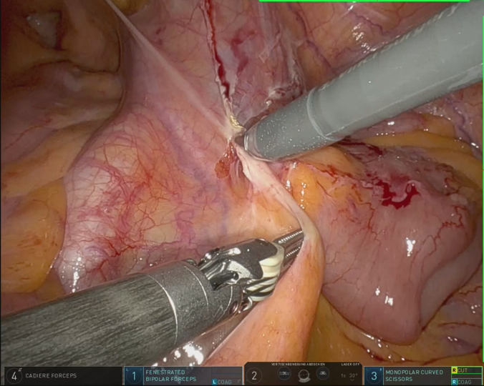
Which structure is being dissected in this surgical step?
A) Appendix
B) Seminal vesicles
C) Ureter
D) Inguinal ring
E) Caecum
(correct answer: C)
Example item to assess prior knowledge in anatomy
Which structure(s) typically run through the fat body of the ischioanal fossa?
A) Middle rectal artery
B) Obturator nerve
C) Perineal nerves
D) Pelvic splanchnic nerves
E) Inferior hypogastric plexus
(correct answer: C)
Sections of the training video
Supplemental Table 1.
The whole prostatectomy operation (>1 hour in total) was cropped into six shorter sections (05:37 min.) that were deemed particularly challenging for the learners.
Section | Timestamp
Visualization of the pelvis | 00:00 – 00:45
Peritoneal dissection | 00:46 – 01:13
Seminal vesicle dissection | 01:14 – 01:35
Lymph node dissection | 01:36 – 03:22
Pelvic cavity inspection | 03:23 – 03:58
Initiation of anastomosis | 03:59 – 05:37

Compiled report of the R script

library(readxl)
library(emmeans)
## Welcome to emmeans.
## Caution: You lose important information if you filter this package's results.
## See '? untidy'
library(ggplot2)
library(patchwork)
### Define directories
analysis_directory <- "XXXXX"
d <- read_excel(file.path(analysis_directory, "XXXXX.xlsx"))
d <- d[d$uni == "XXXXX", ]
###
### Descriptives
###
table(d$gend)
##
## 0 1 2
## 1 87 49
d$age[d$age == 0] <- NA
summary(d$age)
## Min. 1st Qu. Median Mean 3rd Qu. Max. NA's
## 21.00 24.00 25.00 26.54 29.00 45.00 35
table(d$rand_ana)
##
## ana no_ana
## 73 64
table(d$`rand_EMME_mit-ton`)
##
## EMME no_EMME
## 67 70
table(d$Ton)
##
## no yes
## 58 79
###
### Create scales
###
d$ANA <-
d$ana1+
d$ana2+
d$ana3+
d$ana4+
d$ana5+
d$ana6+
d$ana7+
d$ana8+
d$ana9+
d$ana10
hist(d$ANA)
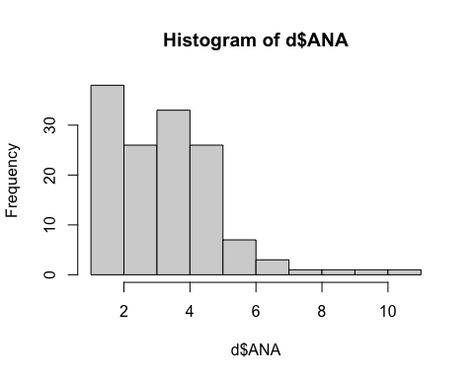
d$ANA_log <- log(d$ANA)
# Transformation did not improve the contribution
d$POST <-
d$`post1_mit-ton`+
d$`post2_mit-ton`+
d$`post3_mit-ton`+
d$`post4_mit-ton`+
d$`post5_mit-ton`+
d$`post6_mit-ton`+
d$`post7_mit-ton`+
d$`post8_mit-ton`+
d$`post9_mit-ton`+
d$`post10_mit-ton`+
d$`post11_mit-ton`+
d$`post12_mit-ton`+
d$`post13_mit-ton`+
d$`post14_mit-ton`
hist(d$POST)
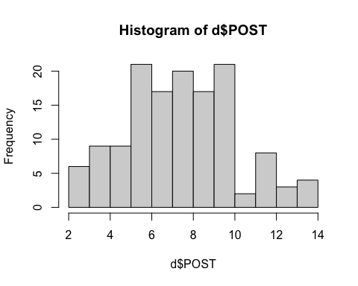
###
### ANCOVA
###
summary(anova_result <- aov(POST ~ rand_ana * `rand_EMME_mit-ton` * Ton + age + gend + sem + ANA, data = d))
## Df Sum Sq Mean Sq F value Pr(>F)
## rand_ana 1 17.2 17.16 3.042 0.0845 .
## `rand_EMME_mit-ton` 1 1.5 1.45 0.258 0.6128
## Ton 1 118.2 118.24 20.964 1.5e-05 ***
## age 1 21.7 21.70 3.848 0.0529 .
## gend 1 0.0 0.03 0.005 0.9457
## sem 1 1.7 1.67 0.297 0.5874
## ANA 1 38.6 38.65 6.852 0.0104 *
## rand_ana:`rand_EMME_mit-ton` 1 16.6 16.64 2.951 0.0893 .
## rand_ana:Ton 1 29.3 29.35 5.204 0.0249 *
## `rand_EMME_mit-ton`:Ton 1 2.2 2.17 0.385 0.5365
## rand_ana:`rand_EMME_mit-ton`:Ton 1 1.5 1.53 0.272 0.6033
## Residuals 90 507.6 5.64
## ---
## Signif. codes: 0 '***' 0.001 '**' 0.01 '*' 0.05 '.' 0.1 ' ' 1
## 35 observations deleted due to missingness
# Randomization to prior knowledge (ana vs no_ana)
cat("\nPrior knowledge activated (rand_ana):\n")
##
## Prior knowledge activated (rand_ana):
print(table(d$rand_ana))
##
## ana no_ana
## 73 64
print(prop.table(table(d$rand_ana)))
##
## ana no_ana
## 0.5328467 0.4671533
# Visual channel activation
cat("\nVisual channel activated (rand_EMME_mit-ton):\n")
##
## Visual channel activated (rand_EMME_mit-ton):
print(table(d$`rand_EMME_mit-ton`))
##
## EMME no_EMME
## 67 70
print(prop.table(table(d$`rand_EMME_mit-ton`)))
##
## EMME no_EMME
## 0.4890511 0.5109489
# Auditory channel activation
cat("\nAuditory channel activated (Ton):\n")
##
## Auditory channel activated (Ton):
print(table(d$Ton))
##
## no yes
## 58 79
print(prop.table(table(d$Ton)))
##
## no yes
## 0.4233577 0.5766423
###
### PLOT
###
em_2way_1 <- emmeans(anova_result, ~ rand_ana * Ton)
## NOTE: Results may be misleading due to involvement in interactions
plot_data_2way_1 <- as.data.frame(em_2way_1)
d$rand_ana <- factor(d$rand_ana, levels = c("no_ana", "ana"))
plot_data_2way_1$rand_ana <- factor(plot_data_2way_1$rand_ana, levels = c("no_ana", "ana"))
plot_data_2way_1$emmean <- plot_data_2way_1$emmean / 14 * 100
plot_data_2way_1$lower.CL <- plot_data_2way_1$lower.CL / 14 * 100
plot_data_2way_1$upper.CL <- plot_data_2way_1$upper.CL / 14 * 100
d$POST_pct <- d$POST / 14 * 100
dodge_width <- 0.90
p2 <- ggplot(plot_data_2way_1, aes(x = factor(rand_ana), y = emmean, fill = Ton)) +
geom_dotplot(data = d,
aes(x = factor(rand_ana), y = POST_pct, fill = Ton),
binaxis = "y", stackdir = "center", dotsize = 0.5,
position = position_dodge(width = dodge_width),
alpha = 0.6)+
geom_errorbar(aes(ymin = lower.CL, ymax = upper.CL, color = Ton),
position = position_dodge(width = dodge_width),
width = 0.2) +
geom_col(aes(color = Ton),
position = position_dodge(width = dodge_width),
alpha = 0.4,
size = 0.5) +
labs(
x = "Prior knowledge activated",
y = "Post-training score (%)",
fill = "Auditory channel activated",
color = "Auditory channel activated") +
theme_light() +
theme(legend.position = "top") +
theme(
legend.position = "top",
axis.title = element_text(size = 12),
axis.text = element_text(size = 12),
legend.title = element_text(size = 12),
legend.text = element_text(size = 12)
) +
scale_y_continuous(limits = c(0, 100), breaks = seq(0, 124, 25)) +
scale_x_discrete(labels = c("ana" = "yes", "no_ana" = "no")) +
scale_fill_manual(values = c("#d18f13", "#4e84a3")) +
scale_color_manual(values = c("#d18f13", "#4e84a3"))
## Warning: Using `size` aesthetic for lines was deprecated in ggplot2 3.4.0.
## ℹ Please use `linewidth` instead.
## This warning is displayed once every 8 hours.
## Call `lifecycle::last_lifecycle_warnings()` to see where this warning was
## generated.
print(p2)
## Bin width defaults to 1/30 of the range of the data. Pick better value with
## `binwidth`.
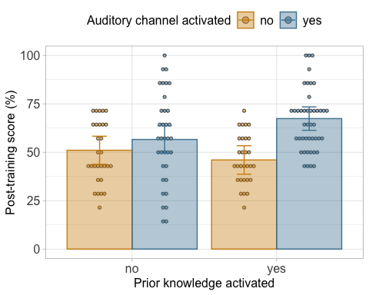
# Plot: rand_EMME_mit-ton × Ton interaction
em_2way_2 <- emmeans(anova_result, ~ `rand_EMME_mit-ton` * rand_ana)
## NOTE: Results may be misleading due to involvement in interactions
plot_data_2way_2 <- as.data.frame(em_2way_2)
plot_data_2way_2$rand_ana <- factor(plot_data_2way_2$rand_ana, levels = c("no_ana", "ana"))
plot_data_2way_2$emmean <- plot_data_2way_2$emmean / 14 * 100
plot_data_2way_2$lower.CL <- plot_data_2way_2$lower.CL / 14 * 100
plot_data_2way_2$upper.CL <- plot_data_2way_2$upper.CL / 14 * 100
p3 <- ggplot(plot_data_2way_2, aes(x = factor(rand_ana), y = emmean, fill = `rand_EMME_mit-ton`)) +
geom_dotplot(data = d,
aes(x = factor(rand_ana), y = POST_pct, fill = `rand_EMME_mit-ton`),
binaxis = "y", stackdir = "center", dotsize = 0.5,
position = position_dodge(width = dodge_width),
alpha = 0.6) +
geom_errorbar(aes(ymin = lower.CL, ymax = upper.CL, color = `rand_EMME_mit-ton`),
position = position_dodge(width = dodge_width),
width = 0.2) +
geom_col(aes(color = `rand_EMME_mit-ton`),
position = position_dodge(width = dodge_width),
alpha = 0.4,
linewidth = 0.5) +
labs(
x = "Prior knowledge activated",
y = "Post-training score (%)",
fill = "Visual channel activated",
color = "Visual channel activated") +
theme_light() +
theme(
legend.position = "top",
axis.title = element_text(size = 12),
axis.text = element_text(size = 12),
legend.title = element_text(size = 12),
legend.text = element_text(size = 12)
) +
scale_y_continuous(limits = c(0, 100), breaks = seq(0, 124, 25)) +
scale_x_discrete(labels = c("ana" = "yes", "no_ana" = "no")) +
scale_fill_manual(values = c("#d18f13", "#4e84a3", "#7a7a7a"),
labels = c("no", "yes", "yes")) +
scale_color_manual(values = c("#d18f13", "#4e84a3", "#7a7a7a"),
labels = c("no", "yes", "yes"))
print(p3)
## Bin width defaults to 1/30 of the range of the data. Pick better value with
## `binwidth`.
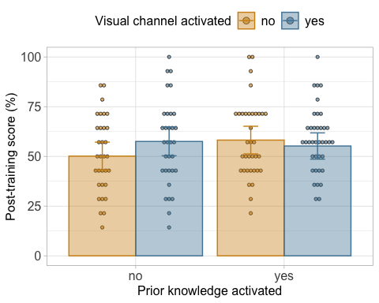
p3+p2
## Bin width defaults to 1/30 of the range of the data. Pick better value with
## `binwidth`.
## Bin width defaults to 1/30 of the range of the data. Pick better value with
## `binwidth`.
