SUPPLEMENTARY DATA
TABLES
Suppl. table 1: Description of the 80 Meloidogyne populations included in the study.
Sample Code | Location | Coordinates | Altitude (m) | Host Plant
09-1 | Aydin-İncirliova | 37°51'40"N,7°42'06"E | 45 | Tomato
09-2 | Aydin-İncirliova | 37°51'44"N,27°42'03"E | 47 | Tomato
09-3 | Aydin-İncirliova | 37°51'38"N 27°42'02"E | 44 | Tomato
09-4 | Aydin-İncirliova | 37°50'56"N 27°44'56"E | 41 | Cucumber
09-5 | Aydin-İncirliova | 37°50'56"N 27°44'58"E | 41 | Cucumber
09-6 | Aydin-İncirliova | 37°50'57"N 27°44'48"E | 42 | Eggplant
09-7 | Aydin-İncirliova | 37°50'58"N 27°44'49"E | 41 | Eggplant
10-1 | Balikesir-Altieylul | 39°41'07"N 27°56'55"E | 118 | Cucumber
10-2 | Balikesir-Altieylul | 39°41'07"N 27°57'03"E | 119 | Cucumber
10-3 | Balikesir-Altieylul | 39°41'07"N 27°57'03"E | 119 | Cucumber
10-4 | Balikesir-Karesi | 39°41'16"N 27°56'21"E | 116 | Cucumber
10-5 | Balikesir-Karesi | 39°41'13"N 27°56'19"E | 116 | Pepper
17-1 | Canakkale-Lapseki | 40°22'38"N 26°43'32"E | 13 | Tomato
17-2 | Canakkale-Lapseki | 40°22'46"N 26°43'35"E | 11 | Tomato
17-3 | Canakkale-Lapseki | 40°23'41"N 26°44'53"E | 7 | Cucumber
17-4 | Canakkale-Lapseki | 40°14'53"N 26°37'05"E | 18 | Tomato
20-1 | Denizli-Cal | 38°07'26"N 29°23'12"E | 770 | Tomato
20-2 | Denizli-Buldan | 38°01'27"N 28°54'54"E | 251 | Tomato
20-3 | Denizli-Buldan | 38°01'32"N 28°53'12"E | 373 | Tomato
20-4 | Denizli-Buldan | 38°03'09"N 28°56'33"E | 238 | Tomato
20-5 | Denizli-Guney | 38°04'42"N 29°00'03"E | 180 | Tomato
35-1 | Izmir-Menderes | 38°06'47"N 27°10'26"E | 85 | Cucumber
35-2 | Izmir-Menderes | 38°06'47"N 27°10'27"E | 84 | Cucumber
35-3 | Izmir-Menderes | 38°07'00"N 27°11'23"E | 69 | Pepper
35-4 | Izmir-Menderes | 38°07'01"N 27°11'27"E | 69 | Cucumber
35-5 | Izmir-Menderes | 38°06'43"N 27°10'36"E | 81 | Cucumber
35-6 | Izmir-Menderes | 38°06'39"N 27°10'32"E | 83 | Cucumber
35-7 | Izmir-Menderes | 38°06'49"N 27°10'36"E | 81 | Cucumber
35-8 | Izmir-Menderes | 38°06'50"N 27°10'29"E | 82 | Cucumber
35-9 | Izmir-Menderes | 38°09'23"N 27°09'33"E | 61 | Bean
35-10 | Izmir-Menderes | 38°09'10"N 27°09'34"E | 64 | Cucumber
35-11 | Izmir-Menderes | 38°09'10"N 27°09'34"E | 63 | Cucumber
35-12 | Izmir-Menderes | 38°08'49"N 27°09'38"E | 69 | Cucumber
35-13 | Izmir-Menderes | 38°09'06"N 27°09'12"E | 67 | Pepper
35-14 | Izmir-Menderes | 38°08'38"N 27°08'56"E | 74 | Cucumber
35-15 | Izmir-Menderes | 38°08'22"N 27°08'51"E | 79 | Cucumber
43-1 | Kutahya-Simav | 39°07'26"N 29°00'06"E | 811 | Tomato
43-2 | Kutahya-Simav | 39°07'25"N 29°00'07"E | 811 | Tomato
43-3 | Kutahya-Simav | 39°07'27"N 28°59'52"E | 807 | Tomato
45-1 | Manisa-Akhisar | 38°57'46"N 27°54'00"E | 207 | Cucumber
45-2 | Manisa-Akhisar | 38°57'20"N 27°53'36"E | 176 | Cucumber
45-3 | Manisa-Akhisar | 38°57'25"N 27°53'45"E | 186 | Cucumber
45-4 | Manisa-Akhisar | 38°57'29"N 27°53'47"E | 186 | Cucumber
45-5 | Manisa-Akhisar | 38°57'29"N 27°53'48"E | 191 | Cucumber
45-6 | Manisa-Akhisar | 38°57'23"N 27°54'20"E | 215 | Cucumber
45-7 | Manisa-Akhisar | 38°58'32"N 27°51'38"E | 118 | Cucumber
48-1 | Mugla-Seydikemer | 36°34'04"N 29°23'53"E | 167 | Tomato
48-2 | Mugla-Seydikemer | 36°31'52"N 29°22'45"E | 122 | Tomato
48-3 | Mugla-Seydikemer | 36°30'56"N 29°22'41"E | 126 | Pepper
48-4 | Mugla-Seydikemer | 36°20'00"N 29°17'38"E | 9 | Tomato
48-5 | Mugla-Seydikemer | 36°19'42"N 29°16'54"E | 5 | Tomato
48-6 | Mugla-Seydikemer | 36°19'04"N 29°18'04"E | 7 | Tomato
48-7 | Mugla-Seydikemer | 36°20'04"N 29°14'25"E | 1 | Tomato
48-8 | Mugla-Seydikemer | 36°20'02"N 29°14'26"E | 1 | Cucumber
48-9 | Mugla-Seydikemer | 36°20'32"N 29°16'12"E | 6 | Tomato
48-10 | Mugla-Seydikemer | 36°19'53"N 29°14'20"E | 1 | Tomato
48-11 | Mugla-Seydikemer | 36°19'49"N 29°13'39"E | 2 | Pepper
48-12 | Mugla-Seydikemer | 36°23'18"N 29°18'46"E | 27 | Tomato
48-13 | Mugla-Seydikemer | 36°30'24"N 29°18'20"E | 139 | Tomato
48-14 | Mugla-Seydikemer | 36°34'41"N 29°18'10"E | 138 | Melon
48-15 | Mugla-Seydikemer | 36°30'11"N 29°20'07"E | 76 | Cucumber
48-16 | Mugla-Fethiye | 36°40'07"N 29°11'32"E | 122 | Bean
48-17 | Mugla-Fethiye | 36°38'45"N 29°09'53"E | 41 | Tomato
48-18 | Mugla-Fethiye | 36°36'33"N 29°14'11"E | 231 | Tomato
48-19 | Mugla-Fethiye | 36°36'29"N 29°15'03"E | 212 | Tomato
48-20 | Mugla-Fethiye | 36°42'21"N 29°04'42"E | 28 | Eggplant
48-21 | Mugla-Fethiye | 36°42'24"N 29°04'45"E | 32 | Tomato
48-22 | Mugla-Fethiye | 36°39'48"N 29°11'26"E | 109 | Tomato
48-23 | Mugla-Fethiye | 36°39'44"N 29°10'24"E | 74 | Tomato
48-24 | Mugla-Fethiye | 36°39'05"N 29°10'14"E | 55 | Tomato
48-25 | Mugla-Fethiye | 36°36'16"N 29°14'39"E | 230 | Tomato
48-26 | Mugla-Fethiye | 36°36'12"N 29°14'35"E | 251 | Tomato
48-27 | Mugla-Fethiye | 36°36'43"N 29°14'34"E | 166 | Tomato
48-28 | Mugla-Fethiye | 36°37'24"N 29°13'60"E | 113 | Tomato
48-29 | Mugla-Fethiye | 36°38'20"N 29°09'25"E | 29 | Tomato
48-30 | Mugla-Fethiye | 36°37'59"N 29°11'42"E | 64 | Tomato
64-1 | Usak-Banaz | 38°46'44"N 29°46'07"E | 949 | Tomato
64-2 | Usak-Banaz | 38°47'16"N 29°46'27"E | 974 | Cucumber
64-3 | Usak-Banaz | 38°47'17"N 29°46'26"E | 968 | Pepper
64-4 | Usak-Banaz | 38°47'11"N 29°46'45"E | 955 | Cucumber
Suppl. table 2: Morphometric measurement of Meloidogyne populations second stage juveniles (n=20)
Pop. Code | Sp.* | L  (µm) | W  (µm) | S  (µm) | SW  (µm) | DGO  (µm) | EPL  (µm) | EPW  (µm) | I  (µm) | T  (µm) | RW  (µm)
48-3 | Inc¹ | 392,16±13,18 (352,86-408,31) | 14,41±0,76 (13,20-16,02) | 13,80±0,82 (12,78-15,58 | 9,31±0,48 (8,43-9,96) | 3,44±0,43 (2,80-4,41) | 78,93±3,23 (74,38-84,69 | 13,62±0,61 (12,62-14,98) | 53,18±2,84 (48,10-58,14) | 46,41±2,88 (42,17-52,39 | 10,53±1,14 (8,37-12,40
48-4 | Inc¹ | 429,78±11,80 (407,41-446,82) | 13,81±0,44 (13,05-14,48) | 13,67±0,42 (12,94-14,87) | 9,00±0,30 (8,43-9,49) | 3,13±0,35 (2,38-3,70) | 86,11±4,37 (80,03-95,64) | 13,08±0,49 (12,12-14,28) | 55,66±3,52 (50,44-60,78) | 46,84±2,64 (42,36-50,36) | 9,61±  0,62 (8,05-10,48)
09-1 | Inc¹ | 442,81±15,21 (419,70-467,66) | 13,50±0,48 (12,76-14,73) | 13,93±0,32 (13,19-14,57) | 8,85±0,27 (8,31-9,53) | 3,70±0,21 (3,37-4,13) | 85,50±3,11 (79,34-92,00) | 12,84±0,42 (11,65-13,39) | 55,48±3,23 (49,45-62,54) | 48,86±1,42 (46,11-52,01) | 8,94±  0,59 (8,09-10,27)
09-3 | Inc¹ | 436,53±20,46 (386,74-461,57) | 14,02±0,62 (13,08-15,34) | 13,86±0,50 (12,98 -14,59) | 8,79±0,29 (8,38-9,35 | 3,52±0,25 (3,00-4,17) | 90,69±3,72 (85,67-97,88) | 13,42±0,55 (12,60-14,28) | 60,14±2,94 (55,86-65,31) | 50,59±1,72 (44,90-52,99) | 9,23±  0,37 (8,48-9,99)
09-6 | Inc¹ | 435,61±11,32 (410,86-453,73) | 15,24±1,17 (13,51-18,74) | 13,66±0,48 (12,89-14,99) | 9,07±0,32(8,59-9,74) | 3,74±0,26 (2,95-4,05) | 89,01±5,41 (80,23-100,51) | 14,08±1,03 (12,51-16,73) | 58,98±5,21 (50,44-68,92) | 52,55±2,79 (48,04-58,54) | 9,69±  0,75 (8,80-11,15)
35-4 | Inc¹ | 428,65±20,14 (373,71-460,58) | 13,83±0,44 (13,08-14,77) | 13,50±0,74 (10,53-13,97) | 8,75±0,31 (8,18-9,57) | 3,60±0,24 (3,04-4,18) | 78,31±3,70 (70,12-85,39) | 12,80±0,54 (12,03-14,46) | 49,50±2,90 (40,47-52,61) | 48,55±1,99 (44,58-51,84) | 8,73±  0,21 (8,20-9,00)
35-6 | Inc¹ | 399,65±28,93 (333,30-433,18) | 13,54±0,78 (12,00-14,96) | 8,92±0,35 (8,36-9,93) | 8,92±0,35 (8,36-9,93) | 2,78±0,21 (2,39-3,26) | 79,16±5,46 (70,22-87,60) | 12,83±0,74 (10,98-14,30) | 47,36±3,38 (41,84-53,42) | 48,15±1,83 (44,74-51,90) | 9,73±  0,75 (8,15-10,90)
35-10 | Inc¹ | 393,91±15,72 (368,26-421,05) | 13,33±0,81 (12,45-16,25) | 13,04±0,73 (11,65-15,00) | 8,62±0,45 (8,07-10,00) | 3,52±0,30 (3,00-3,94) | 78,81±4,23 (72,57-90,0) | 12,62±0,59 (11,97-14,43) | 49,39±3,69 (44,30-60,00) | 48,62±5,16 (41,34-55,75) | 9,46±  1,04 (8,08-12,25)
17-2 | Inc¹ | 354,10±27,72 (319,32-429,32) | 13,04±0,80 (11,80-14,76) | 12,68±0,29 (12,14-13,08) | 8,80±0,17 (8,41-9,14) | 2,41±0,13 (2,20-2,60) | 68,77±5,96 (60,12-85,35) | 12,31±0,70 (11,33-13,97) | 42,74±4,03 (38,20-52,05) | 43,92±2,33 (39,11-49,54) | 8,73±  0,65 (8,08-10,86)
20-5 | Inc¹ | 401,32±9,42 (385,92-415,97) | 13,61±0,57 (12,67-14,63) | 13,39±0,35 (12,59-13,80) | 9,09±0,31 (8,46-9,61) | 2,91±0,09 (2,74-3,01) | 78,98±2,95 (72,00-84,32) | 12,83±0,44 (11,96-13,56) | 46,42±2,02 (42,91-50,77) | 49,15±1,58 (45,49-50,96) | 9,65±  0,64 (8,50-10,75)
45-3 | Inc¹ | 406,69±11,62 (386,39-424,50) | 14,01±0,63 (12,89-15,01) | 13,17±0,17 (12,90-13,59) | 8,69±0,32 (8,09-9,10) | 2,96±0,16 (2,68-3,20) | 80,95±2,60 (75,21-84,75) | 13,14±0,54 (12,13-14,64) | 47,24±2,13 (44,01-50,61) | 49,33±1,25 (46,36-51,29) | 9,71±  0,74 (8,08-10,80)
64-1 | Inc¹ | 431,71±12,54 (406,40-447,87) | 13,71±0,43 (13,01-14,65) | 13,37±0,22 (13,00-13,89) | 8,87±0,37 (7,94-9,50) | 3,01±0,23 (2,43-3,38) | 81,09±2,81 (74,84-85,20) | 12,96±0,50 (12,14-14,01) | 47,07±1,75 (44,13-51,19) | 49,92±1,30 (46,26-51,56) | 9,87±  0,38 (9,20-10,42)
Whitehead (1968) | Inc¹ | 337-403 | - | 9,6-11,7 | - | - | - | - | - | 38-55 | -
Gürkan (2021) | Inc¹ | 340-427 | 10,87-13,77 | 9,38-13,78 | - | - | - | - | 44,17-59,89 | 40,06-49,97 | 7,50-11,12
48-1 | Jav² | 425,47±24,17 (387,19-474,29) | 14,23±1,35 (12,03-16,69) | 13,76±0,92 (11,74-15,46) | 9,65±0,75 (8,54-11,77) | 3,65±0,32 (3,10-4,20) | 87,59±5,40 (80,11-100,63) | 13,55±0,90 (12,29-15,56) | 50,70±3,45 (45,09-56,95) | 54,95±2,96 (50,02-60,50) | 9,50±  0,69 (8,25-10,53)
48-6 | Jav² | 436,53±25,76 (368,70-469,60 | 13,36±15,22 (12,28-0,66) | 13,94±0,43 (13,07-14,67) | 8,82±0,32 (8,29-9,27) | 3,41±0,49 (2,42-4,21) | 81,37±4,33 (71,82-89,70) | 12,86±0,48 (11,65-13,73) | 50,19±2,44 (46,09-54,37) | 50,11±1,90 (46,34-52,79) | 8,96±  0,58 (7,98-10,53)
48-9 | Jav² | 461,56±14,43 (432,23-477,77) | 14,28±0,49 (13,66-15,37) | 14,21±0,45 (13,51-15,59) | 8,82±0,31(8,30-9,53) | 3,87±0,34 (3,31-4,58) | 85,77±2,59 (80,26-89,89) | 13,54±0,51 (12,43-14,66) | 53,20±1,71 (50,39-57,54) | 51,31±1,31 (49,35-53,70) | 9,28±  0,62 (7,64-10,31)
48-17 | Jav² | 449,62±13,24 (425,40-485,98) | 14,39±0,75 (13,35-16,99) | 13,71±0,33 (12,98-14,31) | 8,84±0,18 (8,54-9,19) | 2,88±0,17 (2,59-3,17) | 82,49±2,07 (78,78-86,62) | 13,84±0,64 (12,77-15,64) | 48,89±1,02 (46,82-50,66) | 50,95±1,81 (48,75-56,54) | 9,65±  0,49 (8,44-10,11)
48-20 | Jav² | 452,80±17,57 (417,00-476,00) | 17,30±2,26 (15,00-22,50) | 14,90±0,72 (14,00-16,00) | 9,40±0,68 (8,00-11,00) | 3,98±0,61 (3,80-5,00) | 86,20±7,20 (72,00-97,00) | 14,35±2,03 (10,00-18,00) | 49,00±3,08 (44,00-57,00) | 54,35±2,48 (49,00-59,00) | 9,75±  1,45 (7,00-12,00)
48-22 | Jav² | 425,43±27,08 (386,56-504,01) | 13,57±0,48 (12,31-14,22) | 13,64±0,36 (13,17-14,65) | 8,97±0,28 (8,22-9,50) | 3,41±0,30 (2,63-3,93) | 78,35±5,79 (70,45-92,73) | 12,90±0,45 (11,62-13,57) | 48,64±4,08 (43,38-57,39) | 49,20±1,74 (45,23-52,05) | 8,88±  0,43 (8,26-9,75)
20-1 | Jav² | 424,31±20,09 (390,08-466,02 | 13,23±0,71 (11,73-14,68) | 13,38±0,41 (12,09-13,93) | 8,91±0,61 (8,07-10,87) | 3,37±0,32 (2,85-4,00) | 76,68±3,65 (70,14-84,75) | 12,75±0,87 (11,08-14,48) | 46,94±3,16 (42,76-51,75) | 48,17±3,83 (34,46-52,38) | 9,36±  0,52 (8,59-10,35)
20-4 | Jav² | 409,76±18,17 (382,36-446,25) | 13,24±0,61 (12,10-14,31) | 13,60±0,32 (13,12-14,35) | 8,85±0,28 (8,34-9,34) | 3,57±0,17 (3,24-3,95) | 75,34±4,31 (70,28-85,35) | 12,54±0,62 (11,26-13,72) | 46,62±2,69 (41,56-50,83) | 49,28±1,32 (46,66-51,06) | 9,02±  0,28 (8,53-9,75)
45-6 | Jav² | 434,17±13,31 (406,73-458,30) | 13,65±0,36 (13,08-14,64) | 13,60±0,24 (13,13-14,04) | 8,95±0,37 (8,27-9,55) | 3,50±0,14 (3,17-3,76) | 81,15±2,22 (76,43-84,05) | 12,95±0,43 (12,07-13,82) | 49,34±2,28 (45,12-53,16) | 49,66±2,26 (46,20-54,88) | 8,90±  0,38 (8,20-9,43)
45-7 | Jav² | 439,68±18,53 (404,99-466,10) | 13,34±0,44 (12,39-14,01) | 13,30±0,40 (12,07-13,93) | 8,78±0,31 (8,13-9,22) | 3,68±0,14 (3,40-3,86) | 81,24±3,27 (71,24-85,43) | 12,69±0,48 (11,82-13,71) | 50,16±1,65 (45,41-53,05) | 51,22±1,19 (49,19-52,99) | 9,07±  0,37 (8,26-9,70)
43-3 | Jav² | 440,61±11,66 (416,13-459,42) | 13,65±0,42 (13,01-14,60) | 13,29±0,33 (12,57-13,80) | 8,92±0,22 (8,57-9,49) | 3,55±0,15 (3,34-3,77) | 82,11±2,30 (77,98-87,87) | 12,84±0,43 (12,14-13,63) | 49,20±1,38 (47,31-51,56) | 50,55±1,56 (46,70-52,56) | 9,19±  0,34 (8,30-9,70)
Rammah and Hirchsmann (1990) | Jav² | 425,7±1,34 (377,6-473,6) | 14,8±0,06 (13,0-16,9) | 11,6±0,03 (10,1-12,3) | - | 3,6±0,03 (2,4-4,4) | 83,1±0,23 (61,0-90,3) | - | 59,02±0,16 (54-64,5) | 53,0±0,25 (42,0-60,8) | 9,9±  0,03 (8,9-10,7)
Gürkan (2021) | Jav² | 397,26-465,65 | 12,39-15,12 | 11,98-15,21 | - | - | - | - | 55,55-64,04 | 45,23-56,76 | 9,52-11,23
17-1 | Ar³ | 428,59±23,18 (387,85-477,37) | 13,92±0,43 (13,13-14,52) | 13,52±0,52 (12,44-14,42) | 9,18±0,42 (8,54-10,37) | 3,56±0,21 (3,11-3,92) | 80,43± 4,94 (71,26-86,93) | 13,30±0,41 (12,49-13,96) | 46,54±3,45 (40,82-52,64) | 46,65±2,90 (39,81-52,82) | 10,51±0,70 (9,26-11,76)
20-2 | Ar³ | 432,32±19,32 (389,45-466,03) | 13,87±0,54 (13,24-15,78) | 13,33±0,25 (12,78-13,73) | 8,72±0,21 (8,45-9,33) | 3,82±0,19 (3,23-4,02) | 82,06±4,20 (71,90-87,90) | 13,34±0,52 (12,50-14,88) | 49,09±1,69 (46,11-51,87) | 48,40±2,16 (42,77-53,28) | 10,15±0,58 (9,22-11,44)
Cliff and Hirchmann (1985) | Ar³ | 391.6-605.2 | 12.8-17.8 | 10.1-11.9 | - | 2.7-4.7 | 75.0-105.2 | - | - | 43.6-69.4 | 9.7-12.8
Ataş et.al. (2022) | Ar³ | 389.67-430.12 | 12.29-18.20 | 10.27-13.95 | 7.12-9.99 | 2.68-3.84 | 66.25-101.01 | 10.79-13.61 | - | 40.87-56.66 | 7.59-11.34
10-5 | His⁴ | 410.81±15.60 (383,98-438,13) | 13,77±0,47 (13,05-14,73) | 13,19±0,38 (12,22-13,65) | 8,90±0,13 (8,65-9,16) | 2,88±0,06 (2,76-2,99) | 79,37±3,26 (74,35-84,78) | 12,91±0,47 (12,11-13,95) | 46,44±1,66 (44,13-49,95) | 47,38±2,15 (44,93-52,32) | 9,41±  0,41 (8,78-10,15)
48-7 | His⁴ | 412,81±14,63 (387,90-438,75) | 14,18±1,13 (13,29-17,47) | 12,67±0,28 (12,03-13,17) | 8,92±0,42 (8,28-10,25) | 2,89±0,09 (2,76-3,05) | 76,32±2,18 (72,30-82,69) | 13,53±1,19 (12,40-16,67) | 45,45±1,75 (42,64-49,69) | 47,50±1,04 (45,92-49,70) | 10,22±0,81 (9,48-12,42)
48-8 | His⁴ | 406,78±12,55 (387,70-428,13) | 14,16±0,66 (13,31-16,40) | 12,78±0,23 (12,26-13,11) | 8,65±0,29 (7,99-9,09) | 2,88±0,08 (2,74-3,04) | 76,79±2,79 (70,32-83,15) | 13,38±0,59 (12,34-15,18) | 45,70±1,93 (40,40-49,03) | 46,94±1,52 (44,29-49,58) | 10,46± 0,73 (9,30-12,29)
35-9 | His⁴ | 422,85±8,11 (408,81-437,88) | 13,48±0,22 (13,06-13,88) | 13,34±0,29 (12,70-13,97) | 8,81±0,37 (8,18-9,58) | 2,90±0,10 (2,70-3,13) | 79,77±1,76 (77,63-85,75) | 12,74±0,31 (12,23-13,28) | 48,18±2,07 (44,81-51,37) | 48,87±1,05 (46,89-50,40) | 10,14±0,62 (9,11-11,12)
64-3 | His⁴ | 395,65±12,13 (370,68-416,11) | 13,36±0,27 (13,01-14,02) | 13,28±0,28 (12,77-13,72) | 8,54±0,25 (8,14-8,93) | 2,65±0,15 (2,30-2,87) | 79,48±2,26 (73,81-83,58) | 12,72±0,29 (12,28-13,35) | 47,86±1,64 (45,42-50,66) | 46,38±1,33 (43,20-48,79) | 9,21±  0,39 (8,29-9,74)
Hirschmann (1986) | His⁴ | 356.4-441.4 | 13.4-15.8 | 10.4-11.9 | - | 2.2-3.4 | 73.9-86.0 | 13.1-15.0 | 50.2-61.1 | 41.1-53.4 | 10.2–11.7
Maleita et.al. (2012) | His⁴ | 320.0–514.4 | 13.3–17.8 | 9.2–13.0 | 8.4–10.5 | 2.4–5.3 | 61.6–86.8 | 11.1–15.3 | - | 33.2–56.8 | 9.2–12.0
n: number of nematode [average value ± standard deviation (min, max)] Sp.*: Species Inc¹: M.incognita Jav²: M. javanica Ar³: M. arenaria His⁴: M. hispanica
L: body length W: body width S: stylet length SW: body width at the level of the stylet knobs DGO: distance from the dorsal esophageal gland orifice to the stylet knobs EPL: distance from the head to the excretory pore EPW: body width at the level of the excretory pore I: distance from the head to the metacorpus-intestine junction T: tail length RW: body width at the level

Suppl. table 2: Morphometric measurement of Meloidogyne populations second stage juveniles (n=20) [Continued]
Pop. Code | Sp.* | a (µm) | b (µm) | c (µm) | c' (µm)
48-3 | Inc¹ | 27,30±1,91 (23,41-29,56) | 7,39±0,45 (6,38-8,09) | 8,48±0,64 (7,62-9,68) | 4,44±0,40 (3,51-5,13)
48-4 | Inc¹ | 31,14±1,11 (29,44-33,86) | 7,65±0,25 (6,40-8,12) | 9,20±0,53 (8,56-10,33) | 4,89±0,33 (4,44-5,41)
09-1 | Inc¹ | 32,85±1,65 (28,70-35,16) | 8,00±0,43 (7,28-8,79) | 9,07±0,35 (8,43-9,58) | 5,49±0,40 (4,72-6,19)
09-3 | Inc¹ | 31,20±2,10 (26,36-34,63) | 7,27±0,44 (6,35-8,21) | 8,63±0,39 (7,57-9,15) | 5,49±0,32 (4,68-6,03)
09-6 | Inc¹ | 28,72±1,98 (24,11-32,21) | 7,43±0,59 (6,48-8,67) | 8,31±0,46 (7,28-8,99) | 5,44±0,35 (4,77-6,05)
35-4 | Inc¹ | 31,03±1,66 (26,94-34,32) | 8,67±0,38 (8,04-9,42) | 8,83±0,39 (8,01-9,47) | 5,57±0,31 (5,07-6,32)
35-6 | Inc¹ | 29,52±1,47 (26,86-31,60) | 8,45±0,40 (7,36-8,99) | 8,30±0,47 (7,13-9,20) | 4,97±0,35 (4,49-5,64)
35-10 | Inc¹ | 29,62±1,61 (25,91-31,78) | 8,00±0,47 (7,00-9,09) | 8,16±0,64 (7,21-9,14) | 5,16±0,48 (4,23-6,09)
17-2 | Inc¹ | 27,17±1,63 (23,68-29,11) | 8,31±0,51 (7,27-9,23) | 8,06±0,43 (7,29-8,67) | 5,04±0,23 (4,56-5,42)
20-5 | Inc¹ | 29,55±1,41 (27,58-32,39) | 8,66±0,34 (8,11-9,32) | 8,17±0,18 (7,88-8,57) | 5,11±0,35 (4,47-5,79)
45-3 | Inc¹ | 29,09±1,45 (26,33-31,07) | 8,63±0,44 (7,95-9,33) | 8,25±0,23 (7,81-8,68) | 5,11±0,41 (4,51-6,12)
64-1 | Inc¹ | 31,51±1,04 (29,31-33,55) | 9,18±0,37 (8,68-9,87) | 8,65±0,19 (8,26-8,92) | 5,07±0,21 (4,75-5,46)
Whitehead (1968) | Inc¹ | 24,9-31,5 | 6,4-8,4 | 6,9-10,6 | -
Gürkan (2021) | Inc¹ | - | - | - | -
48-1 | Jav² | 30,14±3,16 (24,78-36,13) | 8,43±0,76 (7,38-10,25) | 7,76±0,50 (6,94-8,63) | 5,82±0,57 (4,93-7,28)
48-6 | Jav² | 32,71±2,15 (28,01-35,52) | 8,70±0,43 (7,49-9,42) | 8,72±0,49 (7,27-9,42) | 5,61±0,43 (4,40-6,34)
48-9 | Jav² | 32,36±1,26 (29,77-34,25) | 8,68±0,32 (8,22-9,28) | 9,00±0,39 (8,31-9,56) | 5,55±0,36 (5,04-6,63)
48-17 | Jav² | 31,32±1,70 (27,16-34,70) | 9,20±0,31 (8,74-9,90) | 8,83±0,30 (8,36-9,46) | 5,30±0,35 (4,89-6,17)
48-20 | Jav² | 26,57±3,37 (20,00-30,93) | 9,27±0,65 (7,72-10,39) | 8,35±0,49 (7,53-9,18) | 5,70±0,95 (4,64-8,14)
48-22 | Jav² | 31,37± 2,13 (28,40-37,33) | 8,77±0,43 (8,07-9,48) | 8,65±0,55 (7,96-9,76) | 5,56±0,35 (4,76-6,08)
20-1 | Jav² | 32,14±2,08 (28,56-35,71) | 9,07±0,64 (7,87-10,15) | 8,85±0,66 (7,90-11,32) | 5,17±0,55 (3,44-5,87)
20-4 | Jav² | 31,00±1,81 (28,75-33,91) | 8,80±0,35 (8,05-9,50) | 8,32±0,46 (7,63-9,06) | 5,47±0,21 (5,09-5,93)
45-6 | Jav² | 31,82±1,23 (29,94-34,15) | 8,81±0,39 (8,06-9,59) | 8,76±0,40 (7,68-9,34) | 5,59±0,35 (4,91-6,30)
45-7 | Jav² | 32,99±1,41 (29,52-35,61) | 8,77±0,43 (7,93-9,54) | 8,58±0,34 (8,02-9,09) | 5,65±0,25 (5,14-6,21)
43-3 | Jav² | 32,30±0,97 (30,67-34,21) | 8,96±0,30 (8,49-9,55) | 8,72±0,31 (8,28-9,57) | 5,51±0,29 (4,90-6,18)
Rammah and Hirchsmann (1990) | Jav² | 28,8±0,17 (24,4-34,09) | 7,2±0,03 (6,4-8,0) | 8,1±0,04 (6,8-9,9) | 5,4±0,03 (4,2-6,2)
Gürkan (2021) | Jav² | - | - | - | -
17-1 | Ar³ | 30,80±1,54 (27,07-34,39) | 9,24±0,54 (8,58-10,55) | 9,22±0,70 (8,27-11,12) | 4,46±0,44 (3,61-5,40)
20-2 | Ar³ | 31,20±1,70 (26,48-33,77) | 8,81±0,33 (8,22-9,43) | 8,94±0,48 (7,87-9,77) | 4,78±0,35 (4,25-5,48)
Cliff ve Hirdchmann (1985) | Ar³ | 22.4-40.5 | - | 7.5-10.9 | -
Ataş vd. (2022) | Ar³ | 23.15-33.71 | 3.27-4.22 | 7.22-9.93 | 4.18-6.63
10-5 | His⁴ | 29,84±0,54 (28,85-30,75) | 8,85±0,19 (8,33-9,18) | 8,68±0,21 (8,01-8,93) | 5,04±0,20 (4,70-5,58)
48-7 | His⁴ | 29,23±1,83 (25,11-31,97) | 9,09±0,44 (8,39-9,84) | 8,69±0,29 (8,18-9,17) | 4,67±0,32 (3,89-5,16)
48-8 | His⁴ | 28,77±1,22 (25,58-30,29) | 8,91±0,33 (8,35-9,75) | 8,67±0,32 (8,07-9,26) | 4,51±0,34 (3,85-5,09)
35-9 | His⁴ | 31,29±0,70 (30,17-32,27) | 8,79±0,40 (8,19-9,60) | 8,66±0,23 (8,27-9,09) | 4,84±0,28 (4,36-5,37)
64-3 | His⁴ | 29,62±0,94 (27,72-31,07) | 8,27±0,32 (7,65-8,84) | 8,53±0,27 (8,17-9,10) | 5,04±0,26 (4,69-5,52)
Hirschmann (1986) | His⁴ | 24.6-30.9 | 6.3- 8.0 | 7.7-9.4 | -
Maleita vd. (2012) | His⁴ | 22.4–35.7 | - | 5.8–12.8 | -
n: number of nematode [average value ± standard deviation (min, max)] Sp.*: Species Inc¹: M.incognita Jav²: M. javanica Ar³: M. arenaria His⁴: M. hispanica
L: body length W: body width S: stylet length SW: body width at the level of the stylet knobs DGO: distance from the dorsal esophageal gland orifice to the stylet knobs EPL: distance from the head to the excretory pore EPW: body width at the level of the excretory pore I: distance from the head to the metacorpus-intestine junction T: tail length RW: body width at the level of the anus
a: L/W b: L/I c: L/T c’: T/RW

FIGURES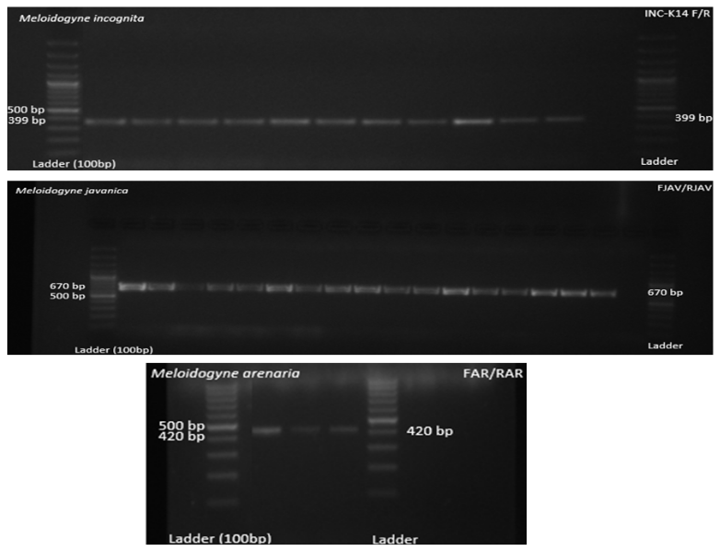
Suppl. figure 1

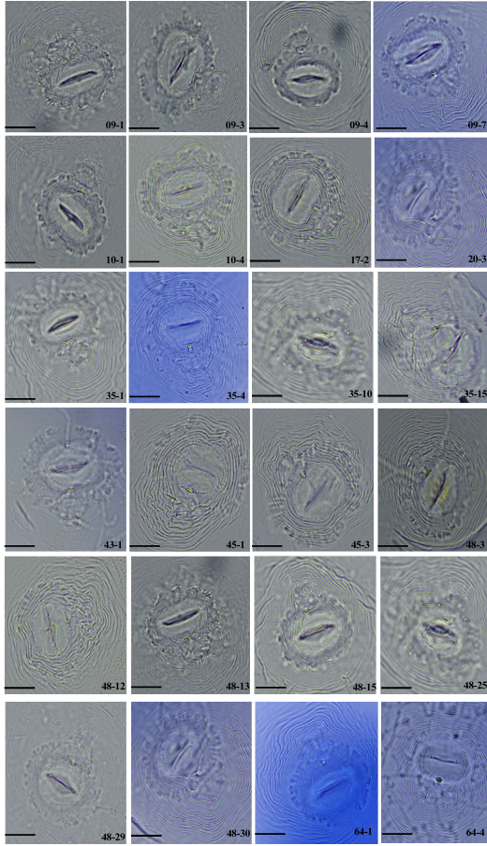
Suppl. figure 2
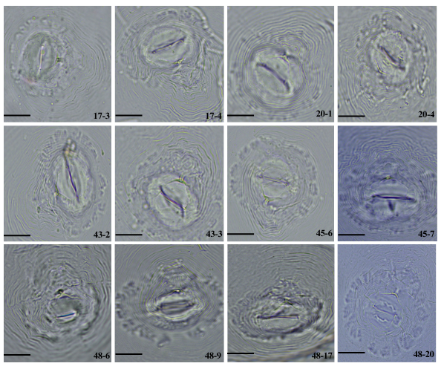
Suppl. figure 3
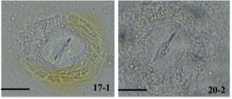
Suppl. figure 4
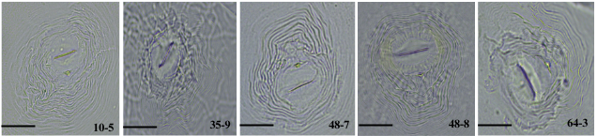
Suppl. figure 5
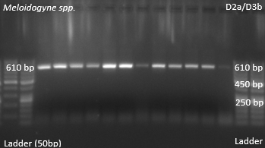
Suppl. figure 6

Suppl. figure 1: Representative band patterns of Meloidogyne incognita, M. javanica, and M. arenaria species-specific PCR products were separated on agarose gel, revealing distinct fragment sizes.
Suppl. figure 2: Perineal patterns of adult females of M. incognita populations Bar: 20 µm.
Suppl. figure 3: Perineal patterns of adult females of M. javanica populations Bar: 20 µm.
Suppl. figure 4: Perineal patterns of adult females of M. arenaria populations Bar: 20 µm.
Suppl. figure 5: Perineal patterns of adult females of M. hispanica populations Bar: 20 µm.
Suppl. figure 6: Representative band pattern of Meloidogyne spp. amplified with universal primers, showing a distinct fragment at approximately 610 bp.

