Supplementary Material

Development and Validation of a Robust Stability-Indicating Reversed Phase High Performance Liquid Chromatography (RP-HPLC) Method for Simultaneous Quantification of Brimonidine Tartrate and Timolol Maleate (Combigan®) in Bulk and Pharmaceutical Dosage Forms

Aktham Mestareehi, PharmD, MS, PhD ^{1,2}*

¹Department of Applied Pharmaceutical Sciences and Clinical Pharmacy, Faculty of Pharmacy, Isra University, P.O. Box 22, Amman 11622, Jordan

²Department of Pharmaceutical Sciences, Eugene Applebaum College of Pharmacy and Health Sciences, Wayne State University, Detroit, MI 48202, USA

Correspondence: Aktham Mestareehi, PharmD, MS, PhD*
Detroit, MI, 48201, USA
Email : aktham.mestareehi@med.wayne.edu
 https://orcid.org/0000-0002-1478-6310

Solution Preparation Procedures

Mobile phase A (Buffer pH 7.0) with 30mM TEA: to prepare one liter of 25 mM potassium phosphate monobasic solution at pH 7.0 with 30mM TEA.

Accurately weigh 3.40 grams of potassium phosphate monobasic and transfer it into a 1000 mL beaker. Add 1000 mL of deionized (DI) water and stir thoroughly until the buffer salts are fully dissolved. add 4.174 mL of TEA. Insert a calibrated pH probe into the solution and adjust the pH to 7.0 as needed. Filter the prepared buffer through a 0.45 µm membrane filter, then sonicate the solution for 20 minutes to remove any entrapped air bubbles.

Mobile phase B (100% Acetonitrile)
Transfer 1000 mL of ACN into the mobile phase reservoir and sonicate for 20 minutes to remove air bubbles.

Stock solution of Brimonidine Tartrate (1,000 ppm)
Accurately weigh 50 mg of Brimonidine Tartrate and place it into a 50 mL volumetric flask. Add approximately 40 mL of deionized water and sonicate for about 10 minutes, or until the compound fully dissolves. Carefully fill the flask to the calibration mark with deionized water and mix well to ensure complete homogenization.

Stock solution of Timolol Maleate (1,000 ppm)
Weigh precisely 50 mg of Timolol Maleate and transfer it into a 50 mL volumetric flask. Add around 40 mL of deionized water and sonicate for roughly 10 minutes or until fully dissolved. Then, top up to the volume mark with deionized water and shake gently to achieve uniform mixing.

Working standard solutions of BT (200ppm) and TM (500ppm)
Transfer 2 mL of Brimonidine Tartrate (1,000ppm) and 5 mL of Timolol Maleate (1,000ppm) into a 10 mL volumetric flask. Fill the flask to the 10 mL mark with distilled water and mix thoroughly to ensure a uniform solution.

Sample Combigan Preparation (600 ppm of BT& 1,500 ppm of TM)

Transfer 3 mL of Combigan eye drops and transfer it into a 10 mL volumetric flask. Then, fill the flask up to the 10 mL mark with distilled water, mixing thoroughly to ensure uniform dilution.

Table S1. Key Infrared (IR) Absorption Peaks of Brimonidine Tartrate, Timolol Maleate and Their Functional Group Assignments

Observed Peak (cm⁻¹) | Functional Group / Vibration | Assignment
Brimonidine Tartrate (BT)
~3198 | N–H stretching / O–H stretching | Amidine group in brimonidine and/or O–H from tartrate
~2918 | Aliphatic C–H stretching | CH₂ and CH₃ groups
~1726 | C=O stretching | Carboxylic acid groups in tartrate counterion
~1617–1500 | Aromatic C=C stretching | Quinoxaline aromatic ring in brimonidine
~1300–1000 | C–N stretching / C–O stretching | Amidine C–N and tartrate C–O groups
~900–700 | Aromatic C–H out-of-plane bending | Substituted aromatic ring
Timolol Maleate (TM)

~3320 | N–H stretching / O–H stretching | Secondary amine in timolol and/or hydroxyl group
~2984–2853 | Aliphatic C–H stretching | CH₂ and CH₃ groups inside chains
~1703 | C=O stretching | Carboxylic acid group in maleate counterion
~1639 | C=C stretching / N–H bending | Maleate double bond or amine bending
~1488–1444 | CH₂ bending / aromatic C–C stretching | Methylene groups or aromatic ring vibrations
~1300–1000 | C–N stretching / C–O stretching | Morpholine ring and other ether or alcohol linkages
~800–600 | Aromatic or alkene C–H out-of-plane bending | Substituted aromatic or alkene hydrogens

Table S2. Selection of five different C18 columns

Column # | Manufacturer | Type | Part Number | Length (mm) | Internal Diameter (mm) | Particle size (µm)
1 | Agilent Zorbax Rx | C₁₈ | 880967-902 | 250 | 4.6 | 5
2 | Agilent Zorbax SB | C₁₈ | 880975-902 | 250 | 4.6 | 5
3 | Supelco Discovery | C₁₈ | 45574-03 | 250 | 4.6 | 5
4 | Phenomenex Maxsil 5 RP-2 | C₁₈ | 006-0391-EO | 250 | 4.6 | 5
5 | Phenomenex Hyperclone BDS | C₁₈ | 00F-4420-EO | 150 | 4.6 | 5
Table S3. Summary of retention times, tailing factors, and theoretical plate numbers under different TEA concentrations using a 80:20 buffer pH 7.0: ACN mobile phase

Combigan® Ophthalmic Solution
 | Brimonidine Tartrate |  |  | Timolol Maleate
Solvent Strength (%B) | Retention Time (min) | Tailing Factor | Theoretical Plates | Retention Time (min) | Tailing Factor | Theoretical Plates
20 | 5.646 | 1.361 | 10473 | 9.960 | 1.972 | 10702
25 | 5.185 | 1.355 | 12849 | 7.143 | 1.598 | 11725
30 | 4.856 | 1.297 | 7065 | 5.894 | 1.462 | 9233

Combigan® Ophthalmic Solution
20% B | Brimonidine Tartrate |  |  | Timolol Maleate
TEA Concentration (mM) | Retention Time (min) | Tailing Factor | Theoretical Plates | Retention Time (min) | Tailing Factor | Theoretical Plates
25 | 5.185 | 1.355 | 12849 | 7.143 | 1.598 | 11725
30 | 4.116 | 1.109 | 12497 | 7.082 | 1.423 | 11320
35 | 4.103 | 1.092 | 11234 | 7.023 | 1.343 | 11132

Table S4. Comparison of the proposed RP-HPLC method with previously reported methods for the determination of Brimonidine Tartrate (BT) and Timolol Maleate (TM)

Analyte(s)  /  Reference | Mobile Phase | Column | Detection (λ, nm) | Linearity Range (µg/mL) | LOD (µg/mL)  &  LOQ (µg/mL) | Precision (%RSD) | Robustness | Forced Degradation tests | Remarks
BT & TM  / This Method 2025 | 20:80 ACN/ monobasic potassium phosphate buffer pH 7.0 with 30 mM TEA | Supelco Discovery C18, 5µm (250 x 4.6 mm) | 245 nm and 295 nm | BT (0.24-500)  TM (0.60-1250) | BT= 0.08  TM=0.20  &  BT=0.24  TM=0.60 | BT=0.549  TM=0.848 | Enhanced | Yes | Stability-indicating, robust, suitable for QC & regulatory use
BT &TM  REF 23 | ACN: 25mM phosphate buffer, pH 4.0 (50: 50, v/v) | BDS Hypersil phenyl (4.6 mm 250 mm, 5- μm) | 210 nm | BT (2.0-80.0)  TM (5.0-200.0) | BT=0.10  TM=0.21  & BT=0.29  TM=0.65 | BT=1.50  TM=1.19 | Moderate | No | Lacked-stability indication
BT& TM  REF 24 | ACN and buffer (25 ml ACN & 475 ml buffer) | C18 (25 cm X 4.6 mm, 5 µm) | 248 nm | BT (10-50)  TM (4-20) | NA | NA | Modderate | No | Lacked-stability indication
BT & TM REF 25 | borate buffer (pH 9.0) | UV-VIS spectrophotometer | 200-400nm | BT (1-40)  TM(1-60) | NA  &  NA | BT=0.20  TM=0.50 | None | No | Lacked-stability indication
BT& Tm/  REF 27 | Ammonium acetate (pH 5.0, 0.01M) - Methanol (40:60, V/V) | BDS HYPERSIL Cyano column (250x4.6 mm, 5μm) | 254 nm and 300 nm | BT (4-24)  TM(10-60) | BT=0.05  TM=0.09  & BT=0.15  TM=0.29 | BT=NA  TM=NA | Moderate | No | Lacked-stability indication

Table S5. The data from both analysts (1; Repeatability Precision 2; Intermediate Precision) for Combigan® ophthalmic solution

Combigan® Ophthalmic Solution
 | Brimonidine Tartrate |  |  | Timolol Maleate
Analyst | Average Peak Area | Standard Deviation | Peak Area %RSD | Average Peak Area | Standard Deviation | Peak Area %RSD
1 | 7239 | 63.96 | 0.884% | 10155 | 136.24 | 1.354%
2 | 7245 | 39.80 | 0.549% | 10062 | 85.28 | 0.848%

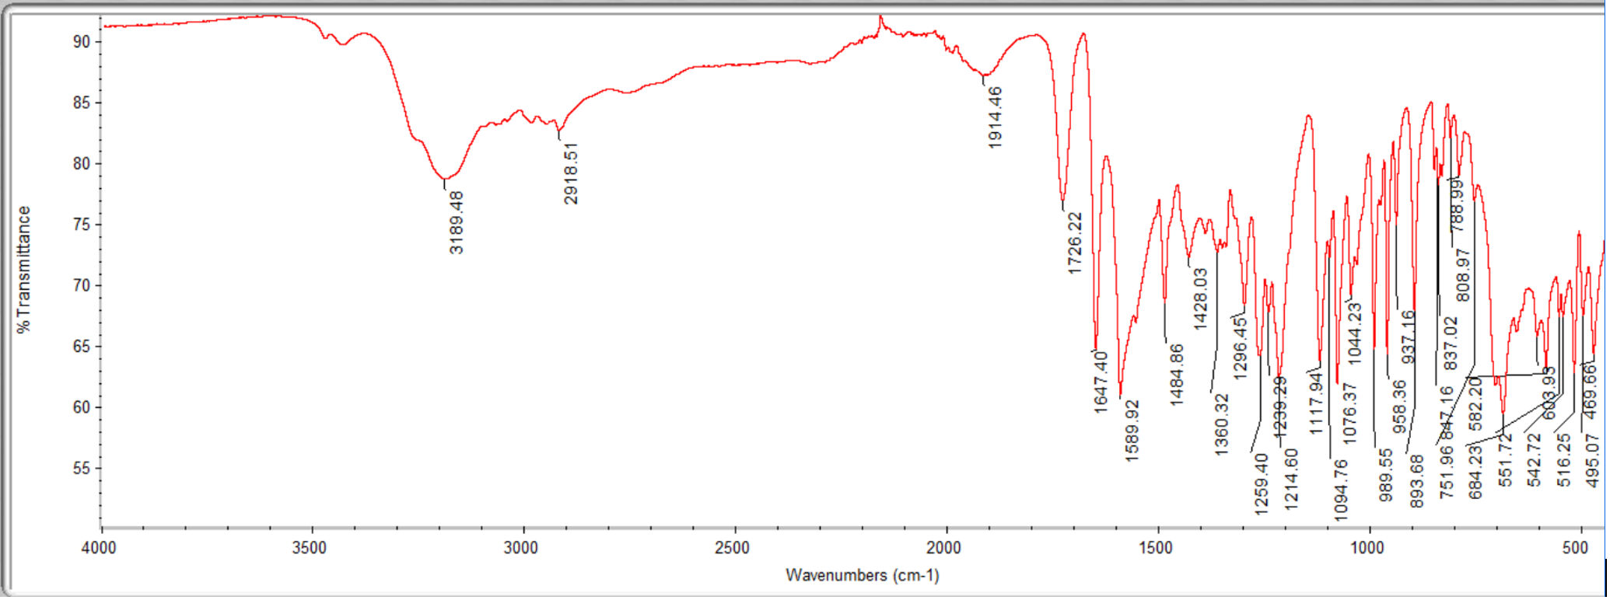
A) Brimonidine Tartrate (BT)

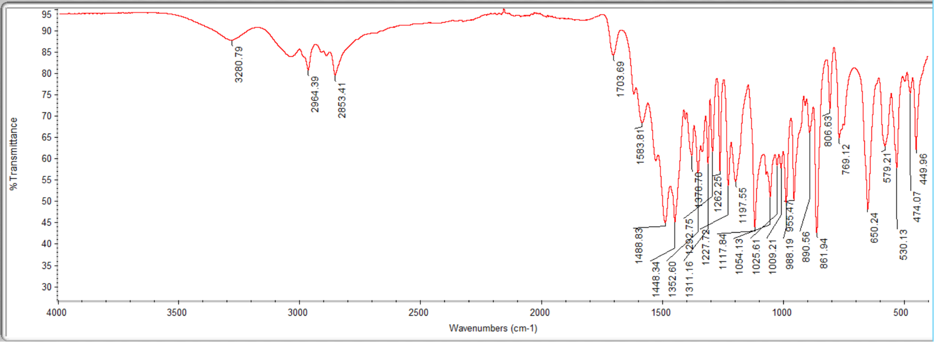
B) Timolol Maleate (TM)

Figure S1. Infrared (IR) spectrum of (A) Brimonidine Tartrate and (B) Timolol Maleate using Thermo Nicolet IR 200 Spectrometer

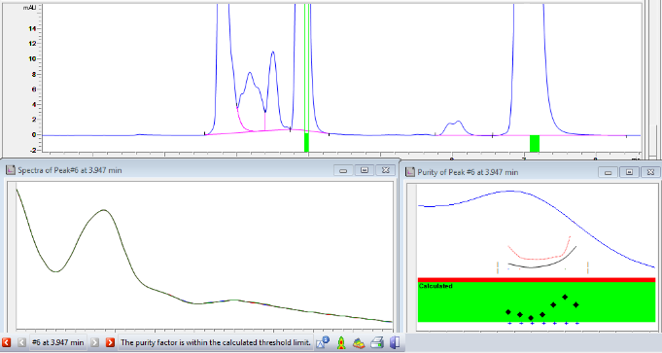  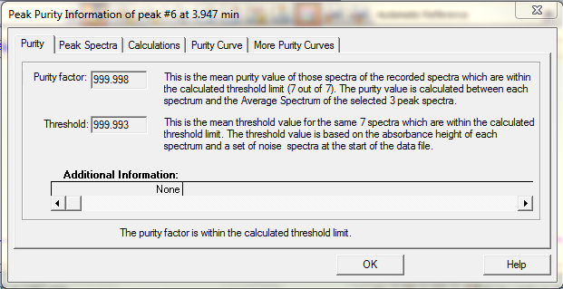 | 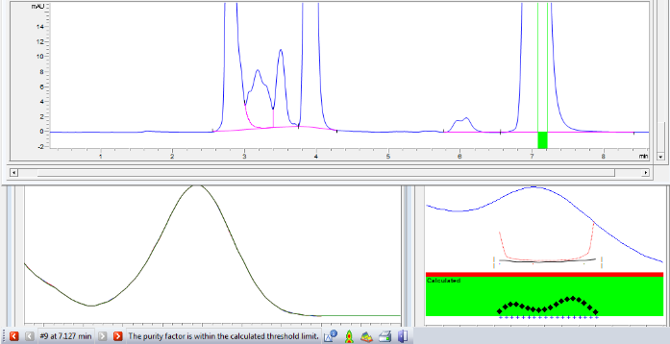  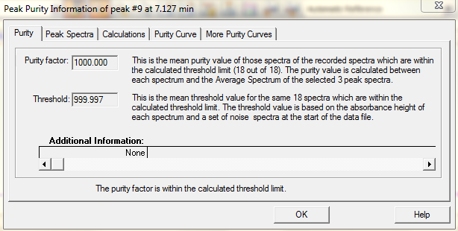

Figure S2. Peak purity information of Brimonidine Tartrate and Timolol Maleate

