Supplementary Information

Generation of continuous-wave 1-11 THz radiation with intersubband polaritonic metasurfaces
J.H. Krakofsky^{1*}, M. Rieder¹, S. Stich¹, I. Lubianskii¹, G. Böhm¹, A. Köninger¹, and M.A. Belkin^{1*}
¹ Walter Schottky Institute, Technical University of Munich, 85748 Garching, Germany.
*Corresponding authors. Emails: jonas.krakofsky@wsi.tum.de, mikhail.belkin@wsi.tum.de

- MQW heterostructure design and MQW absorption measurements
The large nonlinear response $χ_{zzz}^{\left(2\right)}$ provided by multiple quantum well (MQW) semiconductor heterostructures originates from transitions between electron states, also known as electron subbands, that are quantized along the growth direction (z-axis). The energies of the corresponding intersubband transitions and their transition dipole moments can be engineered through the MQW heterostructure design.
Two MQW heterostructures were used for the experiments presented in the paper. The first MQW heterostructure, designed to produce maximum nonlinear response for THz DFG at around 8 THz, is described in Fig. 2(b) in the paper. The second MQW heterostructure was designed to have the maximum nonlinear response for THz DFG at around 5 THz. It is made of 23 repetitions of an In_{0.53}Ga_{0.47}As/GaAs_{0.51}Sb_{0.49} heterostructure with the layer thicknesses of 8.0/4.9/3.0/5.6/5.0/8.0 where the thicknesses are given in nm, the GaAs_{0.51}Sb_{0.49} ​barriers are shown in bold, and the underlined layer is doped at a nominal electron doping density of 3.3×10¹⁸ cm⁻³. The conduction band diagram and the computed electron wavefunctions for one period of this second heterostructure are shown in Fig. S1(a).
Both heterostructures were grown on semi-insulating InP substrates. The complete layer structure of the two grown wafers, including sacrificial etch-stop layers for substrate removal and contact layers to mitigate conduction band bending next to metal layers, is given below:
  - 350 µm semi-insulating InP substrate
  - 1500 nm In_{0.53}Ga_{0.47}As (etch stop 1)
  - 200 nm InP (etch stop 2)
  - 15 nm In_{0.53}Ga_{0.47}As nominally doped to $1×{10}^{19}\text{c}{\text{m}}^{\text{-3}}$ (contact layer)
  - MQW heterostructure
  - 5 nm In_{0.53}Ga_{0.47}As layer nominally doped to $1×{10}^{19}\text{c}{\text{m}}^{\text{-3}}$ (contact layer)
Following the heterostructure growth, absorption measurements were performed to confirm the designed energy levels spacing and to deduce the mid-infrared intersubband transition linewidths that are used in the calculations of $χ_{zzz}^{\left(2\right)}$. To that end, we cleaved wafer pieces of about 1x1 cm² in size, deposited metal Ti (5 nm)/Pt (10 nm)/Au (300 nm) on the top layer of the wafer, and mechanically polished the wafer facets into 45° wedges. Absorption spectroscopy of z-polarized intersubband transitions was then performed by coupling s- and p-polarized light through the polished facets at approximately 45° angle to the MQW layers as described, e.g., in Refs. [24,28,29]. The intersubband absorption coefficient $α_{\text{MQW}}$ is extracted by relating the transmitted intensities of p- and s-polarized light, $I_{p}$and $I_{s}$using the following expression [24,28,29]:
$$α_{\text{MQW}}=\frac{1}{4\sqrt{2}h_{\text{MQW}}n_{p}}\ln\left(\frac{I_{p}}{I_{s}}\right)$$ | (S1)
Here, $h_{\text{MQW}}$ ​ is the total height of the MQW stack and $n_{p}$​ is the number of passes of the optical beam through the MQW stack when the light is bouncing through the wafer sample [24,28,29].
The measured absorption spectra are shown in Fig. S1(b), together with the results of the fitting. By fitting the measurement results, we extracted the transition energies and transition linewidths for the mid-infrared transitions 1-0 and 2-0 (cf. Fig. 2(b) or Fig. S1(a)). A summary of the simulated and experimentally-measured transition energies (ℏω₁₀, ℏω₂₀, and ℏω₂₁), transition dipole moments (ez₁₀, ez₂₀, and ez₂₁), and transition linewidths (γ₁₀ and γ₂₀) for the transitions between the ground and the first two excited electron states in the two MQW heterostructures are provided in Table S1. Also included in the table are the estimated transition linewidths for THz transitions between states 1 and 2 (γ₂₁), the estimated $γ_{ii}$values ($γ_{ii}=\frac{ℏ}{T_{i}},$ where T_{i} is the electron lifetime in state i) and the computed differences in the permanent dipole moments (ez₀₀, ez₁₁, and ez₂₂) of the three electron subbands.
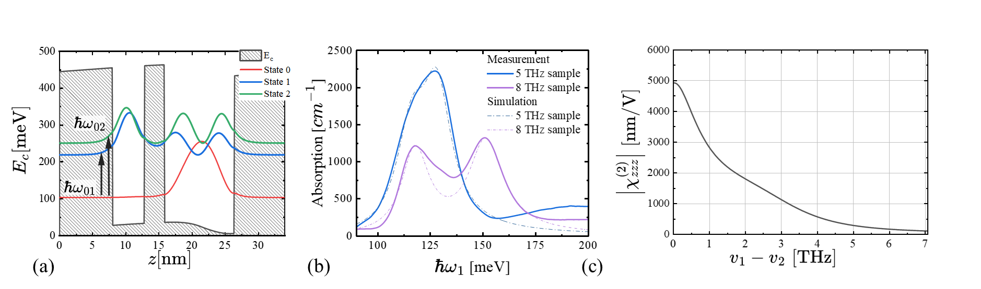
Figure S1. Design and characterization of the MQW structure. (a) Conduction band diagram and computed electron wavefunctions for one period of an In_{0.53}Ga_{0.47}As/GaAs_{0.51}Sb_{0.49} multi-quantum-well heterostructure designed for giant nonlinear response maximized for 5 THz DFG. (b) 45° wedged absorption measurements of the intersubband transitions in the MQW samples designed for the maximum DFG nonlinearity for 8 THz generation and 5 THz generation. The energies of mid-infrared transitions and transition linewidths obtained from the fit are given in Table S1. (c) Computed absolute value of the intersubband nonlinear susceptibility $|χ_{zzz}^{\left(2\right)}|$ of the heterostructure shown in panel (a) as a function of THz difference frequency. Calculations assume a fixed pump 2 frequency ν₂=28 THz and a tunable pump 1 frequency ν₁=28-40 THz.

Transition parameters | Sample 5 THz | Sample 9 THz
$$ℏω_{10}$$  $$ℏω_{20}$$  $$ℏω_{21}$$ | 116 meV (e), 116.1 meV (c)  128 meV (e), 128.0 meV (c)  12 meV(e), 11.9 meV (c) | 117.5 meV (e), 117.6 meV (c)  150.5 meV (e), 150.3 meV (c)  43 meV (e), 35.7 meV (c)
$$z_{10}$$  $$z_{20}$$  $$z_{21}$$ | 1.45 nm (e), 1.52 nm (c)  1.5 nm (e), 1.65 nm (c)  4.7 nm (c) | 1.73 nm (e), 1.72 nm (c)  1.69 nm (e),1.70 nm (c)  4.9 nm (c)
$$γ_{10}$$  $$γ_{20}$$  $$γ_{21}$$ | 9.5 meV (e)  8.5 meV (e)  5 meV (estimate) | 9 meV (e)  10 meV (e)  5 meV (estimate)
$$z_{00}-z_{11}$$  $${z_{00}-z}_{22}$$  $${z_{11}-z}_{22}$$ | 6.38 nm (c)  5.35 nm (c)  1.03 nm (c) | 4.71 nm (c)  4.55 nm (c)  0.16 nm (c)
$$γ_{11},γ_{22}$$ | 2 meV (estimate) | 2 meV (estimate)
Table S1. Intersubband parameters. The parameters marked with (e) are the experimentally measured values, the parameters marked with (c) are the values obtained from our 8-band $k⋅p$bandstructure computations; the parameters marked with (estimate) are estimates taken from literature values reporting similar MQW systems, particularly from Ref. [29].
- Calcination of $χ_{zzz}^{\left(2\right)}$
The nonlinear susceptibility for difference-frequency generation (DFG) associated with intersubband transitions under z-polarized excitation is given by the sum-over-states expression [29,32]:
$$χ_{zzz}^{\left(2\right)}\left(ω_{THz}=ω_{1}-ω_{2} ,ω_{1},ω_{2}\right)=\frac{N_{e}}{2ε_{0}ℏ} \sum_{lmn}{ρ_{ll}}z_{ln}{ z}_{nm} z_{ml}\left\{\frac{1}{\left(E_{nl}-ℏω_{THz}-iγ_{nl}\right)\left(E_{ml}-ℏω_{1}-iγ_{ml}\right) }+\frac{1}{\left(E_{nl}-ℏω_{THz}-iγ_{nl}\right)\left(E_{ml}+{ℏω}_{2}-iγ_{ml}\right)}+\frac{1}{\left(E_{mn}-ℏω_{THz}-iγ_{mn}\right)\left(E_{nl}+ℏω_{1}+iγ_{nl}\right)}+\frac{1}{\left(E_{mn}-ℏω_{THz}-iγ_{mn}\right)\left(E_{nl}-{ℏω}_{2}+iγ_{nl}\right)}+\frac{1}{\left(E_{nm}+ℏω_{THz}+iγ_{nm}\right)\left(E_{ml}-ℏω_{1}-iγ_{ml}\right)}+\frac{1}{\left(E_{nm}+ℏω_{THz}+iγ_{nm}\right)\left(E_{ml}+{ℏω}_{2}-iγ_{ml}\right)}+\frac{1}{\left(E_{ml}+ℏω_{THz}+iγ_{ml}\right)\left(E_{nl}+ℏω_{1}+iγ_{nl}\right)}+\frac{1}{\left(E_{ml}+ℏω_{THz}+iγ_{ml}\right)\left(E_{nl}-{ℏω}_{2}+iγ_{nl}\right)}\right\}$$ | $$A_{lmn}$$  $$B_{lmn}$$  $$C_{lmn}$$  $$D_{lmn}$$  $$E_{lmn}$$  $$F_{lmn}$$  $$G_{lmn}$$  $$H_{lmn}$$ |  | (S2)
Here, N_{e} is the average MQW bulk doping density, $ρ_{ll}$ is the occupation probability of state $\left|l\right\rangle$,${ez}_{ij}$ are the dipole matrix elements$,E_{ij}≡ℏω_{ij}=E_{i}-E_{j}$ are the transition energies, and $γ_{ij}$ are the corresponding dephasing rates. The eight terms in Eq. (S2) represent eight distinct resonance pathways contributing to the second-order nonlinear susceptibility obtained through second-order perturbation theory [32].
When applying Eq. (S2) to our system, the terms in Eq. (S2) can be grouped into a doubly resonant (DR) part and an optical rectification (OR) part [29]: $χ_{zzz}^{\left(2\right)}=χ_{zzz,DR}^{\left(2\right)}+χ_{zzz,OR}^{\left(2\right)}$ [30]. The DR term is maximized when the pump frequencies$ω_{1}$ and $ω_{2}$ are tuned to match the transitions $\left|0\right\rangle →\left|1\right\rangle$ and $\left|0\right\rangle →\left|2\right\rangle , respictively,leading to a peak in nonlinear response at ℏω_{\text{THz}}=E_{21}$.
$$χ_{zzz,DR}^{\left(2\right)}\left(ω_{THz},ω_{1},ω_{2}\right)={(D}_{021}+A_{102})+\left(E_{021}+G_{210}\right)=\frac{z_{02}z_{21}z_{10}}{2ε_{0}ℏ}N_{e}\left[\frac{ρ_{00}-ρ_{11}}{\left(E_{21}-ℏω_{THz}-iγ_{21}\right)\left(E_{10}-ℏω_{2}-iγ_{10}\right)}+\frac{ρ_{00}-ρ_{22}}{\left(ℏω_{THz}-E_{21}-iγ_{21}\right)\left(E_{20}-ℏω_{1}-iγ_{20}\right)} \right]$$ | (S3)
In addition to the DR term, the nonlinear susceptibility for difference-frequency generation also includes the OR term, which becomes significant in the low-frequency limit, i.e., as $ω_{1}-ω_{2}→0.$
$$χ_{zzz,OR}^{\left(2\right)}\left(ω_{THz},ω_{1},ω_{2}\right)=\left(\left(D_{011}+E_{011}+{B_{101}+ G}_{110}){+(H}_{001}+A_{020}+C_{100}+F_{100}\right)\right)+\left({(D_{022}+E}_{022}+B_{202}+G_{220})+{(H}_{002}+A_{020}+C_{200}+F_{200})\right) =\frac{1}{2ε_{0}ℏ}N_{e}\left\{\left(ρ_{00}-ρ_{11}\right)⋅ \frac{z_{01}^{2}\left(z_{00}-z_{11}\right)\left(ℏω_{THz}+2iγ_{20}\right)}{\left(ℏω_{THz}+iγ\right)\left(E_{10}-ℏω_{2}-iγ_{10}\right)\left(ℏω_{1}-E_{10}-iγ_{20}\right)} +\left(ρ_{00}-ρ_{22}\right) \frac{z_{02}^{2}\left(z_{00}-z_{22}\right)\left(ℏω_{THz}+2iγ_{20}\right)}{\left(ℏω_{THz}+iγ\right)\left(E_{20}-ℏω_{1}-iγ_{20}\right)\left(ℏω_{2}-E_{20}-iγ_{20}\right)} \right\}$$ | (S4)
Here, $z_{ii}=\left\langle i\left|\hat{z}\right|i\right\rangle$ denotes the position expectation value of an electron in state i and $γ_{ii}=\frac{1}{T_{i}}≈γ$is a common average intersubband relaxation time [30]. While $χ_{zzz,OR}^{\left(2\right)}$ dominates around ${ℏω}_{THz}≪ E_{21}$ the doubly resonant $χ_{zzz,DR}^{\left(2\right)}$ maximizes for $ℏω_{THz}=E_{12}.$
Our two MQW systems are designed to maximize the value of $|χ_{zzz}^{\left(2\right)}|$ for THz DFG at 8 THz and 5 THz for the mid-infrared pump frequencies tunable between 28 and 40 THz as described in the paper. The computed value of $\left|χ_{zzz}^{\left(2\right)}\right|=|χ_{zzz,DR}^{\left(2\right)}+χ_{zzz,OR}^{\left(2\right)}|$ for the MQW structure shown in Fig. 2(b) is given in Fig. 2(c). The value of $|χ_{zzz}^{\left(2\right)}|$ for THz DFG for the MQW structure shown in Fig. S1(b) is given in Fig. S1(c).
- Linear permittivity of the MQW
The values of MQW dielectric permittivity tensor $ε_{ij}\left(ω\right)$ at mid-infrared and THz frequencies are required for the metasurface nanoresonator design and for the calculations of the overlap integral (Eq. (1) in the main text). We model the MQW permittivity as a diagonal tensor, with each principal component expressed as the sum of three distinct physical contributions as outlined below.
For the diagonal components of the $ε_{ij}\left(ω\right)$ tensor in the plane of MQW layers ($ε_{xx}=ε_{yy}$), we write:
$ε_{xx}\left(ω\right)=ε_{yy}\left(ω\right)=ε_{∞}+ε_{FC}\left(ω\right)+ε_{ph}\left(ω\right)$, | (S5)
where $ε_{∞}≈11.8$ is a constant value corresponding to the dielectric permittivity of the MQW sample excluding free electron and optical phonon contributions, $ε_{FC}$ is the free carrier contribution (FC), $ε_{ph}\left(ω\right)$ is the optical phonon contribution.
We describe $ε_{FC}$with the Drude model:
$ε_{FC}\left(ω\right)=-\frac{ε_{∞}⋅ω_{p}^{2}}{ω^{2}+iωγ_{p}}$, | (S6)
where $ω_{p}$​ is the plasma frequency of the semiconductor material, given by: $ω_{p}=\sqrt{\frac{N_{e}e^{2}}{ε_{0}ε_{∞}m^{*}}}$, where $N_{e}$ is the charge carrier density, $m^{*}=0.044×m_{e}$ is the reduced effective electron mass, and the average charge carrier scattering rate is taken as $γ_{p}= 5 THz.$
The phonon-photon interaction is described by the sum over all binary combinations GaAs, GaSb, and InAs as given by Ref. [30,31,34]:
$$ε_{ph\left(ω\right)}=-\sum_{b}{\frac{ε_{Δ,b}⋅ω_{\text{TO,b}}^{2}}{ω^{2}-ω_{\text{TO,b}}^{2}+iωγ_{b}}}$$ | (S7)
Here, $ω_{\text{TO,b}}$, is the transverse optical phonon resonance frequency of the binary compound $b$, $ε_{Δ,b}=ε_{b}\left(∞\right)-ε_{b}(0)$ is the phonon strength, and $γ_{b}$is the linewidth of the phonon absorption peak. The corresponding material parameters were obtained from Ref. [30,31,34]. All the linewidths $γ_{b}$were set to $0.45×{10}^{12} \text{rad/s}$ to produce the best match to the experimental results.
The intersubband contribution $ε_{\text{isb}}\left(ω\right)$is only present in the $z$ direction and it replaces the FC contribution: $ε_{zz}\left(ω\right)=ε_{∞}+ε_{isb}\left(ω\right)+ε_{ph}\left(ω\right)$, where
$ε_{\text{isb}}\left(ω\right)=\frac{N_{e}}{ε_{0}}\sum_{i,j}{{(ρ_{ii}-ρ}_{jj})\frac{{e^{2}z}_{ij}^{2}}{E_{ji}-ℏω-iγ_{ji}}}$. | (S8)
Here, $N_{e}$ denotes the average volume-doping density, $ρ_{ii}$is the diagonal element of the density matrix corresponding to state $|i⟩$. The values of $z_{ij}$, $E_{ij}$ and $γ_{ij}$ are given in Table S1.

- Nanoresonator design of the metasurface optimized for 5 THz DFG
Our metasurface nanoresonators are engineered to maximize the nonlinear overlap integral defined in Eq. (1). Because the intersubband transitions in MQW heterostructures are polarized in the $z$-direction fields, the resonator must convert the incident $x-$ or $y$- polarized pump light into a strong, localized $E_{z}$ field (see, e.g., Fig. 3(a)). The H-shaped nanoresonator design described in the paper achieves this by supporting three distinct resonator modes – two modes resonant with each of the two pump wavelengths and a third mode resonant at the output THz frequency. The two mid-infrared resonator modes have a relative π-phase reversal of $E_{z}$ in one end of the nanoresonator as shown in Fig. 3(a). This sign flip boosts the overlap integral because it produces a corresponding sign change in the induced THz nonlinear polarization along the THz nanoresonator antenna. At lower THz frequencies, the two mid-infrared pump wavelengths move closer together, making it increasingly difficult to implement a nanoresonator with separate resonances at the two pump frequencies. Therefore, for the metasurface optimized for THz DFG in the 4-6 THz spectral range, we use a Y-shaped nanoresonator that employs a single resonant mode to couple both mid-infrared pumps to the intersubband transitions in the MQW heterostructure.
The Y-shaped nanoresonator design details are given in Fig. S2(a,b,c) and details are given in the figure captions. To obtain the broad tunability, the resonator was designed with an internal angle at the top of the “Y” of 160°, which broadens its mid-infrared resonance.
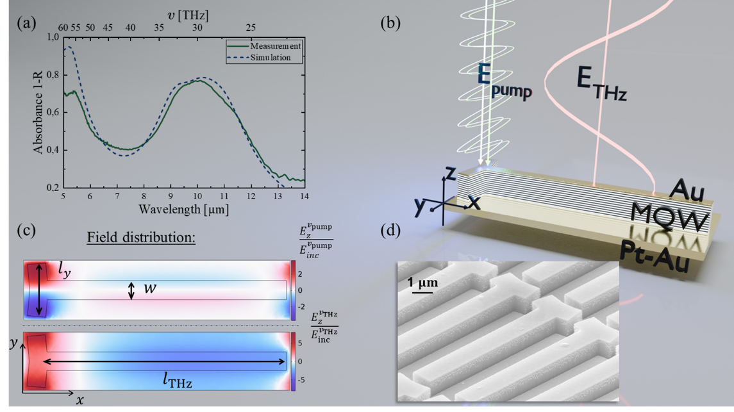
Figure S2. Metasurface optimized for DFG at 4-6 THz. (a) Measured and simulated mid-infrared reflection spectra of the metasurface, displaying a broad mid-infrared resonance peak centered at around 10 μm. (b) Schematic of the Y-shaped resonator design used for the metasurface, indicating the pump polarization along the y-axis and the THz polarization along the x-axis. The coordinate system is given in the figure. (c) Simulated electric field distribution at half the MQW height for the pump mode (the image is for $v_{pump}= 32 THz$) and the resulting THz mode ($the image is for v_{THz}=4.5 \text{THz}$). The nanoresonator dimensions are $l_{y}=2442 nm, w=1100 nm, l_{THz}=9901 nm$. (d) Scanning electron microscope image of the fabricated metasurface.

The Y-shape metasurface was patterned into 81 individual patterns, each measuring 350µm by 350 µm. Within this matrix we systematically varied both $l_{\text{THz}}$ and $l_{y}$ (cf. Fig.S2(c)). The highest conversion efficiency was achieved for $l_{THz}=9900 \text{nm}$ and $l_{y}=2440 \text{µm}$ which is in excellent agreement with our COMSOL Multiphysics simulation-based optimization predictions.

- Metasurface fabrication
Following the wafer growth, a metallic tri-layer made of Ti (5 nm) / Pt (80 nm) / Au (500 nm) is evaporated on both the grown MQW wafer and the host InP wafer. The sample and the host wafers are then placed on top of one another with metallized surfaces facing each other and thermocompressively bonded together at 320º C. Following the thermocompressive bonding, the substrate of the bonded MQW wafer is selectively removed in concentrated HCl. The first etch-stop layer is then stripped in an H₃PO₄ / H₂O₂ solution, and the second etch-stop layer is removed in a 1:1 HCl:H₂O bath.
Nanoresonators are then patterned by electron-beam lithography (Elionix ELS-BODEN 100). A SiN hard mask is defined by fluorine/oxygen ICP-RIE (Oxford PlasmaPro 100), and the MQW nanoresonators are then etched with a Cl₂/Ar/H₂ ICP-RIE. The hard mask is subsequently stripped in a second F/O₂ ICP-RIE step.
Finally, the top metal is deposited on top of the nanoresonators by electron-beam evaporation of a Ti (5 nm) / Pt (10 nm) / Au (35 nm) tri-layer. A large source-to-sample distance is used to minimize sidewall metallization. Scanning electron pictures (SEM) of processed metasurfaces are shown in Fig. 4(a) and Fig S2(d).

- Collection efficiency of the presented setup configuration.
The details of the measurement setup are shown in Fig. S3(a). To relate the THz power measured at the detector to the power generated at the metasurface, we used an analytical model that treats the metasurface as an infinitesimally thin nonlinear layer. This approximation yields closed-form expressions for the THz far field, enabling us to calculate the mirror-system collection efficiency $η_{\text{coll}}$ and thus recover the THz power at the sample.
$$η_{coll}=W_{THz}^{Detector}/W_{THz}^{Sample}$$ | (S9)
The far-field profile of the THz radiation is determined by the focal-spot sizes of the two mid-infrared pump beams, which are treated as Gaussian. Knife-edge measurements yielded the $1/e²$ radii $w_{1}^{ }$ ​ and $w_{2}^{ }$​ for the two mid-infrared pump lasers. Because the nonlinear signal is proportional to the product of the two optical fields, the generated THz beam can also be approximated as Gaussian, with a waist
$$w_{THz}^{ }={\left({\left(w_{1}^{ }\right)}^{-2}+{\left(w_{2}^{ }\right)}^{-2}\right)}^{-1/2}.$$ | (10)
In our setup, $w_{1}=45 \text{µm}$ and $w_{2}=60 \text{µm}$, giving $w_{THz}^{ }≈36 μm$.
We then treat the metasurface output as Fraunhofer diffraction from a Gaussian aperture of 1/e² radius of $w_{THz}^{ }$​. In this formalism, the polar angle dependence of the intensity of the emitted THz radiation is given as
$$I\left(θ\right)∝{\left|E\left(θ\right)\right|}^{2}∝\exp\left(-2\frac{π^{2}w_{0}^{2}}{λ^{2}}\sin^{2}{θ}\right)$$ | (S11)

The collection efficiency $η_{ }$ of a 90° off-axis parabolic mirror (OAP) used for THz radiation collimation is obtained as:
$$η=\frac{\int_{0}^{β}{I\left(θ\right)sinθ dθ}}{\int_{0}^{π/2}{I\left(θ\right)sinθ dθ}}$$ | (12)
Our setup uses a 1.5-inch-diameter 0.8-inch focal length OAP, with the sample placed in the mirror focus (see fig. S3(a)). The mirror has a central through hole of 3 mm in diameter for focus in the mid-infrared pump beams. The power lost through the aperture of the hole is evaluated with a similar expression using Eq. (S11).
The net collection efficiency is calculated with the measured Gaussian-beam focal radii of our pump lasers is plotted in Fig. S3(b). For comparison, the collection efficiency corresponding to the use of the same OAP without a central through hole is also shown to highlight the fraction of power lost through the central hole.
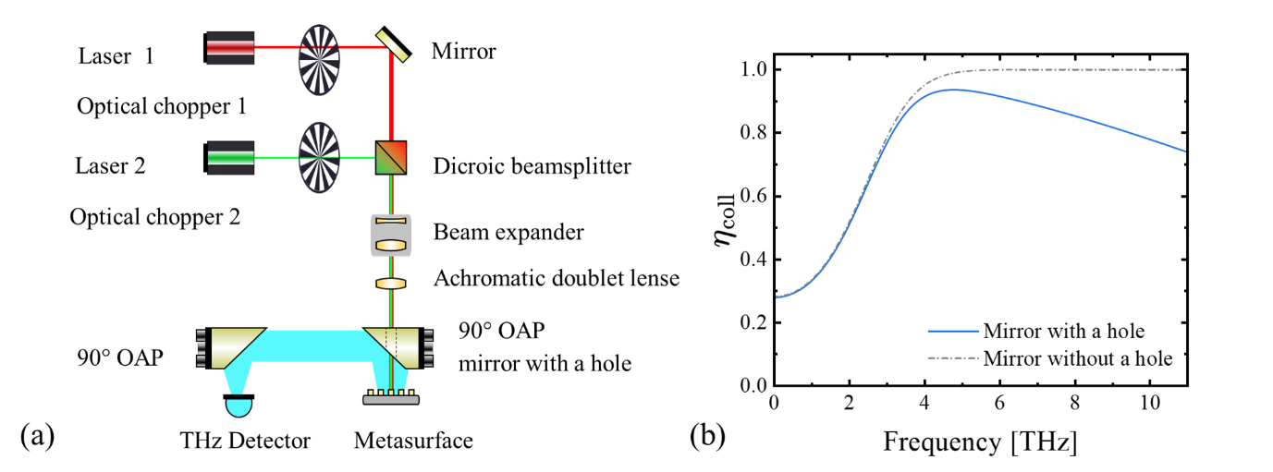
Figure S3. Experimental setup and estimates of THz collection efficiency. (a) Laser 1 (Daylight Solutions MIRcat) and Laser 2 (Access Lasers L4-GL) are combined with a dichroic mirror (Spectrogon LP 10000) and expanded five-fold by a custom ZnSe Galilean beam expander (f₁ = 15 mm, f₂ = 75 mm). The expanded beam is focused onto the metasurface with an achromatic doublet lens through the 3 mm central bore in a 1.5-inch-diameter off-axis parabolic mirror (OAP, f = 0.8 in). The emitted THz radiation is collimated by the same OAP and is then refocused with another OAP without a hole onto a THz detector. (b) Calculated collection efficiency of the OAP next to the sample as a function of THz frequency. The solid curve describes our experimental conditions, the dashed curve shows the collection efficiency of the OAP with the same numerical aperture but without the central hole. A comparison of the two curves highlights the amount of THz power lost through the mirror center hole.

