Table S1 Population structures of seven survey sites
Tree height (m) | Individual number
Tree height (m) | ND | JH | LP | TD | JZ | TBC | CB
0~1.3 | 13 | 529 | 0 | 1 | 36 | 53 | 0
1.3~2.5 | 17 | 276 | 0 | 17 | 5 | 28 | 0
2.5~5 | 8 | 148 | 0 | 1 | 0 | 4 | 0
>5 | 12 | 67 | 1 | 8 | 4 | 1 | 10
JH, LP, ND, TBC, JZ, TD, and CB refer to the Jianhe, Liping, Nandan, Tangbaocun, Jingzhou, Tongdao, and Chengbu populations, respectively.

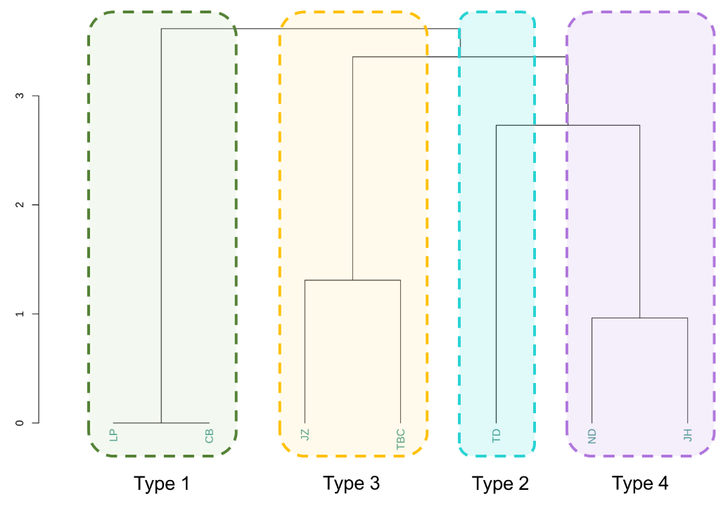
Figure S1 Clustering analysis based on the Ormosia microphylla population age structure. In the picture, JH, LP, ND, TBC, JZ, TD, and CB refer to the Jianhe, Liping, Nandan, Tangbaocun, Jingzhou, Tongdao, and Chengbu populations, respectively.

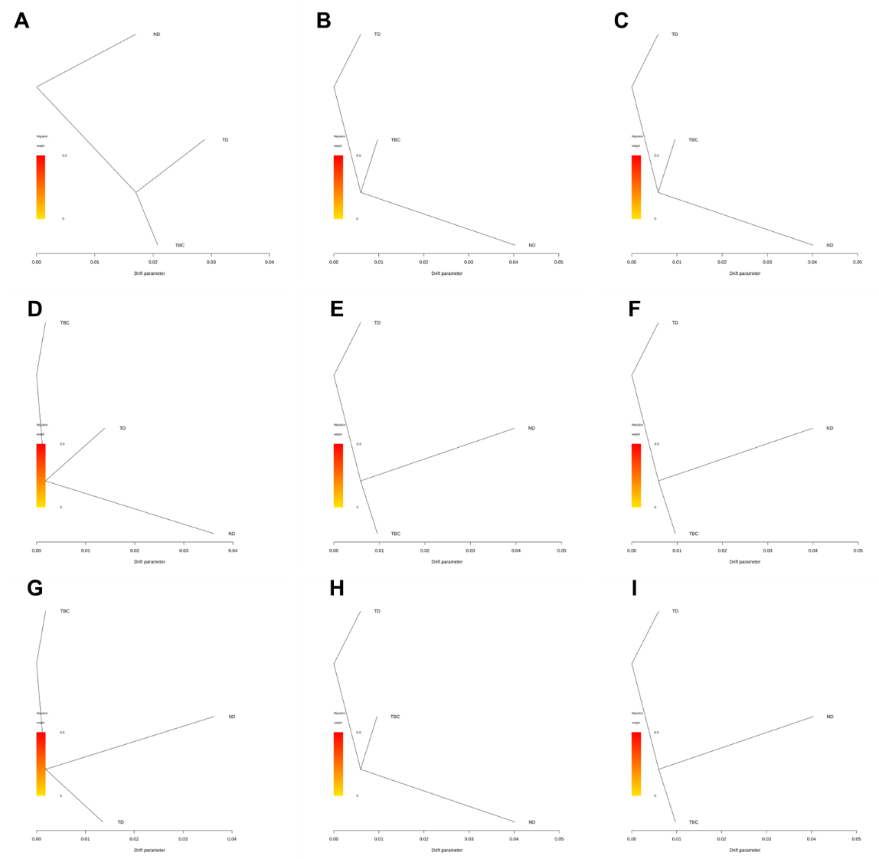
Figure S2 Gene flow between the GX, HG, and HN genetic clusters of Ormosia microphylla.

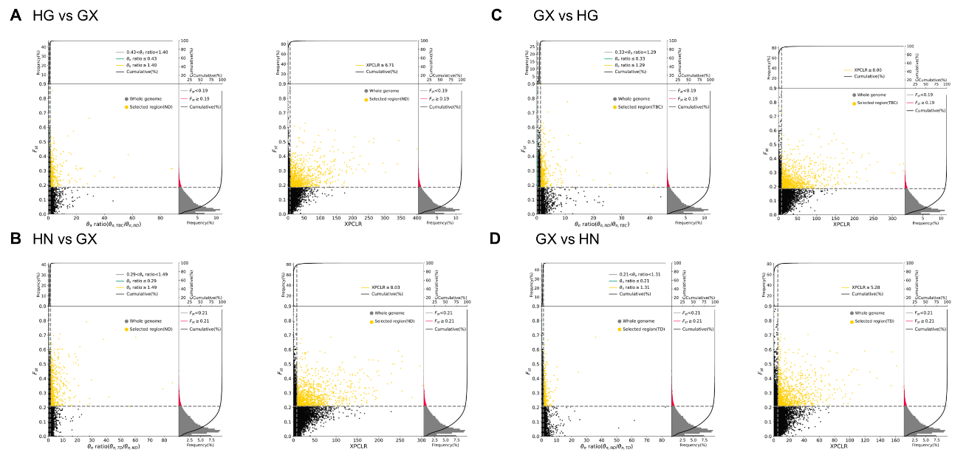
Figure S3 Genomic regions with selective sweep. Screening of selected genes using HG (A) and HN (B) populations, respectively, with the GX population as the background population; Screening of selected genes using the GX population, respectively, with HG (C) and HN (D) populations.

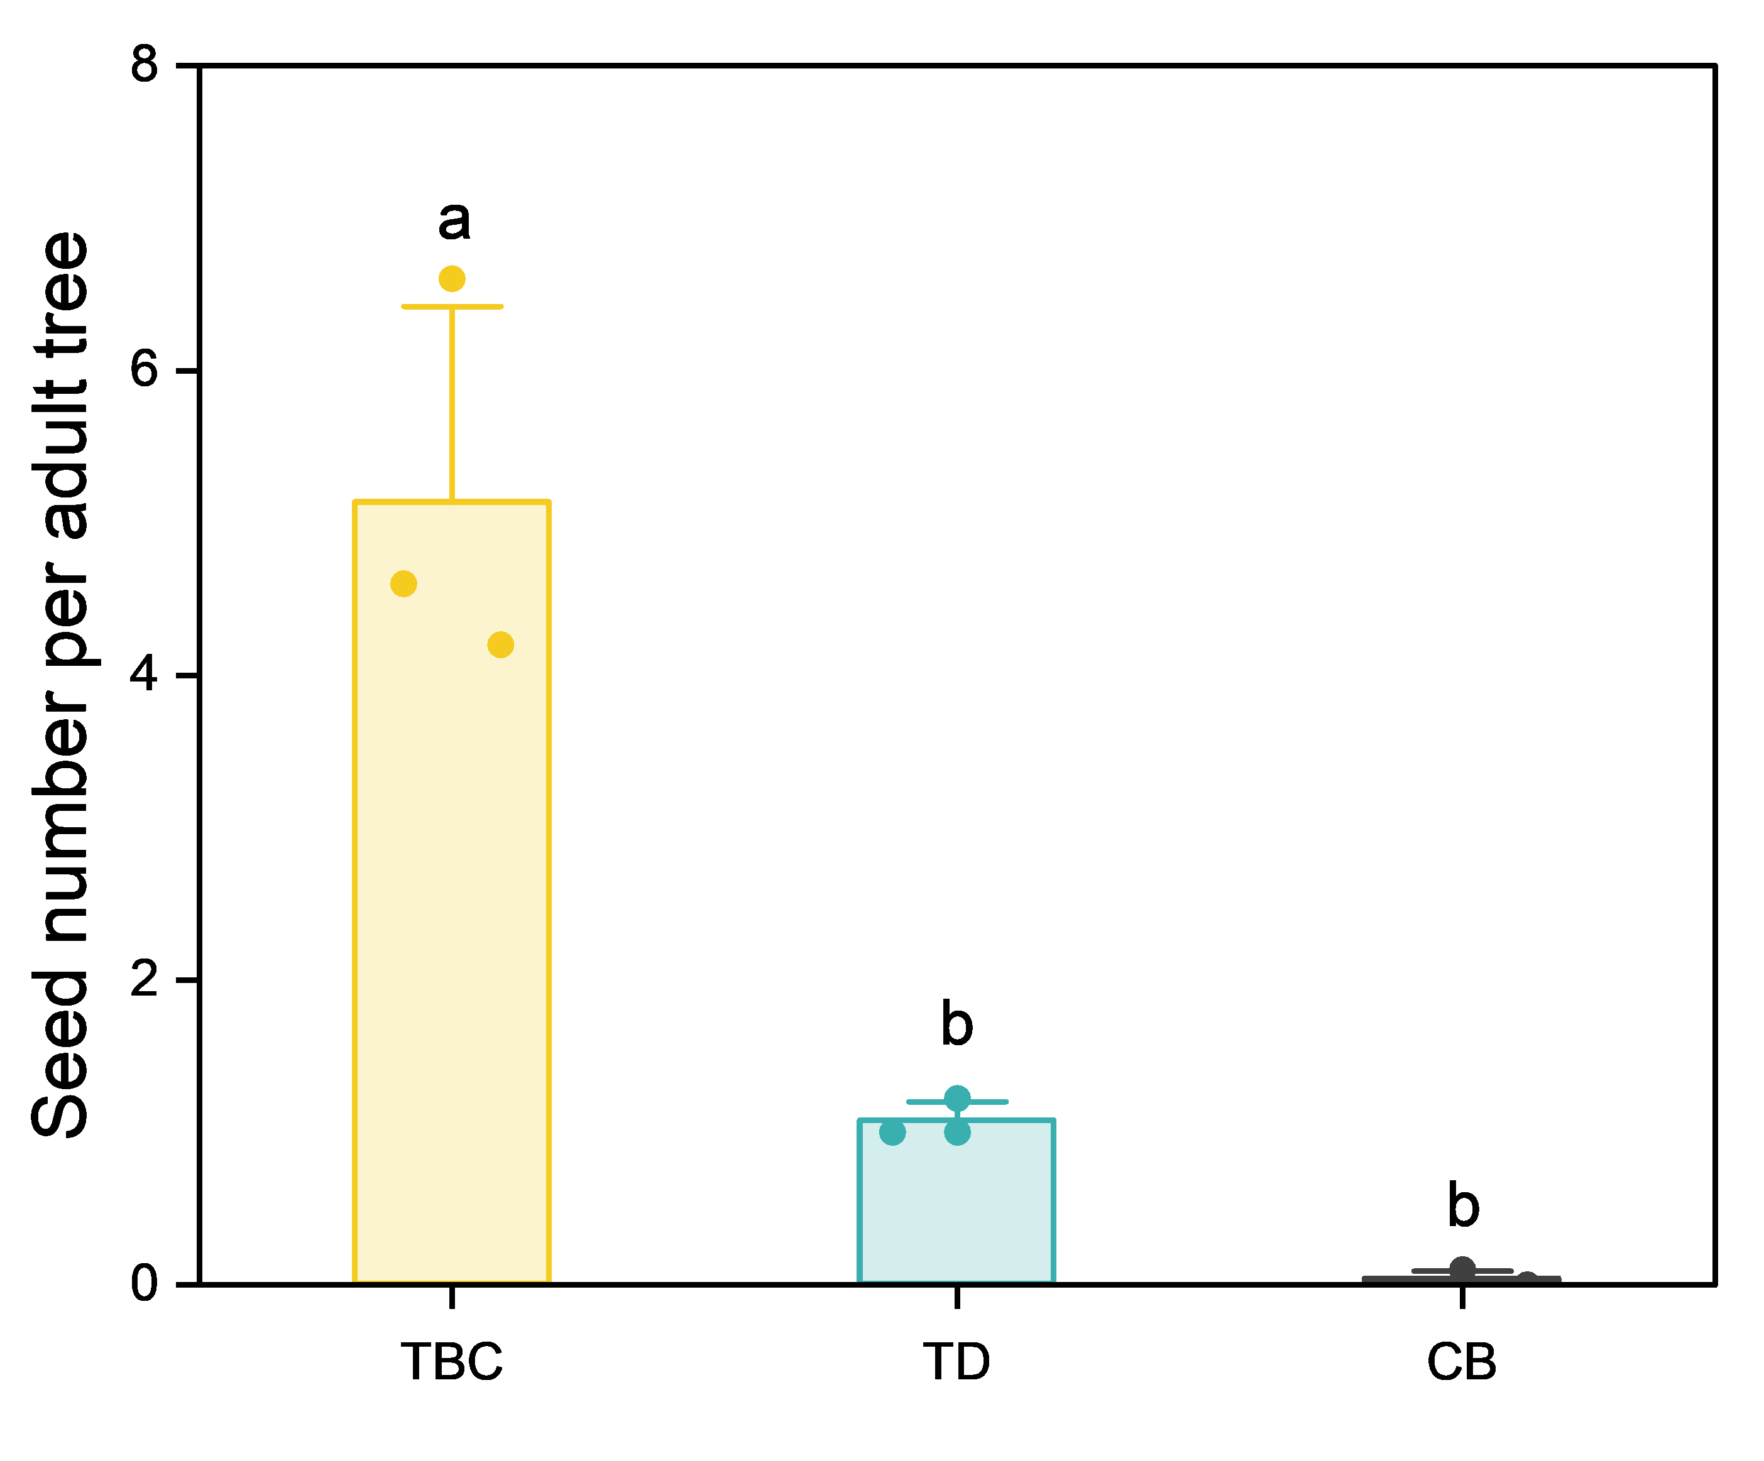
Figure S4 Seed number of a single Ormosia microphylla adult and old tree (with heights > 2.5 m) individual. TD, CB, and TBC refer to the Tongdao, Chengbu, and Tangbaocun populations, respectively. Different letters represent significant differences at p<0.05.

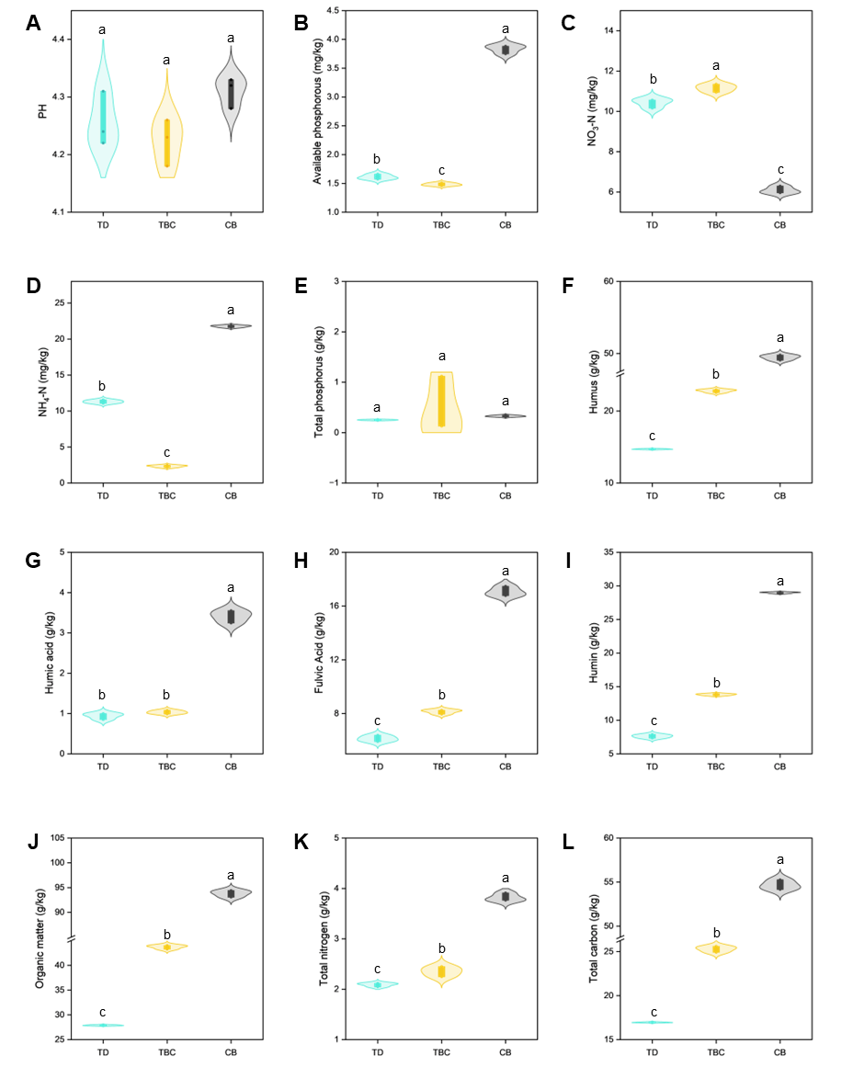
Figure S5 Soil nutrient composition of representative Ormosia microphylla populations. TD, CB, and TBC refer to the Tongdao, Chengbu, and Tangbaocun populations, respectively. Different letters represent significant differences at p<0.05.

Table S2 Investigated bird species.
Order | Family | Species
Galliformes | Phasianidae | Bambusicola thoracica
Galliformes | Phasianidae | Lophura nycthemera
Podicipediformes | Podicipedidae | Tachybaptus ruficollis
Columbiformes | Columbidae | Streptopelia orientalis
Columbiformes | Columbidae | Streptopelia chinensis
Pelecaniformes | Ardeidae | Ardeola bacchus
Piciformes | Capitonidae | Psilopogon faber
Piciformes | Picidae | Blythipicus pyrrhotis
Passeriformes | Vireonidae | Erpornis zantholeuca
Passeriformes | Campephagidae | Pericrocotus solaris
Passeriformes | Laniidae | Lanius schach
Passeriformes | Corvidae | Garrulus glandarius
Passeriformes | Corvidae | Urocissa erythrorhyncha
Passeriformes | Corvidae | Dendrocitta formosae
Passeriformes | Corvidae | Corvus macrorhynchos
Passeriformes | Paridae | Pardaliparus venustulus
Passeriformes | Paridae | Parus cinereus
Passeriformes | Hirundinidae | Hirundo rustica
Passeriformes | Hirundinidae | Cecropis daurica
Passeriformes | Pycnonotidae | Spizixos semitorques
Passeriformes | Pycnonotidae | Pycnonotus xanthorrhous
Passeriformes | Pycnonotidae | Pycnonotus sinensis
Passeriformes | Pycnonotidae | Ixos mcclellandii
Passeriformes | Pycnonotidae | Hemixos castanonotus
Passeriformes | Phylloscopidae | Phylloscopus inornatus
Passeriformes | Cettiidae | Abroscopus albogularis
Passeriformes | Cettiidae | Horornis fortipes
Passeriformes | Aegithalidae | Aegithalos concinnus
Passeriformes | Sylviidae | Sinosuthora webbianus
Passeriformes | Sylviidae | Psittiparus gularis
Passeriformes | Zosteropidae | Yuhina castaniceps
Passeriformes | Timaliidae | Erythrogenys gravivox
Passeriformes | Timaliidae | Erythrogenys swinhoei
Passeriformes | Timaliidae | Pomatorhinus ruficollis
Passeriformes | Timaliidae | Cyanoderma ruficeps
Passeriformes | Pellorneidae | Alcippe morrisonia
Passeriformes | Leiothrichidae | Garrulax canorus
Passeriformes | Leiothrichidae | Garrulax perspicillatus
Passeriformes | Leiothrichidae | Garrulax pectoralis
Passeriformes | Leiothrichidae | Garrulax sannio
Passeriformes | Leiothrichidae | Leiothrix lutea
Passeriformes | Muscicapidae | Tarsiger cyanurus
Passeriformes | Muscicapidae | Phoenicurus auroreus
Passeriformes | Muscicapidae | Rhyacornis fuliginosus
Passeriformes | Muscicapidae | Enicurus schistaceus
Passeriformes | Muscicapidae | Enicurus leschenaulti
Passeriformes | Estrildidae | Lonchura striata
Passeriformes | Estrildidae | Lonchura punctulata
Passeriformes | Passeridae | Passer montanus
Passeriformes | Motacillidae | Motacilla cinerea
Passeriformes | Motacillidae | Motacilla alba
Passeriformes | Motacillidae | Anthus hodgsoni
Passeriformes | Paridae | Fringilla montifringilla
Passeriformes | Paridae | Chloris sinica
Passeriformes | Emberizidae | Emberiza pusilla
Passeriformes | Emberizidae | Emberiza spodocephala

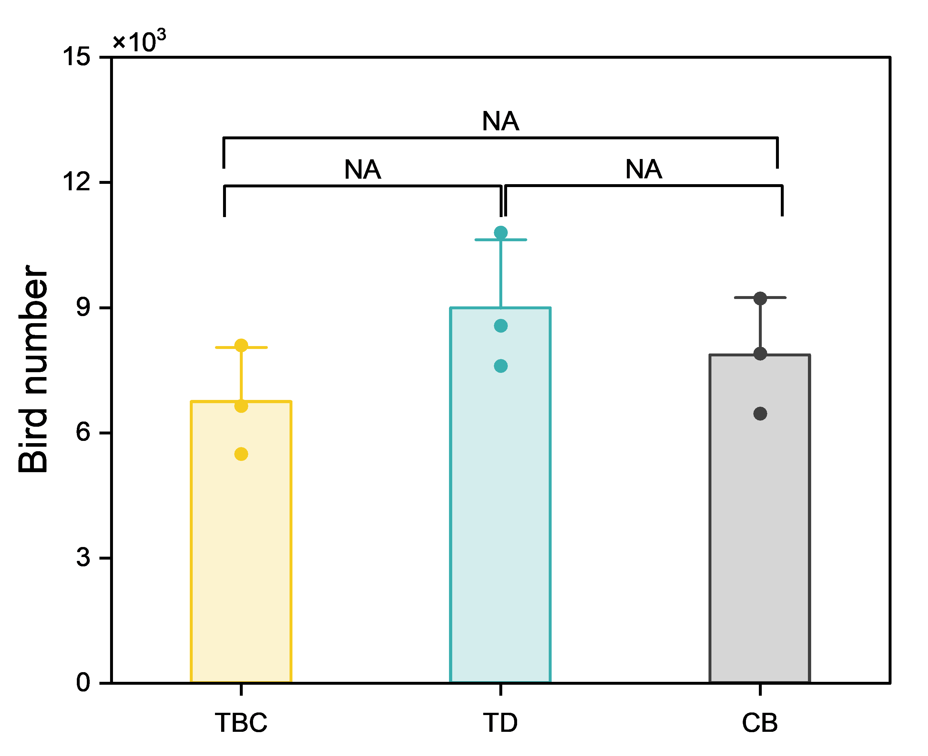
Figure S5 Number of bird individuals investigated in representative Ormosia microphylla populations. TD, CB, and TBC refer to the Tongdao, Chengbu, and Tangbaocun populations, respectively. Different letters represent significant differences at p<0.05.

