S2 Appendix - Healthcare Worker Survey
- Does a pulse oximeter measure heart rate?
- Does a pulse oximeter measure hemoglobin (Hb)?
- Does a pulse oximeter measure blood pressure?
- Is hypoxemia defined as an oxygen saturation below 90%?
- Does oxygen saturation only become seriously low when it falls under 75%?
- Should oxygen be given when a pulse oximeter is not available in children with clinical signs?
- Should oxygen be given to children with pneumonia?
- Should oxygen be given to children with SpO2 below 95% and clinical signs?
- In a 9-month-old with convulsions, is it an emergency requiring urgent help and oxygen?
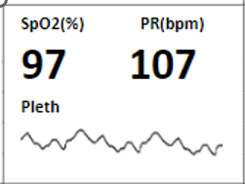
- In a 2-year-old with fast breathing and low SpO2, should oxygen be started?
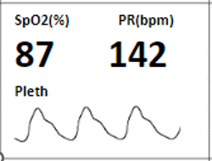
- In a 12-month-old with cough and fever and a poor plethysmograph waveform, should the reading be checked and repeated?
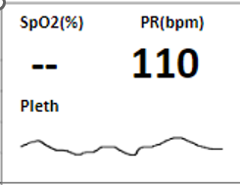
- If a 1700g neonate on oxygen has a high SpO2, should the oxygen flow rate be reduced?
