3a
Model | AIC | BIC | aBIC | Entropy | p value |  | Latent profile probability
 |  |  |  |  | LMRT | BLRT
1 | 33381.205 | 33551.826 | 33412.237 | - | - | - | 1
2 | 31889.082 | 32148.890 | 31936.335 | 0.910 | < 0.0001 | < 0.0001 | 0.46/0.54
3 | 31391.706 | 31740.702 | 31455.180 | 0.945 | 0.0394 | < 0.0001 | 0.43/ 0.44/0.13
4 | 31093.919 | 31532.104 | 31173.615 | 0.924 | 0.0444 | < 0.0001 | 0.28/0.22/0.37/0.13
5 | 30937.652 | 31465.024 | 31033.569 | 0.930 | 0.3382 | < 0.0001 | 0.27/ 0.33/0.14/0.13/0.13

5a
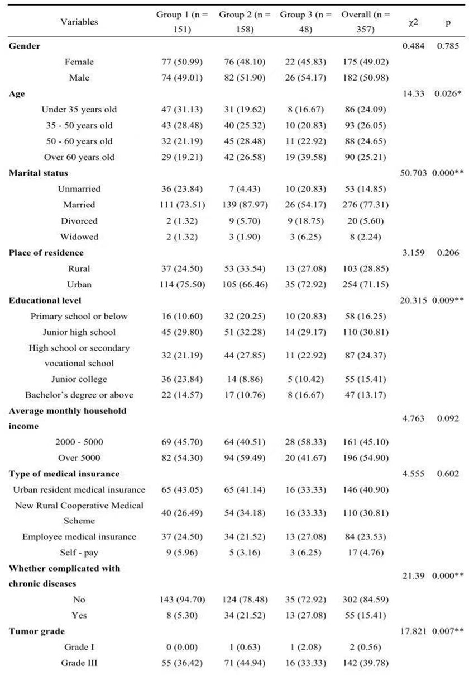
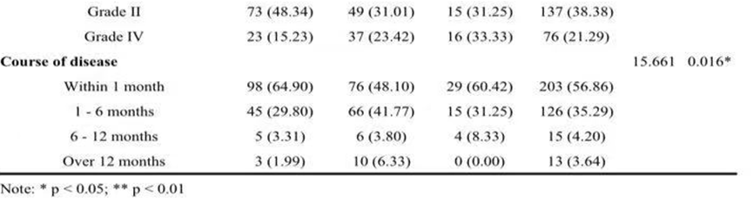

5b
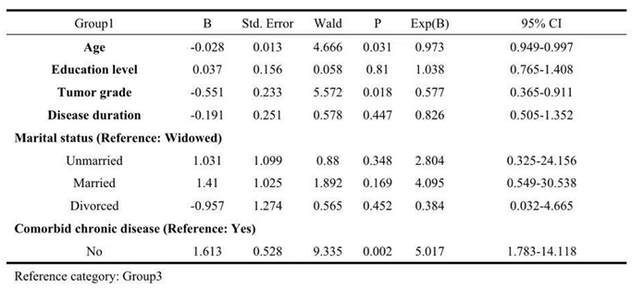
5c
