Supplementary Materials for “Enhancing Predictive Modeling for Respiratory Support with LLM-Driven Guideline Adherence”

Section 1: EHR features used for the RepFlow-CFR model.

Table 1. Model features summary.
Demographic features | Age, Gender, care unit identifier - ED, care unit identifier- Ward, hours between hospital admit and care unit admit (ED/Ward), duration from care unit admission until current time
Vital signs and laboratory measurements | HR, O2Sat, Temp, SBP, MAP, DBP, Resp, EtCO2, BaseExcess, HCO3, FiO2, pH, PaCO2, SaO2, AST, BUN, Alkalinephos, Calcium, Chloride, Creatinine, BilirubinDirect, Glucose, Lactate, Magnesium, Phosphate, Potassium, BilirubinTotal, TroponinI, Hct, Hgb, PTT, WBC, Fibrinogen, Platelets, PaO2, BNP, Sodium, Procalcitonin, CRP, Ammonia, Hgb_A1C, lymphocytes, lymphocytes_differential, albumin, ALT, D_Dimer, Ferritin, Red_cell_width, Sedimentation_Rate, LDH
Comorbidities | Disseminated intravascular coagulation, Necrotizing Fasciitis, Tumor Lysis Syndrome, Shock, Metastatic Cancer, STEMI, Myeloblastic Leukemia, Liver Failure, Malignant Pleural Effusion, Pneumothorax, Cachexia, Coma, Peritonitis, Lymphoma, Endocarditis, Myocarditis, Pericarditis, Septic Embolism, Coagulation Defect, Primary Lung Cancer, Lymphoid Leukemia, Pericardial Effusion, Cerebral Infarction, Meningitis/Encephalitis, Malignant Liver Cancer, GI Hemorrhage, Acute Renal Failure, Chronic Liver Disease, Neutropenia, Cardiac Arrhythmia, Malnutrition, Pulmonary Heart Disease, Chronic Kidney Disease, Plasma Protein Disorder, Pancytopenia/Aplasia, Aspiration Pneumonitis, AMI/Non-STEMI, CHF, Encephalopathy, Thrombocytopenia Including Purpuric, HIT, & Other Platelet defects, Coronary artery disease, COPD, Diabetes, HIV, Hypertension, Obesity, Severe Brain Conditions, Other Pulmonary Conditions, Non-Rheumatic Valve Disease, UTI, Anemia, Pneumonia, Hyperlipidemia, Major depressive disorder, Bacterimia, Gastro-esophageal reflux disease, Hypothyroidism, Long term use of insulin, Liver cirrhosis, Immune conditions, Solid malignancy, Organ transplant, Rheumatologic/Inflammatory
Medications | Anesthesia, Anticoagulants, Anticonvulsants, Antipsychotics, Bleeding reversal agents, Continuous infusion vasodilator, Continuous infusion anti-hypertensive, Continuous infusion antiarrhythmics, Inhaled prostacyclin, Continuous infusion for neuromuscular blockade, Continuous infusion for pain, Steroids

Section 2: RepFlow-CFR Development, Training and Evaluation
We proposed the RepFlow-CFR model, a flow-based confounder adjustment model that integrates representation learning, normalizing flows and counterfactual inference. Figure 1 presents the architecture overview of the RepFlow-CFR model, which contains three modules as follows.
Stage 0 (CFR-based representation learning): We utilized the counterfactual regression architecture (CFR) that includes shared representation layers and two distinct heads for predicting outcomes under different treatments. The shared representation layers, based on the Vent.io architecture, include a TSLM layer for adjusting the importance of labs and vitals, followed by a feedforward neural network. By training the CFR model, the shared representation is encouraged to balance the distribution of measured confounders across treatment groups. The loss function is formulated as
$L_{0}=E\left[L_{CFR}\left(x,a,y\right)+λ∙IPM_{G} \left({\left\{ϕ_{i }\right\}}_{i,a=HFNC} ,{\left\{ϕ_{i }\right\}}_{i,a=NIV}\right)\right]$,
where $IPM_{G}$ is the empirical probability metric (e.g. Wasserstein distance). $L_{CFR}$ is the prediction loss. $λ$ denotes the trade-off parameter that balances prediction accuracy and representation distribution matching.
After training Stage 0, we assume that the learned representation $ϕ$ captures sufficient information from measured covariates such that potential outcomes are conditionally independent of treatment assignment, given $ϕ$ and a latent variable $u$ representing unmeasured confounding as
$$Y\left(A\right) ⫫A |ϕ,u,$$
where $Y$ and $A$ denote the outcome and treatment, respectively.
The observed distribution is defined as
$p\left(y | ϕ,a\right)=\int{p(y|ϕ,u,a)p(u|ϕ,a)du}$.
The interventional distribution, which removes the influence of $a$ on $u$, is
$p\left(Y\left(a\right)=y | ϕ\right)=\int{p(y|ϕ,u,a)p(u|ϕ)du}$.
If $p\left(u | ϕ,a\right)= p\left(u | ϕ\right),$we will have $p\left(Y\left(a\right)=y | ϕ\right)=p\left(y | ϕ,a\right)$. However, in observational studies, this assumption rarely holds due to treatment assignment bias or unmeasured confounding. Directly using $p\left(y | ϕ,a\right)$ to estimate counterfactual outcomes would lead to biased inference. To address this, RepFlow-CFR includes two additional stages to explicitly model and account for this hidden bias.
Stage 1 (Modeling outcome distribution): We used a conditional normalizing flow (CNF) to model the observed outcome distribution $p\left(y | ϕ,a\right)$, where $a∈\left\{NIV, HFNC\right\}$. The CNF learns an invertible transformation $f_{ϕ,a}^{1}$ that maps a standard normal latent variable $U\sim N(0,I)$ to the outcome space. The loss function is formulated as
$$L_{1} =\sum_{i=1}^{n}{p\left(f_{ϕ_{i},a_{i}}^{1}\left(U\right)=y_{i}\right).}$$
Stage 2 (Adjusting for hidden confounding): Since the learned representation $ϕ$ may not satisfy unconfoundedness due to unmeasured confounding, we introduced a second CNF $f_{ϕ,a}^{2}$ . It transforms a new latent variable $\tilde{U}\sim N(0,I)$ to an interventional latent variable that approximates $p(u|ϕ)$. The resulting latent sample is then passed through the Stage 1 transformation
$f_{ϕ,a}^{1}$, which shifts the latent distribution $p\left(u | ϕ,a\right)$ toward the interventional distribution $p(u|ϕ)$. This adjustment allows us to account for hidden biases arising from factors like clinician decision-making, treatment selection bias, and unobserved patient severity. The loss function is formulated as
$L_{2}=\sum_{i=1}^{n}{p\left(f_{ϕ_{i},a_{i}}^{1}\left(f_{ϕ_{i},a_{i }}^{2}(\tilde{U})\right)=y_{i}\right)}$.
Inference stage: During inference, we sampled $\tilde{U}$ using the CNF from Stage 2 and mapped it to $y$ using the CNF from stage 1, then averaged multiple predicted outcomes. ITE was obtained by the difference between the averaged outcomes under NIV and under HFNC.

We split the UCSD early HFNC/NIV cohort into an 80% training and 20% internal validation set. We applied Bayesian optimization to tune hyperparameters including learning rates, weight regularization factor, number of hidden layers and flow depth. The optimization process was guided by validation performance across the CFR module and both CNF modules. Each module was trained separately using the Adam optimizer, with early stopping based on validation loss to mitigate overfitting. To ensure robustness of model estimation during inference, we drew 100 latent samples per encounter from the Stage 2 CNF and mapped them through the Stage 1 transformation to obtain predicted outcomes. These were then averaged to produce stable estimates for each treatment condition. Model performance, including both predictive accuracy and ITE estimation quality, was evaluated on the entire UCSD early HFNC/NIV cohort. To assess generalizability, we further conducted external validation on an independent early HFNC/NIV cohort from UCI site.

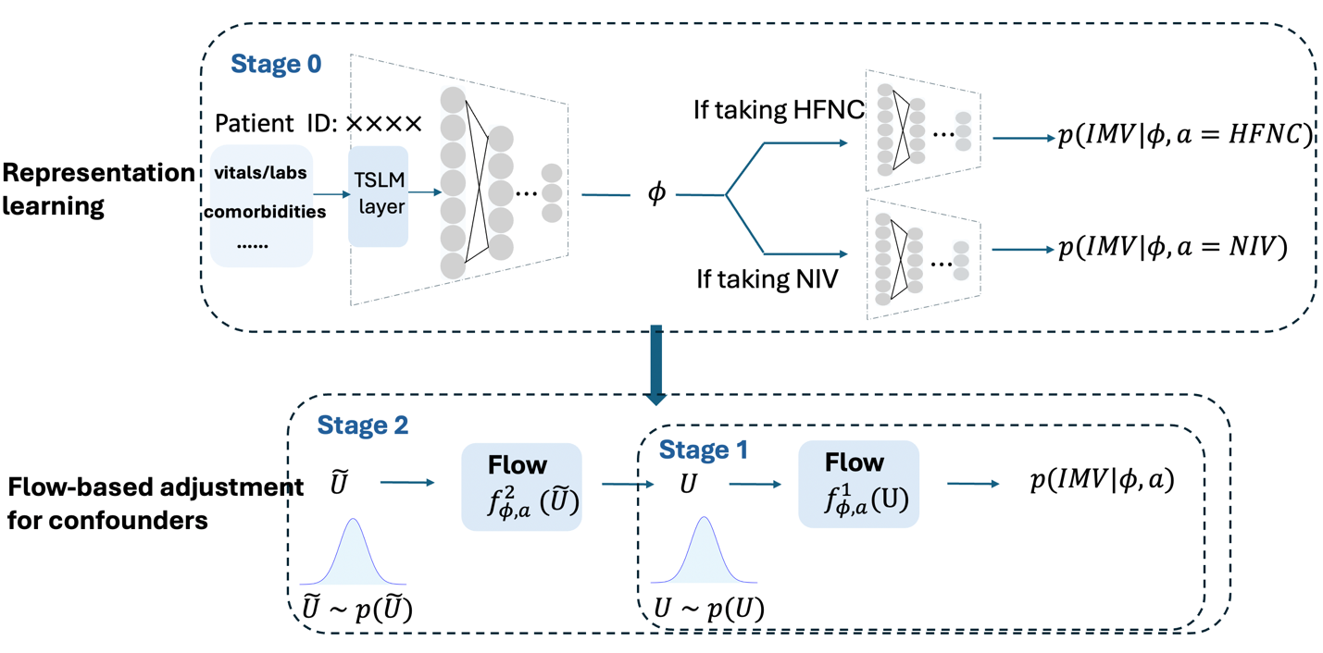

Figure 1. Overview of the RepFlow-CFR model, which contains CFR-based representation learning, output distribution modeling and hidden confounding adjustment.

Section 3: Instruction prompt for the LLM.
Table 2. Instruction prompt.
prompt = """You are a clinical reasoning assistant. You will be provided with:
- The RepFlow-CFR model recommendation, including:
(1) the preferred oxygenation modality (NIV or HFNC or Indifferent), and
(2) the rationale based on EHR data.
- Recent clinical information (EHR, notes and radiology report), particularly from the last 24–48 hours.

Your tasks:
1. Review all details provided in the <context> tags carefully.
2. Compare the RepFlow-CFR recommendation with current clinical guideline criteria.
3. Determine whether the model's recommendation is aligned with guideline-based decision rules.
4. Make an independent recommendation based solely on the clinical data using the guideline criteria (NIV, HFNC, or Indifferent).
5. Provide rationale citing relevant parts of the clinical guideline.
6. If data is insufficient, return: `"insufficient_data": true`.

### Guideline Criteria Summary:

### NIV-ERS/ATS 2017 Guidelines:

Recommend NIV if any of the following are true:

- COPD exacerbation with acute or acute-on-chronic respiratory acidosis (pH ≤ 7.35, PaCO₂ > 45 mmHg)

- Acute respiratory failure due to cardiogenic pulmonary edema, including acute (or “flash”) pulmonary edema

- Neuromuscular disease or obesity hypoventilation syndrome (OHS) with acute or acute-on-chronic respiratory acidosis (pH ≤ 7.35, PaCO₂ > 45 mmHg)

- Use NIV prophylatically post-extubation in high-risk patients (for example, those with COPD or CHF) but not in low risk patients or in patients with established post-extubation respiratory failure

- Immunocompromised patients with mild-to-moderate acute respiratory failure (conditional recommendation).

- post-operative ARF. (Conditional recommendation, moderate certainty of evidence.)

- chest trauma patients with ARF. (Conditional recommendation, moderate certainty of evidence.)

### HFNC ERS 2022 Guidelines

Recommend HFNC if any of the following are true:

- De novo (or acute) hypoxemic respiratory failure (e.g., AHRF, ARDS, pneumonia, COVID-19)

- Post-operative post-extubation in high-risk patients: HFNC is preferred over conventional oxygen but NIV is also an acceptable prophylactic treatment for high-risk patients.

- The patient isintolerant to NIV and moderate to severe acute respiratory failure is present

- Moderate to severe acute respiratory failure is present and there is not an indication for treatment with NIV.

Do not recommend HFNC as first-line if:

- The patient has acute hypercapnic respiratory failure (e.g., COPD with acidosis) unless NIV is contraindicated or not tolerated.

- There is clear guideline indication for NIV

Suggested JSON Output Format
Below is an example of how you might structure your response in JSON.

{
"o2_recommendation":{
"niv_recommended": {"answer": "Yes or No or Either",
"confidence": "high / medium / low",
"explanation": "Brief rationale"
},
"hfnc_recommended": {"answer": "Yes or No or Either",
"confidence": "high / medium / low",
"explanation": "Brief rationale"
}
"model_alignment": {
"alignment": "true / false",
"explanation": "Was RepFlow-CFR aligned with guideline-based decision?"
}
}
}
"""

# Define the JSON schema
json_format = [{
"toolSpec": {
"name": "o2_recommendation",
"description": "Return a structured JSON recommendation for NIV vs. HFNC based on the patient summary.",

"inputSchema": {
"json": {
"type": "object",
"properties": {

"niv_recommended": {
"type": "object",
"properties": {
"recommendation": {
"type": "string",
"description": "niv_recommended",
"enum": ["Yes", "No", "Either"]
},
"confidence": {
"type": "string",
"description": "Certainty assessment based on the available documentation. ",
"enum": ["high", "medium", "low"]
},
"explanation": {
"type": "string",
"description": "Brief rationale including guideline reference."
}
}
},

"hfnc_recommended": {
"type": "object",
"properties": {
"recommendation": {
"type": "string",
"description": "hfnc_recommended",
"enum": ["Yes", "No", "Either"]
},
"confidence": {
"type": "string",
"description": "Certainty assessment in based on the available documentation. ",
"enum": ["high", "medium", "low"]
},
"explanation": {
"type": "string",
"description": "Brief rationale including guideline reference."
}
}
},

"model_alignment": {
"type": "object",
"properties": {
"alignment": {
"type": "string",
"description": "model_alignment",
"enum": ["true", "false"]
},
"explanation": {
"type": "string",
"description": "Was RepFlow-CFR aligned with guideline-based decision?"
}
}
},

},

"required": [
"niv_recommended",
"hfnc_recommended",
"model_alignment",

]
}
}
}
}]

