Supplementary Information (SI 1). List of primers used for gene expression analysis.

Gene name | Primer sequence | Generating band
GAPDH | Forward: (5'-GTGGAAGGACTCATGACCACAG-3')  Reverse: (3'-CTGGTGCTCAGTGTAGCCCAG-5') | 0.475 kb
P⁵³ | Forward: (5'-GCGTCTTAGAGACAGTTGCCT-3')  Reverse: (3'-GGATAGGTCGGCGGTTCATGC-5') | 0.458kb
Bax | Forward: (5'-GGCCCACCAGCTCTGAGCAGA-3')  Reverse:(3'-GCCACGTGGGCGTCCCAAAGT-5') | 0.479 kb
Bcl-2 | Forward: (5'-GTGGAGGAGCTCTTCAGGGA-3')  Reverse: (3'-AGGCACCCAGGGTGATGCAA-5') | 0.304 kb
Caspase-3 | Forward: (5'-TGG ACTGTGGCATTGAGACAG-3')  Reverse: (3'- CGACCCGTCCTTTGAATTTC-5') | 0.137 kb
Caspase-9 | Forward: 5′-GCTGCCTGAGAAGTACAAAGA-3′  Reverse: 3′-TCGTTGGGCAGGTTCTTATC-5′ | 0.487 kb

Supplementary Information (SI 2). IR spectral data of Pt (II) L complex
Wavenumber (cm⁻¹) | Intensity | Assignment / Functional Group
~3430 | Broad | O–H or N–H stretching (hydrogen bonded)
~3060 | Strong | Aromatic C–H stretching
~1600 | Medium | C=N stretching (imine group)
~1500 | Medium | Aromatic C=C stretching
~1240 | Medium | C–O or C–N stretching
750–850 | Medium | Aromatic C–H bending

Supplementary Information (SI 3). ¹H-NMR Spectral Data of Ligand L
δ (ppm) | Multiplicity | Integration | Assignment
11.63 | br s | 1H | OH/NH (exchangeable)
8.56–8.16 | m | 3H | Aromatic or imine
7.82–7.37 | m | 3H | Aromatic protons
3.85–3.17 | m | 2H | CH₂ or OCH₃
2.51 | s | — | DMSO-d₆ solvent peak
1.05 | t | 3H | Methyl (–CH₃)

Supplementary Information (SI 4 Fig). Uncropped gel image for Fig 3E
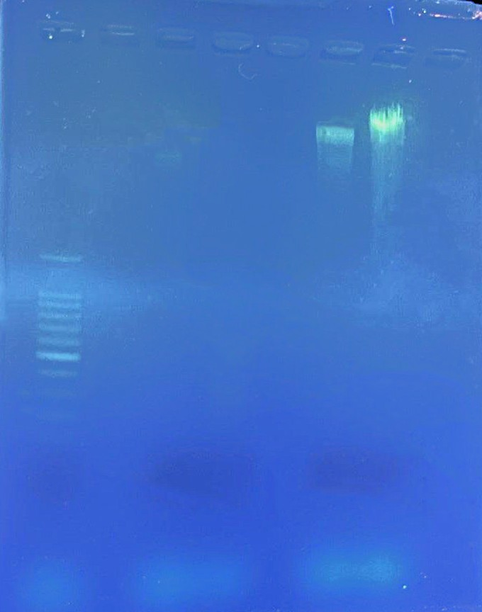
Gel electrophoresis DNA fragmentation
control
treatment
DNA Ladder 1kb

Supplementary Information (SI 5 Fig). Unprocessed gel image for Fig 5B
Gel electrophoresis of platinum complex RT-PCR products
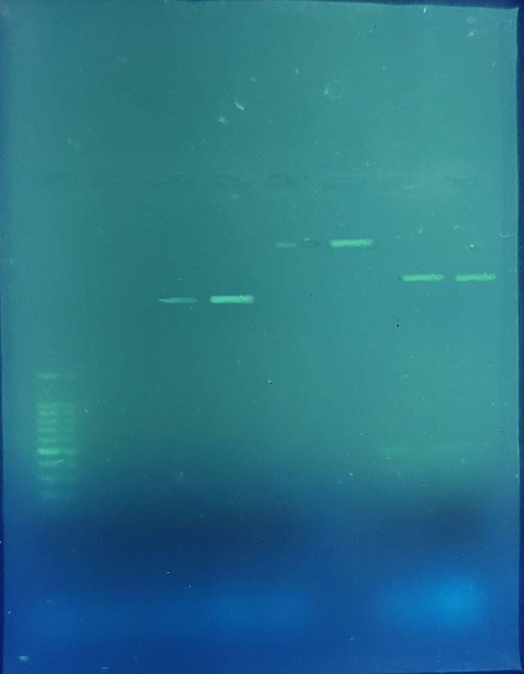
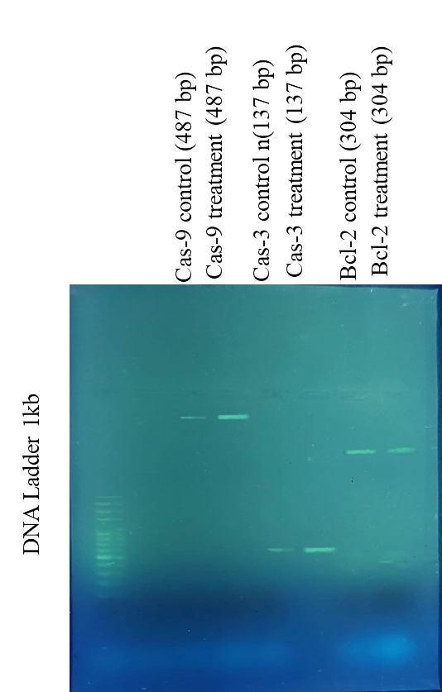
DNA Ladder 1kb
p53 control(458 bp)
p53 treatment (458 bp)
Bax treatment (479 bp)
GAPDH treatment (475 bp)
Bax control (479 bb)
GAPDH control (475 bp)

