SUPPLEMENTARY MATERIAL: Effect of antibiotic and healthcare exposure on long-term dynamics of extended-spectrum beta-lactamase producing (ESBL) Enterobacterales colonisation in Cambodian children

Supplementary methods
Multivariable logistic regression models for risk factors for ESBL E. coli and K. pneumoniae at presentation to healthcare (baseline)
Due to few cases and sparse data, comorbidities and surgery in the previous 3 months were not included in multivariable models. Comparison groups were composed of non-ESBL (irrespective of CRE [carbapenem-resistant enterobacteria] colonisation); and non-CRE (irrespective of ESBL colonisation). We constructed two multivariable models for each outcome: one ‘simple’ model including exposures associated with AMR colonisation in univariable analysis with a p-value ≤0.1 and one ‘stepwise’ model using automated stepwise backward selection methods. The final model was selected based on Akaike’s information criterion and simplicity. Age and sex were included as a priori risk factors for all models. Only sex and age were included as covariates in the multivariable model for CRE E. coli and only univariate analysis was performed for CRE K. pneumoniae, given the few cases and sparse data.

Multivariable Cox proportional hazard regression models for effect of antibiotic and healthcare exposure on time-to-gain and time-to-loss of ESBL E. coli and K. pneumoniae colonisation during 6-month follow-up
Each child’s follow-up was divided into 3 periods: enrolment to month 1, month 1 to month 3 and month 3 to month 6. We included only the periods with potential ESBL-E colonisation gain for the time-to-gain analysis (non-colonised in previous visit and non-missing posterior follow-up visit, N= 218 periods for ESBL E. coli and N= 1118 periods for ESBL K. pneumoniae), and with potential colonisation loss in the time-to-loss analysis (colonised in previous visit and non-missing posterior follow-up visit, N= 1325 periods for ESBL E. coli and N= 425 periods for ESBL K. pneumoniae). The Cox regression model was clustered by participant unique ID, to account for the inclusion of more than one period per child. Schoenfeld residuals were used to evaluate the proportional hazards assumption of the Cox proportional hazards model. The assumption held true for all included variables.

Supplementary Tables and Figures Index

Supplementary Table 1: Characteristics of current disease at enrolment of children under 5 years old presenting at the Angkor Hospital for Children.
Supplementary Table 2: Gastrointestinal colonising bacteria and their resistance pattern isolated from children at their presentation to Angkor Hospital for Children and consecutive follow-up visits.
Supplementary Figure 1: Gastrointestinal bacterial colonisation rates at enrolment among children under 5 years old presenting at the Angkor Hospital for Children for health care, stratified by inpatient or outpatient location and by age group.
Supplementary Table 3: Association between sociodemographic, personal history and environmental factors and gastrointestinal carriage of ESBL Escherichia coli.
Supplementary Table 4: Association between sociodemographic, personal history and environmental factors and gastrointestinal carriage of ESBL Klebsiella pneumoniae.
Supplementary Table 5: Association between sociodemographic, personal history and environmental factors and gastrointestinal carriage of carbapenem-resistant Escherichia coli
Supplementary Table 6: Association between sociodemographic-personal history and environmental factors and gastrointestinal carriage of carbapenem-resistant Klebsiella pneumoniae.
Supplementary Figure 2: A) Escherichia coli and B) Klebsiella pneumoniae gastrointestinal colonisation by number of antibiotic resistance in children under 5 years old seen at Angkor Hospital for Children, at enrolment and during 6 months follow-up.
Supplementary table 7: Number and proportion of antibiotic and healthcare exposures per colonisation gain or loss episodes for A) Escherichia coli and B) Klebsiella pneumoniae during the 6 months follow-up for under 5-year-old children seen at Angkor Hospital for Children.

Supplementary Table 1: Disease diagnoses and prescribed antibiotics at enrolment for children under 5 years old presenting at the Angkor Hospital for Children.

 |  | N (%)
 | N | All  (N=605) | Outpatient  (N=460) | Inpatient  (N=145)
Current disease:
Diagnoses | 605
Upper respiratory infection |  | 258 (43) | 241 (52) | 17 (12)
Gastroenteritis |  | 115 (19) | 57 (12) | 58 (40)
Bronchiolitis |  | 60 (10) | 19 (4.1) | 41 (28)
Reactive airway disease |  | 42 (7) | 27 (5.9) | 15 (10)
Pneumonia |  | 37 (6) | 18 (3.9) | 19 (13)
Skin problem/rash |  | 35 (7) | 35 (7.6) | 0 (0)
Malnutrition |  | 27 (5) | 20 (4.3) | 7 (4.8)
Skin/soft tissue infection |  | 16 (2.6) | 14 (3.0) | 2 (1.4)
Dengue |  | 12 (2) | 5 (1.1) | 7 (4.8)
Urinary tract infection |  | 8 (1.3) | 2 (0.4) | 6 (4.1)
Meningitis |  | 6 (0.9) | 0 (0) | 6 (4.1)
Allergic reaction |  | 3 (0.5) | 3 (0.7) | 0 (0)
Melioidosis |  | 2 (3) | 0 (0) | 2 (1.4)
Antibiotic prescribed
Outpatient | 460
Amoxicillin |  | 23 (4) | 23 (45) | -
Cloxacillin |  | 10 (2) | 10 (20) | -
Amoxicillin-clavulanate |  | 9 (1) | 9 (18) | -
Ciprofloxacin / ofloxacin |  | 7 (1) | 7 (14) | -
Azithromycin / Clarithromycin/ Erythromycin |  | 1 (0.2) | 1 (2.0) | -
Empiric for Inpatients | 145
Ceftriaxone / cefotaxime |  | 17 (3) | - | 17 (12)
Meropenem |  | 1 (0.7) | - | 1 (0.7)

Supplementary Table 2: Number and resistance profiles of gastrointestinal colonising bacteria from children at enrolment and consecutive follow-up visits.

 | All isolates | Enrolment  N = 605 | Month 1  N = 531 | Month 3  N = 514 | Month 6  N = 497
E. coli | 1882 | 525* | 473# | 445# | 439##
AMP-GEN | 440 (23%) | 129 (25%) | 129 (27%) | 89 (20%) | 93 (21%)
3GC | 1882 (100%) | 525 (100%) | 473 (100%) | 445 (100%) | 439 (100%)
FQ | 795 (42%) | 232 (44%) | 200 (42%) | 179 (40%) | 184 (37%)
Carbapenem | 30 (2%) | 13 (2%) | 3 (0.6%) | 7 (2%) | 7 (2%)
MDR | 1304 (69%) | 358 (68%) | 326 (69%) | 303 (68%) | 317 (72%)
K. pneumoniae | 627 | 170** | 172# | 135** | 150#
AMP-GEN | 110 (18%) | 37 (21%) | 30 (17%) | 23 (17%) | 20 (13%)
3GC | 626 (100%) | 169 (97%) | 172 (100%) | 135 (100%) | 150 (100%)
FQ | 317 (51%) | 95 (56%) | 95 (55%) | 56 (41%) | 71 (47%)
Carbapenem | 24 (4%) | 8 (4%) | 8 (5%) | 5 (4%) | 3 (2%)
MDR | 383 (61%) | 106 (61%) | 112 (65%) | 74 (55%) | 91 (61%)
3GC: 3rd-generation cephalosporin; AMP: ampicillin; FQ: fluoroquinolones; GEN: gentamicin; MDR: multidrug resistant (non-susceptibility to ≥1 agent in ≥3 antimicrobial classes tested, excluding intrinsic resistance).
On occasions, some children were colonised with two strains of E.coli or K.pneumoniae i.e. one ESBL and another CRE. Here are the number of children where this occurred: *: 4, **: 3, #: 2, ##: 1

Supplementary Figure 1: Gastrointestinal bacterial colonisation proportions rates among children under 5 years old presenting at the Angkor Hospital for Children for health care, by inpatient or outpatient location and by age group (N= 605).
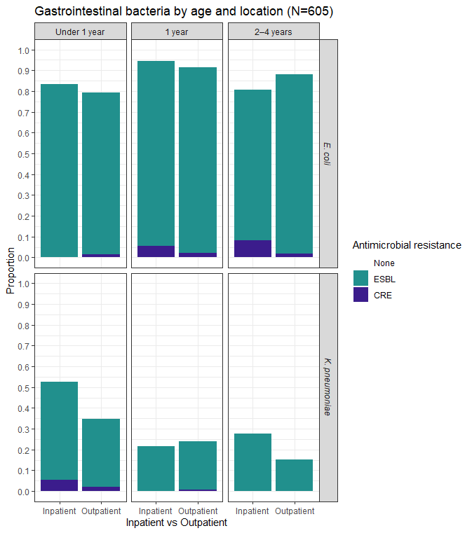

CRE: carbapenem-resistant enterobacteria, ESBL: extended spectrum beta-lactamase producers.

Supplementary Table 3: Association between sociodemographic, personal history and environmental factors with gastrointestinal carriage of ESBL Escherichia coli isolated from children at their presentation to Angkor Hospital for Children, Cambodia. (*Adjusted for all the variables in the model).

 |  | ESBL E. coli, N (%) |  | Univariate |  |  | Multivariable
Characteristic | N | No (N = 93) | Yes (N = 512) | OR | 95% CI | p-value | AOR* | 95% CI | p-value
Sociodemographics:
Female sex | 605 | 55 (59.1%) | 230 (44.9%) | 0.56 | 0.36-0.88 | 0.012 | 0.56 | 0.36-0.88 | 0.013
Age (years) (median, IQR) | 605 | 1.05 (0.46-2.55) | 1.45 (0.86-2.39) | 1.09 | 0.89-1.33 | 0.419 | 1.09 | 0.89-1.33 | 0.422
Environment:
People in household (median, IQR) | 605 | 5 (4-7) | 5 (4-7) | 1.02 | 0.93-1.13 | 0.644
Any animal in household | 605 | 65 (69.9%) | 311 (60.7%) | 0.67 | 0.41-1.06 | 0.096
Farm animals | 605 | 36 (38.7%) | 189 (36.9%) | 0.93 | 0.59-1.47 | 0.742
Pets (dogs/cats) | 605 | 51 (54.8%) | 247 (48.2%) | 0.77 | 0.49-1.19 | 0.243
Toilet in the house
Inside | 605 | 53 (57.0%) | 281 (54.9%) | 0.92 | 0.59-1.43 | 0.707
With basin for handwashing | 605 | 77 (82.8%) | 417 (81.4%) | 0.91 | 0.49-1.60 | 0.757
School/day care attendance | 605 | 4 (4.3%) | 17 (3.3%) | 0.76 | 0.28-2.70 | 0.636
Personal history:
BMI Z score (mean, SD) | 538 | -0.53 (1.05) | -0.68 (1.21) | 0.90 | 0.73-1.09 | 0.276
Weight for age Z score (mean, SD) | 605 | -0.79 (1.28) | -0.96 (1.33) | 0.91 | 0.77-1.07 | 0.254
Breastfeeding currently | 605 | 33 (35.5%) | 169 (33.0%) | 0.90 | 0.57-1.44 | 0.641
Health care previous 3 months
Any healthcare attendance | 605 | 70 (75.3%) | 441 (86.1%) | 2.04 | 1.18-3.44 | 0.009 | 1.99 | 1.14-3.39 | 0.013
Inpatient | 604 | 10 (10.8%) | 48 (9.4%) | 0.86 | 0.43-1.86 | 0.683
Antibiotics previous 4 weeks | 605 | 6 (6.5%) | 35 (6.8% | 1.06 | 0.47-2.88 | 0.892 | 0.88 | 0.38-2.42 | 0.788
AOR: Adjusted odds ratio; BMI: body mass index; CI: confidence interval; ESBL: extended spectrum beta-lactamase producer; HC: health care; IQR: interquartile range; OR: Odds ratio; SD: standard deviation.

Supplementary Table 4: Association between sociodemographic, personal history and environmental factors with gastrointestinal carriage of ESBL Klebsiella pneumoniae isolated from children at their presentation to Angkor Hospital for Children, Cambodia. (*Adjusted for all the variables in the model).

 |  | ESBL K. pneumoniae, N (%) |  | Univariate |  |  | Multivariable
Characteristic | N | No (N = 443) | Yes (N = 162) | OR | 95% CI | p-value | AOR* | 95% CI | p-value
Sociodemographics:
Female sex | 605 | 213 (48.1%) | 72 (44.4%) | 0.86 | 0.60-1.24 | 0.428 | 0.95 | 0.65-1.39 | 0.795
Age (years) (median, IQR) | 605 | 1.61 (0.90-2.55) | 0.97 (0.61-1.92) | 0.70 | 0.58-0.83 | <0.001 | 0.59 | 0.47-0.73 | <0.001
Environment:
People in household (median, IQR) | 605 | 5 (4-7) | 5 (4-6) | 0.96 | 0.88-1.03 | 0.271
Any animal in household | 605 | 284 (64.1%) | 92 (56.8%) | 0.74 | 0.51-1.06 | 0.101 | 0.76 | 0.52-1.12 | 0.164
Farm animals | 605 | 169 (38.1%) | 56 (34.6%) | 0.86 | 0.59-1.24 | 0.420
Pets (dogs/cats) | 605 | 226 (51.0%) | 72 (44.4%) | 0.77 | 0.53-1.10 | 0.153
Toilet in the house
Inside | 605 | 250 (56.4%) | 84 (51.9%) | 0.83 | 0.58-1.19 | 0.316
With basin for handwashing | 605 | 353 (79.7%) | 141 (87.0%) | 1.71 | 1.04-2.92 | 0.040 | 1.66 | 0.98-2.90 | 0.067
School/day care attendance | 605 | 16 (3.6%) | 5 (3.1%) | 0.85 | 0.27-2.21 | 0.755
Personal history:
BMI Z score (mean, SD) | 538 | -0.62 (1.18) | -0.76 (1.20) | 0.91 | 0.77-1.07 | 0.245
Weight for age Z score (mean, SD) | 605 | -0.87 (1.34) | -1.09 (1.26) | 0.88 | 0.76-1.01 | 0.076 | 0.82 | 0.71-0.95 | 0.011
Breastfeeding currently | 605 | 151 (34.1%) | 51 (31.5%) | 0.89 | 0.60-1.30 | 0.548 | 0.51 | 0.32-0.79 | 0.003
Health care previous 3 months
Any healthcare attendance | 605 | 370 (83.5%) | 141 (87.0%) | 1.32 | 0.80-2.28 | 0.292
Inpatient | 604 | 29 (6.6%) | 29 (17.9%) | 3.11 | 1.79-5.40 | <0.001 | 2.40 | 1.32-4.35 | 0.004
Antibiotics previous 4 weeks | 605 | 24 (5.4%) | 17 (10.5%) | 2.05 | 1.05-3.90 | 0.031 | 1.56 | 0.74-3.21 | 0.234
AOR: Adjusted odds ratio; BMI: body mass index; CI: confidence interval; ESBL: extended spectrum beta-lactamase producer; HC: health care; IQR: interquartile range; OR: Odds ratio; SD: standard deviation.

Supplementary Table 5: Association between sociodemographic, personal history and environmental factors with gastrointestinal carriage of carbapenem-resistant Escherichia coli isolated from children at their presentation to Angkor Hospital for Children, Cambodia. (*Adjusted for age and sex).

 | N | CRE E. coli N (%) |  | Univariate |  |  | Multivariable
 | N | No (N= 592) | Yes (N=13) | OR | 95% CI | p-value | AOR* | 95% CI | p-value
Sociodemographics:
Female sex | 605 | 278 (47.0%) | 7 (53.8%) | 1.32 | 0.43-4.14 | 0.624 | 1.26 | 0.41-3.98 | 0.680
Age (years) (median, IQR) | 605 | 1.67 (1.13) | 2.26 (1.48) | 1.49 | 0.95-2.29 | 0.070 | 1.48 | 0.95-2.28 | 0.074
Environment:
People in household (median, IQR) | 605 | 5 (4-7) | 5 (4-6) | 1.01 | 0.77-1.24 | 0.964
Any animal in household | 605 | 366 (61.8%) | 10 (76.9%) | 2.06 | 0.62-9.25 | 0.277
Farm animals | 605 | 219 (37.0%) | 6 (46.2%) | 1.46 | 0.46-4.45 | 0.501
Pets (dogs/cats) | 605 | 291 (49.2%) | 7 (53.8%) | 1.21 | 0.40-3.79 | 0.738
Toilet
Inside house | 598 | 328 (55.4%) | 6 (46.2%) | 0.69 | 0.22-2.10 | 0.509
With basin for handwashing | 598 | 486 (82.1%) | 8 (61.5%) | 0.35 | 0.11-1.17 | 0.070 | 0.35 | 0.11-1.17 | 0.068
School/day care attendance | 605 | 20 (3.4%) | 1 (7.7%) | 2.38 | 0.13-13.0 | 0.415
Personal history:
BMI Z score (mean, SD) | 538 | -0.65 (1.19) | -0.77 (1.14) | 0.92 | 0.58-1.49 | 0.737
Weight for age Z score (mean, SD) | 605 | -0.92 (1.33) | -1.21 (1.30) | 0.85 | 0.56-1.28 | 0.442
Breastfeeding currently | 605 | 199 (33.6%) | 3 (23.1%) | 0.59 | 0.13-1.96 | 0.430
Health care previous 3 months
Any HC attendance | 605 | 499 (84.3%) | 12 (92.3%) | 2.24 | 0.43-41.0 | 0.442
In-hospital stay | 604 | 56 (9.5%) | 2 (15.4%) | 1.74 | 0.26-6.68 | 0.480
Antibiotics previous 4 weeks | 549 | 36 (6.1%) | 5 (38.5%) | 9.65 | 2.80-30.5 | <0.001 | 9.04 | 2.56-29.2 | <0.001
AOR: Adjusted odds ratio; BMI: body mass index; CI: confidence interval; CRE: carbapenem-resistant enterobacteria; HC: health care; IQR: interquartile range; OR: Odds ratio; SD: standard deviation.

Supplementary table 6: Association between sociodemographic-personal history and environmental factors with gastrointestinal carriage of carbapenem-resistant Klebsiella pneumoniae isolated from children at their presentation to Angkor Hospital for Children, Cambodia.

 |  | CRE K. pneumoniae N (%) |  | Univariate
 | N | No (N= 597) | Yes (N=8) | OR | 95% CI | p-value
Sociodemographics:
Female sex | 605 | 282 (47.2%) | 3 (37.5%) | 0.67 | 0.14-2.76 | 0.586
Age (years) (median, IQR) | 605 | 1.42 (0.80-2.45) | 0.61 (0.56-0.74) | 0.17 | 0.03-0.58 | 0.020
Environment:
People in household (median-IQR) | 605 | 5 (4-7) | 6 (4-6) | 1.05 | 0.76-1.34 | 0.725
Any animal in household | 605 | 369 (61.8%) | 7 (87.5%) | 4.33 | 0.76-81.1 | 0.172
Farm animals | 605 | 223 (37.4%) | 2 (25.0%) | 0.56 | 0.08-2.45 | 0.479
Pets (dogs/cats) | 605 | 292 (48.9%) | 6 (75.0%) | 3.13 | 0.72-21.5 | 0.164
Toilet
Inside house | 598 | 330 (55.3%) | 4 (50.0%) | 0.81 | 0.19-3.45 | 0.766
With basin for handwashing | 598 | 487 (81.6%) | 7 (87.5%) | 1.58 | 0.28-29.7 | 0.670
School/day care attendance | 605 | 20 (3.4%) | 1 (12.5%) | 4.12 | 0.22-24.8 | 0.195
Personal history:
BMI Zscore (mean-SD) | 538 | -0.65 (1.19) | -0.86 (0.90) | 0.87 | 0.48-1.62 | 0.650
Weight for age Zscore (mean-SD) | 605 | -0.92 (1.33) | -1.74 (0.89) | 0.62 | 0.39-1.05 | 0.063
Breastfeeding currently | 605 | 198 (33.2%) | 4 (50.0%) | 2.02 | 0.47-8.60 | 0.325
Health care previous 3 months
Any HC attendance | 605 | 505 (84.6%) | 6 (75.0%) | 0.55 | 0.12-3.77 | 0.464
In-hospital stay | 604 | 55 (9.2%) | 3 (37.5%) | 5.90 | 1.19-24.7 | 0.017
Antibiotics previous 4 weeks  BMI: body mass index; CI: confidence interval; CRE: carbapenemase-resistant enterobacteria; HC: health care; IQR: interquartile range; OR: Odds ratio; SD: standard deviation. | 549 | 40 (6.7%) | 1 (12.5%) | 1.99 | 0.11-11.6 | 0.525

Supplementary Figure 2: Sankey graph of temporal variation of A) Escherichia coli and B) Klebsiella pneumoniae gastrointestinal colonisation, by the number of antibiotic agents resistant to, in children under 5 years old seen at Angkor Hospital for Children, at enrolment and during 6 months follow-up.
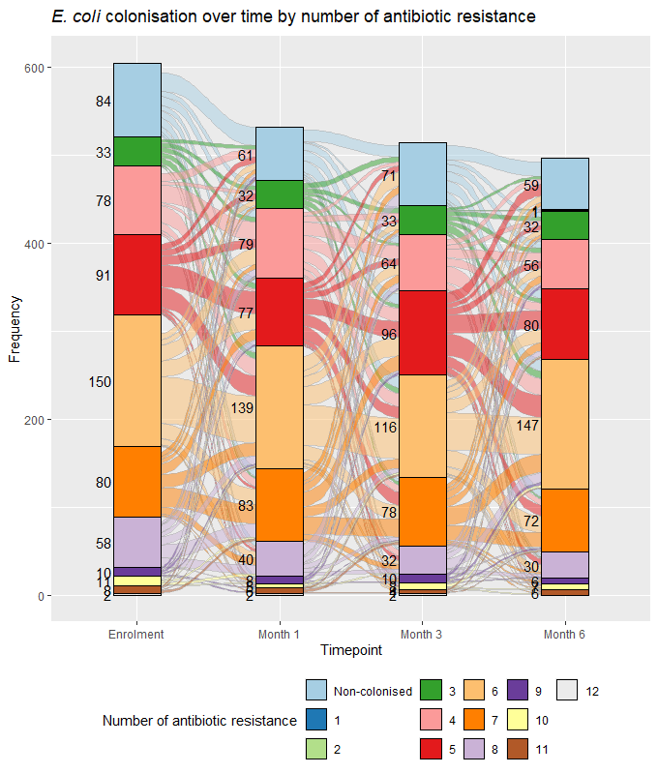
A)

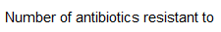
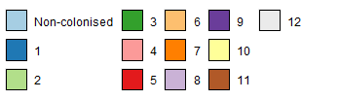

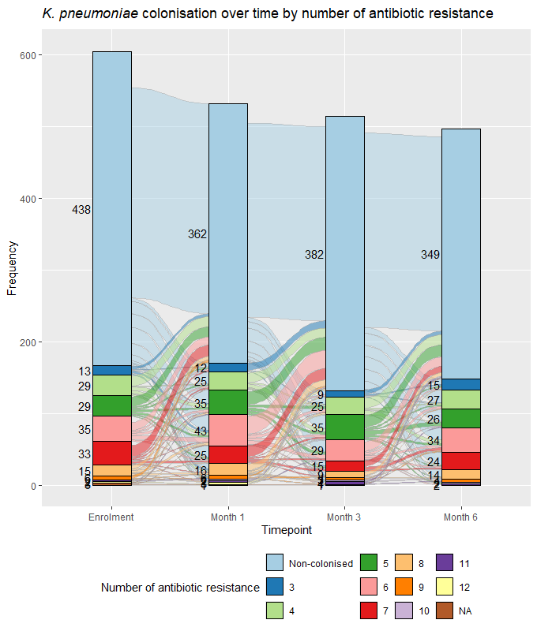
B)

Supplementary table 7: Number and proportion of antibiotic and healthcare exposures per colonisation gain or loss episodes for A) Escherichia coli and B) Klebsiella pneumoniae during the 6 months follow-up for under 5-year-old children seen at Angkor Hospital for Children.

- Escherichia coli

 | Colonisation gain episodes |  |  | Colonisation loss episodes
Exposures | Overall  (N = 218) | No gain  (N = 58) | Gain  (N = 160) | Overall  (N = 1325) | No loss  (N = 1180) | Loss  (N = 145)
Any antibiotic | 41 (19%) | 14 (24%) | 27 (17%) | 295 (22%) | 266 (23%) | 29 (20%)
Cephalosporin 3rd gen | 5 (2.3%) | 2 (3.4%) | 3 (1.9%) | 30 (2.3%) | 29 (2.5%) | 1 (0.7%)
Any healthcare | 200 (92%) | 56 (97%) | 144 (90%) | 1207 (91%) | 1078 (91%) | 129 (89%)
Inpatient | 35 (16%) | 10 (17%) | 25 (16%) | 194 (15%) | 179 (15%) | 15 (10%)

- Klebsiella pneumoniae

 | Colonisation gain episodes |  |  | Colonisation loss episodes
Exposures | Overall  (N = 1181) | No gain  (N = 868) | Gain  (N = 250) | Overall  (N = 425) | No loss  (N = 190) | Loss  (N = 235)
Any antibiotic | 232 (21%) | 164 (19%) | 68 (27%) | 104 (24%) | 53 (28%) | 51 (22%)
Cephalosporin 3rd gen | 19 (1.7%) | 10 (1.2%) | 9 (3.6%) | 16 (3.8%) | 10 (5.3%) | 6 (2.6%)
Any healthcare | 1017 (91%) | 783 (90%) | 234 (94%) | 390 (92%) | 181 (95%) | 209 (89%)
Inpatient | 157 (14%) | 108 (12%) | 49 (20%) | 72 (17%) | 42 (22%) | 30 (13%)

