Supplementary
An Integrated DFT+U and Device Simulation Design of Doped CsGeCl₃ for High Efficiency Flexible Solar Absorbers
Dholon Kumar Paul^{1,3}, Shahnil Zulkarnain¹, Somayia^{1,2}, M. L. Rahman^{1,3}, A. K. M. Akther Hossain³, A F M Yusuf Haider¹, Firoze H. Haque^{*1}
¹Department of Mathematics and Natural Sciences (MNS), BRAC University, Dhaka, Bangladesh
²Department of Engineering and Applied Science, University of Regina, Regina, Canada
³Department of Physics, Bangladesh University of Engineering and Technology, Dhaka, Bangladesh

1. SCAPS -1D Theory
The widely used SCAPS -1D software solves fundamental equations that govern charge transport, generation, recombination and electric field distribution in a simulated solar cell device [1], [2]. It utilizes Gummel iteration method utilizing Newton-Raphson sub steps in solving coupled partial differential equations, that are solved across all the layers in a solar cell device under certain boundary conditions [1], [2], [3], [4]. A system of coupled differential equations, Poisson’s equation for electron and holes (1), equation of continuity for hole and electron (2), and the carrier transport equations for hole and electron (3), are solved to extract key performance metrics: [5]
 | $$\frac{d^{2}ψ}{dx^{2}} =\frac{dE(x)}{dx} = \frac{e}{ϵ_{0}ϵ_{r}} ( p(x)-n(x)+N_{D} -N_{A}+ρ_{p}-ρ_{n})$$ | ……………(8)
Here, $ψ$ and $E$ Corresponds to the electric potential and electric field, $e$ is the electric charge. $ϵ_{0},ϵ_{r},$ $p$, $n$, $N_{d}$, $N_{a}$, $ρ_{n}$, $ρ_{n}$ are the permittivity of Vacuum, relative permittivity of the material, hole and electron free carrier concentration, Donor and Acceptor Concentration and hole and electron distribution. This equation determines the electrostatic potential across the device setting the condition for charge transport. The continuity equations for electron and holes ensures conservation of charge: [5]
 | $$\frac{dJ_{n}}{dx}= G - R$$ | ……………(9)
 | $$\frac{dJ_{p}}{dx}= G-R$$ | ……………(10)
Where, $G$ and $R$ is the Generation and Recombination rate of electron and hole pair. These two equations determine how charge carriers move and interact within the device. The drift-diffusion model is used to describe the electron and hole currents: [1], [5]
 | $$J_{n }= D_{n}\frac{dn}{dx} + μ_{n}n\frac{dϕ}{dx}$$ | ……………(11)
 | $$J_{p }= D_{p}\frac{dp}{dx} + μ_{p}n\frac{dϕ}{dx}$$ | ……………(12)
Both hole and electron current consist of two terms, where the first term is for diffusion containing discussion coefficient $D_{p}$ or $D_{n }$and the second one is for drift where the mobility of hole $μ_{p}$and the mobility of electron $μ_{n}$ plays the key role. These equations account for carrier transport due to drift in the electric field and diffusion due to concentration gradients.

2. Highest Occupied Crystal Orbital (HOCO) and the Lowest Unoccupied Crystal Orbital (LUCO) figures:
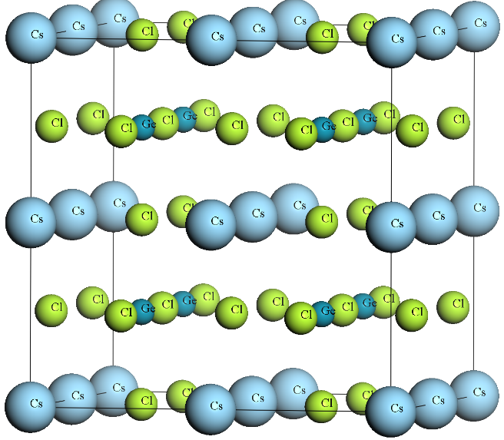  (b)  (a) | 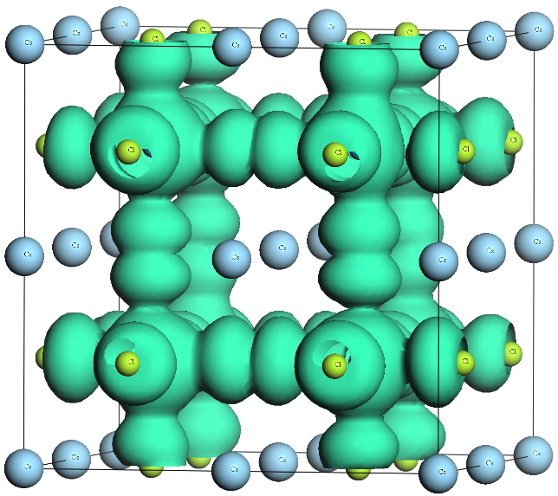
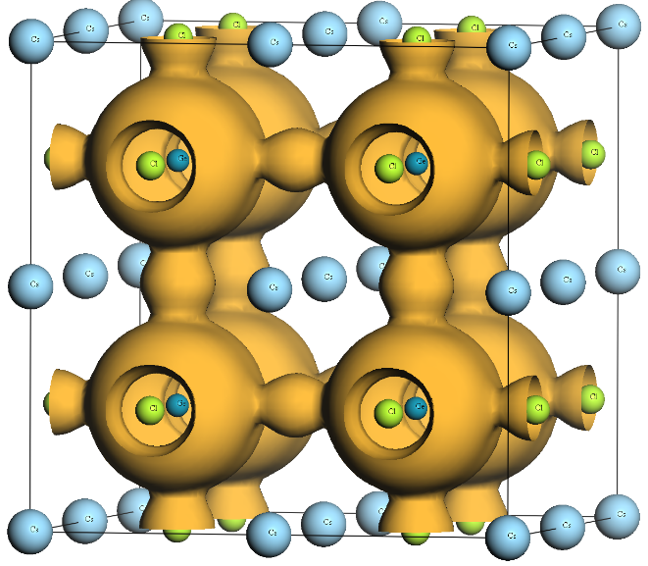
(c)
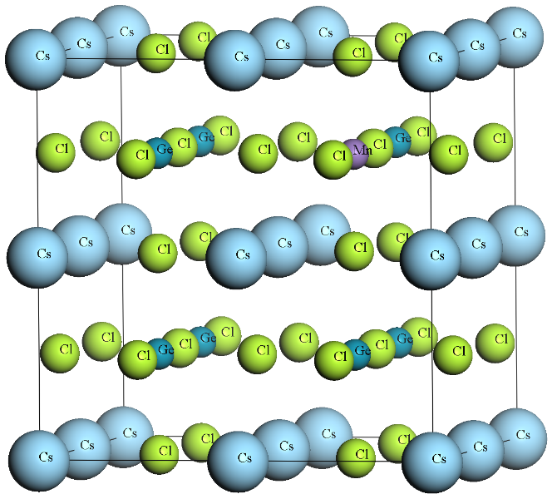  (d) | 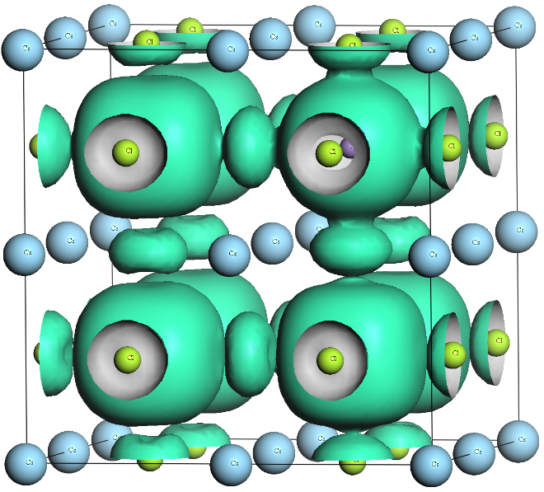  (e)
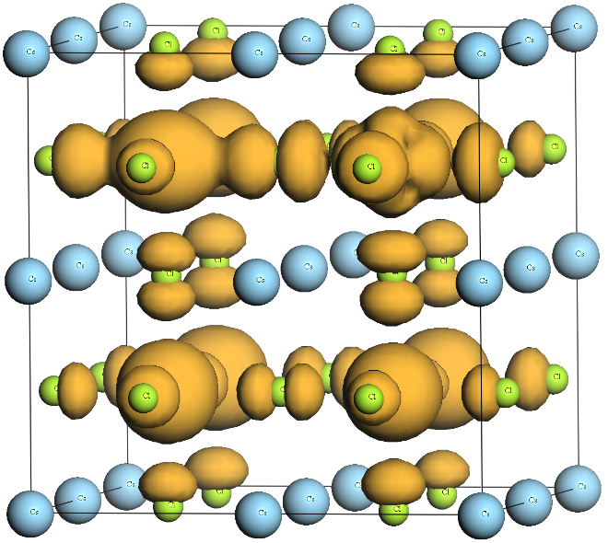
(f)
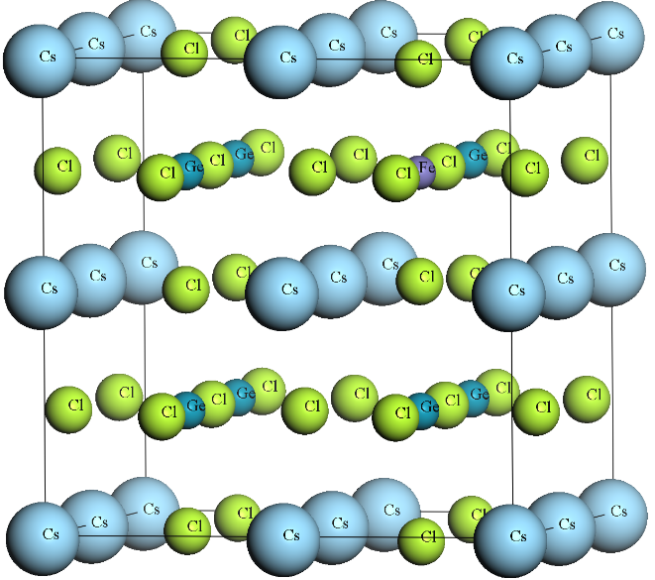  (g) | 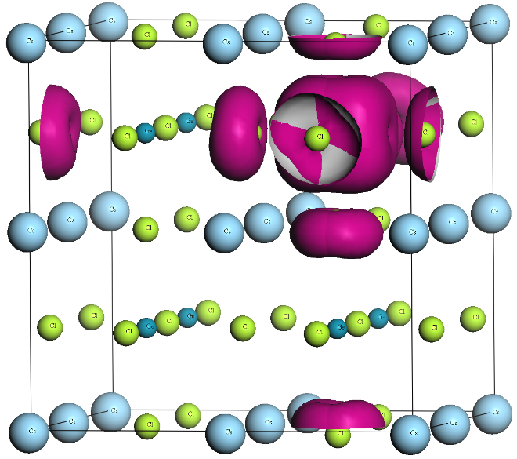  (h)
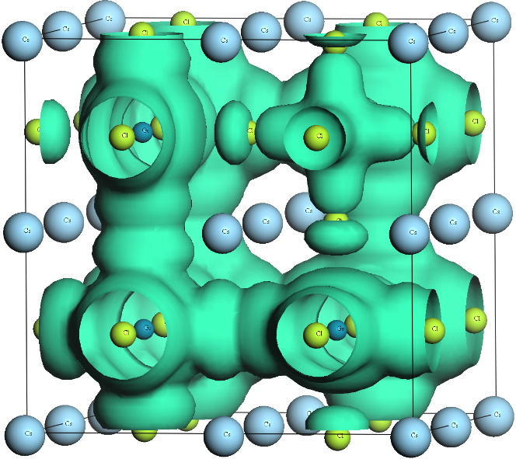  (i) | 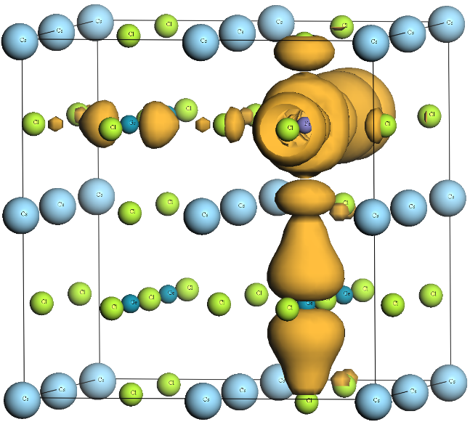  (j)

Figure S1: The HOCO (b), (e), (i) and LUCO (c), (f), (j) of pure CsGeCl₃, CsGe_{0.875}Mn_{0.125}Cl₃, and CsGe_{0.875}Fe_{0.125}Cl₃ respectively. (h) is the active orbital of CsGe_{0.875}Fe_{0.125}Cl₃ at fermi level.

3. Recombination Coefficient Analysis
(a) | (b)
(c) | CsGe_{0.875}Mn_{0.125}Cl₃  (d)
CsGe_{0.875}Fe_{0.125}Cl₃  (e) | CsGe_{0.875}Fe_{0.125}Cl₃  (f)

Figure S2: PCE across range of varied Auger Recombination $(C$) and Radiative Recombination Coefficient $(β)$ with different ETL.

3. Total Work Flow Diagram
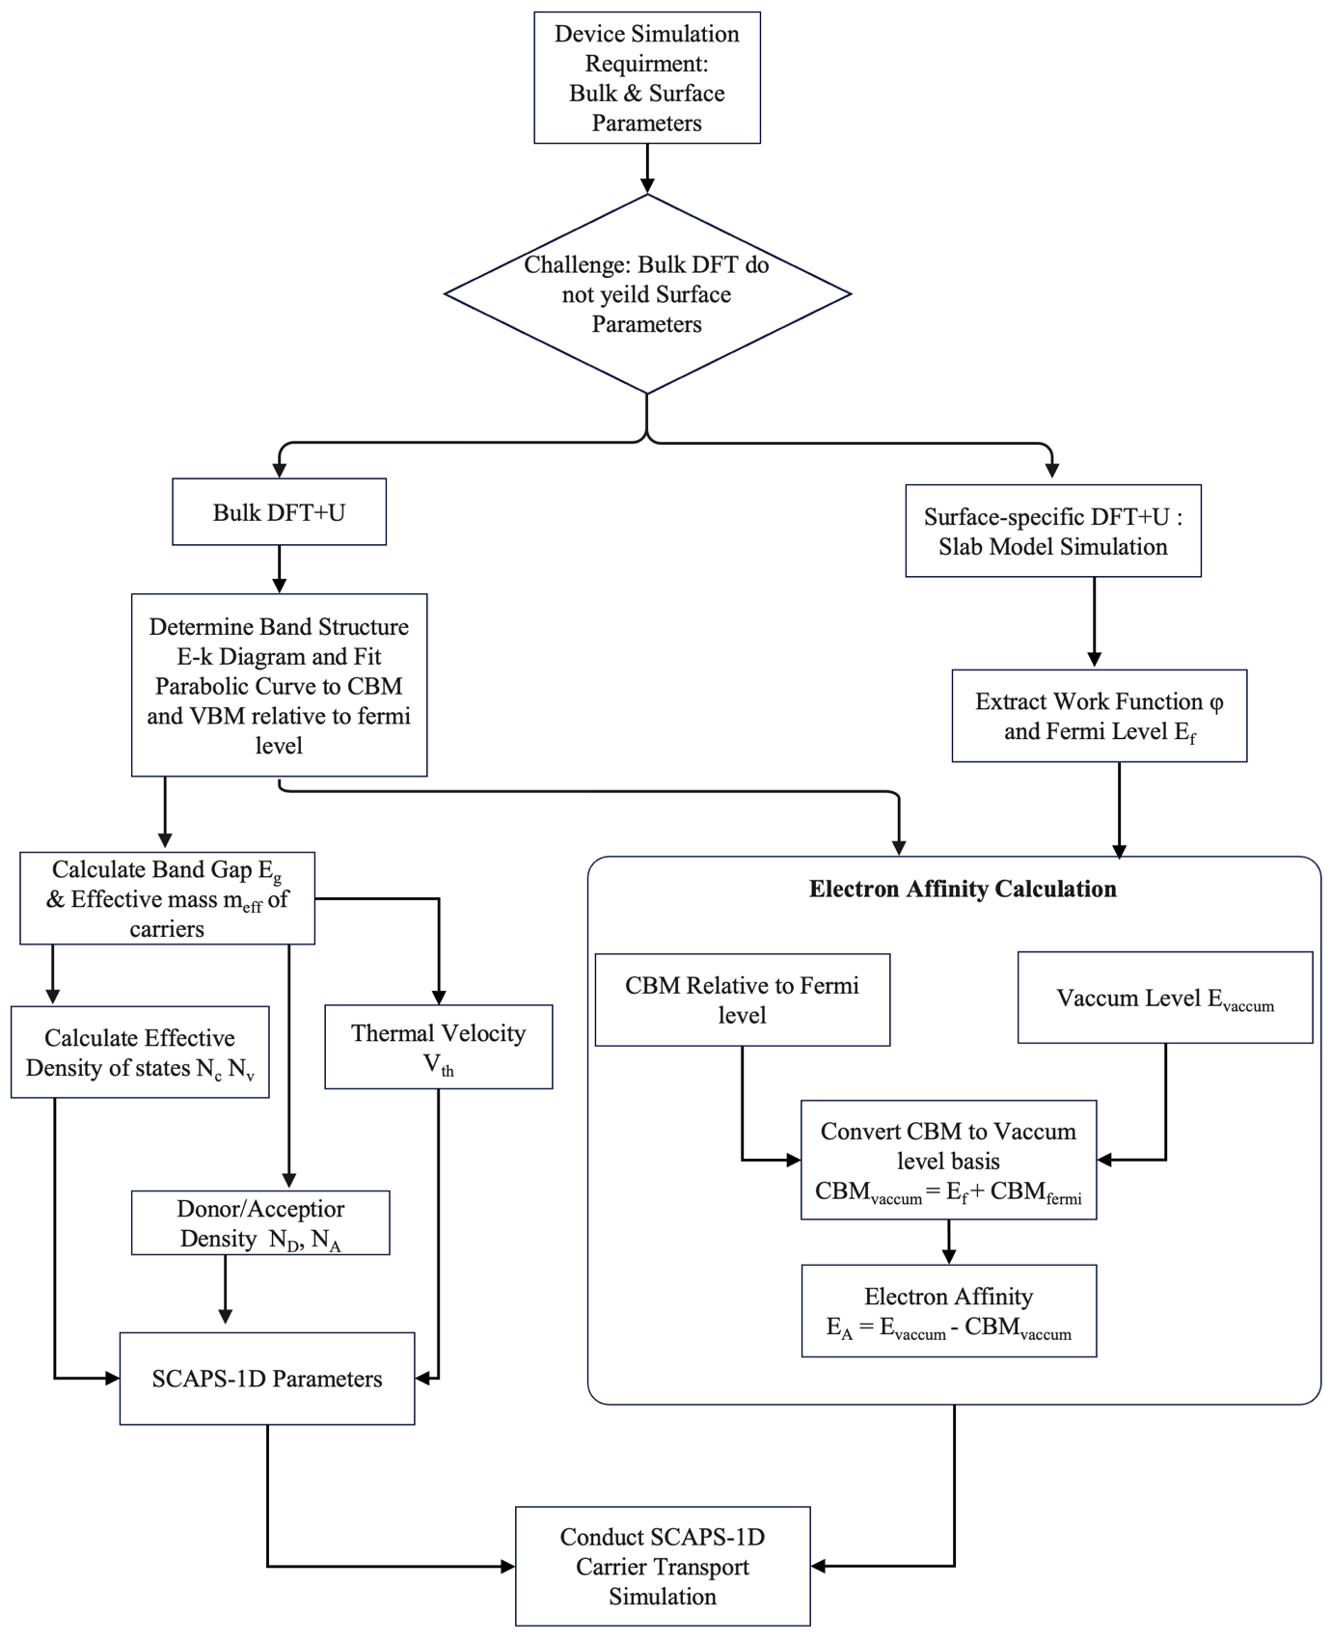
Figure S3: Computational workflow for the extraction of self-consistent parameters for device simulation.

4. References
[1] J. Verschraegen and M. Burgelman, ‘Numerical modeling of intra-band tunneling for heterojunction solar cells in scaps’, Thin Solid Films, vol. 515, no. 15 SPEC. ISS., pp. 6276–6279, May 2007, doi: 10.1016/j.tsf.2006.12.049.
[2] K. Decock, S. Khelifi, and M. Burgelman, ‘Modelling multivalent defects in thin film solar cells’, in Thin Solid Films, Aug. 2011, pp. 7481–7484. doi: 10.1016/j.tsf.2010.12.039.
[3] K. Decock, P. Zabierowski, and M. Burgelman, ‘Modeling metastabilities in chalcopyrite-based thin film solar cells’, J Appl Phys, vol. 111, no. 4, Feb. 2012, doi: 10.1063/1.3686651.
[4] G. Yu, W. Wang, S. Attique, and S. Yuan, ‘Multiscale Simulations Facilitate the Design of High-Performance Perovskite Solar Cells’, Solar RRL, vol. 8, no. 4, p. 2300930, 2024, doi: https://doi.org/10.1002/solr.202300930.
[5] M. Burgelman, P. Nollet, and S. Degrave, ‘Modelling polycrystalline semiconductor solar cells’. [Online]. Available: www.elsevier.com/locate/tsf

