Extended Figures:
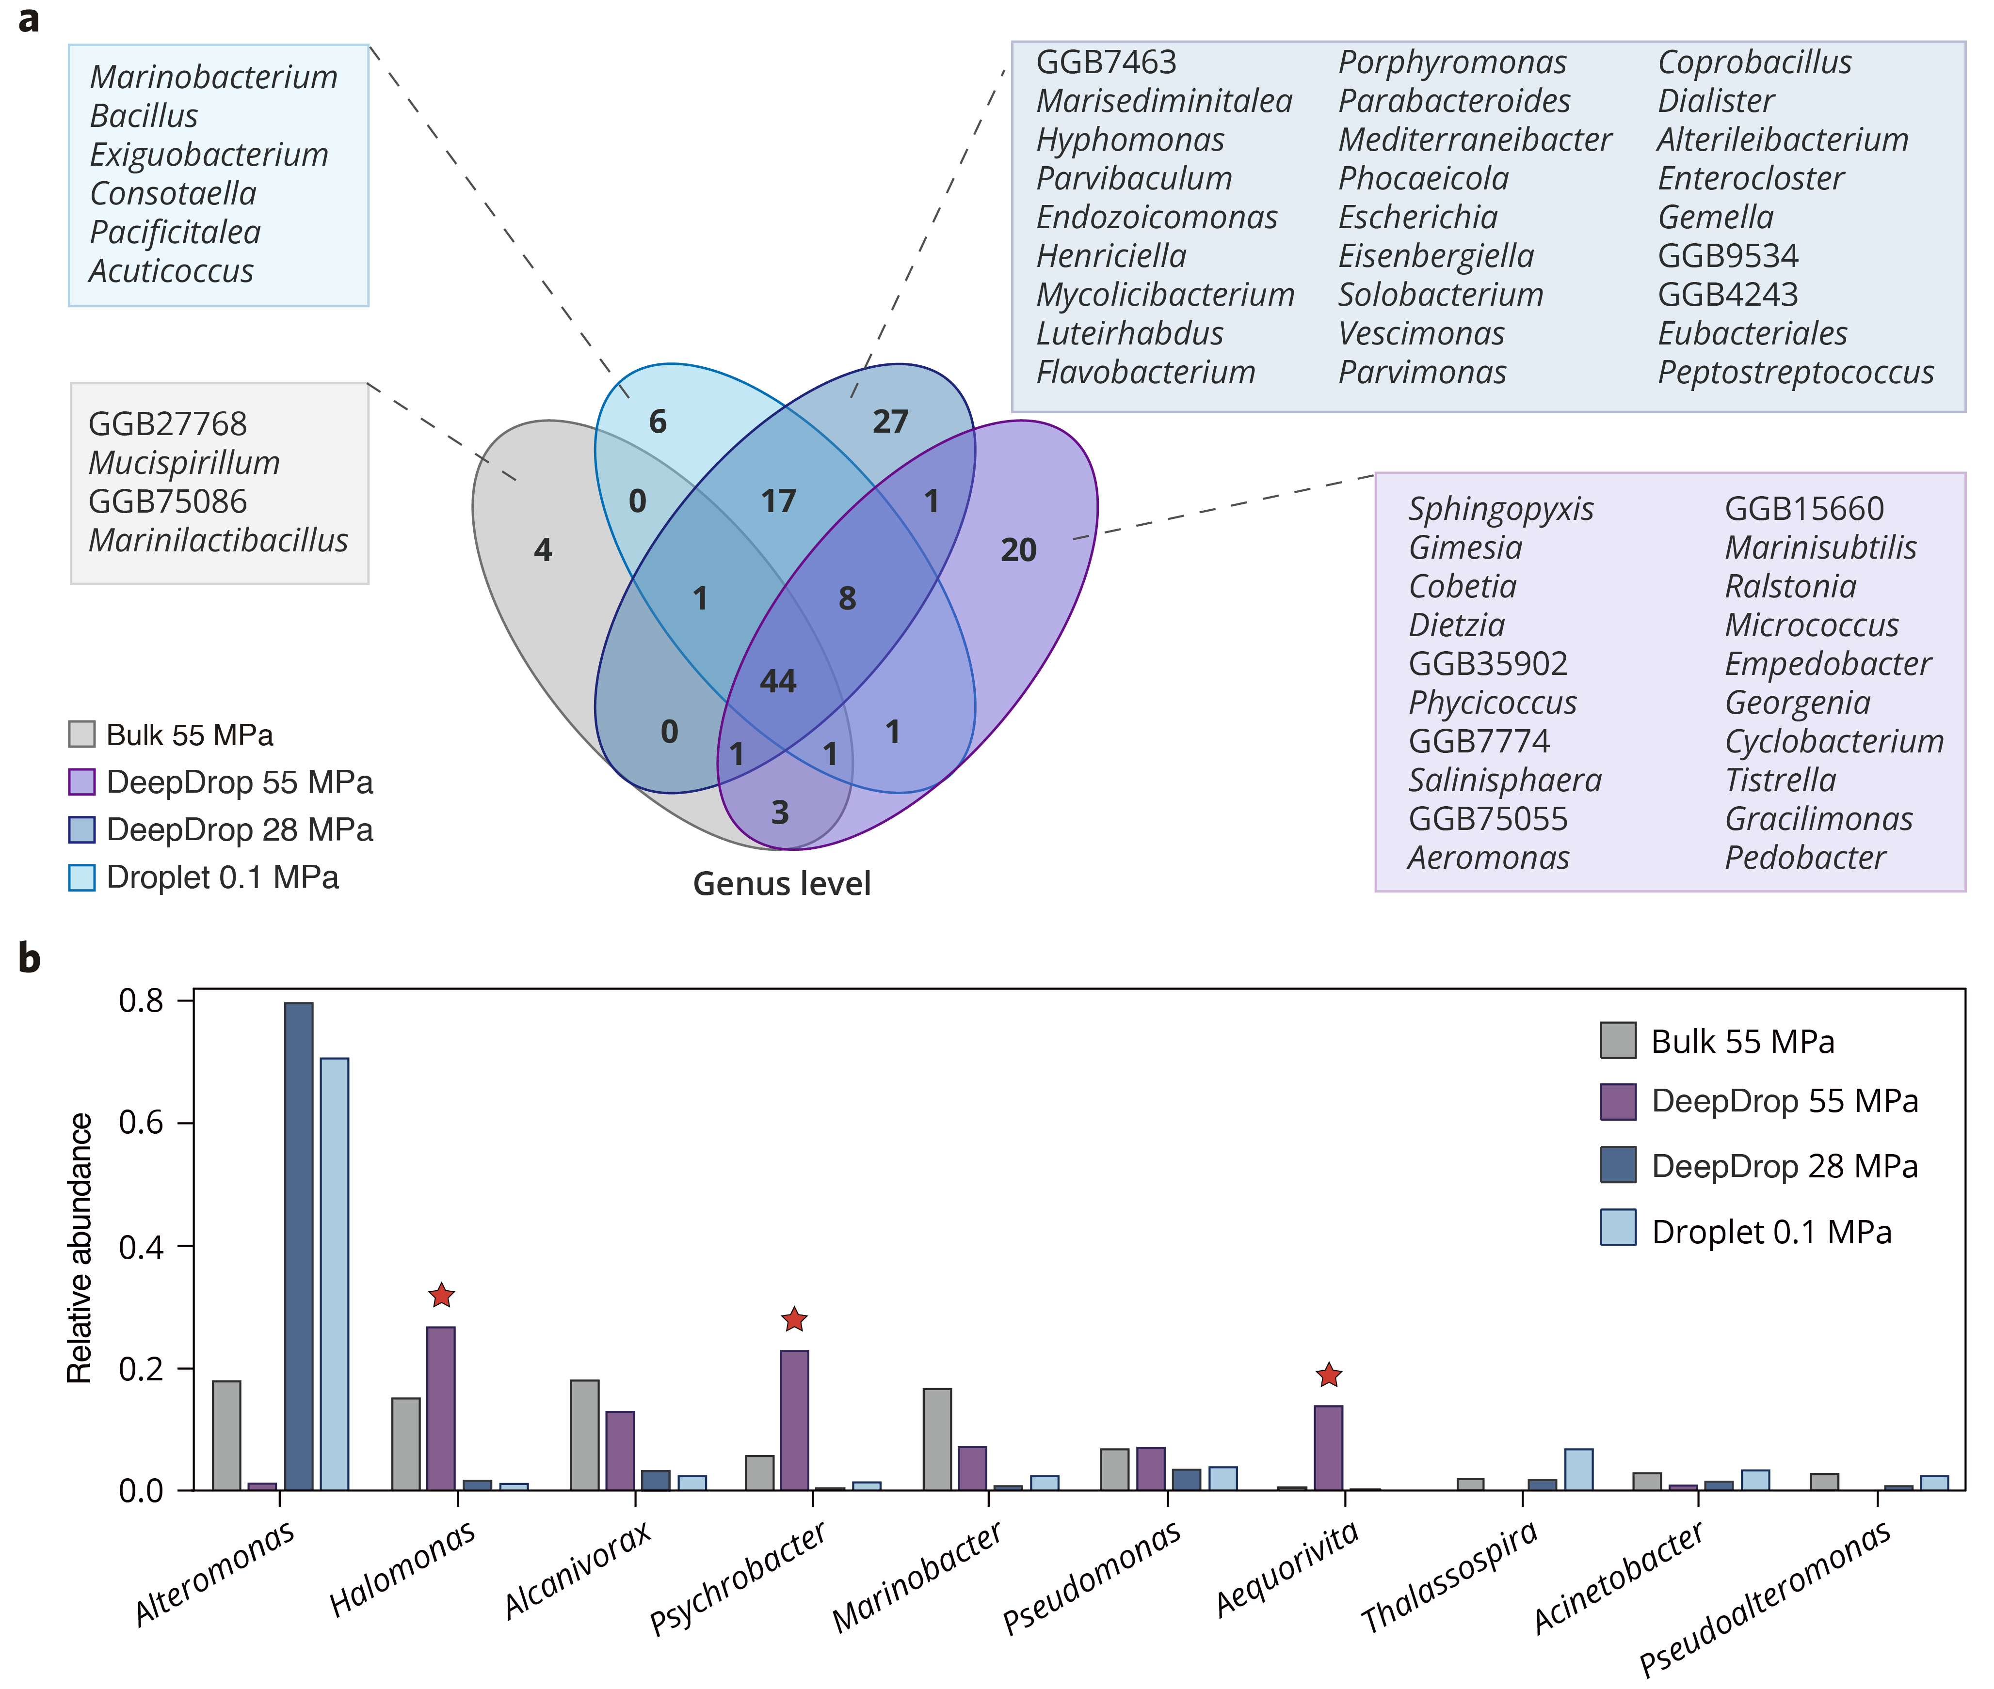
Extended Fig. 1 | Genus-level diversity and enrichment across cultivation conditions. a, Venn diagram showing shared and unique genera identified under four cultivation regimes: Bulk 55 MPa (gray), DeepDrop 55 MPa (purple), DeepDrop 28 MPa (blue), and Droplet 0.1 MPa (light blue). Exclusively recovered genera are listed in shaded boxes. b, Top 10 differentially abundant genera identified by the Kruskal–Wallis test across the four conditions. Red stars denote genera significantly enriched in DeepDrop conditions.

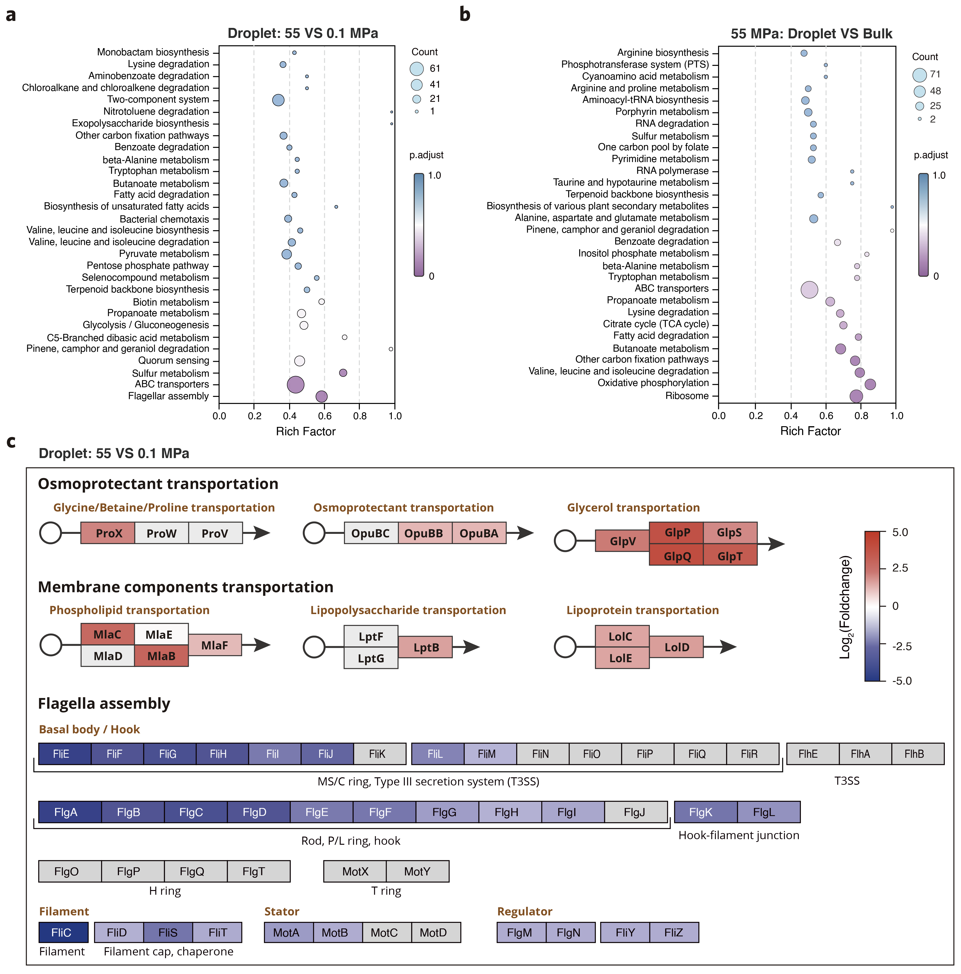
Extended Fig. 2 | Transcriptomic responses of Halomonas meridiana CR14 under high-pressure droplet confinement. a, KEGG pathway enrichment of differentially expressed genes (DEGs) between cultures at 55 MPa versus 0.1 MPa in droplets, highlighting pressure-responsive transcriptional programs. b, KEGG enrichment of DEGs between droplet and bulk cultures at 55 MPa, isolating gene expression changes attributable to microdroplet confinement. In both panels, bubble size represents the number of DEGs per pathway, while color intensity corresponds to the adjusted P-value. c, Summary of pressure-induced expression changes in transport systems and motility modules. ABC transporters for osmoprotectants (such as glycine, betaine, and proline), glycerol, and membrane components (including phospholipids, lipopolysaccharides, and lipoproteins) show increased expression under 55 MPa in droplets. In contrast, genes related to flagellar assembly, including the basal body, filament, stator, and regulatory components, are consistently downregulated. The color scale indicates log₂(fold change) relative to 0.1 MPa droplet cultures. n = 3 biological replicates.
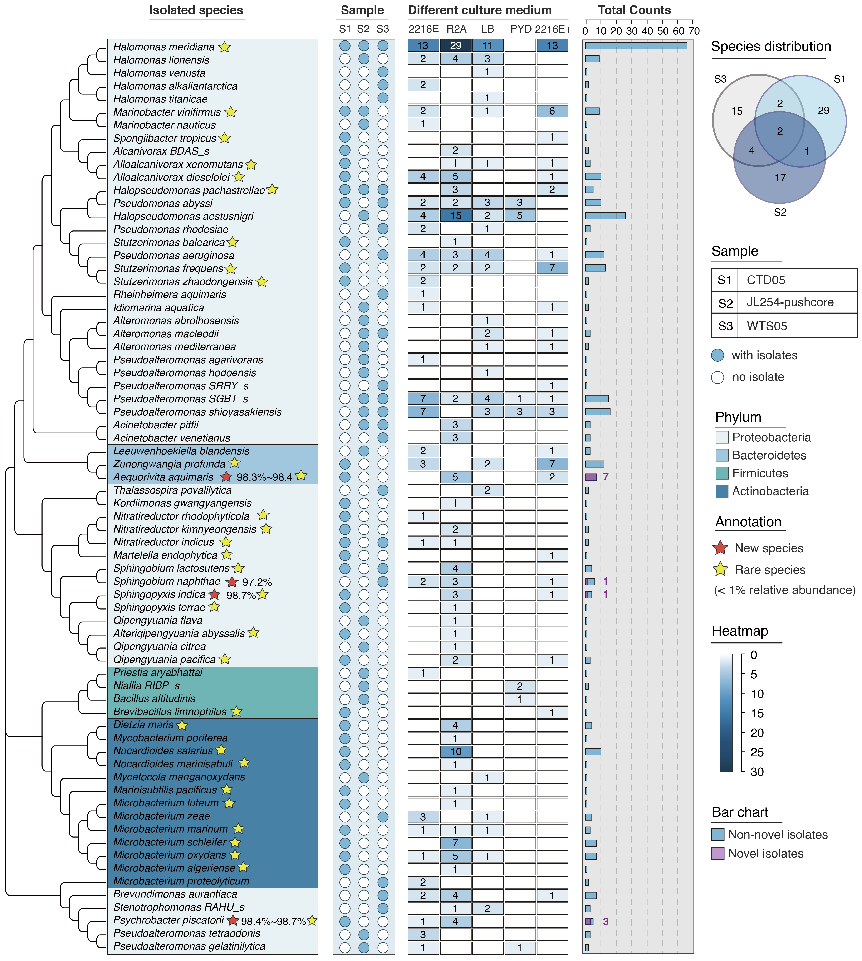
Extended Fig. 3 | Taxonomic composition and media distribution of DeepDrop-cultured isolates. Phylogenetic tree of all 70 isolated species, color-coded by phylum. Sampling origins (S1: CTD05, S2: JL254-pushcore, S3: WTS05) are marked by filled circles. Yellow stars indicate rare taxa (<1% relative abundance); red stars denote putative novel species based on 16S rRNA identity. The central heatmap shows species-specific isolate counts across five marine agar media (2216E, R2A, LB, PYD, and 2216E+NaCl). The bar chart on the right summarizes total isolate counts per species, with novel isolates highlighted in purple. The Venn diagram (top right) illustrates the overlap of species across the three sampling sites.

