Supplementary informations

Engineering wheat rhizoplane microbiomes with niche-conserved consortium to enhance phosphorus acquisition and plant growth
Brahim Benbrik*¹, Dounia Nkir¹, Hicham Chaouki¹, Yassine Aallam¹, Tessa E. Reid², Tim H. Mauchline², Adnane Bargaz*¹
¹ AgroBiosciences Program, College of Agriculture and Environmental Sciences, Mohammed 6 Polytechnic University, Ben Guerir, Morocco.
² Sustainable Soils and Crops, Rothamsted Research, Harpenden, United Kingdom.
Corresponding author (s):
Adnane Bargaz: Adnane.bargaz@um6p.ma
Brahim Benbrik: Brahim.benbrik-ext@um6p.ma
ORCID
Braim Benbrik : https://orcid.org/0000-0001-7739-0711
Adnane Bargaz: https://orcid.org/0000-0003-2850-027X
Physical mailing address:
Mohammed 6 Polytechnic University Lot 660, Hay Moulay Rachid Ben Guerir, 43150, Morocco.

This file includes:
Four Supplementary Figures S1-S4
One Supplementary Table S1

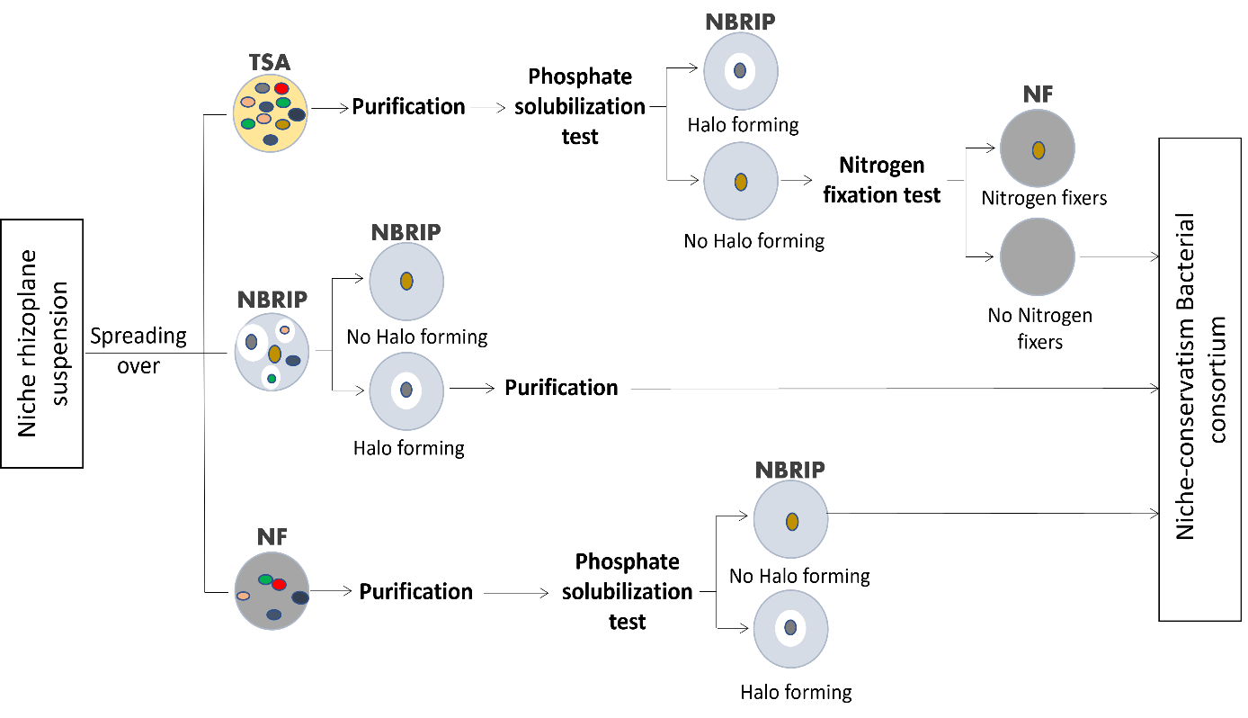
Figure S1. Bacterial consortium-oriented isolation diagram. BC-oriented isolation is an isolation strategy within the niche-conserved approach, based on preserving the niche intra-diversity features, that allows the isolation of a representative multi-PGP traits consortium from a given niche sample, using three culture media (PDA, NBRIP and NF) simultaneously. With TSA medium we isolate bacteria without PS and NF capacities, but potentially with other PGP traits. Whereas with the second (NBRIP) and third (NF) media, only PS and NF bacteria were isolated, respectively. BC: bacterial consortia, PS: phosphate solubilization, NF: Nitrogen fixation.

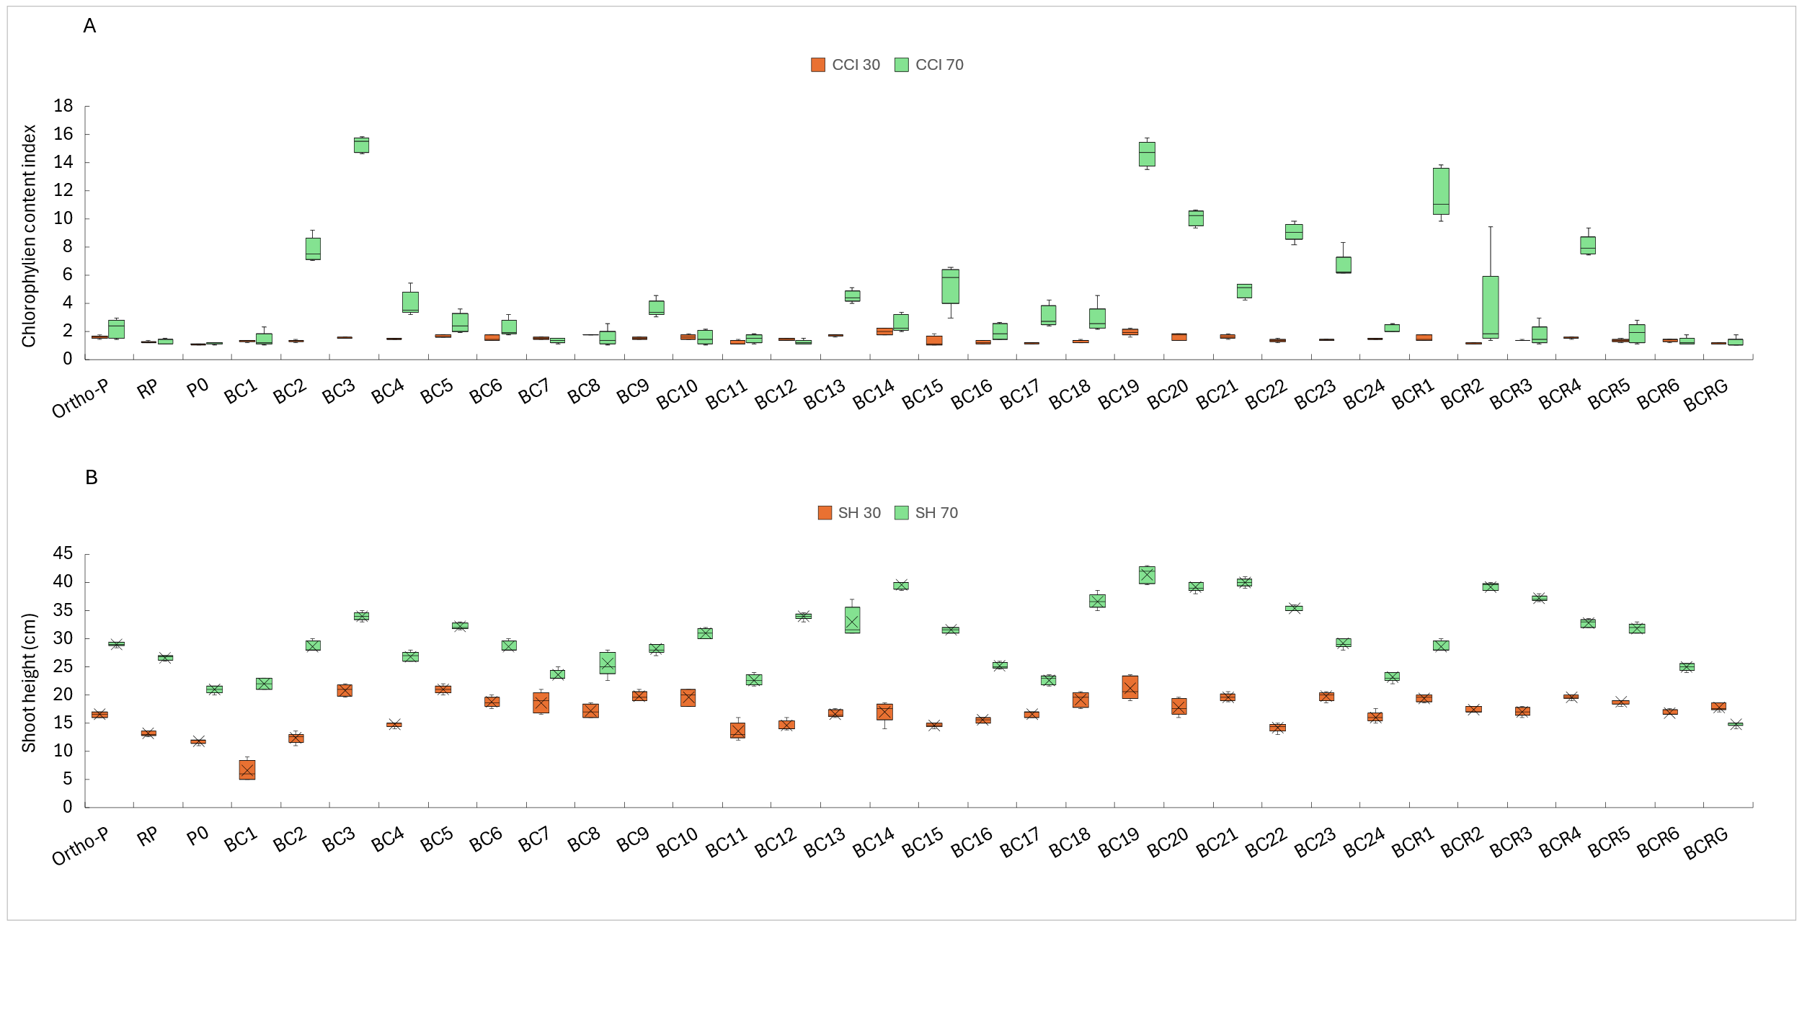 Figure S2. Effect of BC inoculation on Chlorophyll content index (A) and shoot height (B) old wheat plants compared to inoculated controls (Ortho-P, RP, and P₀). Ortho-P: fertilized with orthophosphates, RP: fertilized with rock P, P₀: unfertilized and uninoculated, BC₁-BC₂₄: niche-conserved BC, BC_{R1}-FC_{R6}: intra-regional BC, BCRG: global (inter-regional) BC, CCI: chlorophyll content index, SH: shoot length, 30: 30-day old plants, 70: 70-day old plants). The results are means ± SD (n = 5). Different letters indicate values that are statistically different at p < 0.05.

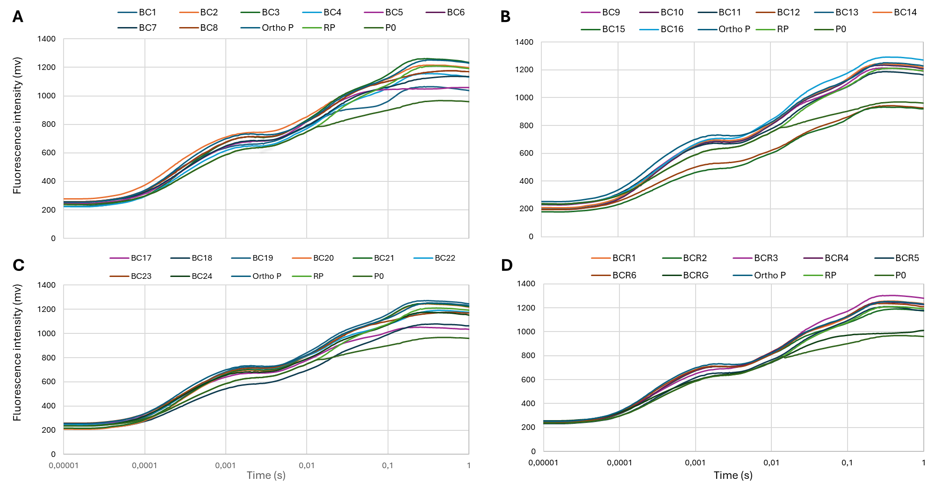
Figure S3. Fluorescence intensity of 30-day old plants inoculated with BC (A’: BC₁-BC₈, (B’: BC₉-BC₁₆, (C’: BC₁₇-BC₂₄, (D’: BC_{R1}-BC_{R6}, and BC_{RG}) compared to uninoculated plants (ortho-P, RP, and P₀). Ortho-P: fertilized with orthophosphates, RP: fertilized with rock P, P₀: unfertilized and uninoculated, BC₁-BC₂₄: niche-conserved BC, BC_{R1}-FC_{R6}: intra-regional BC, BCRG: global (inter-regional) BC.
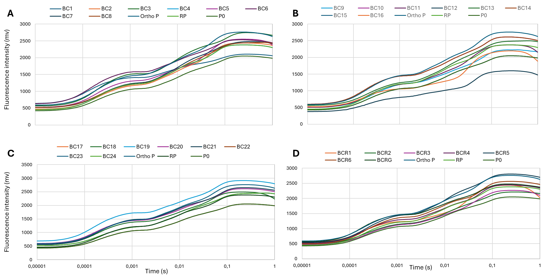
Figure S4. Fluorescence intensity of 70-day old plants inoculated with BC (A’: BC₁-BC₈, (B’: BC₉-BC₁₆, (C’: BC₁₇-BC₂₄, (D’: BC_{R1}-BC_{R6}, and BC_{RG}) compared to uninoculated plants (ortho-P, RP, and P₀). Ortho-P: fertilized with orthophosphates, RP: fertilized with rock P, P₀: unfertilized and uninoculated, BC₁-BC₂₄: niche-conserved BC, BC_{R1}-FC_{R6}: intra-regional BC, BCRG: global (inter-regional) BC.
Table S1. Annotation, composition, and provenance of niche-conserved (BC1-BC24), intra-region (BCR1-BCR6), and global (BCRG: inter-regions) BC. BC: zone or niche-conserved bacterial consortia, BCR: intra-region BC, BCRG: global or inter-regions BC).
Region | R1 : Sidi Kacem (SK) |  |  |  | R2 : Meknes (MK) |  |  |  | R3 : Settat (ST) |  |  |  |  | R4 : Beni Mellal (ST) |  |  |  |  | R5 : Safi (SA) |  |  |  |  | R6 : Azilal (AZ)
Zone | Sidi Kacem | Sidi Slimane | Dar Laaouinat | Labhalil | Ait Lhakkour | Meknes | Ait Ouhssine | El Borj | Khmessat  Chaouia | Zakkach | Foqra Oulad  Amer | Oulad Fdel | Ouaramane |  | Afourar | Sidi Jaber | Fkih Ben Saleh | El Haddada |  | Oulad Taleb | Oulad  Hammou | Bouguedra | Lounasda |  | Zalgane | Maskaoun | Eddachra
Zone Consortia ID | BC1 | BC2 | BC3 | BC4 | BC5 | BC6 | BC7 | BC8 | BC9 | BC10 | BC11 | BC12 | BC13 |  | BC14 | BC15 | BC16 | BC17 |  | BC18 | BC19 | BC20 | BC21 |  | BC22 | BC23 | BC24
Nbr of isolates  per BC | 6 | 3 | 5 | 3 | 2 | 2 | 0 | 3 | 4 | 5 | 3 | 3 | 5 |  | 2 | 6 | 3 | 4 |  | 4 | 4 | 3 | 4 |  | 6 | 3 | 3
Bacterial composition  of niche-conserved BC | 1  2  3  4  6  7 | 9  10  12 | 14  15  16  17  18 | 19  20  22 | 23  24 | 26  27 | _ | 31  32  34 | 35  36  38  39 | 40  41  42  43  44 | 45  46  48 | 50  51  52 | 55  57  58  59  60 |  | 61  62 | 64  65  66  67  68  69 | 70  71  72 | 75  76  77  78 |  | 80  81  82  83 | 85  86  87  88 | 89  90  91 | 92  93  94  95 |  | 97  98  99  100  101  102 | 103  105  107 | 108  110  112
Bacterial composition  of intra-region BC (BCR) | 1, 3, 4, 9, 10, 12,  17, 19  (BCR1) |  |  |  | 24, 26, 27, 31,  32, 34  (BCR2) |  |  |  | 36, 38, 40, 41, 43, 46,  48, 51,52  (BCR3) |  |  |  |  | 60, 62, 71, 72  (BCR4) |  |  |  |  | 75, 78, 80, 81, 82,  85, 86, 87,  88, 89, 91  (BCR5) |  |  |  |  | 93, 95, 100, 108  (BCR6)
Bacterial composition  of inter-regions BC | 3, 10, 12, 27, 45, 51, 108  (BCRG)

