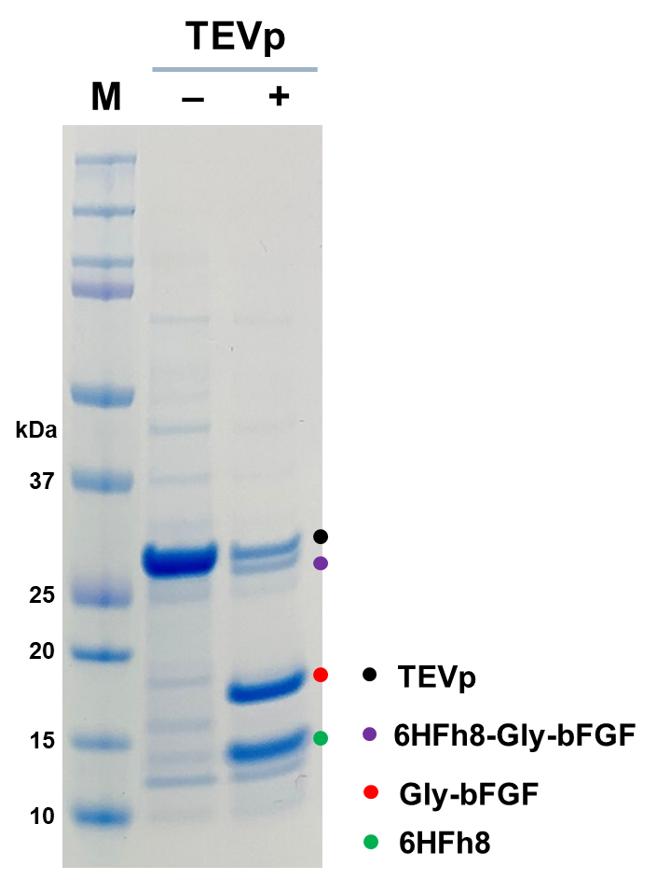
Figure S1. Enhancement of TEV protease cleavage efficiency by modification of the N-terminus of the protein of interest. Glycine was inserted between the TEV protease cleavage site and N-terminus of bFGF, the protein of interest. The fusion protein was purified by HisTrap chromatography and cleaved by the TEV protease. The protein mixtures were resolved on 4–12% Bis-Tris Plus SDS-PAGE gel. The image is representative of two independent experiments.
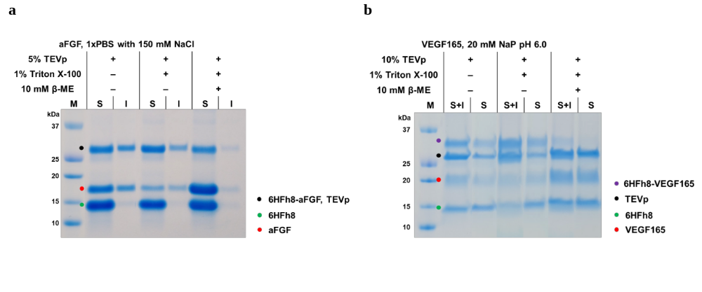

Figure S2. TEV protease treatment of aFGF (a) and VEGF165 (b) fusion proteins under different conditions. For the experiment, the fusion protein was purified by HisTrap chromatography and dialyzed against each buffer. TEV protease was treated with or without Triton X-100 and/or β-mercaptoethanol. The proteins were resolved on 4–12% Bis-Tris Plus SDS-PAGE gel. S, soluble fraction (after centrifugation); I, insoluble fraction; S+I, soluble and insoluble fraction mixture before centrifugation. The image is representative of two independent experiments.

Table S1. Structural properties and molecular masses of growth factors overproduced in the current study. ‒, the range of specific region (heparin binding region in the structural properties) and protein without signal peptide and pro-region; ↔, the binding position of each residue.
Protein | UniProtKB | No. disulfide bonds (no. Cys) | Structural properties | Molecular mass (kDa), no. amino acids (protein region)
aFGF | P05230 | 0 (3) | 127‒143: heparin binding | 15.8, 140  (16‒155)
bFGF | P09038 | 0 (4) | 261‒277: heparin binding | 16.4, 146  (143‒288)
EGF | P01133 | 3 (6) | 976↔990/984↔1001/1003↔1012: Disulfide bond (intrachain) | 6.3, 53  (971‒1023)
hGH | P01241 | 2 (4) | 79↔191/208↔215: disulfide bond (intrachain) | 22.1, 191  (27‒217)
IGF-1 | P05019 | 3 (6) | 54↔96/66↔109/95↔100: disulfide bond (intrachain) | 7.7, 70  (49‒118)
KGF-1 | P21781 | 0 (5) | 45: N-linked glyosylation | 18.9, 163  (32‒194)
VEGF165 | P15692-4 | 5 (16) | 52↔94/83↔128/87↔130: disulfide bond (intrachain)  77↔77/86↔86: disulfide bond (interchain)  101: N-linked asparagine | 19.2, 165  (27–191)
PGF | P49763 | 5 (10) | 33/101: N-linked asparagine  52↔94/83↔128/87↔130: disulfide bond (intrachain)  77↔77/86↔86: disulfide bond (interchain) | 22.8, 203  (19‒221)
SCF | P21583 | 2 (4) | 29↔114/68↔163: disulfide bond  90/118/145: N-linked asparagine  167: N-linked serine  168/180: N-linked threonine | 18.5, 165  (26‒190)
TIMP-1 | P01033 | 6 (12) | 24↔93/26↔122/36↔147/150↔197/155↔160/168↔189: disulfide bond (intrachain)  53/101: N-linked asparagine | 20.7, 184  (24–207)

