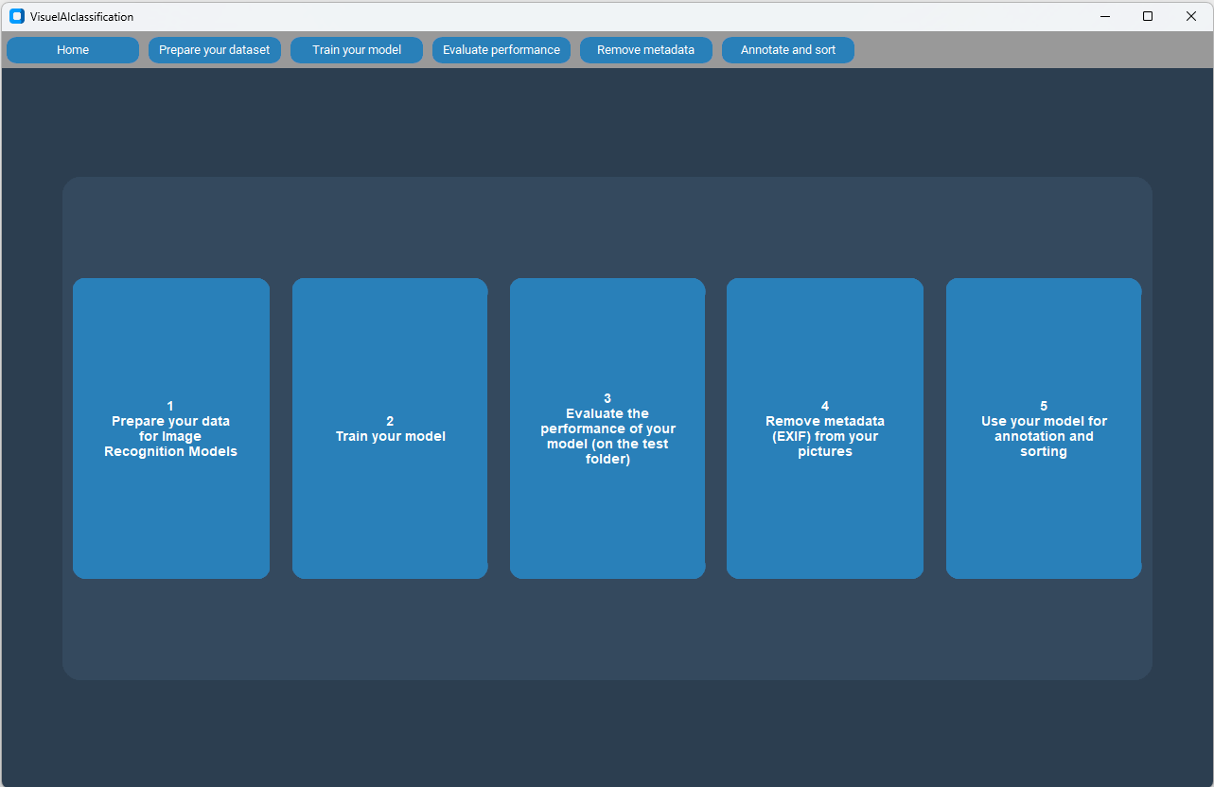
Figure S1. Home page with the 5 modules available.

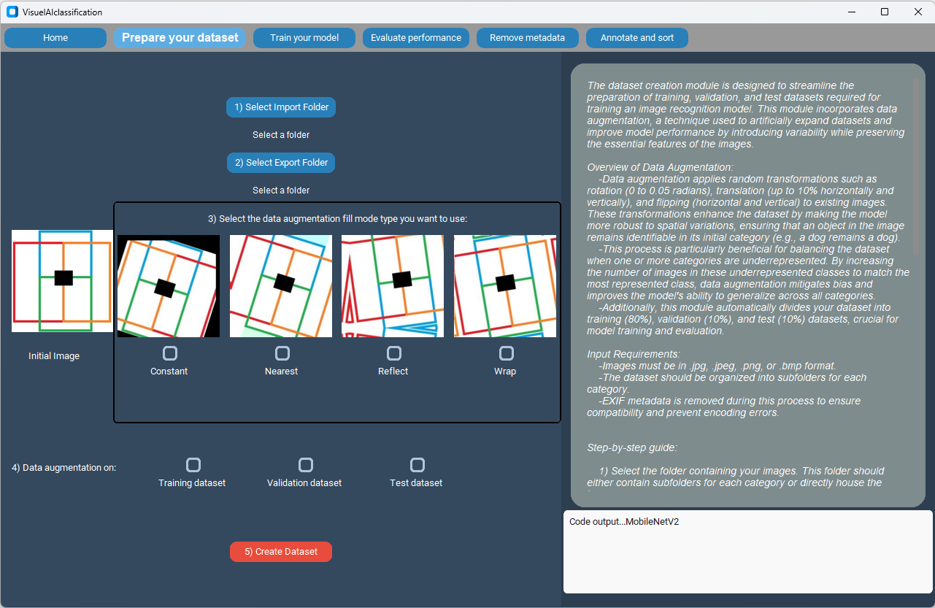
Figure S2. Dataset preparation page with the 4 types of filling mode available.

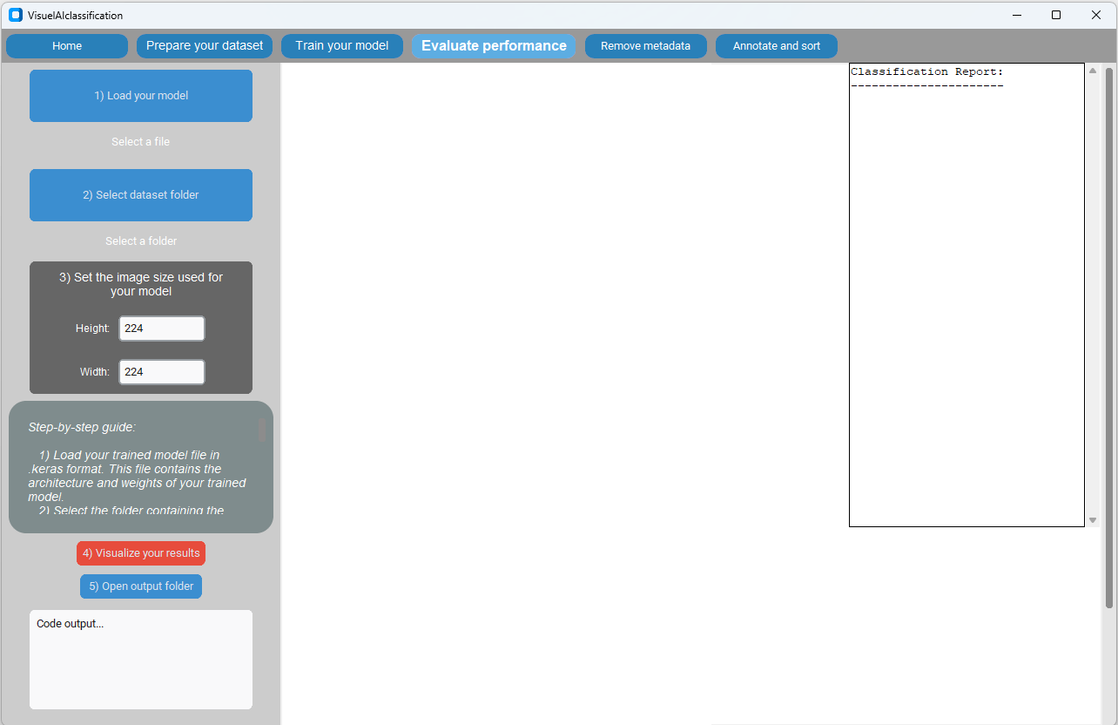
Figure S3. Model testing page to evaluate the performance of a model on a separate dataset.

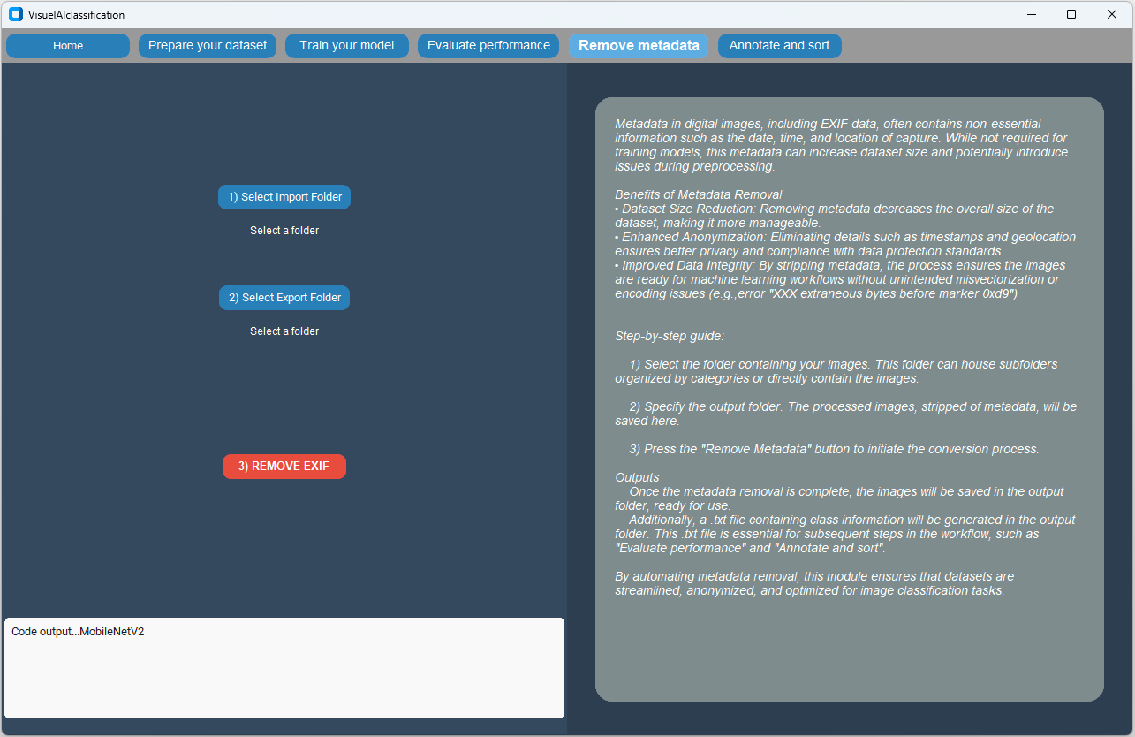
Figure S4. Removing metadata module. Minimalist and simple interface with explanations.

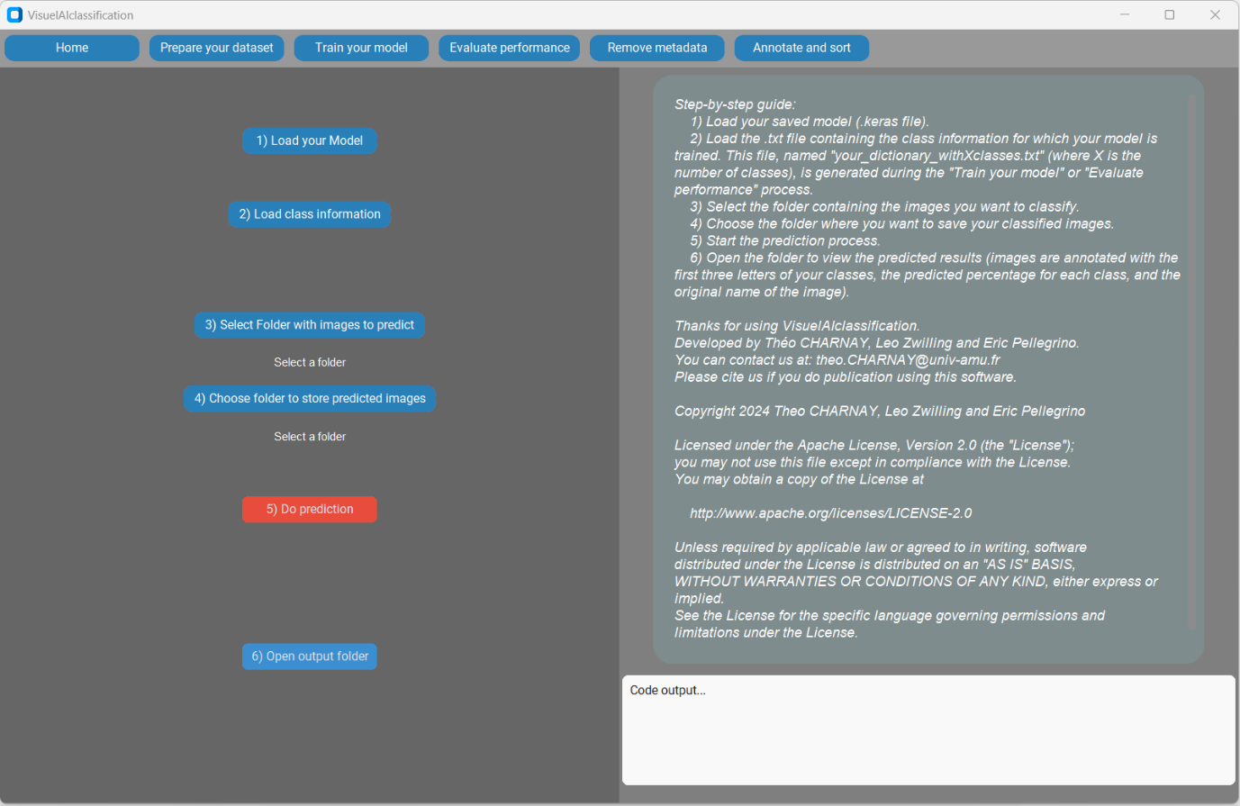
Figure S5. Image annotation with sorting module. Creates folders for your classes and creates copies of your images annotated with the first three letters of your classes, the predicted percentage for each class, and the original name of the image.

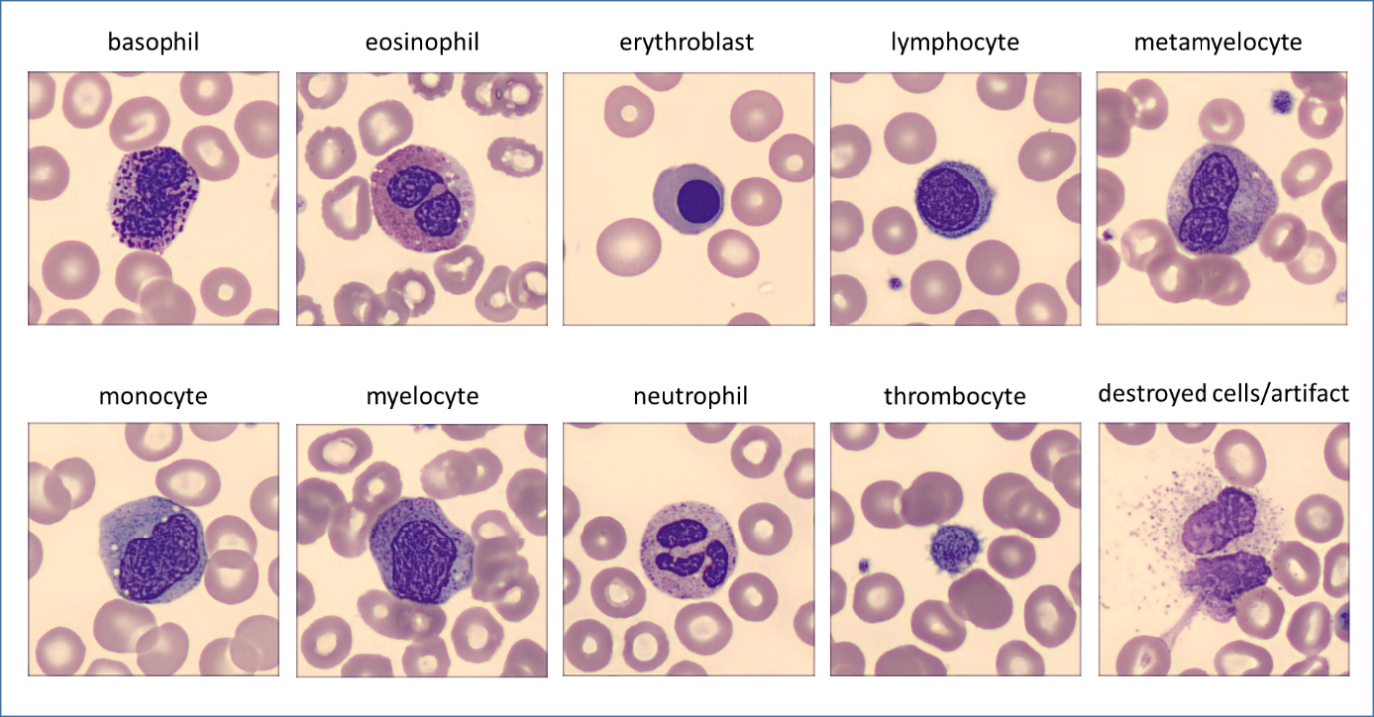
Figure S6. Representative image of each category. Dataset separated into 10 distinct categories: basophils, eosinophils, erythroblasts, lymphocytes, metamyelocytes, monocytes, myelocytes, neutrophils, thrombocytes, destroyed cells/artifact.

