Support Information for: QGeoSEP: A Novel Multitask Learning Framework Integrating Quantum, Geometric, and Semantic Features for Collaborative Prediction of Multiple Properties of Energetic Molecules

Mingchi Gao ^{1,2‡} Zhijiang Yang^{2‡} Tengxin Huang² Mingtian Li¹ Yingjun Zhang^{1*} Liangliang Wang^{2*} Junjie Ding^{2*}
1. School of Materials Science and Engineering, Sichuan University of Science and Engineering, Zigong, 643000, China
2. State Key Laboratory of Chemistry for NBC Hazards Protection, P. R. China.
‡Mingchi Gao and Zhijiang Yang contributed equally to this work.
* Corresponding authors: Yingjun Zhang, School of Materials Science and Engineering, Sichuan University of Science and Engineering, zhangyingjun@hrbeu.edu.cn; Liangliang Wang, State Key Laboratory of Chemistry for NBC Hazards Protection, P. R. China, wangliangliang@pku.org.cn; Junjie Ding, State Key Laboratory of Chemistry for NBC Hazards Protection, P. R. China, djj224@163.com

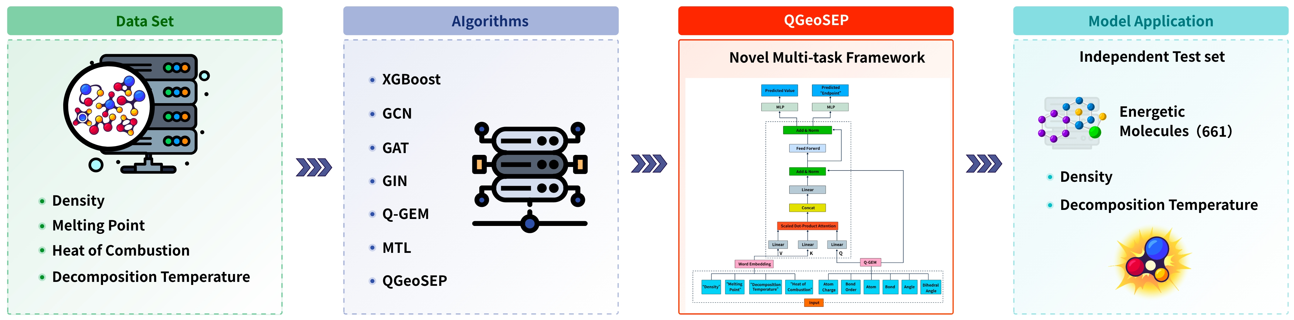
Keywords: Energetic molecule design; Multitask learning framework; Cross-modal feature integration; Collaborative property prediction; Geometric Graph Neural Network

Table S1 Detailed hyperparameter tuning configurations for each model
Model | Parameter | Tuning range | Step
XGBoost | Trees number | 500 ~ 1000 | +100
XGBoost | Learning rate | 10⁻¹ ~ 10⁻³ | ×10⁻¹
XGBoost | Maximum depth | 3 ~ 10 | +1
GCN/GAT/GIN | Hidden size | 50 ~ 300 | +50
GCN/GAT/GIN | Hidden layers | 5 ~ 8 | +1
GCN/GAT/GIN | Batch size | 2⁵ ~ 2⁸ | ×2
GCN/GAT/GIN | Learning rate | 0.0001,0.001, 0.01,0.05
GCN/GAT/GIN | Drop out | 0.2 ~ 0.5 | +0.1
Q-GEM | Hidden size | 256, 512 | -
Q-GEM | Hidden layers | 2, 3 | -
Q-GEM | Batch size | 128, 256, 512 | -
Q-GEM | Learning rate | 1e-3,1e-3; 1e-3,4e-3; 4e-3,4e-3;  4e-4,4e-3; 1e-4,1e-3; 1e-4,1e-4 | -
Q-GEM | Drop out | 0.1 ~ 0.5 | +0.1
MTL | Hidden size | 256, 512 | -
MTL | Hidden layers | 2, 3 | -
MTL | Batch size | 128, 256 | -
MTL | Learning rate | 1e-3,1e-3; 1e-3,4e-3; 4e-3,4e-3;  4e-4,4e-3; 1e-4,1e-3; 1e-4,1e-4 | -
MTL | Drop out | 0.1 ~ 0.5 | +0.1
Q-GeoSEP | Hidden size | 256, 512 | -
Q-GeoSEP | Hidden layers | 2, 3 | -
Q-GeoSEP | Batch size | 128, 256 | -
Q-GeoSEP | Learning rate | 1e-3,1e-3; 1e-3,4e-3; 4e-3,4e-3;  4e-4,4e-3; 1e-4,1e-3; 1e-4,1e-4 | -
Q-GeoSEP | Drop out | 0.0 ~ 0.5 | +0.1

Datasets Data Analysis
To comprehensively evaluate the transferability and scalability of the training model, we systematically characterized the structural features of the molecules within the dataset. As shown in Figure S1, the statistical analysis of the four property endpoints indicates that the density values are mainly distributed in the range of 1.0-1.5 g·cm⁻³; the peak of the melting point is concentrated around 400 K; the peak of the decomposition temperature occurs in the range of 450-500 K, with a broader distribution and higher dispersion than the melting point, suggesting greater variability in this range. The data for density, melting point, and decomposition temperature are basically normally distributed, while the combustion heat shows a right-skewed distribution. This indicates that molecules with extremely high combustion heat are extremely rare in the dataset. Such molecules typically require specific structures and their synthesis is significantly more difficult and dangerous than that of conventional molecules, resulting in scarce experimental data.
The molecular skeleton analysis results in Figure S2 reveal the high structural diversity of the dataset, covering aromatic structures such as benzene rings, chain-like carbon frameworks, and complex topological structures formed by the interconnection of multiple rings. This diverse skeleton composition directly reflects the complexity of the collected compounds at the structural level. In this study, the visualization of the above molecular structures was accomplished using the scopy software package developed by our research group, which effectively supports the drawing and analysis of molecular structures.
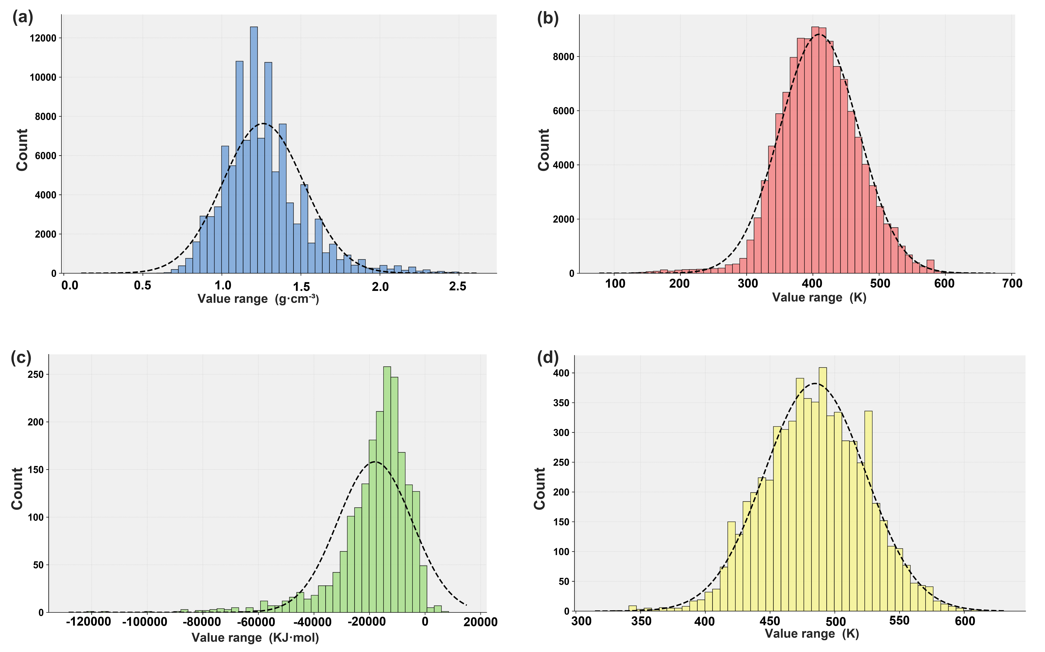
Fig S1. Distribution of endpoint data for four properties: (a) density; (b) melting point; (c) heat of combustion; (d) decomposition temperature
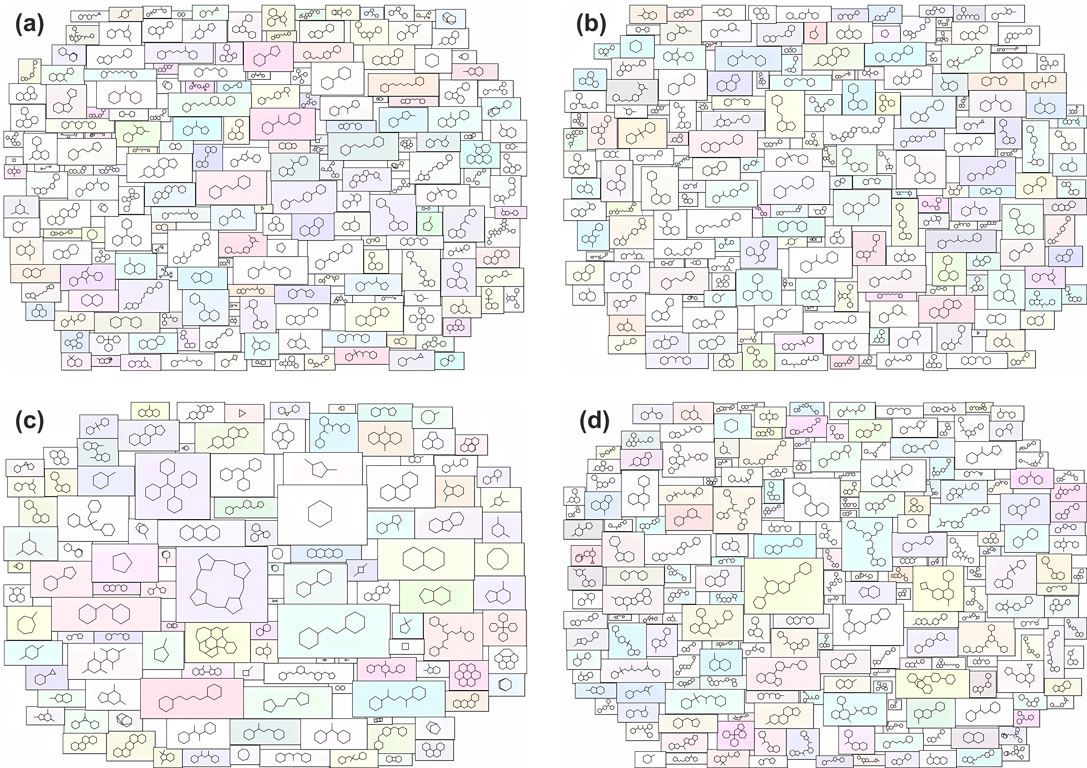
Fig S2. Four property endpoint data skeleton cloud diagrams: (a) density; (b) melting point; (c) heat of combustion; (d) decomposition temperature

