Figure1A_ Calcein AM_ 0μm
Figure1A_ Calcein AM_ 2μM
Figure1A_ Calcein AM_ 10μM
Figure1A_ Calcein AM_ 50μM
Figure1A_ Calcein AM_ 100μM

Figure1A_ Calcein PI_ 0μM
Figure1A_ Calcein PI_ 2μM
Figure1A_ Calcein PI_ 10μM
Figure1A_ Calcein PI_ 50μM
Figure1A_ Calcein PI_ 100μM

Figure1G_ EDU DAPI_ 0μM
Figure1G_ EDU 594_ 0μM
Figure1G_ EDU Merge_ 0μM
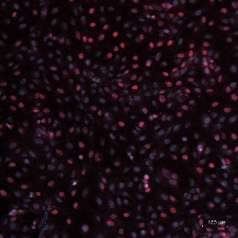
Figure1G_ EDU DAPI_ 2μM
Figure1G_ EDU 594_ 2μM
Figure1G_ EDU Merge_ 2μM
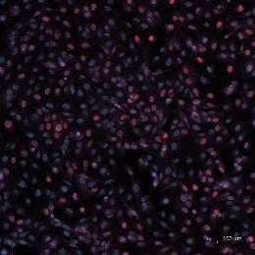
Figure1G_ EDU DAPI_ 10μM
Figure1G_ EDU 594_ 10μM
Figure1G_ EDU Merge_ 10μM
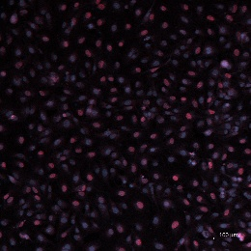
Figure1G_ EDU DAPI_ 50μM
Figure1G_ EDU 594_ 50μM
Figure1G_ EDU Merge_ 50μM
Figure1G_ EDU DAPI_ 100μM
Figure1G_ EDU 594_ 100μM
Figure1G_ EDU Merge_ 100μM

Figure2D_ Western Blot_COL1A1
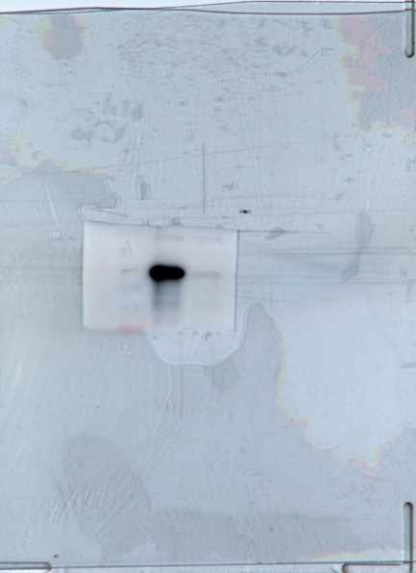
Figure2D_ Western Blot_ACTA2
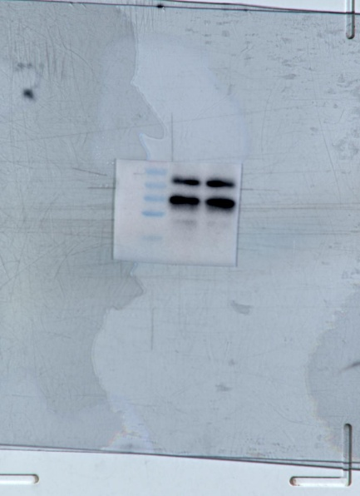
Figure2D_ Western Blot_GAPDH
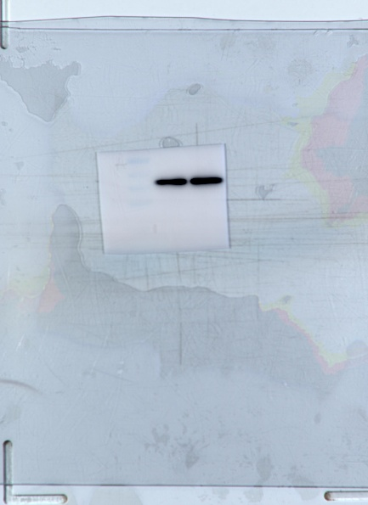

Figure2E_ Western Blot_ACTA2_1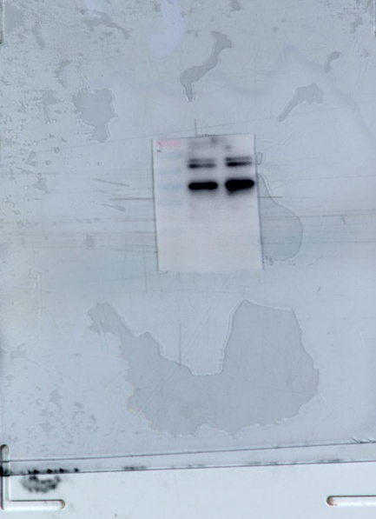

Figure2F_ Western Blot_COL1A1_1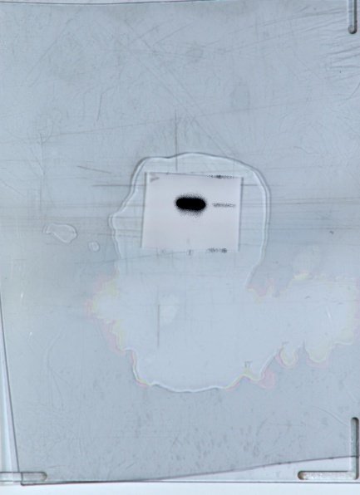

Figure2E, F_ Western Blot_GAPDH_1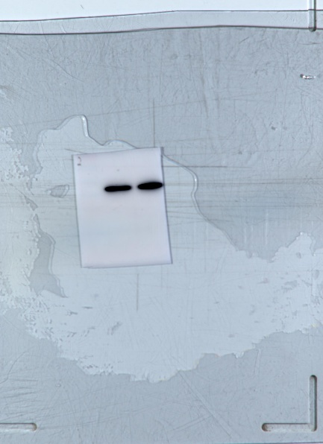

Figure2E_ Western Blot_ACTA2_2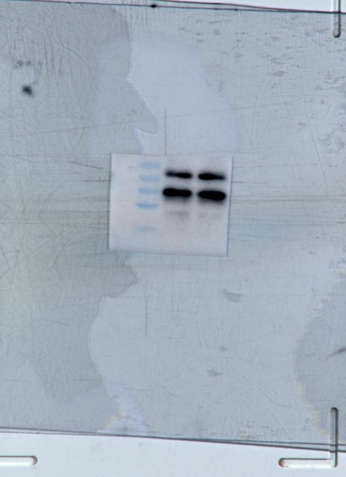
Figure2F_ Western Blot_COL1A1_2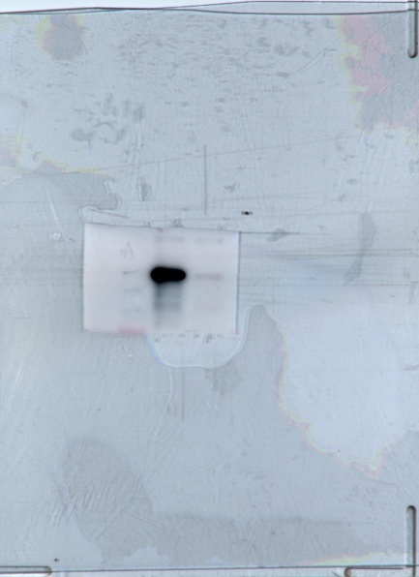
Figure2E,F_ Western Blot_GAPDH_2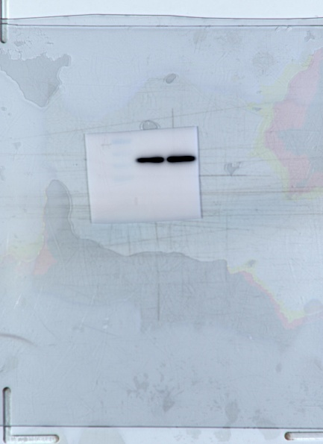

Figure2E_ Western Blot_ACTA2_3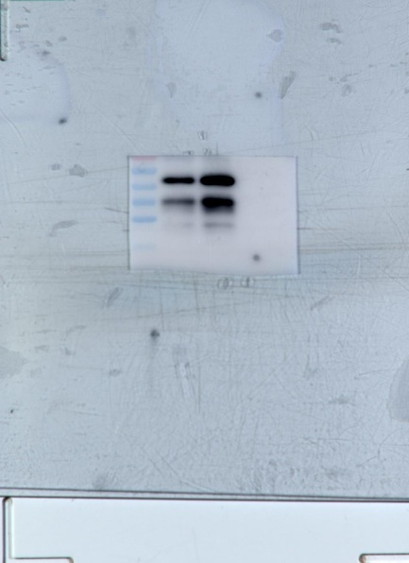
Figure2F_ Western Blot_COL1A1_3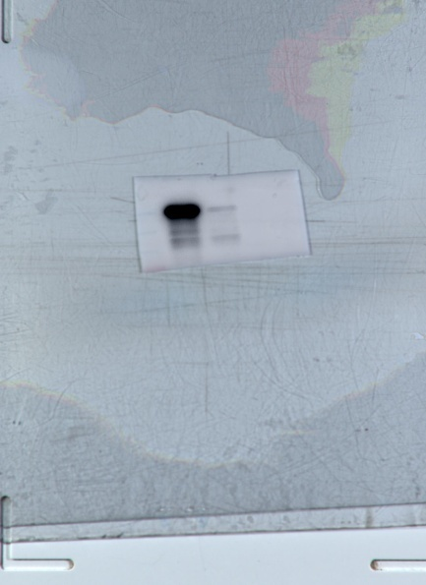
Figure2E, F_ Western Blot_GAPDH_3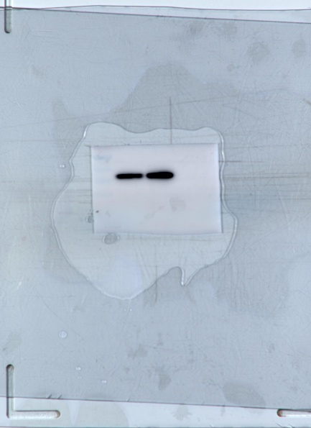

Figure2E_ Western Blot_ACTA2_4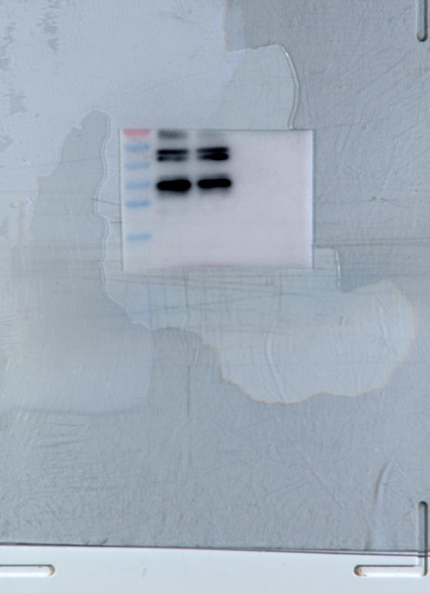
Figure2F_ Western Blot_COL1A1_4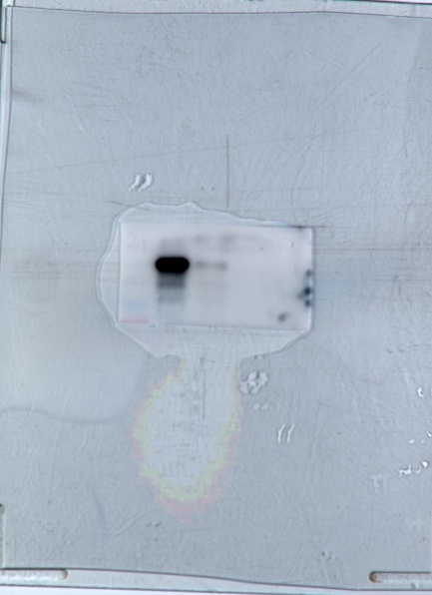
Figure2E,F_ Western Blot_GAPDH_4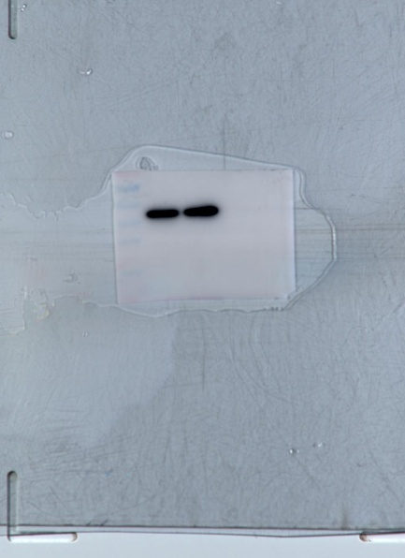

Figure3G_ Western Blot_ACTA2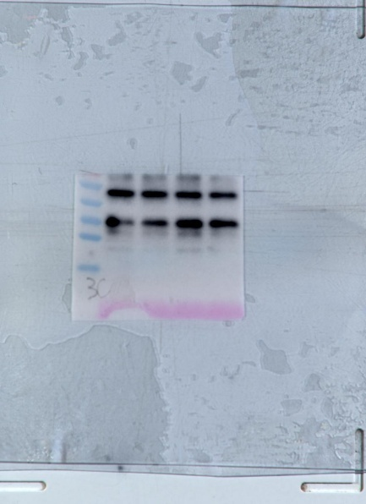
Figure3G_ Western Blot_COL1A1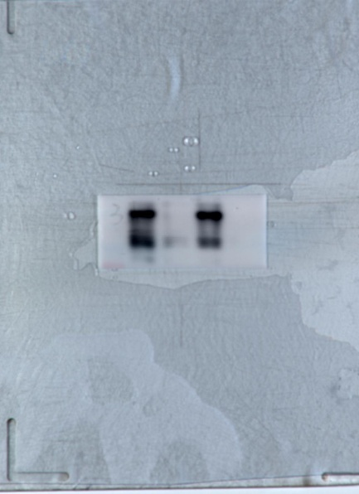
Figure3G_ Western Blot_GAPDH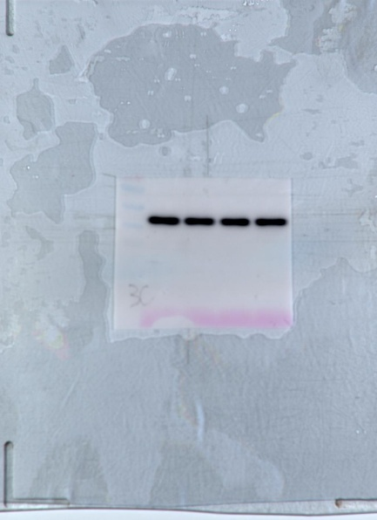

Figure3H_ Western Blot_ACTA2_1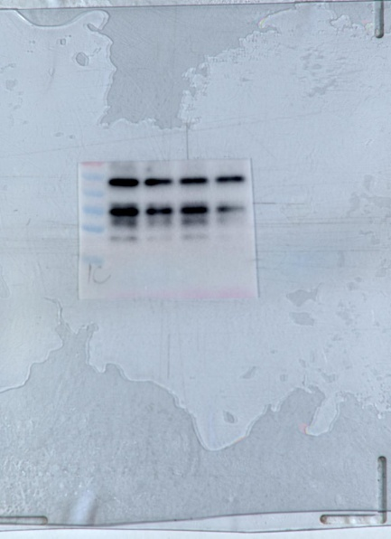
Figure3I_ Western Blot_COL1A1_1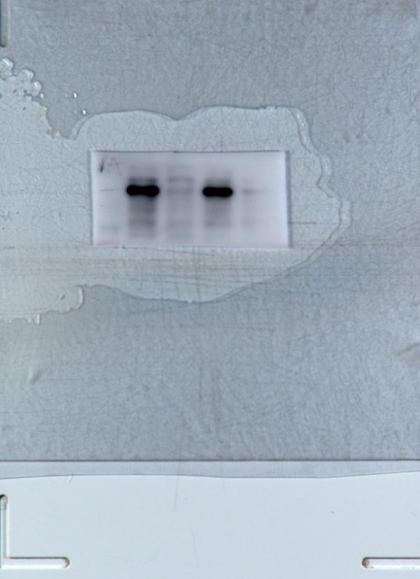
Figure3H,I_ Western Blot_GAPDH_1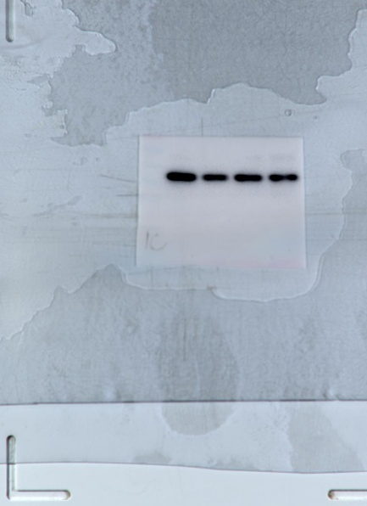

Figure3H_ Western Blot_ACTA2_2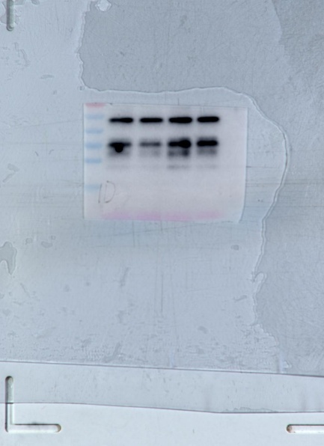
Figure3I_ Western Blot_COL1A1_2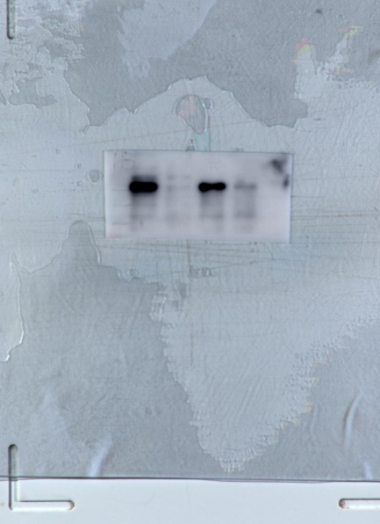
Figure3H,I_ Western Blot_GAPDH_2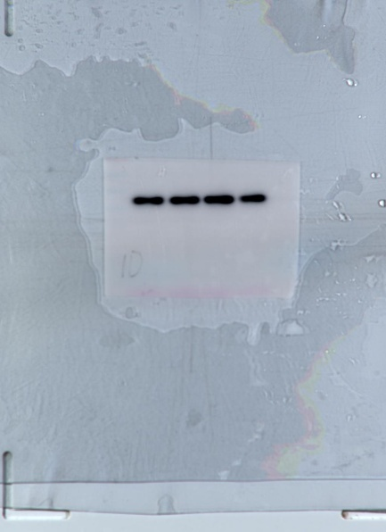

Figure3H_ Western Blot_ACTA2_3
Figure3I_ Western Blot_COL1A1_3
Figure3H,I_ Western Blot_GAPDH_3

Figure3H_ Western Blot_ACTA2_4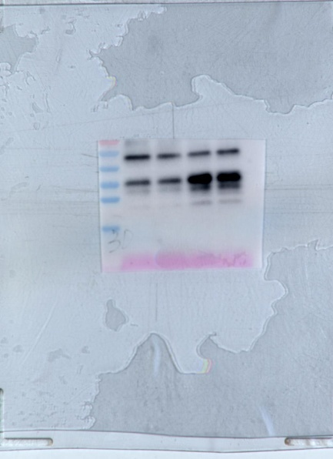
Figure3I_ Western Blot_COL1A1_4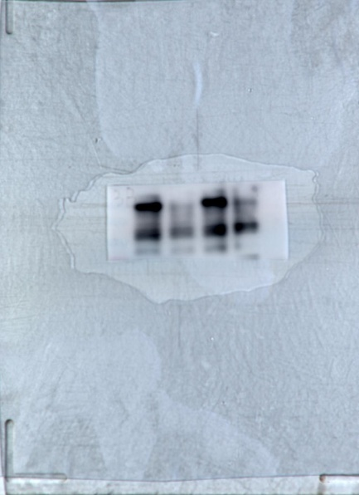
Figure3H,I_ Western Blot_GAPDH_4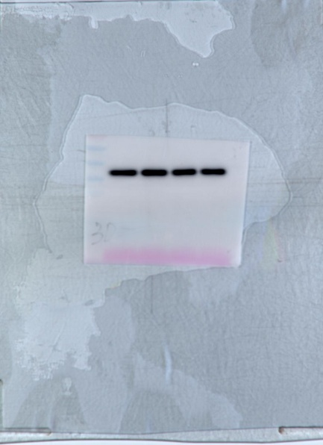

Figure4A_ Western Blot_SQSTM1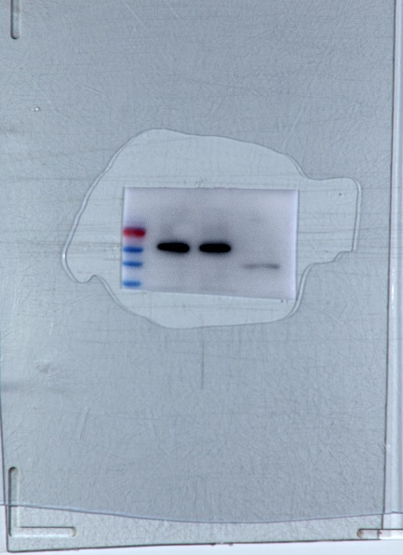
Figure4A_ Western Blot_LC3B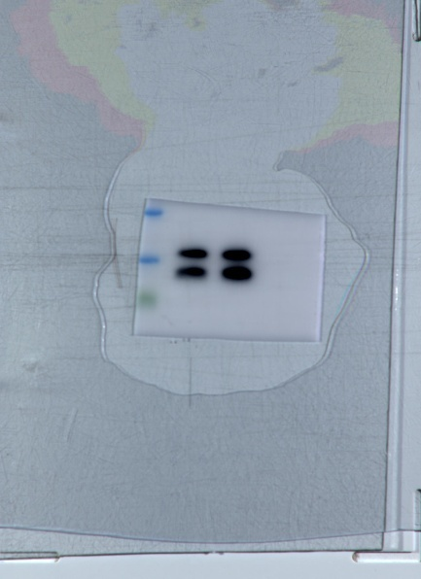
Figure4A_ Western Blot_GAPDH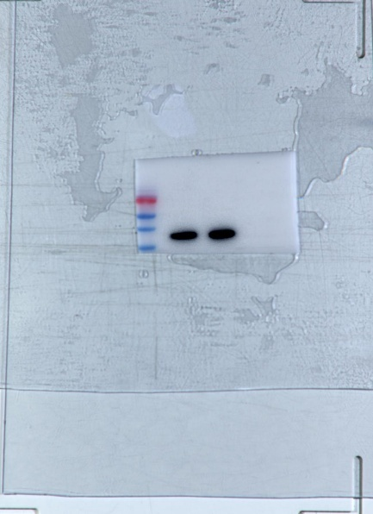

Figure4B_ Western Blot_SQSTM1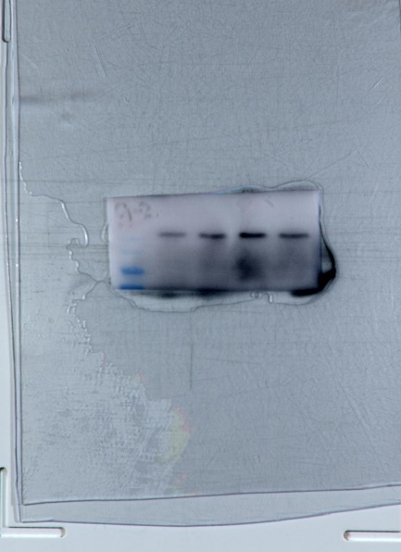
Figure4D_ Western Blot_LC3B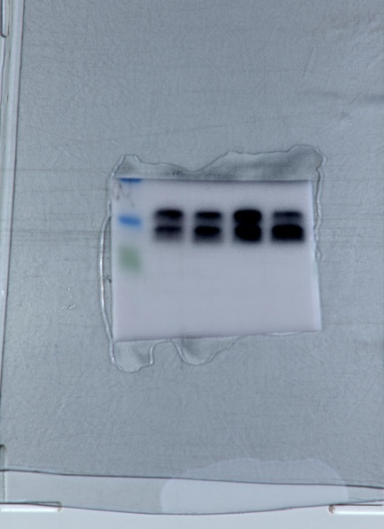
Figure4D_ Western Blot_GAPDH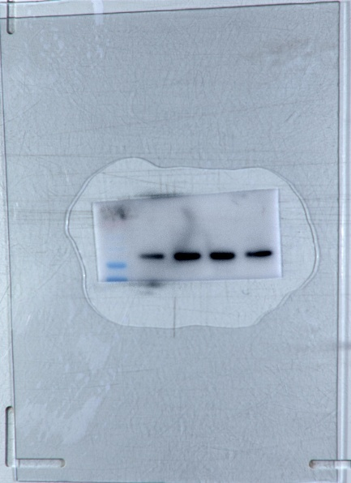

Figure4C_Ctrl_GFP
Figure4C_ Ctrl _mCherry
Figure4C_ Ctrl _Merge

Figure4C_Lificiguat _GFP
Figure4C_Lificiguat _mCherry
Figure4C_Lificiguat _Merge

Figure4C_Rapamycin _GFP
Figure4C_Rapamycin _mCherry
Figure4C_Rapamycin _Merge

Figure4D_Ctrl
_GFP_1
Figure4D_ Ctrl
_mCherry_1
Figure4D_ Ctrl
_Merge_1

Figure4D_Ctrl
_GFP_2
Figure4D_ Ctrl
_mCherry_2
Figure4D_ Ctrl
_Merge_2

Figure4D_Ctrl
_GFP_3
Figure4D_ Ctrl
_mCherry_3
Figure4D_ Ctrl
_Merge_3

Figure4D_Lificiguat
_GFP_1
Figure4D_Lificiguat
_mCherry_1
Figure4D_Lificiguat
_Merge_1

Figure4D_Lificiguat
_GFP_2
Figure4D_Lificiguat
_mCherry_2
Figure4D_Lificiguat
_Merge_2

Figure4D_Lificiguat
_GFP_3
Figure4D_Lificiguat
_mCherry_3
Figure4D_Lificiguat
_Merge_3

Figure4D_Lificiguat
_GFP_4
Figure4D_Lificiguat
_mCherry_4
Figure4D_Lificiguat
_Merge_4

Figure4D_Rapamycin
_GFP_1
Figure4D_Rapamycin
_mCherry_1
Figure4D_Rapamycin
_Merge_1

Figure4D_Rapamycin
_GFP_2
Figure4D_Rapamycin
_mCherry_2
Figure4D_Rapamycin
_Merge_2

Figure4D_Rapamycin
_GFP_3
Figure4D_Rapamycin
_mCherry_3
Figure4D_Rapamycin
_Merge_3

Figure4D_Rapamycin
_GFP_4
Figure4D_Rapamycin
_mCherry_4
Figure4D_Rapamycin
_Merge_4

Figure5G_ Western Blot_ACTA2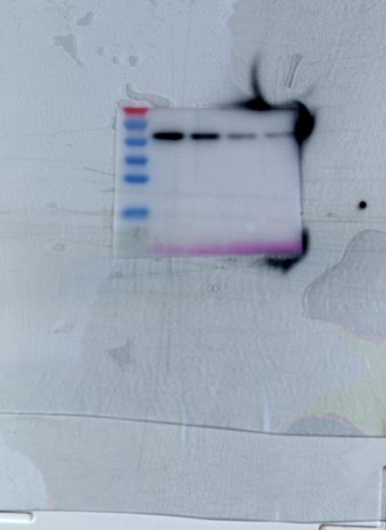
Figure5G_ Western Blot_COL1A1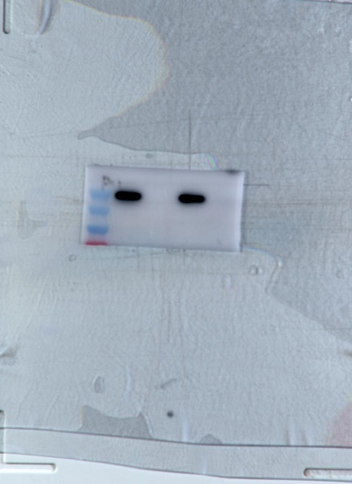
Figure5G_ Western Blot_GAPDH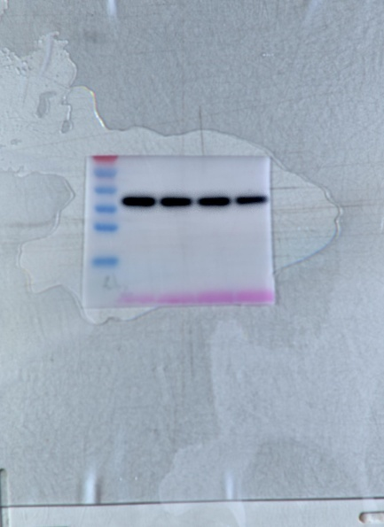

Figure5H_ Western Blot_ACTA2_1
Figure5I_ Western Blot_COL1A1_1
Figure5H,I_ Western Blot_GAPDH_1

Figure5H_ Western Blot_ACTA2_2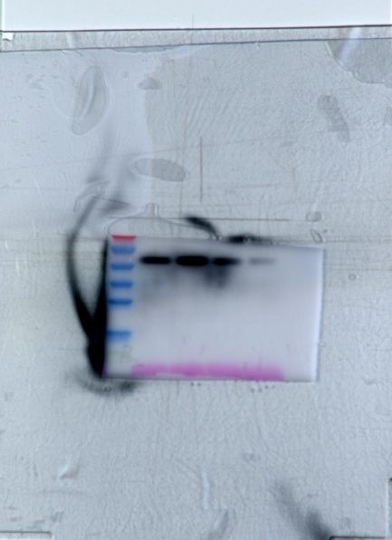
Figure5I_ Western Blot_COL1A1_2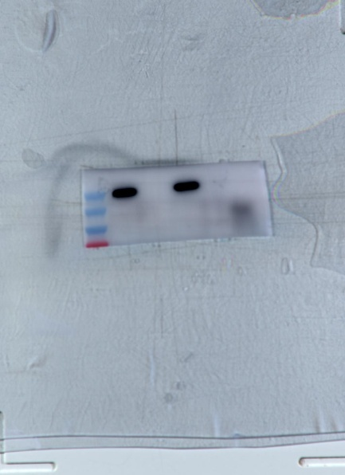
Figure5H,I_ Western Blot_GAPDH_2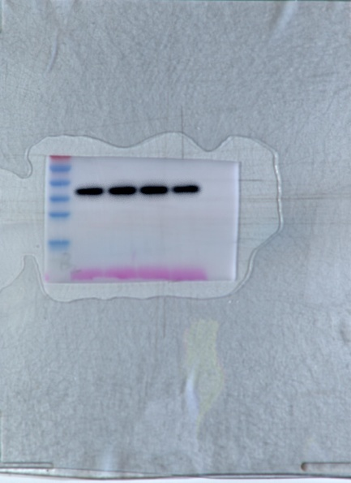

Figure5H_ Western Blot_ACTA2_3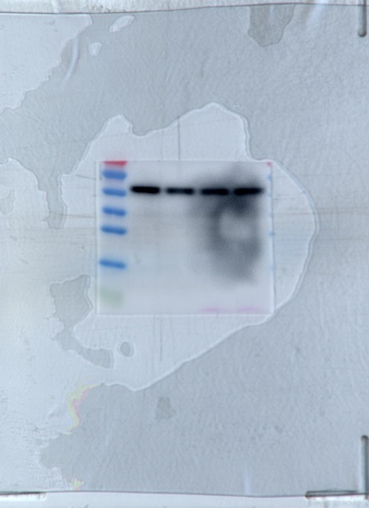
Figure5I_ Western Blot_COL1A1_3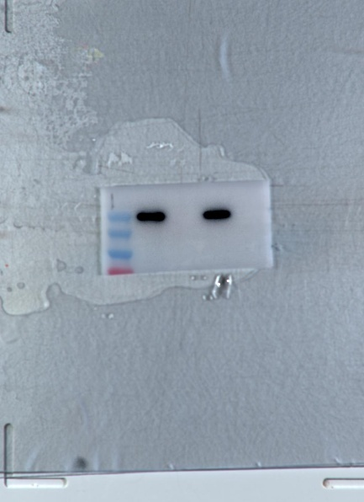
Figure5H,I_ Western Blot_GAPDH_3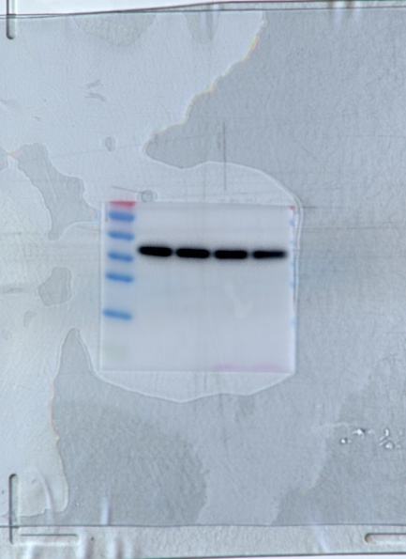

Figure5H_ Western Blot_ACTA2_4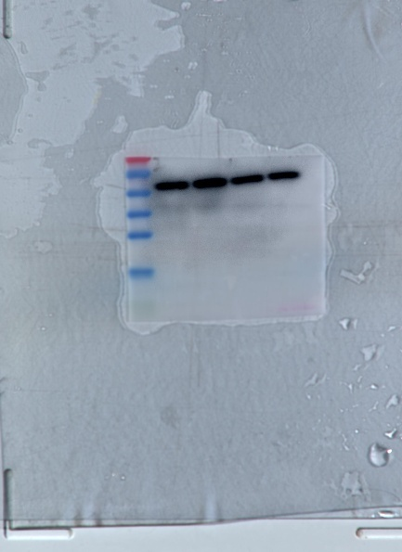
Figure5I_ Western Blot_COL1A1_4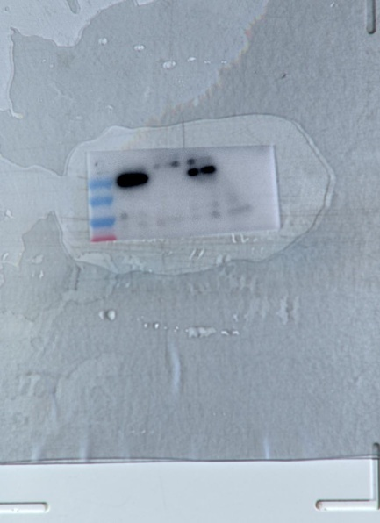
Figure5H,I_ Western Blot_GAPDH_4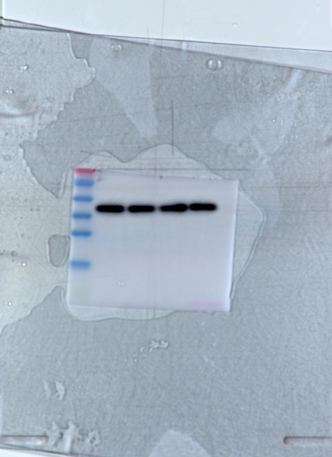

Figure6A_ Volcano plot of DEGs
Figure6B_Heatmap of DEGs
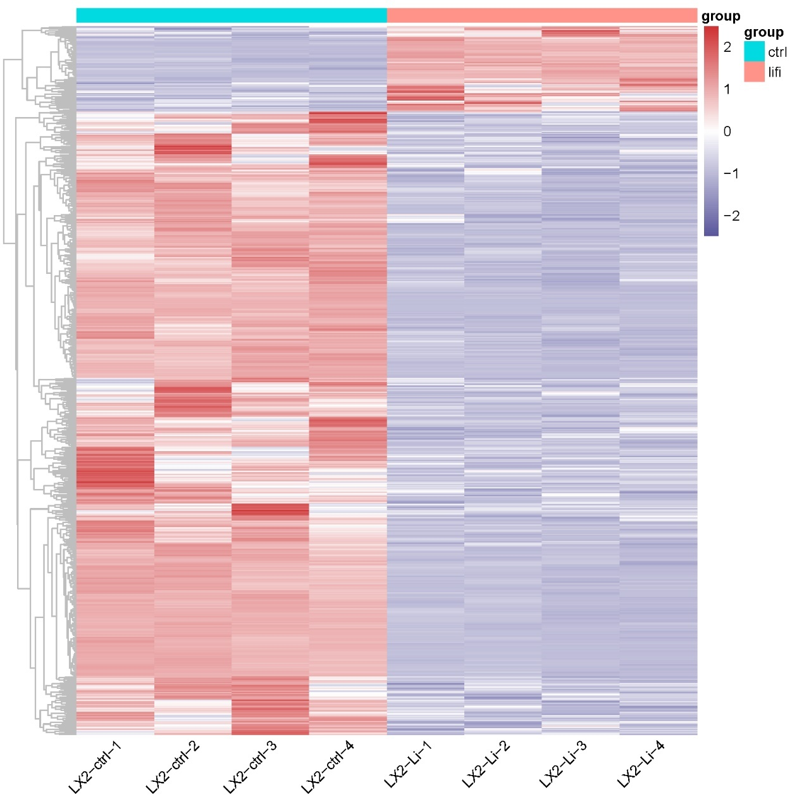
Figure6C_ GO classification of DEGs.
Figure6D_ KEGG classification of DEGs
Figure6E_ GSEA of DEGs
Figure6F_ Heatmap of normalized expression for cytokine- and extracellular matrix-related DEGs
Figure6G_ JAK-STAT signaling pathway
Figure6H_ ECM-receptor interaction pathway
Figure6I_ IL-17 signaling pathway
Figure7G _Masson trichrome staining and sirius red staining of liver sections collected from control mice, CCl4-challenged mice treated with or without lificiguat.

