TableS1 Caregiving ability of caregivers between control group and intervention group
Items | Intervention group (n=51) | Control group (n=51) | P value
FCTI
Total scores | 18（17-20） | 18（16-20） | 0.497
Learning to cope with new role | 4（2-5） | 4（2-5） | 0.894
Providing care according to care-receiver’s needs | 3（3-4） | 3（2-4） | 0.444
Managing own emotional needs | 3（3-4） | 3（3-4） | 0.749
Appraising supportive resources | 4（3-4） | 4（3-4） | 0.409
Balancing caregiving needs and own needs | 4（4-5） | 4（4-5） | 0.803
ZBI
Total scores | 34.86±8.81 | 34.45±10.00 | 0.826
Personal strain | 17.33±4.28 | 17.06±4.65 | 0.757
Role strain | 9.39±3.45 | 9.29±4.00 | 0.895
SF-36
Total scores | 499.29±25.66 | 506.78±24.65 | 0.136
Physical functioning (PF) | 75（75-80） | 80（75-85） | 0.290
Role-physical (RP) | 50（50-75） | 75（50-75） | 0.168
Bodily pain (BP) | 72（62-84） | 72（72-84） | 0.214
General health（GH) | 62（57-62） | 62（57-62） | 0.457
Vitality（VT） | 55（50-55） | 50（45-60） | 0.604
Social functioning（SF） | 62.5（50-62.5） | 50（50-62.5） | 0.571
Role-emotional（RE） | 66.67（66.67-66.67） | 66.67（66.67-66.67） | 0.632
Mental health（MH） | 56（52-64） | 56（52-64） | 0.796

Table S2 Caregiving abilities of caregivers between the two groups after intervention
Items | Group | Baseline | Discharge | Discharged 3 months | Discharged 6 months
FCTI
Total scores | intervention group (n=51) | 18（17-20） | 13（12-14） | 9（8-10） | 7（6-8）
Total scores | control group(n=51) | 18（16-20） | 15（14-16） | 12（11-13） | 11（9-11）
Total scores | P value | 0.497 | ＜0.001 | ＜0.001 | ＜0.001
Learning to cope with new role | intervention group (n=51) | 4(2-5） | 2(2-3) | 2(1-2) | 1(1-2)
Learning to cope with new role | control group(n=51) | 4(2-5) | 3(2-3) | 2(2-3) | 2(1-2)
Learning to cope with new role | P value | 0.894 | 0.003 | ＜0.001 | 0.001
Providing care according to care-receiver’s needs | intervention group (n=51) | 3(3-4) | 3(2-3) | 2(1-2) | 1(1-1)
Providing care according to care-receiver’s needs | control group(n=51) | 3(2-4) | 3(2-3) | 2(2-3) | 2(2-2)
Providing care according to care-receiver’s needs | P value | 0.444 | 0.040 | ＜0.001 | ＜0.001
Managing own emotional needs | intervention group (n=51) | 3（3-4） | 2（2-2） | 2（1-2） | 1（1-1）
Managing own emotional needs | control group(n=51) | 3（3-4） | 2（2-3） | 2（2-2） | 2（1-2）
Managing own emotional needs | P value | 0.749 | ＜0.001 | ＜0.001 | ＜0.001
Appraising supportive resources | intervention group (n=51) | 4（3-4） | 3（2-3） | 2（2-2） | 1（1-2）
Appraising supportive resources | control group(n=51) | 4（3-4） | 3（3-4） | 3（2-3） | 2（2-3）
Appraising supportive resources | P value | 0.409 | 0.002 | ＜0.001 | ＜0.001
Balancing caregiving needs and own needs | intervention group (n=51) | 4（4-5） | 3（3-3） | 2（2-3） | 2（2-2）
Balancing caregiving needs and own needs | control group(n=51) | 4（4-5） | 4（3-4） | 3（3-3） | 3（2-3）
Balancing caregiving needs and own needs | P value | 0.803 | ＜0.001 | ＜0.001 | ＜0.001
ZBI
Total scores | intervention group (n=51) | 34.86±8.81 | 30.18±5.26 | 29.45±4.97 | 27(25-30)
 | control group(n=51) | 34.45±10.01 | 32.88±5.86 | 32.37±5.64 | 30(28-33)
 | P value | 0.826 | 0.016 | 0.007 | ＜0.001
Personal strain | intervention group (n=51) | 17.33±4.28 | 15（14-17） | 15（13-16） | 14（12-15）
 | control group(n=51) | 17.06±4.65 | 16（15-18） | 16（14-17） | 15（14-17）
 | P value | 0.757 | 0.016 | 0.006 | ＜0.001
Role strain | intervention group (n=51) | 9.39±3.45 | 8（7-9） | 8（7-9） | 7（6-8）
 | control group(n=51) | 9.29±4.00 | 8（8-10） | 8（8-9） | 8（7-9）
 | P value | 0.895 | 0.039 | 0.006 | 0.002
SF-36
Total scores | intervention group (n=51) | 499.29±25.66 | 478.46±25.11 | 569.27±28.37 | 644.10±28.65
 | control group(n=51) | 506.78±24.65 | 464.66±28.14 | 500.26±26.29 | 552.42±30.84
 | P value | 0.136 | 0.010 | ＜0.001 | ＜0.001
Physical functioning (PF) | intervention group (n=51) | 75（75-80） | 75（70-80） | 85（80-85） | 90（90-95）
Physical functioning (PF) | control group(n=51) | 80（75-85） | 75（70-80） | 80（70-80） | 85（80-85）
 | P value | 0.290 | 0.060 | ＜0.001 | ＜0.001
Role-physical (RP) | intervention group (n=51) | 50（50-75） | 50（50-75） | 75（75-75） | 75（75-100）
Role-physical (RP) | control group(n=51) | 75（50-75） | 50（50-75） | 75（50-75） | 75（50-75）
 | P value | 0.168 | 0.687 | 0.024 | ＜0.001
Bodily pain (BP) | intervention group (n=51) | 72（62-84） | 62（62-72） | 84（72-84） | 84（84-84）
Bodily pain (BP) | control group(n=51) | 72（72-84） | 62（62-72） | 72（62-84） | 84（72-84）
 | P value | 0.214 | 0.341 | 0.008 | ＜0.001
General health（GH) | intervention group (n=51) | 62（57-62） | 57（57-62） | 72（67-72） | 80（77-85）
General health（GH) | control group(n=51) | 62（57-62） | 57（57-62） | 62（57-62） | 72（67-77）
 | P value | 0.457 | 0.992 | ＜0.001 | ＜0.001
Vitality（VT） | intervention group (n=51) | 55（50-55） | 55（50-60） | 70（65-75） | 79.31±7.68
Vitality（VT） | control group(n=51) | 50（45-60） | 50（50-55） | 60（50-65） | 60.88±9.20
 | P value | 0.604 | 0.008 | ＜0.001 | ＜0.001
Social functioning（SF） | intervention group (n=51) | 62.5（50-62.5） | 50（50-62.5） | 62.5（50-62.5） | 75（75-87.5）
Social functioning（SF） | control group(n=51) | 50（50-62.5） | 50（37.5-50） | 50（50-62.5） | 62.5（50-75）
 | P value | 0.571 | 0.034 | 0.004 | ＜0.001
Role-emotional（RE） | intervention group (n=51) | 66.67（66.67-66.67） | 66.67（33.33-66.67） | 66.67（66.67-66.67） | 66.67（66.67-100）
Role-emotional（RE） | control group(n=51) | 66.67（66.67-66.67） | 66.67（33.33-66.67） | 66.67（33.33-66.67） | 66.67（66.67-66.67）
 | P value | 0.632 | 0.684 | ＜0.001 | ＜0.001
Mental health（MH） | intervention group (n=51) | 56（52-64） | 59.22±9.83 | 68（64-72） | 72（72-80）
Mental health（MH） | control group(n=51) | 56（52-64） | 54.82±7.73 | 56（52-60） | 60（56-64）
 | P value | 0.796 | 0.014 | ＜0.001 | ＜0.001

TableS3 Distribution of patients and caregivers in each trajectory group of the intervention group

Variable | FCTI |  |  |  | SF-36 |  |  | ZBI
Variable | N | Class1,  N = 9¹ | Class2,  N = 42¹ | p-value² | Class1,  N = 21¹ | Class2,  N = 30¹ | p-value³ | Class1,  N = 35¹ | Class2,  N = 10¹ | Class3,  N = 6¹ | p-value⁴
Patients with decompensated liver cirrhosis
Gender | 51 |  |  | >0.9 |  |  | >0.9 |  |  |  | 0.2
Male |  | 7 (78%) | 32 (76%) |  | 16 (76%) | 23 (77%) |  | 27 (77%) | 6 (60%) | 6 (100%)
Female |  | 2 (22%) | 10 (24%) |  | 5 (24%) | 7 (23%) |  | 8 (23%) | 4 (40%) | 0 (0%)
Age | 51 | 52 (50, 54) | 54 (51, 60) | 0.14 | 54 (52, 60) | 54 (50, 60) | 0.9 | 56 (53, 63) | 52 (50, 54) | 53 (51, 54) | 0.15
Education level | 51 |  |  | 0.8 |  |  | 0.2 |  |  |  | 0.7
Primary school and below |  | 2 (22%) | 15 (36%) |  | 7 (33%) | 10 (33%) |  | 11 (31%) | 5 (50%) | 1 (17%)
Junior high school |  | 4 (44%) | 11 (26%) |  | 9 (43%) | 6 (20%) |  | 9 (26%) | 3 (30%) | 3 (50%)
Senior high school / Vocational college |  | 1 (11%) | 6 (14%) |  | 1 (4.8%) | 6 (20%) |  | 5 (14%) | 1 (10%) | 1 (17%)
Undergraduate and above |  | 2 (22%) | 10 (24%) |  | 4 (19%) | 8 (27%) |  | 10 (29%) | 1 (10%) | 1 (17%)
Work status | 51 |  |  | 0.12 |  |  | 0.14 |  |  |  | 0.13
Farmer |  | 5 (56%) | 23 (55%) |  | 14 (67%) | 14 (47%) |  | 22 (63%) | 3 (30%) | 3 (50%)
Unemployed |  | 4 (44%) | 6 (14%) |  | 1 (4.8%) | 9 (30%) |  | 4 (11%) | 5 (50%) | 1 (17%)
Retire |  | 0 (0%) | 8 (19%) |  | 4 (19%) | 4 (13%) |  | 5 (14%) | 2 (20%) | 1 (17%)
Other |  | 0 (0%) | 5 (12%) |  | 2 (9.5%) | 3 (10%) |  | 4 (11%) | 0 (0%) | 1 (17%)
Marriage | 51 |  |  | >0.9 |  |  | 0.2 |  |  |  | 0.5
Married |  | 8 (89%) | 37 (88%) |  | 17 (81%) | 28 (93%) |  | 30 (86%) | 10 (100%) | 5 (83%)
Unmarried |  | 1 (11%) | 5 (12%) |  | 4 (19%) | 2 (6.7%) |  | 5 (14%) | 0 (0%) | 1 (17%)
Time of detecting liver cirrhosis | 51 |  |  | 0.5 |  |  | >0.9 |  |  |  | 0.076
<1 year |  | 4 (44%) | 22 (52%) |  | 12 (57%) | 14 (47%) |  | 21 (60%) | 3 (30%) | 2 (33%)
1-5 years |  | 3 (33%) | 10 (24%) |  | 5 (24%) | 8 (27%) |  | 8 (23%) | 4 (40%) | 1 (17%)
6-10 years |  | 2 (22%) | 4 (9.5%) |  | 2 (9.5%) | 4 (13%) |  | 2 (5.7%) | 1 (10%) | 3 (50%)
＞10 years |  | 0 (0%) | 6 (14%) |  | 2 (9.5%) | 4 (13%) |  | 4 (11%) | 2 (20%) | 0 (0%)
Understanding of liver cirrhosis | 51 |  |  | 0.9 |  |  | 0.3 |  |  |  | 0.2
Very familiar |  | 1 (11%) | 5 (12%) |  | 3 (14%) | 3 (10%) |  | 4 (11%) | 1 (10%) | 1 (17%)
Fairly familiar |  | 2 (22%) | 7 (17%) |  | 3 (14%) | 6 (20%) |  | 8 (23%) | 1 (10%) | 0 (0%)
Moderately familiar |  | 4 (44%) | 14 (33%) |  | 5 (24%) | 13 (43%) |  | 9 (26%) | 7 (70%) | 2 (33%)
Not familiar |  | 2 (22%) | 16 (38%) |  | 10 (48%) | 8 (27%) |  | 14 (40%) | 1 (10%) | 3 (50%)
Types of medical expenses | 51 |  |  | 0.4 |  |  | 0.2 |  |  |  | 0.2
Government-funded healthcare |  | 3 (33%) | 6 (14%) |  | 2 (9.5%) | 7 (23%) |  | 5 (14%) | 4 (40%) | 0 (0%)
New rural cooperative medical scheme |  | 5 (56%) | 30 (71%) |  | 14 (67%) | 21 (70%) |  | 26 (74%) | 4 (40%) | 5 (83%)
Medical insurance |  | 1 (11%) | 6 (14%) |  | 5 (24%) | 2 (6.7%) |  | 4 (11%) | 2 (20%) | 1 (17%)
Child-Pugh grade | 51 |  |  | >0.9 |  |  | 0.9 |  |  |  | 0.4
Class B |  | 4 (44%) | 21 (50%) |  | 10 (48%) | 15 (50%) |  | 18 (51%) | 3 (30%) | 4 (67%)
Class C |  | 5 (56%) | 21 (50%) |  | 11 (52%) | 15 (50%) |  | 17 (49%) | 7 (70%) | 2 (33%)
Caregiver General Information
Gender | 51 |  |  | 0.7 |  |  | 0.5 |  |  |  | 0.2
Male |  | 2 (22%) | 13 (31%) |  | 5 (24%) | 10 (33%) |  | 11 (31%) | 4 (40%) | 0 (0%)
Female |  | 7 (78%) | 29 (69%) |  | 16 (76%) | 20 (67%) |  | 24 (69%) | 6 (60%) | 6 (100%)
Age | 51 | 51 (45, 52) | 52 (44, 57) | 0.3 | 54 (50, 57) | 51 (43, 55) | 0.13 | 52 (44, 57) | 51 (50, 52) | 51 (44, 54) | 0.8
Education level | 51 |  |  | 0.6 |  |  | 0.032 |  |  |  | 0.6
Primary school and below |  | 4 (44%) | 22 (52%) |  | 15 (71%) | 11 (37%) |  | 18 (51%) | 4 (40%) | 4 (67%)
Junior high school |  | 3 (33%) | 6 (14%) |  | 4 (19%) | 5 (17%) |  | 5 (14%) | 3 (30%) | 1 (17%)
Senior high school / Vocational college |  | 2 (22%) | 9 (21%) |  | 1 (4.8%) | 10 (33%) |  | 8 (23%) | 3 (30%) | 0 (0%)
Undergraduate and above |  | 0 (0%) | 5 (12%) |  | 1 (4.8%) | 4 (13%) |  | 4 (11%) | 0 (0%) | 1 (17%)
Marriage | 51 |  |  | 0.3 |  |  | >0.9 |  |  |  | 0.3
Married |  | 8 (89%) | 41 (98%) |  | 20 (95%) | 29 (97%) |  | 34 (97%) | 10 (100%) | 5 (83%)
Unmarried |  | 1 (11%) | 1 (2.4%) |  | 1 (4.8%) | 1 (3.3%) |  | 1 (2.9%) | 0 (0%) | 1 (17%)
Relationship with patient | 51 |  |  | 0.7 |  |  | 0.7 |  |  |  | 0.6
Spouse |  | 6 (67%) | 30 (71%) |  | 14 (67%) | 22 (73%) |  | 23 (66%) | 9 (90%) | 4 (67%)
Child/daughter-in-law/son-in-law |  | 1 (11%) | 7 (17%) |  | 3 (14%) | 5 (17%) |  | 7 (20%) | 0 (0%) | 1 (17%)
Other |  | 2 (22%) | 5 (12%) |  | 4 (19%) | 3 (10%) |  | 5 (14%) | 1 (10%) | 1 (17%)
Monthly family income | 51 |  |  | 0.5 |  |  | 0.5 |  |  |  | 0.5
Less than 1000 yuan |  | 5 (56%) | 19 (45%) |  | 12 (57%) | 12 (40%) |  | 17 (49%) | 5 (50%) | 2 (33%)
1000-2000 yuan |  | 1 (11%) | 13 (31%) |  | 6 (29%) | 8 (27%) |  | 10 (29%) | 1 (10%) | 3 (50%)
3000-5000 yuan |  | 2 (22%) | 4 (9.5%) |  | 1 (4.8%) | 5 (17%) |  | 3 (8.6%) | 2 (20%) | 1 (17%)
Over 5000 yuan |  | 1 (11%) | 6 (14%) |  | 2 (9.5%) | 5 (17%) |  | 5 (14%) | 2 (20%) | 0 (0%)
Daily care time for patient | 51 |  |  | 0.3 |  |  | 0.2 |  |  |  | 0.3
Within 4h |  | 1 (11%) | 15 (36%) |  | 7 (33%) | 9 (30%) |  | 14 (40%) | 2 (20%) | 0 (0%)
4-12h |  | 4 (44%) | 17 (40%) |  | 6 (29%) | 15 (50%) |  | 13 (37%) | 5 (50%) | 3 (50%)
More than 12h |  | 4 (44%) | 10 (24%) |  | 8 (38%) | 6 (20%) |  | 8 (23%) | 3 (30%) | 3 (50%)
Having a co-caregiver | 51 |  |  | >0.9 |  |  | 0.7 |  |  |  | 0.001
Yes |  | 1 (11%) | 5 (12%) |  | 3 (14%) | 3 (10%) |  | 1 (2.9%) | 5 (50%) | 0 (0%)
No |  | 8 (89%) | 37 (88%) |  | 18 (86%) | 27 (90%) |  | 34 (97%) | 5 (50%) | 6 (100%)
Work status | 51 |  |  | >0.9 |  |  | 0.8 |  |  |  | >0.9
Employed |  | 5 (56%) | 24 (57%) |  | 13 (62%) | 16 (53%) |  | 20 (57%) | 5 (50%) | 4 (67%)
Retire |  | 1 (11%) | 5 (12%) |  | 2 (9.5%) | 4 (13%) |  | 4 (11%) | 1 (10%) | 1 (17%)
Unemployed |  | 3 (33%) | 13 (31%) |  | 6 (29%) | 10 (33%) |  | 11 (31%) | 4 (40%) | 1 (17%)
¹Median (IQR); n (%)
²Wilcoxon rank sum exact test; Fisher's exact test; Wilcoxon rank sum test
³Wilcoxon rank sum exact test; Fisher's exact test; Wilcoxon rank sum test; Pearson's Chi-squared test
⁴Kruskal-Wallis rank sum test; Fisher's exact test

Table S4 Distribution of patients and caregivers in each trajectory group of the control group

Variable | FCTI |  |  |  | SF-36 |  |  | ZBI
Variable | N | Class1,  N = 22¹ | Class2,  N = 29¹ | p-value² | Class1,  N = 12¹ | Class2,  N = 39¹ | p-value³ | Class1,  N = 9¹ | Class2,  N = 32¹ | Class3,  N = 10¹ | p-value⁴
Patients with decompensated liver cirrhosis
Gender | 51 |  |  | 0.8 |  |  | 0.3 |  |  |  | 0.8
Male |  | 16 (73%) | 20 (69%) |  | 7 (58%) | 29 (74%) |  | 6 (67%) | 22 (69%) | 8 (80%)
Female |  | 6 (27%) | 9 (31%) |  | 5 (42%) | 10 (26%) |  | 3 (33%) | 10 (31%) | 2 (20%)
Age | 51 | 55 (51, 62) | 55 (53, 62) | 0.4 | 55 (51, 63) | 55 (52, 62) | 0.9 | 52 (51, 55) | 58 (51, 62) | 57 (54, 61) | 0.3
Education level | 51 |  |  | 0.8 |  |  | 0.3 |  |  |  | >0.9
Primary school and below |  | 6 (27%) | 8 (28%) |  | 2 (17%) | 12 (31%) |  | 3 (33%) | 7 (22%) | 4 (40%)
Junior high school |  | 10 (45%) | 10 (34%) |  | 7 (58%) | 13 (33%) |  | 4 (44%) | 12 (38%) | 4 (40%)
Senior high school / Vocational college |  | 2 (9.1%) | 5 (17%) |  | 0 (0%) | 7 (18%) |  | 1 (11%) | 5 (16%) | 1 (10%)
Undergraduate and above |  | 4 (18%) | 6 (21%) |  | 3 (25%) | 7 (18%) |  | 1 (11%) | 8 (25%) | 1 (10%)
Work status | 51 |  |  | 0.7 |  |  | 0.6 |  |  |  | 0.7
Farmer |  | 12 (55%) | 18 (62%) |  | 7 (58%) | 23 (59%) |  | 7 (78%) | 17 (53%) | 6 (60%)
Unemployed |  | 5 (23%) | 3 (10%) |  | 1 (8.3%) | 7 (18%) |  | 0 (0%) | 6 (19%) | 2 (20%)
Retire |  | 3 (14%) | 4 (14%) |  | 3 (25%) | 4 (10%) |  | 1 (11%) | 4 (13%) | 2 (20%)
Other |  | 2 (9.1%) | 4 (14%) |  | 1 (8.3%) | 5 (13%) |  | 1 (11%) | 5 (16%) | 0 (0%)
Marriage | 51 |  |  | 0.6 |  |  | 0.6 |  |  |  | 0.10
Married |  | 20 (91%) | 28 (97%) |  | 11 (92%) | 37 (95%) |  | 7 (78%) | 31 (97%) | 10 (100%)
Unmarried |  | 2 (9.1%) | 1 (3.4%) |  | 1 (8.3%) | 2 (5.1%) |  | 2 (22%) | 1 (3.1%) | 0 (0%)
Time of detecting liver cirrhosis | 51 |  |  | 0.5 |  |  | 0.14 |  |  |  | 0.6
<1 year |  | 10 (45%) | 18 (62%) |  | 6 (50%) | 22 (56%) |  | 7 (78%) | 17 (53%) | 4 (40%)
1-5 years |  | 5 (23%) | 4 (14%) |  | 4 (33%) | 5 (13%) |  | 0 (0%) | 7 (22%) | 2 (20%)
6-10 years |  | 4 (18%) | 2 (6.9%) |  | 2 (17%) | 4 (10%) |  | 1 (11%) | 3 (9.4%) | 2 (20%)
＞10 years |  | 3 (14%) | 5 (17%) |  | 0 (0%) | 8 (21%) |  | 1 (11%) | 5 (16%) | 2 (20%)
Understanding of liver cirrhosis | 51 |  |  | 0.4 |  |  | 0.5 |  |  |  | 0.6
Very familiar |  | 4 (18%) | 2 (6.9%) |  | 0 (0%) | 6 (15%) |  | 1 (11%) | 3 (9.4%) | 2 (20%)
Fairly familiar |  | 2 (9.1%) | 6 (21%) |  | 2 (17%) | 6 (15%) |  | 2 (22%) | 5 (16%) | 1 (10%)
Moderately familiar |  | 9 (41%) | 9 (31%) |  | 6 (50%) | 12 (31%) |  | 1 (11%) | 13 (41%) | 4 (40%)
Not familiar |  | 7 (32%) | 12 (41%) |  | 4 (33%) | 15 (38%) |  | 5 (56%) | 11 (34%) | 3 (30%)
Types of medical expenses | 51 |  |  | 0.021 |  |  | 0.4 |  |  |  | 0.8
Government-funded healthcare |  | 3 (14%) | 4 (14%) |  | 3 (25%) | 4 (10%) |  | 0 (0%) | 6 (19%) | 1 (10%)
New rural cooperative medical scheme |  | 12 (55%) | 24 (83%) |  | 7 (58%) | 29 (74%) |  | 7 (78%) | 21 (66%) | 8 (80%)
Medical insurance |  | 7 (32%) | 1 (3.4%) |  | 2 (17%) | 6 (15%) |  | 2 (22%) | 5 (16%) | 1 (10%)
Child-Pugh grade | 51 |  |  | 0.5 |  |  | >0.9 |  |  |  | 0.8
Class B |  | 8 (36%) | 13 (45%) |  | 5 (42%) | 16 (41%) |  | 4 (44%) | 12 (38%) | 5 (50%)
Class C |  | 14 (64%) | 16 (55%) |  | 7 (58%) | 23 (59%) |  | 5 (56%) | 20 (63%) | 5 (50%)
Caregiver General Information
Gender | 51 |  |  | 0.6 |  |  | 0.5 |  |  |  | 0.8
Male |  | 6 (27%) | 10 (34%) |  | 5 (42%) | 11 (28%) |  | 3 (33%) | 11 (34%) | 2 (20%)
Female |  | 16 (73%) | 19 (66%) |  | 7 (58%) | 28 (72%) |  | 6 (67%) | 21 (66%) | 8 (80%)
Age | 51 | 54 (50, 60) | 53 (49, 56) | 0.6 | 54 (51, 58) | 53 (49, 59) | 0.6 | 52 (50, 55) | 53 (46, 58) | 56 (53, 62) | 0.2
Education level | 51 |  |  | 0.4 |  |  | 0.2 |  |  |  | >0.9
Primary school and below |  | 11 (50%) | 17 (59%) |  | 7 (58%) | 21 (54%) |  | 6 (67%) | 16 (50%) | 6 (60%)
Junior high school |  | 5 (23%) | 4 (14%) |  | 0 (0%) | 9 (23%) |  | 2 (22%) | 5 (16%) | 2 (20%)
Senior high school / Vocational college |  | 3 (14%) | 7 (24%) |  | 3 (25%) | 7 (18%) |  | 1 (11%) | 7 (22%) | 2 (20%)
Other |  | 3 (14%) | 1 (3.4%) |  | 2 (17%) | 2 (5.1%) |  | 0 (0%) | 4 (13%) | 0 (0%)
Marriage | 51 |  |  | 0.4 |  |  | 0.6 |  |  |  | >0.9
Married |  | 18 (82%) | 27 (93%) |  | 10 (83%) | 35 (90%) |  | 8 (89%) | 28 (88%) | 9 (90%)
Unmarried |  | 4 (18%) | 2 (6.9%) |  | 2 (17%) | 4 (10%) |  | 1 (11%) | 4 (13%) | 1 (10%)
Relationship with patient | 51 |  |  | 0.014 |  |  | 0.14 |  |  |  | 0.034
Spouse |  | 14 (64%) | 23 (79%) |  | 7 (58%) | 30 (77%) |  | 5 (56%) | 22 (69%) | 10 (100%)
Child/daughter-in-law/son-in-law |  | 1 (4.5%) | 5 (17%) |  | 1 (8.3%) | 5 (13%) |  | 0 (0%) | 6 (19%) | 0 (0%)
Other |  | 7 (32%) | 1 (3.4%) |  | 4 (33%) | 4 (10%) |  | 4 (44%) | 4 (13%) | 0 (0%)
Monthly family income | 51 |  |  | 0.2 |  |  | 0.8 |  |  |  | 0.4
Less than 1000 yuan |  | 11 (50%) | 10 (34%) |  | 4 (33%) | 17 (44%) |  | 4 (44%) | 15 (47%) | 2 (20%)
1000-2000 yuan |  | 5 (23%) | 11 (38%) |  | 5 (42%) | 11 (28%) |  | 4 (44%) | 7 (22%) | 5 (50%)
3000-5000 yuan |  | 5 (23%) | 3 (10%) |  | 2 (17%) | 6 (15%) |  | 0 (0%) | 6 (19%) | 2 (20%)
Over 5000 yuan |  | 1 (4.5%) | 5 (17%) |  | 1 (8.3%) | 5 (13%) |  | 1 (11%) | 4 (13%) | 1 (10%)
Daily care time for patient | 51 |  |  | 0.5 |  |  | 0.11 |  |  |  | 0.3
Within 4h |  | 8 (36%) | 9 (31%) |  | 3 (25%) | 14 (36%) |  | 3 (33%) | 13 (41%) | 1 (10%)
4-12h |  | 7 (32%) | 14 (48%) |  | 3 (25%) | 18 (46%) |  | 3 (33%) | 11 (34%) | 7 (70%)
More than 12h |  | 7 (32%) | 6 (21%) |  | 6 (50%) | 7 (18%) |  | 3 (33%) | 8 (25%) | 2 (20%)
Having a co-caregiver | 51 |  |  | 0.3 |  |  | 0.4 |  |  |  | 0.7
Yes |  | 5 (23%) | 3 (10%) |  | 3 (25%) | 5 (13%) |  | 2 (22%) | 5 (16%) | 1 (10%)
No |  | 17 (77%) | 26 (90%) |  | 9 (75%) | 34 (87%) |  | 7 (78%) | 27 (84%) | 9 (90%)
Work status | 51 |  |  | 0.4 |  |  | 0.7 |  |  |  | 0.5
Employed |  | 11 (50%) | 20 (69%) |  | 6 (50%) | 25 (64%) |  | 8 (89%) | 17 (53%) | 6 (60%)
Retire |  | 3 (14%) | 2 (6.9%) |  | 1 (8.3%) | 4 (10%) |  | 0 (0%) | 4 (13%) | 1 (10%)
Unemployed |  | 8 (36%) | 7 (24%) |  | 5 (42%) | 10 (26%) |  | 1 (11%) | 11 (34%) | 3 (30%)
¹Median (IQR); n (%)
²Wilcoxon rank sum exact test; Pearson's Chi-squared test; Wilcoxon rank sum test; Fisher's exact test
³Wilcoxon rank sum exact test; Fisher's exact test; Wilcoxon rank sum test
⁴Kruskal-Wallis rank sum test; Fisher's exact test

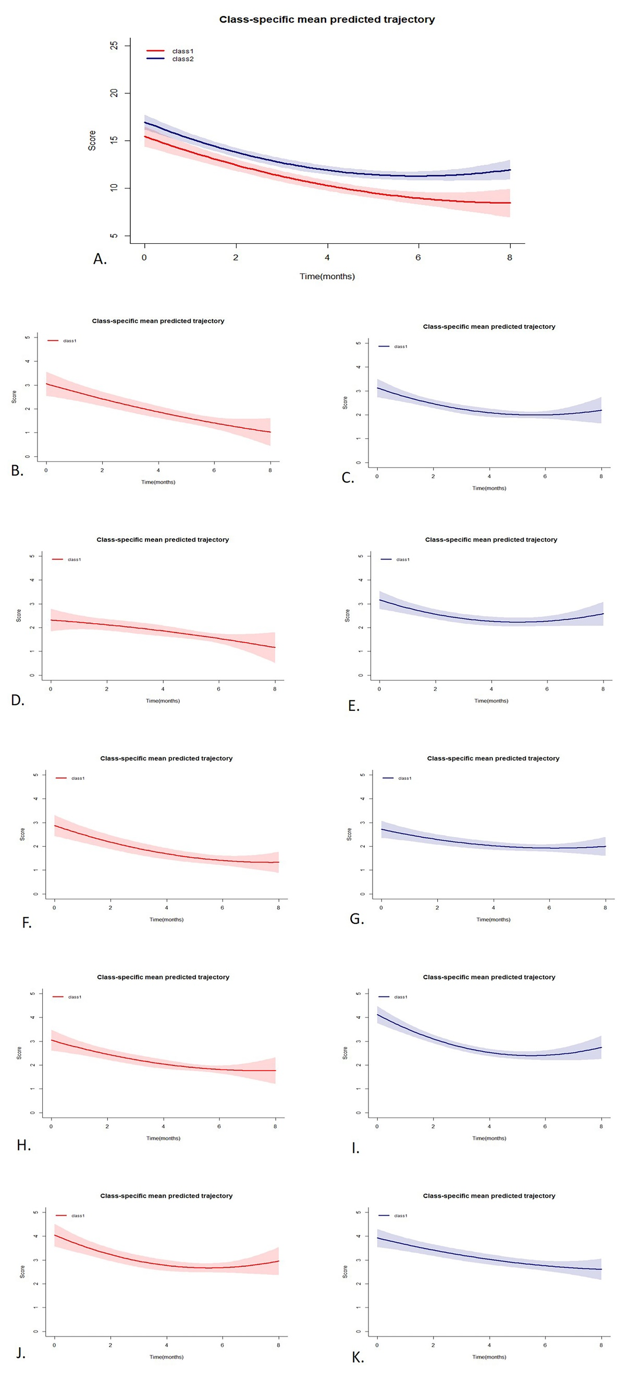
Figure S1 The trajectory map of FCTI in the control group and the distribution of trajectories in each dimension. A. The trajectory distribution of the total score; B. The trajectory distribution of Class 1 in the dimension of "adaptation to caregiving roles"; C. The trajectory distribution of Class 2 in the dimension of "adaptation to caregiving roles"; D. The trajectory distribution of Class 1 in the dimension of "strain and assistance provided"; E. The trajectory distribution of class 2 in the dimension of "strain and assistance provided"; F. The trajectory distribution of Class 1 in the dimension of "handling personal emotions"; G. The trajectory distribution of Class 2 in the dimension of "handling personal emotions"; H. The trajectory distribution of Class 1 in the dimension of "evaluating family and community resources"; I. The trajectory distribution of Class 2 in the dimension of "evaluating family and community resources"; J. The trajectory distribution of class1 in the dimension of "adjusting life to meet caregiving needs"; K. The trajectory distribution of class2 in the dimension of "adjusting life to meet caregiving needs";

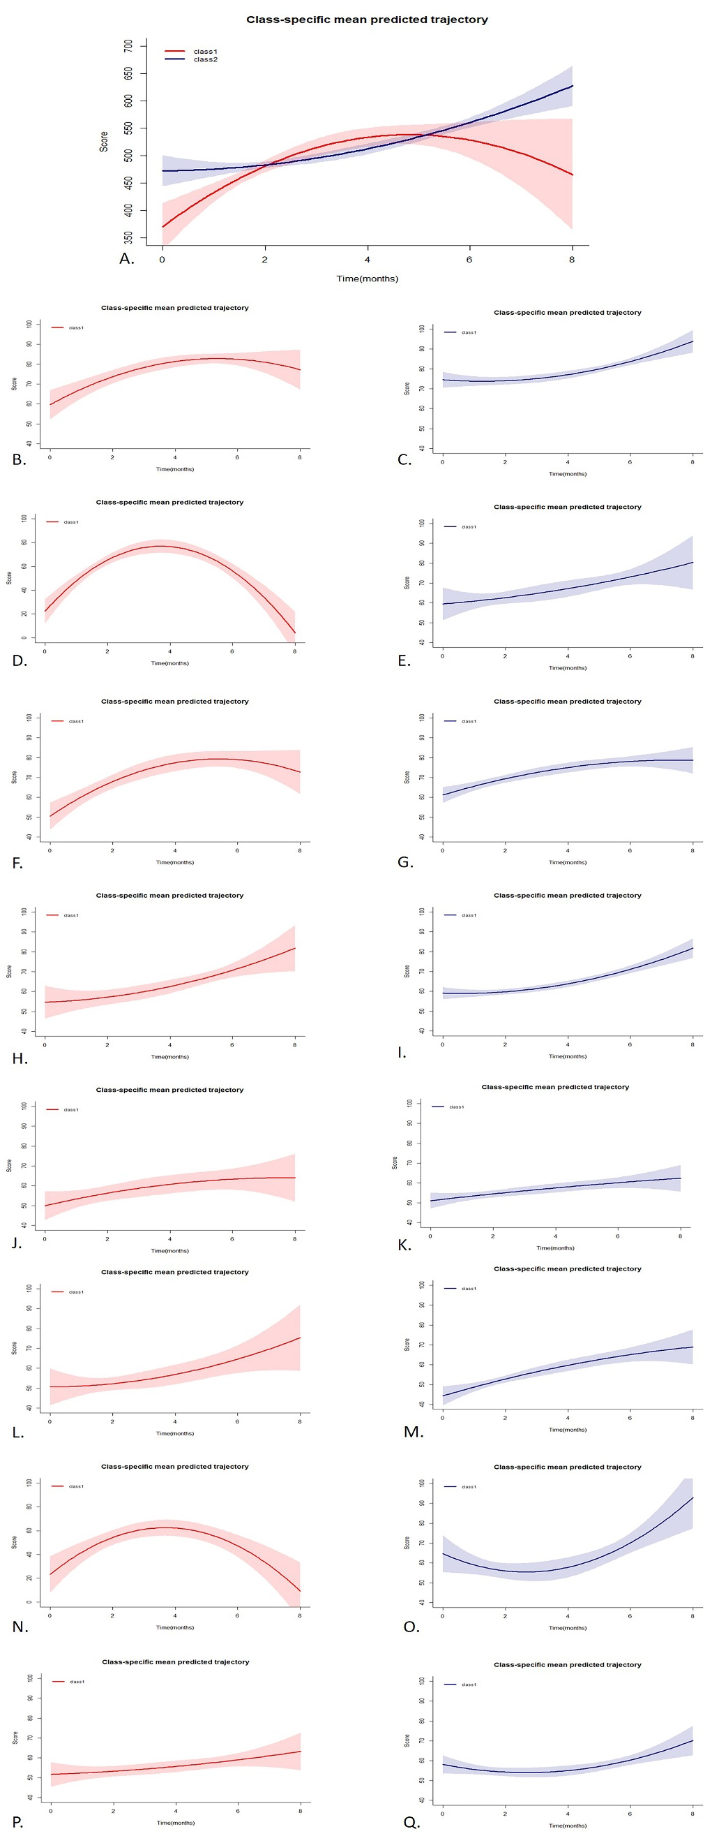
FigureS2 The trajectory map of SF-36 in the control group and the distribution of trajectories in each dimension. A. The trajectory distribution of the total score; B. The trajectory distribution of Class 1 in the dimension of "physiological function (PF)"; C. The trajectory distribution of class 2 in the dimension of "physiological function (PF)"; D. The trajectory distribution of Class 1 in the dimension of "physiological function (RP)"; E. The trajectory distribution of Class 2 in the dimension of "physiological function (RP)"; F. The trajectory distribution of Class 1 in the dimension of "Physical Pain (BP)"; G. The trajectory distribution of Class 2 in the dimension of "Physical Pain (BP)"; H. The trajectory distribution of Class 1 in the dimension of "General Health Status (GH)"; I. The trajectory distribution of Class 2 in the dimension of "General Health Status (GH)"; J. The trajectory distribution of class 1 in the dimension of "energy (VT)"; K. The trajectory distribution of class 2 in the dimension of "energy (VT)"; L. The trajectory distribution of Class 1 in the dimension of "Social Function (SF)"; M. The trajectory distribution of Class 2 in the dimension of "Social Function (SF)"; N. The trajectory distribution of Class 1 in the dimension of "Emotional Function (RE)"; O. The trajectory distribution of Class 2 in the dimension of "Emotional Function (RE)"; P. The trajectory distribution of Class 1 in the dimension of "Mental Health (MH)"; Q. The trajectory distribution of Class 2 in the dimension of "Mental Health (MH)".

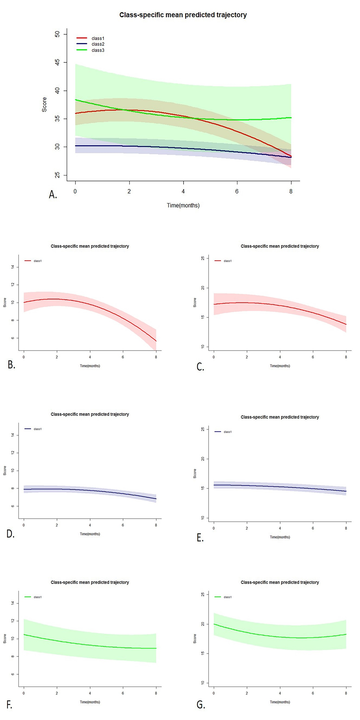
FigureS3 The trajectory map of ZBI in the control group and the distribution of trajectories in each dimension. A. The trajectory distribution of the total score; B. The trajectory distribution of Class 1 in the dimension of "personal burden"; C. The trajectory distribution of class 1 in the dimension of "responsibility burden"; D. The trajectory distribution of class 2 in the dimension of "personal burden"; E. The trajectory distribution of class 2 in the dimension of "responsibility burden"; F. The trajectory distribution of Class 3 in the dimension of "personal burden"; G. The trajectory distribution of class 3 in the dimension of "responsibility burden";

