Phase Behavior of Selected Condensed Double-Decker Shaped Silsesquioxane Compounds

David F. Vogelsangª, Robert E. Maleczka Jr.^{*b}, and Andre Lee^{*a}

ª Department of Chemical Engineering and Materials Science, Michigan State University, 428 S. Shaw Lane, Room 2100, East Lansing, Michigan 48824-1226 USA
^{b}Department of Chemistry, Michigan State University, 578 S. Shaw Lane, East Lansing, Michigan 48824-1322 USA

* Corresponding authors

AL - leea@msu.edu
REM - maleczka@msu.edu

Electronic Supporting Information Document

Contents

1. Spectral information 2
2. Crystal structures 9
3. DSC traces for pure compounds, for all cases exo up 11
4. Binary eutectic DSC traces 13
5. Binary ideal phase diagrams 17
6. Ternary ideal phase diagrams 21

Spectral information
Obtained following the procedure described in the analytical section

DDSQ-2Me₂
¹H-NMR (CDCl₃, 500 MHz)
¹³C-NMR (CDCl₃, 129 MHz)
²⁹Si-NMR (CDCl₃, 99 MHz)

DDSQ-2Et₂

¹H-NMR (CDCl₃, 500 MHz)
¹³C-NMR (CDCl₃, 129 MHz)
²⁹Si-NMR (CDCl₃, 99 MHz)

DDSQ-2iPr₂

¹H-NMR (CDCl₃, 500 MHz)
¹³C-NMR (CDCl₃, 129 MHz)
²⁹Si-NMR (CDCl₃, 99 MHz)

DDSQ-2nBu₂

¹H-NMR (CDCl₃, 500 MHz)

¹³C-NMR (CDCl₃, 129 MHz)
²⁹Si-NMR (CDCl₃, 99 MHz)

DDSQ-2CyP₂

¹H-NMR (CDCl₃, 500 MHz)
¹³C-NMR (CDCl₃, 129 MHz)
²⁹Si-NMR (CDCl₃, 99 MHz)

DDSQ-2CyH₂

¹H-NMR (CDCl₃, 500 MHz)
¹³C-NMR (CDCl₃, 129 MHz)
²⁹Si-NMR (CDCl₃, 99 MHz)

DDSQ-2Ph₂

¹H-NMR (CDCl₃, 500 MHz)
¹³C-NMR (CDCl₃, 129 MHz)
²⁹Si-NMR (CDCl₃, 99 MHz)

Crystal structures

The crystal structures reported in this document can be obtained free of charge in the Cambridge crystallographic database under the CCDC numbers described next to the abbreviated name of each structure.
DDSQ-2Me₂ CCDC# 1832148 | DDSQ-2Et₂ CCDC# 1832146
 | 
DDSQ-2iPr₂ CCDC# 1832150 | DDSQ-2nBu₂ CCDC# 1847481
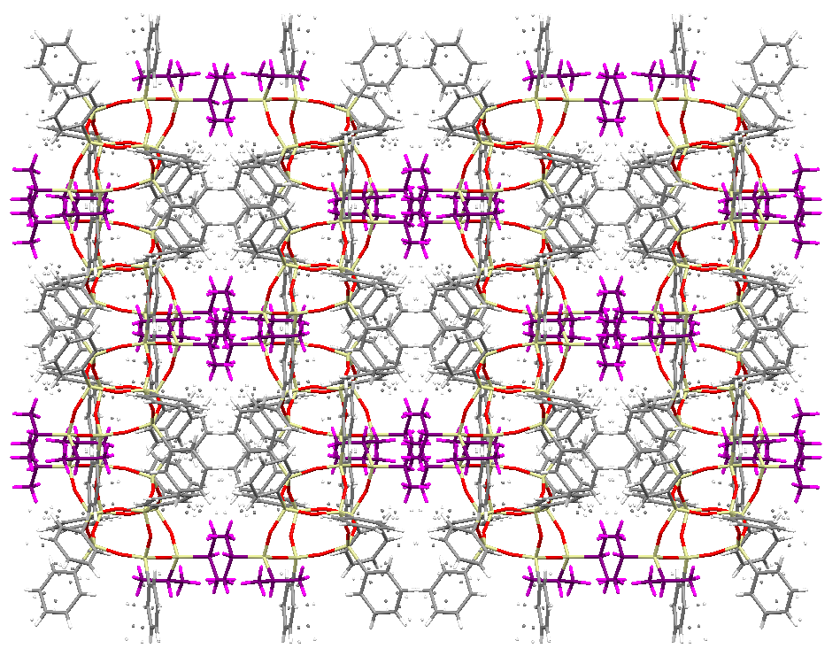 | 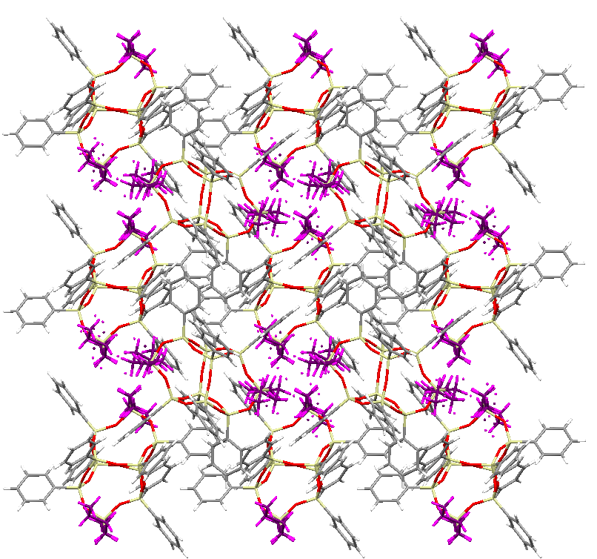
DDSQ-2CyP₂ CCDC# 2009506 | DDSQ-2CyH₂ CCDC# 1847753
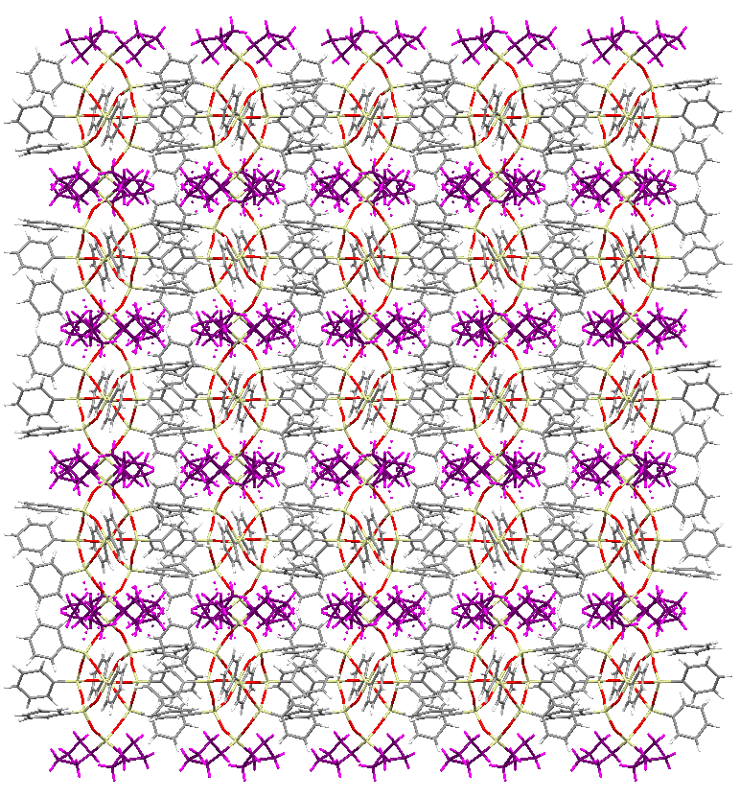 | 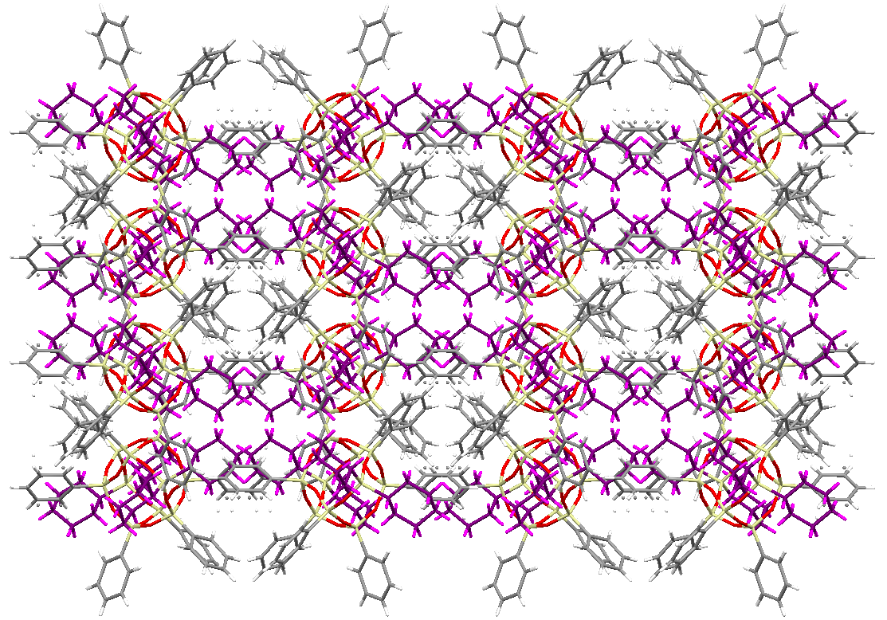
DDSQ-2Ph₂ CCDC# 1832151


DSC traces for pure compounds, for all cases exo up

DDSQ-2Me₂ | DDSQ-2Et₂
DDSQ-2iPr₂ | DDSQ-2nBu₂
DDSQ-2CyP₂ | DDSQ-2CyH₂
DDSQ-2Ph₂

Binary eutectic DSC traces

Obtained as described in the analytical methodology. Cooling and heating traces, for all cases exotherm points upwards.

DDSQ-2Me₂:DDSQ-2Et₂ | DDSQ-2Me₂:DDSQ-2iPr₂
DDSQ-2Me₂:DDSQ-2nBu₂ | DDSQ-2Me₂:DDSQ-2CyP₂
DDSQ-2Me₂:DDSQ-2CyH₂ | DDSQ-2Me₂:DDSQ-2Ph₂
DDSQ-2Et₂:DDSQ-2iPr₂ | DDSQ-2Et₂:DDSQ-2nBu₂
DDSQ-2Et₂:DDSQ-2CyP₂ | DDSQ-2Et₂:DDSQ-2CyH₂
DDSQ-2Et₂:DDSQ-2Ph₂ | DDSQ-2iPr₂:DDSQ-2nBu₂
DDSQ-2iPr₂:DDSQ-2CyP₂ | DDSQ-2iPr₂:DDSQ-2CyH₂
DDSQ-2iPr₂:DDSQ-2Ph₂ | DDSQ-2nBu₂:DDSQ-2CyP₂
DDSQ-2nBu₂:DDSQ-2CyH₂ | DDSQ-2nBu₂:DDSQ-2Ph₂
DDSQ-2CyP₂:DDSQ-2CyH₂ | DDSQ-2CyP₂:DDSQ-2Ph₂
DDSQ-2CyH₂:DDSQ-2Ph₂

Binary ideal phase diagrams

Solid green and blue lines represent the theoretically calculated solid-liquid equilibrium, intercept between these two lines was recognized as the ideal eutectic composition. Solid red line represents the calculated ideal temperature. Black dots are representative of experimental data collected from DSC.

DDSQ-2Me₂:DDSQ-2Et₂ | DDSQ-2Me₂:DDSQ-2iPr₂
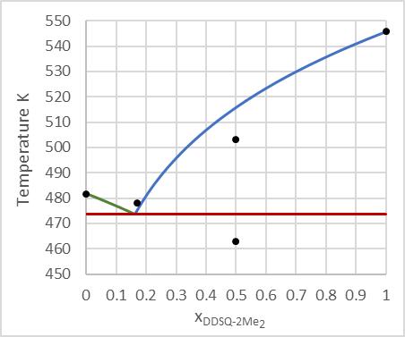 | 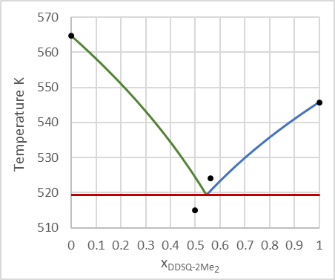
DDSQ-2Me₂:DDSQ-2nBu₂ | DDSQ-2Me₂:DDSQ-2CyP₂
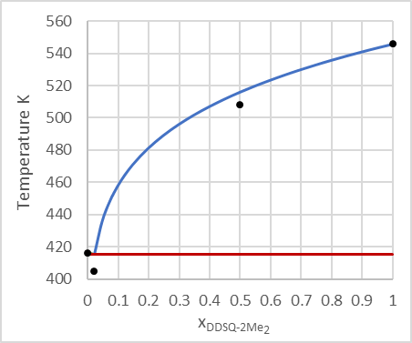 | 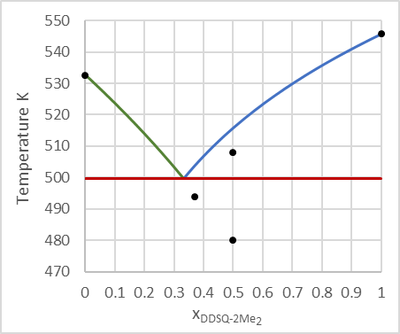
DDSQ-2Me₂:DDSQ-2CyH₂ | DDSQ-2Me₂:DDSQ-2Ph₂
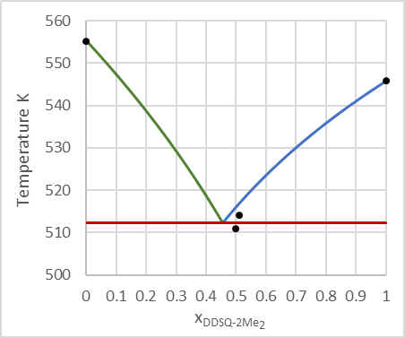 | 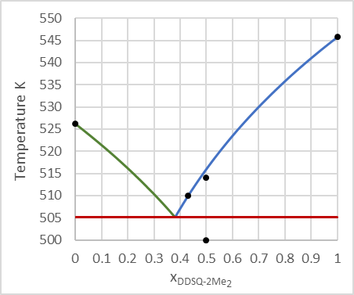
DDSQ-2Et₂:DDSQ-2iPr₂ | DDSQ-2Et₂:DDSQ-2nBu₂
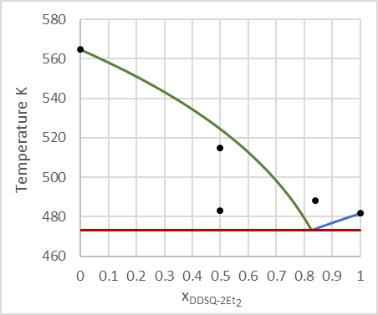 | 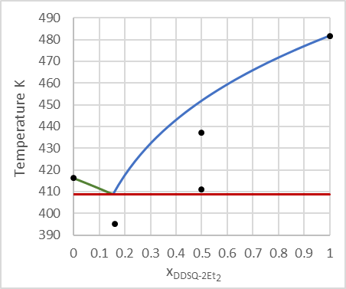
DDSQ-2Et₂:DDSQ-2CyP₂ | DDSQ-2Et₂:DDSQ-2CyH₂
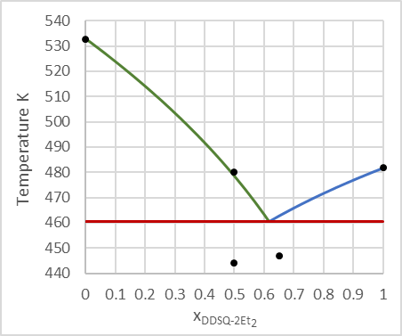 | 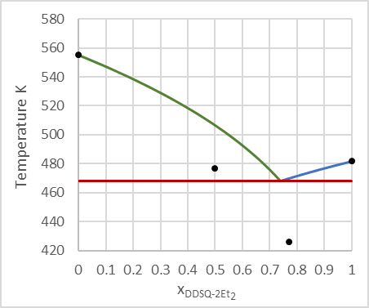
DDSQ-2Et₂:DDSQ-2Ph₂ (Experimental values determined from bumps in baseline) | DDSQ-2iPr₂:DDSQ-2nBu₂
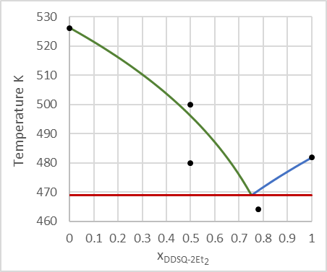 | 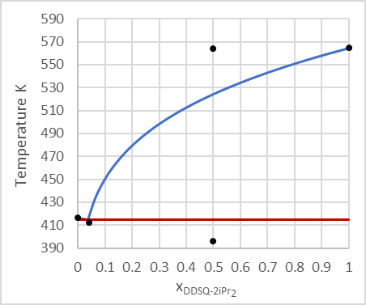
DDSQ-2iPr₂:DDSQ-2CyP₂ | DDSQ-2iPr₂:DDSQ-2CyH₂
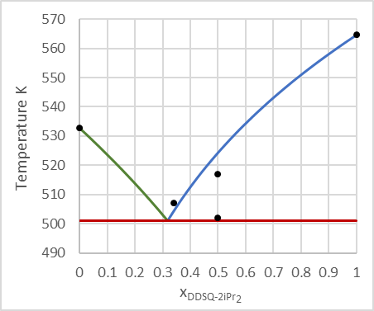 | 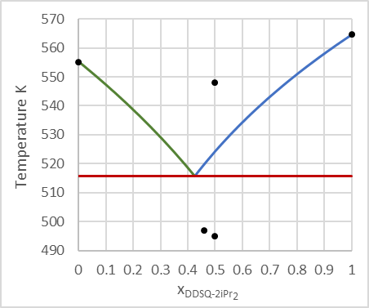
DDSQ-2iPr₂:DDSQ-2Ph₂ | DDSQ-2nBu₂:DDSQ-2CyP₂
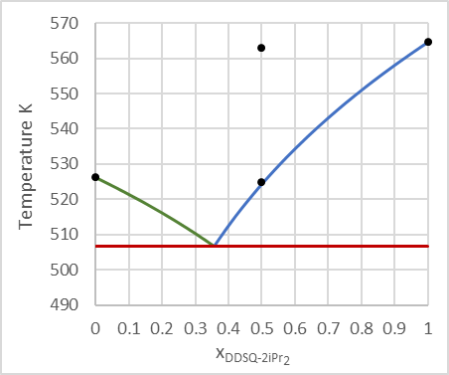 | 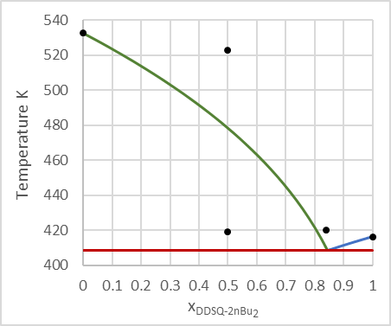
DDSQ-2nBu₂:DDSQ-2CyH₂ | DDSQ-2nBu₂:DDSQ-2Ph₂
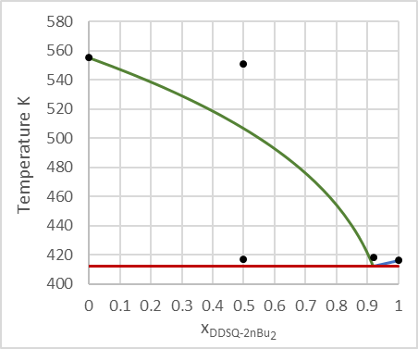 | 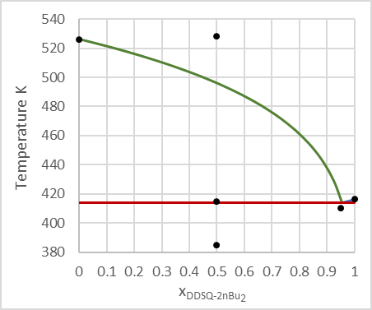
DDSQ-2CyP₂:DDSQ-2CyH2 | DDSQ-2CyP₂:DDSQ-2CyH₂ - Assuming solid miscibility
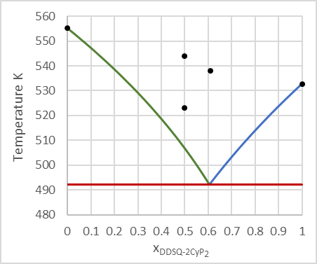 | 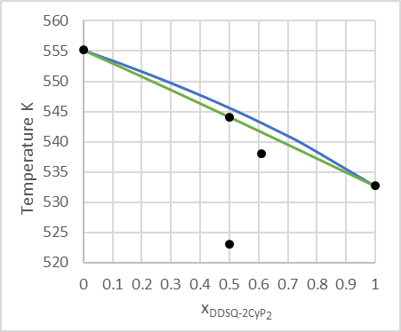
DDSQ-2CyP₂:DDSQ-2Ph₂ | DDSQ-2CyH₂:DDSQ-2Ph₂
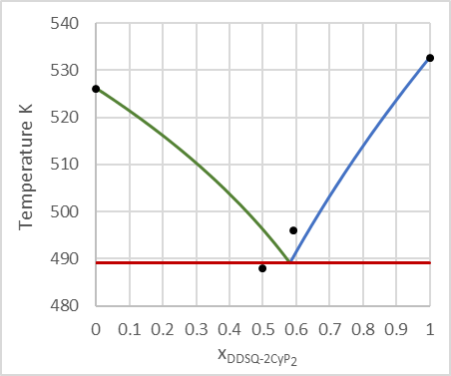 | 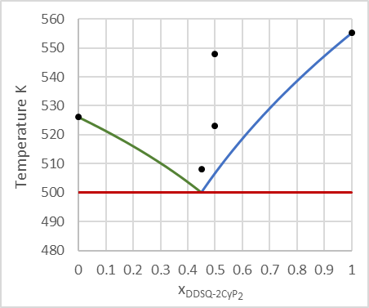

Ternary ideal phase diagrams

DDSQ-2Me₂:DDSQ-2Et₂:DDSQ-2iPr₂
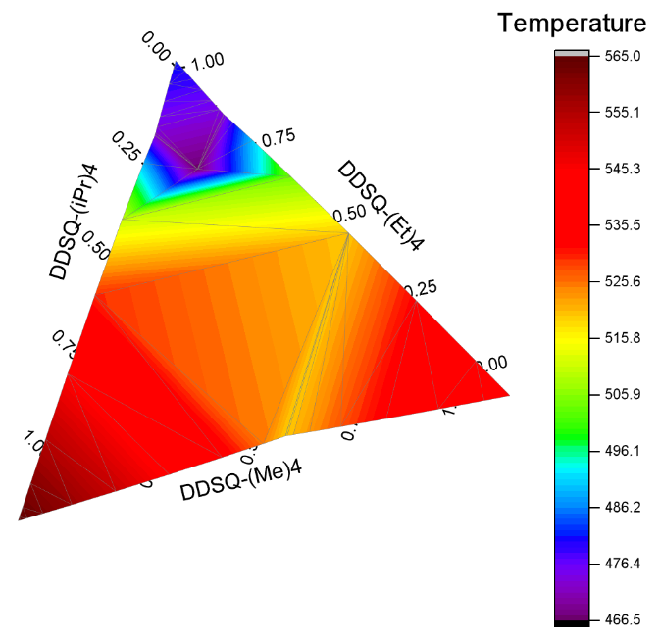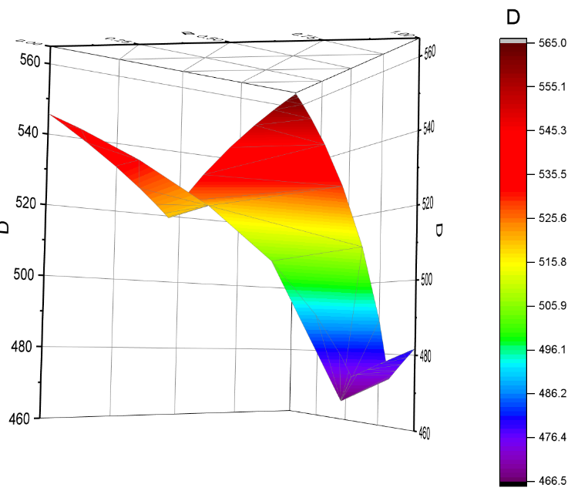

DDSQ-2Me₂:DDSQ-2CyP₂:DDSQ-2Ph₂
