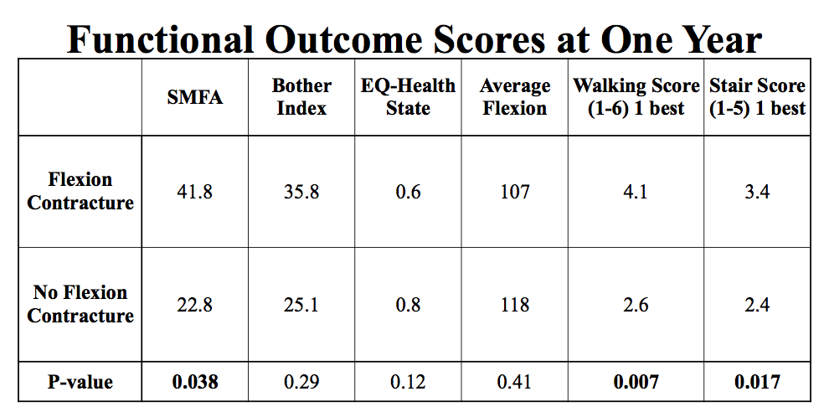
Table 1: Functional Outcome Scores at One Year. Patients with a flexion contracture had significantly worse outcome at one year regarding the SMFA Score, Walking Score and Stair Score.
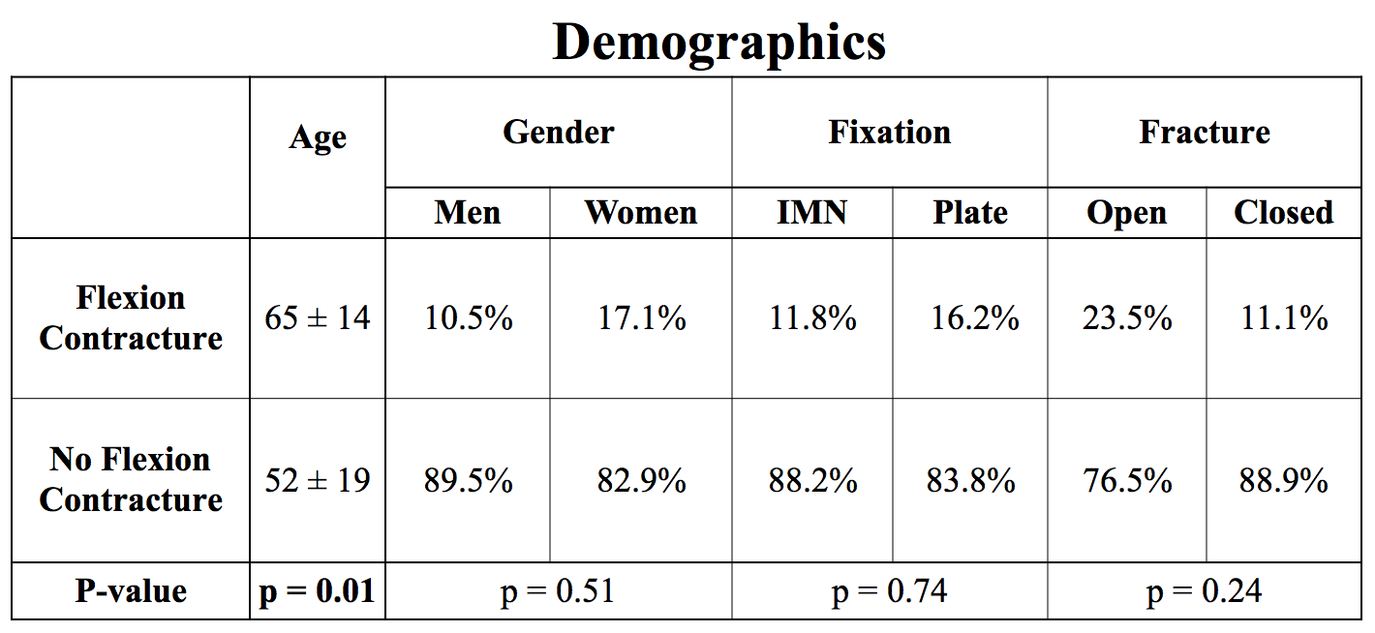
Table 2: Demographics. Patients who had a flexion contractures were older than patients who did not have a flexion contracture. Gender, type of fixation and whether the patient was open or closed was not associated with the development of a flexion contracture.

