Supplementary file: Uncropped Gels and Blots

Figure 3: Psen1 c.325A>T variant results in full loss of function in homozygous neurons.

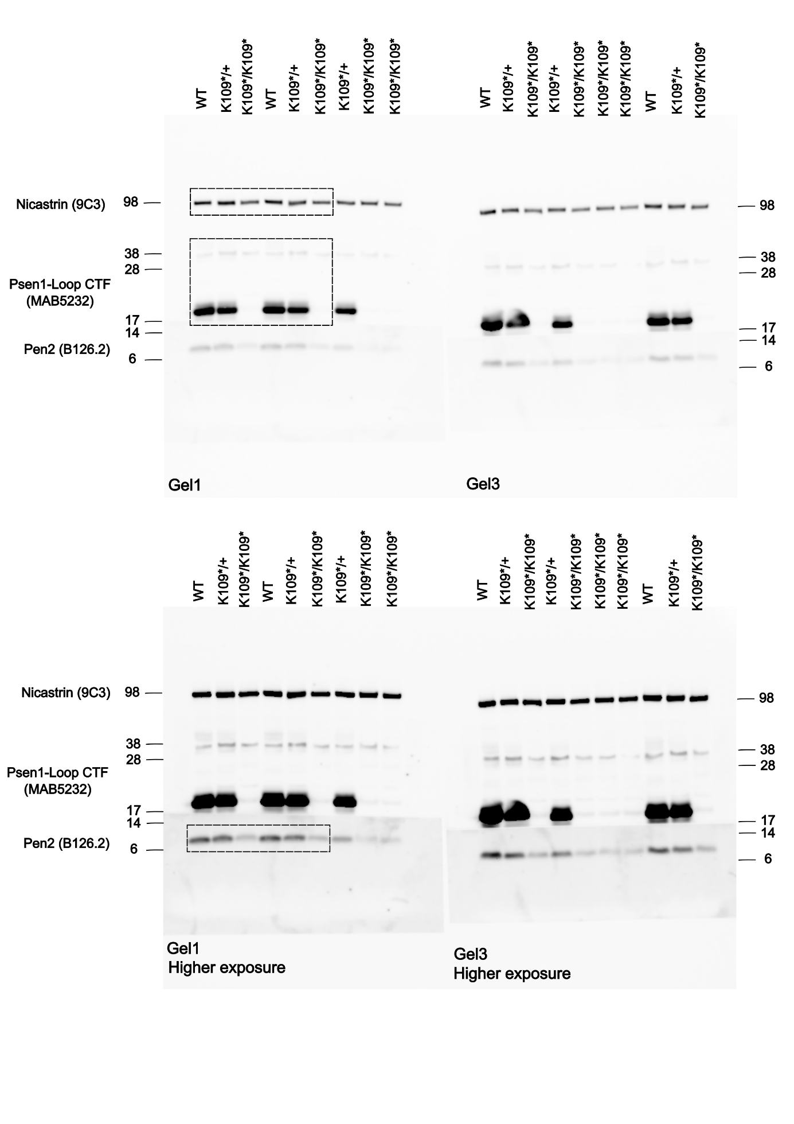
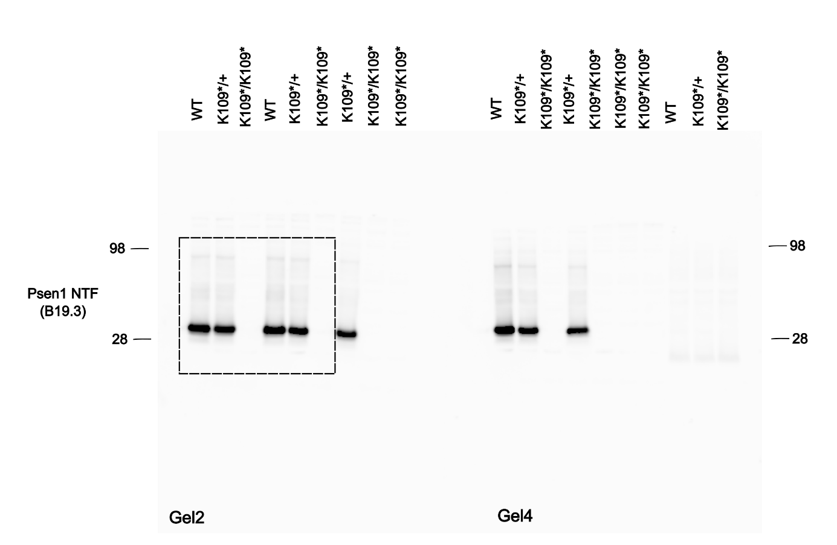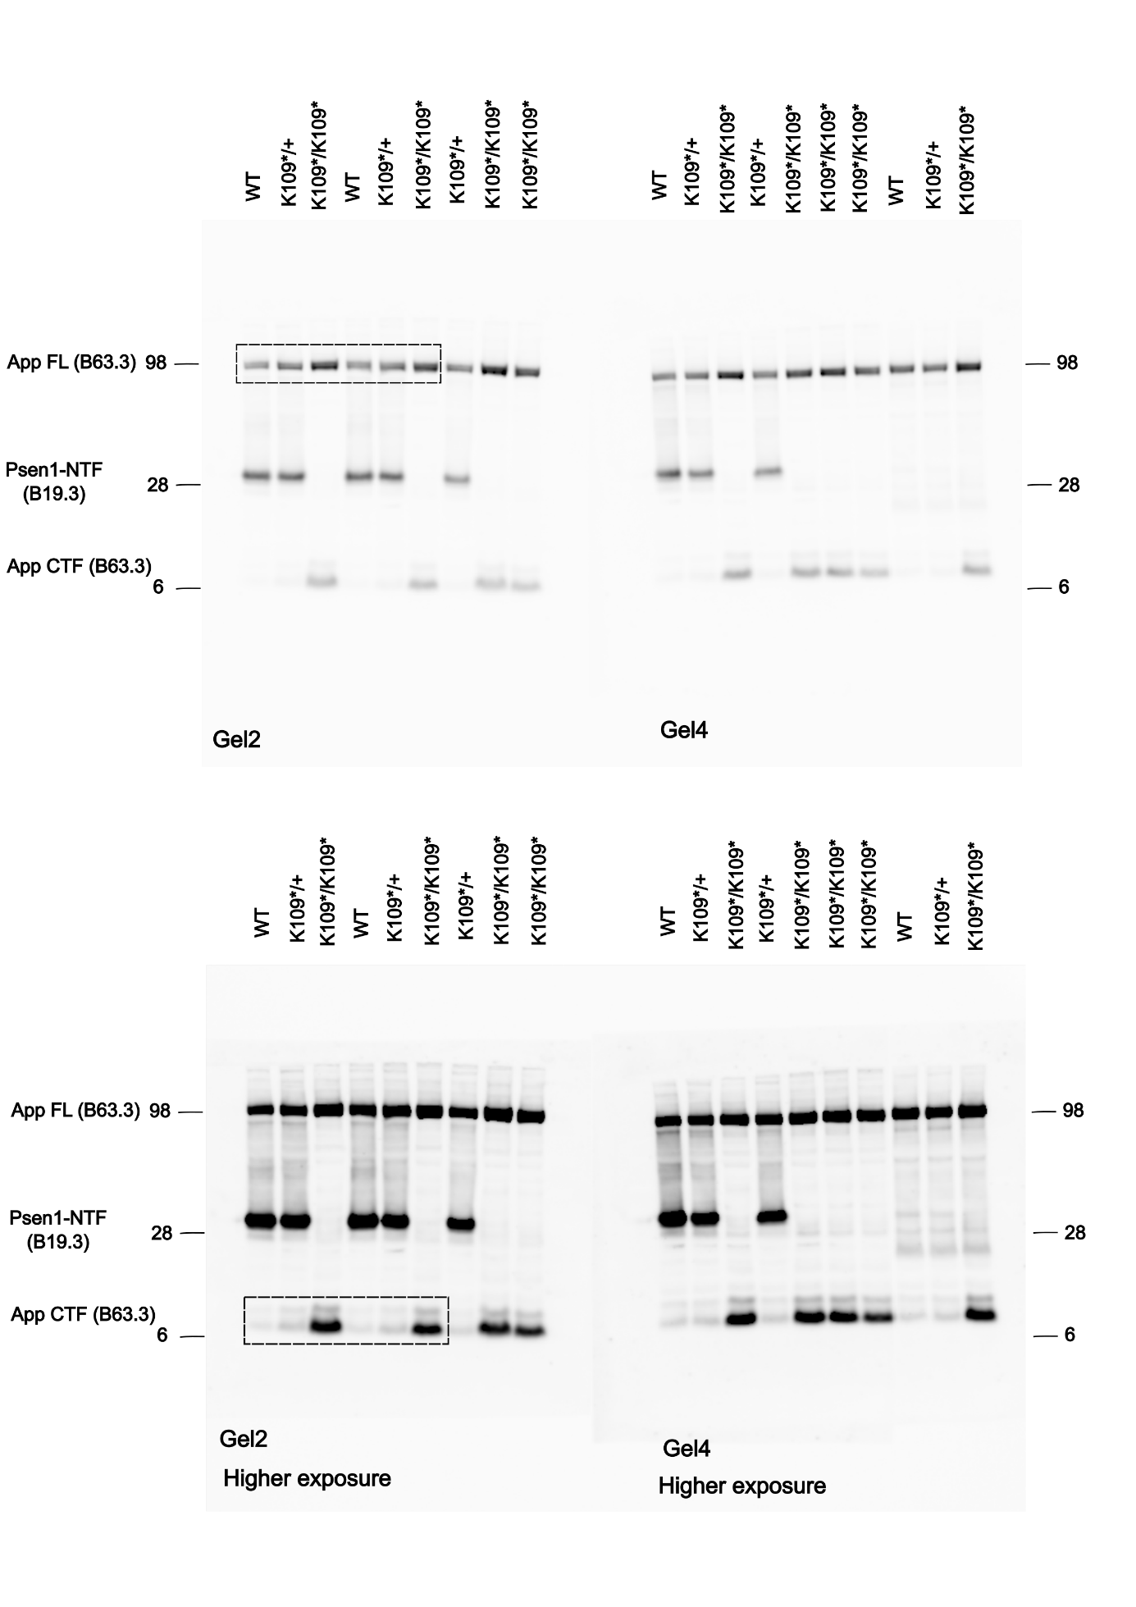

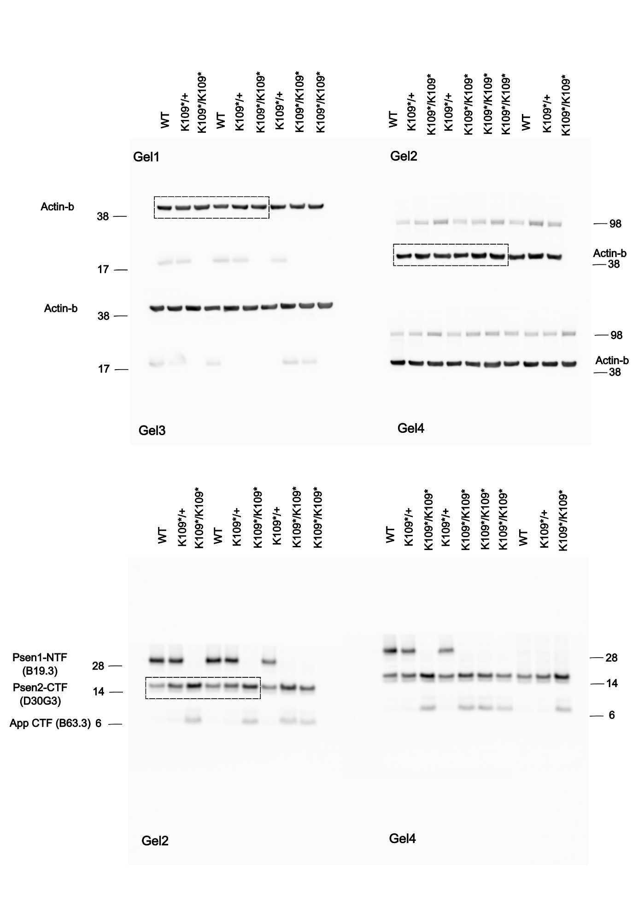

Figure 4: Comparison of Psen1^{K109*/+};App^{hu/hu} and Psen1^{+/-} aged heterozygous mice.
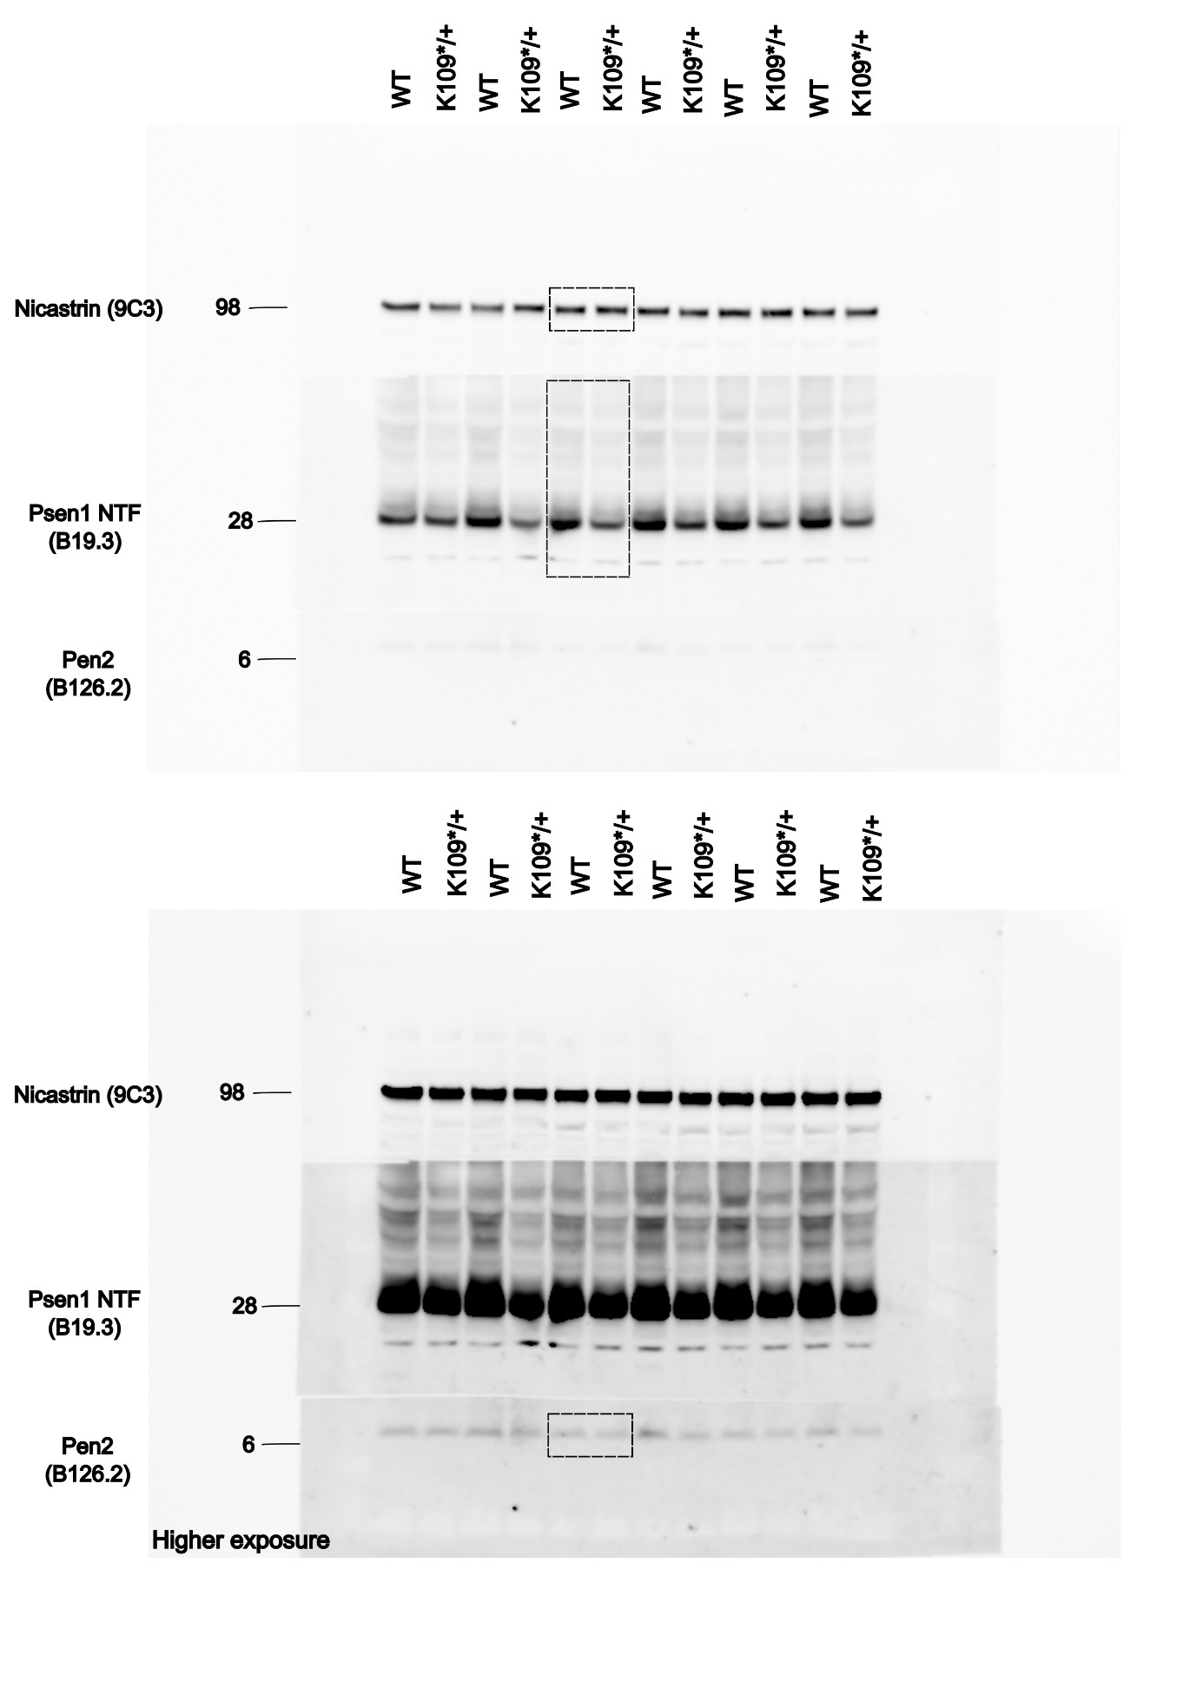
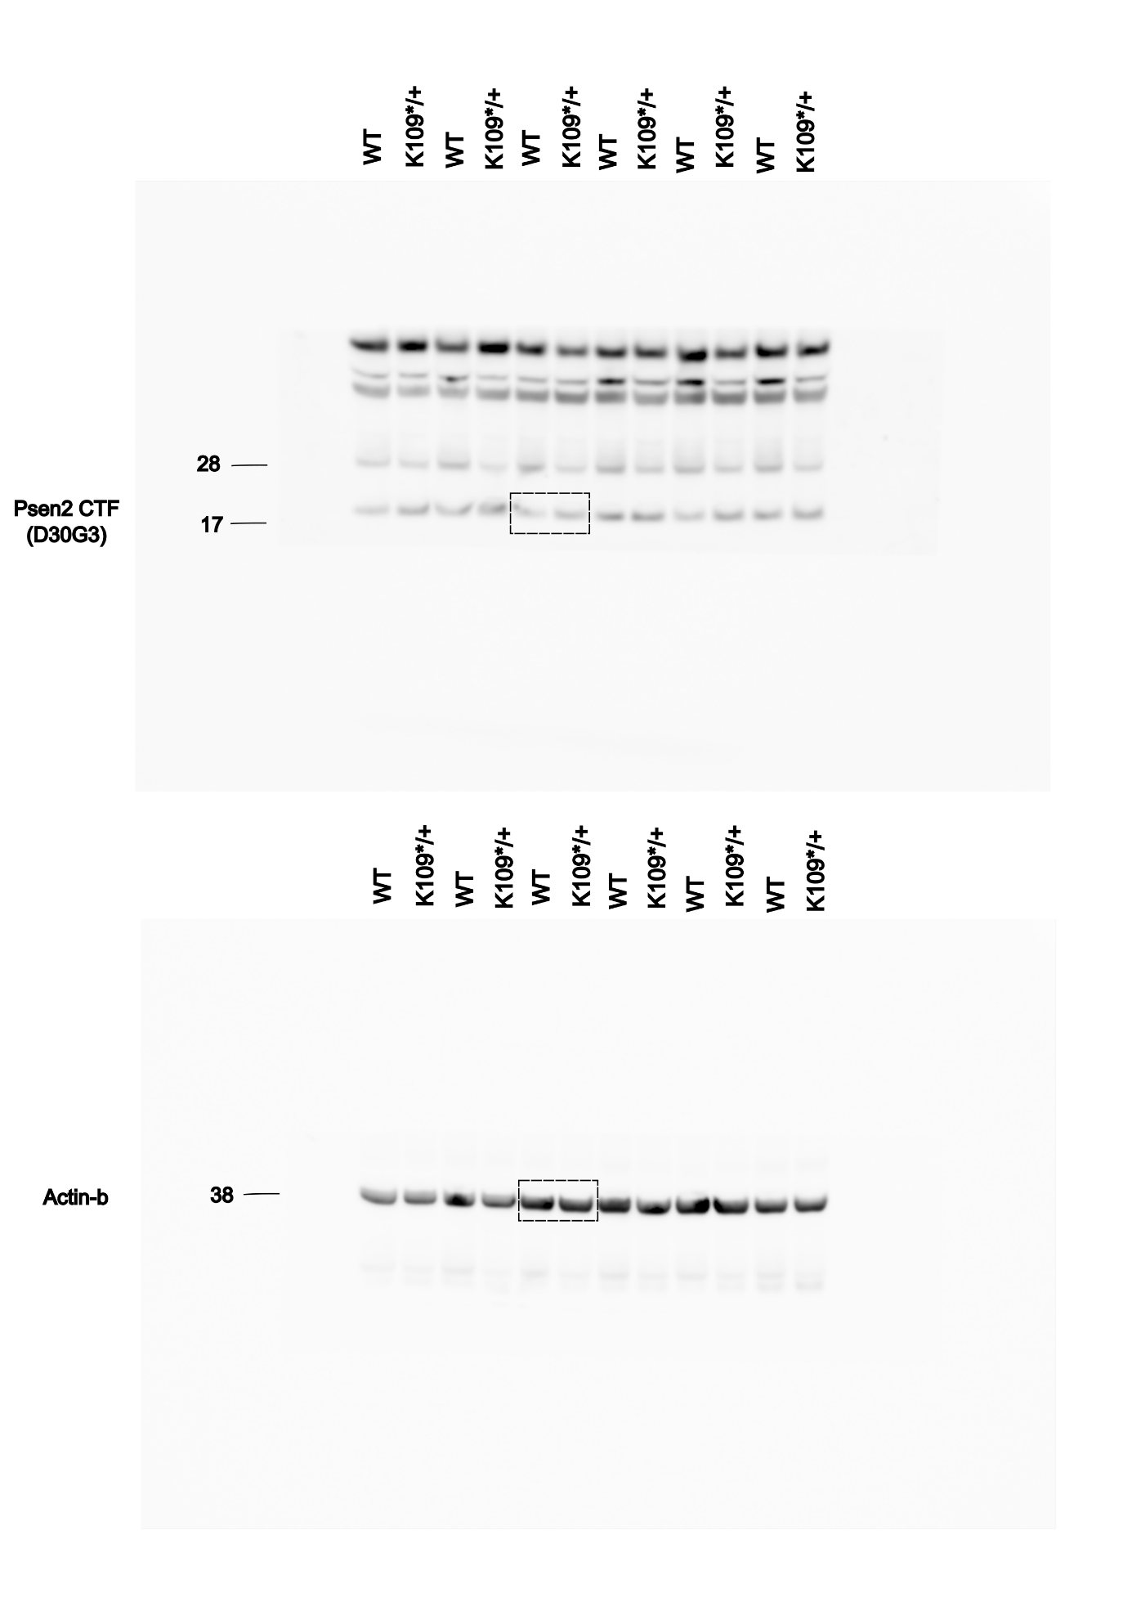
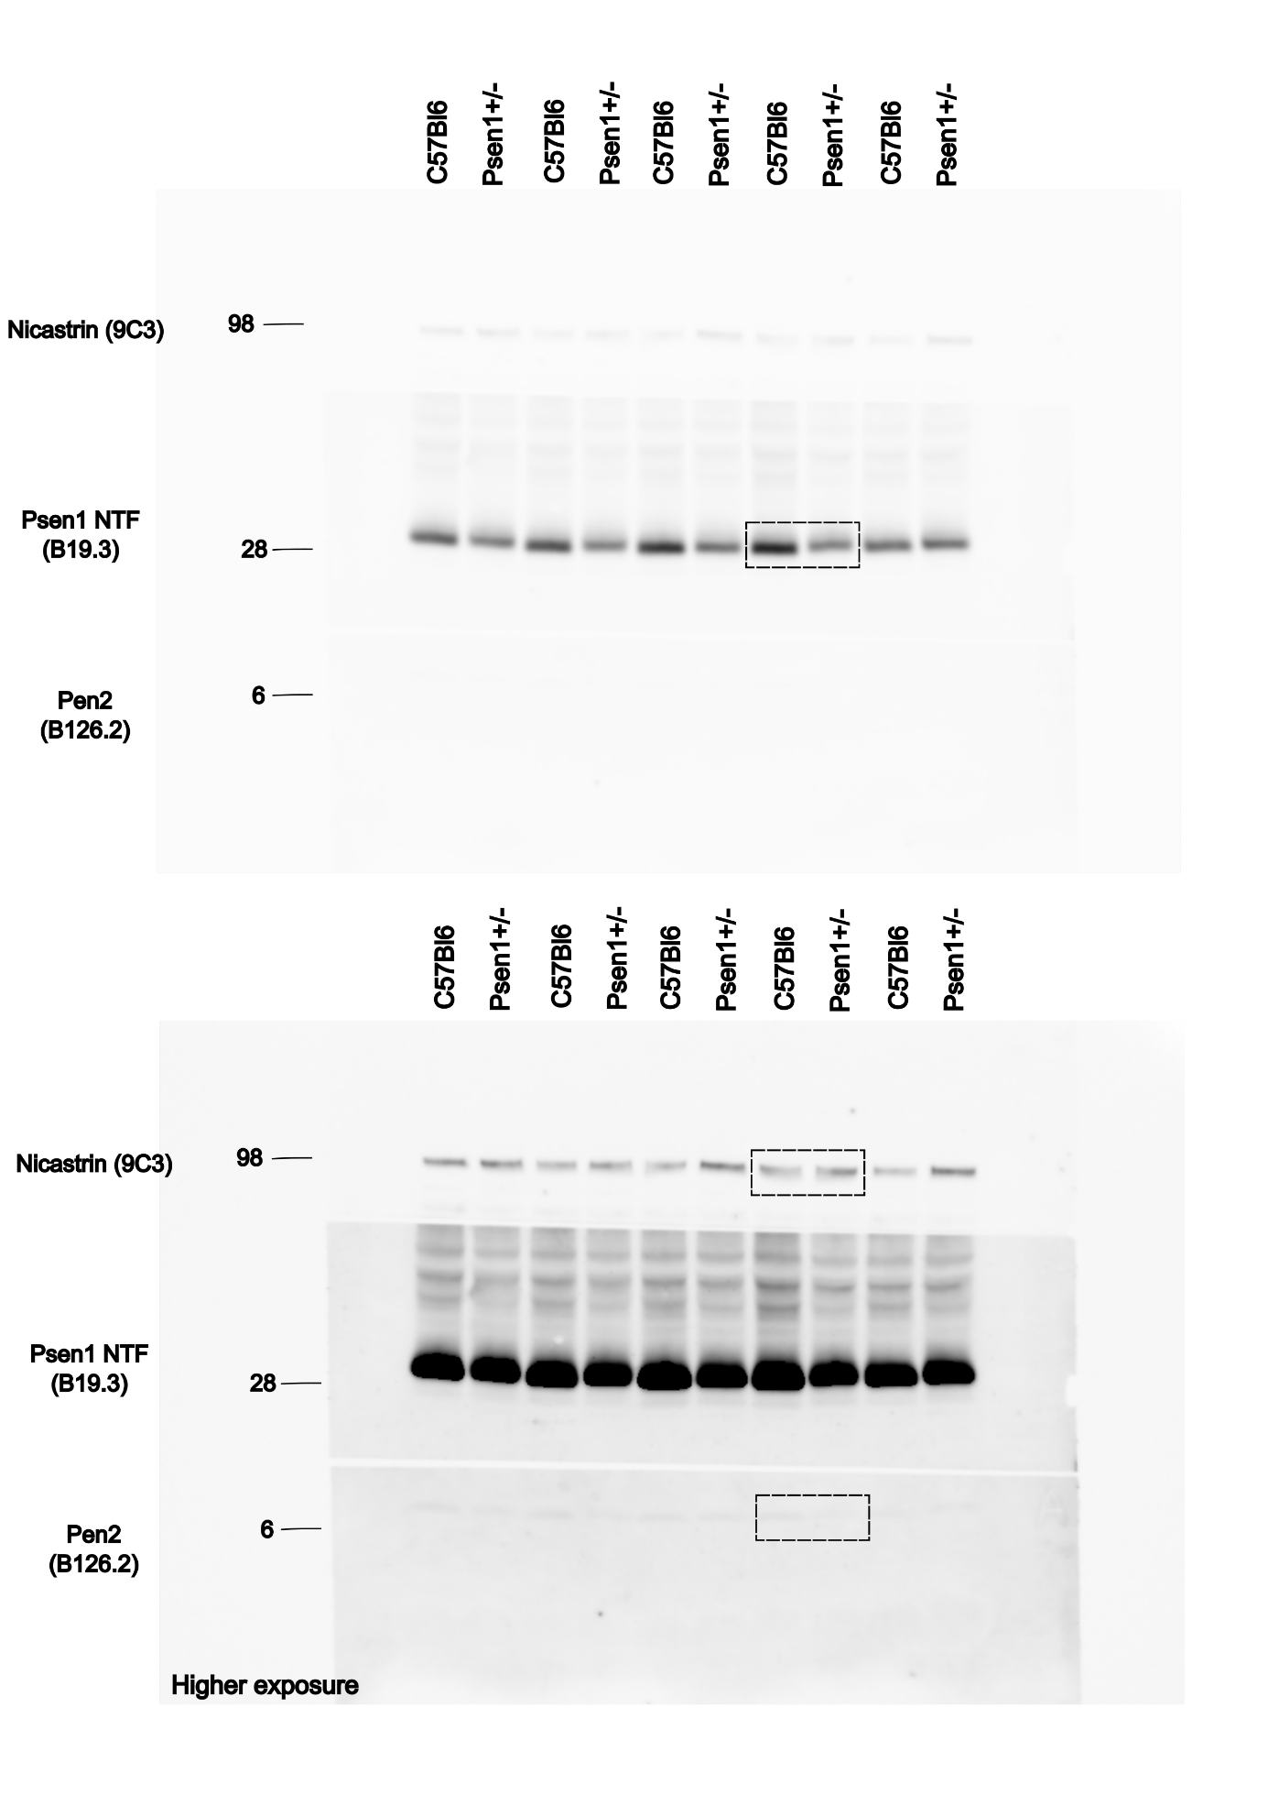
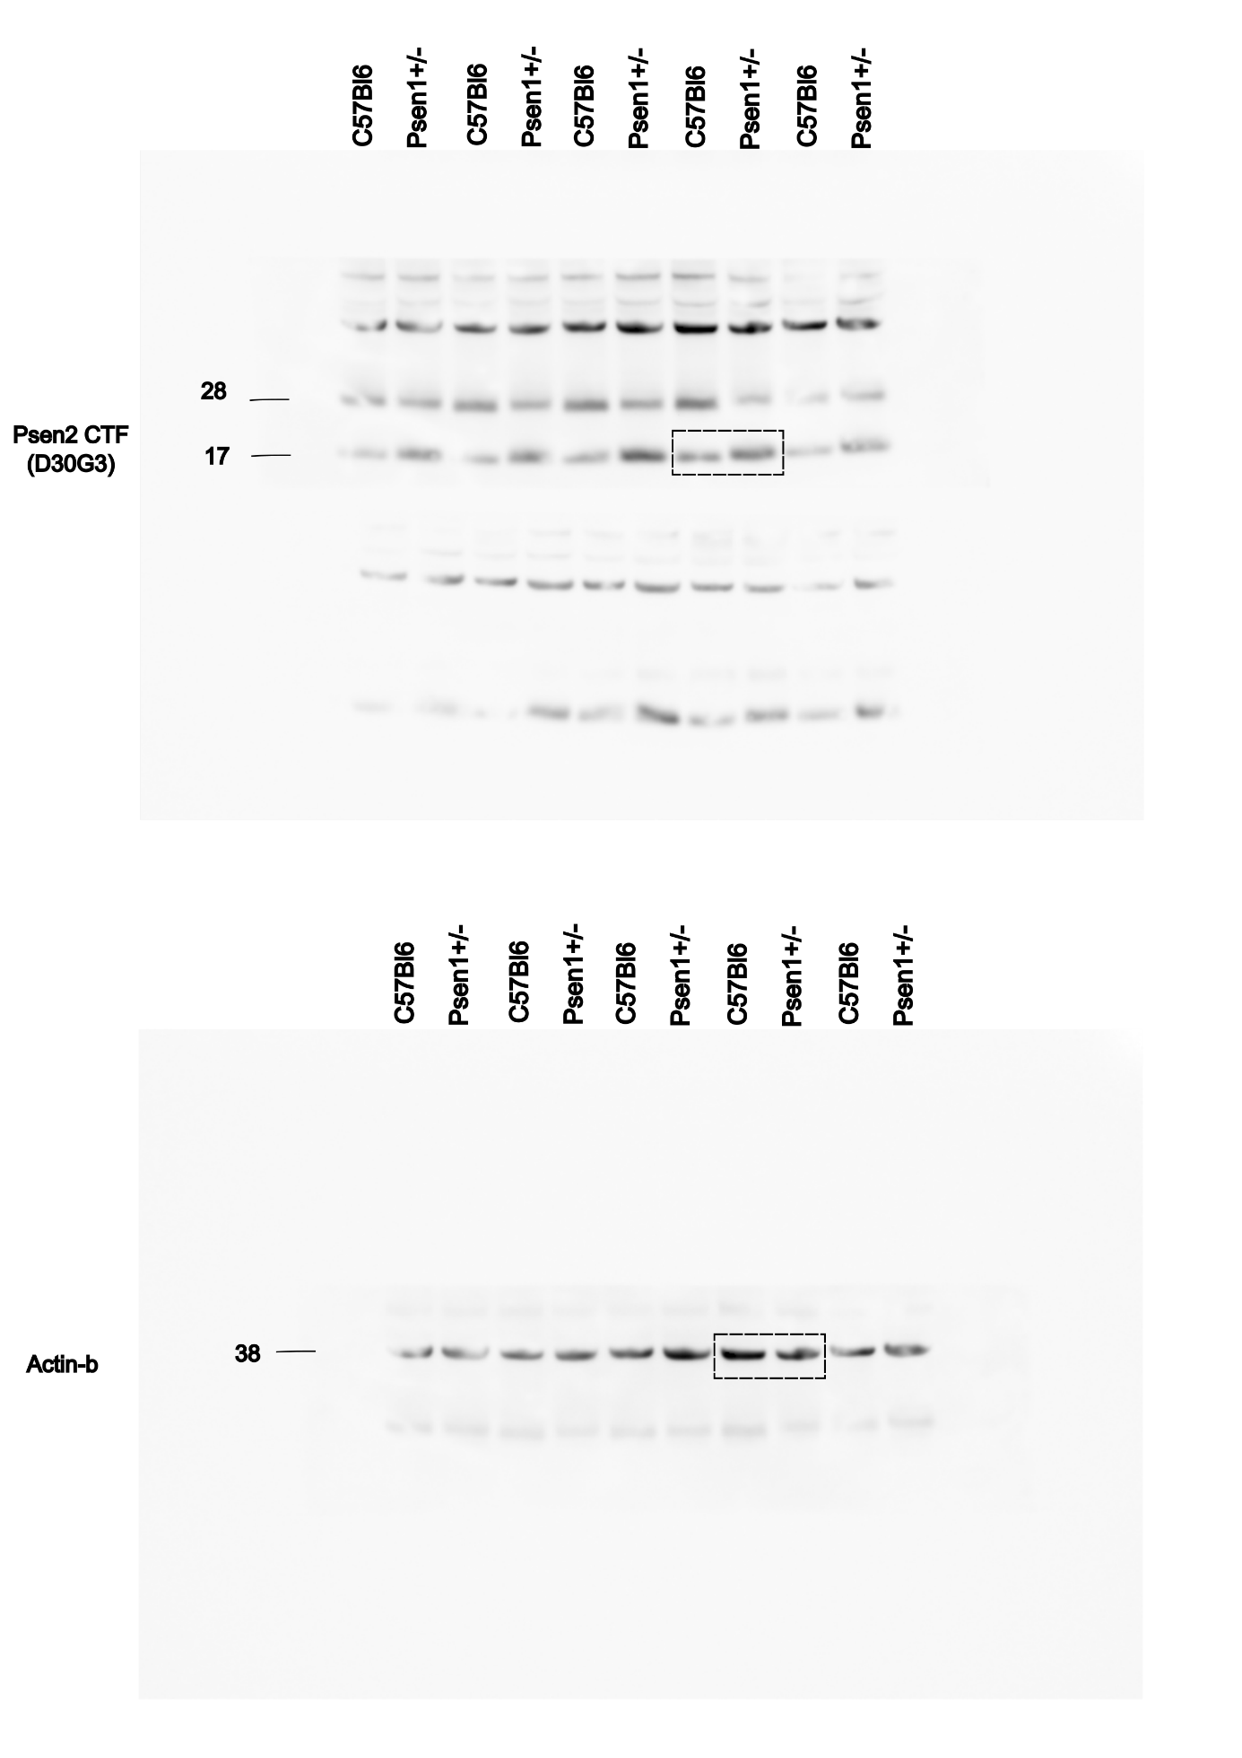

Figure 5: hPSEN1^{K109*} short fragments do not reconstitute γ-secretase enzymatic activity.
A
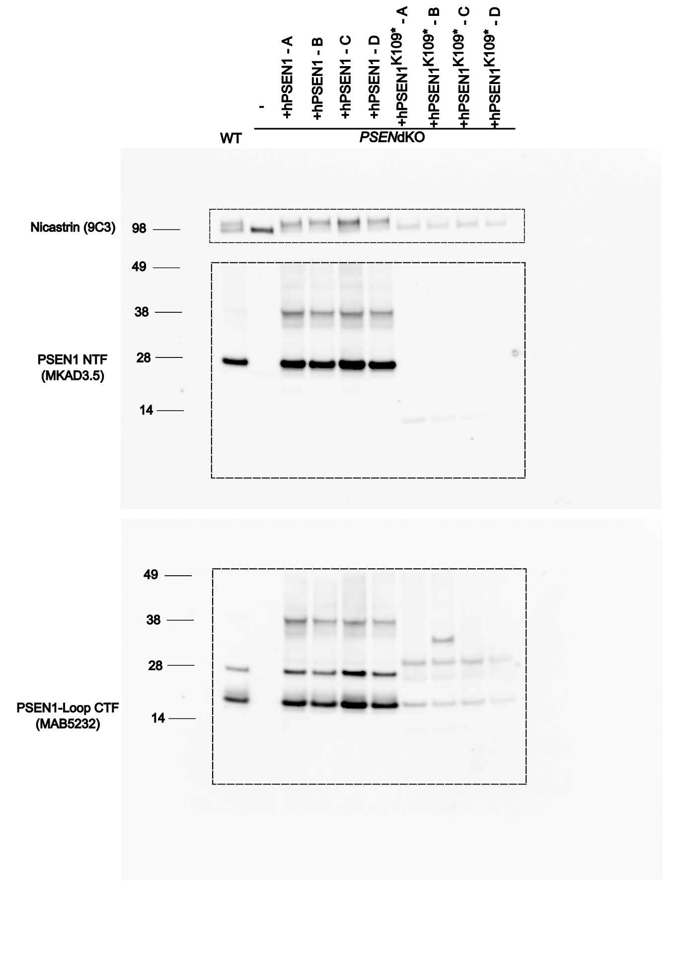

B
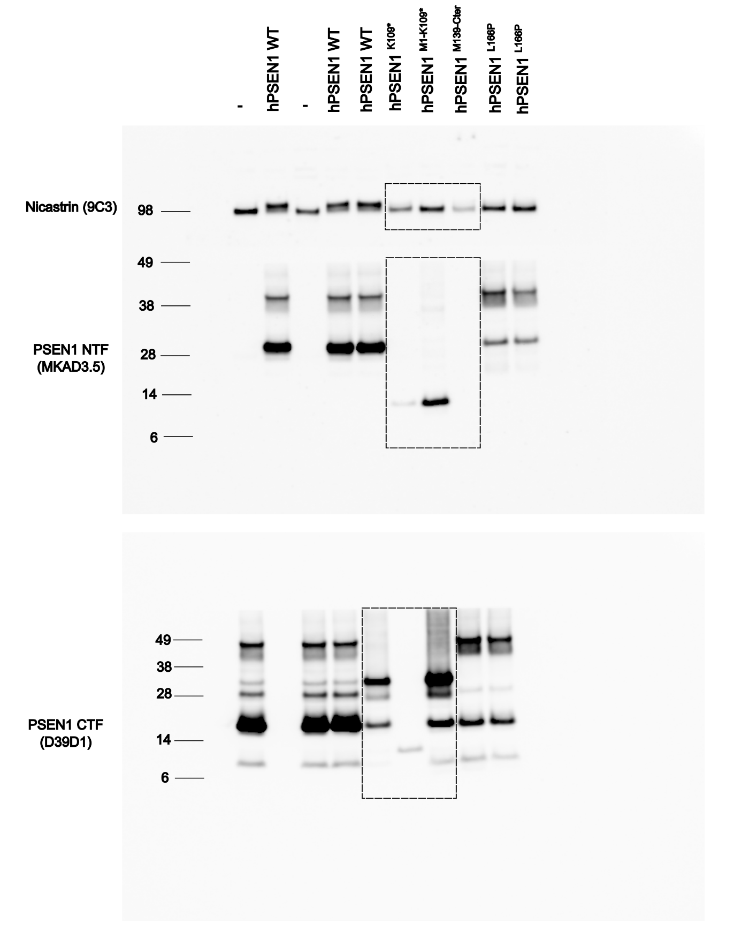
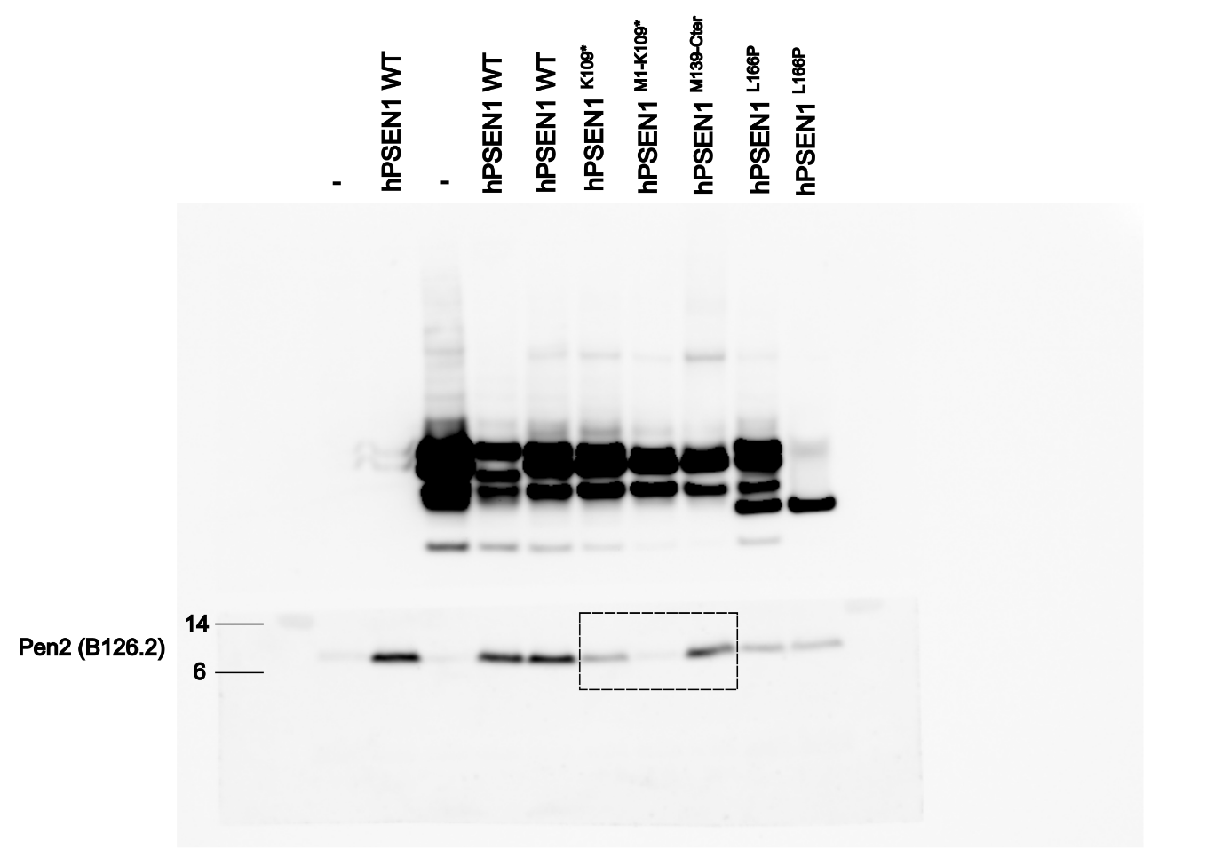

C
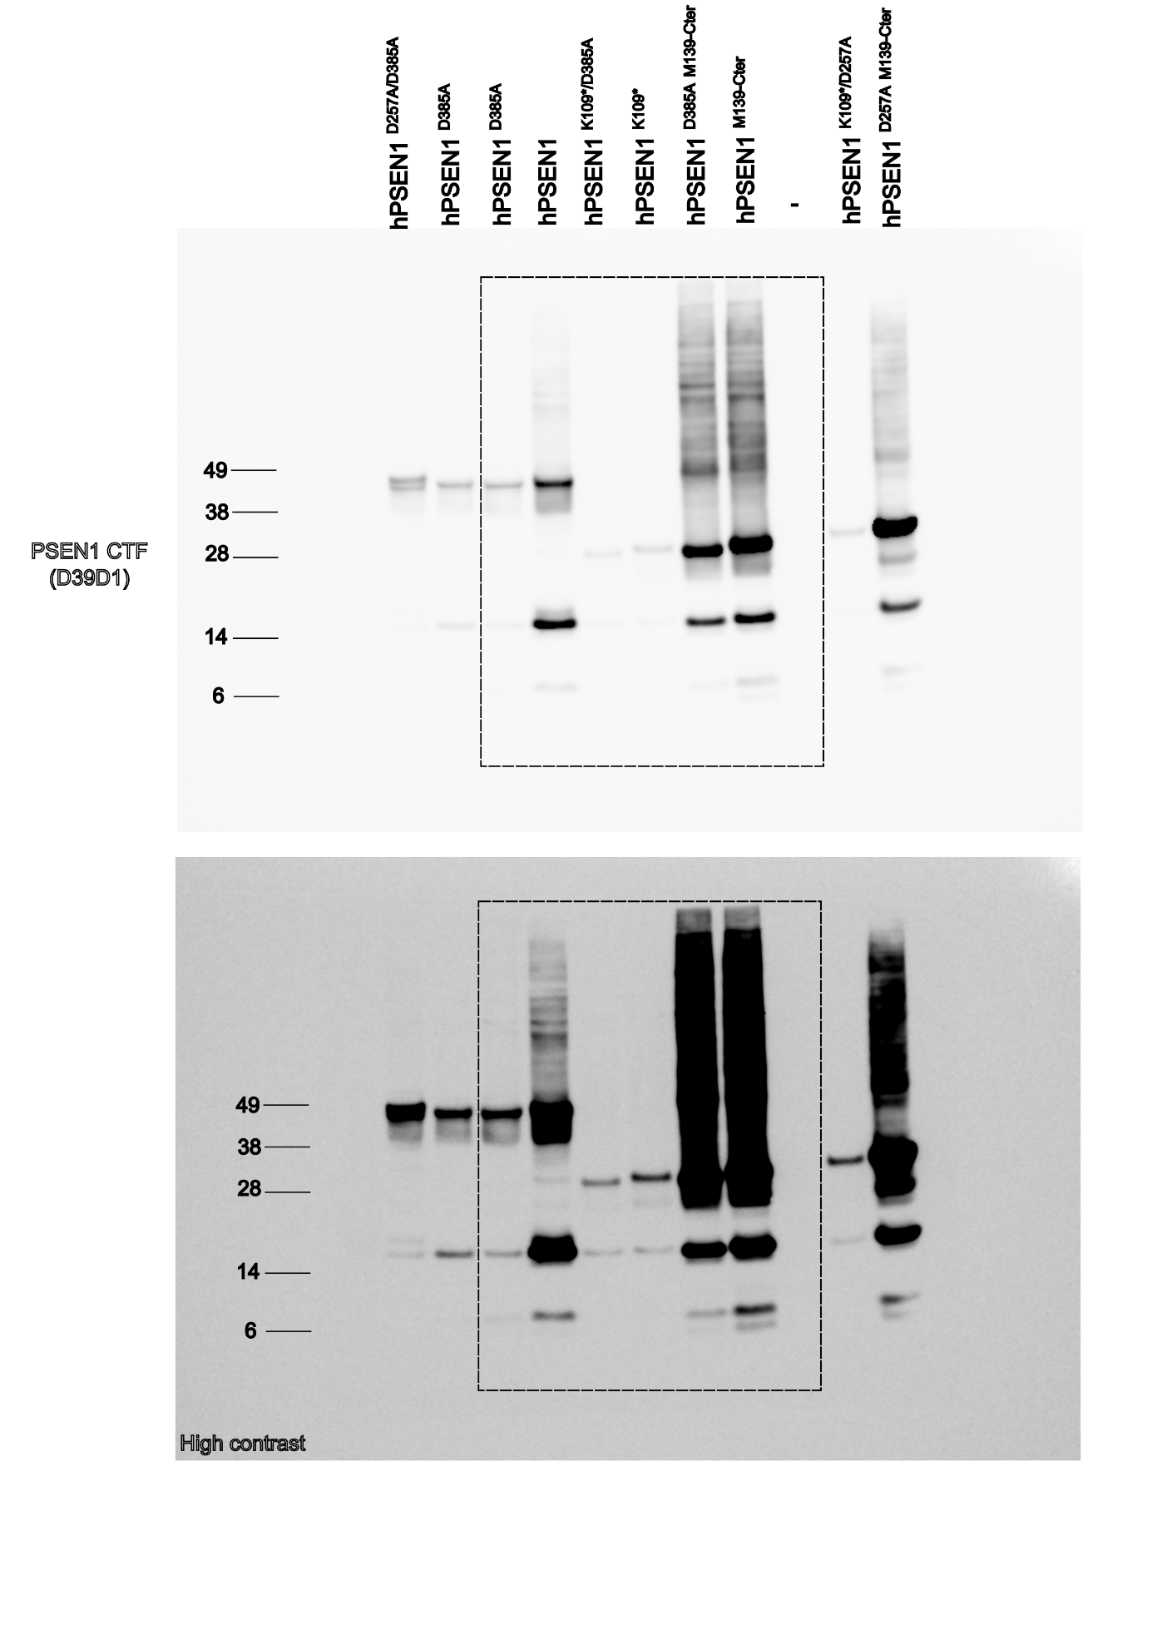

Supplementary Figure 1: PSEN1-NTF* (~12kDa) fragment only detected in primary neuronal cultures.
A
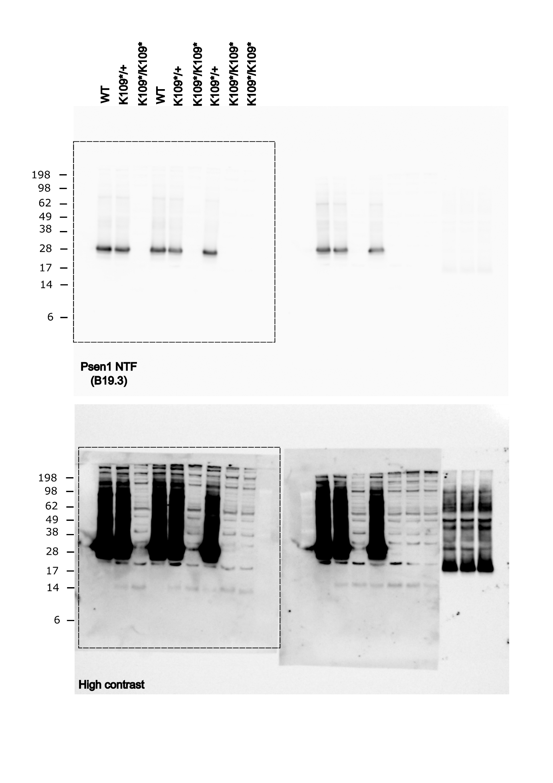
B
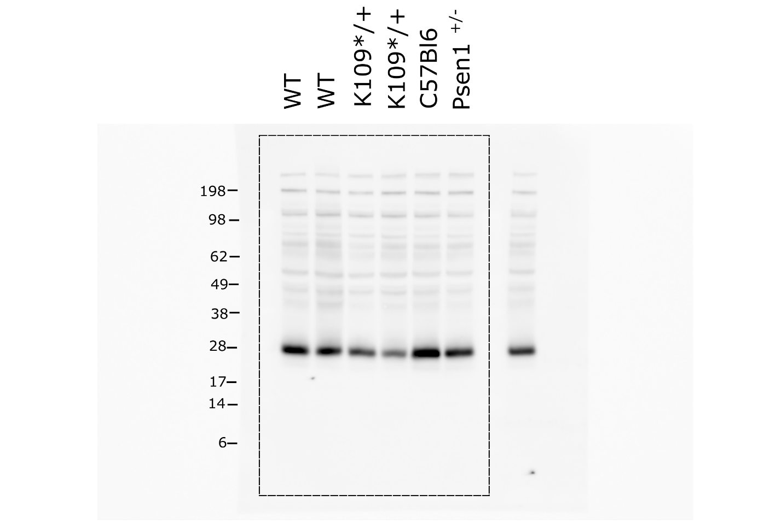
C
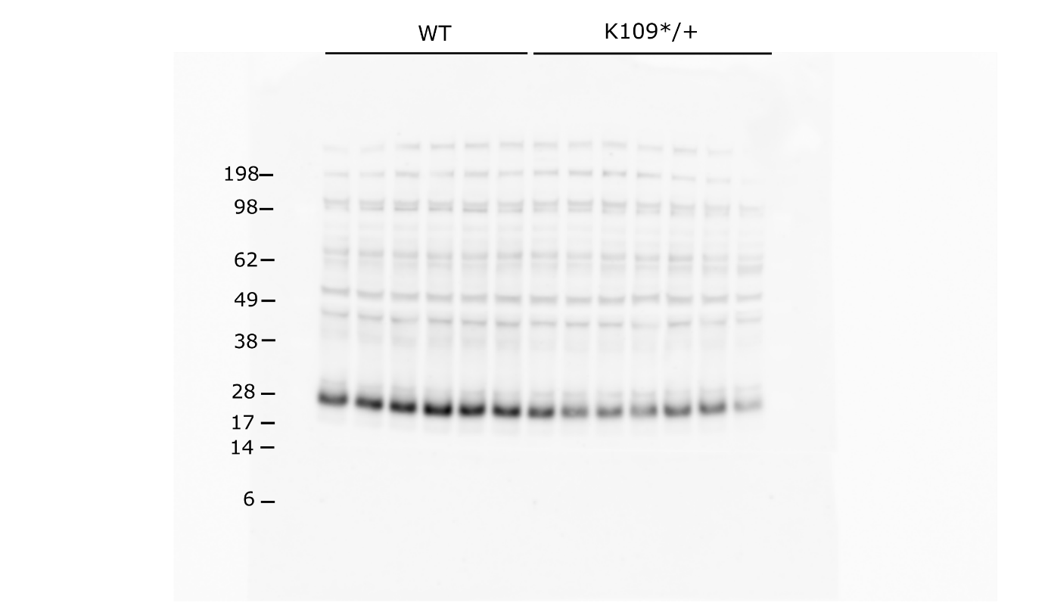

Supplementary Figure 4: Human PSEN1 p.K109* variant and its fragments do not confer γ-secretase activity
B
