Supplementary Figures

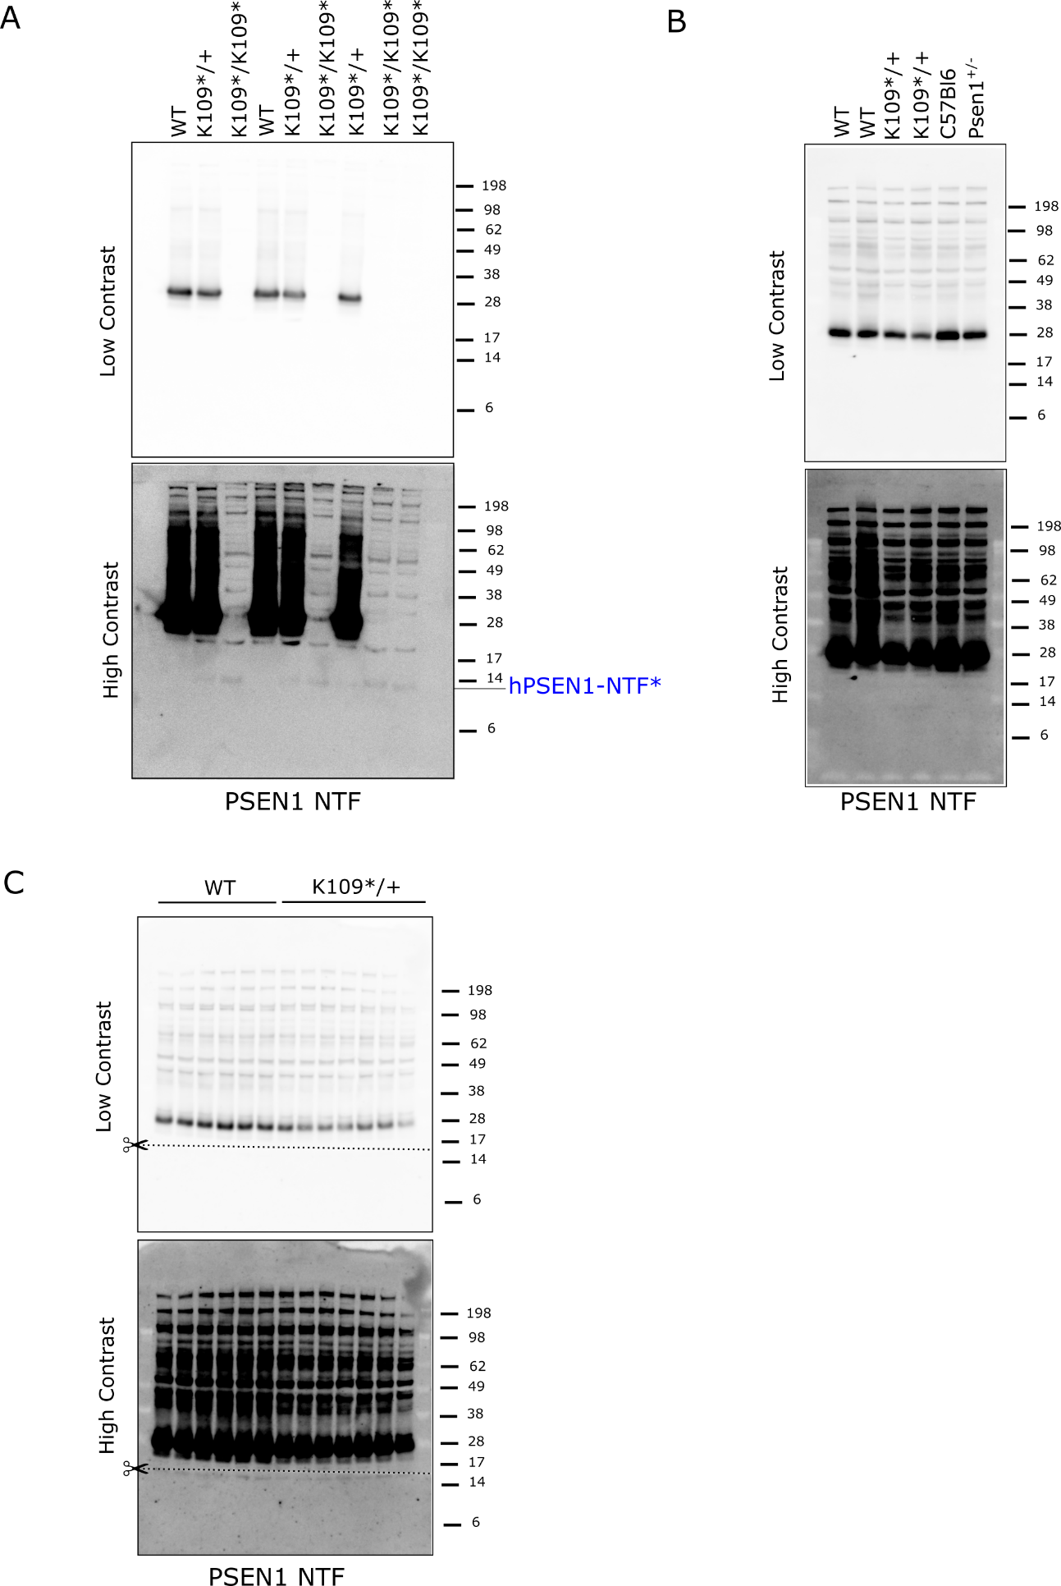
Supplementary Figure 1: PSEN1-NTF* (~12kDa) fragment only detected in primary neuronal cultures.
A) Western blot from wild-type Psen1;App^{hu} (WT); Psen1^{K109*/+};App^{hu} (K109*/+) and Psen1^{K109*/K109*};App^{hu} (K109*/K109*) primary neurons at E14.5. Lower panel is the same as the upper panel with higher contrast. Membrane was stained with an antibody against Psen1 NTF (B19.3) recognizing Psen1 FL, the canonical proteolytic NTF fragment and the aberrant NTF* fragment of ~12kDa indicated in blue. NuPAGE Bis-Tris 10% gels were used and all lanes were loaded with 20μg of protein. Ponceau S staining was done as loading control.
B) Western blot from brain tissue homogenate of 6.5 months Psen1^{K109*/+};App^{hu} mice and their wild-type littermates, C57Bl6 and Psen1^{+/-} mice. Lower panel is the same as the upper panel with higher contrast. Membrane was stained with an antibody against Psen1 NTF (B19.3) recognizing Psen1 FL and the canonical proteolytic NTF fragment. No other fragments could be detected. NuPAGE Bis-Tris 4-12% gels were used and all lanes were loaded with 25μg of protein. Ponceau S staining was done as loading control.
C) Western blot from brain tissue homogenate of 18 months Psen1^{K109*/+};App^{hu} mice and their wild-type littermates. Scissors symbol and dashed line indicates where the membrane was cut to allow different time exposures, allowing the detection of lower expression bands. Lower panel is the same as the upper panel with higher contrast. Membrane was stained with an antibody against Psen1 NTF (B19.3) recognizing Psen1 FL and the canonical proteolytic NTF fragment. No other fragments could be detected. NuPAGE Bis-Tris 4-12% gels were used and all lanes were loaded with 25μg of protein. Ponceau S staining was done as loading control.

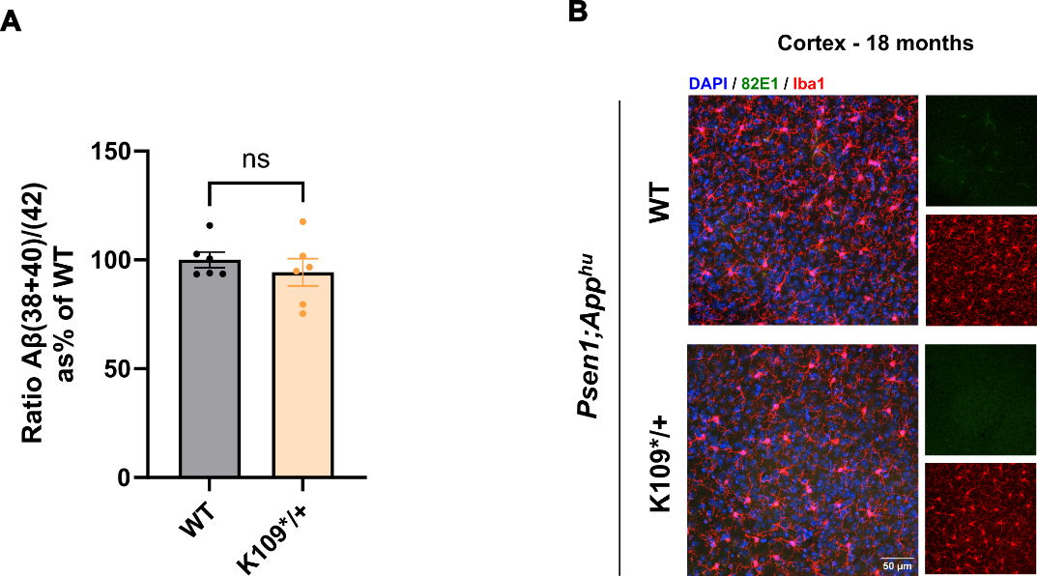
Supplementary Figure 2: Psen1^{K109*} in aged mice does not cause Aβ plaque deposition
A) Bar plot showing the quantified ratio Aβ(38+40)/42 from the Aβ profile in Figure 4C from WT (grey bars) and K109*/+ (orange bars) 18 months old mice. Data is shown as % of the WT. Two-tailed unpaired Student’s t-test.
B) Representative images of cortex brain sections of 18 months Psen1^{K109*/+};App^{hu} mice and their wild-type controls after immunofluorescence antibody staining. Amyloid beta stained in green (82E1), microglia in red (Iba1) and DAPI in blue for nuclei counterstaining. Scale bar: 50μm.

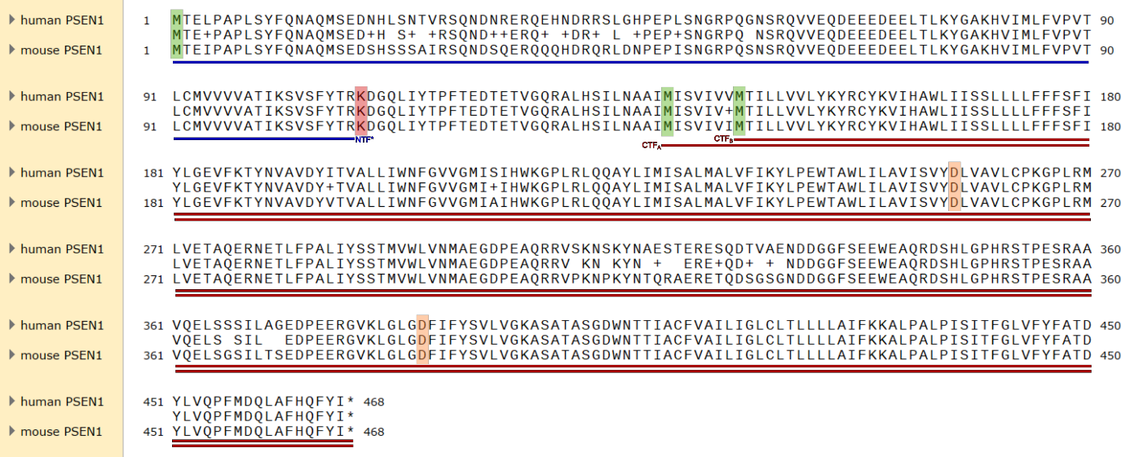
Supplementary Figure 3: Alignment of human and mouse PSEN1 protein sequences
Human PSEN1 and mouse PSEN1 protein sequences were aligned using local alignment (Smith-Waterman, SnapGene). Similar amino acid substitutions are indicated with “+” whereas not similar are indicated by a blank space. Methionines in position 1 (M1), 139 (M139) and 146 (M146) are highlighted by green squares, mutation c.325A>T (p.K109) by a red square and the two aspartate catalytic sites in positions 257 and 385 (D257 and D385 respectively) by orange squares. The generated PSEN1-NTF* from M1 to the p.K109* variant, CTF_{A} from M139 and CTF_{B} from M146 fragments to the canonical stop codon are depicted by blue and red lines respectively.

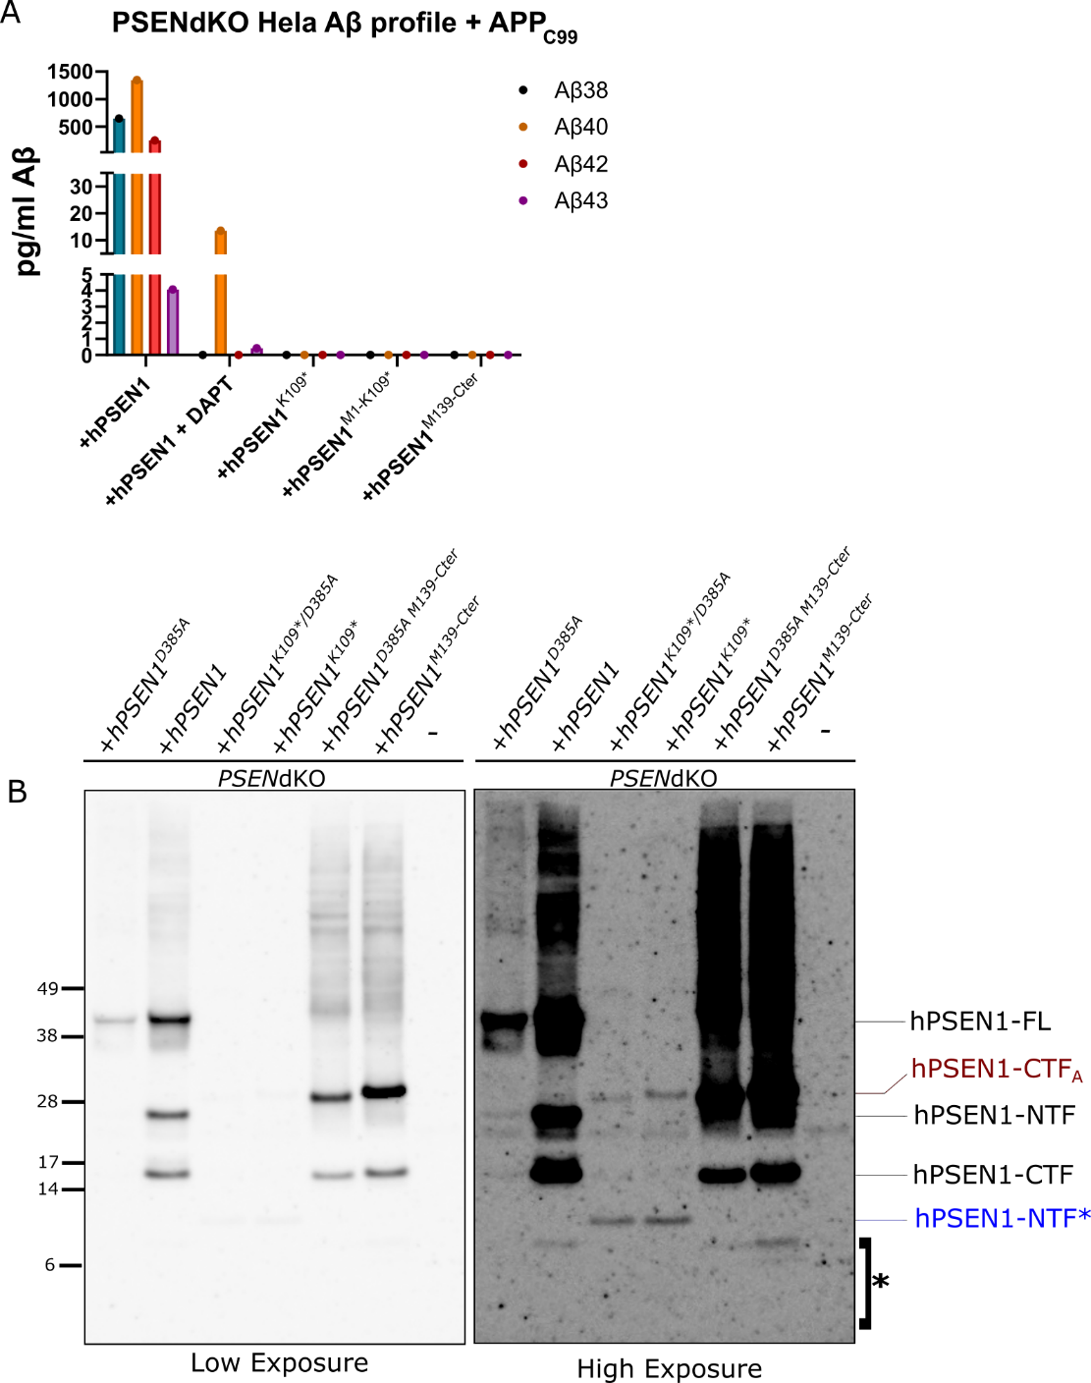
Supplementary Figure 4: Human PSEN1 p.K109* variant and its fragments do not confer γ-secretase activity
A) Bar plot showing the Aβ profile (Aβ38 in blue, Aβ40 in orange, Aβ42 in red and Aβ43 in purple) of Hela PSENdKO cells stably transfected with hPSEN1, hPSEN1^{K109*}, hPSEN1^{M1-K109*} and hPSEN1^{M139-Cter}, transiently expressing APP_{C99}. DAPT was used at 10μM final concentration. Aβ levels were measured by MSD-ELISA from conditioned media.
B) Representative western blot of PSENdKO Hela cell lines stably transfected with hPSEN1, hPSEN1^{K109*} or hPSEN1^{M139-Cter} alone or in combination with the D385A mutation. The membrane from Figure 5C was re-stained with an antibody against hPSEN1 NTF (MKAD3.5) allowing the detection of hPSEN1 FL, hPSEN1 NTF and the shorter hPSEN1 NTF* fragment of ~12kDa indicated in blue. hPSEN1 CTF and hPSEN1-CTF_{A} (in red) fragments can be visualized from previous staining (Figure 5C). Unknown bands are indicated with an asterisk (*). NuPAGE Bis-Tris 4-12% gels were used and all lanes were loaded with 25μg of protein. Ponceau S staining was done as loading control. N=3 independent experiments.

Supplementary Tables

Genes tested in NGS commercial panel:
A2M, AAAS, ACE, APOE, APP, ATP13A2, ATP1A3, CSF1R, DCTN1, DNT1, EIF4G1, FBX07, GBA, GCH1, GRN, HTRA2, LRRK2, MAPT, MPO, PARK2, PARK7, PINK1, PLA2G6, POLG, PRKRA, PRNP, PSEN1, PSEN2, SL6A3, SNCA, SNCB, TAF1, TH, TREM2, TYROBP, UCHL1, VPS35

Supplementary Table 1: List of genes tested in the index patient for relevant genetic variants.
Supplementary Table 2: Variants identified by Whole Genome Sequencing in the Index case. (See Excel file)
Primer | Sequence (5' - 3')
Sequencing
First amplification Forward | GCGCCAAGCATGTGATCATG
First amplification Reverse | GATGACATGCTGTAAAGAAAAGCCACAC
Nested PCR Forward | TGTAAAACGACGGCCAGTGCTCTTTGTCCCTGTGACTCTCTG
Nested PCR Reverse | CAGGAAACAGCTATGACAGAAAAGCCACACTGGCTTTGAG
RT-qPCR
mouse Psen1 WT Forward | CAGTCAGCTTCTATACCCGGA
mouse Psen1 WT Reverse | GGATGACCTTGTAGCACCTG
mouse Psen1 K109* Forward | CTTCTATACgCGttAGGAtGGg
mouse Psen1 K109* Reverse | GGATGACCTTGTAGCACCTG
mouse Psen2 WT Forward | CTGGAGGAGGAGGAGGAAAG
mouse Psen2 WT Reverse | GAGACACAAGCCAATGAGGATG
mouse β-actin Forward | GTGACGTTGACATCCGTAAAGA
mouse β-actin Reverse | GCCGGACTCATCGTACTCC
mouse GAPDH Forward | CGTCCCGTAGACAAAATGGT
mouse GAPDH Reverse | TTGATGGCAACAATCTCCAC
mouse HPRT Forward | GCTTTCCCTGGTTAAGCAGTACA
mouse HPRT Reverse | GGTCCTTTTCACCAGCAAGCT
Supplementary Table 3: List of mouse primer sequences for target and reference genes
 | Antibody | Species | Reference ID/ Catalogue # | Company | Dilution
Western blot
 | Nicastrin | Mouse/Human | 9C3 | Home-made (W. Annaert) | 1/4.000
 | Psen1-NTF | Mouse | B19.3 | Home-made | 1/10.000
 | PSEN1-NTF | Human | MKAD3.5 | Mitsubishi Kasei Institute of Life Sciences  (Marc Mercken) | 1/1.000
 | Psen1-CTF | Mouse | MAB5232 | Sigma Aldrich | 1/1.000
 | PSEN1-CTF | Human | D39D1 / MAB5232 | Cell Signaling/ Calbiochem | 1/1.000
 | Psen2-CTF/ PSEN2-CTF | Mouse/Human | D30G3 | Cell Signaling Technology | 1/1.000
 | Pen2/ PEN2 | Mouse/Human | B126.2 | Home-made | 1/1.000
 | AppC20/APPC20 | Mouse/Human | B63 | Home-made | 1/5.000
 | Actin-β | Mouse/Human | A5441 | Sigma Aldrich | 1/20.000
 | Goat Anti-Rabbit igG (H+L)-HRP | Rabbit | 170-615 | Bio-rad | 1/10.000
 | Goat Anti-Mouse igG (H+L)-HRP | Mouse | 170-6515 | Bio-rad | 1/10.000
IHC
 | Amyloidβ₁₋₄₂ | Human/Mouse | AB5078P | Merck Millipore | 1/150
 | AT8 | Human | MN1020 | Thermo Fischer Scientific | 1/200
 | Amyloidβ | Human | 82E1 | IBL | 1/200
 | Iba1 | Human/Mouse | 019-19741 | WAKO | 1/500
 | Alexa488 Donkey anti-mouse igG(H+L) | Mouse | A21202 | Invitrogen | 1/500
 | Alexa594 Donkey anti-rabbit igG(H+L) | Rabbit | A21207 | Invitrogen | 1/500

Supplementary Table 4: List of mouse and human antibodies

