Supporting Information

Sustainable extraction of rare earth elements from coal fly ash leachates using a recyclable ionic liquid

Ting Liu ¹ and Ching-Hua Huang ^{1, *}
¹ School of Civil and Environmental Engineering, Georgia Institute of Technology, 200 Bobby Dodd Way, Atlanta, GA 30332, USA; tliu335@gatech.edu (T.L.); ching-hua.huang@ce.gatech.edu (C.-H.H.)
* Correspondence: ching-hua.huang@ce.gatech.edu; Tel.: +1-404-894-7694

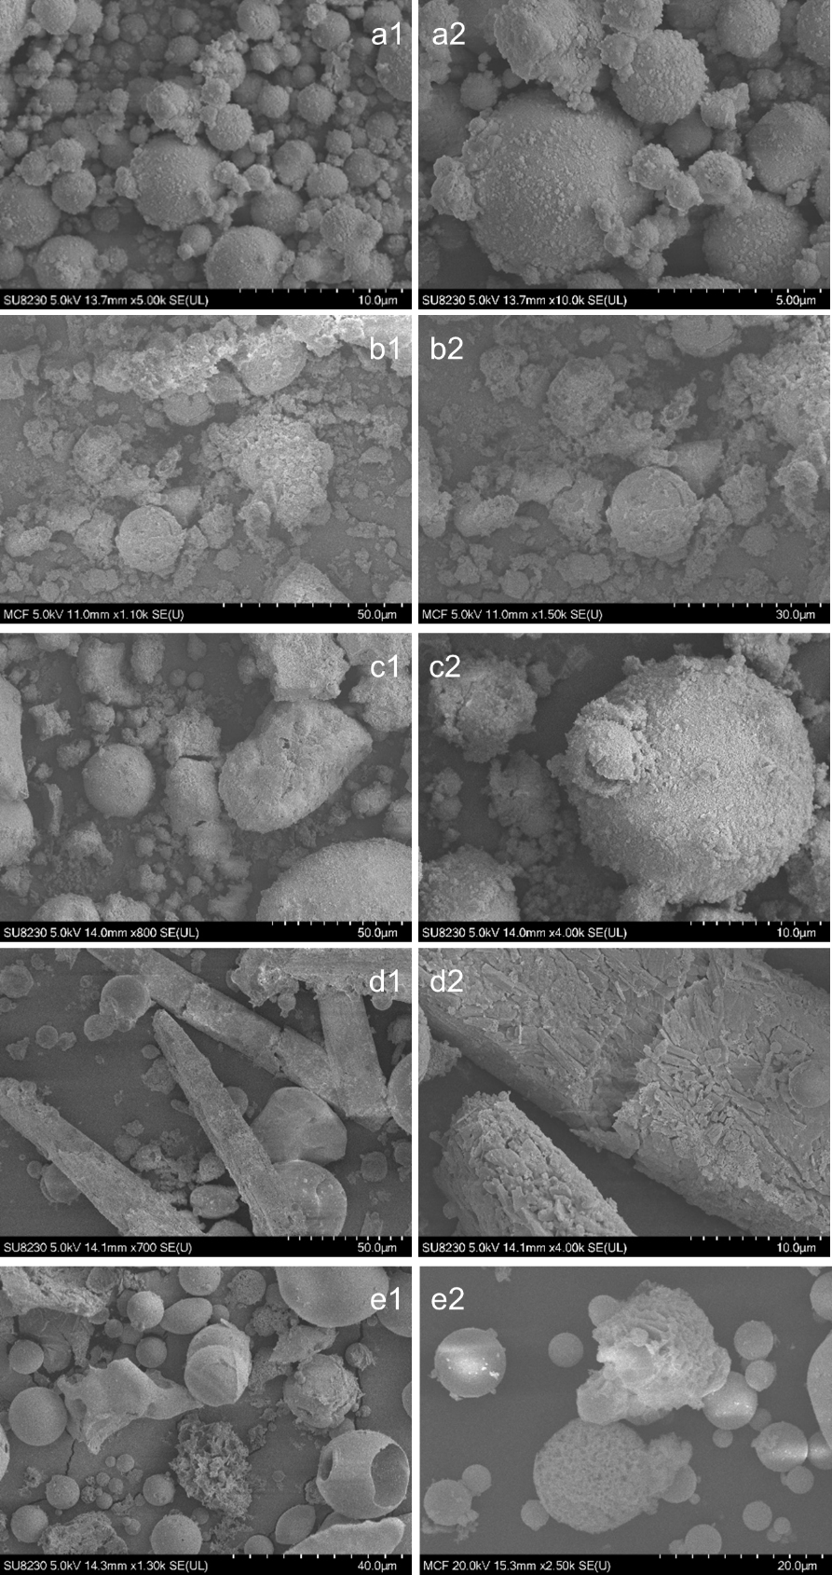
Figure S1. SEM images of Class C CFA under low (left) and high (right) magnifications. (a) as received; (b) after HCl leaching; (c) after HNO₃ leaching; (d) after H₂SO₄ leaching; and (e) after citrate leaching.
Figure S2. Effect of leachate pH on non-REE elements’ distribution, D, for extraction from (a) HCl, (b) citrate, (c) HNO₃, and (d) H₂SO₄ leachates.

Figure S3. Results of (a) distribution, D, and (b) recovery, R%, of Nd in simulated AQ-IL systems. Extraction conditions: pH ~11 and 10 mg betaine/g AQ.

Figure S4. Effect of adding 1 wt% betaine to HCl and citrate leachates on REE recovery, R%.

