Supplementary material

Integrative proteogenomic analyses discover novel plasma proteins that impact risk of ischemic stroke
Lazaros Belbasis¹, Adam von Ende¹, Parag Gajendragadkar¹, Elsa Valdes-Marquez¹, Federico Murgia¹, Cornelia van Duijn¹, Jemma C Hopewell¹
¹Nuffield Department of Population Health, University of Oxford, Oxford, U.K.

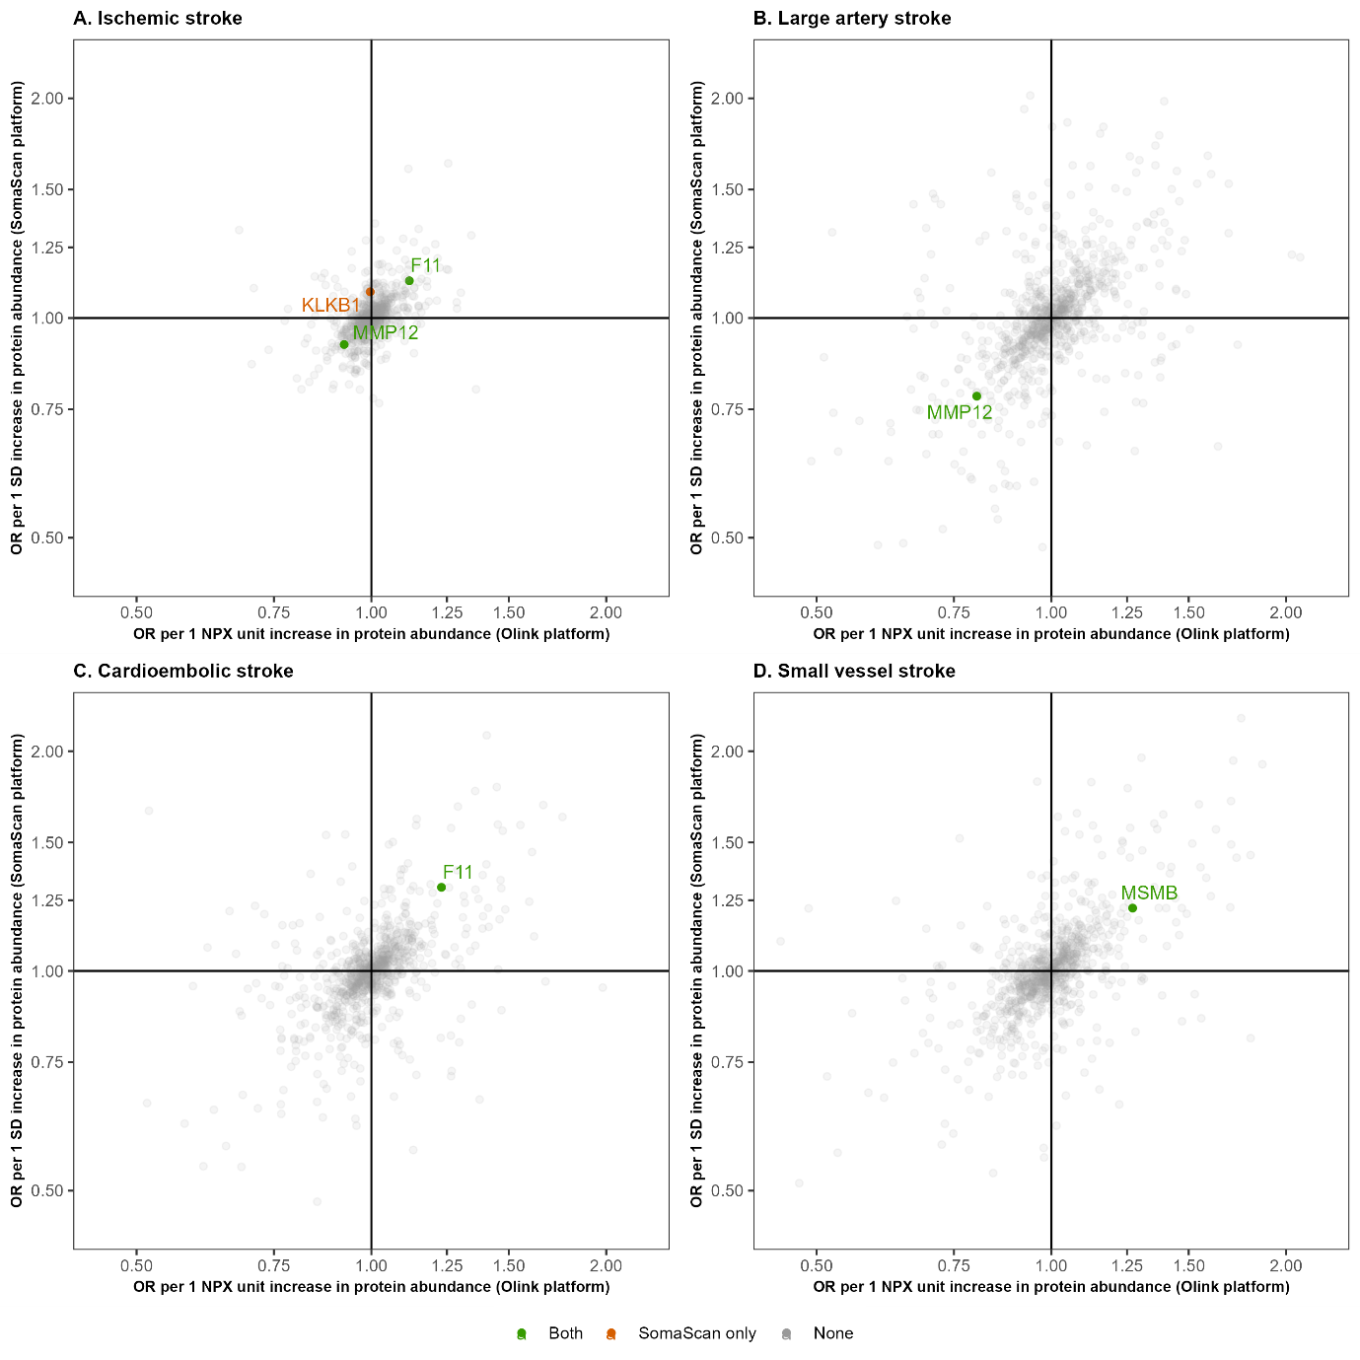
Supplementary Figure S1. MR effect estimate of plasma protein abundance on ischemic stroke and its subtypes based on two different proteomic platforms. The scatter plots allow for a comparison of findings across the two proteomic platforms for ischemic stroke (A) and its subtypes: large artery stroke (B), cardioembolic stroke (C), and small vessel stroke (D). The x-axis represents ORs using cis pQTLs from the Olink platform, while the y-axis represents ORs using cis pQTLs from the SomaScan platform. Proteins that were statistically significant using either cis pQTLs from either Olink or SomaScan are annotated. Proteins statistically significant in both platforms are labelled in green, proteins statistically significant only in the SomaScan platform are labelled in orange, and proteins that were not associated with ischemic stroke phenotypes are labelled in grey.
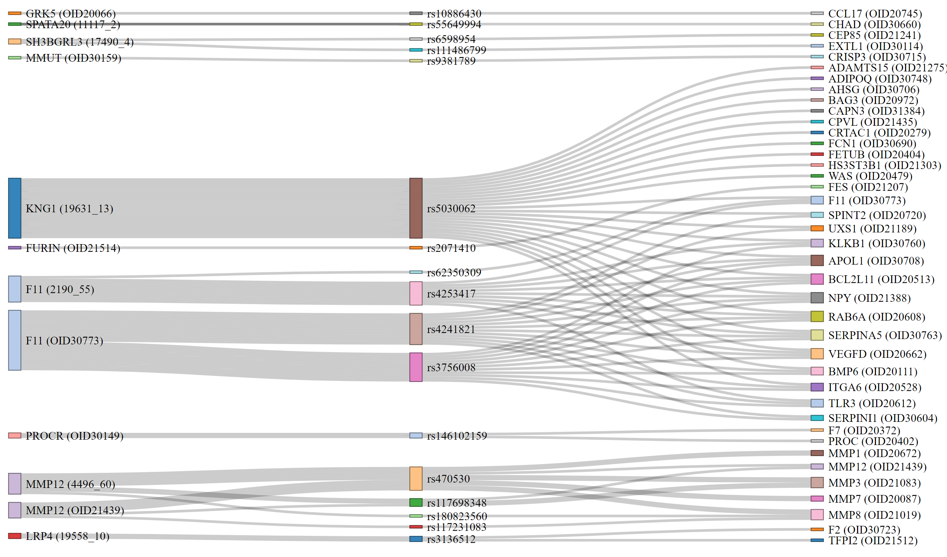
Supplementary Figure S2. Effect of genetic instrumental variables for the ischemic stroke-associated proteins on the abundance of plasma proteins measured through Olink platform. The left column includes the proteins with a statistically significant effect on ischemic stroke and/or its subtypes. The middle column includes the cis pQTLs which (a) are used as instrumental variables for the proteins with a statistically significant association with ischemic stroke (or its subtypes) and (b) are also pQTLs for other proteins measured on the Olink platform. The right column shows these plasma proteins influenced by these cis pQTLs.

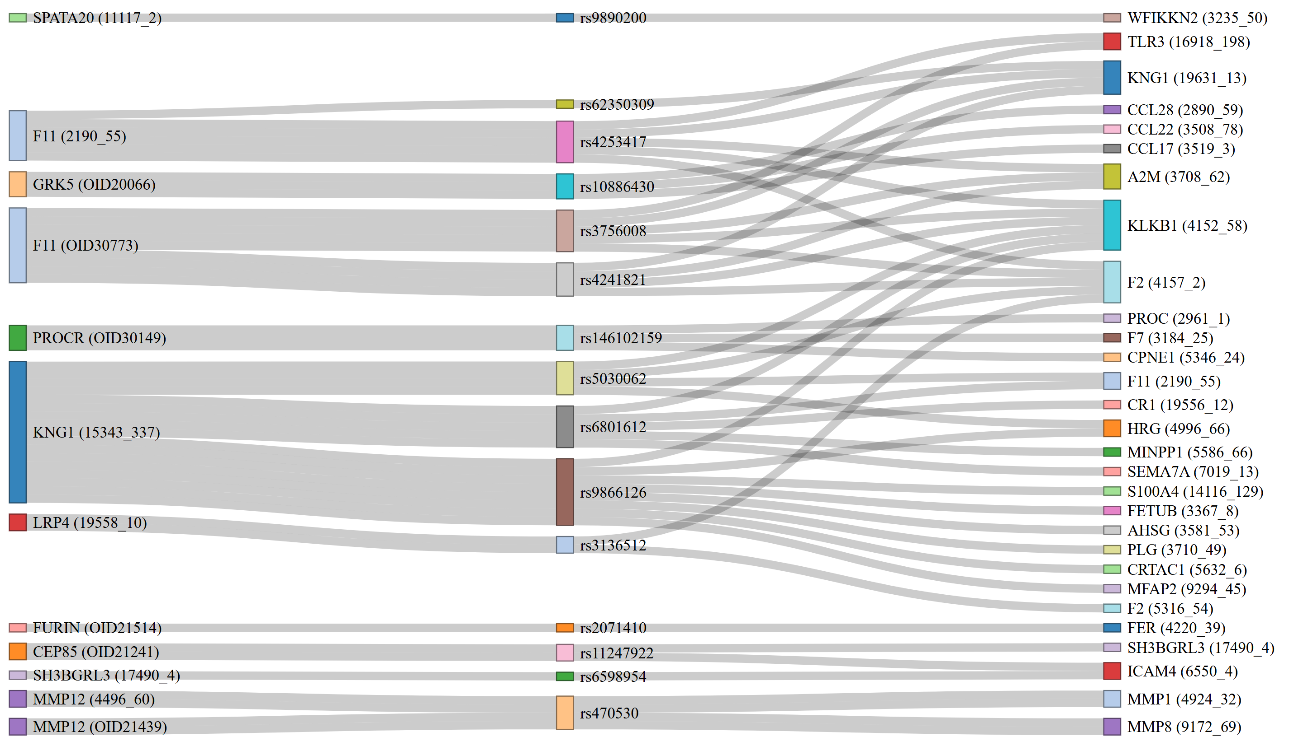
Supplementary Figure S3. Effect of genetic instrumental variables for the ischemic stroke-associated proteins on the abundance of plasma proteins measured through SomaScan platform. The left column includes the proteins with a statistically significant effect on ischemic stroke and/or its subtypes. The middle column includes the cis pQTLs which (a) are used as instrumental variables for the proteins with a statistically significant association with ischemic stroke (or its subtypes) and (b) are also pQTLs for other proteins measured on the SomaScan platform. The right column shows these plasma proteins influenced by these cis pQTLs.

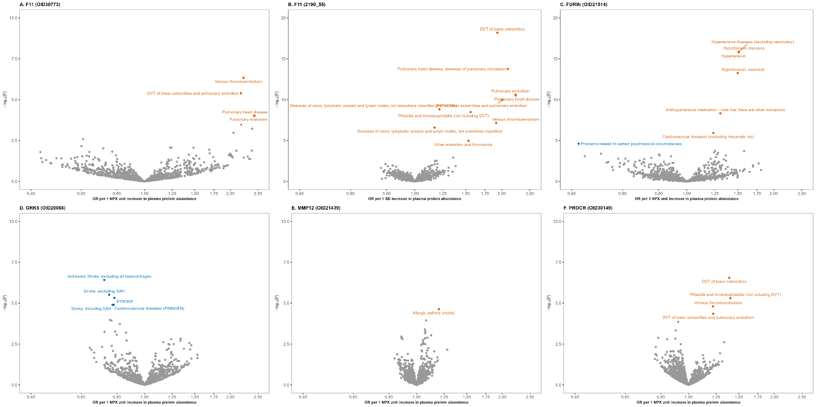
Supplementary Figure S4. Mendelian randomisation randomisation analysis for the effect of ischemic stroke-associated proteins on multiple health-related outcomes in FinnGen. Each panel represents a different protein, showing only those with at least one statistically significant association with a health outcome. Statistically significant associations (at 5% FDR) are highlighted in orange (positive associations) and blue (negative associations). Grey dots indicate outcomes without statistically significant association.
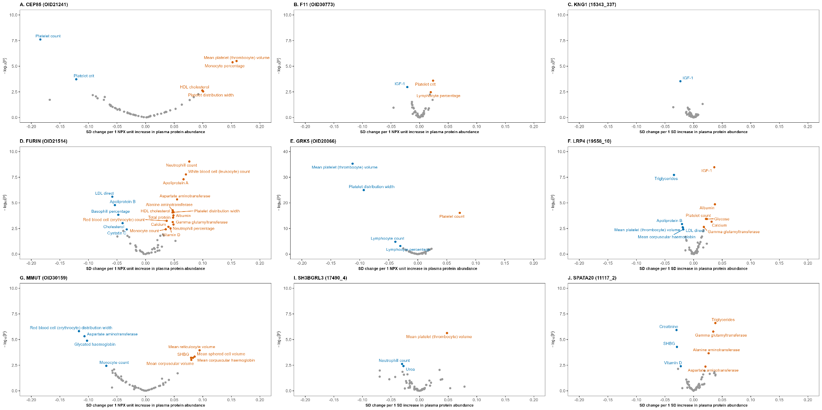
Supplementary Figure S5. Mendelian randomisation randomisation analysis for the association of ischemic stroke-associated proteins with blood biomarkers in the UK Biobank. Each panel (A-J) represents a different protein, showing only those with at least one statistically significant association with a blood biomarker. Statistically significant associations are highlighted in blue for negative associations and orange for positive associations, while statistically non-significant associations are represented in grey.

