Supplementary file

Supplementary Table 1. List of premiers and templates to amplify DNA by PCR.

No. | Template | Primer_forward | Sequence(5`→3`) | Primer_reverse | Sequence(5`→3`)
1 | pBYR2HS-U6GAD | pPcUf-AtU6pro-F | ccaagctccaattagggccc cgtacgaccctcctgcagttcc | space-U6end-R | tgctagactagtcggttcg cgcagatttgcatccaaaac
2 | PRI201-AN | Nost-F | atcccgggagtgatcgttc aaacatttggcaataaag | PcUbi-Nost-R | cgttgctagggcgcgccga tctagtaacatagatgacacc
3 | SlESK-target2 | space-U6-26-F | ccgactagtctagcaagc ttcctttttttcttcttcttcgttc | SlHWS-target6R | ctcaagcagatcatcccat tcaatcactacttcgactctagc
4 | SlESK-target2 | SlHWS-target6F | aatgggatgatctgcttgagg ttttagagctagaaatagcaag | Nost-U6-endR | gatcactcccgggatttcg cgcagatttgcatccaaaac
5 | pPcUf-SlESKGAD3 | XmaⅠ-U6(26)-F | tgcgcgaaatcccgg ctttttttcttcttcttcgttc | U6-ESKtarget1-R | agagactgttctttacccaac aatcactacttcgactctagc
6 | pPcUf-SlESKGAD3 | ESKtarget1-gRNA-F | ttgggtaaagaacagtctct gttttagagctagaaatagcaag | U6end-XmaI-R | aacgatcactcccgggttcg cgcagatttgcatccaaaac

Supplementary Table 2. List of primers to amplify DNA region from tomato genome.
No. | Primer_Forward | Sequnece(5`→3`) | Primer_reverse | Sequence(5`→3`)
1 | SlGAD3-multiF | cccgaaccctagcagatcgtcttg | SlGAD3-multiR | tcttccaaaactcagcaattgccc
2 | ESK1-target2-multinaF | cagtacacgtaccccttgataga | ESK1-target2-multinaR | caggcatgatgatcctgttcaat
3 | ESK2-target2-multinaF | ctcatataaaataagaccgaggg | ESK2-target2-multinaR | caggcatgatgattctgttcaag
4 | ESK3-target2-multinaF | attcttttcaaatctacttatgg | ESK3-target2-multinaR | tgattctggcatgatgagtctgg
5 | ESK1-target1-multinaF | gaggactccatgtatcagaactg | ESK1-target1-multinaR | caagcagcaactttgctttaaac
6 | ESK2-target1-multinaF | gttacttgcttgaggaatggaag | ESK2-target1-multinaR | cgtaatagctgacaaatacctcc
7 | ESK3-target1-multinaF | gtttttgataatgttactcatcc | ESK3-target1-multinaR | agtaaaacagatagatcgaaacg
8 | M13-47 | cgccagggttttcccagtcacgac | RV-P | ggaaacagctatgaccatgattac
9 | PrimerCheck11-F | gttttcccagtcacgacgtt | Nos-seqR | accggcaacaggattcaatc
10 | PcUbiCheck2-F | tcagatcccctcttccttca | fcoCAS9Check2-R | gtgtccttggagagctggag
11 | fcoCAS9Check3-F | atcctcctctccgacatcct | fcoCAS9Check3-R | agcttctcgttctggagctg
12 | fcoCAS9Check3.5-F | gcgacatgtacgtcgaccag | fcoCAS9Check3.5-R | gacggagtaggcgacggtag
13 | fcoCAS9Check4-F2 | atcaccatcatggagcgctc | fcoCAS9Check4-R2 | acttgtggccgtttacgtcg
14 | gfbsd2Check5-F | cacatgaagcagcacgactt | CaMV35sCheck5-R | gatttcagcgtgtcctctcc
15 | NPTIICheck6-F | agacaatcggctgctctgat | PpcUfcoCas9Check6-R | gcaacgctctgtcatcgtta
16 | AminoPhoCheck7-F | gaaagctgcctgttccaaag | pBR322Check7-R | agctcactcaaaggcggtaa
17 | pBR322Check8-F | gagtcagtgagcgaggaagc | pVS1Check8-R | gattggatgtaccgcgagat
18 | pVS1Check9-F | ggtatcggttcatggattcg | pVS1Check9-R | gagctgcccattcttgagtc
19 | pVS1Check10-F | acccgcctttctggttaagt | PrimerCheck10-R | ctggcgtaatagcgaagagg
20 | HWS-offcheck-1F | tatgttggcagctggccttg | HWS-offcheck-1R | tgcagtgtagccacgtacag
21 | GAD3-offcheck-1F | accagccgagatcattaggc | GAD3-offcheck-1R | tgccacttcctcaatggtcc
22 | ESKtar1-offcheck-1F2 | gagtttgagaaggatggaggc | ESKtar1-offcheck-1R2 | gccattgccatatcatcagcc
23 | ESKtar1-offcheck-2F | ccacagagtctgaagaaacagg | ESKtar1-offcheck-2R | ctgattccaatgccaatgc
24 | ESKtar1-offcheck-3F | gaaccatgatctagggctcg | ESKtar1-offcheck-3R | tgatggtggaaactcccacc
25 | ESKtar1-offcheck-4F | atggttgccctaacttggag | ESKtar1-offcheck-4R | accttgatgcaccaggatcc
26 | ESKtar1-offcheck-5F | aactctctggcttctctgcc | ESKtar1-offcheck-5R | gcagaacaagtagctcccag
27 | ESK1tar2-offcheck-1F | gtggtactcgaacctcctcc | ESK1tar2-offcheck-1R | tcatcacgtgcaatccaagc
28 | ESK1tar2-offcheck-2F | tggtactcgaacctcctccg | ESK1tar2-offcheck-2R | gtaccaatggaagacccagc
29 | SlNCED1-F | caacagcaaggaagaagacg | SlNCED1-R | tgcctccaacttcaaactca

Supplementary Table 3. Sequences of eskgad3 lines in T₀ generations.

line | Sample name | Target gene | Sequence | Mutation rate
esksgad3  esksgad3  esksgad3 | 58 | GAD3 | CCCGAATGCCAAA---GTGG CCCGAATGCC---AAAGTGG | 1/4  1/4
esksgad3  esksgad3  esksgad3 | 58 | ESK1target | AGAG----TTCTTTACCCAA AGA----GTTCTTTACCCAA  AGA-----TTCTTTACCCAA | 1/4  1/4  2/4
esksgad3  esksgad3  esksgad3 | 58 | ESK2target1 | AGAAGACTGTTCTTTACCCAA AGA------TCTTTACCCAA | 3/4  1/4
esksgad3  esksgad3  esksgad3 | 58 | ESK3target1 | AGAAGACTGTTCTTTACCCAA AGA------TCTTTACCCAA | 2/4  2/4
esksgad3  esksgad3  esksgad3 | 58 | ESK1target2 | ATGCCACTGTGGA----TAC | 3/4
esksgad3  esksgad3  esksgad3 | 60 | GAD3 | CCCGAATGCCAAAAAAGATGG | 1/4
esksgad3  esksgad3  esksgad3 | 60 | ESK1target1 | AGA—CTGTTCTTTACCCAA  --AGACTGTTCTTTACCCAA | 1/3  2/3
esksgad3  esksgad3  esksgad3 | 60 | ESK2target1 | AGA------TCTTTACCCAA | 4/4
esksgad3  esksgad3  esksgad3 | 60 | ESK3target1 | AG----TGTTCTTTACCCAA AGAG----TTCTTTACCCAA AGA----GTTCTTTACCCAA | 2/4  1/4  1/4
esksgad3  esksgad3  esksgad3 | 60 | ESK1target2 | 「ATGCCACTG-----------」-- ATGCCACT---------TAC  ATGCC------------AC | 2/4  1/4  1/4
esksgad3  esksgad3  esksgad3 | 69 | GAD3 | CCCGAATGCCAAAAAAGATGG CCCGAATGCCAAAAAAGTTGG | 1/4  2/4
esksgad3  esksgad3  esksgad3 | 69 | ESK1target1 | AGATGACTGTTCTTTACCCAA | 3/4
esksgad3  esksgad3  esksgad3 | 69 | ESK2target1 | AGAAGACTGTTCTTTACCCAA | 1/3
esksgad3  esksgad3  esksgad3 | 69 | ESK3target1 | AGAAGACTGTTCTTTACCCAA AGA------TCTTTACCCAA | 3/6  2/6
esksgad3  esksgad3  esksgad3 | 69 | ESK1target2 | ATGCCACTGTGGA----TAC | 4/4
esksgad3  esksgad3  esksgad3 | 76 | ESK1target1 | AGATGACTGTTCTTTACCCAA | 3/4
esksgad3  esksgad3  esksgad3 | 76 | ESK2target1 | AGAAGACTGTTCTTTACCCAA AGA—CTGTTCTTTACCCAA  --AGACTGTTCTTTACCCAA | 2/4  1/4  1/4
esksgad3  esksgad3  esksgad3 | 76 | ESK3target1 | AGAAGACTGTTCTTTACCCAA  ---------「--AGACTGTTCTTTACCCAA」  -------「--AGACTGTTCTTTACCCAA」 | 2/4  1/4  1/4
esksgad3  esksgad3  esksgad3 | 76 | ESK1target2 | ATGCCACTGT-------TAC ATGCCA-------ATTTTAC | 1/4  1/4
esksgad3  esksgad3  esksgad3 | 91 | GAD3 | CCCGAATGCCAA-----TGG | 1/3
esksgad3  esksgad3  esksgad3 | 91 | ESK1target1 | AGATGACTGTTCTTTACCCAA | 1/4
esksgad3  esksgad3  esksgad3 | 91 | ESK2target1 | AGAAGACTGTTCTTTACCCAA  -CAGACTGTTCTTTACCCAA | 1/4  3/4
esksgad3  esksgad3  esksgad3 | 91 | ESK3target1 | AGA-ACTGTTCTTTACCCAA | 4/4
esksgad3  esksgad3  esksgad3 | 91 | ESK1target2 | 「ATGCCACTGTGG--------」--GGC | 4/4
esksgad3  esksgad3  esksgad3 | 102 | GAD3 | CCCGAATGCCAAAAAAGGTGG | 2/3
esksgad3  esksgad3  esksgad3 | 102 | ESK1target1 | AGA----------TACCCAA | 4/4
esksgad3  esksgad3  esksgad3 | 102 | ESK2target1 | AGA----------TACCCAA  A-----TATTCTTTACCCAA  AGA-----TTCTTTACCCAA | 2/4  1/4  1/4
esksgad3  esksgad3  esksgad3 | 102 | ESK3target1 | AGAG----TTCTTTACCCAA | 4/4
esksgad3  esksgad3  esksgad3 | 102 | ESK1target2 | ATGCCACTGTGGAAT---AC | 4/4
esksgad3  esksgad3  esksgad3 | 105 | ESK1target1 | AGA-----TTCTTTACCCAA | 1/2
esksgad3  esksgad3  esksgad3 | 105 | ESK2target1 | AGA----GTTCTTTACCCAA  AGA--------------CAA  AGAG----TTCTTTACCCAA | 1/4  2/4  1/4
esksgad3  esksgad3  esksgad3 | 105 | ESK3target1 | AGA-----------ACCCAA  AGA--CTGTTCTTTACCCAA  AGA--CGGTTCTTTACCCAA | 2/4  1/4  1/4
esksgad3  esksgad3  esksgad3 | 127 | GAD3 | CCCGAATGCCAAA----TGG CCCGAATGCCAAAAAAGTTGG CCCGAATGCCAAAAGAGTTGG | 2/4  1/4  1/4
esksgad3  esksgad3  esksgad3 | 127 | ESK1target1 | AGA-----TTCTTTACCCAA  AGA-----TTCTGTACCCAA | 3/4  1/4
esksgad3  esksgad3  esksgad3 | 127 | ESK2target1 | AGAAGACTGTTCTTTACCCAA AGA------TCTTTACCCAA | 2/4  2/4
esksgad3  esksgad3  esksgad3 | 127 | ESK3target1 | AGA-----TTCTTTACCCAA | 4/4
esksgad3  esksgad3  esksgad3 | 150 | ESK1target1 | AGA--CTGTTCTTTACCCAA | 4/4
esksgad3  esksgad3  esksgad3 | 150 | ESK2target1 | AGA----GTTCTTTACCCAA AGAG----TTCTTTACCCAA | 1/2  1/2
esksgad3  esksgad3  esksgad3 | 150 | ESK3target1 | AGA--CTGTTCTTTACCCAA | 2/2
esksgad3  esksgad3  esksgad3 | 150 | ESK1target2 | ATGCCACTGTGGAAT---AC | 3/4
esksgad3  esksgad3  esksgad3 | 152 | ESK2target1 | --AGACTGTTCTTTACCCAA | 1/2
Supplementary Table 4. Sequences of eskgad3 lines in T₁ generations.
line | Sample name | Target gene | Sequence
esksgad3 | 76-1 | ESK1target1 | AGATGACTGTTCTTTACCCAA
esksgad3 | 76-1 | ESK2target1 | --AGACTGTTCTTTACCCAA
esksgad3 | 76-1 | ESK3target1 | hetero
esksgad3 | 76-2 | ESK1target1 | AGATGACTGTTCTTTACCCAA
esksgad3 | 76-2 | ESK2target1 | hetero
esksgad3 | 76-2 | ESK3target1 | hetero
esksgad3 | 76-2 | ESK1target2 | hetero
esksgad3 | 76-3 | ESK1target1 | AGATGACTGTTCTTTACCCAA
esksgad3 | 76-3 | ESK2target1 | AGAAGACTGTTCTTTACCCAA
esksgad3 | 76-3 | ESK3target1 | ---------「--GACTGTTCTTTACCCAA」
esksgad3 | 76-3 | ESK1target2 | ATGCCACTGTG-------TTAC
esksgad3 | 76-4 | ESK1target1 | AGATGACTGTTCTTTACCCAA
esksgad3 | 76-4 | ESK2target1 | --AGACTGTTCTTTACCCAA
esksgad3 | 76-4 | ESK3target1 | AGAAGACTGTTCTTTACCCAA
esksgad3 | 76-4 | ESK1target2 | ATGCCACTGTGGA----TAC
esksgad3 | 76-5 | ESK1target1 | AGATGACTGTTCTTTACCCAA
esksgad3 | 76-5 | ESK2target1 | hetero
esksgad3 | 76-5 | ESK3target1 | hetero
esksgad3 | 76-5 | ESK1target2 | hetero
esksgad3 | 76-6 | ESK1target1 | AGATGACTGTTCTTTACCCAA
esksgad3 | 76-6 | ESK2target1 | --AGACTGTTCTTTACCCAA
esksgad3 | 76-6 | ESK3target1 | ---------「--GACTGTTCTTTACCCAA」
esksgad3 | 76-6 | ESK1target2 | ATGCCACTG-------TTAC
esksgad3 | 76-7 | ESK1target1 | AGATGACTGTTCTTTACCCAA
esksgad3 | 76-7 | ESK2target1 | --AGACTGTTCTTTACCCAA
esksgad3 | 76-7 | ESK3target1 | AGAGACTGTTCTTTACCCAA
esksgad3 | 76-7 | ESK1target2 | hetero
esksgad3 | 76-8 | ESK1target1 | AGATGACTGTTCTTTACCCAA
esksgad3 | 76-8 | ESK2target1 | hetero
esksgad3 | 76-8 | ESK3target1 | AGAGACTGTTCTTTACCCAA
esksgad3 | 76-8 | ESK1target2 | ATGCCACTG-------TTAC
esksgad3 | 76-9 | ESK1target1 | AGATGACTGTTCTTTACCCAA
esksgad3 | 76-9 | ESK2target1 | AGAAGACTGTTCTTTACCCAA
esksgad3 | 76-9 | ESK3target1 | ---------「--GACTGTTCTTAACACTG」
esksgad3 | 76-9 | ESK1target2 | hetero
esksgad3 | 76-10 | ESK1target1 | AGATGACTGTTCTTTACCCAA
esksgad3 | 76-10 | ESK2target1 | hetero
esksgad3 | 76-10 | ESK3target1 | hetero
esksgad3 | 76-11 | ESK1target1 | AGATGACTGTTCTTTACCCAA
esksgad3 | 76-11 | ESK2target1 | hetero
esksgad3 | 76-11 | ESK3target1 | TTAGACTGT-----------」---
esksgad3 | 76-11 | ESK1target2 | ATGCCACTG-------TTAC
esksgad3 | 102-6 | ESK3target1 | hetero
esksgad3 | 102-10 | ESK2target1 | hetero
esksgad3 | 105-1 | ESK1target1 | hetero
esksgad3 | 105-2 | ESK1target1 | hetero
esksgad3 | 105-2 | ESK3target1 | AGA--C---------CCCAA
esksgad3 | 105-3 | ESK1target1 | AGA-----TTCTTTACCCAA
esksgad3 | 105-3 | ESK2target1 | hetero
esksgad3 | 105-3 | ESK3target1 | --AGACTGTTCTTTACCCAA
esksgad3 | 105-4 | ESK1target1 | hetero
esksgad3 | 105-4 | ESK2target1 | hetero
esksgad3 | 105-4 | ESK3target1 | --AGACTGTTCTTTACCCAA
esksgad3 | 105-5 | ESK1target1 | AGATAC-GCTCT--------」-TA
esksgad3 | 105-5 | ESK2target1 | hetero
esksgad3 | 105-5 | ESK3target1 | AGA--C---------CCCAC
esksgad3 | 105-6 | ESK1target1 | hetero
esksgad3 | 105-6 | ESK2target1 | AGA----GTTCTTTACCCAA
esksgad3 | 105-6 | ESK3target1 | AGA--CT-TT-T---CCCAA
esksgad3 | 105-7 | ESK1target1 | AGA-----TTCTGTACCCAA
esksgad3 | 105-7 | ESK2target1 | hetero
esksgad3 | 105-7 | ESK3target1 | hetero
esksgad3 | 105-8 | ESK1target1 | AGA-----TTCTGTACCCAA
esksgad3 | 105-8 | ESK2target1 | hetero
esksgad3 | 105-8 | ESK3target1 | hetero
esksgad3 | 127-1 | GAD3 | CCCGAATGCCAAAAAAGTTGG
esksgad3 | 127-1 | ESK1target1 | AGA-----TTCTTTACCCAA
esksgad3 | 127-1 | ESK2target1 | hetero
esksgad3 | 127-1 | ESK3target1 | AGA-----TTCTTTACCCAA
esksgad3 | 127-2 | GAD3 | CCCGAATGCCAAA----TGG
esksgad3 | 127-2 | ESK1target1 | AGA-----TTCTTTACCCAA
esksgad3 | 127-2 | ESK2target1 | mono
esksgad3 | 127-2 | ESK3target1 | AGA-----TTCTTTACCCAA
esksgad3 | 127-3 | GAD3 | CCCGAATGCCAAA----TGG
esksgad3 | 127-3 | ESK2target1 | AGAAGACTGTTCTTTACCCAA
esksgad3 | 127-3 | ESK3target1 | AGA-----TTCTTTACCCAA
esksgad3 | 127-4 | GAD3 | CCCGAATGCCAAAAAAGTTGG
esksgad3 | 127-4 | ESK1target1 | AGA-----TTCTTTACCCAA
esksgad3 | 127-4 | ESK2target1 | hetero
esksgad3 | 127-4 | ESK3target1 | AGA-----TTCTTTACCCAA
esksgad3 | 127-5  (EG Line1) | GAD3 | CCCGAATGCCAAA----TGG
esksgad3 | 127-5  (EG Line1) | ESK1target1 | AGA-----TTCTTTACCCAA
esksgad3 | 127-5  (EG Line1) | ESK2target1 | AGA------TCTTTACCCAA
esksgad3 | 127-5  (EG Line1) | ESK3target1 | AGA-----TTCTTTACCCAA
esksgad3 | 127-6 | GAD3 | CCCGAATGCCAAA----TGG
esksgad3 | 127-6 | ESK1target1 | AGA-----TTCTTTACCCAA
esksgad3 | 127-6 | ESK2target1 | hetero
esksgad3 | 127-6 | ESK3target1 | AGA-----TTCTTTACCCAA
esksgad3 | 127-7 | GAD3 | CCCGAATGCCAAA----TGG
esksgad3 | 127-7 | ESK1target1 | AGA-----TTCTTTACCCAA
esksgad3 | 127-7 | ESK2target1 | AGAAGACTGTTCTTTACCCAA
esksgad3 | 127-7 | ESK3target1 | AGA-----TTCTTTACCCAA
esksgad3 | 127-8 | GAD3 | hetero
esksgad3 | 127-8 | ESK1target1 | AGA-----TTCTTTACCCAA
esksgad3 | 127-8 | ESK2target1 | AGA------TCTTTACCCAA
esksgad3 | 127-8 | ESK3target1 | AGA-----TTCTTTACCCAA
esksgad3 | 127-8 | ESK1target2 | hetero
esksgad3 | 127-9  (EG Line2) | GAD3 | CCCGAATGCCAAAAAAGTTGG
esksgad3 | 127-9  (EG Line2) | ESK1target1 | AGA-----TTCTTTACCCAA
esksgad3 | 127-9  (EG Line2) | ESK2target1 | hetero
esksgad3 | 127-9  (EG Line2) | ESK3target1 | AGA-----TTCTTTACCCAA
esksgad3 | 127-10 | GAD3 | CCCGAATGCCAAA----TGG
esksgad3 | 127-10 | ESK1target1 | AGA-----TTCTTTACCCAA
esksgad3 | 127-10 | ESK3target1 | AGA-----TTCTTTACCCAA
esksgad3 | 150-1 | ESK1target1 | hetero
esksgad3 | 150-1 | ESK2target1 | AGAGA----TCTTTACCCAA
esksgad3 | 150-1 | ESK3target1 | AGA----GTTCTTTACCCAA
esksgad3 | 150-1 | ESK1target2 | hetero
esksgad3 | 150-2 | ESK1target1 | hetero
esksgad3 | 150-2 | ESK2target1 | AGA----GTTCTTTACCCAA
esksgad3 | 150-2 | ESK3target1 | hetero
esksgad3 | 150-2 | ESK1target2 | hetero
esksgad3 | 150-3 | ESK1target1 | --AGACTGTTCTTTACCCAA
esksgad3 | 150-3 | ESK2target1 | AGA----GTTCTTTACCCAA
esksgad3 | 150-3 | ESK3target1 | --AGACTGTTCTTTACCCAA
esksgad3 | 150-3 | ESK1target2 | ATGCCACTGTGGAA---TAC
esksgad3 | 150-4 | ESK1target1 | hetero
esksgad3 | 150-4 | ESK2target1 | AGA----GTTCTTTACCCAA
esksgad3 | 150-4 | ESK3target1 | hetero
esksgad3 | 150-4 | ESK1target2 | hetero
esksgad3 | 150-5 | ESK1target1 | hetero
esksgad3 | 150-5 | ESK2target1 | AGAGA----TCTTTACCCAA
esksgad3 | 150-5 | ESK3target1 | hetero
esksgad3 | 150-5 | ESK1target2 | ATGCCA--------------」--------------
esksgad3 | 150-6 | ESK1target1 | hetero
esksgad3 | 150-6 | ESK2target1 | AGA----GTTCTTTACCCAA
esksgad3 | 150-6 | ESK3target1 | AGA----GTTCTTTACCCAA
esksgad3 | 150-6 | ESK1target2 | ATGCCA----------------」------------
esksgad3 | 150-7 | ESK1target1 | --AGACTGTTCTTTACCCAA
esksgad3 | 150-7 | ESK2target1 | AGA----GTTCTTTACCCAA
esksgad3 | 150-7 | ESK3target1 | --AGACTGTTCTTTACCCAA
esksgad3 | 150-7 | ESK1target2 | ATGCCACTGTGGAA---TAC
esksgad3 | 150-8 | ESK1target1 | hetero
esksgad3 | 150-8 | ESK2target1 | AGA----GTTCTTTACCCAA
esksgad3 | 150-8 | ESK3target1 | hetero
esksgad3 | 150-8 | ESK1target2 | ATGCCA--------------」--------------
esksgad3 | 150-9 | ESK1target1 | hetero
esksgad3 | 150-9 | ESK2target1 | AGAGA----TCTTTACCCAA
esksgad3 | 150-9 | ESK3target1 | hetero
esksgad3 | 150-9 | ESK1target2 | hetero
esksgad3 | 150-10 | ESK1target1 | hetero
esksgad3 | 150-10 | ESK2target1 | AGAGA----TCTTTACCCAA
esksgad3 | 150-10 | ESK3target1 | hetero

Supplementary Table. 5 Sequences of EG Line 2 sibling.
line | Sample name | Target gene | Sequence
esksgad3 (Sibling of Line 2) | 127-9-1 | ESK2target1 | hetero
esksgad3 (Sibling of Line 2) | 127-9-2 | ESK2target1 | AGA------TCTTTACCCAA
esksgad3 (Sibling of Line 2) | 127-9-3 | ESK2target1 | AGA------TCTTTACCCAA
esksgad3 (Sibling of Line 2) | 127-9-4 | ESK2target1 | AGAAGACTCTTCTTTACCCAA
esksgad3 (Sibling of Line 2) | 127-9-5 | ESK2target1 | hetero
esksgad3 (Sibling of Line 2) | 127-9-6 | ESK2target1 | hetero
esksgad3 (Sibling of Line 2) | 127-9-7 | ESK2target1 | hetero
esksgad3 (Sibling of Line 2) | 127-9-8 | ESK2target1 | hetero
esksgad3 (Sibling of Line 2) | 127-9-9 | ESK2target1 | hetero
esksgad3 (Sibling of Line 2) | 127-9-10 | ESK2target1 | AGA------TCTTTACCCAA
esksgad3 (Sibling of Line 2) | 127-9-14 | ESK2target1 | AGA------TCTTTACCCAA
esksgad3 (Sibling of Line 2) | 127-9-18 | ESK2target1 | hetero
esksgad3 (Sibling of Line 2) | 127-9-26 | ESK2target1 | AGA------TCTTTACCCAA
esksgad3 (Sibling of Line 2) | 127-9-29 | ESK2target1 | AGA------TCTTTACCCAA
esksgad3 (Sibling of Line 2) | 127-9-30 | ESK2target1 | hetero
esksgad3 (Sibling of Line 2) | 127-9-31 | ESK2target1 | hetero

Supplementary Table 6. Results of off-target
line | Sample name | Off-target candidate region | Sequence | Mutation
esksgad3 | 127-5  (Line1) | GAD3-off | CCCGAATCCAAACAAATGGGGG | N
esksgad3 | 127-5  (Line1) | ESKtarget1-off1 | TTGGAGAAAGAACAGTTCT | N
esksgad3 | 127-5  (Line1) | ESKtarget1-off2 | AAAGACTGTTCTTTGAGCCAA | N
esksgad3 | 127-5  (Line1) | ESKtarget1-off3 | TTGGGGAAAGAACAGTACT | N
esksgad3 | 127-5  (Line1) | ESKtarget1-off4 | TTGGGGAAAGAACAGTACT | N
esksgad3 | 127-5  (Line1) | ESKtarget1-off5 | AAGACTGTTCTTTGCCCCA | N
esksgad3 | 127-5  (Line1) | ESKtarget2-off1 | ATGCCATTGTGGAATTTAA | N
esksgad3 | 127-5  (Line1) | ESKtarget2-off2 | ATGCCATTGTGGAATTTAA | N
esksgad3 | 127-9  (Line 2) | GAD3-off | CCCGAATCCAAACAAATGGGGG | N
esksgad3 | 127-9  (Line 2) | ESKtarget1-off1 | TTGGAGAAAGAACAGTTCT | N
esksgad3 | 127-9  (Line 2) | ESKtarget1-off2 | AAAGACTGTTCTTTGAGCCAA | N
esksgad3 | 127-9  (Line 2) | ESKtarget1-off3 | TTGGGGAAAGAACAGTACT | N
esksgad3 | 127-9  (Line 2) | ESKtarget1-off4 | TTGGGGAAAGAACAGTACT | N
esksgad3 | 127-9  (Line 2) | ESKtarget1-off5 | AAGACTGTTCTTTGCCCCA | N
esksgad3 | 127-9  (Line 2) | ESKtarget2-off1 | ATGCCATTGTGGAATTTAA | N
esksgad3 | 127-9  (Line 2) | ESKtarget2-off2 | ATGCCATTGTGGAATTTAA | N

A
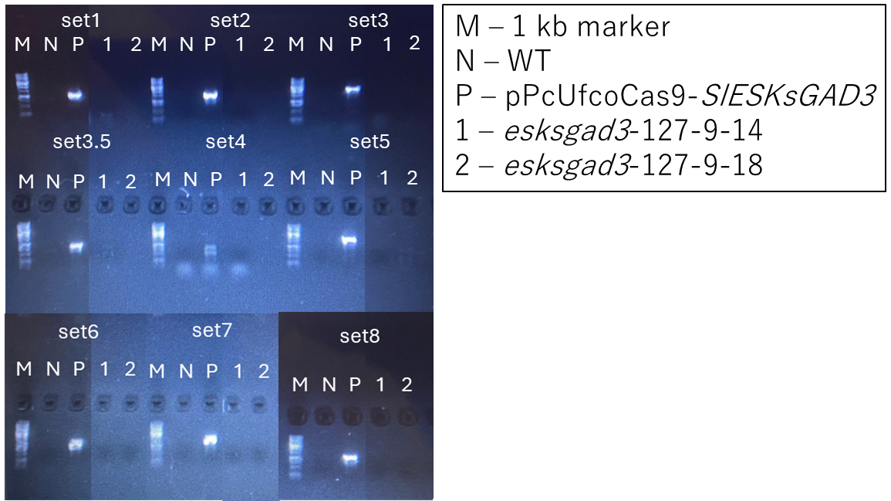
B
Line | Sample name | Result(N,P)
esksgad3 | 127-5-3 | P
esksgad3 | 127-5-6 | N
esksgad3 | 127-5-13 | P
esksgad3 | 126-5-14 | P
esksgad3 | 127-5-15 | P
esksgad3 | 127-9-2 | P
esksgad3 | 127-9-4 | P
esksgad3 | 127-9-10 | P
esksgad3 | 127-9-14 | N
esksgad3 | 127-9-18 | N
esksgad3 | 127-9-26 | N
esksgad3 | 127-9-29 | N
esksgad3 | 127-9-30 | P
Supplementary Figure.1 (Result of foreign gene check)
(A) Results of PCR for foreign gene check. M, maker 1kbp; N, negative control (Mili-Q); P, positive control (Vector for targeting SlESK 1-3 and SlGAD3, the bands could be detected.); 1 and 2, samples (the bands couldn’t be detected). (B) Results of foreign gene check. The results were confirmed in the same way as (A). P, positive result of foreign gene; N, negative result of foreign gene. 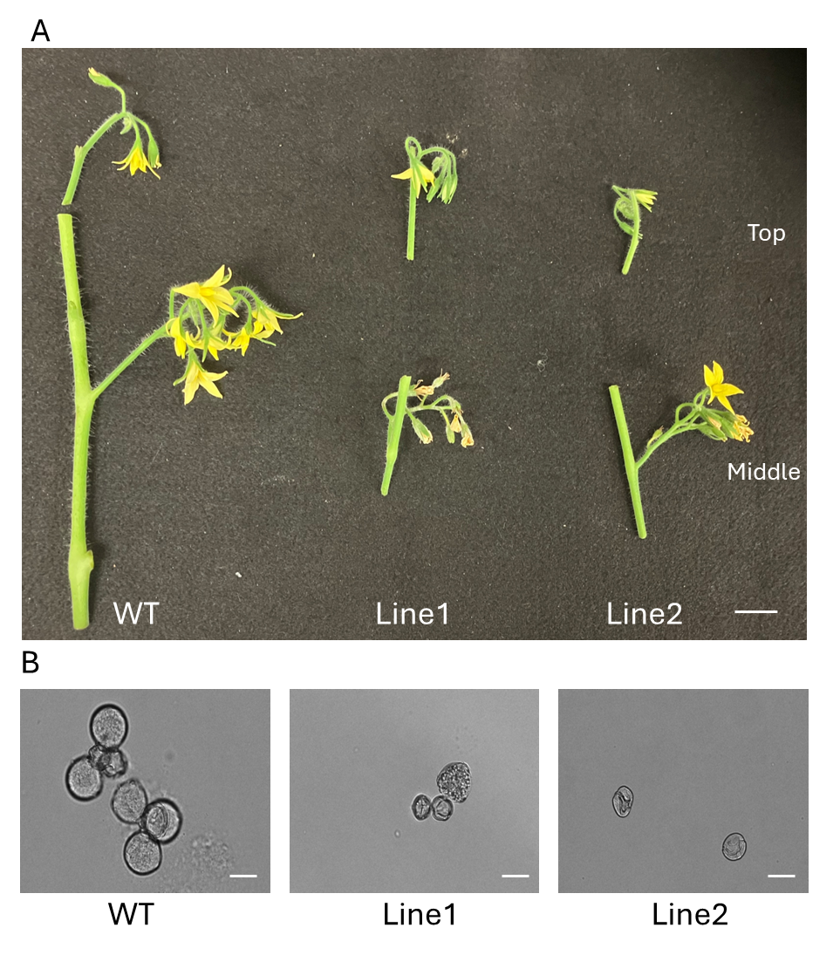Supplementary Figure 2. (A) An image of flower in WT and EG lines. Top indicates the flower which is top parts of plants and 10 days old flowers. Middle indicates the flower which is middle parts of plants and 20 days old flowers. (left: WT, middle: EG Line1, right: EG Line 2) (B) Illustrations of pollen in WT and EG lines. The pollens of WT are circled shape and identical size, while the pollens of EG lines are inconsistent shape and size. (Scale bar: 20μm)

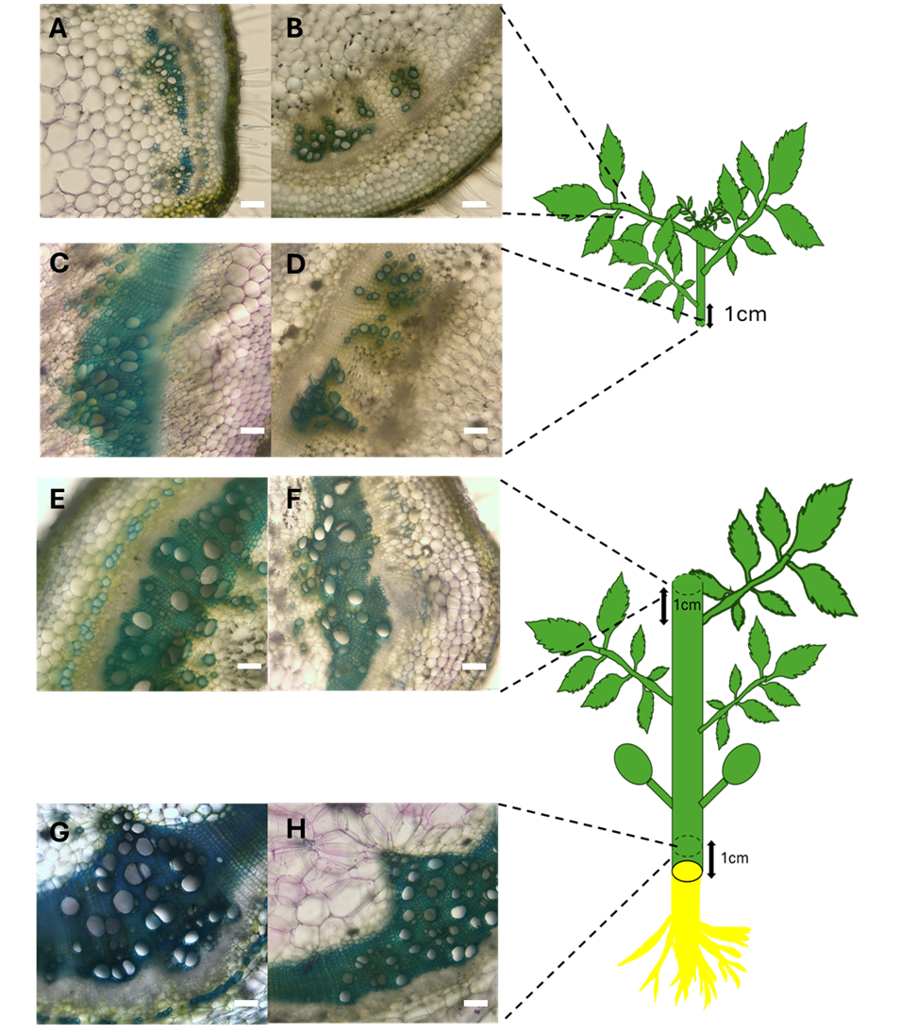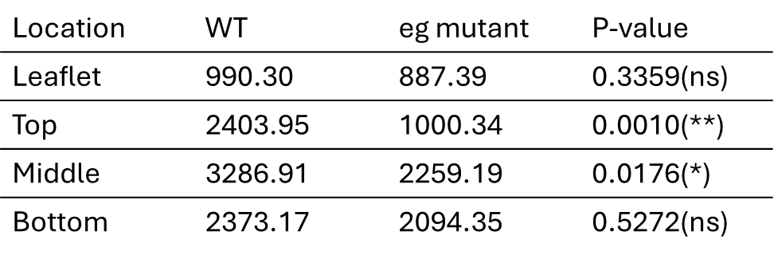
I
Supplementary Figure 3. (A-H) Xylem of stem (left: WT, right: EG Line 2) (Scale bar: 100μm) (A-B) Xylem of leaflet part. (C-D) Xylem of upper part. (E-F) Xylem of middle part. (G-H) Xylem of above part. (I) Average width of vessel (μm²). Statistical significance: ns, no significant difference; *, p < 0.05; *, p < 0.5; **).
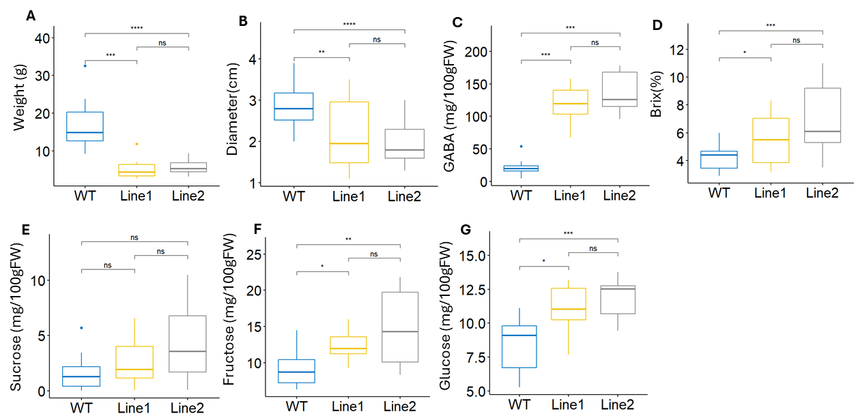
Supplementary Figure 4. Parameter of fruits from WT and EG Lines (EG Line 1 and EG Line 2) during Summer season.
(A)Fruit weight. (B) Fruit diameter. (C) GABA concentration in fruits. (D) Brix value of fruits. (E) Sucrose concentration in fruits. (F) Fructose concentration in fruits. (G) Glucose concentration in fruits. Statistical significance: ns, no significant difference; *, p < 0.05; *, p < 0.5; **, p < 0.01; ***, p < 0.001; ****, p < 0.0001.

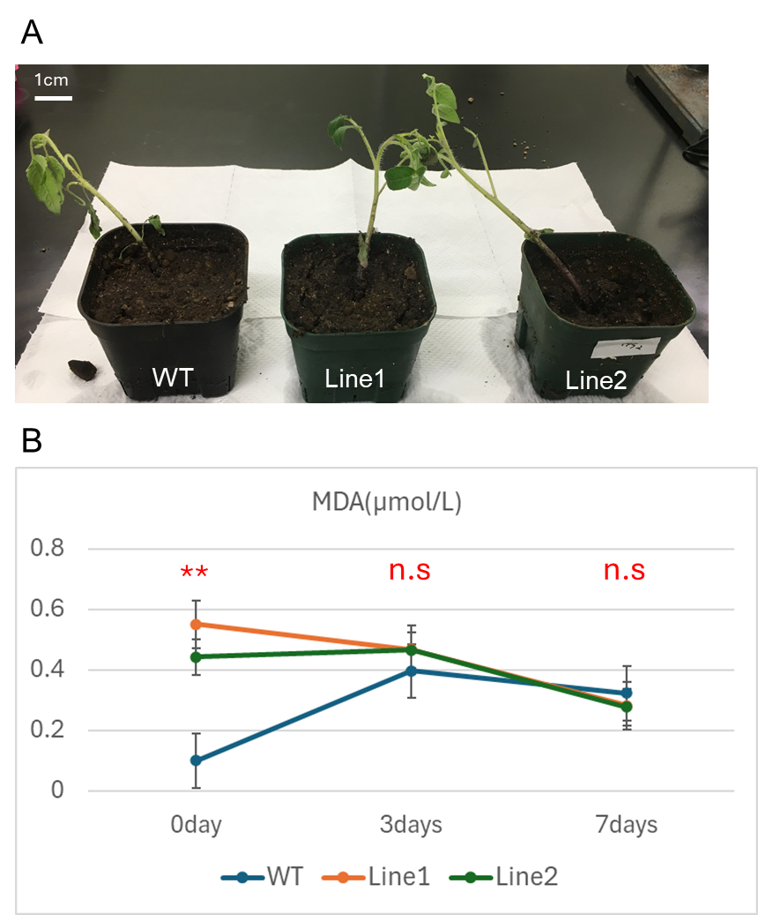

Supplementary Figure 5. EG Line 1 and Line 2 didn’t exhibit cold stress tolerance.
(A) Illustrates are of representative plants of WT and EG Line 1, EG Line 2 7 days after cold stress treatment. Scale bar represents 1 cm in length. (B) Concentration of MDA before stress (0 day) and after 3-days and 7-days the cold stress treatment. Statistical significance: ns, no significant difference; **, p < 0.01.

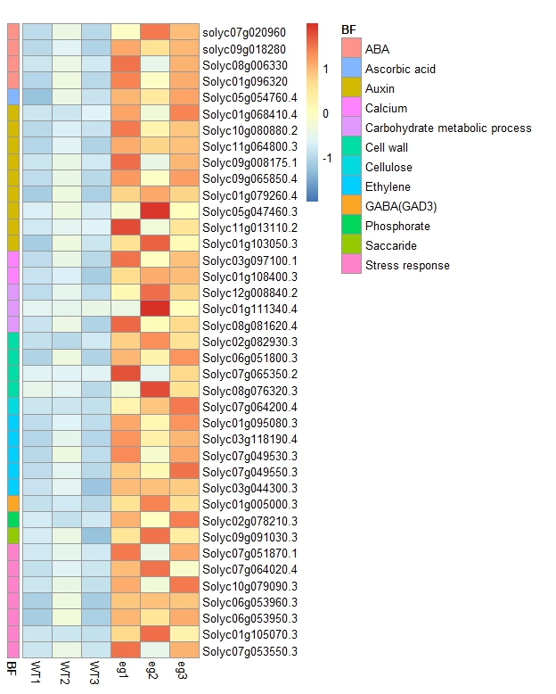
Supplementary Figure 6. Heatmap for representative up-regulated gene expression by RNA-seq for differentially expressed genes (DEGs) between WT and EG Line 2. Red is higher expression and blue is lower expression; DEGs defined as genes with a log base two fold change value less than -1 or greater than 1 and FDR adjusted p-value less than 0.05. BF represents biological function.

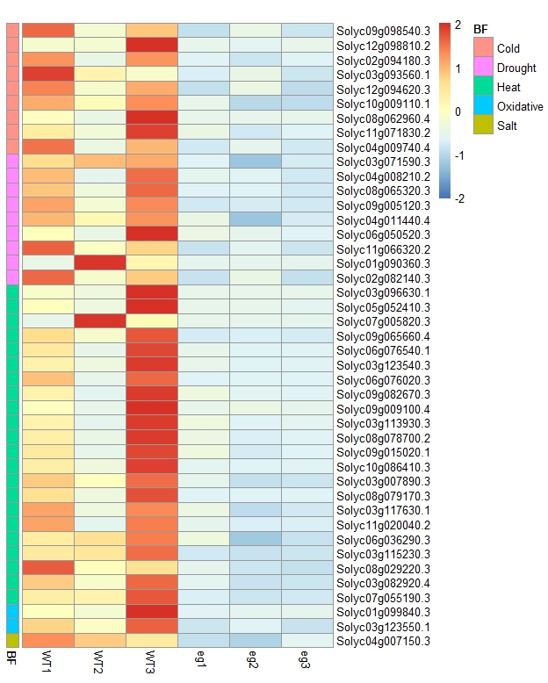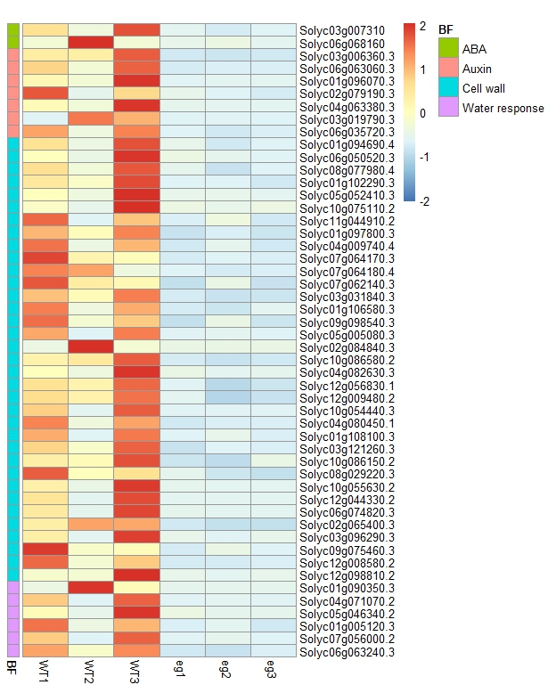
Supplementary Figure 7. Heatmap for representative down-regulated gene expression by RNA-seq for differentially expressed genes (DEGs) between WT and EG Line 2. Red is higher expression and blue is lower expression; DEGs defined as genes with a log base two fold change value less than -1 or greater than 1 and FDR adjusted p-value less than 0.05. BF represents biological function.

