Appendix A. Supplementary material
This document provides supplementary information to “Porosity reduction by co-axial laser shock modulation of molten pool in powder-bed selective laser sintering: take widely-used stainless steel as an example.”
- Mathematical models and results
Based on the previous research[1][2], a model applied to the co-axial laser shock modulation of molten pool in powder-bed selective laser sintering was established. The model size is 400 × 400 × 1000 µm and contains the substrate, powder layer with a thickness of 36 µm and protective gas domains as shown in Fig. S1(a). Based on different pulsed laser parameters in the co-axial experiments, numerical simulations also study the effects of various mechanical effects on bubble evolution both in single and double molten track. The case numbered shock 0 associated with the No Co-axial shock condition, and it demonstrates the formation mechanism of pores in the molten track. Periodic collapse at the bottom of the keyhole causes gas to be entrained into the molten pool, forming bubbles that are subsequently trapped by the solid-liquid interface. In contrast, cases numbered shock 1 to shock 10 provide results regarding the influence of stronger mechanical effects on the keyhole. As shown in Fig.S1(b), stronger mechanical effects directly reduce the number of pores. In the numerical simulations, the keyholes in shock 2 and shock 3 tend to be more stable as shown in Fig. S1(c), which is consistent with the pore reduction results provided by CT tests. In the double track results, pores tend to merge and grow due to remelting as shown in Fig. S1(c). However, the high-frequency of the co-axial shock (consistent with the experimental parameter of 30 kHz) effectively inhibits this process. Complete numerical simulation results can be found in Video S3&4.
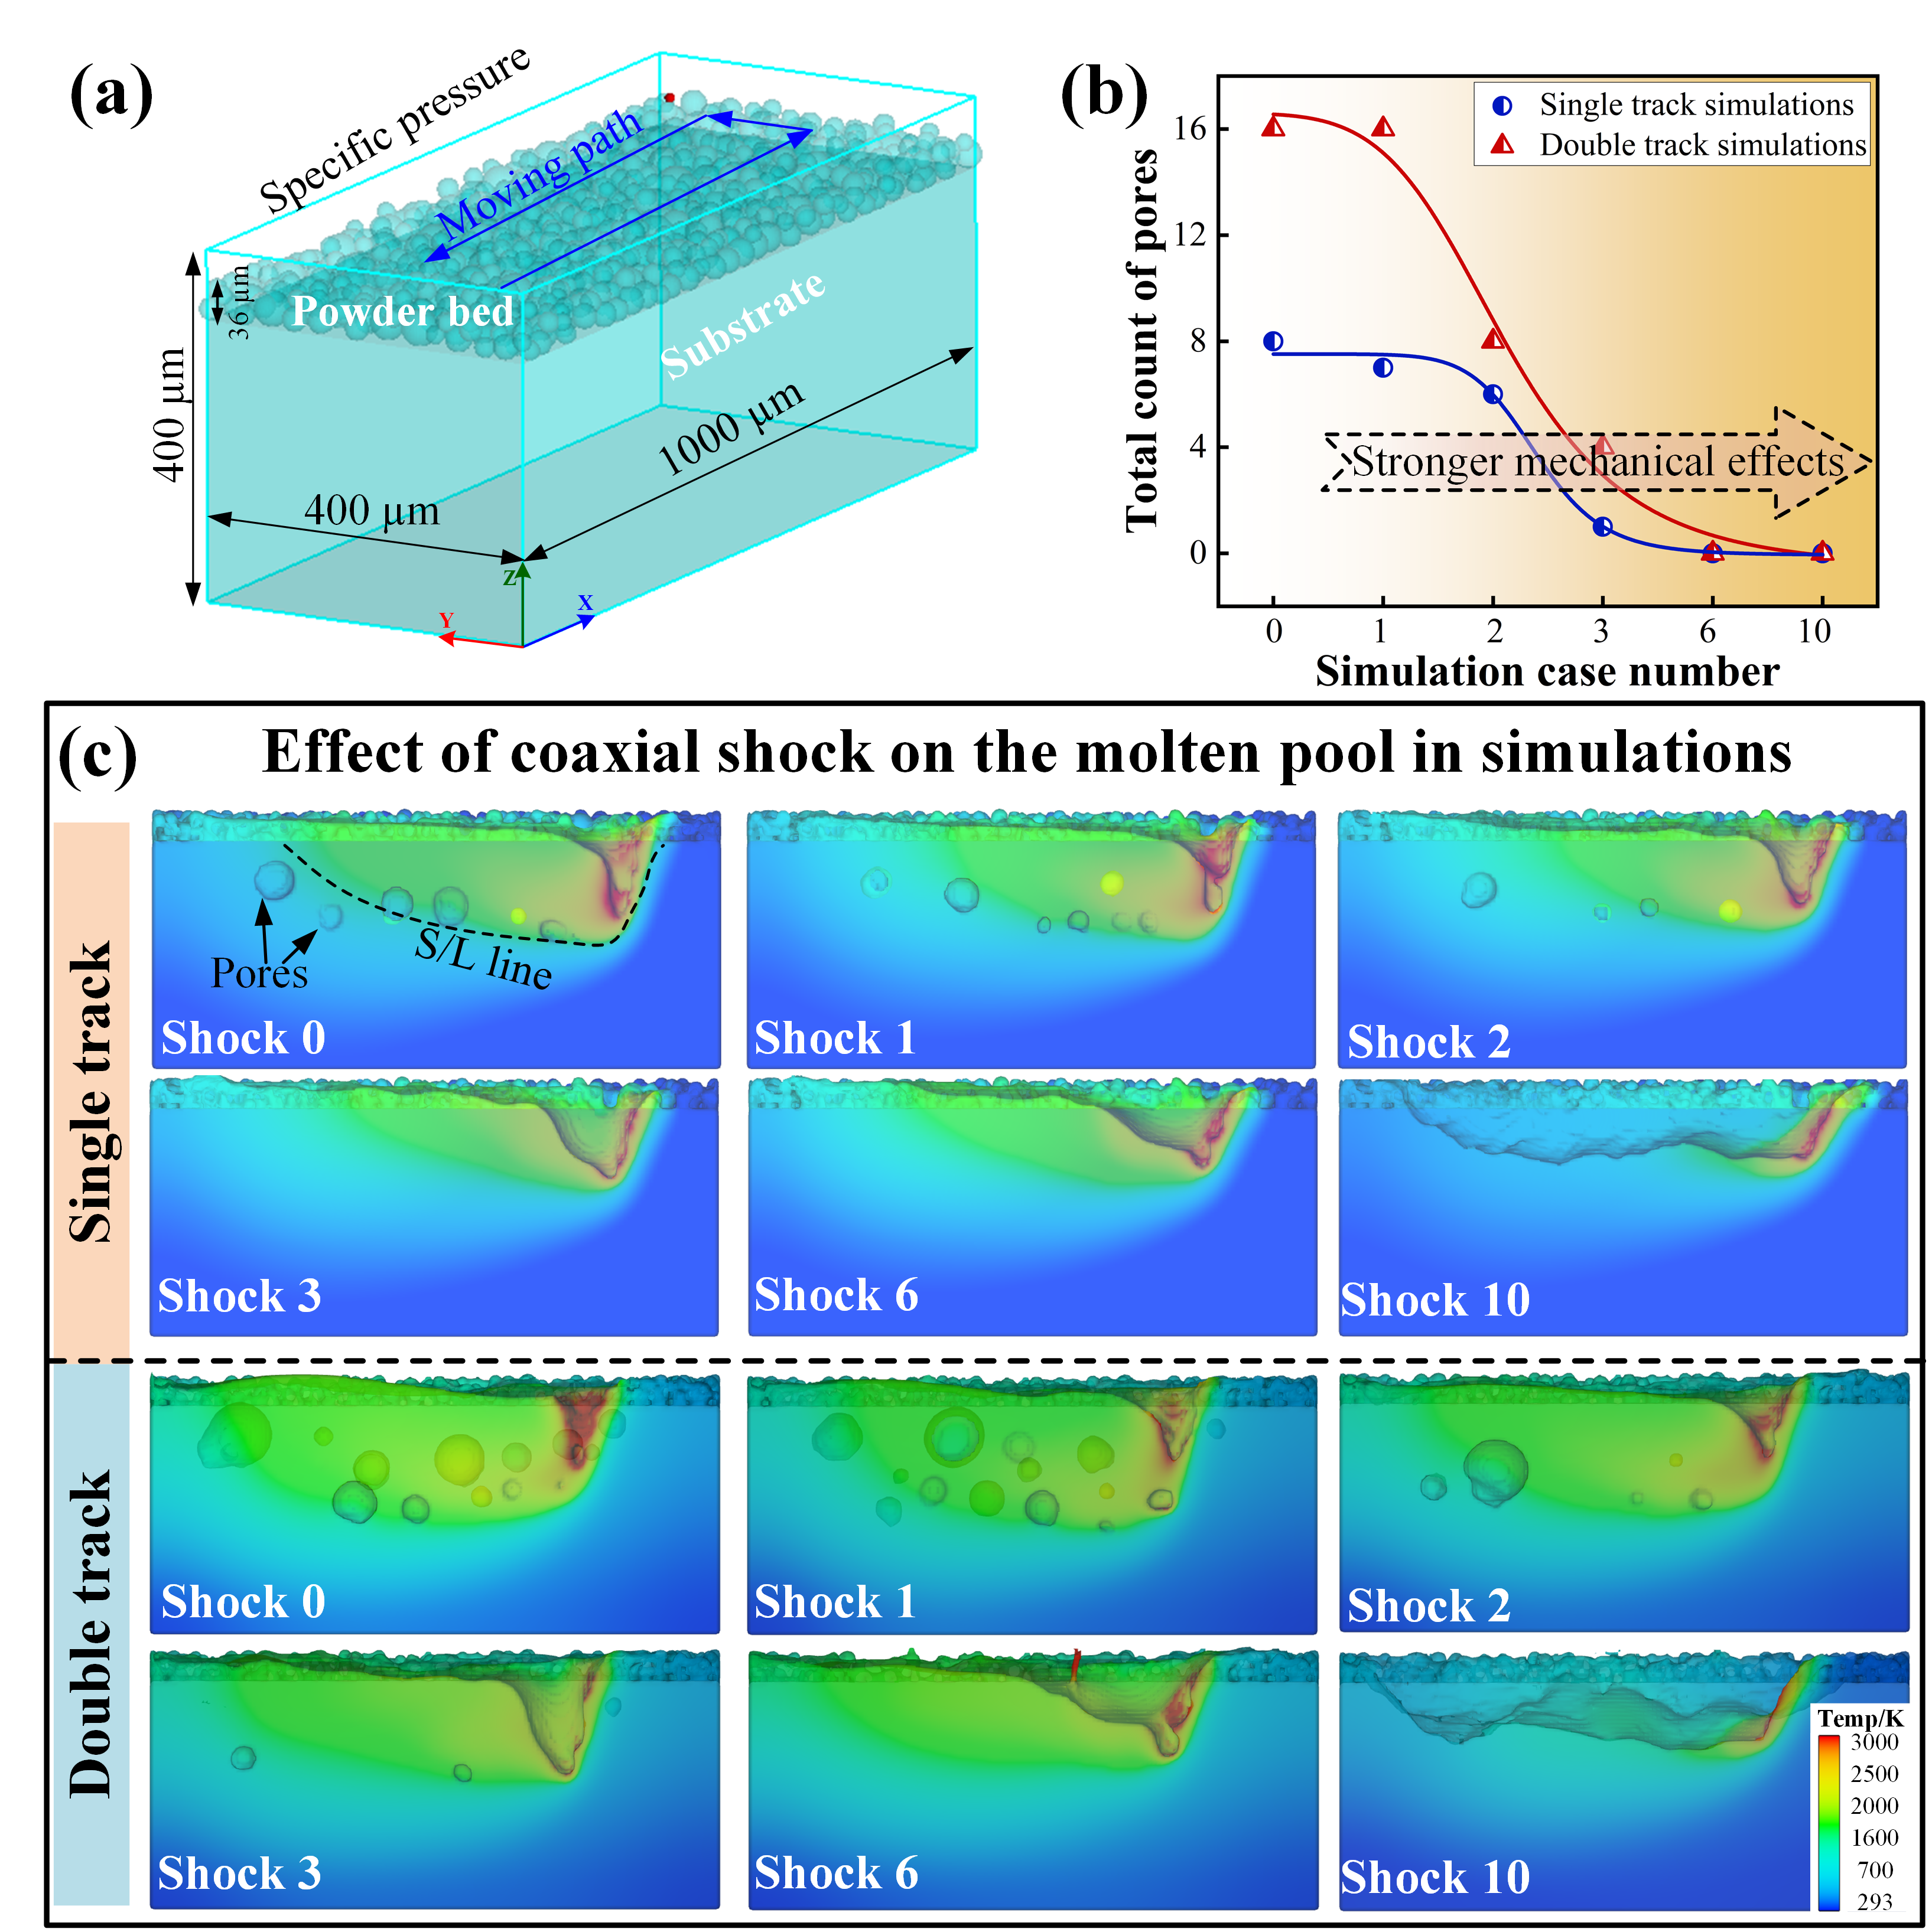
Fig. S1. Various mechanical effects of Co-axial shock on bubble evolution both in single and double molten track.
- Pores distribution under the C-shock and No C-shock processing
For each printed sample, the same size of 3000 × 4000 × 1000 μm is cut to count the porosity as shown in Fig. S2(a). Under the No Co-axial shock processing conditions, the porosity decreases from 3.58%, 1.06%, 0.59%, 0.1115% to 0.0510%, as the CL power raised gradually from 140 W to 180 W. Associated numbers of pores are 4435, 2079, 2732, 870 and 440 respectively. At the lower CL power of 140 W, 150 W and 160 W, the powder does not fully melt into a uniform liquid state. This leads to different types of unfused and gas-trapped pores appear inside the sample as shown in Fig. S2(b)-(d). The proportion of unfused pores is small, but their volume is large. Maximum volume of unfused pores with a flat shape as shown in Fig. S2(b) reaches 64.65 × 10⁵ μm³. Smaller gas-trapped pores concentrate in the dense area as shown in Fig. S2(b)-(d). The sphericity of these pores is close to 1, and they distribute in the sample unevenly. When the CL power raised to 170 W and 180 W, the type of pores is gas-trapped pores while the number decreases to 870 and 440 significantly as shown in Fig. S2(e) and (f). The maximum volume of pores is 6.44 × 10⁵ μm³ and 1.89 × 10⁵ μm³ separately lower than that of unfused pores.
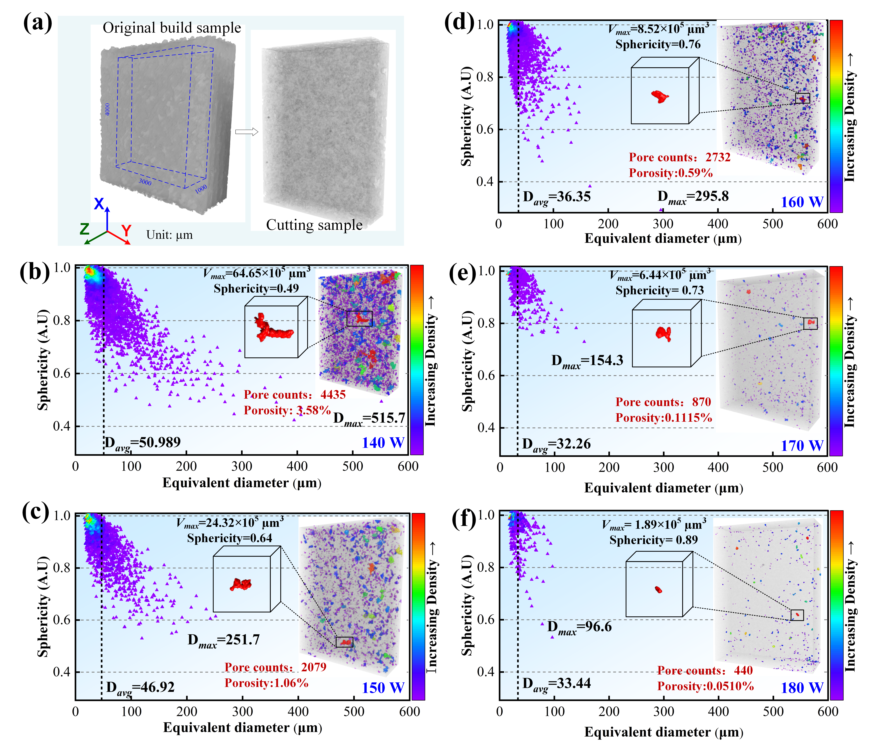
Fig. S2. 3D rendered pores model and distribution in the No Co-axial processing: (b) 140 W, (c) 150 W, (d) 160 W, (d) 170 W and (f) 180 W.
Although increasing CL power reduce unfused pores caused by insufficient melting, tiny gas-trapped pores still remain due to factors such as molten pool dynamics, keyhole collapse, and powder characteristics. Therefore, co-axial shock experiments with different pulsed laser currents were investigated for CL powers of 170 W and 180 W. Fig. S3 and S4 show the pore statistics results under pulsed laser currents ranging from 7.5 A to 10 A, respectively. Compared with the No Co-axial shock 170w and180w conditions, the porosity is reduced to 0.0158% and 0.0216% respectively under the optimal pulsed laser current of 8.5 A, with a porosity reduction of over 50% in both cases. The associated pore counts are 139 and 197. On the other hand, the size of remaining pores is regulated. The maximum diameter is reduced, and their sphericity approaches 1 as shown in Fig. S3 and S4. This indicates that co-axial shock not only inhibits the periodic collapse at the keyhole bottom to reduce bubble generation, the enhanced fluid flow caused by co-axial shock also provides sufficient driving force for some bubbles to collapse or escape.
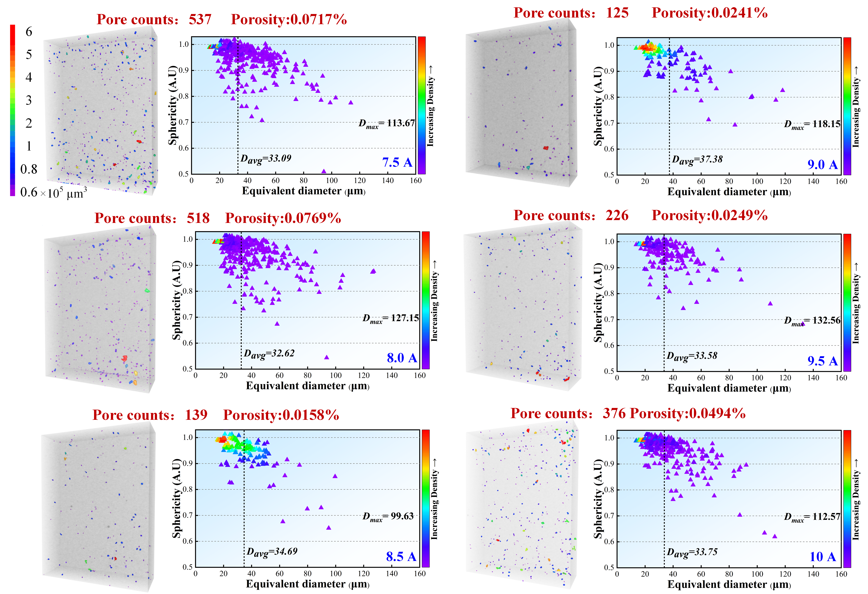
Fig. S3. 3D rendered pores model and distribution in the Co-axial shock processing at the CL power of 170 W.
Porosity and pore count exhibit a trend of first decreasing and then increasing as the pulsed laser current raising from 7.5 A to 10 A. Two groups of samples porosity fabricated with Co-axial shock are 0.0717%, 0.0769%, 0.0158%, 0.0241%, 0.0249%, 0.0494% and 0.0390%, 0.0384%, 0.0216%, 0.0227%, 0.0231%, 0.0325% respectively. The associated pore counts are 537, 518, 139, 125, 226, 376 and 302, 344, 197, 244, 303, 322. Compared with the No Co-axial shock conditions, the quality of samples is improved. When the current is below 8 A, the peak pressure generated by the pulsed laser decreases, and the mechanical effect on the molten pool becomes weak, failing to effectively suppress the collapse at the keyhole bottom and enhance convection, which results in uncontrolled bubble generation sources and difficulty in bubble escape. This reduces the beneficial effects induced by Co-axial shock. However, enhanced mechanical effects disrupt the stability of the molten pool and even induce turbulence when the current exceeds 9 A, which causes imbalance in the surface tension and entrainment of more gas to form new bubbles. Therefore, the strength of Co-axial shock within the appropriate range of 8.5 A to 9 A achieves a balance between inhibiting bubble generation and promoting bubble escape, enabling effective control of pores.
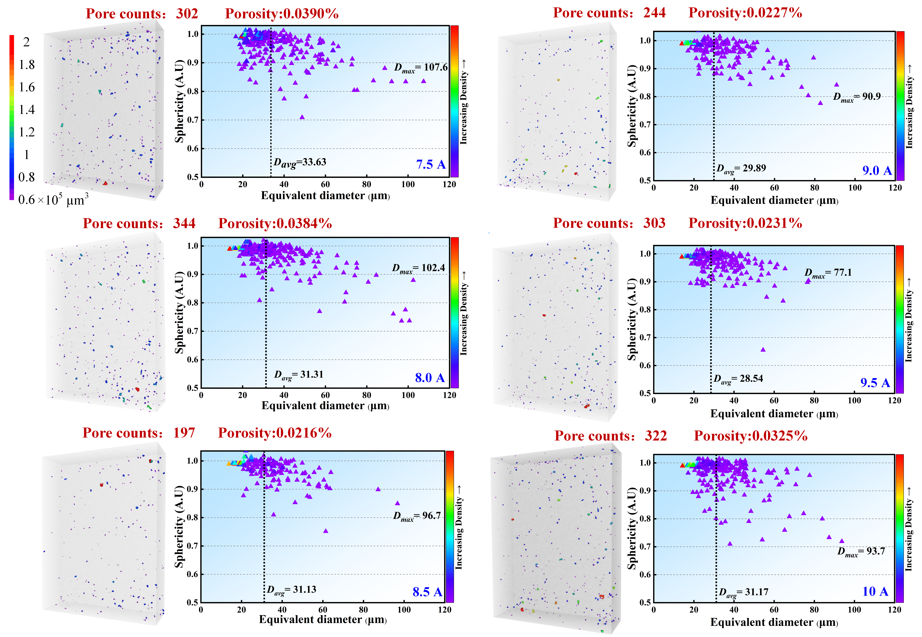
Fig. S4. 3D rendered pores model and distribution in the Co-axial shock processing at the CL power of 180 W.
- The effect of Co-axial shock processing on grain growth
In the No C-axial shock processing, the molten pool exhibits a high solidification rate owing to its small size and high scanning speed. At the initial stage of solidification, grains near the solidified substrate or molten pool boundary nucleate first and grow rapidly perpendicular to the isotherms line (i.e., along the heat flow direction toward the pool center), forming coarse columnar grains. This directional growth stems from the thermal driving force dominated by temperature gradients, making grains extend along the fastest heat dissipation path. The central region undergoes a slower cooling rate with a relatively gentle temperature gradient. When the supercooling degree is sufficient, it triggers non-uniform nucleation, and grains grow freely in all directions, eventually forming equiaxed grains. The directional grain growth mode and the molten pool boundary (marked by black dashed lines) are observed under the condition of 0 A current as shown in Fig. S5. After excluding boundary grains, the number of grains in the molten pool is 214, with an average equivalent circular diameter of 5.48 μm. Taking low angle grain boundaries (LAGB: 2–15°) and high angle grain boundaries (HAGB: >15°) for reference, the proportion of HAGB among the molten pool reaches 88.4%.
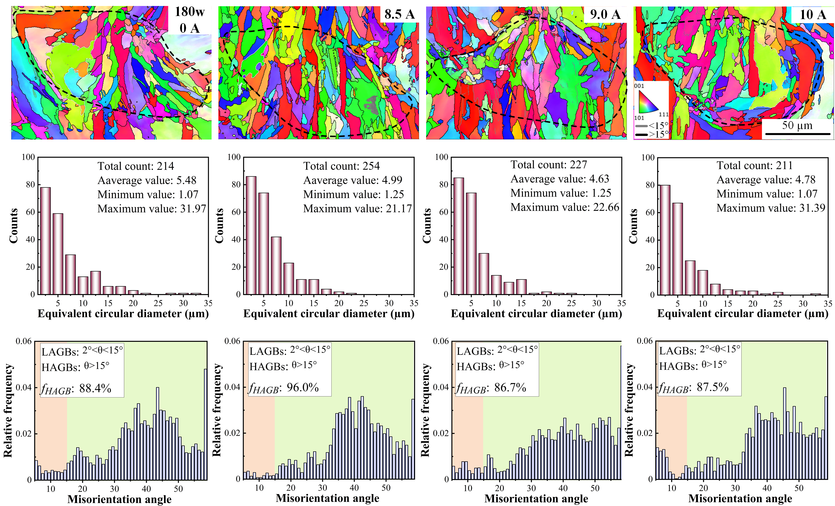
Fig. S5. Inverse pole images and distribution of grains in the Co-axial shock processing at the CL power of 180 W.
After Co-axial shock causes oscillations in the molten pool, the grain growth orientation no longer aggregates toward the center as shown in Fig. S5. The number of grains increases while their size decreases, and those grains larger than 25 μm reduces significantly. Particularly, the proportion of HAGB increases to 96% under the optimal pulsed laser current of 8.5 A. This indicates that the molten pool convection changes under mechanical effects, and the directional growth of columnar grains dominated by temperature gradients is inhibited.

References
[1] Y. He, H. Lu, X. Zhang, S. Xu, H. Li, Y. Hu, Study on in situ laser shock modulation of molten pool and defects in wire-feed laser additive manufacturing of steel to aluminum alloy, Thin-Walled Struct. 204 (2024) 112326. https://doi.org/10.1016/j.tws.2024.112326.
[2] H. Lu, X. Zhang, J. Liu, S. Zhao, X. Lin, H. Li, Y. Hu, Study on laser shock modulation of melt pool in laser additive manufacturing of FeCoCrNi high-entropy alloys, J. Alloys Compd. 925 (2022) 166720. https://doi.org/10.1016/j.jallcom.2022.166720.

