(a)
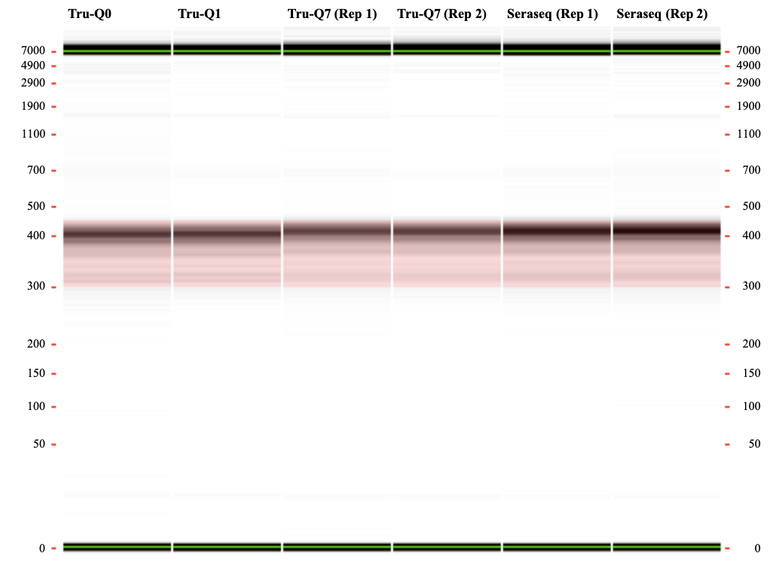

(b)
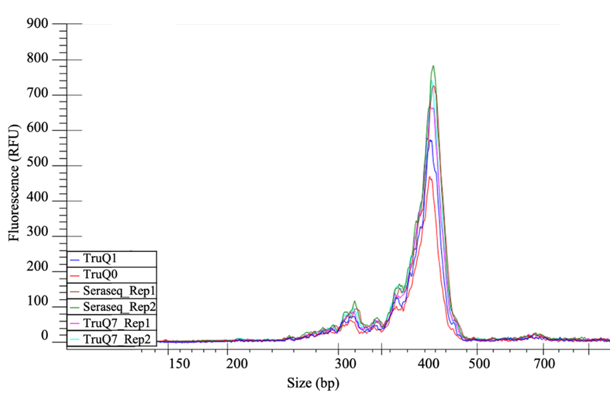

Supplementary Figure S1. Representative image of (a) Labchip gel and (b) multiple overlay electropherogram of the constructed libraries of the reference standards. The image shows the quality and quantity of input DNA for the second NGS run for the technical validation of the custom NGS panel. The majority of the constructed libraries were within the targeted size range of 400 bp.
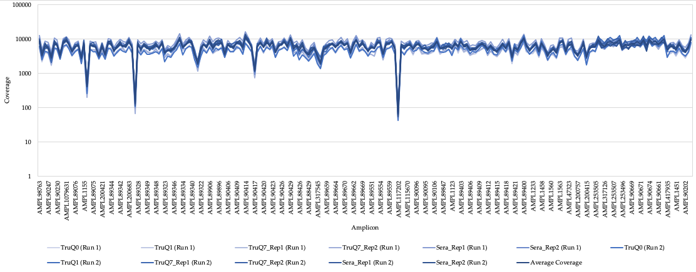
Supplementary Figure S2. Amplicon coverage across reference standards in the technical validation of the custom NGS panel. More details on the amplicon regions can be found in Supplementary Table S2 and Additional File 1.
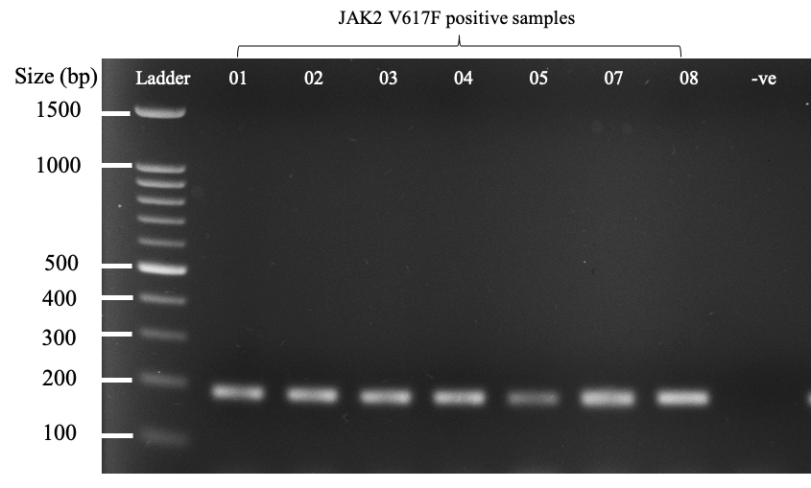
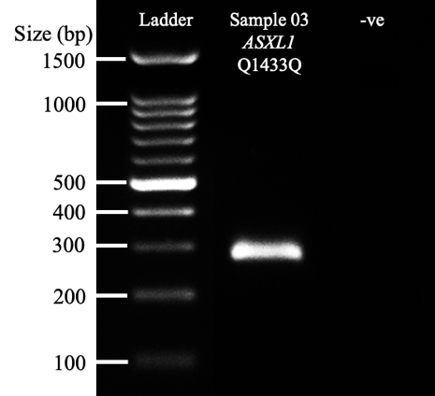
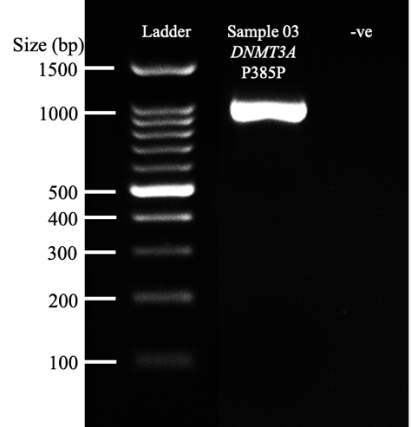
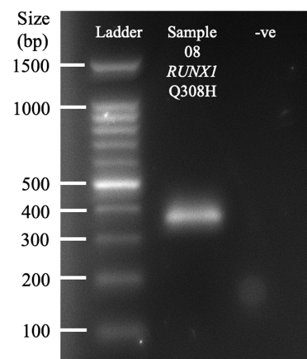
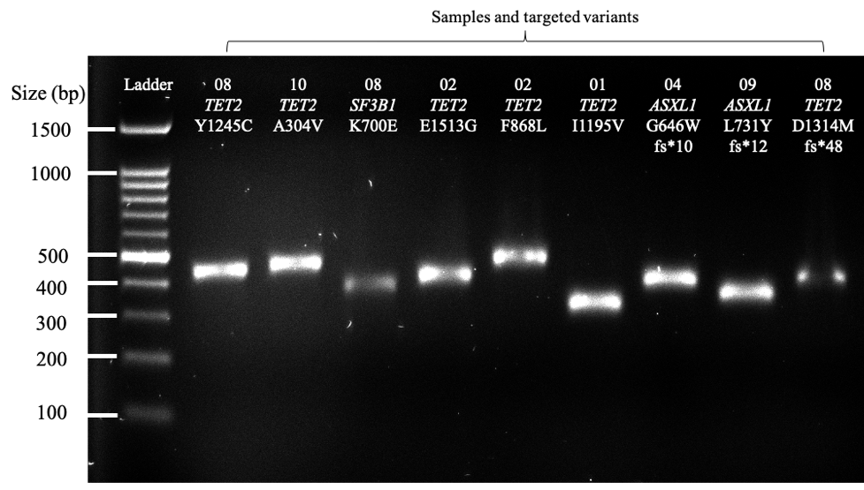

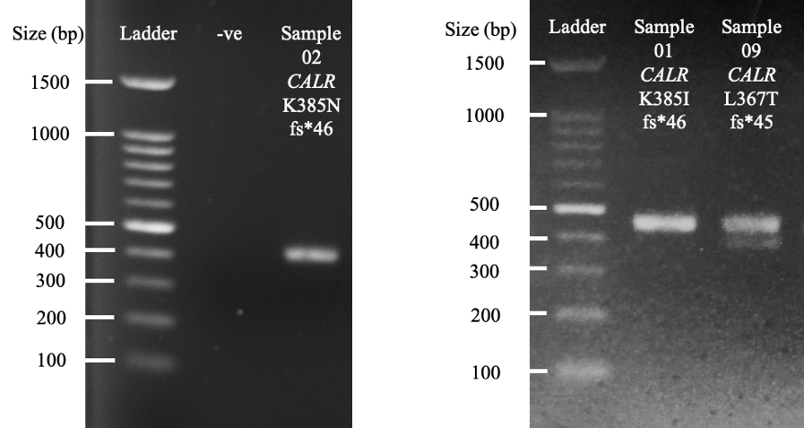
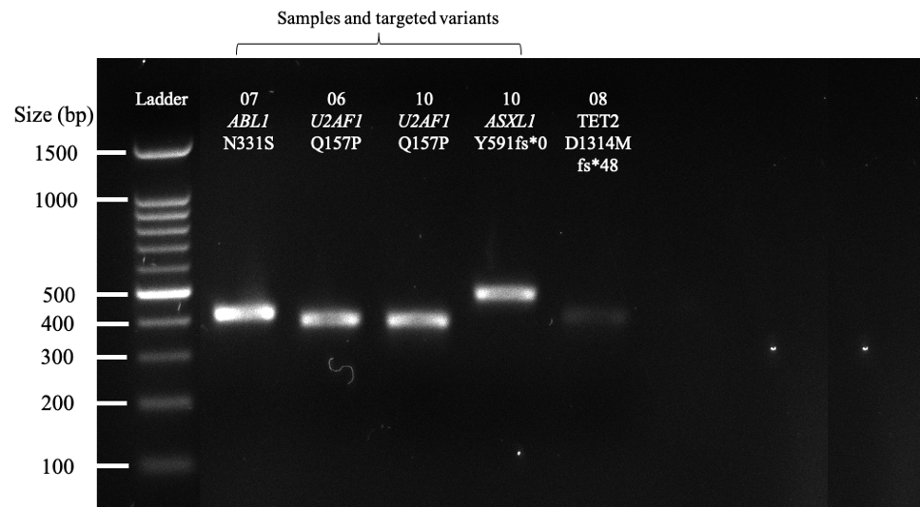

Supplementary Figure S3. Gel electrophoresis images. -ve, Negative control.
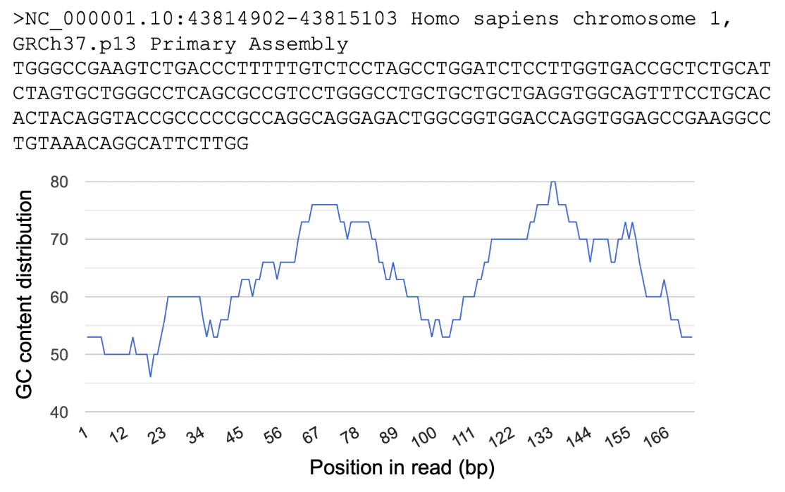
Supplementary Figure S4. Distribution of GC content across AMPL117202 (MPL exon 10, chr1:43814902-43815103). Graph generated using the GC Content Calculator by Guerra et al. [61]

Supplementary Table S1. Targeted exons of 22 MPN-associated genes in the custom NGS panel.
Target Region | hg19 Genomic Location
ABL1_Exon 4 (ENST00000372348);  ABL1_Exon 4 (ENST00000318560) | chr9:133738150-133738422
ABL1_Exon 5 (ENST00000372348);  ABL1_Exon 5 (ENST00000318560) | chr9:133747516-133747600
ABL1_Exon 6 (ENST00000372348);  ABL1_Exon 6 (ENST00000318560) | chr9:133748247-133748424
ABL1_Exon 7 (ENST00000372348);  ABL1_Exon 7 (ENST00000318560) | chr9:133750255-133750439
ABL1_Exon 8 (ENST00000372348);  ABL1_Exon 8 (ENST00000318560) | chr9:133753802-133753954
ABL1_Exon 9 (ENST00000372348);  ABL1_Exon 9 (ENST00000318560) | chr9:133755455-133755544
ASXL1_Exon 10 (ENST00000375687) | chr20:31019386-31019482
ASXL1_Exon 11(ENST00000375687) | chr20:31020683-31020788
ASXL1_Exon 12 (ENST00000375687) | chr20:31021087-31021720
ASXL1_Exon 13 (ENST00000375687) | chr20:31022235-31025141
CALR_Exon 9 (ENST00000316448 ) | chr19:13054527-13054727
CBL_Exon 8 (ENST00000264033) | chr11:119148876-119149007
CBL_Exon 9 (ENST00000264033) | chr11:119149220-119149423
CEBPA_Exon 1 (ENST00000498907) | chr19:33792244-33793320
CSF3R_Exon 10 (ENST00000373103);  CSF3R_Exon 10 (ENST00000373104);  CSF3R_Exon 10 (ENST00000373106) | chr1:36937034-36937247
CSF3R_Exon 14 (ENST00000373103);  CSF3R_Exon 14 (ENST00000373104); CSF3R_Exon 14 (ENST00000373106) | chr1:36933423-36933563
CSF3R_Exon 15 (ENST00000373103);  CSF3R_Exon 15 (ENST00000373104);  CSF3R_Exon 15 (ENST00000373106) | chr1:36933159-36933252
CSF3R_Exon 16 (ENST00000373103);  CSF3R_Exon 16 (ENST00000373104);  CSF3R_Exon 16 (ENST00000373106) | chr1:36932831-36932912
CSF3R_Exon 17 (ENST00000373103);  CSF3R_Exon 17 (ENST00000373106) | chr1:36931958-36932509
CSF3R_Exon 18 (ENST00000373104) | chr1:36931697-36931801
DNMT3A_Exon 1 (ENST00000380746) | chr2:25475063-25475066
DNMT3A_Exon 2 (ENST00000380746) | chr2:25472526-25472593
DNMT3A_Exon 2 (ENST00000321117);  DNMT3A_Exon 2 (ENST00000264709);  DNMT3A_Exon 2 (ENST00000380746) | chr2:25536782-25536853
DNMT3A_Exon 3 (ENST00000321117);  DNMT3A_Exon 3 (ENST00000264709);  DNMT3A_Exon 3 (ENST00000380746) | chr2:25523008-25523112

Supplementary Table S1. Cont.
DNMT3A_Exon 4 (ENST00000321117);  DNMT3A_Exon 4 (ENST00000264709);  DNMT3A_Exon 4 (ENST00000380746) | chr2:25505257-25505580
DNMT3A_Exon 5 (ENST00000321117);  DNMT3A_Exon 5 (ENST00000264709) | chr2:25498369-25498412
DNMT3A_Exon 6 (ENST00000321117);  DNMT3A_Exon 6 (ENST00000264709) | chr2:25497810-25497956
DNMT3A_Exon 7 (ENST00000321117);  DNMT3A_Exon 7 (ENST00000264709);  DNMT3A_Exon 3 (ENST00000380746) | chr2:25470906-25471121
DNMT3A_Exon 8 (ENST00000321117);  DNMT3A_Exon 8 (ENST00000264709);  DNMT3A_Exon 4 (ENST00000380746) | cchr2:25470460-25470618
DNMT3A_Exon 9 (ENST00000321117);  DNMT3A_Exon 9 (ENST00000264709);  DNMT3A_Exon 5 (ENST00000380746) | chr2:25469920-25470027
DNMT3A_Exon 10 (ENST00000321117);  DNMT3A_Exon 10 (ENST00000264709);  DNMT3A_Exon 6 (ENST00000380746) | chr2:25469489-25469645
DNMT3A_Exon 11 (ENST00000321117);  DNMT3A_Exon 11 (ENST00000264709);  DNMT3A_Exon 7 (ENST00000380746) | chr2:25469029-25469178
DNMT3A_Exon 12 (ENST00000321117);  DNMT3A_Exon 12 (ENST00000264709);  DNMT3A_Exon 8 (ENST00000380746) | chr2:25468889-25468933
DNMT3A_Exon 13 (ENST00000321117);  DNMT3A_Exon 13 (ENST00000264709);  DNMT3A_Exon 9 (ENST00000380746) | chr2:25468122-25468201
DNMT3A_Exon 14 (ENST00000321117);  DNMT3A_Exon 14 (ENST00000264709);  DNMT3A_Exon 10 (ENST00000380746) | chr2:25467409-25467521
DNMT3A_Exon 15 (ENST00000321117);  DNMT3A_Exon 15 (ENST00000264709);  DNMT3A_Exon 11 (ENST00000380746) | chr2:25467024-25467207
DNMT3A_Exon 16 (ENST00000321117);  DNMT3A_Exon 16 (ENST00000264709);  DNMT3A_Exon 12 (ENST00000380746) | chr2:25466767-25466851
DNMT3A_Exon 17 (ENST00000321117);  DNMT3A_Exon 17 (ENST00000264709);  DNMT3A_Exon 13 (ENST00000380746) | chr2:25464431-25464576
DNMT3A_Exon 18 (ENST00000321117);  DNMT3A_Exon 18 (ENST00000264709);  DNMT3A_Exon 14 (ENST00000380746) | chr2:25463509-25463599
DNMT3A_Exon 19 (ENST00000321117 ;  DNMT3A_Exon 19 (ENST00000264709);  DNMT3A_Exon 15 (ENST00000380746) | chr2:25463171-25463319

Supplementary Table S1. Cont.
DNMT3A_Exon 20 (ENST00000321117);  DNMT3A_Exon 20 (ENST00000264709);  DNMT3A_Exon 16 (ENST00000380746) | chr2:25461999-25462084
DNMT3A_Exon 21 (ENST00000321117);  DNMT3A_Exon 21 (ENST00000264709);  DNMT3A_Exon 17 (ENST00000380746) | chr2:25459805-25459874
DNMT3A_Exon 22 (ENST00000321117);  DNMT3A_Exon 22 (ENST00000264709);  DNMT3A_Exon 18 (ENST00000380746) | chr2:25458576-25458694
DNMT3A_Exon 23 (ENST00000321117);  DNMT3A_Exon 23 (ENST00000264709);  DNMT3A_Exon 19 (ENST00000380746) | chr2:25457148-25457289
EZH2_Exon 2 (ENST00000320356 );  EZH2_Exon 2 (ENST00000350995);  EZH2_Exon 2 (ENST00000476773) | chr7:148544274-148544390
EZH2_Exon 3 (ENST00000320356 );  EZH2_Exon 3 (ENST00000350995);  EZH2_Exon 3 (ENST00000476773) | chr7:148543562-148543690
EZH2_Exon 4 (ENST00000320356 );  EZH2_Exon 4 (ENST00000476773) | chr7:148529726-148529842
EZH2_Exon 5 (ENST00000320356 );  EZH2_Exon 4 (ENST00000350995);  EZH2_Exon 5 (ENST00000476773) | chr7:148526820-148526940
EZH2_Exon 6 (ENST00000320356 );  EZH2_Exon 5 (ENST00000350995);  EZH2_Exon 6 (ENST00000476773) | chr7:148525832-148525972
EZH2_Exon 7 (ENST00000320356 );  EZH2_Exon 6 (ENST00000350995);  EZH2_Exon 7 (ENST00000476773 ) | chr7:148524256-148524358
EZH2_Exon 8 (ENST00000320356 );  EZH2_Exon 7 (ENST00000350995);  EZH2_Exon 8 (ENST00000476773) | chr7:148523546-148523724
EZH2_Exon 9 (ENST00000320356 );  EZH2_Exon 8 (ENST00000350995);  EZH2_Exon 9 (ENST00000476773) | chr7:148516688-148516779
EZH2_Exon 10 (ENST00000320356);  EZH2_Exon 9 (ENST00000350995);  EZH2_Exon 10 (ENST00000476773) | chr7:148514969-148515209
EZH2_Exon 11 (ENST00000320356);  EZH2_Exon 10 (ENST00000350995);  EZH2_Exon 11 (ENST00000476773) | chr7:148514314-148514483
EZH2_Exon 12 (ENST00000320356);  EZH2_Exon 11 (ENST00000350995);  EZH2_Exon 12 (ENST00000476773) | chr7:148513776-148513870
EZH2_Exon 13 (ENST00000320356);  EZH2_Exon 12 (ENST00000350995);  EZH2_Exon 13 (ENST00000476773) | chr7:148512598-148512638
Supplementary Table S1. Cont.
EZH2_Exon 14 (ENST00000320356 );  EZH2_Exon 13 (ENST00000350995) | chr7:148512006-148512131
EZH2_Exon 15 (ENST00000320356 );  EZH2_Exon 14 (ENST00000350995);  EZH2_Exon 14 (ENST00000476773) | chr7:148511051-148511229
EZH2_Exon 16 (ENST00000320356 );  EZH2_Exon 15 (ENST00000350995);  EZH2_Exon 15 (ENST00000476773) | chr7:148508717-148508812
EZH2_Exon 17 (ENST00000320356 );  EZH2_Exon 16 (ENST00000350995);  EZH2_Exon 16 (ENST00000476773) | chr7:148507425-148507506
EZH2_Exon 18 (ENST00000320356 );  EZH2_Exon 17 (ENST00000350995);  EZH2_Exon 17 (ENST00000476773) | chr7:148506402-148506482
EZH2_Exon 19 (ENST00000320356 );  EZH2_Exon 18 (ENST00000350995);  EZH2_Exon 18 (ENST00000476773) | chr7:148506163-148506247
EZH2_Exon 20 (ENST00000320356 );  EZH2_Exon 19 (ENST00000350995);  EZH2_Exon 19 (ENST00000476773) | chr7:148504738-148504798
FLT3_Exon 13 (ENST00000241453) | chr13:28608438-28608544
FLT3_Exon 14 (ENST00000241453) | chr13:28608219-28608351
FLT3_Exon 15 (ENST00000241453) | chr13:28608024-28608128
FLT3_Exon 20 (ENST00000241453) | chr13:28592604-28592726
IDH1_Exon 4 (ENST00000345146) | chr2:209113093-209113384
IDH2_Exon 4 (ENST00000330062) | chr15:90631819-90631979
JAK2_Exon 12 (ENST00000381652) | chr9:5069925-5070052
JAK2_Exon 13 (ENST00000381652) | chr9:5072492-5072626
JAK2_Exon 14 (ENST00000381652) | chr9:5073698-5073785
JAK2_Exon 15 (ENST00000381652) | chr9:5077453-5077580
JAK2_Exon 16 (ENST00000381652) | chr9:5078306-5078444
KIT_Exon 2 (ENST00000288135) | chr4:55561678-55561947
KIT_Exon 8 (ENST00000288135) | chr4:55589750-55589864
KIT_Exon 9 (ENST00000288135) | chr4:55592023-55592216
KIT_Exon 10 (ENST00000288135) | chr4:55593384-55593490
KIT_Exon 11 (ENST00000288135) | chr4:55593582-55593708
KIT_Exon 13 (ENST00000288135) | chr4:55594177-55594287
KIT_Exon 17 (ENST00000288135) | chr4:55599236-55599358
KIT_Exon 18 (ENST00000288135) | chr4:55602664-55602775
MPL_Exon 10 (ENST00000372470) | chr1:43814934-43815030
NPM1_Exon 11 (ENST00000296930 );  NPM1_Exon 10 (ENST00000351986) | chr5:170837531-170837569
PDGFRA_Exon 12 (ENST00000257290) | chr4:55141008-55141140
PDGFRA_Exon 14 (ENST00000257290) | chr4:55144063-55144173
Supplementary Table S1. Cont.
PDGFRA_Exon 18 (ENST00000257290) | chr4:55152008-55152130
RUNX1_Exon 1 (ENST00000344691 );  RUNX1_Exon 1 (ENST00000358356 ) | chr21:36259140-36259409
RUNX1_Exon 2 (ENST00000437180) | chr21:36421139-36421196
RUNX1_Exon 3 (ENST00000437180) | chr21:36265222-36265260
RUNX1_Exon 5 (ENST00000437180);  RUN X1_Exon 2 (ENST00000344691);  RUNX1_Exon 2 (ENST00000358356) | chr21:36252854-36253010
RUNX1_Exon 5 (ENST00000358356) | chr21:36193965-36193993
RUNX1_Exon 6 (ENST00000437180);  RUNX1_Exon 3 (ENST00000344691);  RUNX1_Exon 3 (ENST00000358356) | chr21:36231771-36231875
RUNX1_Exon 7 (ENST00000437180 );  RUNX1_Exon 4 (ENST00000344691);  RUNX1_Exon 4 (ENST00000358356 ) | chr21:36206707-36206898
RUNX1_Exon 8 (ENST00000437180 );  RUNX1_Exon 5 (ENST00000344691) | chr21:36171598-36171759
RUNX1_Exon 9 (ENST00000437180 );  RUNX1_Exon 6 (ENST00000344691) | chr21:36164432-36164907
SF3B1_Exon 13 (ENST00000335508 ) | chr2:198267673-198267759
SF3B1_Exon 14 ENST00000335508) | chr2:198267280-198267550
SF3B1_Exon 15 ENST00000335508) | chr2:198266709-198266854
SF3B1_Exon 16 ENST00000335508) | chr2:198266466-198266612
SRSF2_Exon 1 (ENST00000392485) | chr17:74732881-74733242
TET2_Exon 3 (ENST00000380013 );  TET2_Exon 3 (ENST00000305737) | chr4:106155100-106158597
TET2_Exon 4 (ENST00000380013) | chr4:106162496-106162586
TET2_Exon 5 (ENST00000380013) | chr4:106163991-106164084
TET2_Exon 6 (ENST00000380013) | chr4:106164727-106164935
TET2_Exon 7 (ENST00000380013) | chr4:106180776-106180926
TET2_Exon 8 (ENST00000380013) | chr4:106182916-106183005
TET2_Exon 9 (ENST00000380013) | chr4:106190767-106190904
TET2_Exon 10 (ENST00000380013) | chr4:106193721-106194075
TET2_Exon 11 (ENST00000380013) | chr4:106196205-106197676
U2AF1_Exon 2 (ENST00000380276) | chr21:44524425-44524512
U2AF1_Exon 6 (ENST00000380276 | chr21:44514765-44514898
TP53_Exon 2 (ENST00000269305 );  TP53_Exon 1 (ENST00000617185);  TP53_Exon 2 (ENST0000045526) | chr17:7579839-7579912
TP53_Exon 3 (ENST00000269305 );  TP53_Exon 2 (ENST00000617185);  TP53_Exon 3 (ENST0000045526) | chr17:7579700-7579721
TP53_Exon 4 (ENST00000269305 );  TP53_Exon 3 (ENST00000617185);  TP53_Exon 4 (ENST0000045526) | chr17:7579312-7579590
Supplementary Table S1. Cont.
TP53_Exon 5 (ENST00000269305 );  TP53_Exon 5 (ENST00000622645);  TP53_Exon 4 (ENST00000617185);  TP53_Exon 4 (ENST00000610292);  TP53_Exon 5 (ENST00000455263) | chr17:7578371-7578554
TP53_Exon 6 (ENST00000269305 );  TP53_Exon 6 (ENST00000622645);  TP53_Exon 5 (ENST00000617185);  TP53_Exon 5 (ENST00000610292);  TP53_Exon 6 (ENST00000455263);  TP53_Exon 2 (ENST00000510385);  TP53_Exon 2 (ENST00000610623);  TP53_Exon 2 (ENST00000619186) | chr17:7578177-7578289
TP53_Exon 7 (ENST00000269305 );  TP53_Exon 7 (ENST00000622645);  TP53_Exon 6 (ENST00000617185);  TP53_Exon 6 (ENST00000610292);  TP53_Exon 7 (ENST00000455263);  TP53_Exon 3 (ENST00000510385);  TP53_Exon 3 (ENST00000610623);  TP53_Exon 3 (ENST00000619186) | chr17:7577499-7577608
TP53_Exon 8 (ENST00000269305 );  TP53_Exon 8 (ENST00000622645);  TP53_Exon 7 (ENST00000617185);  TP53_Exon 7 (ENST00000610292);  TP53_Exon 8 (ENST00000455263);  TP53_Exon 4 (ENST00000510385);  TP53_Exon 4 (ENST00000610623);  TP53_Exon 4 (ENST00000619186) | chr17:7577019-7577155
TP53_Exon 9 (ENST00000269305 );  TP53_Exon 9 (ENST00000622645);  TP53_Exon 8 (ENST00000617185);  TP53_Exon 8 (ENST00000610292);  TP53_Exon 9 (ENST00000455263);  TP53_Exon 5 (ENST00000510385);  TP53_Exon 5 (ENST00000610623);  TP53_Exon 5 (ENST00000619186) | chr17:7576853-7576926
TP53_Exon 10 (ENST00000622645);  TP53_Exon 9 (ENST00000617185);  TP53_Exon 6 (ENST00000510385) | chr17:7576625-7576657
TP53_Exon 10 (ENST00000455263);  TP53_Exon 6 (ENST00000610623) | chr17:7576537-7576584
TP53_Exon 10 (ENST00000269305 );  TP53_Exon 9 (ENST00000610292);  TP53_Exon 6 (NM_001126115) | chr17:7573927-7574033
TP53_Exon 11 (ENST00000269305 );  TP53_Exon 10 (ENST00000610292);  TP53_Exon 7 (NM_001126115) | chr17:7572927-7573008
Supplementary Table S2. Amplicon regions.
No. | Amplicon | Chromosome | Start Position | End Position
1 | AMPL98763 | chr9 | 5069847 | 5070002
2 | AMPL98764 | chr9 | 5069942 | 5070209
3 | AMPL200312 | chr9 | 5072428 | 5072691
4 | AMPL90247 | chr9 | 5073605 | 5073878
5 | AMPL90231 | chr9 | 5077317 | 5077554
6 | AMPL90232 | chr9 | 5077465 | 5077699
7 | AMPL90230 | chr9 | 5078234 | 5078508
8 | AMPL1554 | chr17 | 7572828 | 7573106
9 | AMPL1120 | chr17 | 7573853 | 7574119
10 | AMPL1079631 | chr17 | 7576470 | 7576652
11 | AMPL89085 | chr17 | 7576534 | 7576785
12 | AMPL89078 | chr17 | 7576758 | 7577034
13 | AMPL89076 | chr17 | 7576947 | 7577221
14 | AMPL1108 | chr17 | 7577373 | 7577640
15 | AMPL89077 | chr17 | 7578062 | 7578321
16 | AMPL1155 | chr17 | 7578184 | 7578446
17 | AMPL1156 | chr17 | 7578360 | 7578579
18 | AMPL1582 | chr17 | 7579263 | 7579513
19 | AMPL89075 | chr17 | 7579379 | 7579615
20 | AMPL89084 | chr17 | 7579585 | 7579843
21 | AMPL89079 | chr17 | 7579713 | 7579991
22 | AMPL200421 | chr19 | 13054318 | 13054595
23 | AMPL200422 | chr19 | 13054523 | 13054702
24 | AMPL117175 | chr19 | 13054634 | 13054811
25 | AMPL89344 | chr2 | 25457023 | 25457296
26 | AMPL89345 | chr2 | 25457241 | 25457463
27 | AMPL89341 | chr2 | 25458476 | 25458754
28 | AMPL89342 | chr2 | 25459665 | 25459930
29 | AMPL89335 | chr2 | 25461854 | 25462128
30 | AMPL89351 | chr2 | 25463078 | 25463354
31 | AMPL200683 | chr2 | 25463420 | 25463689
32 | AMPL89336 | chr2 | 25464282 | 25464554
33 | AMPL89337 | chr2 | 25464411 | 25464625
34 | AMPL89328 | chr2 | 25466602 | 25466882
35 | AMPL89329 | chr2 | 25466820 | 25467067
36 | AMPL89330 | chr2 | 25467017 | 25467290
37 | AMPL89349 | chr2 | 25467257 | 25467528
38 | AMPL89350 | chr2 | 25467455 | 25467732
39 | AMPL89347 | chr2 | 25467912 | 25468183
40 | AMPL89348 | chr2 | 25468123 | 25468398
41 | AMPL89331 | chr2 | 25468791 | 25469066
42 | AMPL89332 | chr2 | 25469006 | 25469224
43 | AMPL89323 | chr2 | 25469290 | 25469565
44 | AMPL89324 | chr2 | 25469472 | 25469740
45 | AMPL89338 | chr2 | 25469854 | 25470085
46 | AMPL89346 | chr2 | 25470399 | 25470668
47 | AMPL89325 | chr2 | 25470872 | 25471124
48 | AMPL89326 | chr2 | 25471065 | 25471217
Supplementary Table S2. Cont.
49 | AMPL89334 | chr2 | 25472420 | 25472700
50 | AMPL89327 | chr2 | 25474886 | 25475152
51 | AMPL89318 | chr2 | 25497733 | 25497996
52 | AMPL89340 | chr2 | 25498240 | 25498480
53 | AMPL89320 | chr2 | 25505121 | 25505378
54 | AMPL89321 | chr2 | 25505241 | 25505511
55 | AMPL89322 | chr2 | 25505350 | 25505605
56 | AMPL89339 | chr2 | 25522980 | 25523258
57 | AMPL89343 | chr2 | 25536682 | 25536954
58 | AMPL89906 | chr13 | 28592520 | 28592795
59 | AMPL89919 | chr13 | 28607935 | 28608208
60 | AMPL89900 | chr13 | 28608133 | 28608408
61 | AMPL89896 | chr13 | 28608365 | 28608627
62 | AMPL90402 | chr20 | 31019319 | 31019552
63 | AMPL90410 | chr20 | 31020612 | 31020881
64 | AMPL90406 | chr20 | 31021053 | 31021328
65 | AMPL90407 | chr20 | 31021257 | 31021526
66 | AMPL90408 | chr20 | 31021466 | 31021619
67 | AMPL90409 | chr20 | 31021559 | 31021746
68 | AMPL90412 | chr20 | 31022147 | 31022420
69 | AMPL90413 | chr20 | 31022344 | 31022616
70 | AMPL90414 | chr20 | 31022561 | 31022729
71 | AMPL90415 | chr20 | 31022669 | 31022875
72 | AMPL90416 | chr20 | 31022815 | 31022995
73 | AMPL90417 | chr20 | 31022935 | 31023187
74 | AMPL90418 | chr20 | 31023127 | 31023404
75 | AMPL90419 | chr20 | 31023344 | 31023610
76 | AMPL90420 | chr20 | 31023550 | 31023788
77 | AMPL90421 | chr20 | 31023727 | 31023979
78 | AMPL90422 | chr20 | 31023918 | 31024184
79 | AMPL90423 | chr20 | 31024124 | 31024350
80 | AMPL90424 | chr20 | 31024290 | 31024556
81 | AMPL90425 | chr20 | 31024496 | 31024667
82 | AMPL90426 | chr20 | 31024607 | 31024872
83 | AMPL90427 | chr20 | 31024812 | 31024992
84 | AMPL90428 | chr20 | 31024932 | 31025133
85 | AMPL90429 | chr20 | 31025073 | 31025256
86 | AMPL32886 | chr19 | 33792123 | 33792403
87 | AMPL32888 | chr19 | 33792342 | 33792490
88 | AMPL88426 | chr19 | 33792429 | 33792714
89 | AMPL88427 | chr19 | 33792654 | 33792858
90 | AMPL88428 | chr19 | 33792798 | 33793017
91 | AMPL88429 | chr19 | 33792823 | 33793091
92 | AMPL32897 | chr19 | 33792987 | 33793139
93 | AMPL32898 | chr19 | 33793079 | 33793347
94 | AMPL317545 | chr21 | 36164263 | 36164539
95 | AMPL89657 | chr21 | 36164427 | 36164674
96 | AMPL89658 | chr21 | 36164612 | 36164785
97 | AMPL89659 | chr21 | 36164644 | 36164907
Supplementary Table S2. Cont.
98 | AMPL89660 | chr21 | 36164761 | 36164944
99 | AMPL89671 | chr21 | 36171566 | 36171835
100 | AMPL89664 | chr21 | 36193836 | 36194110
101 | AMPL89665 | chr21 | 36206681 | 36206910
102 | AMPL89666 | chr21 | 36206860 | 36206985
103 | AMPL89670 | chr21 | 36231691 | 36231961
104 | AMPL89674 | chr21 | 36252796 | 36253068
105 | AMPL317555 | chr21 | 36258905 | 36259189
106 | AMPL89662 | chr21 | 36259126 | 36259402
107 | AMPL89663 | chr21 | 36259317 | 36259451
108 | AMPL89668 | chr21 | 36264989 | 36265262
109 | AMPL89669 | chr21 | 36265211 | 36265363
110 | AMPL89667 | chr21 | 36421010 | 36421288
111 | AMPL89573 | chr1 | 36931628 | 36931886
112 | AMPL89551 | chr1 | 36931865 | 36932118
113 | AMPL89552 | chr1 | 36932013 | 36932236
114 | AMPL89553 | chr1 | 36932149 | 36932377
115 | AMPL89554 | chr1 | 36932316 | 36932540
116 | AMPL89564 | chr1 | 36932754 | 36933031
117 | AMPL89567 | chr1 | 36933053 | 36933305
118 | AMPL89559 | chr1 | 36933339 | 36933610
119 | AMPL89571 | chr1 | 36936943 | 36937102
120 | AMPL89572 | chr1 | 36937030 | 36937303
121 | AMPL117202 | chr1 | 43814902 | 43815103
122 | AMPL89822 | chr21 | 44514676 | 44514947
123 | AMPL89820 | chr21 | 44524311 | 44524583
124 | AMPL115670 | chr4 | 55140953 | 55141196
125 | AMPL200888 | chr4 | 55144003 | 55144234
126 | AMPL115657 | chr4 | 55151945 | 55152194
127 | AMPL90096 | chr4 | 55561523 | 55561789
128 | AMPL90097 | chr4 | 55561729 | 55561972
129 | AMPL90098 | chr4 | 55589666 | 55589931
130 | AMPL90095 | chr4 | 55591996 | 55592269
131 | AMPL90107 | chr4 | 55593313 | 55593571
132 | AMPL201076 | chr4 | 55593508 | 55593783
133 | AMPL90106 | chr4 | 55594111 | 55594375
134 | AMPL253513 | chr4 | 55599207 | 55599388
135 | AMPL90108 | chr4 | 55602581 | 55602852
136 | AMPL89847 | chr17 | 74732798 | 74733072
137 | AMPL89848 | chr17 | 74733010 | 74733262
138 | AMPL89849 | chr17 | 74733193 | 74733461
139 | AMPL1123 | chr15 | 90631710 | 90631979
140 | AMPL1124 | chr15 | 90631919 | 90632092
141 | AMPL89402 | chr4 | 106154875 | 106155149
142 | AMPL89403 | chr4 | 106155089 | 106155280
143 | AMPL89404 | chr4 | 106155220 | 106155475
144 | AMPL89405 | chr4 | 106155415 | 106155683
145 | AMPL89406 | chr4 | 106155623 | 106155878
146 | AMPL89407 | chr4 | 106155818 | 106156067
Supplementary Table S2. Cont.
147 | AMPL89408 | chr4 | 106156007 | 106156279
148 | AMPL89409 | chr4 | 106156219 | 106156470
149 | AMPL89410 | chr4 | 106156410 | 106156676
150 | AMPL89411 | chr4 | 106156616 | 106156887
151 | AMPL89412 | chr4 | 106156827 | 106157102
152 | AMPL89413 | chr4 | 106157042 | 106157315
153 | AMPL89414 | chr4 | 106157254 | 106157528
154 | AMPL89415 | chr4 | 106157468 | 106157732
155 | AMPL89416 | chr4 | 106157672 | 106157951
156 | AMPL89417 | chr4 | 106157889 | 106158132
157 | AMPL89418 | chr4 | 106158072 | 106158283
158 | AMPL89419 | chr4 | 106158223 | 106158438
159 | AMPL89420 | chr4 | 106158378 | 106158622
160 | AMPL89421 | chr4 | 106162393 | 106162664
161 | AMPL89401 | chr4 | 106163889 | 106164153
162 | AMPL89399 | chr4 | 106164648 | 106164878
163 | AMPL89400 | chr4 | 106164816 | 106165005
164 | AMPL1398 | chr4 | 106180619 | 106180878
165 | AMPL1399 | chr4 | 106180818 | 106181052
166 | AMPL1233 | chr4 | 106182796 | 106183047
167 | AMPL1414 | chr4 | 106190693 | 106190957
168 | AMPL1457 | chr4 | 106193664 | 106193919
169 | AMPL1458 | chr4 | 106193859 | 106194113
170 | AMPL1558 | chr4 | 106196160 | 106196409
171 | AMPL1559 | chr4 | 106196349 | 106196621
172 | AMPL1560 | chr4 | 106196560 | 106196821
173 | AMPL1561 | chr4 | 106196761 | 106197034
174 | AMPL1562 | chr4 | 106196974 | 106197249
175 | AMPL1563 | chr4 | 106197189 | 106197407
176 | AMPL1564 | chr4 | 106197347 | 106197501
177 | AMPL1565 | chr4 | 106197441 | 106197709
178 | AMPL47323 | chr11 | 119148794 | 119149059
179 | AMPL200758 | chr11 | 119149187 | 119149457
180 | AMPL253478 | chr9 | 133738047 | 133738317
181 | AMPL200757 | chr9 | 133738257 | 133738510
182 | AMPL200561 | chr9 | 133747442 | 133747711
183 | AMPL200414 | chr9 | 133748144 | 133748418
184 | AMPL200415 | chr9 | 133748358 | 133748545
185 | AMPL200672 | chr9 | 133750218 | 133750480
186 | AMPL200554 | chr9 | 133753746 | 133754011
187 | AMPL253505 | chr9 | 133755364 | 133755636
188 | AMPL90657 | chr7 | 148504633 | 148504900
189 | AMPL90666 | chr7 | 148506075 | 148506342
190 | AMPL317126 | chr7 | 148506310 | 148506575
191 | AMPL253481 | chr7 | 148507328 | 148507604
192 | AMPL1138 | chr7 | 148508594 | 148508869
193 | AMPL253507 | chr7 | 148511012 | 148511272
194 | AMPL90663 | chr7 | 148511912 | 148512187
195 | AMPL253486 | chr7 | 148512501 | 148512736

Supplementary Table S2. Cont.
196 | AMPL253496 | chr7 | 148513689 | 148513958
197 | AMPL90660 | chr7 | 148514249 | 148514516
198 | AMPL90668 | chr7 | 148514757 | 148515022
199 | AMPL90669 | chr7 | 148514962 | 148515234
200 | AMPL90658 | chr7 | 148516593 | 148516867
201 | AMPL90670 | chr7 | 148523365 | 148523600
202 | AMPL90671 | chr7 | 148523540 | 148523803
203 | AMPL90672 | chr7 | 148524083 | 148524338
204 | AMPL90673 | chr7 | 148524278 | 148524514
205 | AMPL90674 | chr7 | 148525756 | 148526022
206 | AMPL90675 | chr7 | 148526789 | 148527039
207 | AMPL90667 | chr7 | 148529637 | 148529905
208 | AMPL90661 | chr7 | 148543458 | 148543731
209 | AMPL90655 | chr7 | 148544118 | 148544334
210 | AMPL90656 | chr7 | 148544274 | 148544448
211 | AMPL417935 | chr5 | 170837379 | 170837627
212 | AMPL1449 | chr2 | 198266297 | 198266560
213 | AMPL90214 | chr2 | 198266483 | 198266751
214 | AMPL1451 | chr2 | 198266691 | 198266880
215 | AMPL1453 | chr2 | 198267125 | 198267374
216 | AMPL1454 | chr2 | 198267314 | 198267578
217 | AMPL90202 | chr2 | 198267560 | 198267821
218 | AMPL90132 | chr2 | 209113057 | 209113312
219 | AMPL90133 | chr2 | 209113252 | 209113426

Supplementary Table S3. Details of variants present in reference standards.
Reference standard | Gene | Variant | Expected/Target  Allelic Frequency, %
Horizon Tru-Q 0 | EGFR | G719S | 16.70
(Wildtype standard) | BRAF | V600E | 8.00
 | KRAS | G13D | 25.00
 | PIK3CA | H1047R | 30.00
Horizon Tru-Q 1 | BRAF | V600E | 8.00
 | BRAF | V600K | 4.00
 | EGFR | G719S | 16.70
 | EGFR | T790M | 4.20
 | FLT3 | ΔI836 | 5.00
 | IDH1 | R132C | 5.00
 | JAK2 | V617F | 5.00
 | KRAS | G12A | 5.00
 | KRAS | G12R | 5.00
 | KRAS | G13D | 25.00
 | MEK1 | P124L | 5.00
 | NOTCH1 | L1600P | 4.80
 | NRAS | Q61K | 5.00
 | PIK3CA | H1047R | 30.00
Horizon Tru-Q 7 | ABL1 | T315I | 1.30
 | ALK | F1174L | 1.30
 | BRAF | V600E | 8.00
 | BRAF | V600G | 1.00
 | BRAF | V600K | 1.00
 | BRAF | V600M | 1.00
 | BRAF | V600R | 1.00
 | EGFR | G719S | 16.70
 | EGFR | L858R | 1.00
 | EGFR | L861Q | 1.00
 | EGFR | T790M | 1.00
 | EGFR | ΔE746-A750 | 1.00
 | FGFR2 | S252W | 1.00
 | FLT3 | D835Y | 1.30
 | FLT3 | ΔI836 | 1.30
 | GNA11 | Q209L | 1.30
 | GNAQ | Q209L | 1.30
 | IDH1 | R132C | 1.30
 | IDH1 | R132H | 1.30
 | IDH2 | R140Q | 1.30
 | IDH2 | R172K | 1.30
 | JAK2 | V617F | 1.30
 | KIT | D816V | 1.30
 | KRAS | A146T | 1.30
 | KRAS | G12A | 1.30
 | KRAS | G12C | 1.30
 | KRAS | G12D | 1.30
 | KRAS | G12R | 1.30
 | KRAS | G12S | 1.30
 | KRAS | G12V | 1.30
 | KRAS | G13D | 25.00
Supplementary Table S3. Cont.
Reference standard | Gene | Variant | Expected/Target  Allelic Frequency, %
Horizon Tru-Q 7 | KRAS | Q61H | 1.30
 | KRAS | Q61L | 1.30
 | MEK1 | P124L | 1.30
 | MET | Y1253D | 1.00
 | NOTCH | L1601P | 1.30
 | NRAS | Q61H | 1.30
 | NRAS | Q61K | 1.30
 | NRAS | Q61L | 1.30
 | NRAS | Q61R | 1.30
 | PDGFRA | D842V | 1.30
 | PIK3CA | E542K | 1.30
 | PIK3CA | E545K | 1.30
 | PIK3CA | H1047R | 30.00
Seraseq Myeloid | CALR | L367fs*46 | 5.00
Mutation DNA Mix | CSF3R | T618I | 5.00
 | FLT3 | dup c.1759_1800 | 5.00
 | IDH1 | R132C | 5.00
 | JAK2 | V617F | 5.00
 | MPL | W515L | 5.00
 | NPM1 | W288fs*12 | 5.00
 | SF3B1 | K700E | 5.00
 | SF3B1 | K666N | 5.00
 | SRSF2 | P95_R102del | 5.00
 | ABL1 | T315I | 10.00
 | ASXL1 | E635fs*15 | 10.00
 | ASXL1 | G646fs*12 | 10.00
 | BRAF | V600E | 10.00
 | CBL | L380P | 10.00
 | CBL | R420Q | 10.00
 | FLT3 | dup chr 13:28,608,250-28,608,277 | 10.00
 | FLT3 | D835Y | 10.00
 | JAK2 | N542_E543del | 10.00
 | MYD88 | L265P | 10.00
 | U2AF1 | S34F | 10.00
 | CEBPA | H24fs*84 | 15.00
 | CEBPA | K313_V314insK | 15.00

Supplementary Table S4. Primers used in variant confirmation.
Target | RefSeq | Primer sequence (5' to 3') | Product size (bp)
ABL1 exon 6 p.N331S | NM_005157 | F: CTGAGGAGCAGAGTCAGAATCC  R: CACTGAGGTTAGAAGCTGCG | 397
ASXL1 exon 12 p.Y591fs*0 | NM_015338 | F: GTGGCATATAACAGCCCTTGAG  R: ACCTCCCTCATCGGTGGC | 462
ASXL1 exon 12 p.G646Wfs*10 | NM_015338 | F: TTACCAGATATGCCCCCGGA  R: AGCTCTGGACATGGCAGTTC | 389
ASXL1 exon 12 p.L731Yfs*12 | NM_015338 | F: GAGCACCCCTGGAAAGTGTA  R: TGGTGCCAGACTCACATTCA | 350
ASXL1 exon 12 p.Q1433Q | NM_015338 | F: GGGCATAGTCCCCTGGAACT  R: GGCTCGCACCAAAGTTTGCT | 286
CALR exon 9 p.K385T;  p.K385Ifs*46/ p.L367Tfs*45 | NM_004343 | F: GAGTTTGGCAACGAGACGTG  R: CCCAAATCCGAACCAGCCT | 440/394
DNMT3A exon 10 p.P385P | NM_175629 | F: ATAAAGGACAGAAGATTCGGC  R: TTCTCTTCTGGGTGCTGATA | 229
JAK2 exon 14 p.V617F | NM_004972 | F: CTTTCTTTGAAGCAGCAAGT  R: AGTTTACACTGACACCTAGC | 189
RUNX1 exon 6 p.Q308H | NM_001001890 | F: TAGGCGGTATCATCCTGGGTAGC  R: TCAGTAGGGCCTCCACACGGC | 577
SF3B1 exon 15 p.K700E | NM_012433 | F: TTCTGCAGTTTGGCTGAATAGT  R: ATAGCCTTCAAGAAAGCAGCC | 372
TET2 exon 3 p.A304V | NM_001127208 | F: CATTGCGGTGCAGAAAACCA  R: AGTGAACACTGAGCTTTGCT | 448
TET2 exon 3 p.F868L | NM_001127208 | F: TGTCCAAATGGGACTGGAGG  R: GATGCCACCTTAGAGCAGCA | 464
TET2 exon 5 p.I1195V | NM_001127208 | F: GGCATGAGTCTTTGATCTGGG  R: CCGTTCATTTCTCAGGATGTGG | 315
TET2 exon 6 p.Y1245C | NM_001127208 | F: TGCCCTAATTGTGATCTAAACATGA  R: ATGTAAAAGTGCACGCTGAA | 431
TET2 exon 7 p.D1314Mfs*48 | NM_001127208 | F: ACAGAGTTAGATTAGACTTCTTTT  R: ACAGTTTGGGAAAAACTTTGAT | 390
TET2 exon 11 p.E1513G | NM_001127208 | F: TCAGAACCCTGACTTTGCTCTT  R: GGGCTGGTGCTTCCATAGAT | 398
U2AF1 exon 6 p.Q157P | NM_006758 | F: ATTCCACCTTACTATACCTGAGTGT  R: CATGAAGTTGCAGAAGCCGC | 373

Supplementary Table S5. Sequencing metrics of NGS runs for the technical validation of the custom NGS panel.
 | Forward read |  | Reverse read
Metric | Run 1 | Run 2 | Run 1 | Run 2
Cluster Density (K/mm2) | 860 ± 28 | 878 ± 17 | 860 ± 28 | 878 ± 17
Clusters PF (%)¹ | 94.76 ± 0.53 | 93.09 ± 1.44 | 94.76 ± 0.53 | 93.09 ± 1.44
% >= Q30² | 97.80 | 97.35 | 96.12 | 95.27
¹ The percentage of clusters passing filter (%PF) is an indication of signal purity from each cluster. ² Q30 indicates an accuracy of 99.9%. The percentage of bases >Q30 is averaged across the entire run. The Miseq System specifications are 865-965 K/mm2 cluster density and >80% of bases above Q30. K, kilobases; PF, passing filter.

Supplementary Table S6. Amplicon coverage data for the technical validation of the custom NGS panel.
Sample | Amplicon mean coverage depth |  | Uniformity of coverage³
 | Run 1 | Run 2 | Run 1 | Run 2
Tru-Q0 | 6261 | 4643 | 98.17 | 98.63
Tru-Q1 | 4589 | 6455 | 98.17 | 98.17
Tru-Q7-rep1 | 6887 | 6304 | 98.63 | 98.63
Tru-Q7-rep2 | 4646 | 6717 | 98.17 | 98.17
Seraseq-rep1 | 7944 | 6256 | 98.17 | 98.17
Seraseq-rep2 | 6543 | 6321 | 98.17 | 98.63
³ The uniformity of coverage is measured as the percentage of targeted base positions in which the read depth is 20% greater than that of the mean region target coverage depth.

