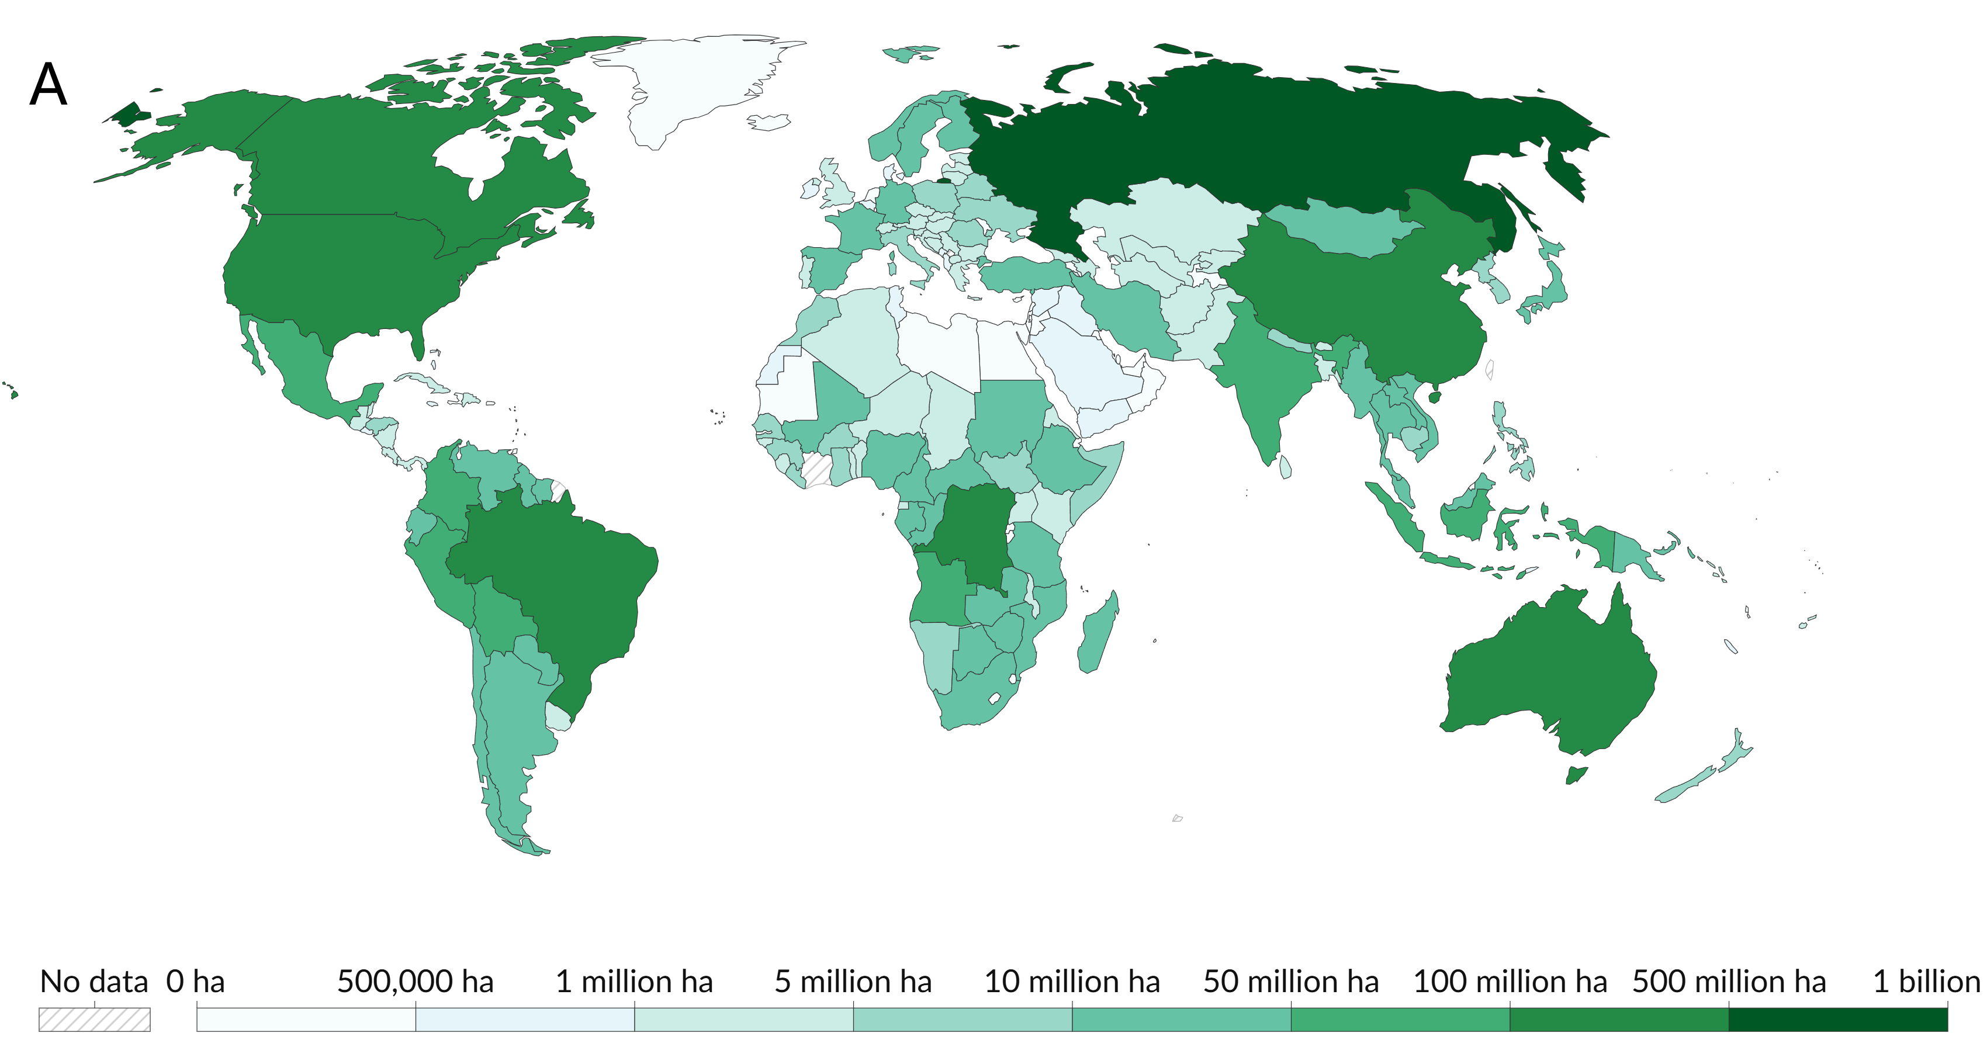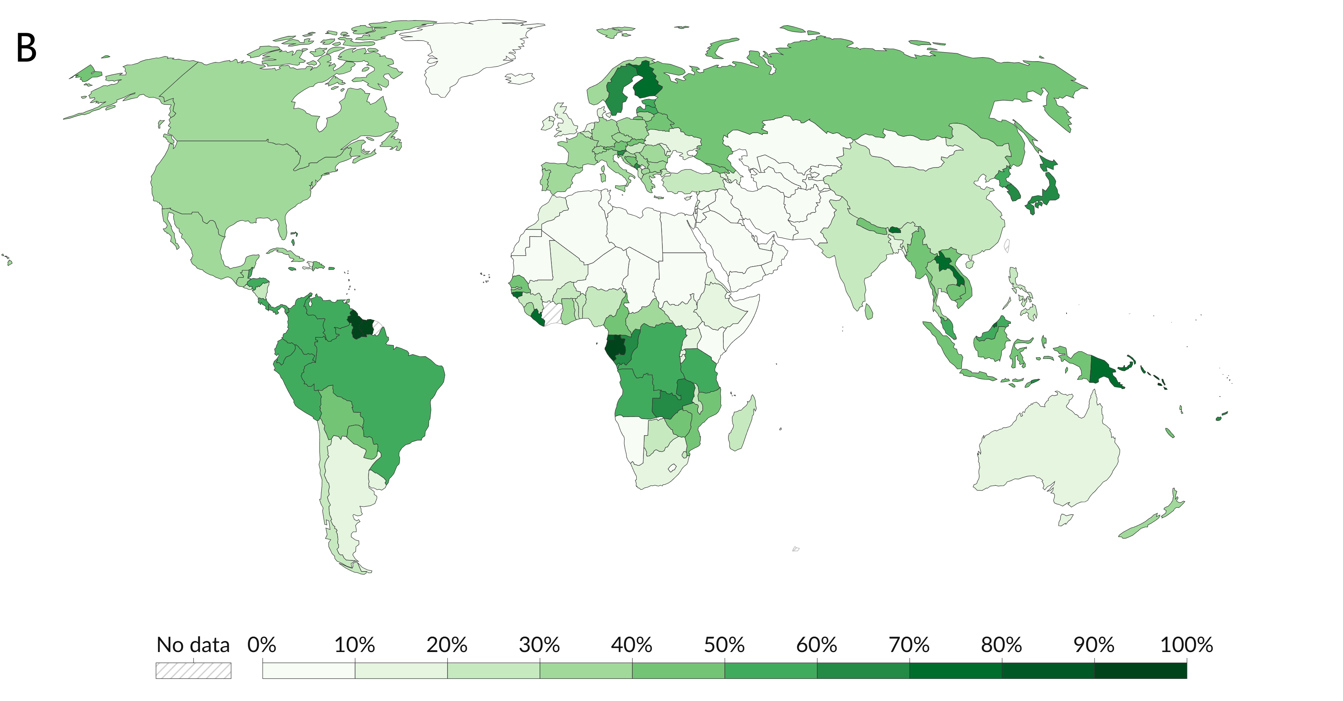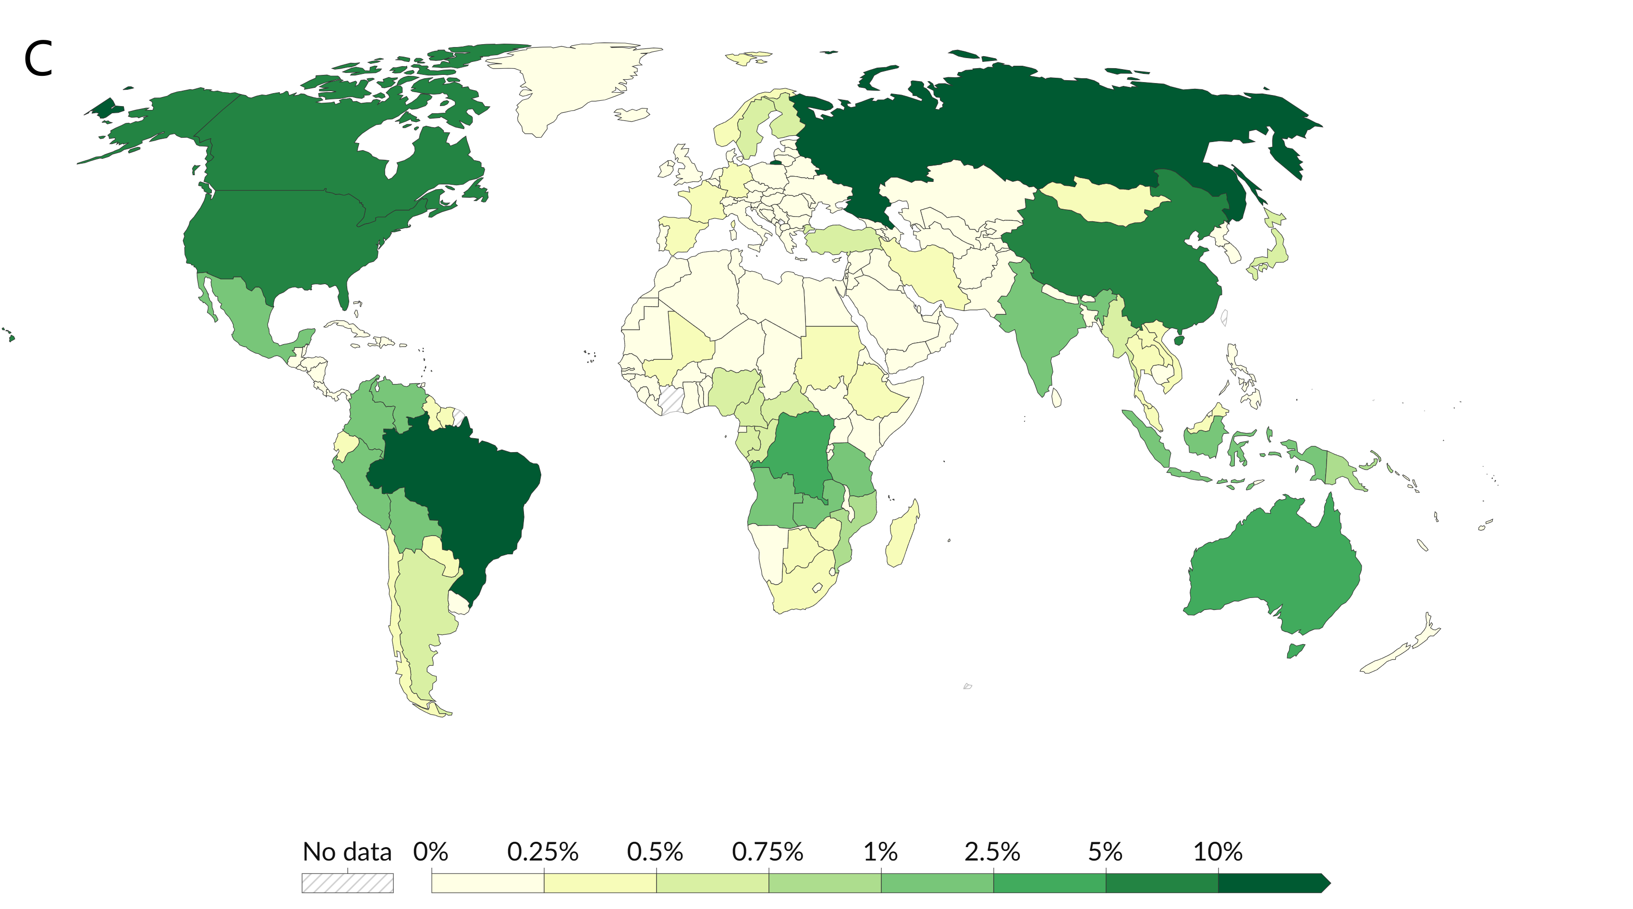
Supplemental Figure S1. World map of forest area (A), forest cover percent (B), and share of global forest area (C) in 2020.

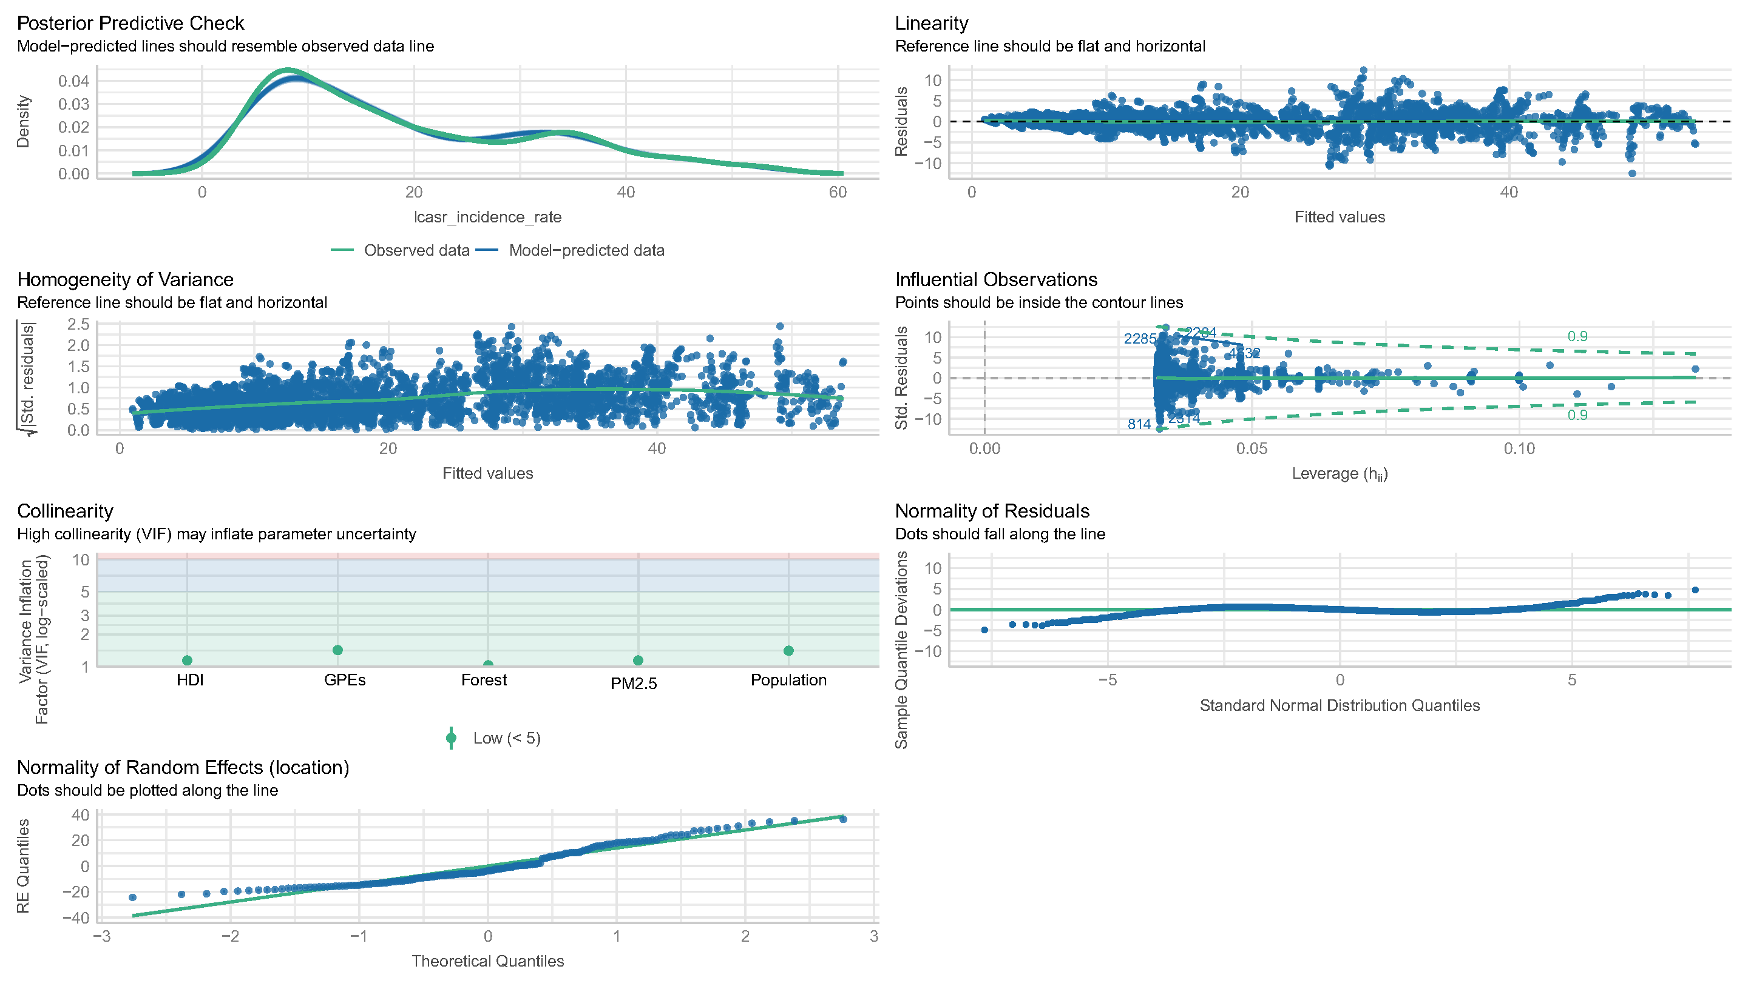
Supplemental Figure S2. Mixed-effects model evaluation.

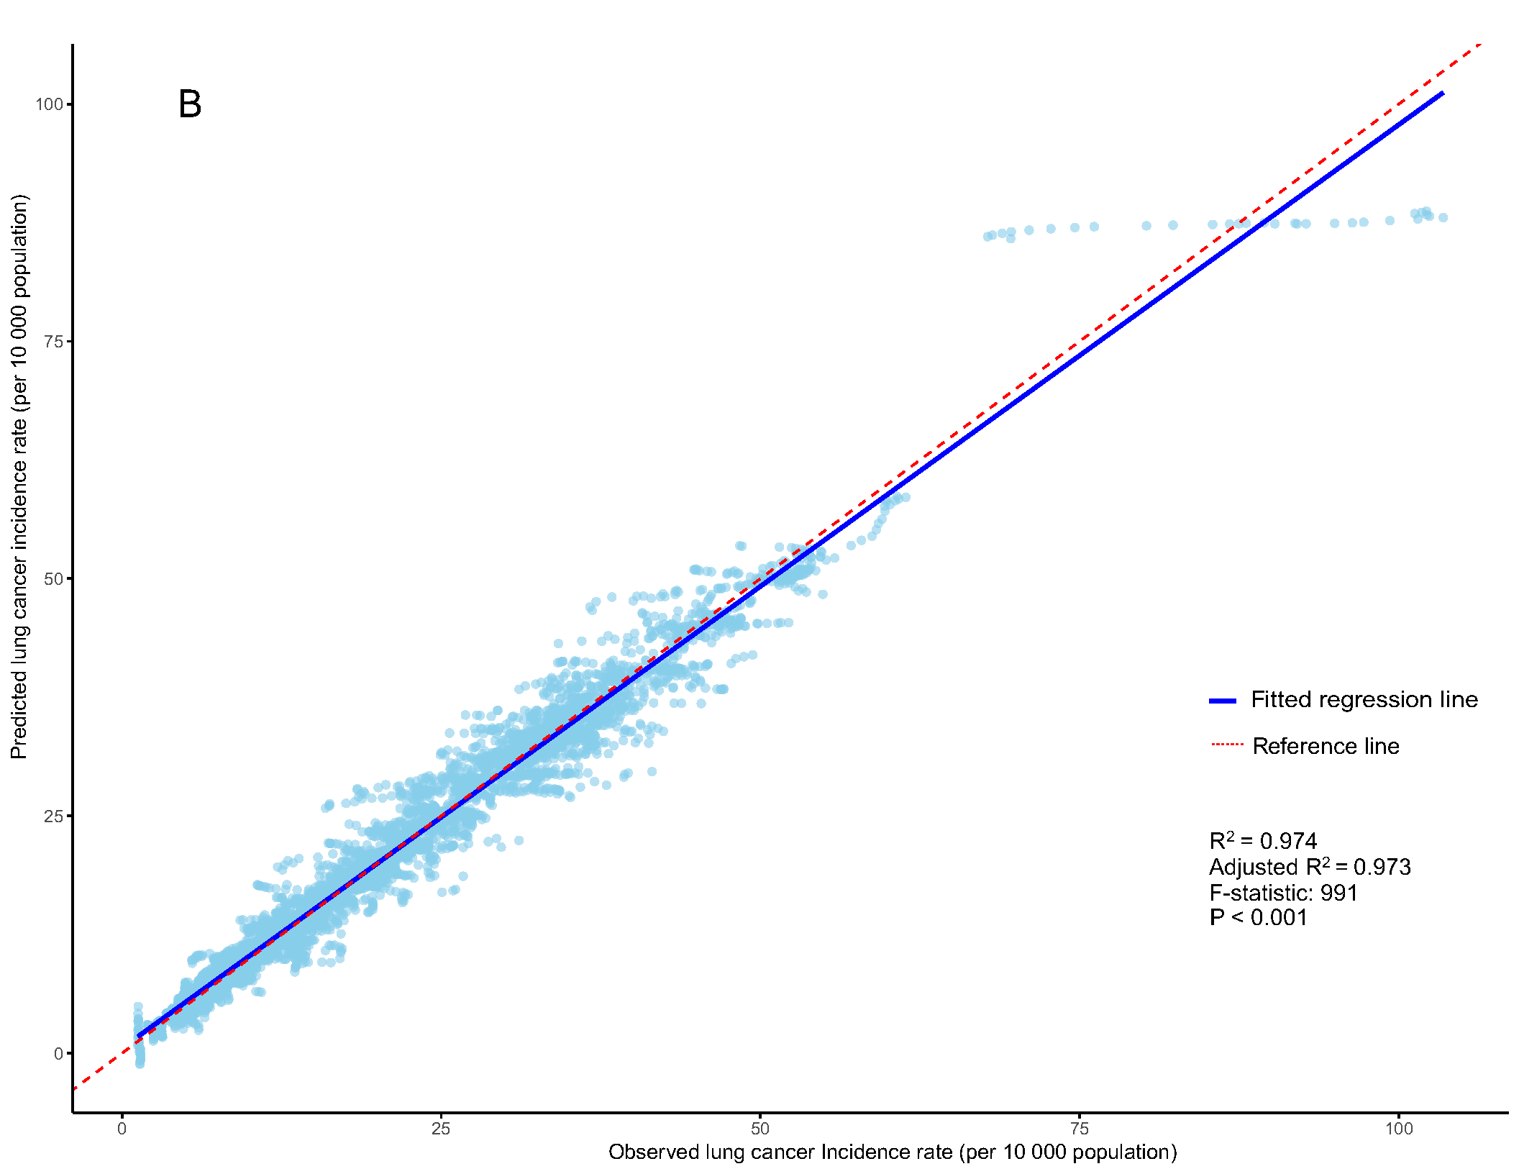
Supplemental Figure S3. Difference-in-differences approach model evaluation.

