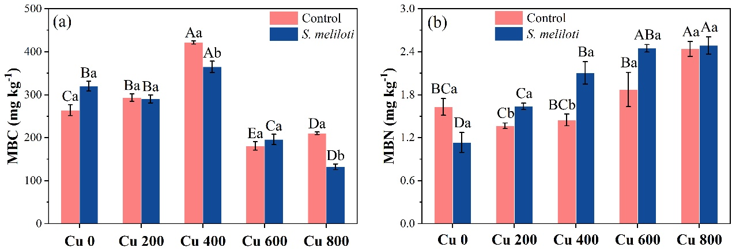
Fig. S1. The effect of inoculation with S. meliloti on soil MBC and MBN under different Cu concentration treatments. MBC: microbial biomass carbon; MBN: microbial biomass nitrogen. The capitalized letters indicate significant differences between different Cu concentrations, whereas the lower-case letters indicate significant differences between non-inoculated and inoculated alfalfa under the same Cu concentration condition (P < 0.05). Each value represents the mean ± SE (n = 3).

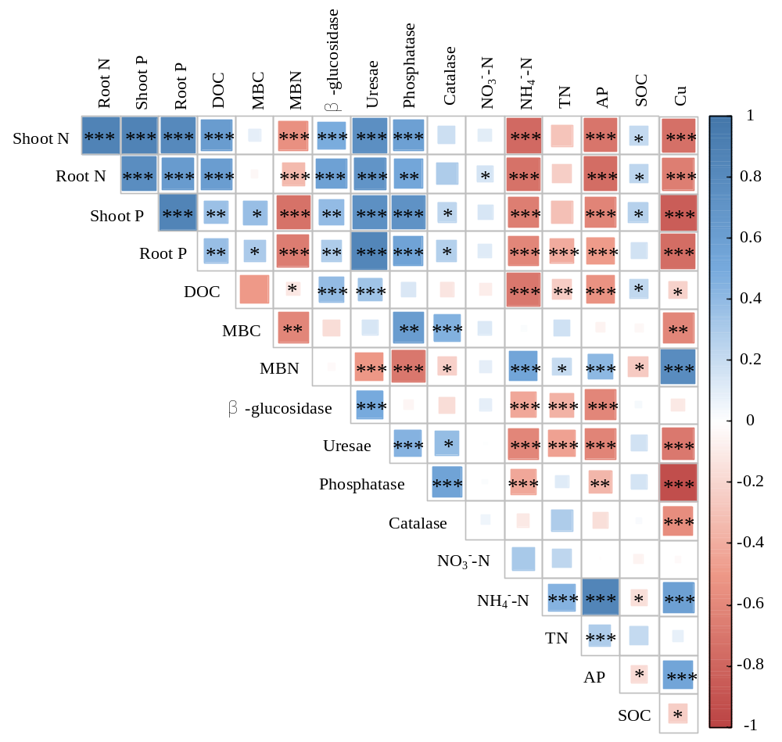
Fig. S2. A correlation heat map illustrating pairwise relationships between plant nutrient elements and soil properties based on Pearson correlation analysis. Shoot N: shoot nitrogen concentration; Shoot P: shoot phosphorus concentration; Root N: root nitrogen concentration; Root P: root phosphorus concentration; DOC: dissolved organic carbon; MBC: microbial biomass carbon; MBN: microbial biomass nitrogen; TN: total nitrogen; AP: available phosphorus; SOC: soil organic carbon. ***, P < 0.001; **, P < 0.01; *, P < 0.05.

