SUPPLEMENTARY FIGURES

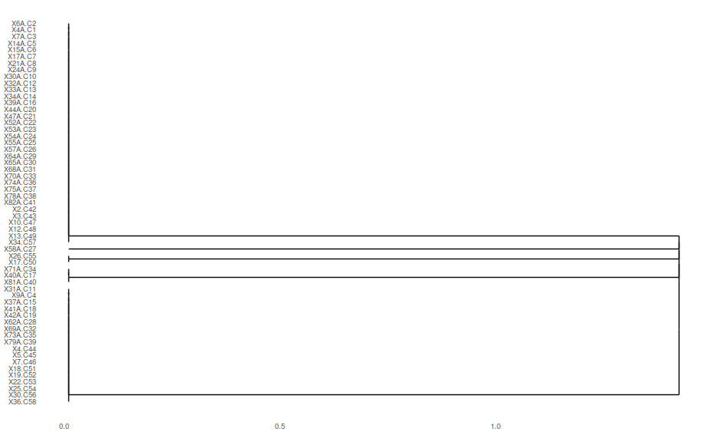

Supplementary Figure 1. Heat map dendrogram demonstrating the grouping of all the S. aureus strains according to resistance aspects (a) and (b).
b)
a)

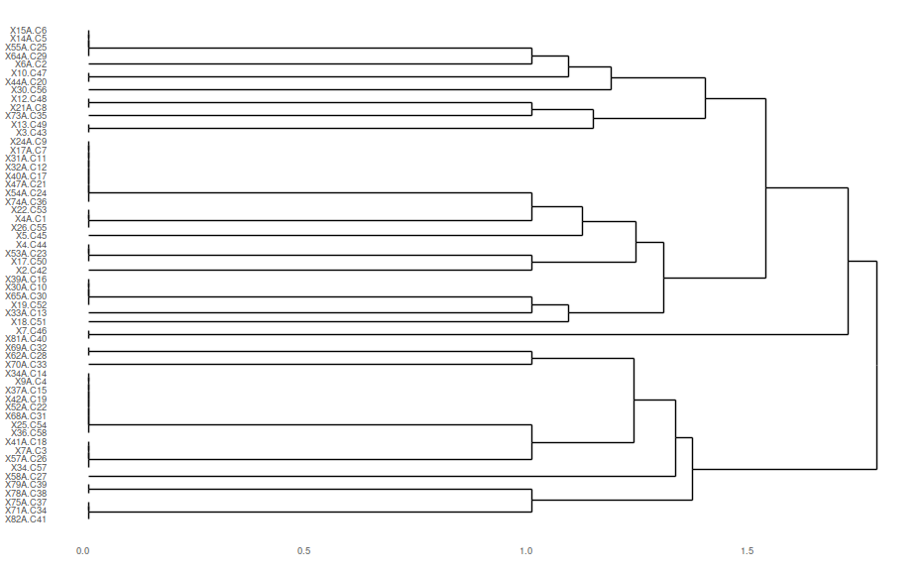
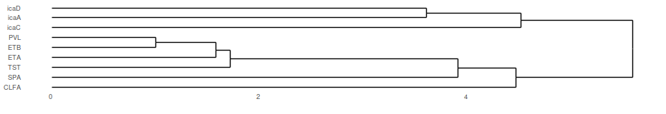
Supplementary Figure 2. Heat map dendrogram demonstrating the grouping of all the S. aureus strains according to the virulence aspects.
b)
a)
a)
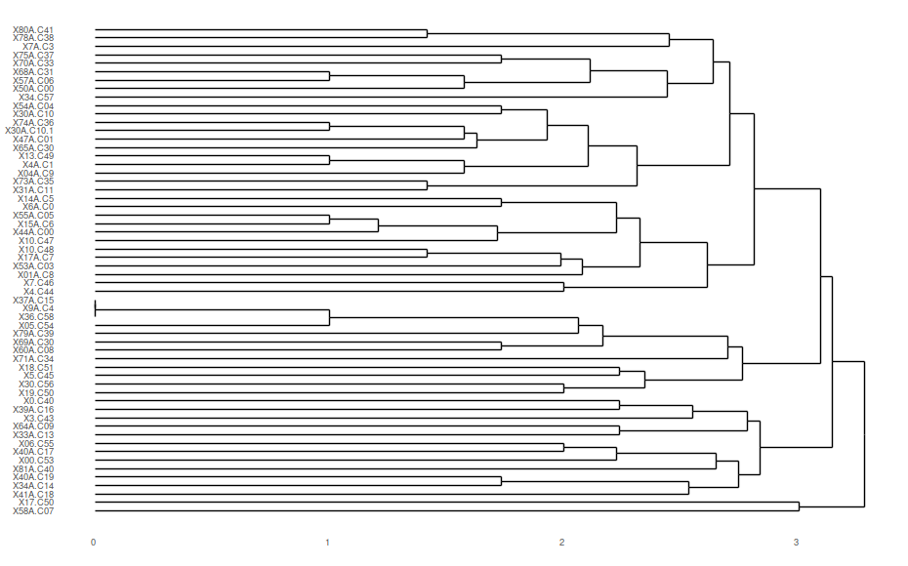
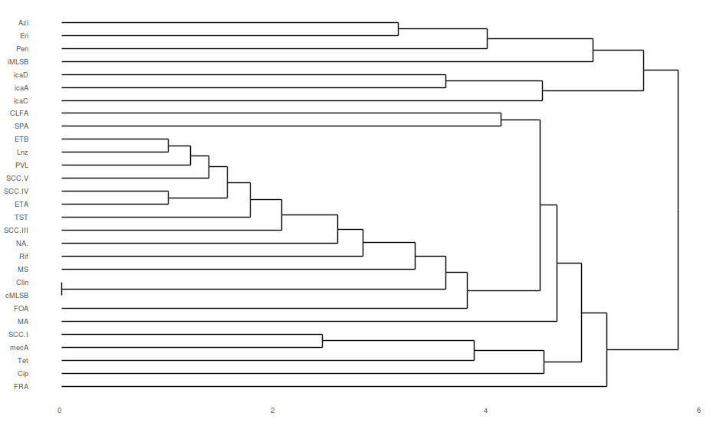
b)
Supplementary Figure 3. Heat map dendrogram demonstrating the grouping of all the S. aureus strains according to phenotypic and genotypic aspects (a) and (b).

