Supplement information
Nattokinase-mediated regulation of tumor physical microenvironment to enhance the therapeutic effect of photosensitive in situ gel vaccine for tumor synergistic therapy

Chunmin Deng,¹ Dong Shen,¹ Mengyi Li,¹ Changsong Zhang,^{1*} Qingzhen Wang¹*

- Suzhou Research Center of Medical School, Suzhou Hospital, Affliated Hospital of Medical School, Nanjing University, Suzhou 215153, Jiangsu Province, China.

*Corresponding author email: hbzcs@126.com (Changsong Zhang) and 17715187193@163.com (Changsong Zhang)

Experimental section

Materials
Folic acid (FA), 4-(4,6-Dimethoxy-1,3,5-triazin-2-yl)-4-methylmorpholinium chloride (DMTMM), 4-Aminophenylboronic acid hydrochloride (contains varying amounts of water), Polyvinyl alcohol, Serotonin, N-(3-Dimethylaminopropyl)-N′-ethylcarbodiimide hydrochloride (EDC), Hyaluronic acid (HA), N-hydroxysuccinimide (NHS), calreticulin rabbit monoclonal antibody-AF1666, HMGB1 and ATP ELISA kit were purchased from Aladdin Reagent Company (Shanghai, China). Potassium permanganate was purchased from Sinopharm Chemical Reagent (Beijing, China). Anti-mouse CD3, anti-mouse CD8a, anti-mouse CD44, anti-mouse CD62L, anti-mouse CD11c, anti-mouse CD80, anti-mouse CD86, Cell counting kit-8 (CCK-8) and DAPI were purchased from Sigma (New York, NY, USA). Fetal bovine serum (FBS), Trypsin, RPMI Medium Modified (RPMI-1640), Phosphate buffered saline (PBS) and penicillin-streptomycin were procured from Hyclone (Logan, UT, USA). Nattokinase was purchased from Yangtze River Delta Health Research Institute (Zhengjiang China). Deionized water was used in the experiments. Calreticulin rabbit monoclonal antibody-AF1666, HMGB1 and ATP ELISA kit.

Apparatus and procedures
Transmission electron microscopy (TEM) image was required through a JEOL 2100 transmission electron microscope. Fourier transform infrared (FTIR) spectra was acquired by a NicoletNexus 470 spectrometer (USA). ζ-potential measurement was performed via a NanoBrook Omni (Brookhaven, USA). X-ray photoelectron spectroscopy (XPS) was acquired from XPS spectrometer (Thermo Kalpha). Gelation time was measured through the tube inversion test. The morphology of FPLT@DOX PA was tested via ZEISS SIGMA scanning electron microscope. Mechanical property of FPLT@DOX PA was measured through compression testing by a universal material experiment machine (WDW3020, China). FPLT@DOX PA was cuted into two semicircles to examine their self-healing ability. FPLT@DOX PA was placed into a syringe and injected into a star-shaped mold via a needle of 25 to measure their injectable. A TA rheometer (DHR-2) was measured to test rheological property of FPLT@DOX PA. 808 nm irradiation laser was performed via a fiber-coupled NIR laser (MDL-N-808 nm-10W, Beijing Laserwave OptoElectronics Technology Co., Ltd., Beijing, China). The infrared thermal camera (HT-19, Guangzhou, China) was utilized to taken the infrared thermal photos and record the temperature changes.

Synthesis of PPLT@DOX NAs
The synthesis steps of PPLT@DOX NAs were slightly modified according to the previous method.¹⁻² 20 mg polyvinyl alcohol (PVA) was dissolved into 20 mL ultrapure water and stirred at 90 °C for 30 min until PVA was completely dissolved. Once PVA solution cooled down to room temperature, 300 mg serotonin, 100 mg KMnO₄ and 10 mg doxorubicin were added into above solution and stirred at room temperature for 2 h. And then, the solution was collected and precipitated by centrifugation at 5000 rpm for 5 min, after which the supernatant was placed into a dialysis bag (MWCO 100,000) and dialyzed for 3 days (the water was changed every 12 h). Finally, the resulting dialysis solution was freeze-dried via a vacuum freeze dryer. The obtained black powder was PPLT@DOX NAs.

Synthesis of boronic acid-modified hyaluronic acid
0.6 mmol hyaluronic acid (HA) was added into 50 mL deionized water and stirred until HA was completely dissolved. Next, 0.6 mmol DMTMM was added into 1 mL deionized water and dropped into HA solution. After being stirred for 4 h, 1 mL 4-aminophenylboronic acid hydrochloride solution (0.6 mmol) was dropped into above mixture and stirring was continued for 72 h. Finally, the mixed solution was dropped into a dialysis bag (MWCO 100,000) and dialyzed for 3 days. The obtained dialysate was freeze-dried in a vacuum freeze dryer to obtain boric acid modified hyaluronic acid (PA).³⁻⁴

DOX releasing behavior
To verify the release behavior of DOX from FA-PPLT@DOX NAs in different environments, FA-PPLT@DOX NAs was immersed in PBS, pH = 6.5, pH = 6.5 + NIR, pH = 5.5, and pH = 5.5 + NIR to evaluate DOX releasing behavior from FA-PPLT@DOX NAs. The absorbance of DOX was detected by Fluorescence spectrometer at designed time point to evaluate the degradation performance of FA-PPLT@DOX NAs in different environment.⁵
Cell culture
4T1 cells (Mouse breast cancer cells), and 293T cells (Human renal epithelial cells) were obtained from SUNNCELL Biotechnology Co., Ltd. These cells were incubated in fresh RPMI-1640 medium containing 10% heat-inactivated fetal bovine serum and 1% penicillin-streptomycin. All cell lines were approved by Nanjing University.

Apoptosis in tumor cells and release of tumor antigens induced by FA-PPLT@DOX PA combined with NIR.
HMGB1 enzyme-linked immunosorbent assay: 4T1 cells (2×10⁵/well) were inoculated into a 24-well culture plate and placed in a cell incubator (37℃, 5% CO₂). After 12 h, DOX, FA-PPLT@DOX NAs and FA-PPLT@DOX PA were added to the above culture plates and exposed under NIR irradiation (0.75 W/cm², 2 min). After 12 h, the supernatant of each treatment group was sucked into eppendorf microtest tubes. Subsequently, the standards and samples were respectively added to the pre-coated strips at a ratio of 100 μL per well (n = 3/group). After washing the incubation plate for five times, 100 μL antibody labeled with horseradish peroxidase was added to each well and incubated for 1 h at room temperature with the reaction wells being sealed with transparent plate sealing film. After 5 times of cleaning, 100 μL of TMB solution was added to each well and incubated for 20 min at room temperature in the dark, with the reaction wells being sealed with white sealing film. Finally, 50 μL of stop solution was added to each well and the absorbance of each group was detected at 450 nm after mixing.⁶
ATP detection: 4T1 cells (2×10⁵/well) were inoculated into a 24-well culture plate and placed in a cell incubator (37℃, 5% CO₂). After 12 h, DOX, FA-PPLT@DOX NAs and FPLT@DOX PA were added to the above culture plates and exposed under NIR irradiation (0.75 W/cm², 2 min). After 12 h, the supernatant of each treatment group was sucked into EP tube. Next, add 100 μL ATP detection working solution into the detection tube for each hole. Subsequently, add 20 μL of standard and sample per hole into the detection tube respectively and quickly mix it with a pipette gun. The RLU value was detected with a chemiluminescence instrument and the concentration of ATP was calculated by standard curve.⁷

Tumor models and animal welfare
- week-old BALB/c female mice were purchased from Qinglongshan Biotechnology Co., LTD (Nanjing, China) and fed in the specific pathogen-free-conditions. 200 μL of 4T1 (1×10⁷) cells were injected subcutaneously into the right lower mammary gland of female BALB/c mice to establish a subcutaneous transplanted tumor model. When the tumor volume exceeds 1500 mm³, the mouse is considered dead. All animal experiments were performed by the protocol approved of Institutional Animal Care and Use Committee of Nanjing University. All efforts were made to minimize the animals’ suffering and reduce the frequency of animal use. The animal study is reported in accordance with ARRIVE guidelines and all methods were carried out in accordance with relevant guidelines and regulations.

T cell analysis of tumor tissue
Distant tumors of 4T1 transplanted mice in each treatment group were chopped and digested with Dulbecco modified Eagle medium containing DNase I (100 μg/mL), hyaluronidase (100 μg/mL), collagenase Ⅳ (1 mg/mL) and 10% fetal bovine serum at 37℃ and 200 rpm for 30 min. Then they were purified with erythrocyte lysate and 40% percoll solution. The lymphocytes were collected and stained with anti-mouse CD3, anti-mouse CD4 and anti-mouse CD8a for flow cytometry analysis.⁸

Safety evaluation
Mice were treated with PBS, DOX, PPLT@DOX NAs, FA-PPLT@DOX NAs and FPLT@DOX PA via intratumor injection as in the schedule for the in vivo anti-tumor efficacy study. Body weights were detected every day at the beginning of the experiment. Major organs (heart, liver, spleen, lungs, and kidney) were obtained after the last treatment and fixed with H&E staining to assess toxicity. Besides, blood samples were collected into anti-coagulated tubes to analyze the hemocyte indexes as well as the serum levels of blood liver and kidney function indexes.¹⁰

Statistical Analysis
The experimental data were analyzed using OriginPro and SPSS 17.0. All experiments were repeated at least three times, and the results were expressed as mean ± standard deviation. Statistical significance was determined using the t-test. A p-value < 0.05 was considered statistically significant. * p < 0.05, ** p < 0.01, *** p < 0.001.

Results

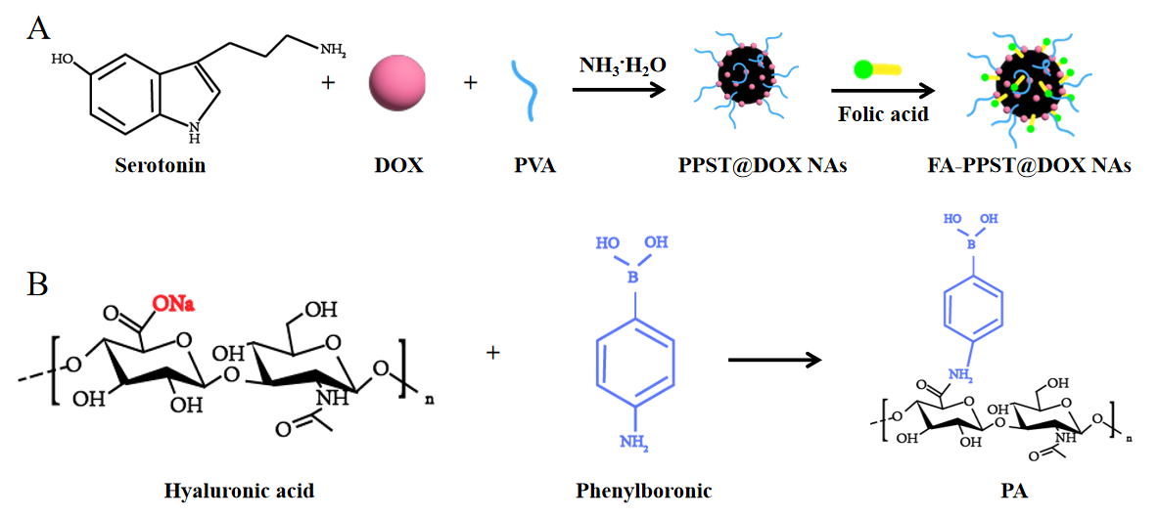
Figure S1. (A) Schematic illustration of the synthesis process of FA-PPST@DOX NAs. (B) Schematic illustration of the synthesis process of PA.

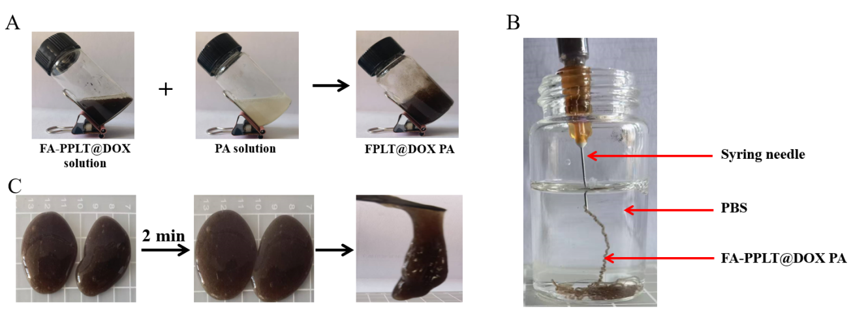
Figure S2. (A) Photographs of PA solution, FA-PPLT@DOX NAs dispersion solution, and FPLT@DOX PA at room temperature. (B) The injectability of FPLT@DOX PA in PBS solution. (C) Self-healing performance of FPLT@DOX PA.
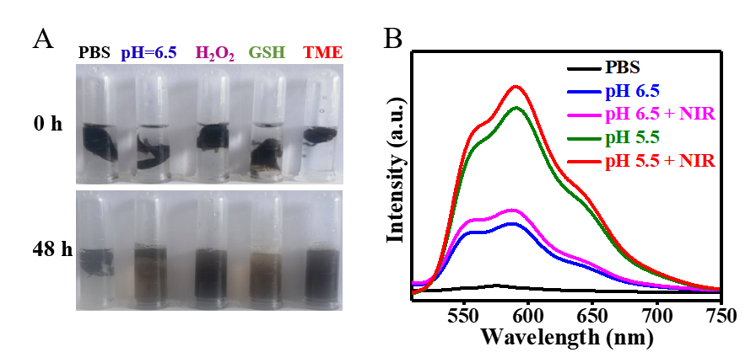
Figure S3. (A) Photograph of FPLT@DOX PA immersed into different solution at 0 h and 48 h. (B) Fluorescence spectra of DOX once FA-PPLT@DOX NAs immersed into different solution after 24 h.
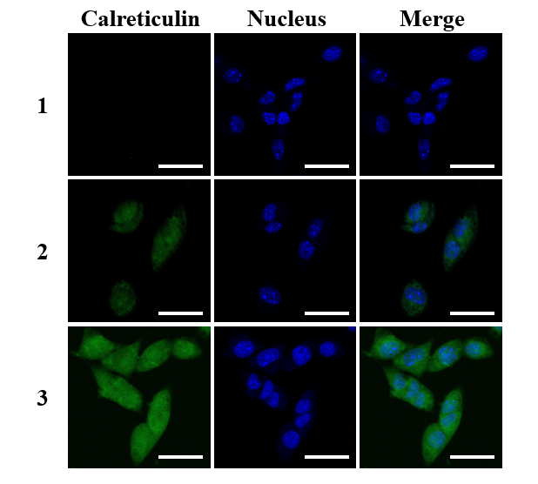
Figure S4. Fluorescence imaging of CRT exposed on the surface of 4T1 cells after treated with PBS (1), FPLT@DOX PA (2), and FPLT@DOX PA under NIR irradiation (3).
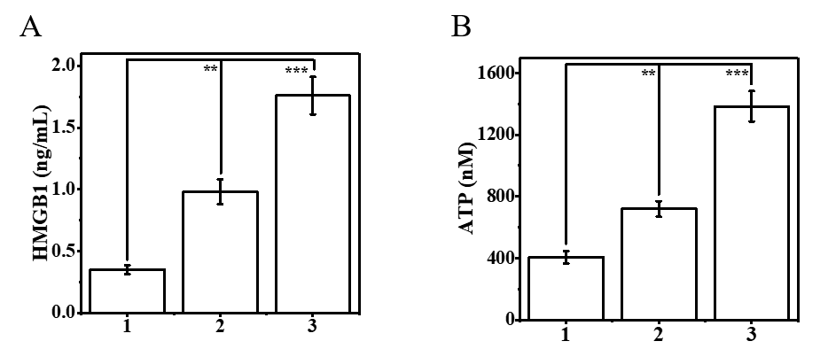
Figure S5. Extracellular release of (A) HMGB1 and (B) ATP from 4T1 cells after treated with PBS (1), FPLT@DOX PA (2), and FPLT@DOX PA under NIR irradiation (3).
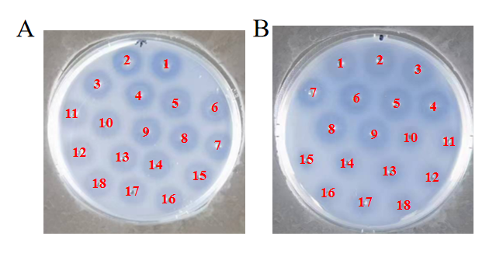

Figure S6. (A) The activity of NT after different time treatment for 120 s (35 ℃: 1-3，40 ℃：4-6，45 ℃：7-9，50 ℃：10-12，55 ℃：13-15，60 ℃：16-18). (B) The activity of NT after different treatment (PBS: 1-3，H₂O₂：4-6，GSH：7-9，pH=6.5：10-12，TME：13-15，TME+NIR：16-18).

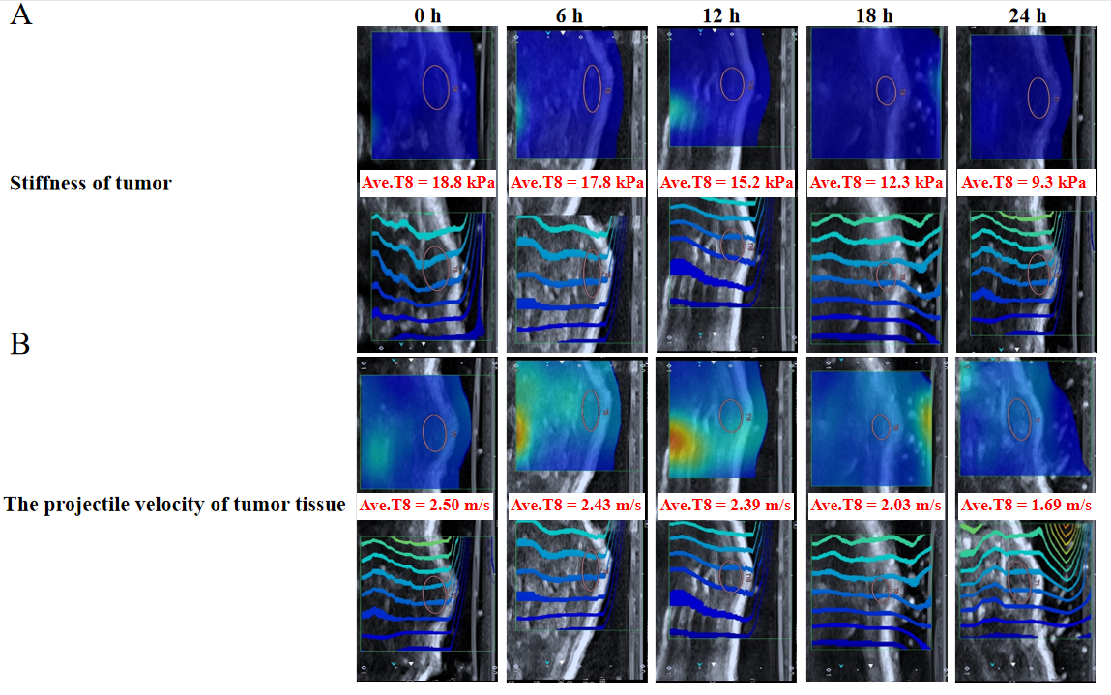
Figure S7. Photoacoustic images shown the stiffness and the projectile velocity of tumor tissue after treated with or without NT at different time points.

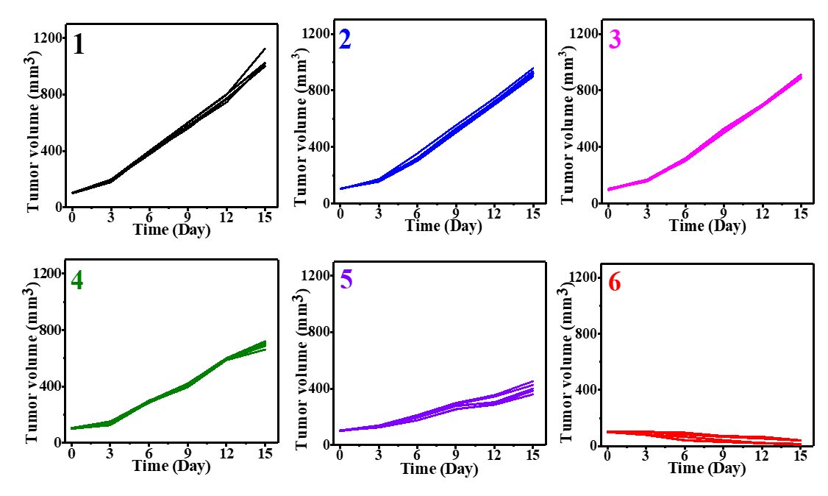
Figure S8. Individual tumor volume curves of 4T1 tumor-bearing mice after 15 days of different treatments (n=6/group). 1: PBS + NIR, 2: DOX+ NIR, 3: NT+ NIR, 4: FA-PPLT@DOX NAs + NIR, 5: FPLT@DOX PA + NIR, 6: FPLT@DOX PA + NT + NIR.
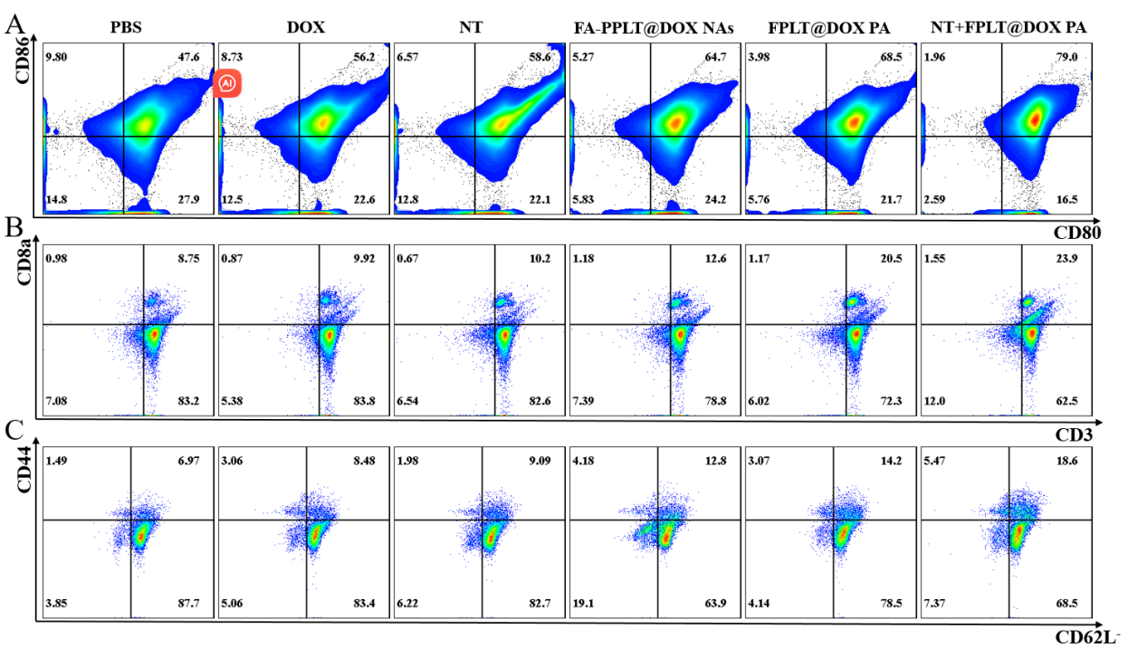
Figure S9. Flow cytometry plots showing (A) the maturation of DC cells (CD11c⁺CD80⁺CD86⁺) and (B) CD8⁺ T cells (CD3⁺CD4⁺CD8a⁺), extracted from tumor tissues following different treatments. (C) Flow cytometry plots of memory T cells (CD44⁺CD62L⁻CD3⁺CD8a⁺ T cells) extracted from lymph nodes after various treatments.
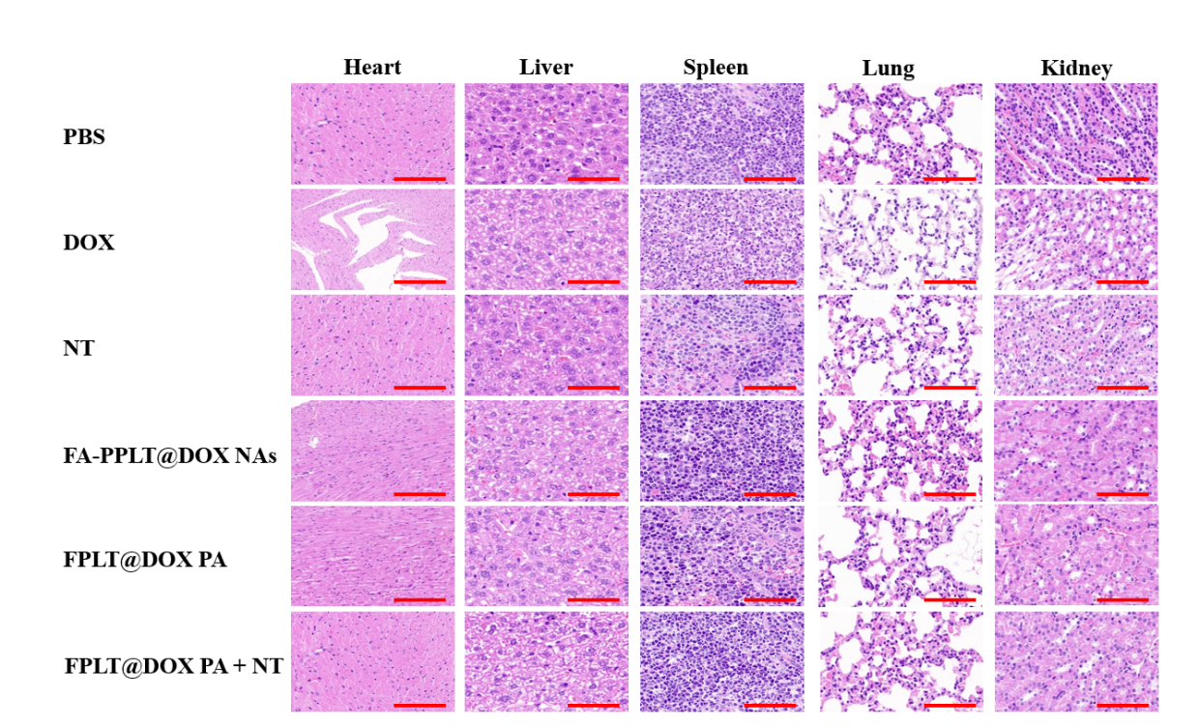
Figure S10. H&E-stained images of the major organs (Heart, Liver, Spleen, Lung and Kidney) in the different groups. Scale bar: 100 μm.

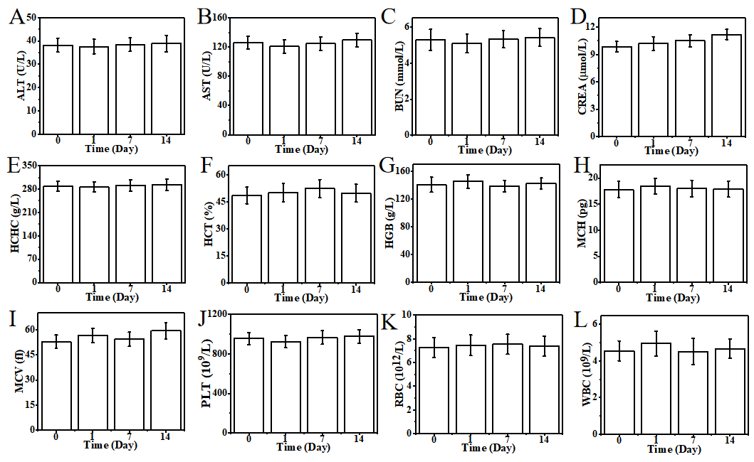
Figure S11. The serum biochemistry index (A-D) and the blood tests (E-L) of the mice on the 0 st, 1st, 7th, and 15th day after the treatment of FA-PPLT@DOX PA + NT.

Reference:
- Ying Wang , Qing Ji, Chao Yan, et al. Biomimetic intelligent nanoplatform with cascade amplification effect for tumor synergy therapy. Sci. Rep., 2024. 14: 31067.
- Zhengzou Fang, Zhihui Yan, Zhangzuo Li, et al. Polydopamine nanoparticles cross-linked hyaluronic acid photothermal hydrogel with cascading immunoinducible effects for in situ antitumor vaccination. Int. J Biol. Macromol., 2024. 269: 132177.
- Ye Wu, Yu Wang, Linyu Long, et al. A spatiotemporal release platform based on pH/ROS stimuli-responsive hydrogel in wound repairing. J. Control. Release, 2022. 341: 147-165.
- Shuai Liu, Xin Liu, Yanhan Ren, et al. Mussel-Inspired Dual-Cross-linking Hyaluronic Acid/epsilon-Polylysine Hydrogel with Self-Healing and Antibacterial Properties for Wound Healing. ACS Appl. Mater. Interfaces, 2020. 12: 27876-27888.
- Hui Wang, Yu Chen, Ran Wei, et al. Synergistic Chemoimmunotherapy Augmentation via Sequential Nanocomposite Hydrogel-Mediated Reprogramming of Cancer-Associated Fibroblasts in Osteosarcoma. Adv. Mater., 2024. 36: e2309591.
- João Conniot, Anna Scomparin, Carina Peres, et al. Immunization with mannosylated nanovaccines and inhibition of the immune-suppressing microenvironment sensitizes melanoma to immune checkpoint modulators. Nat. Nanotechnol., 2019. 14: 891-901.
- Jiexin Li, He Ren, Qian Qiu, et al. Manganese Coordination Micelles That Activate Stimulator of Interferon Genes and Capture In Situ Tumor Antigens for Cancer Metalloimmunotherapy. ACS Nano, 2022. 16: 16909-16923.
- Audrey Gallud, Olesja Bondarenko, Neus Feliu, et al. Macrophage activation status determines the internalization of mesoporous silica particles of different sizes: Exploring the role of different pattern recognition receptors. Biomaterials, 2017. 121: 28-40.
- Mingkang Zhang, Jing-Jie Ye, Yu Xia, et al. Platelet-Mimicking Biotaxis Targeting Vasculature-Disrupted Tumors for Cascade Amplification of Hypoxia-Sensitive Therapy. ACS Nano, 2019. 13: 14230-14240.
- Zhengzou Fang, Ziyu Zhu, Zijian Zhuang, et al. Cascade biomimetic intelligent nanotheranostic agents for imaging-guided tumor synergistic therapy. Nanomedicine (Lond), 2023. 18: 35-52.

