Fluorescence Localization Imaging via a Spectral-Splitting Perovskite Single-Pixel Detector
Yujin Liu^{1,2,3,#}, Hongling Wan^{1,#}, Jingyang Xing¹, Hao Wang¹, Hanyan Zhao¹, Jieyu Tian¹, Xianping He¹, Jiaqi Wei¹, Zhong Ji^{1,2,3,}*, Xueli Chen^{1,2,3,}*
¹Bi-optoelectronic-integration and Medical Instrumentation Laboratory, Guangzhou Institute of Technology, Xidian University, Guangzhou, Guangdong 510555, China
²Center for Biomedical-photonics and Molecular Imaging, Advanced Diagnostic-Therapy Technology and Equipment Key Laboratory of Higher Education Institutions in Shaanxi Province, School of Life Science and Technology, Xidian University, Xi'an, Shaanxi 710126, China.
3Center for Bi-optoelectronic-integration and Medical Instrumentation (BMI), State Key Laboratory of Electromechanical Integrated Manufacturing of High-Performance Electronic Equipment, Xidian University, Xi’an, Shaanxi 710071, China.
*Corresponding authors:
xlchen@xidian.edu.cn, jizhong@xidian.edu.cn
# These two authors contributed equally to this work.
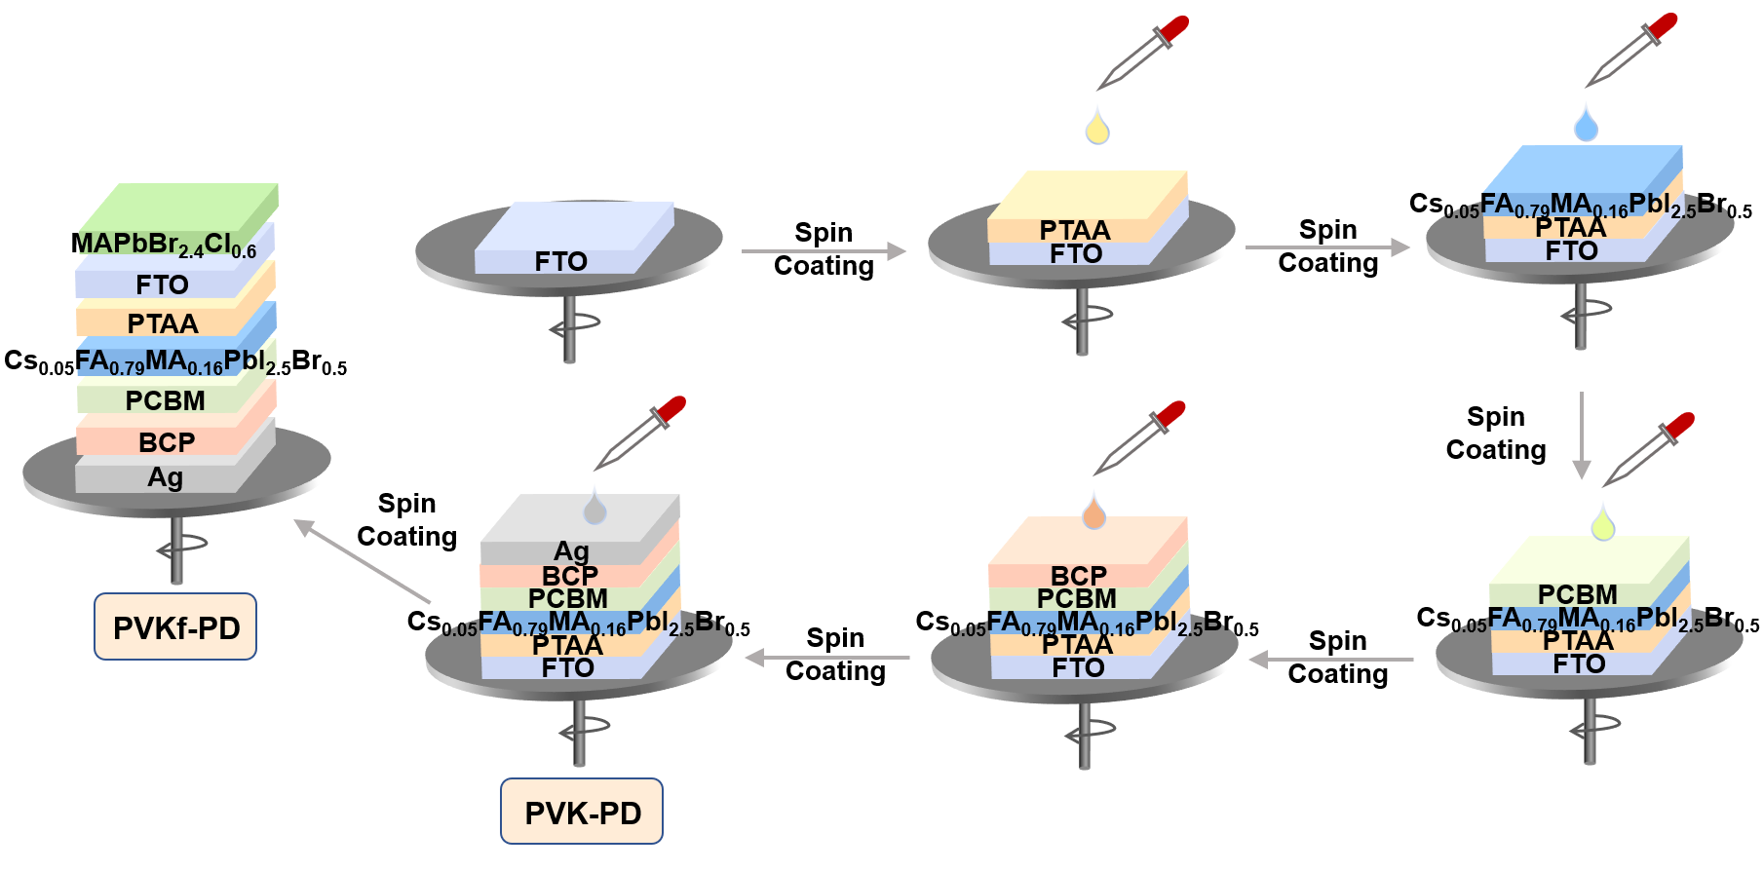
Fig. S1. Preparation of the PVK-PD and PVKf-PDs.
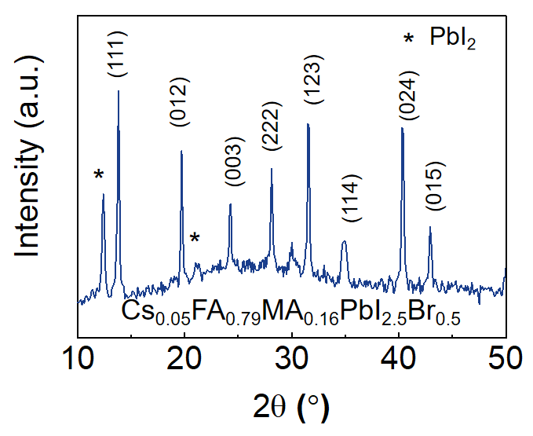
Fig. S2. The survey XRD spectra of the PPL.
To characterize the crystalline quality of the perovskite photodetector layer (PPL) composed of Cs_{0.05}FA_{0.79}MA_{0.16}PbI_{2.5}Br_{0.5}, we present its X-ray diffraction (XRD) pattern in Fig. S2. The PPL exhibits three prominent diffraction peaks corresponding to the (111), (123), and (024) crystal planes of the perovskite phase, confirming its high crystalline quality.
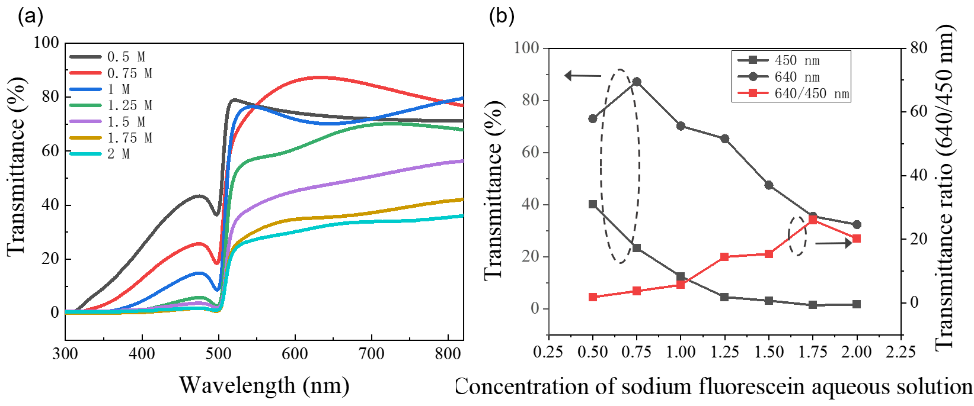
Fig. S3. The absorption spectrum of nine concentration gradients of PFLs.
The results demonstrate that increasing the precursor concentration not only reduces the transmittance of short-wavelength excitation light but also decreases long-wavelength fluorescence transmission. However, the fluorescence/backscattered light ratio exhibits an overall increasing trend, indicating that precursor concentration modulation serves as an effective optimization strategy.
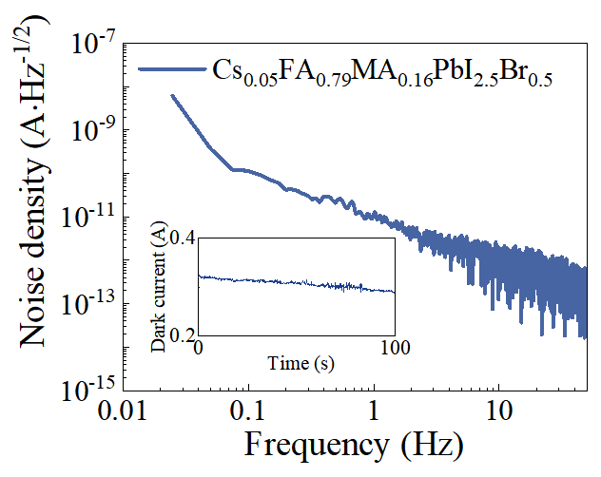
Fig. S4. The noise spectral density of PVK-PD.
We further analyzed the noise spectral density of the PVK-PD through Fourier transform of the time-domain waveforms of dark currents. The results demonstrate that the PVK-PD achieves an ultralow noise level of 10⁻¹² A·Hz⁻¹/², highlighting its exceptional performance for weak-signal detection applications.
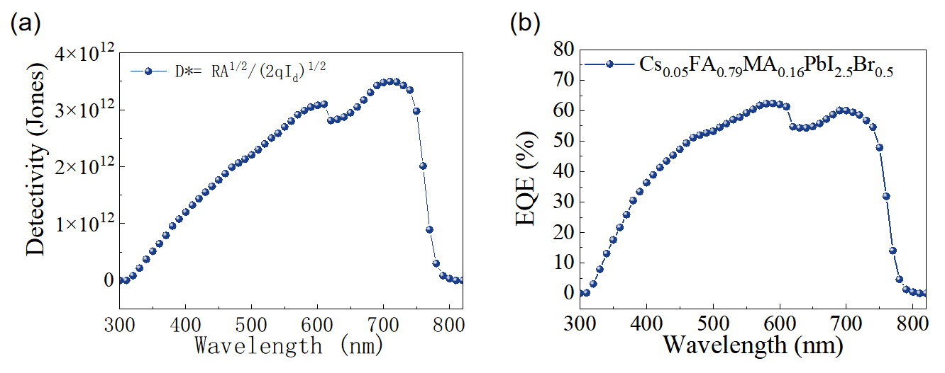
Fig. S5. PVK-PD performance characterization.
The wavelength-dependent external quantum efficiency (EQE) and specific detectivity rate results shown in Figure S5 jointly prove the excellent photovoltaic performance of PVK-PD.
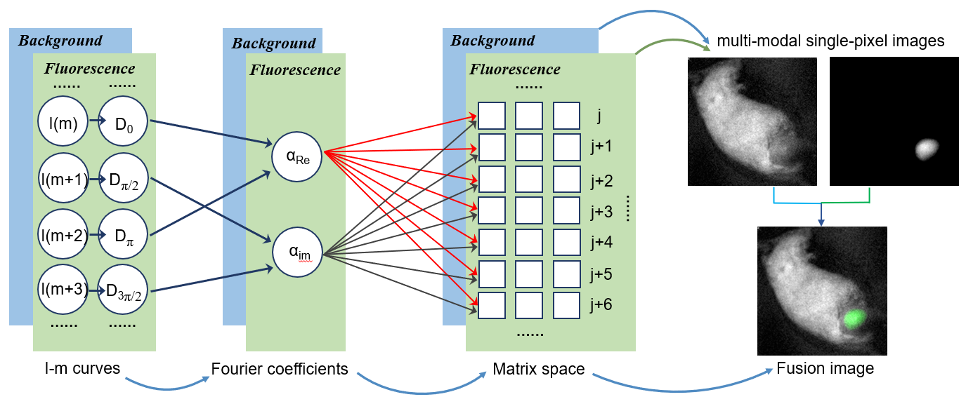
Fig. S6. Schematic diagram of imaging algorithm.
We employed a typical four-step phase-shifting Fourier algorithm for two-dimensional image reconstruction, with Fig. S6 detailing the complete image reconstruction workflow. Initially, the acquired I-t curve was averaged into I-m curve based on predetermined averaging cycles, where m represents the pattern sequence. Subsequently, complex-valued Fourier coefficients (α) were calculated from the I-m curves using the four-step phase-shift method, expressed as $α={[D}_{0}-D_{π}]+j∙[D_{π/2}-D_{3π/2}]$. These coefficients were systematically measured across Fourier space to construct the complete Fourier spectrum of the target image. Final multi-modal image reconstruction was achieved through inverse Fourier transform (IFT) of the acquired Fourier spectrum.
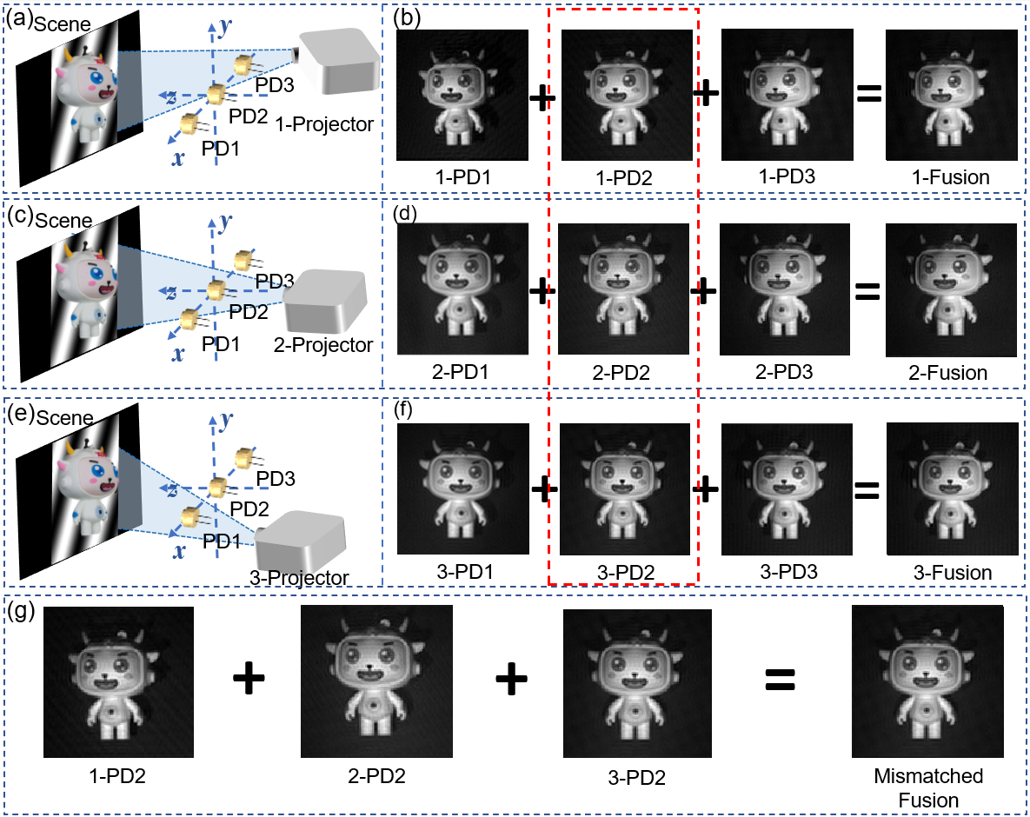
Fig. S7. Multi-Angle Imaging with PVK-PD and Light Source.
When the structured illumination patterns maintain consistent positioning, the PDs acquire perfectly registered images with identical FOV and pixel alignment regardless of their physical locations, enabling direct image fusion through simple superposition (Fig. S7a-f). However, when the structured light illumination patterns shift position, significant FOV misalignment occurs even for images captured by the same PD, rendering image fusion challenging without advanced registration algorithms (Fig. S7g). This comparative analysis demonstrates the inherent advantage of single-pixel imaging systems over dual-camera setups for simultaneous fluorescence/background bimodal imaging acquisition.
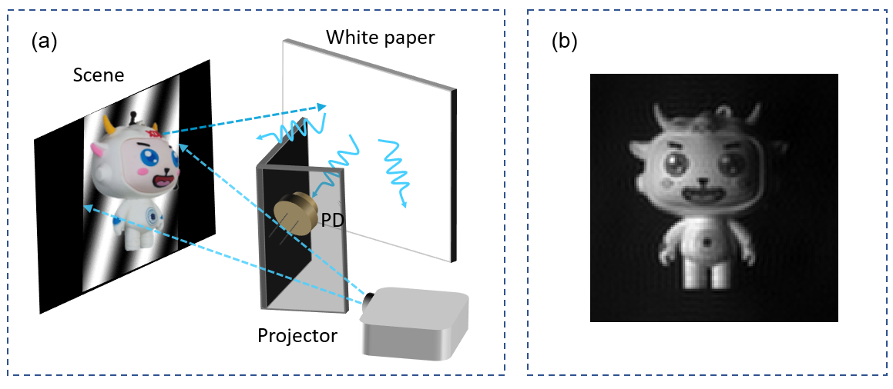
Fig. S8. Non-line-of-sight imaging.
To further validate that the success of single-pixel imaging is independent of detector’s positioning, we conducted the non-line-of-sight (NLOS) imaging experiment. The experiments involved shielding the PVK-PD from the object illuminated by structured light patterns, ensuring that the PD only received diffuse reflection from the white paper. The final imaging results provide definitive evidence for the superior spatial registration capabilities of single-pixel imaging.
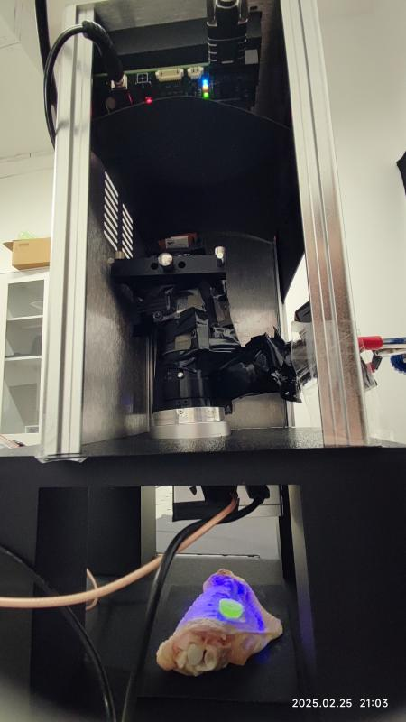
Fig. S9. The experimental setup.
​​The schematic of the actual imaging system.Structured illumination patterns are projected via a DMD, while two PDs acquire fluorescence and background images under multichannel acquisition program control.
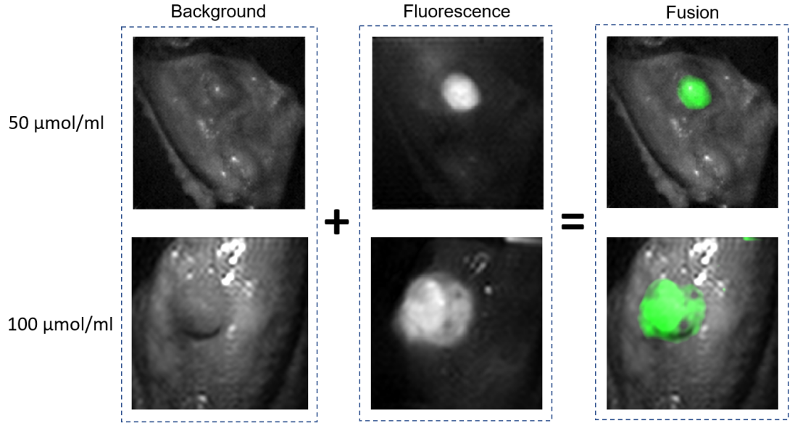
Fig. S10. Simulated tumor experiment with chicken wings.
Two concentrations of sodium fluorescein aqueous solution were selected for Tumor-simulating experiments to validate the system's response capability to fluorescence signals of varying intensities in tumor localization studies.
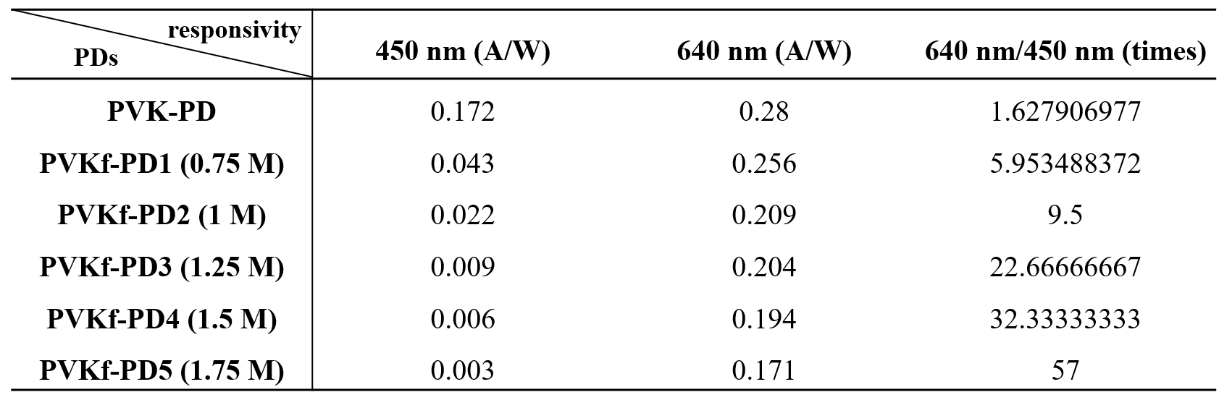
Table S1. The detailed variations in detector response parameters and corresponding signal suppression ratios.
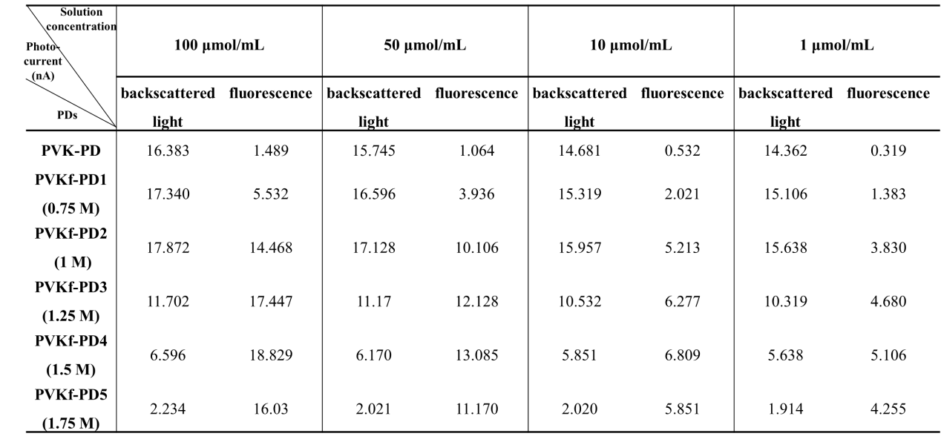
Table S2. The fluorescence and backscattered signal intensities obtained from sodium fluorescein aqueous solution with varying concentrations.

