Supporting Information for
Subpolar North Atlantic Ocean Heat Content as a Precursor to 21st-century Arctic Temperature Variability
Di Cai^{1,2}, Xianyao Chen^{1,3,*}
¹ Frontier Science Center for Deep Ocean Multi-spheres and Earth System and Physical Oceanography Laboratory, Ocean University of China, Qingdao, China
² Alfred Wegener Institute Helmholtz Center for Polar and Marine Research, Bremerhaven, Germany
³ Laoshan Laboratory, Qingdao, China
*Corresponding author: Xianyao Chen (chenxy@ouc.edu.cn)
ORCID: Di Cai (0009-0001-9672-0875); Xianyao Chen (0000-0001-9825-5295)

Validation of CESM1 Large Ensemble Performance
To assess the performance of CESM1 LE and validate the robustness of our analysis, we compare historical SAT, AHT, and OHT against multiple observational and reanalysis datasets. Fig. S1 illustrates that the global SAT trends during the 1979–2020 period in CESM1 LE closely resemble the mean trends from HadCRUT5, GISTEMP, and ERA5. Both the observations and the model capture the Arctic amplification phenomenon, with the Barents-Kara Seas emerging as pronounced warming centers. The temporal evolution of Arctic SAT from 1950 to 2020 in CESM1 LE mirrors observational data (Fig. S1e), reflecting a mid-century cooling phase followed by accelerated warming, in agreement with previous findings (England, 2021).

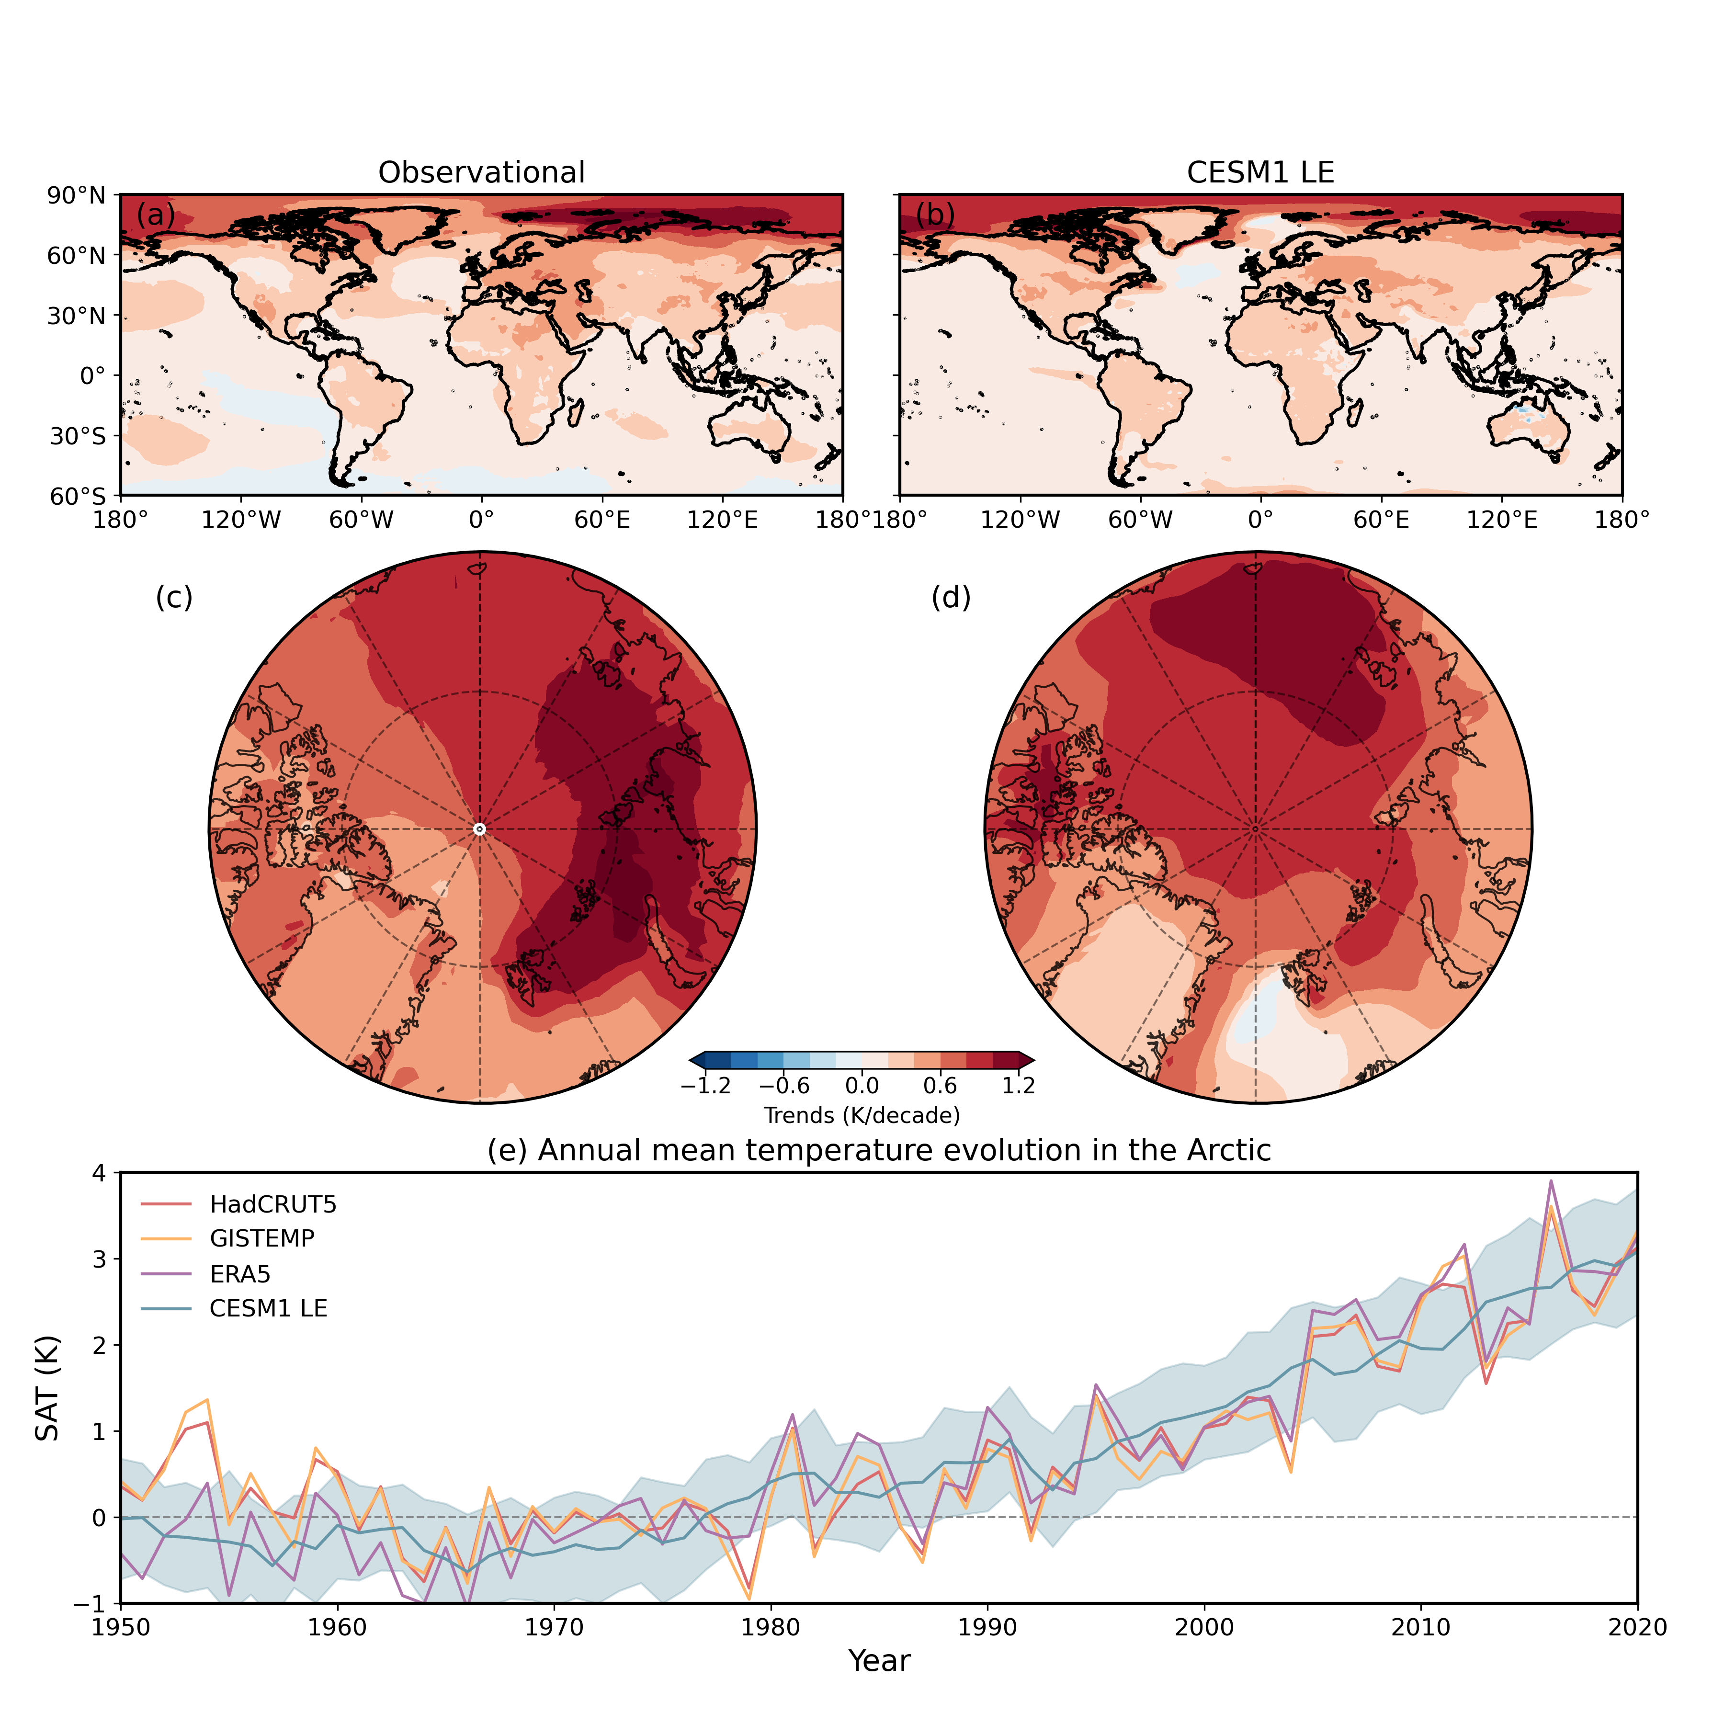
Fig. S1. (a, b) Global annual mean SAT trends (1979–2020) derived from: (a) the average of HadCRUT5, GISTEMP, and ERA5, and (b) the CESM1 LE. (c, d) The same as in (a, b), but focused on the region north of 70°N. (e) Annual mean Arctic SAT anomalies (1950–2020) from three observational datasets—HadCRUT5 (red), GISTEMP (orange), and ERA5 (purple)—compared with the CESM1 LE ensemble mean (blue); shaded areas denote ±1 standard deviation from the CESM1 LE.

Regarding meridional energy redistribution, CESM1 LE realistically simulates the hemispherically antisymmetric structure of heat transport, exhibiting peak magnitudes of approximately 5.5 PW (1 PW = 10¹⁵ W) near 40°N/S. Figure S2a demonstrates excellent agreement between the mean AHT and OHT computed from CESM1 LE and the observational estimates provided by Trenberth and Caron (2001). In the tropics, wind-driven shallow circulations dominate OHT, while in higher latitudes, both buoyancy- and wind-driven dynamics are operative, with limited deep ocean influence (Yang et al. 2015). To further elucidate the different contributions, we examine the mean meridional OHT in distinct ocean basins: the Atlantic and Indo-Pacific regions (Fig. S2b). In the Indo-Pacific Ocean, the heat transport is entirely governed by wind-driven circulation (Held, 2001), with negligible poleward advective transport north of 60°N. In contrast, the Atlantic heat transport relies on both wind-driven thermocline flows and thermohaline overturning, the latter being dominant (Ferrari and Ferreira 2011).
Poleward OHT enters the Arctic through three key gateways: the Barents Sea Opening (71°N to 77°N, 20°E), the Fram Strait (80°N, 14°W to 10°E), and the Bering Strait (65.5°N, 167°W to 170°W). Since observational estimates are primarily based on these three passages, we further compare the OHT in CESM1 LE with estimates obtained from ORAS5 reanalysis and mooring data at the Barents Sea Opening (1997–2007; Skagseth et al. 2020), the Fram Strait (1997–2009; Beszczynska-Möller et al. 2012), and the Bering Strait (1999–2018; Woodgate and Peralta Ferriz 2021). As summarized in Table S1, both CESM1 LE and ORAS5 simulate mean OHT values that are comparable to observations across all three gateways. The discrepancy in the mean Bering Strait OHT magnitude is attributed to the use of a reference temperature of -1.9 °C in the observational computations.

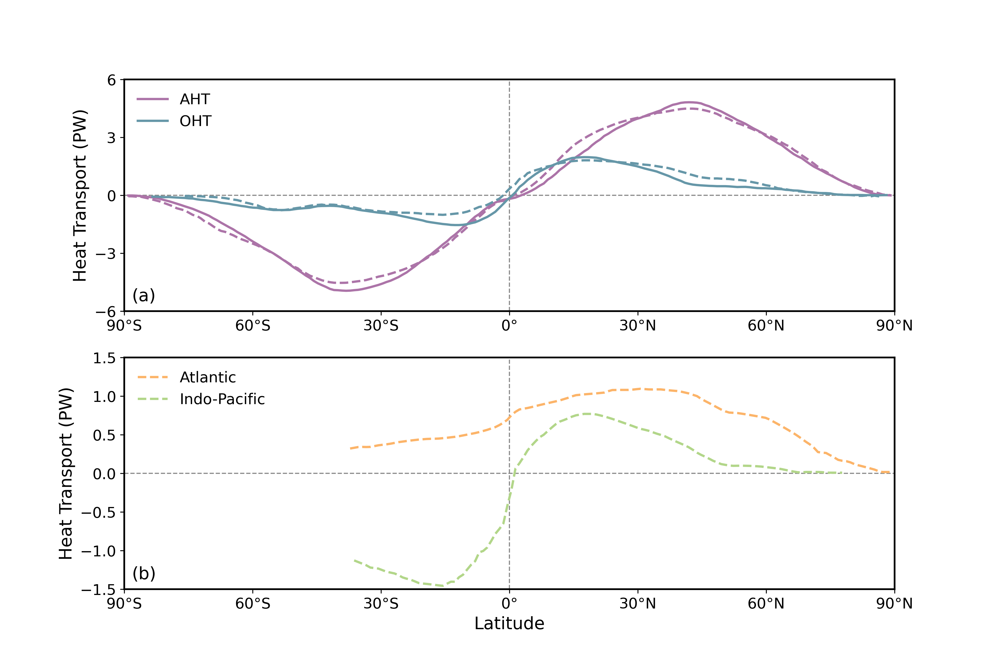
Fig. S2. (a) Mean AHT (purple) and OHT (blue) (units: PW). Solid lines represent observations (Trenberth and Caron 2001), while dotted lines denote CESM1 LE results. (b) Mean meridional OHT (units: PW) for the Atlantic (orange) and Indo-Pacific (green) as derived from CESM1 LE.

Table S1. Mean OHT values (units: TW) through the Barents Sea Opening, Fram Strait, and Bering Strait from CESM1 LE (2001–2010) are compared with estimates from ORAS5 (1979–2020) and observational estimates. Reference periods for the observational data are indicated in parentheses.
Gate | CESM1 LE  (2001–2010) | ORAS5  (1979–2020) | Observations
Barents Sea Opening | 58.8 ± 8.5 | 52 to 90 | 50 to 70 (1997–2007)
Fram Strait | 21.5 ± 2.1 | 18 to 45 | 30 to 42 (1997–2009)
Bering Strait | 4.3 ± 1.5 | 5 to 12 | 10 to 20 (1999–2018)

In addition to evaluating the mean state of OHT, we assess the upper-layer current velocity from 1979 to 2020. Polyakov et al. (2023) employed ORAS5 reanalysis data to demonstrate that, during 2007–2021 compared to 1992–2006, current exchanges in the upper 50 m intensified in the northern Barents Sea Opening and central Barents Sea while weakening in the Fram Strait. This regime shift coincides with the emergence of a dominant Arctic Dipole (AD) pattern post-2007, with alternating AD phases playing a pivotal role in modulating the relative strength of the Fram Strait and Barents Sea branches that transport Atlantic water into the Arctic Ocean. Figure S3 shows that the simulated changes generally agree with the ORAS5-based results, providing support for the model’s performance. Collectively, these findings affirm CESM1 LE’s capacity to replicate key features of the observed climate system.

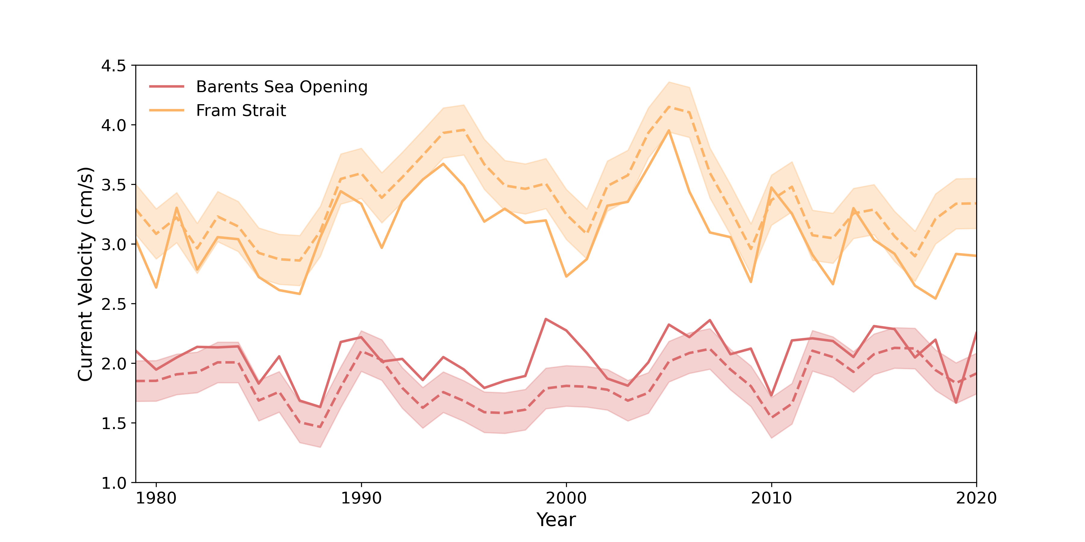
Fig. S3. Time series of annual mean oceanic currents in the upper 50 m entering the Arctic via the Barents Sea Opening (red) and Fram Strait (yellow) from 1979 to 2020. Solid lines indicate ORAS5 reanalysis estimates; dotted lines represent CESM1 LE ensemble means. Shaded areas denote ±1 standard deviation from the CESM1 LE.

Supplementary Figures
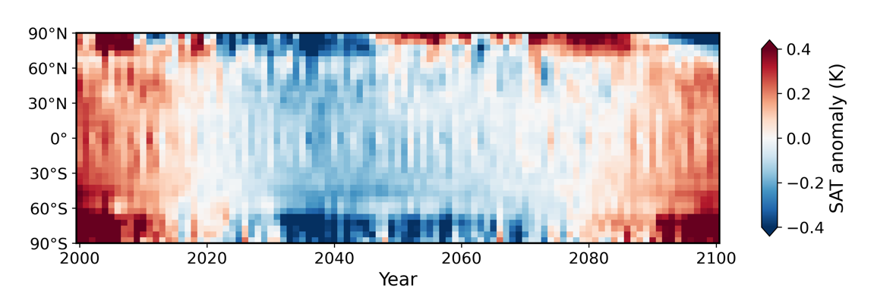
Fig. S4. Linearly detrended SAT anomalies (K) for each 5-degree latitude band for the 21st century, based on the GFDL-CM3 Large Ensemble means.

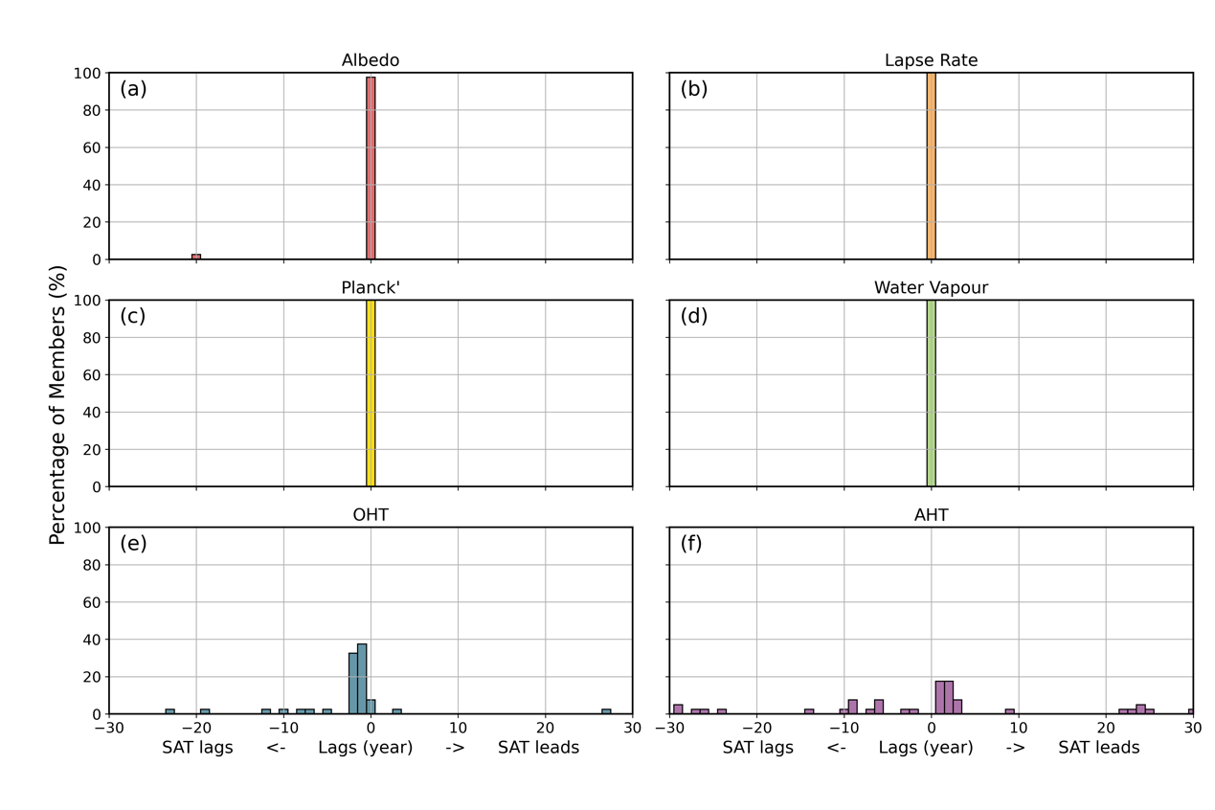
Fig. S5. Histograms of lead-lag correlation peaks between temperature contributions from individual processes—(a) albedo feedback, (b) lapse rate feedback, (c) Planck feedback, (d) water vapor feedback, (e) OHT, and (f) AHT—and multi-decadal Arctic surface temperature anomalies in CESM1 LE for the 21st century.

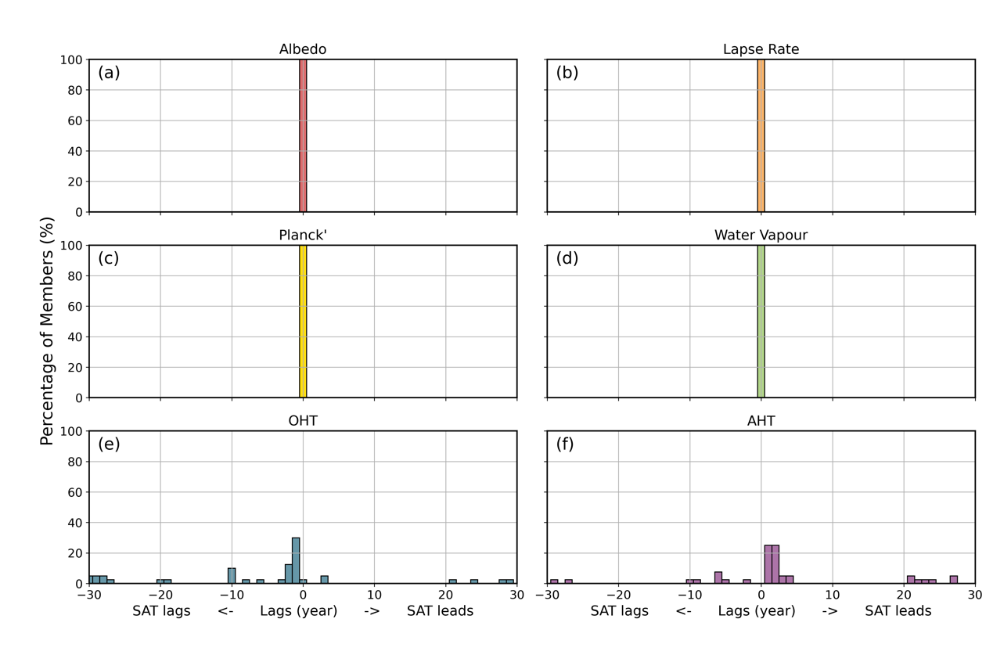
Fig. S6. Histograms of lead-lag correlation peaks between temperature contributions from individual processes—(a) albedo feedback, (b) lapse rate feedback, (c) Planck feedback, (d) water vapor feedback, (e) OHT, and (f) AHT—and Arctic surface temperature deviations in CESM1 LE for the 21st century.

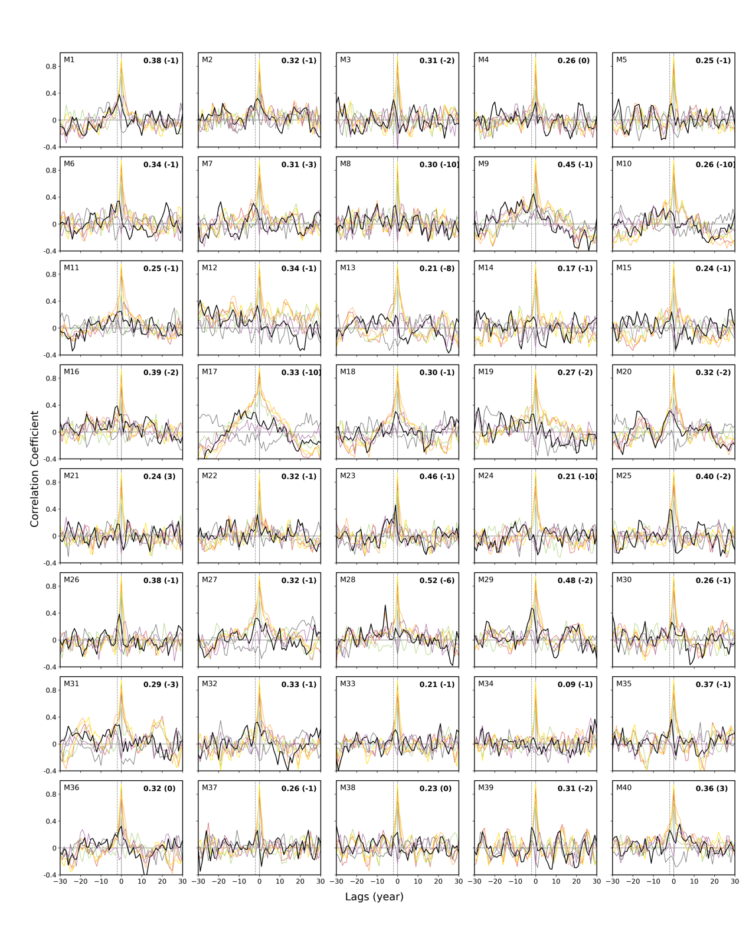
Fig. S7. Lead-lag correlations between the temperature contributions from each process and Arctic temperature deviations during the 21st century. The x-axis represents time in years, with negative (positive) values indicating that Arctic temperature deviations lag (lead) other time series. Processes include albedo (red), lapse rate (orange), Planck (yellow), water vapor (green), cloud (light blue) feedbacks, OHT (black), and AHT (purple), based on 40 members from CESM1 LE.

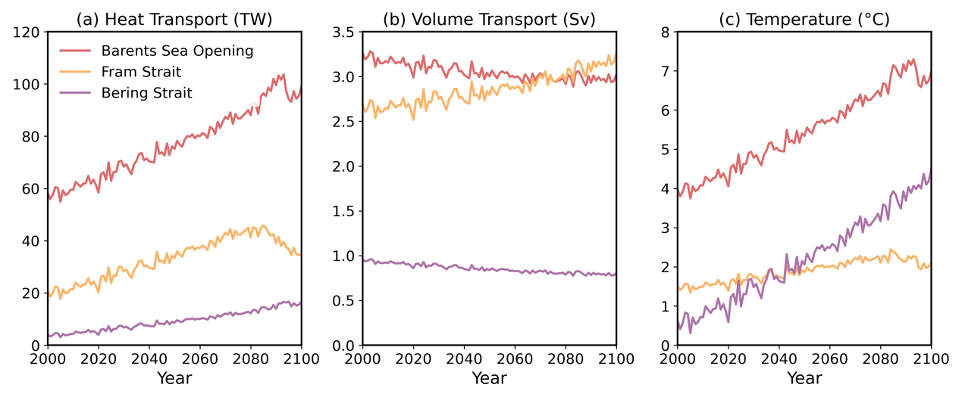
Fig. S8. Time series of annual mean (a) OHT, (b) volume transport, and (c) water mean temperature at the three gateways for CESM-LE. Barents Sea Opening in red, Bering Strait in purple, and Fram Strait in yellow.

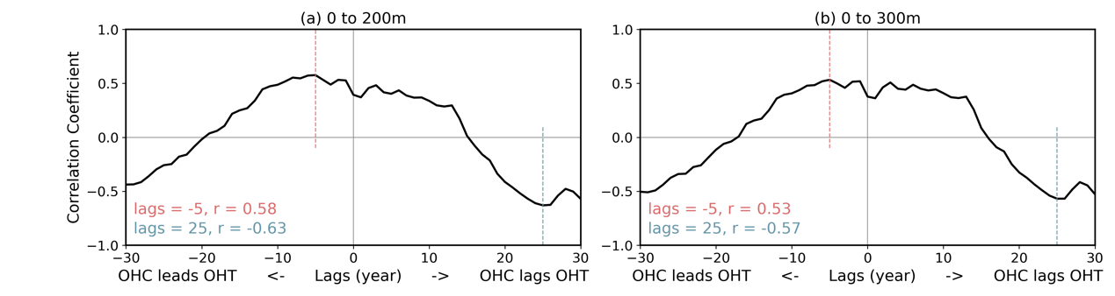
Fig. S9. Lead-lag correlations between (a) 0–200 m and (b) 0–300 m OHC anomalies in the subpolar North Atlantic and the temperature contributions from OHT to Arctic temperature anomalies in the 21st century. The x-axis represents time in years, with negative (positive) values indicating that subpolar North Atlantic OHC anomalies lead (lag) the OHT contributions.

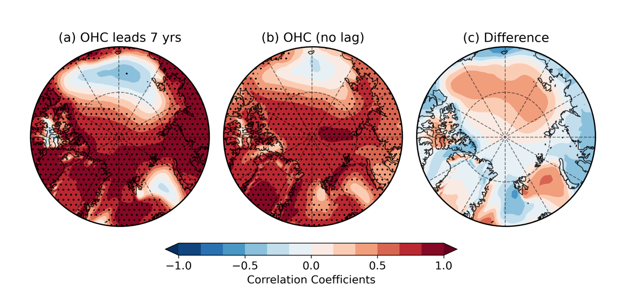
Fig. S10. Lead-lag regressions between upper (0–200 m) subpolar North Atlantic OHC and SAT anomalies on multi-decadal timescales, based on CESM1 LE means. Panels show OHC leading SAT anomalies by 7 years (a), with no lag (b), and the difference between (b) and (a). Stippling indicates regions above the 95% significance level.

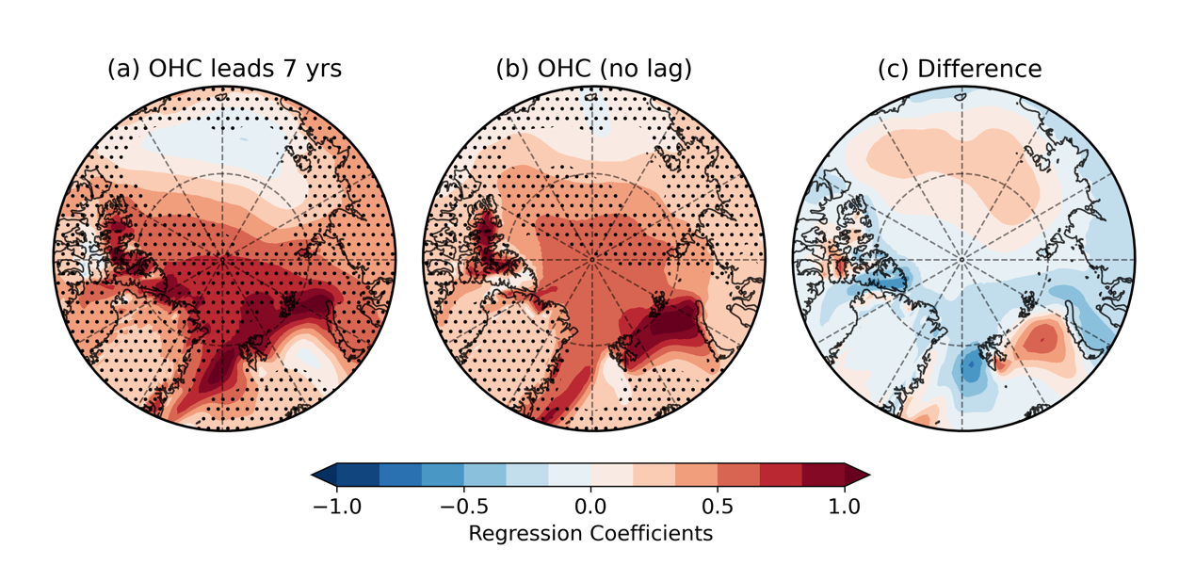
Fig. S11. Lead-lag correlations between upper (0–300 m) subpolar North Atlantic OHC and SAT anomalies on multi-decadal timescales, based on CESM1 LE means. Panels show OHC leading SAT anomalies by 7 years (a), with no lag (b), and the difference between (b) and (a). Stippling indicates regions above the 99.99% significance level.

References
England MR (2021) Are multi‐decadal fluctuations in Arctic and Antarctic surface temperatures a forced response to anthropogenic emissions or part of internal climate variability? Geophys Res Lett 48(6):e2020GL090631. https://doi.org/10.1029/2020GL090631
Trenberth KE, Caron JM (2001) Estimates of meridional atmosphere and ocean heat transports. J Clim 14:3433–3443
Yang H, Li Q, Wang K, Sun Y, Sun D (2015) Decomposing the meridional heat transport in the climate system. Clim Dyn 44(9–10):2751–2768
Held IM (2001) The partitioning of the poleward energy transport between the tropical ocean and atmosphere. J Atmos Sci 58:943–948
Ferrari R, Ferreira D (2011) What processes drive the ocean heat transport? Ocean Model 38:171–186. doi:10.1016/j.ocemod.2011.02.013
Skagseth Ø, Eldevik T, Årthun M, Asbjørnsen H, Lien VS, Smedsrud LH (2020) Reduced efficiency of the Barents Sea cooling machine. Nat Clim Change. https://doi.org/10.1038/s41558-020-0772-6
Beszczynska-Möller A, Fahrbach E, Schauer U, Hansen E (2012) Variability in Atlantic water temperature and transport at the entrance to the Arctic Ocean, 1997–2010. ICES Journal of Marine Science, 69(5):852–863, https://doi.org/10.1093/icesjms/fss056
Woodgate RA, Peralta Ferriz C (2021) Warming and freshening of the Pacific inflow to the arctic from 1990-2019 implying dramatic shoaling in Pacific winter water ventilation of the arctic water column. Geophys Res Lett 48(9): e2021GL092528. https://doi.org/10.1029/2021GL092528
Polyakov IV, Ingvaldsen RB, Pnyushkov AV, Bhatt US, Francis JA, Janout M et al (2023) Fluctuating Atlantic inflows modulate Arctic atlantification. Science 381(6661):972–979. https://doi.org/10.1126/science.adh5158

