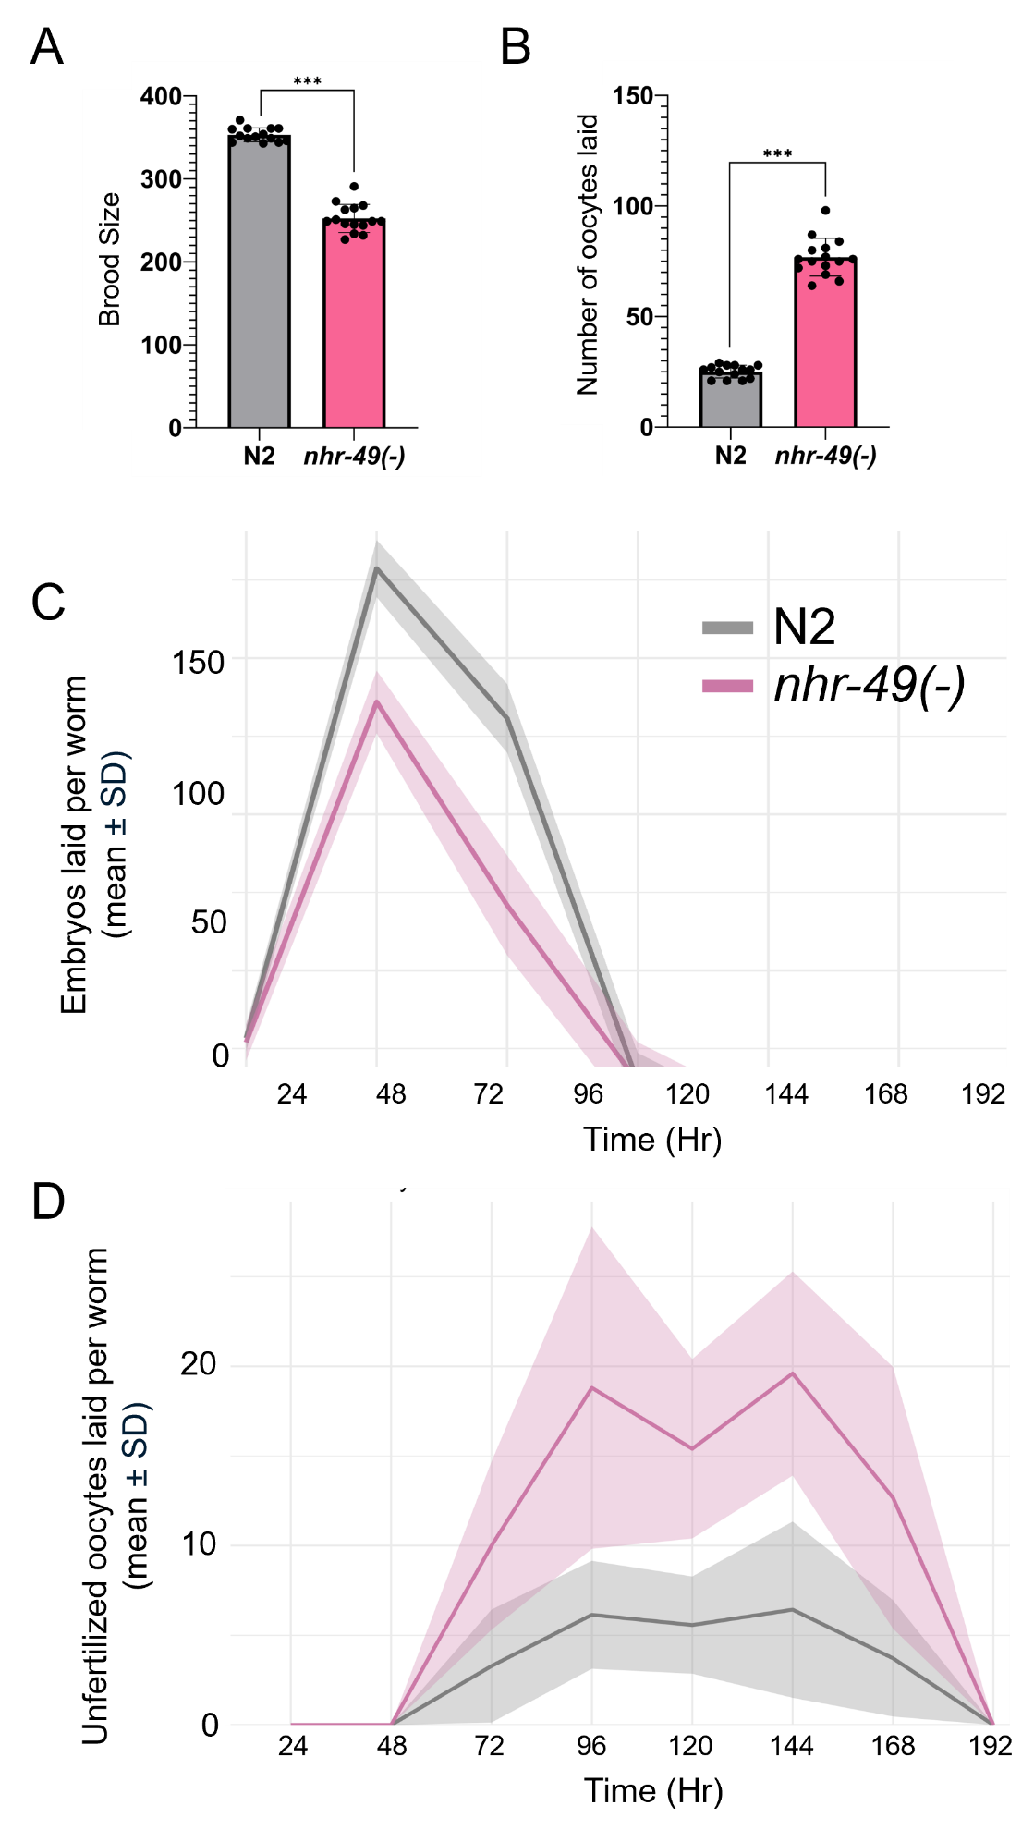
Figure S1. NHR-49 is required for the retention of unfertilized oocytes in reproductive and post-reproductive hermaphrodites. (A) Bar graphs showing mean brood size of N2 (wild-type) and nhr-49(gk405) mutants. (B) Bar graphs showing the mean number of unfertilized oocytes laid by N2 (wild-type) and nhr-49(gk405) mutants on day 6 of adulthood. (C-D) Line graphs showing the number of embryos (C) and unfertilized oocytes (mean±SD) (D) laid by N2 and nhr-49(gk405) worms throughout their reproductive span. Mean values were calculated based on the number of embryos or oocytes laid by at least 14 worms from two independent replicates. Embryo and unfertilized oocyte counts were recorded starting from the L4 larval stage.

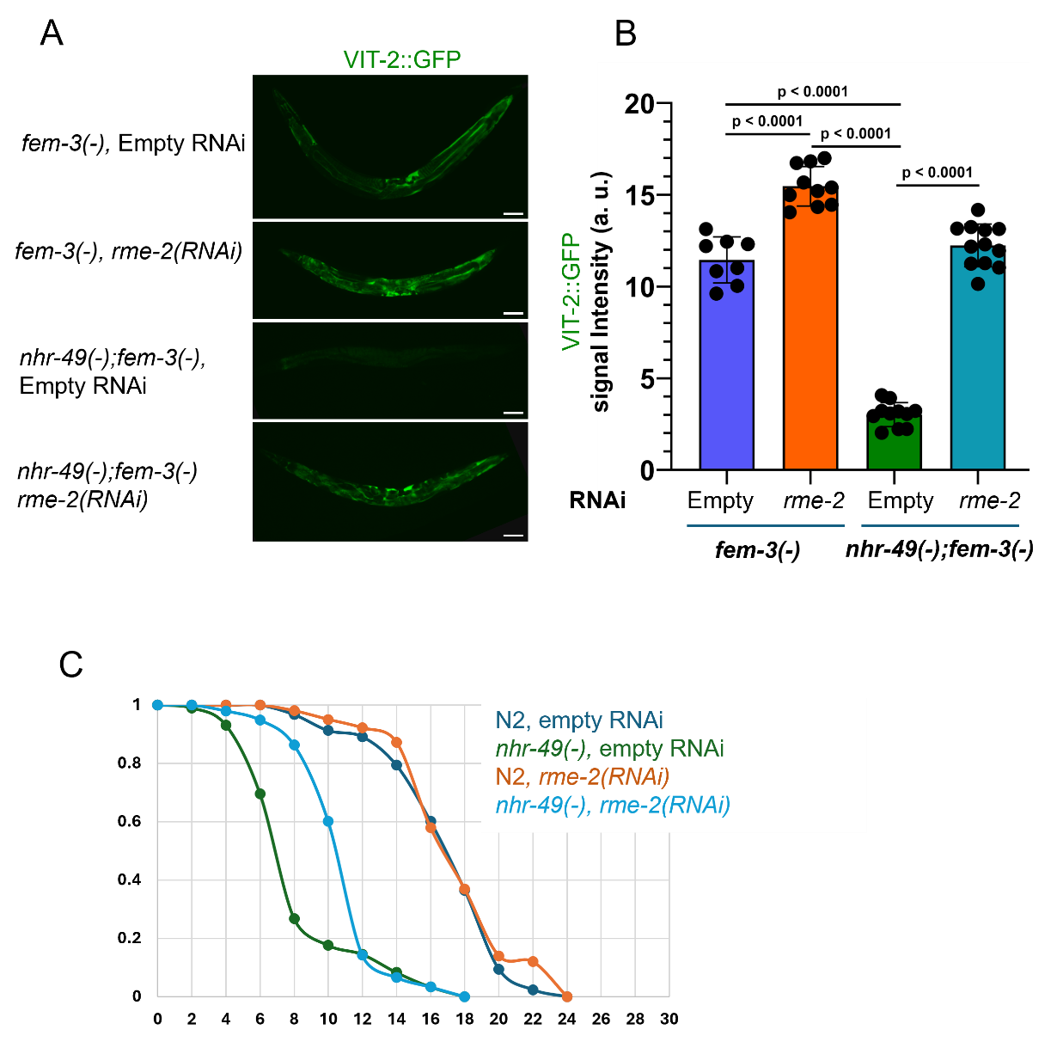
Figure S2. Lifespan shortening and fat loss in nhr-49 mutants are partially dependent on RME-2-mediated yolk transport into oocytes. (A) Representative images of VIT-2::GFP (YP170::GFP) ⁴²expression in fem-3(e1996);nhr-49(gk405) worms with and without rme-2 RNAi. (B) Bar graph showing fluorescence intensity in the indicated strains on day 1 of adulthood. Fluorescence intensity is shown as the mean intensity (N >10) for the indicated genotype with or without rme-2 RNAi. Two-tailed P values were computed using an unpaired t-test. (E) Survival curves for N2 (Wildtype), and nhr-49(gk405) mutants treated with control RNAi (EV) and rme-2 RNAi from one representative experiment. Quantitative data and Kaplan–Meier statistics are provided in table 2.
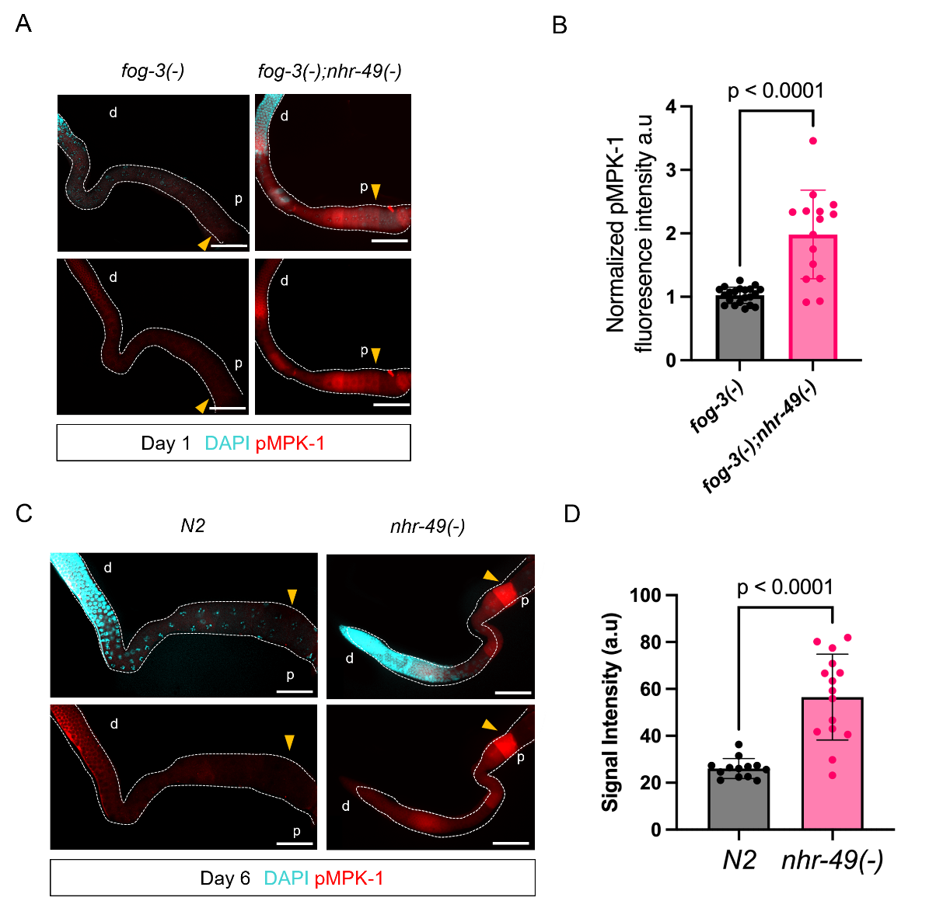
Figure S3. NHR-49 negatively regulates oocyte activation in the proximal gonad of feminized mutants. (A) Representative images of dpMPK-1 staining (red) of dissected gonads from day-1 adult feminized fog-3(q443) and fog-3(q443);nhr-49(gk405) double mutants. The position of the oocyte most proximal to the spermatheca in each image is marked by a yellow arrowhead. (B) Bar graph showing dpMPK-1 mean signal intensity in the proximal oocytes of the strains indicated in (A). Two-tailed p-values were computed using an unpaired t-test. (C) Representative images of dpMPK-1 staining of dissected gonads from post-reproductive N2 (wild-type) and nhr-49(gk405) mutants at day 6 adulthood. The position of the oocyte most proximal to the spermatheca in each image is marked by a yellow arrowhead. (D) Bar graph showing dpMPK-1 mean signal intensity in the proximal oocytes of the strains indicated in (C). Two-tailed p-value were computed using an unpaired t-test.
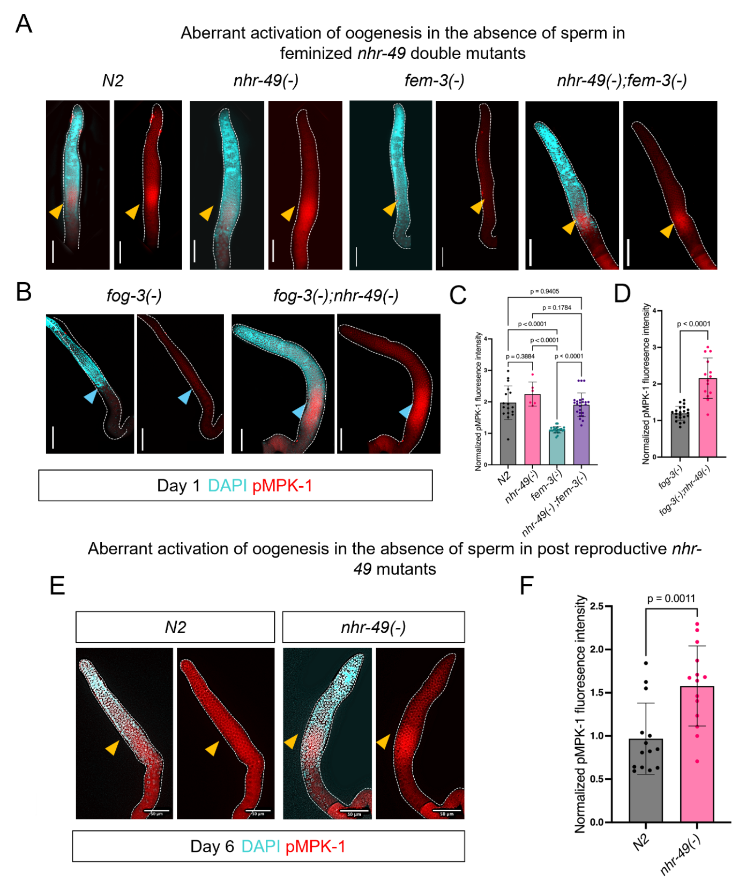
Figure S4. NHR-49 promotes germline MPK-1 activation in feminized and post-reproductive animals. (A-B) Representative images of dpMPK-1 staining (red) in dissected gonads from day 1 adult N2 (wild-type), nhr-49(gk405), fem-3(e1996), fem-3(e1996);nhr-49(gk405), fog-3(q443), and fog-3(q443);nhr-49(gk405). DAPI (cyan) marks germ cell nuclei. The position of the oocyte most proximal to the spermatheca in each image is marked by a yellow or arrowhead. (C-D) Bar graph showing dpMPK-1 signal intensity in the proximal oocytes of the indicated strains. Statistical comparisons were performed using one-way analysis of variance (ANOVA) followed by Tukey’s multiple comparisons test. More than 45 worms from 2 independent replicates per genotype were analyzed. (E) Representative images of dpMPK-1 staining in dissected gonads from day 6 N2 and nhr-49(gk405) worms. Scale bars = 50 µm. (F) Bar graph showing dpMPK-1 signal intensity in the proximal oocytes of day 6 post-reproductive adults of the indicated strains. Statistical comparisons were performed using one-way analysis of variance (ANOVA) followed by Tukey’s multiple comparisons test. More than 45 worms from 2 independent replicates per genotype were analyzed. Panel (D) and (F) were analyzed using unpaired two-tailed t-tests. Bars represent mean ± SD.
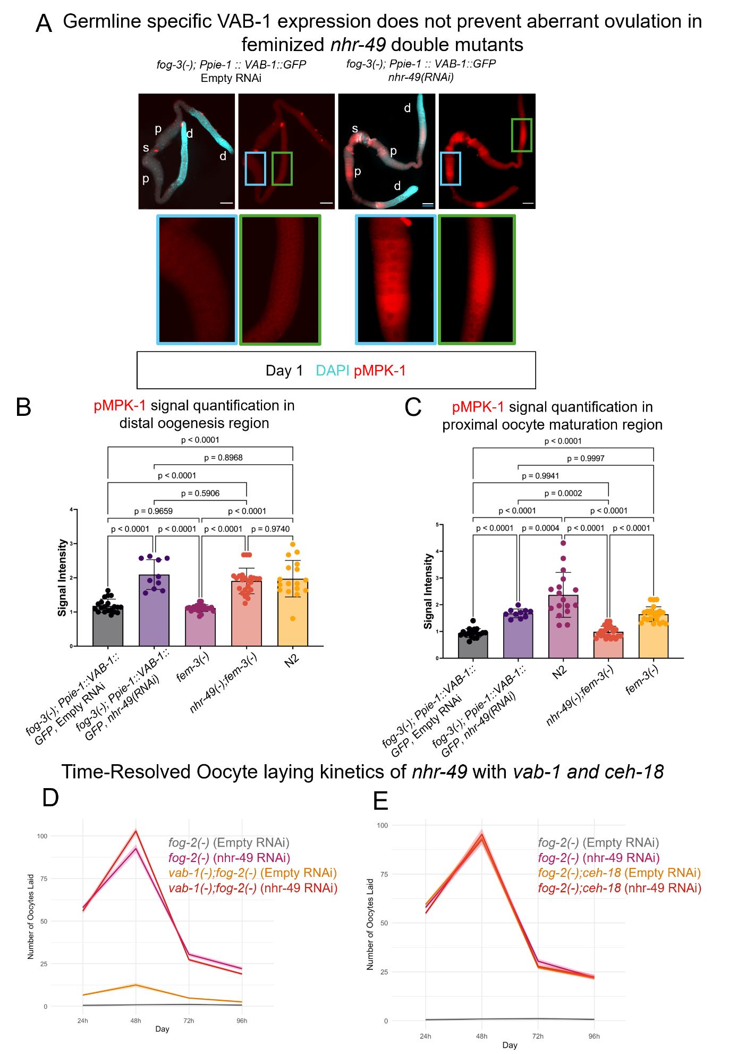Figure S5. NHR-49 likely regulates oocyte activation primarily through somatic tissues. (A-B) Bar graphs showing mean dpMPK-1 signal intensities from immunostained gonads of fog-3(q443);Ppie-1::VAB-1::GFP worms, in which vab-1 is driven by a germline-specific promoter pie-1. Quantification of signal intensities in the distal oogenesis region (A) and in the proximal oocyte maturation region (B). These worms still showed aberrant dpMPK-1 expression upon nhr-49 RNAi in both distal and proximal regions. Comparisons were statistically tested by one-way analysis of variance (ANOVA) followed by multiple comparisons with Tukey's correction, based on more than 45 worms from two independent replicates per genotype. (C) Representative images of dpMPK-1 staining (red) in dissected gonads of fog-3(q443);Ppie-1::VAB-1::GFP animals. Animals were treated with control (EV) or nhr-49 RNAi. DAPI staining (blue) was used to stain germ cell nuclei. Blue box indicates proximal maturation region, and the green box indicates distal oogenesis region. (D) Line graphs showing the number of unfertilized oocytes (mean±SD) laid by fog-2(q71), vab-1(dx31);fog-2(q71) (E) fog-2(q71), fog-2(q71);ceh-18(mg57) animals treated with control (EV) or nhr-49 RNAi. Mean values were calculated based on the number of embryos or oocytes laid by at least 15 worms from two independent replicates. Embryo and unfertilized oocyte counts were recorded starting from the L4 larval stage.
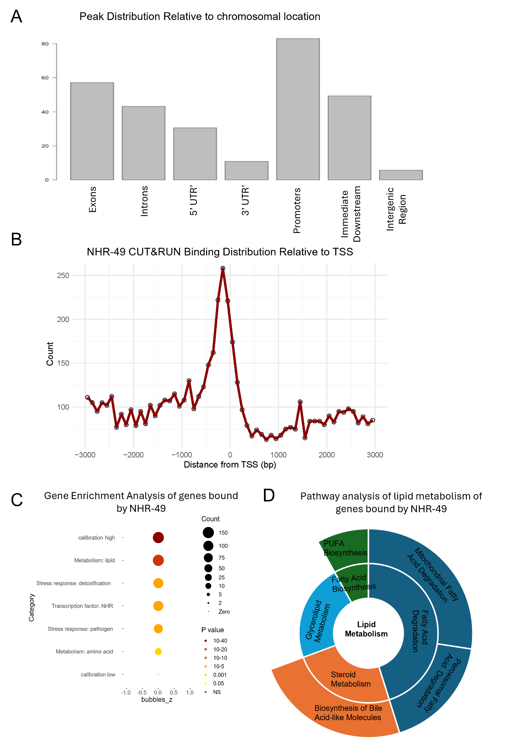
Figure S6. Genome-wide binding profile of NHR-49::HA revealed by CUT&RUN. (A) Distribution of NHR-49 binding peaks across genomic features. The majority of NHR-49 binding is localized to promoter regions. (B) NHR-49 binding peak distribution relative to transcription start sites (TSS). The majority of NHR-49 binding peaks are located within 1kb upstream of the TSS. (C) WormCat gene set enrichment analysis of NHR-49 binding targets. Dot size represents the number of genes; color indicates adjusted p-value. (D) KEGG pathway analysis of lipid metabolism genes associated with NHR-49 CUT&RUN binding peaks. Sunburst plot shows enriched lipid metabolic pathways, with the inner ring representing broader categories (e.g., fatty acid metabolism, steroid metabolism), and the outer ring representing more specific sub-pathways.

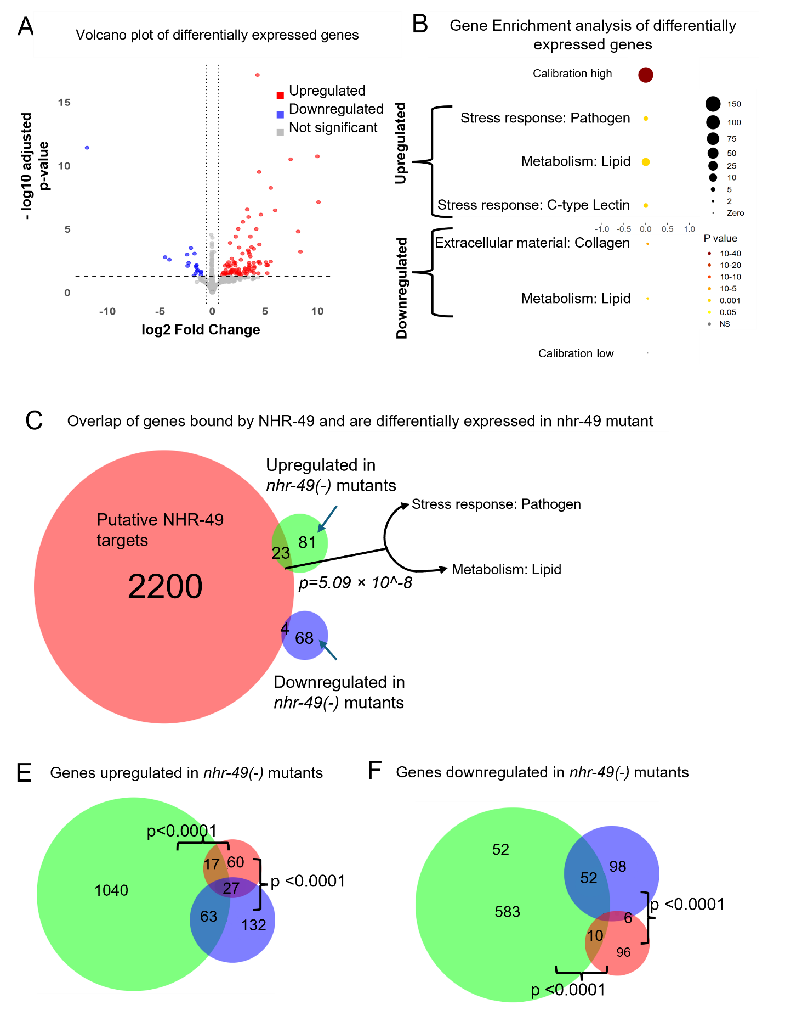
Fig S7. NHR-49 binding targets overlap with genes differentially expressed in nhr-49 mutants and across published whole-worm transcriptomes.
(A) Volcano plot showing differential gene expression in nhr-49(gk405) mutants compared to N2 (wild-type) animals, based on whole-worm RNA-seq analyzed using DESeq2. Significantly upregulated (red) and downregulated (blue) genes are indicated (adjusted p < 0.05, log₂FC > 0.58). (B) Gene set enrichment analysis of genes upregulated (top) and downregulated (bottom) in nhr-49(gk405) mutants. Dot size represents the number of genes; color indicates adjusted p-value. (C) Venn diagram showing overlap between NHR-49 CUT&RUN binding targets (red) and genes upregulated (green) or downregulated (blue) in nhr-49(gk405) mutants. p-value calculated using Fisher’s exact test. (D) Gene set enrichment analysis of the genes overlapping between NHR-49 CUT&RUN binding targets and differentially expressed gene in nhr-49(gk405) mutants. (E, F) Venn diagrams comparing genes upregulated (E) or downregulated (F) in this study with previously published whole-worm transcriptomes from Ratnappan et al³³ (2014) and Doering et al¹⁹ (2021).

