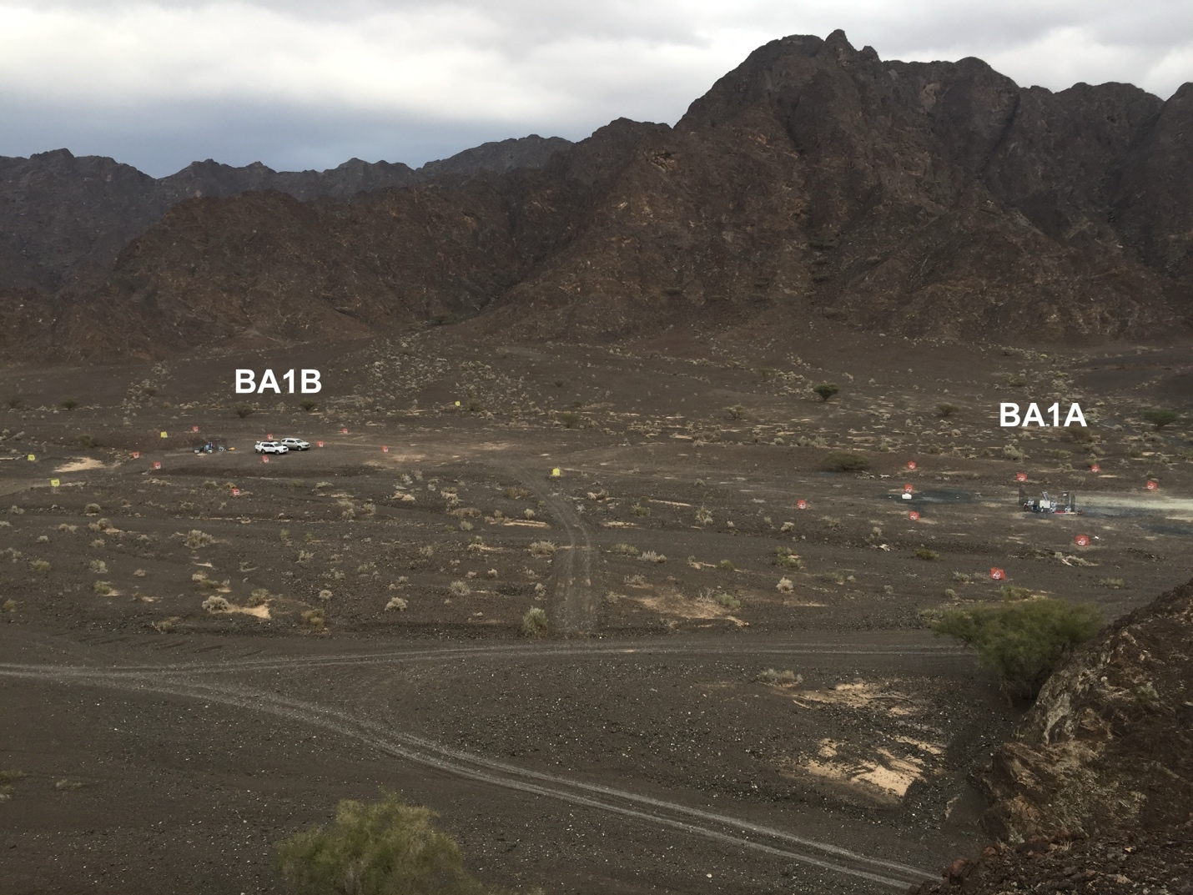
Fig. S1. Photo of the study site showing the location of boreholes BA1A and BA1B and the geophones in Wadi Lawayni. The surface expressions of the PASSCAL BIHO geophones (case and solar panel) are surrounded by orange or yellow plastic fencing to prevent interference. Chain link fences, installed for protection, are visible around both boreholes.

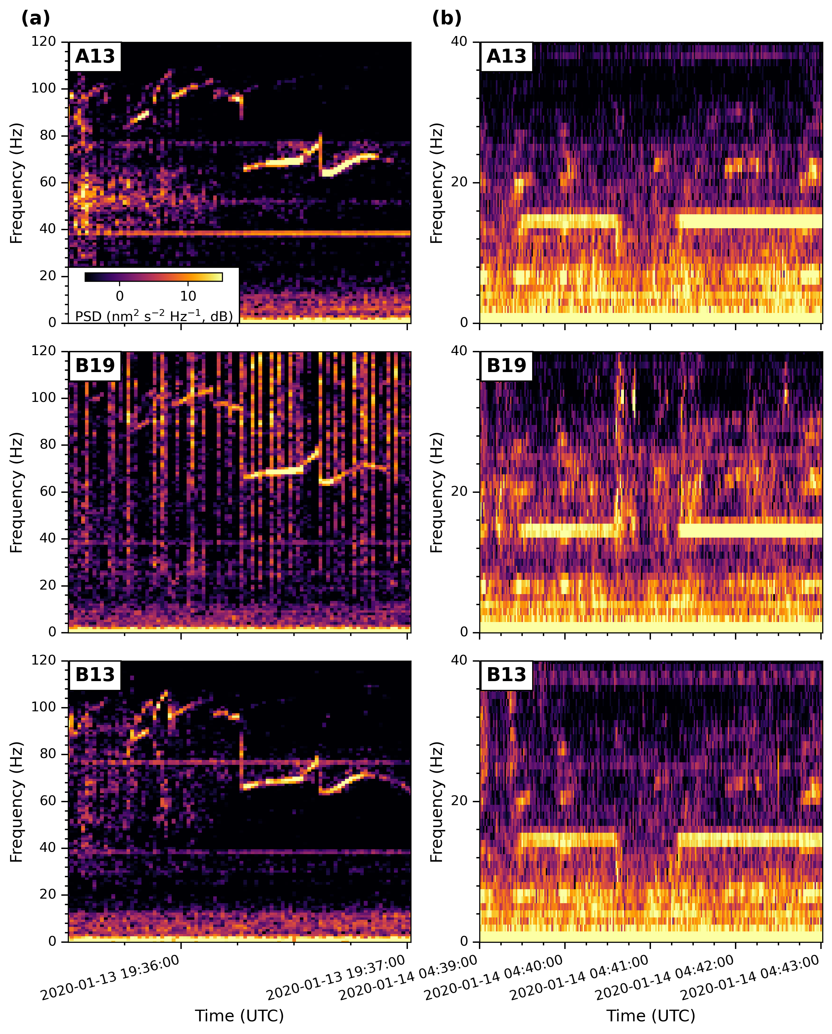
Fig. S2. Transient resonances are ubiquitous in the geophone data. Here we show examples of (a) a resonance with strong frequency gliding and (b) one without, recorded on geophones A13, B19, and B13 (Fig. 1a). The same color scale is used for all panels.

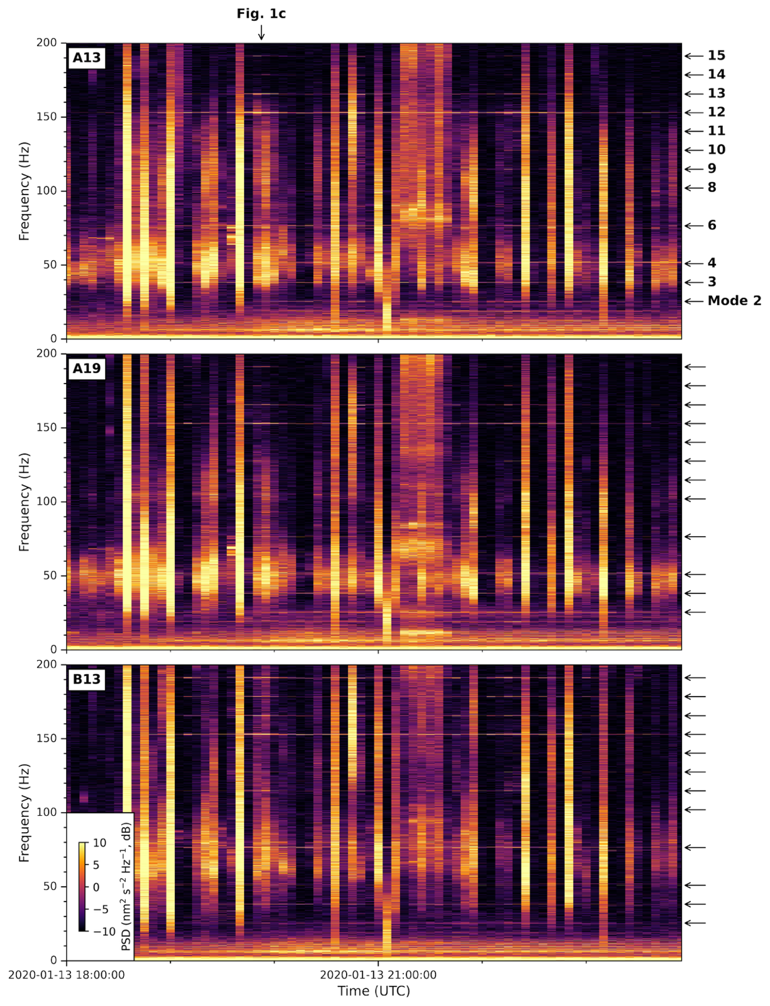
Fig. S3. Spectrograms of A13, A19, and B03 for UTC 18:00:00–24:00:00 of Jan 13, 2020. Arrows mark the frequencies of the harmonic modes and the time window shown in Fig. 1c.

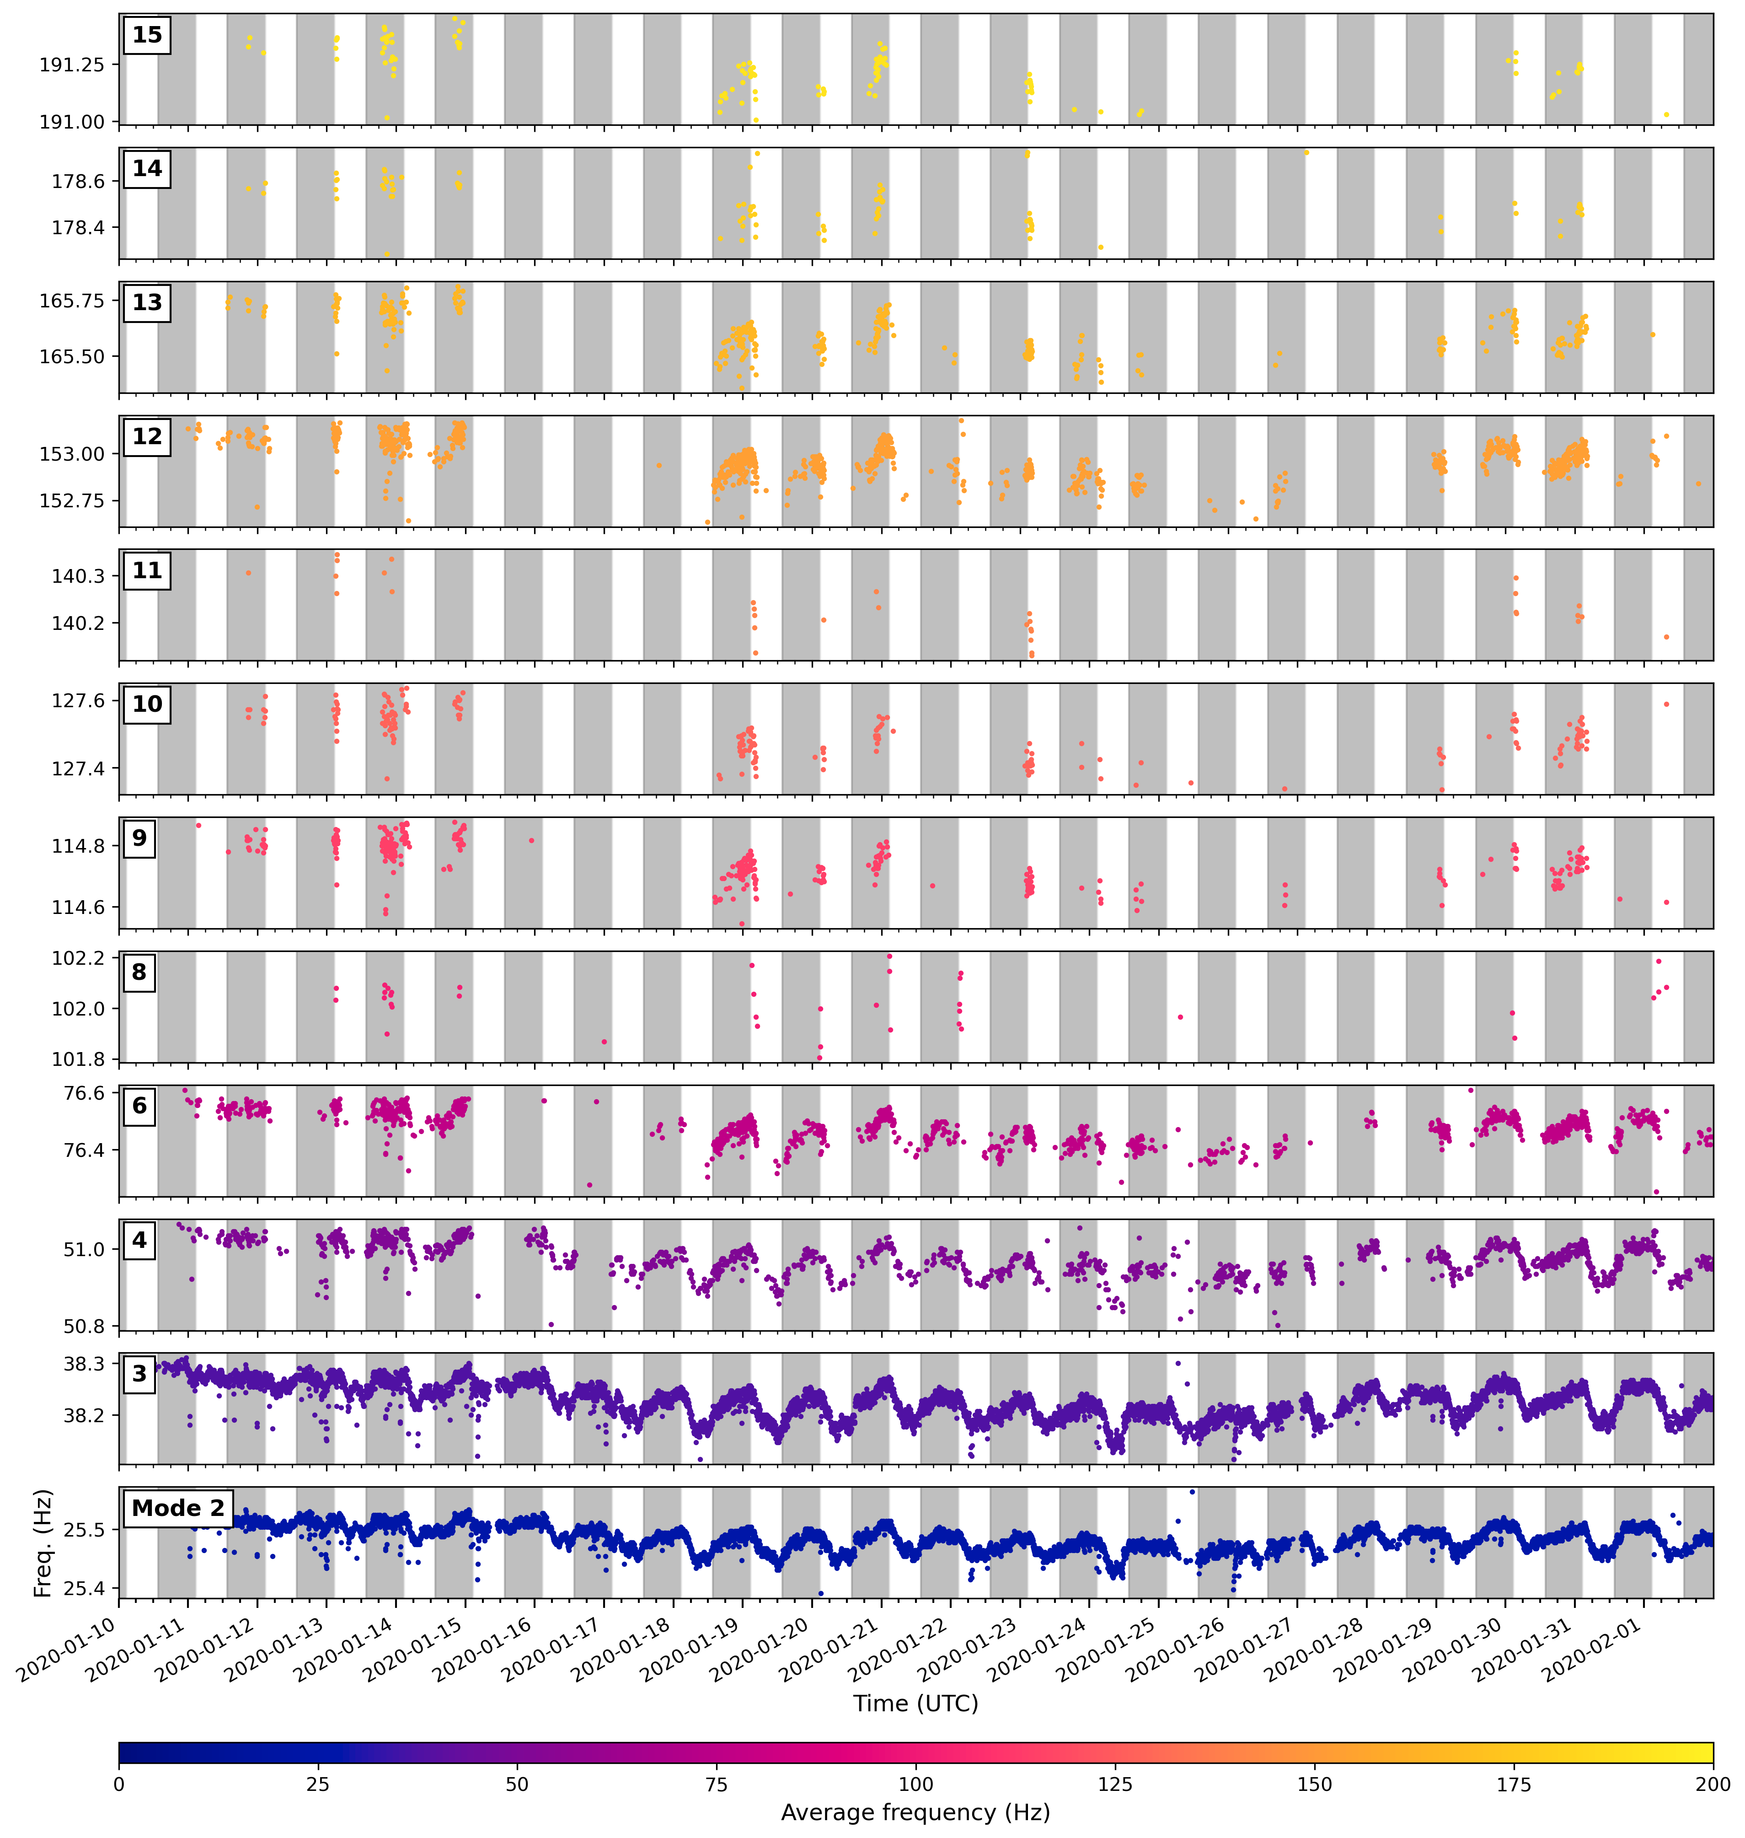Fig. S4. Frequency as a function of time for all modes detected from geophone spectrograms. Each dot represents a detection of the mode (Materials and Methods) and is colored by the average frequency of the mode. White and gray stripes indicate daytime and nighttime intervals, respectively.

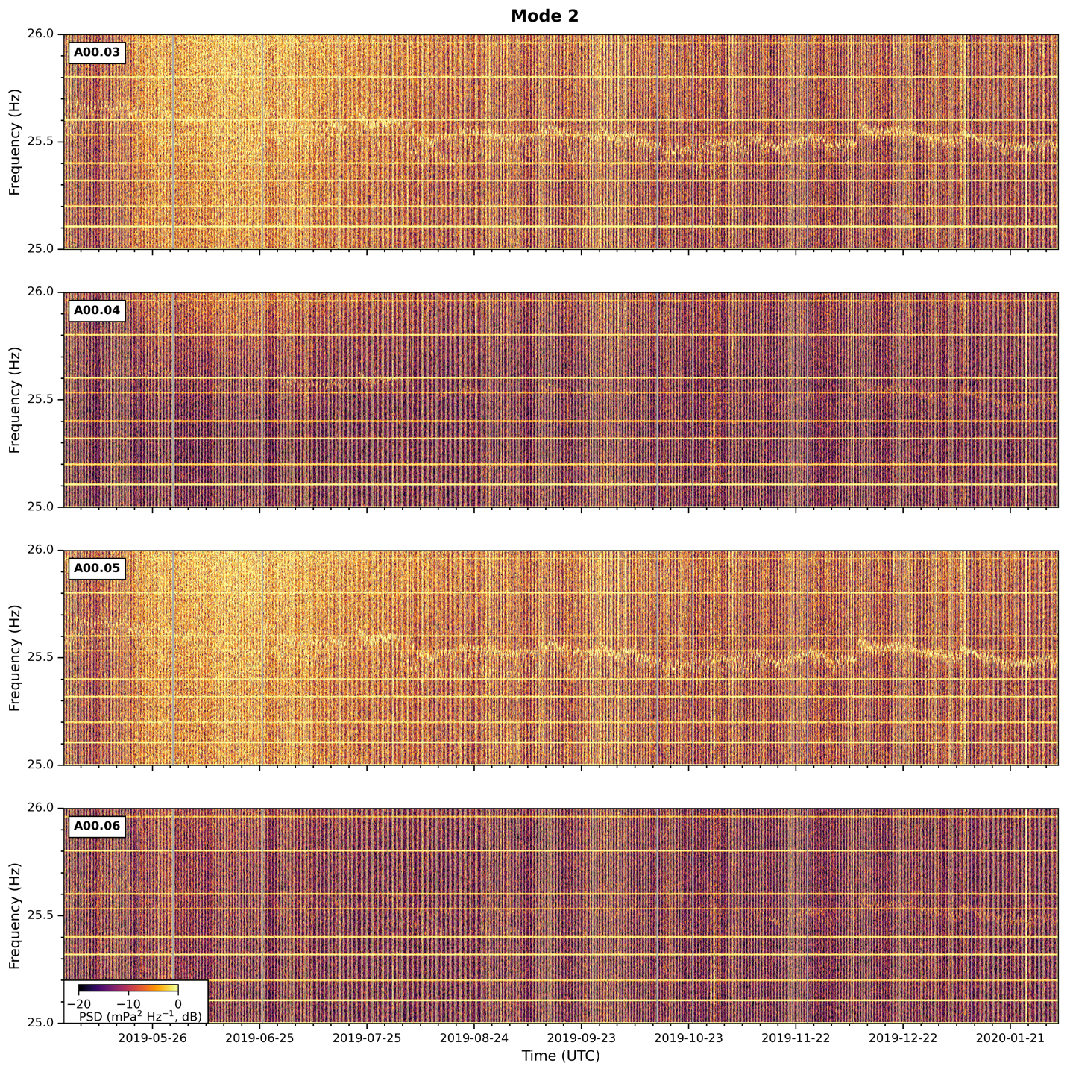Fig. S5. Nine-month spectrograms of Mode 2 on hydrophones A00.03–06 in BA1A. The color scale is adjusted from Fig. 2 to enhance the signal visibility on Hydrophones 04 and 06, where the signal-to-noise ratio is low.

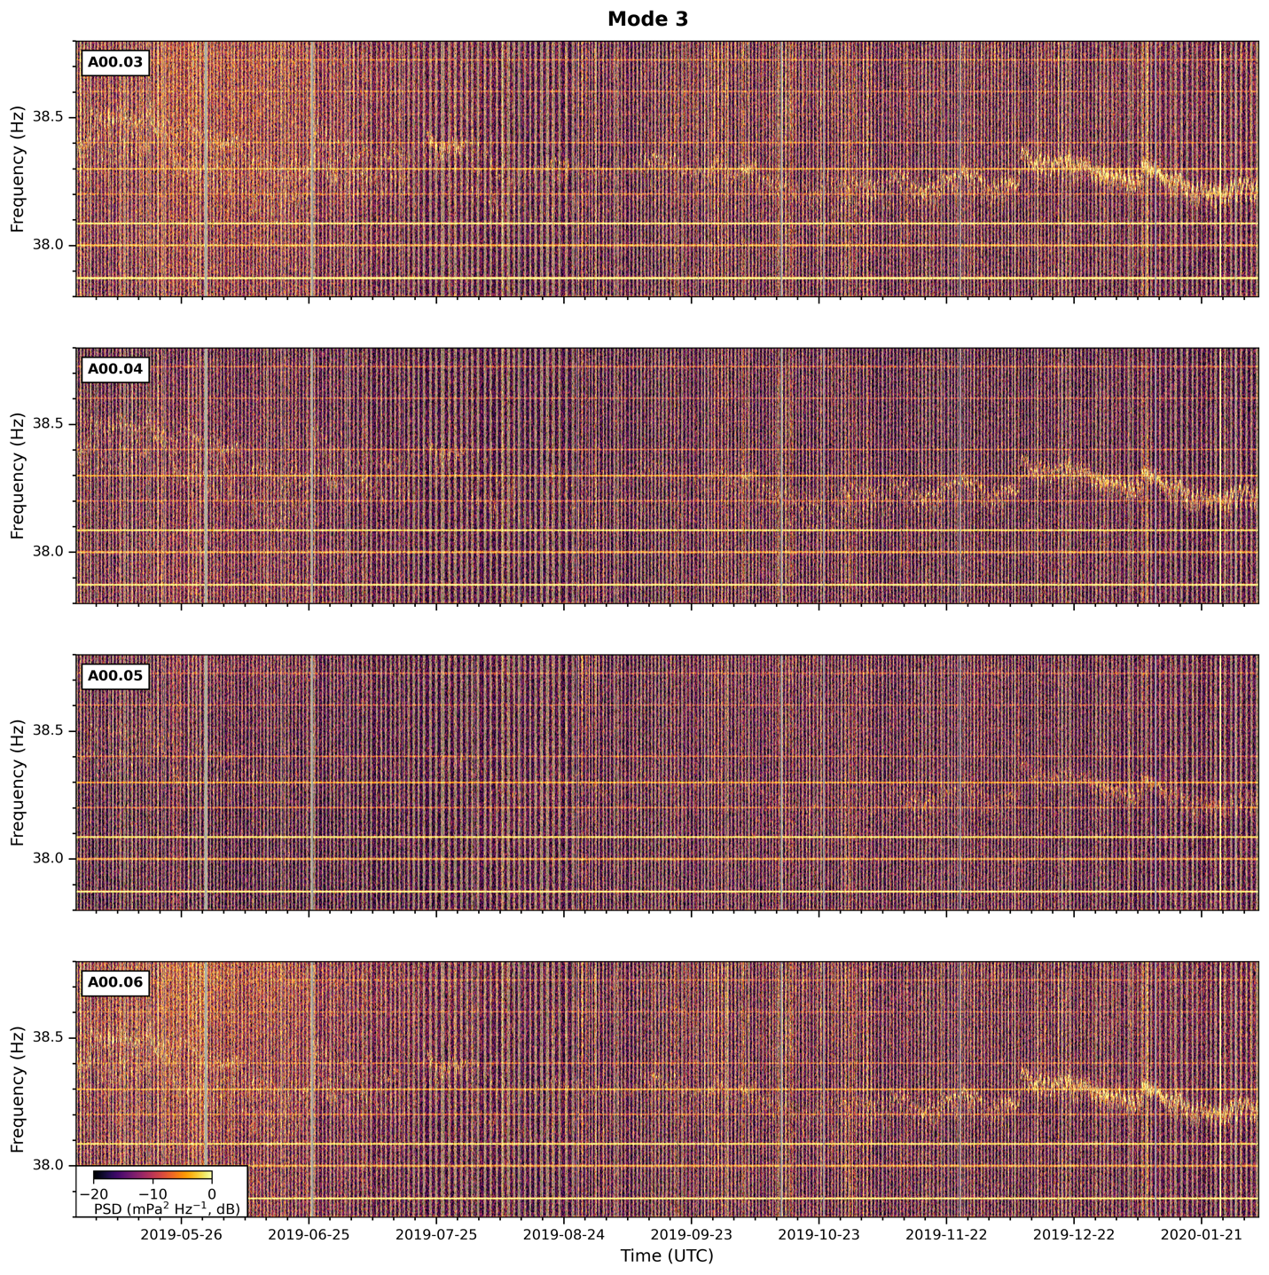Fig. S6. Same as Fig. S4, but for Mode 3.

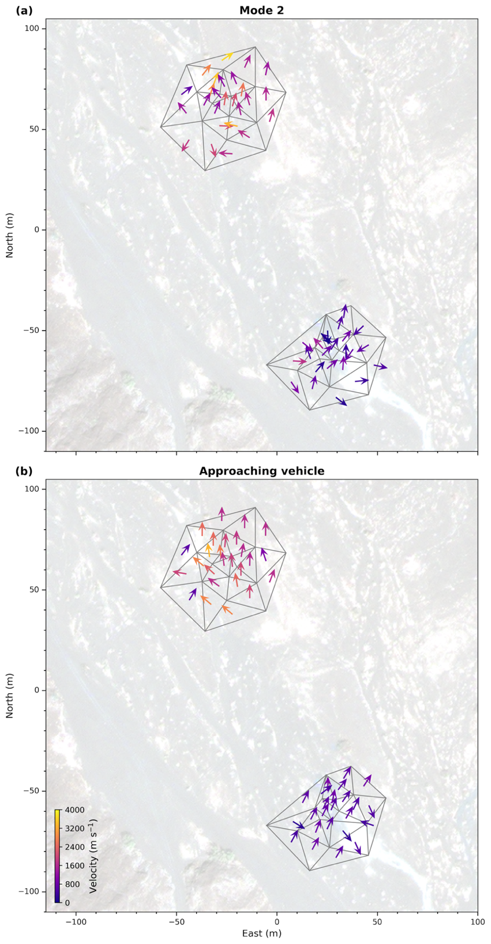
Fig. S7. Time-averaged propagation vectors color-coded by apparent velocity of (a) the signals from Mode 2 of the tremors (same as in Fig. 3a) and (b) a vehicle approaching from the south. Only the horizontal component with the smaller variance is plotted (Materials and Methods).

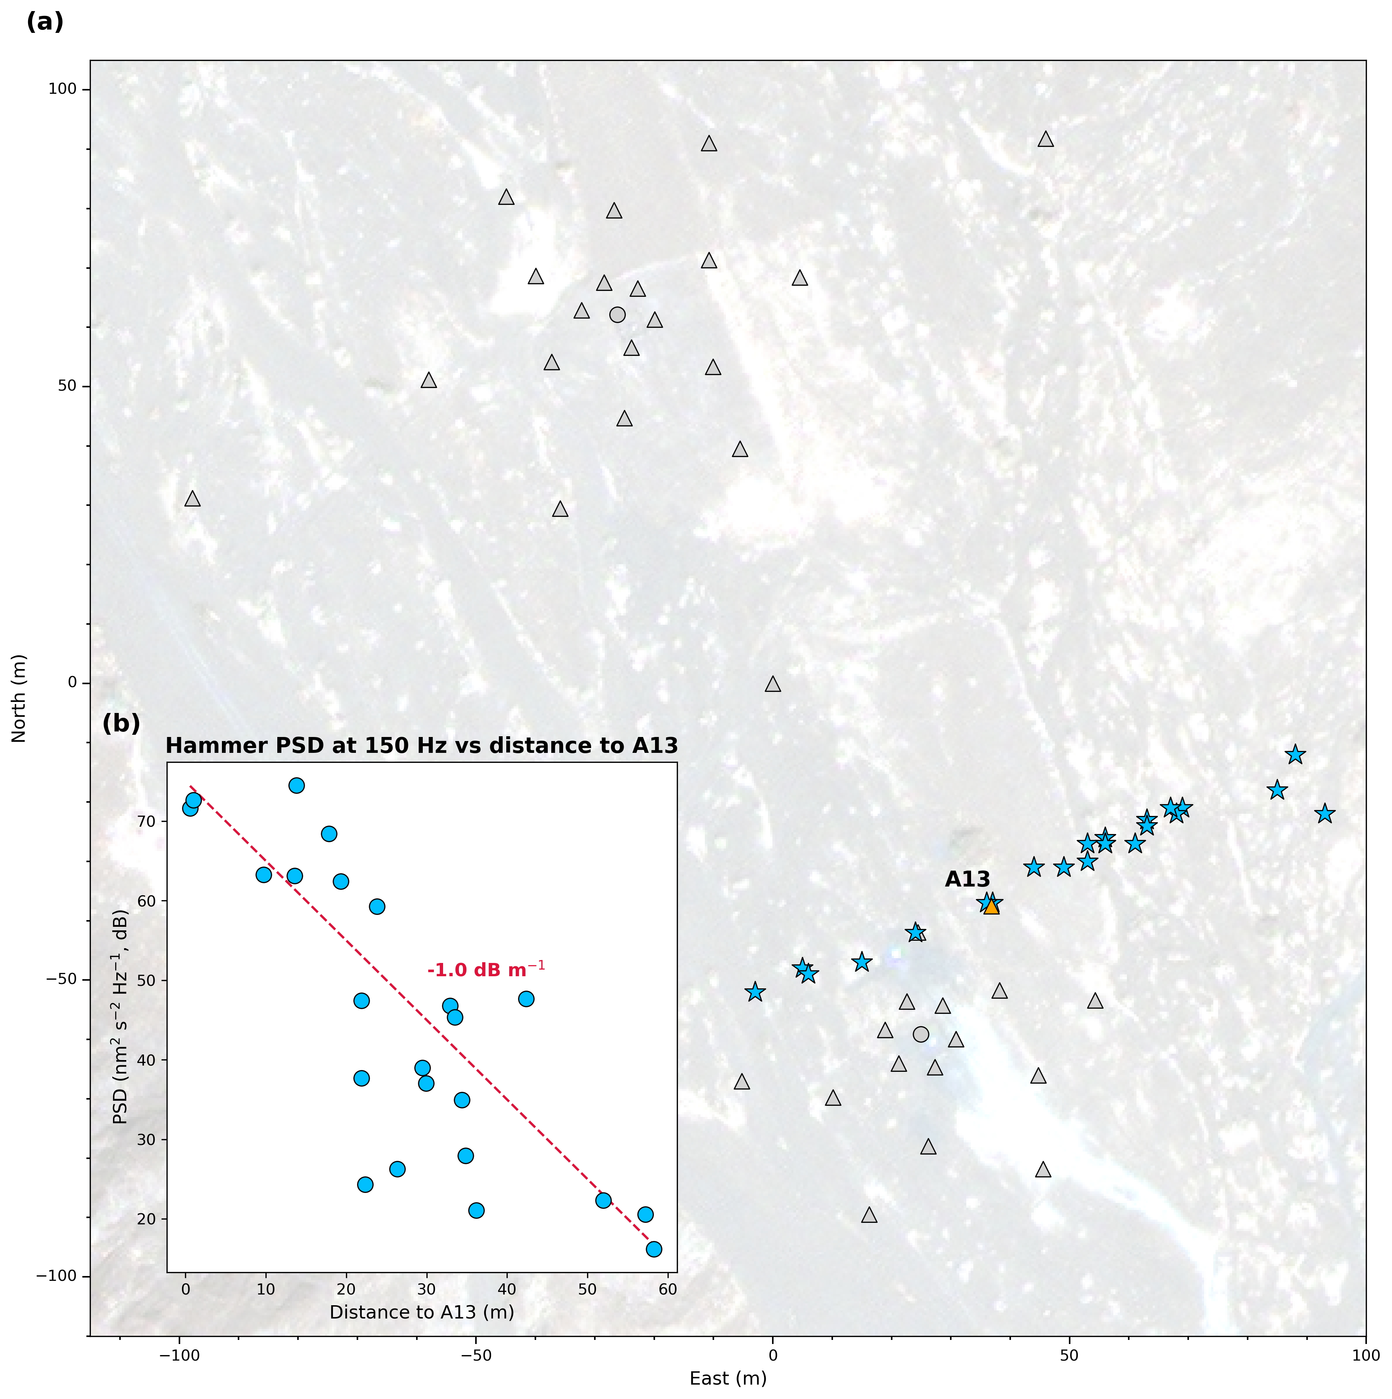Fig. S8. Decay rate of seismic energy at 150 Hz revealed by hammer-shot signals recorded on A13. (a) Locations of A13 (orange triangle) and hammer shots (stars). (b) PSD of the hammer-shot signals at 150 Hz as a function of distance to A13.

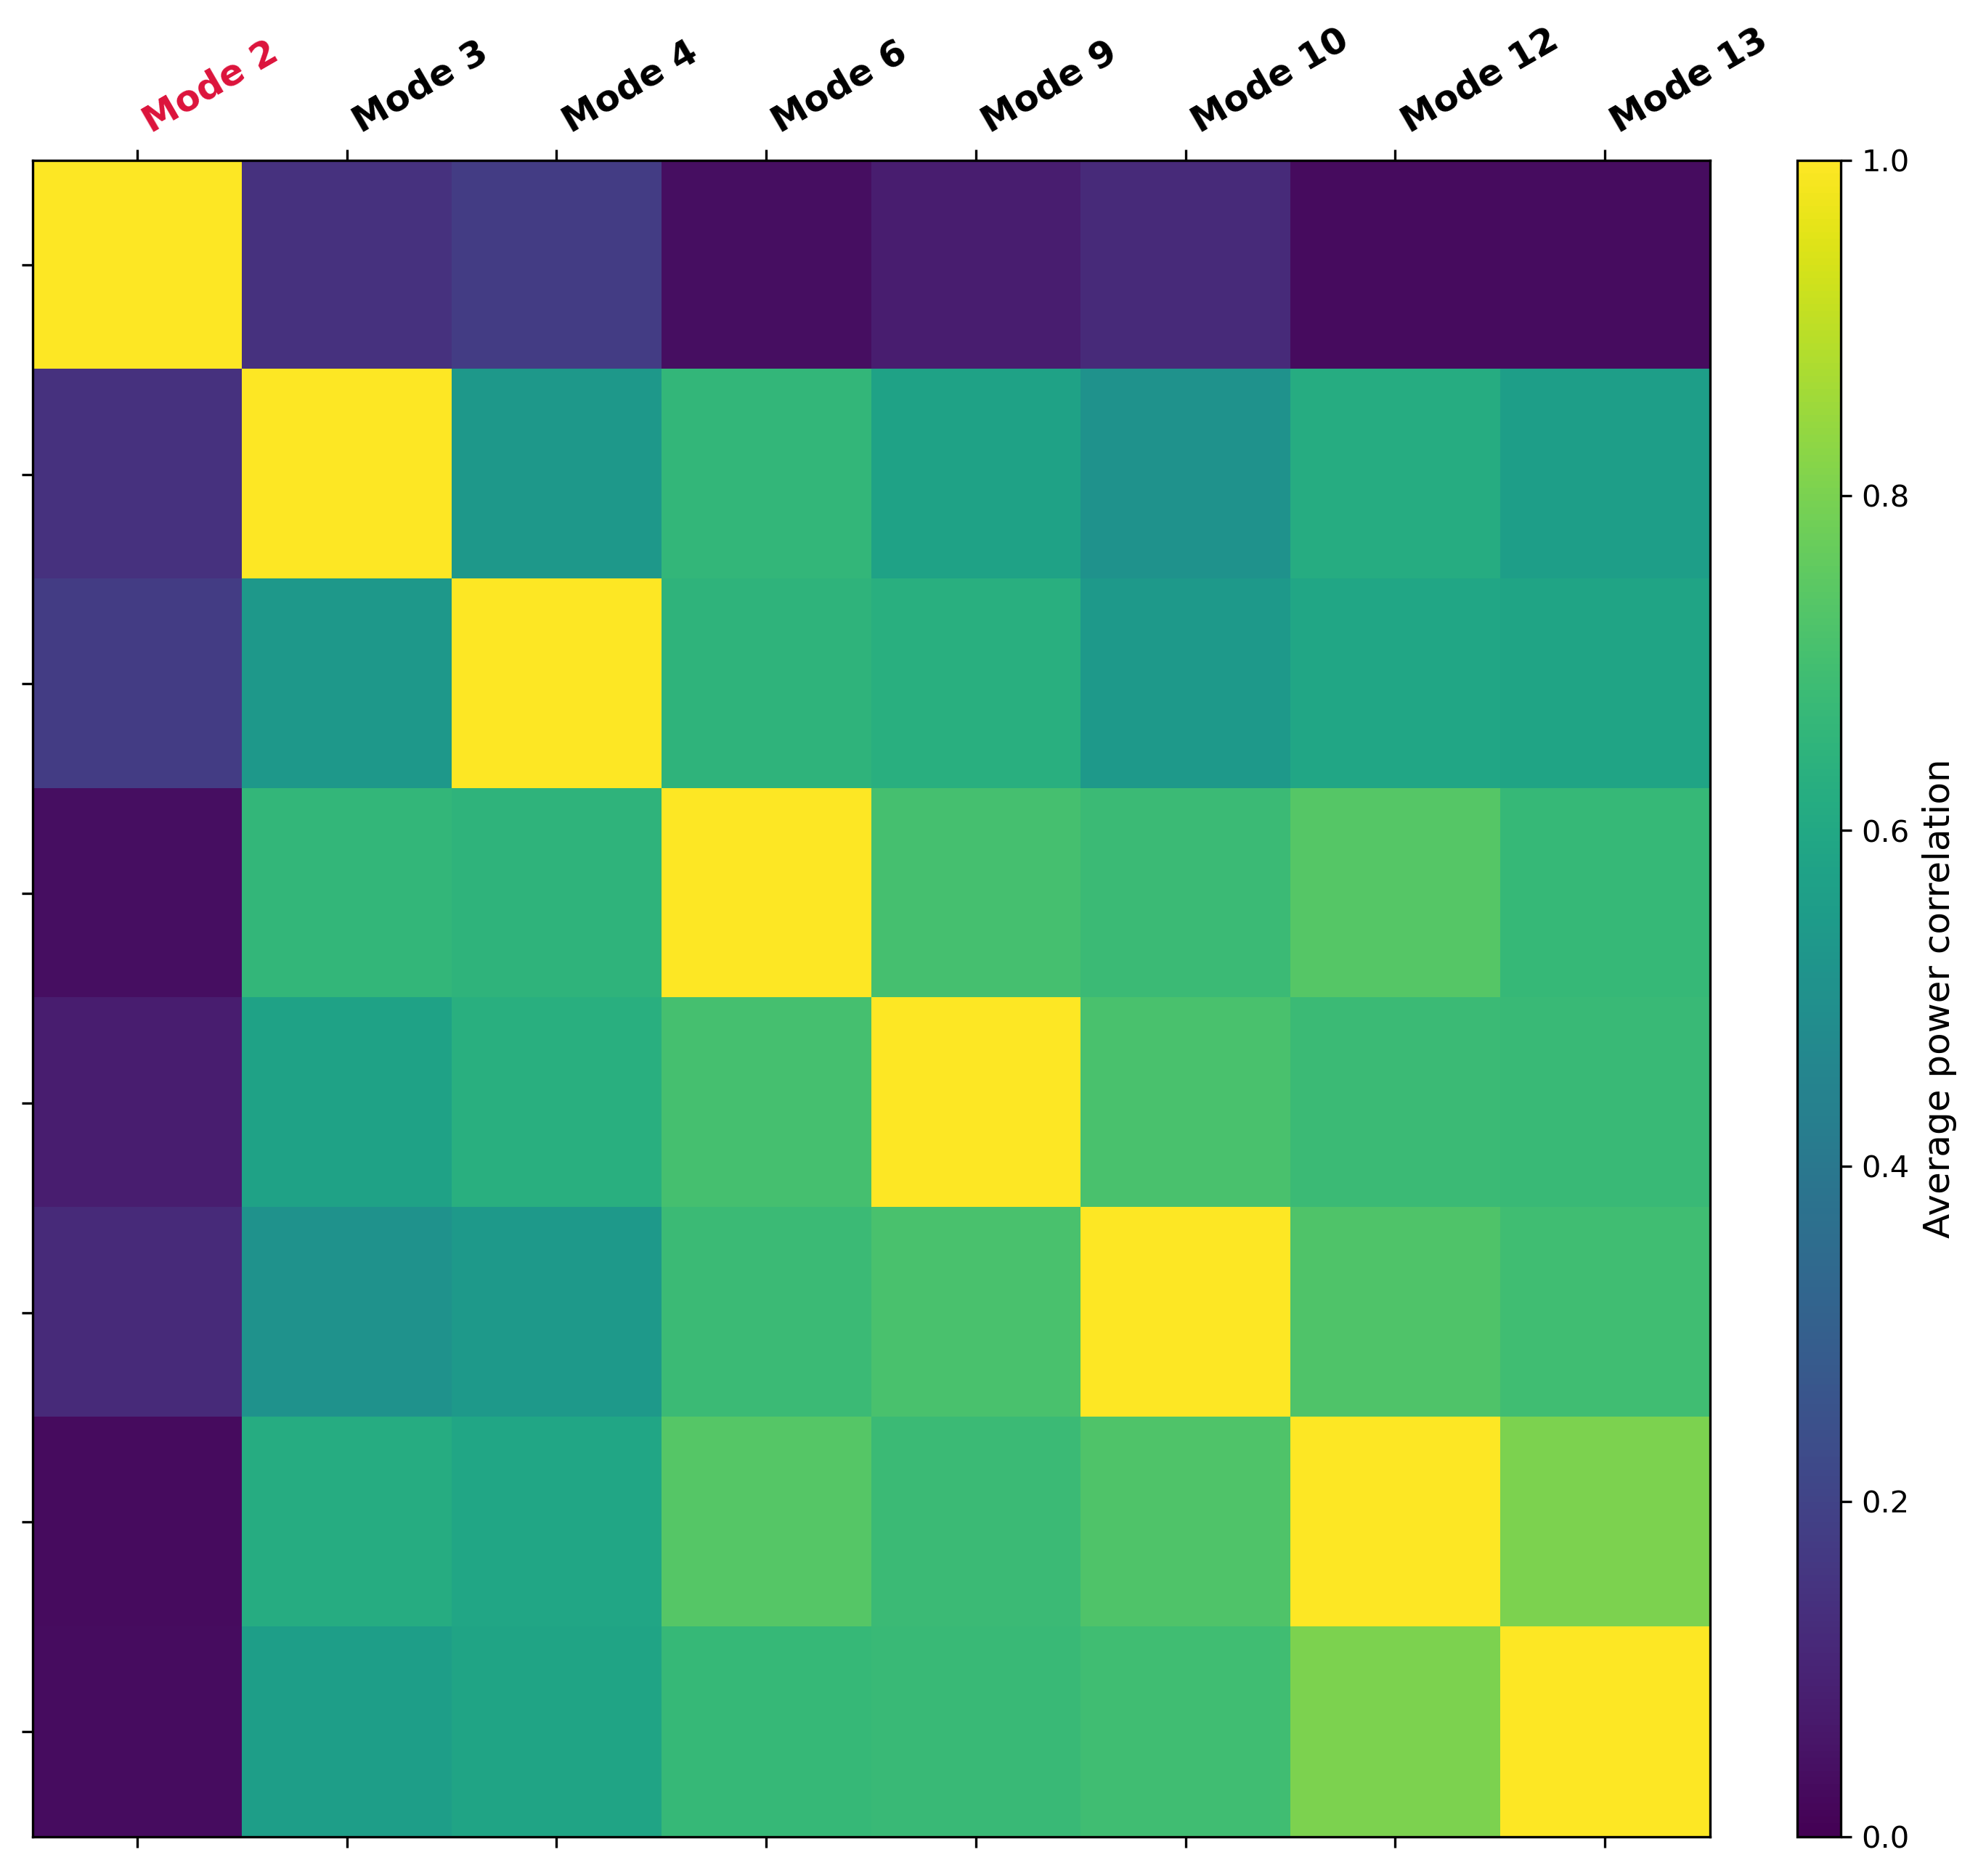
Fig. S9. Power correlation matrix (Materials and Methods) of Modes 2, 3, 4, 6, 9, 10, 12, and 13 averaged over all geophones.

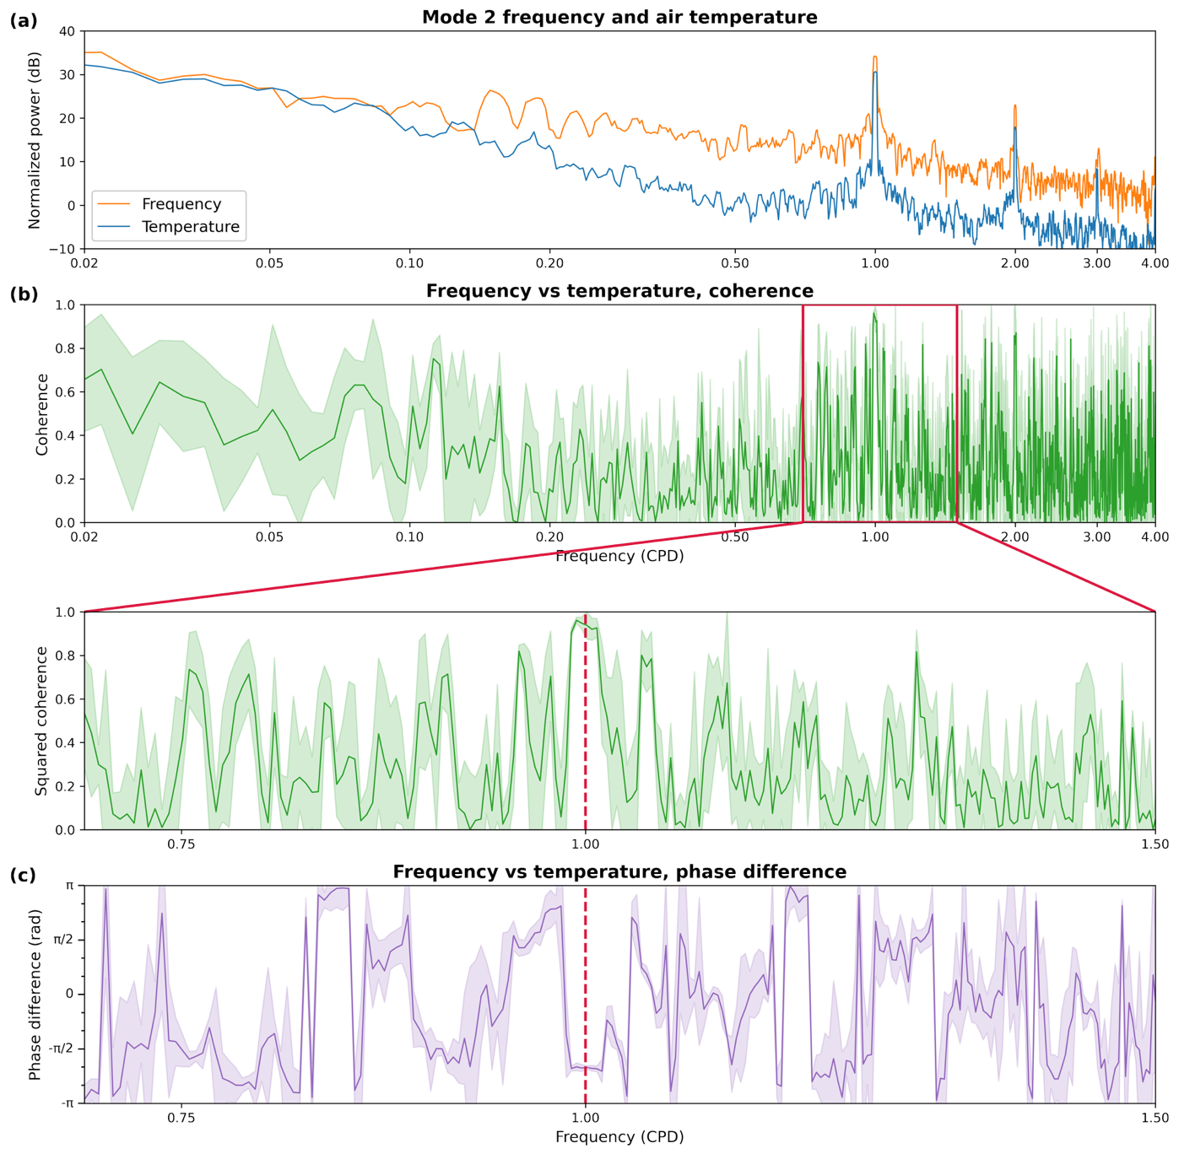Fig. S10. Cross-spectral analysis of Mode-2 frequency and air temperature. CPD: cycle-per-day. (a) Power spectral densities (Materials and Methods) of the frequency of Mode 2 (orange) and temperature (blue). (b) and (c) Cross-spectral squared coherence (green) and phase difference (purple) between the frequency of Mode 2 and temperature, with the bottom two panels highlighting the range around 1 CPD. A positive phase difference indicates frequency leading temperature. Transparent colored areas indicate uncertainties.

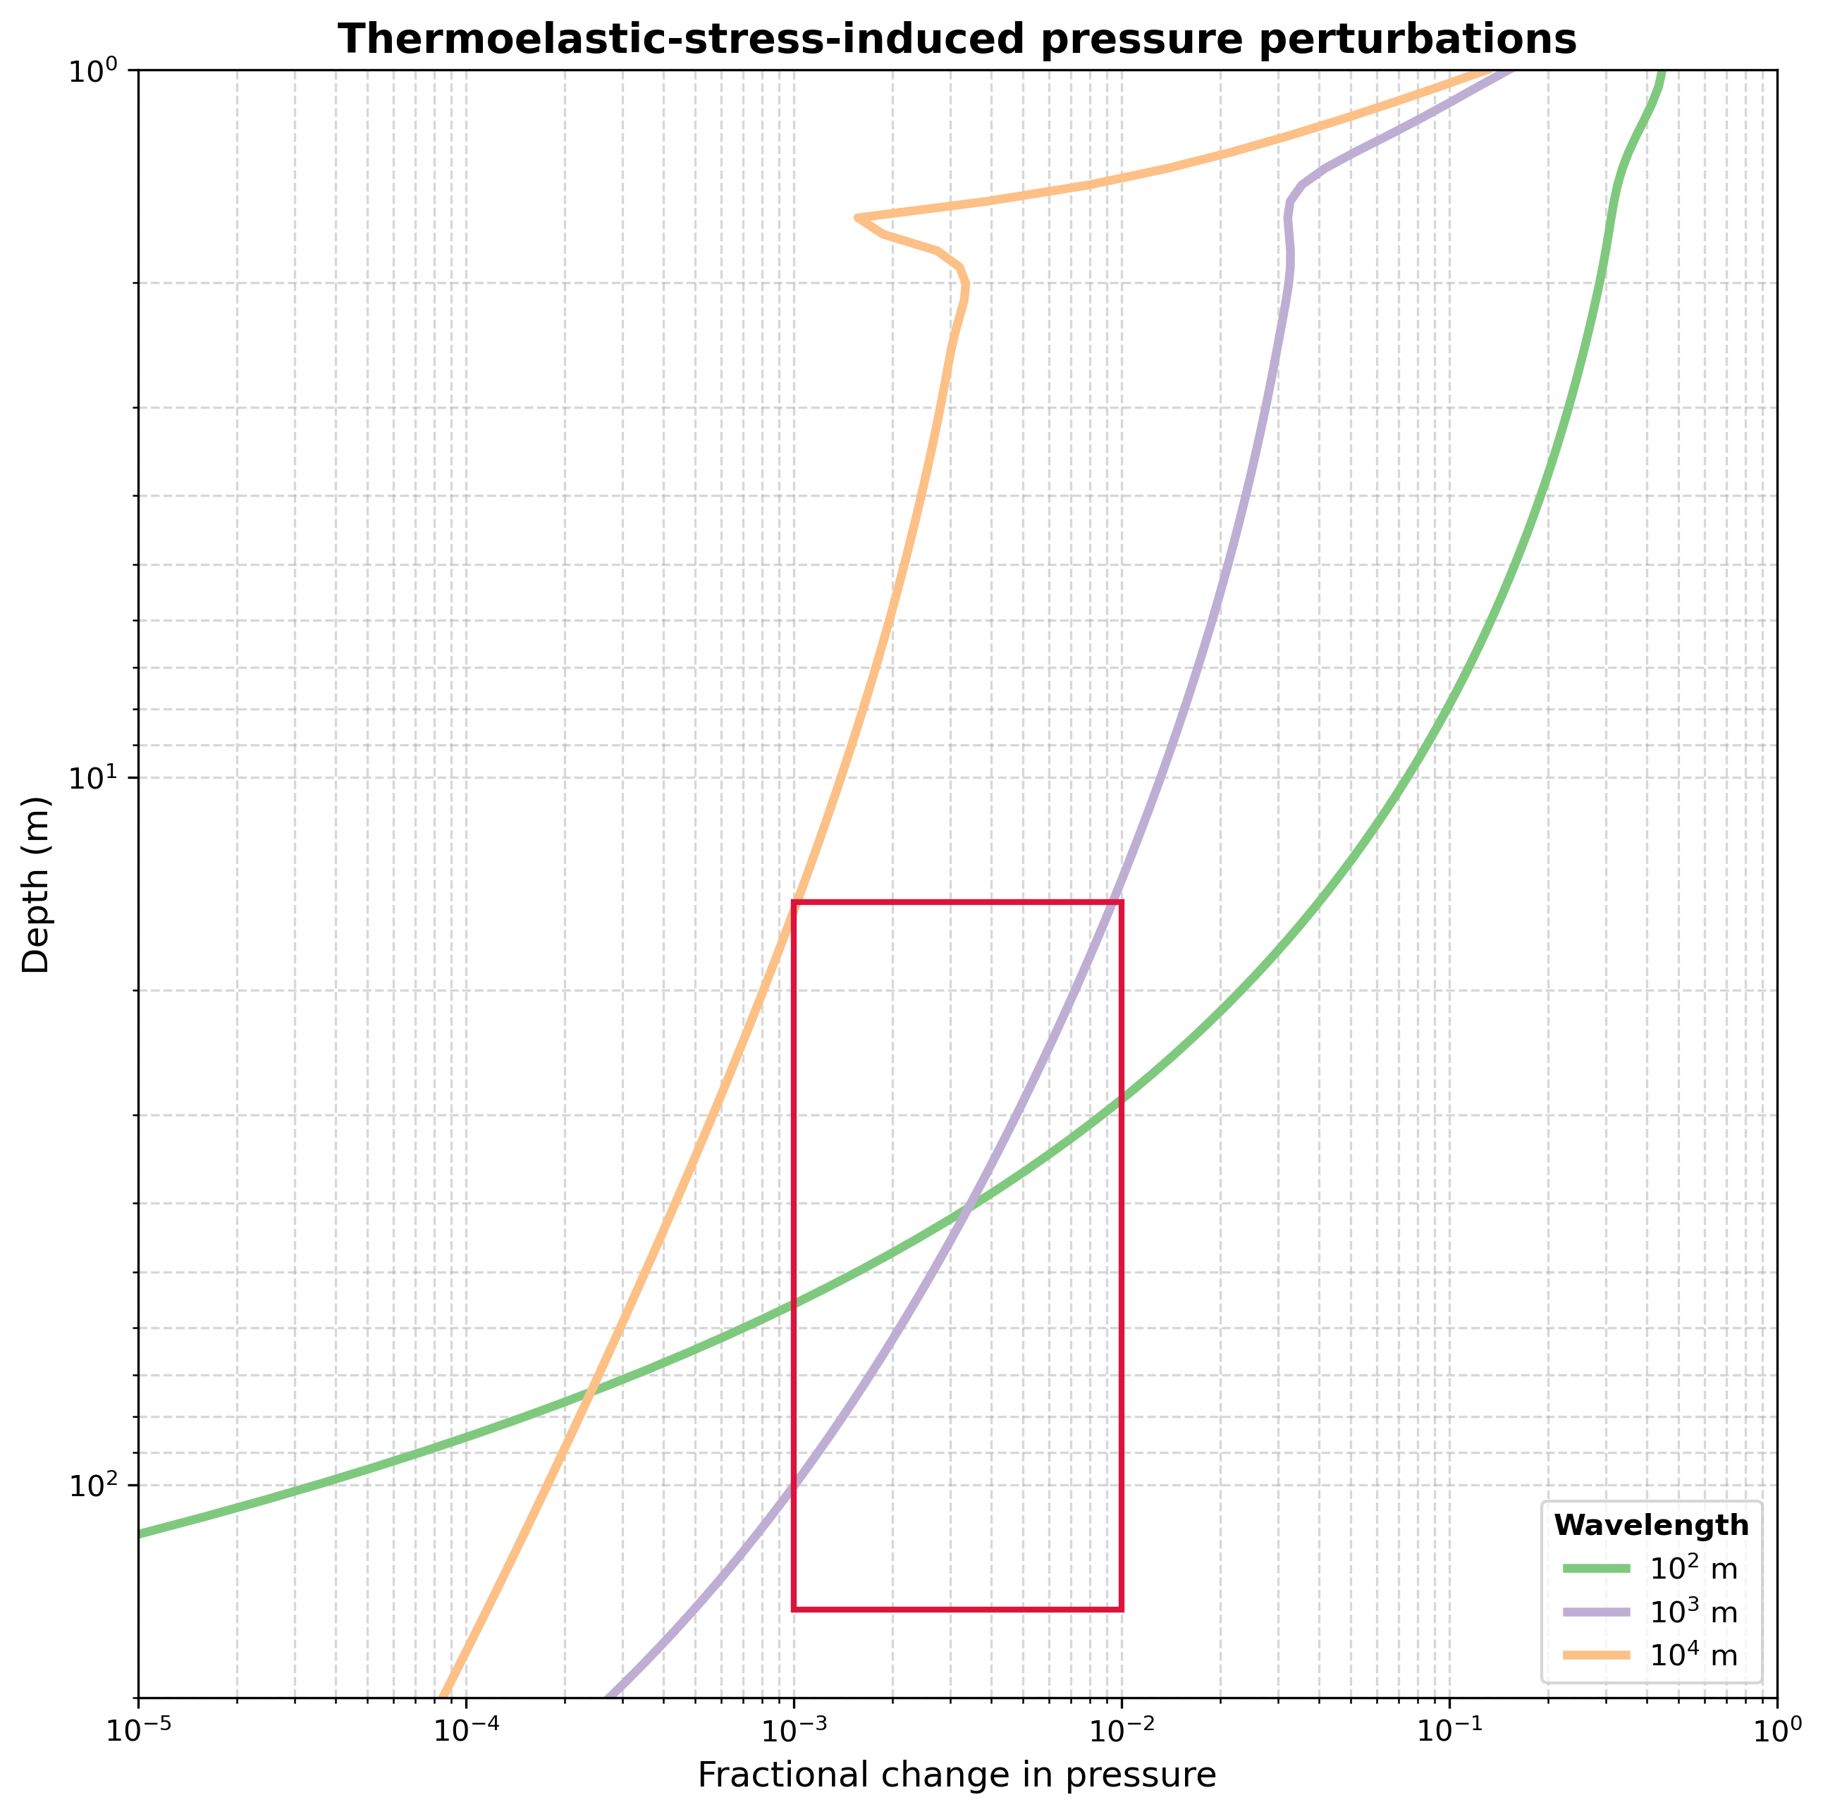Fig. S11. Thermoelastic-stress induced pressure perturbations as functions of depths for three horizontal wavelengths of surface-temperature anomalies. The red box highlights the observed range of fractional frequency variation and likely depth range of the source.
Table S1.
Frequency ranges for extracting the resonance modes

Mode order | Min. frequency (Hz) | Max. frequency (Hz)
2 | 25.385 | 25.569
3 | 38.103 | 38.353
4 | 50.804 | 51.121
6 | 76.240 | 76.640
8 | 101.758 | 102.209
9 | 114.543 | 114.943
10 | 127.327 | 127.694
11 | 139.962 | 140.512
12 | 152.629 | 153.246
13 | 165.330 | 165.864
14 | 178.265 | 178.732
15 | 190.866 | 191.516

Table S2.
Parameters for computing the effective sound speed of the fluid mixture in the crack
Molar mass of hydrogen M (kg mole⁻¹) | 2.016×10⁻³
Adiabatic index of hydrogen γ | 1.4
Gas constant R (J K⁻¹ mole⁻¹) | 8.315
Surface temperature T₀ (K) | 273.16
Sound speed of water c_{w} (m s⁻¹) | 1500
Density of water ρ_{w} (kg m⁻³) | 1000
P wave velocity of rock matrix v_{p} (m s⁻¹) | 4000
Density of rock matrix ρ_{s} (kg m⁻³) | 2500
Gravitational acceleration g (m s⁻²) | 10

