Sleep Estimation from Low Frequency Smartphone Sensors via Bayesian Hidden Markov Model

Andrew Jin Soo Byun¹, Yufan Li², Sam Cong¹, Alex Dhima¹, Shiwei Wang¹, Matthew Flathers¹, John B. Torous¹
¹Division of Digital Psychiatry, Beth Israel Deaconess Medical Center, Harvard Medical School, Boston, MA, USA; ²Department of Statistics, Harvard University, Cambridge, MA, USA

*Andrew Jin Soo Byun: 0000-0003-2062-7647 (jbyun1@bidmc.harvard.edu)
Yufan Li: 0000-0001-5412-3397
Sam Cong: 0009-0008-0227-372X
Alex Dhima: 0009-0006-3228-5655
Shiwei Wang: 0009-0001-6257-0397
Matthew Flathers: 0009-0004-3351-0688
John Torous: 0000-0002-5362-7937 (jtorous@bidmc.harvard.edu)

SUPPLEMENTARY MATERIALS
Cluster Profiles
Cluster 1: Healthy Early Chronotype, Low Para-Sleep Smartphone Activity (N = 107)
Participants in this cluster demonstrated above-average sleep score, probability, and duration, with earlier-than-average bedtimes and waketimes (z < 0). Pre- and post-sleep smartphone activity was substantially below average (z < 0), reflecting lower engagement with devices outside the sleep period. Symptom EMA scores were around average (z ≈ 0), indicating normative psychiatric burden, and sleep–symptom reactivity was near zero.
Cluster 2: Severe Symptom Insomnia (N = 91)
This group was characterized by reduced sleep score and duration (z < 0), increased fragmentation, and slightly later bedtime and waketime. Smartphone activity outside sleep hovered around the cohort average (z ≈ 0). Symptom EMA scores were the highest among all clusters (z >> 0), indicating substantial clinical severity. Reactivity values were generally positive or near-zero, suggesting little benefit of improved sleep or paradoxically higher symptoms on nights with better sleep.
Cluster 3: Late Chronotype, Low Symptom (N = 106)
Cluster 3 showed later-than-average bedtimes and waketimes (z >> 0), but sleep probability and duration were around average. Pre- and post-sleep smartphone activity was also elevated (z >> 0), indicating greater device use outside sleep. Symptom EMA scores were low (z < 0), and reactivity values were close to zero.
Cluster 4: Healthy Early Chronotype, High Para-Sleep Smartphone Activity (N = 124)
Participants in this cluster had early bed/wake time, high sleep score and duration, and the highest levels of smartphone activity before and after sleep (z >> 0). Symptom EMA values were low, and sleep reactivity was minimal.
Cluster 5: Moderate Symptoms, Fragmented Sleep (N = 81)
This group exhibited the lowest sleep score and duration, the highest fragmentation (z << 0), and bed/wake time earlier than the average cohort. Smartphone activity levels were also around average. Symptom EMA scores were moderately elevated (z > 0), and sleep reactivity was mildly negative or close to cohort average.

Clinical Profiles of Data-Driven Clusters Based on Independent Symptom Ratings
Building on our earlier findings that sleep–symptom coupling is highly heterogeneous at the individual level, we next asked whether data-driven subgroups derived from real-world sensor and survey features would correspond to meaningful differences in independently collected clinical assessments.
To test the clinical relevance of these data-driven subtypes, we leveraged separately collected clinical assessment data from two cohorts: (1) Social Media Study participants (N = 314/509) and (2) Digital Clinic Study participants (N = 152/509). These gold-standard measures, including PHQ-9, GAD-7, ISI, and PROMIS, were not used to define the clusters and thus provide an independent test of their validity.
As shown in Supplementary Figure 1, cluster membership was strongly associated with differences in clinical symptom severity across both cohorts. Clusters characterized by higher sensor-derived sleep disruption and greater symptom EMA (e.g., Cluster 2 and 5) consistently exhibited significantly higher clinical depression, anxiety, and insomnia/sleep disturbance scores on independent assessment (all ANOVA p < 1e-7). In contrast, clusters with more consolidated sleep and lower symptom EMA (e.g., Cluster 1 and 4) showed consistently lower clinical scores. This pattern was robust across both the social media and digital clinic cohorts, supporting the generalizability of the behavioral phenotypes.

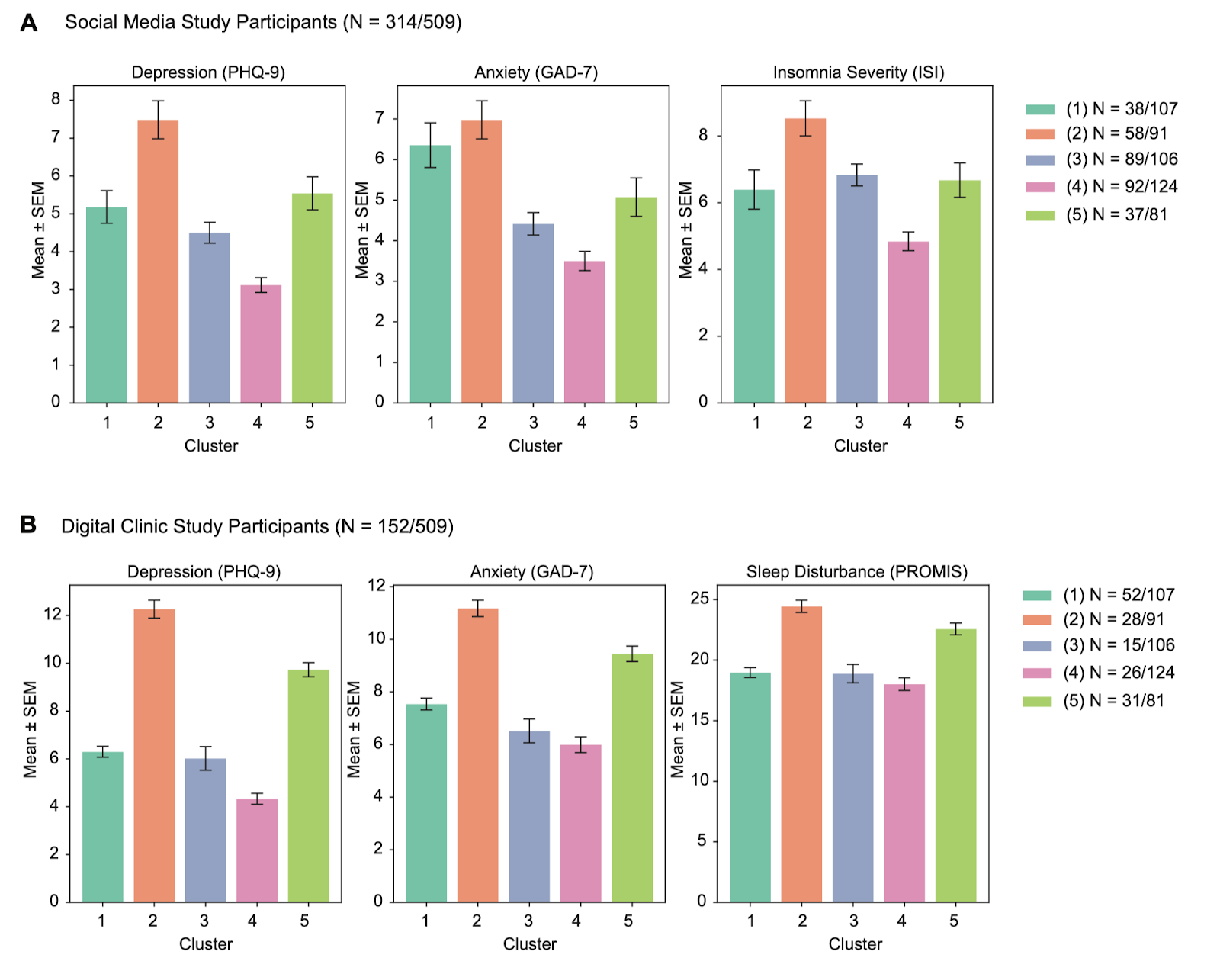
Supplementary Figure 1. Clinical Symptom Validation of Data-Driven Clusters in Social Media and Digital Clinic Cohorts
(a) Mean ± SEM depression (PHQ-9), anxiety (GAD-7), and insomnia severity (ISI) scores for social media study participants (N = 314/509) across five clusters derived from sensor-based and EMA features. (b) Mean ± SEM depression (PHQ-9), anxiety (GAD-7), and sleep disturbance (PROMIS) scores for digital clinic participants (N = 152/509) by cluster. Symptom measures were not included in the original UMAP clustering. Consistent clinical profiles across clusters support the validity of the subtypes: Cluster 2 shows the highest symptom severity, Cluster 4 the lowest, while Clusters 1, 3, and 5 display intermediate or mixed profiles. Cluster membership mirrors sleep and EMA-derived phenotypes, confirming external validity.

