Supplementary Data & Figures
Exploring multiple bioprocess monitoring modalities for Large-scale 3D Bioprinted Tissue Cultivation
Laura Chastagnier¹, Sarah Pragnere^{1,2} , Yilbert Gimenez^{1,3} , Celine Loubière⁴ , Lucie Essayan¹, Kleanthis Mazarakis ⁵ , Timo Schmidberger ⁶ , Eric Olmos ³ , Simon Auguste Lambert ² , Christophe Marquette ¹ , Emma Petiot ¹.
Supplementary Table 1_Regulation parameters (PID) optimisation (Proportional kp; Integral ki; Derivative kd). The column in white indicates the original PID parameters commonly set for cell culture processes, while values in the grey column are the optimised PID parameters for 3D bioprinted tissues. The regulation parameters that were significantly changed are indicated in bold red. dO₂ is the dissolved oxygen measured in % of air saturation.

Parameter regulated | dO₂ |  | pH
Output | Sparger gas flow mix (Air/CO₂) | Sparger gas flow mix (Air/N₂/CO₂) | NaOH 1M/ Sparger gas flow mix (Air/N₂/CO₂)
Effect | Increases dO₂ | Increases/decreases dO₂ | Increases/decreases pH
Sparger maximal flow rate (mL.min⁻¹) | 5 | 5 | 5
Sparger minimal flow rate (mL.min⁻¹) | 0 | 0 | 0
Proportional term (kp) | 2.5 | 5 | 2
Derivative term (ki) | 0 | 0 | 0.0001
Integral term (kd) | 0.005 | 0.001 | 0

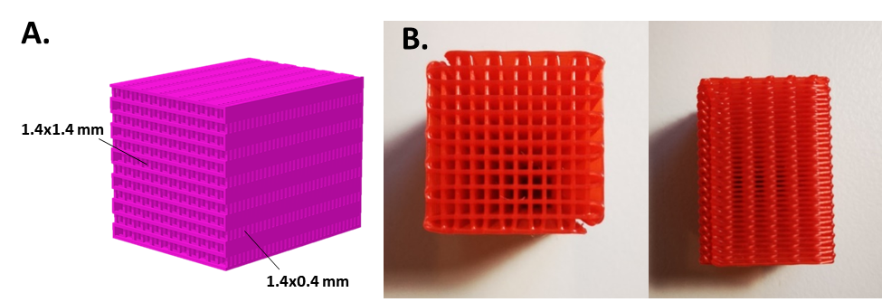
Supplementary Figure 1. Design of the 12×12 channels mock scaffold. A. STL file showing the two porosity levels. B. Different views of the scaffold 3D printed in PLA.

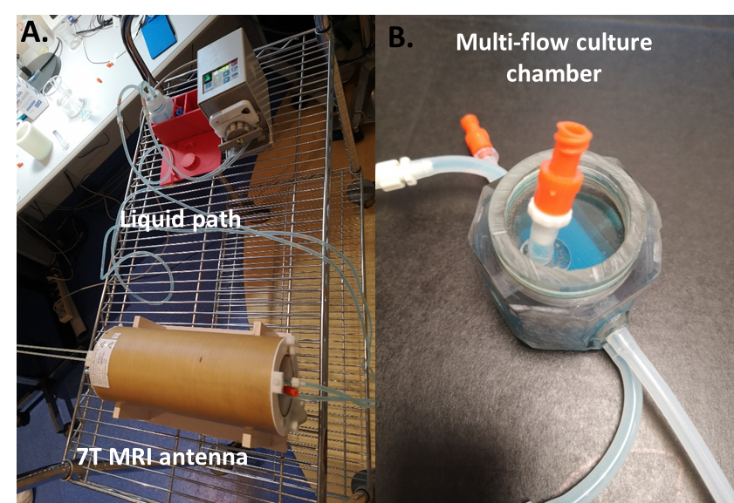
Supplementary Figure 2. Set-up for 3D Imaging of the perfusion flow velocities thanks to 7 Tesla MRI. A. Antenna integrating the multi-flow bioreactor and connected with a peristaltic pump and its fluid feeding reservoir. B. Close view of the perfusion chamber.

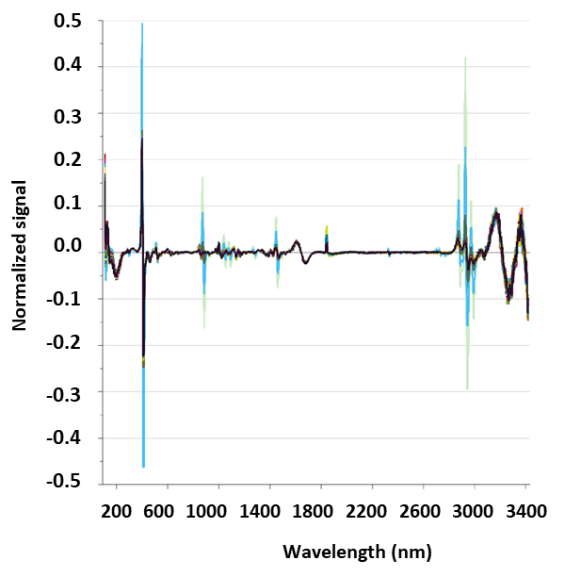
Supplementary Figure 3. Example of Raman spectra obtained from the continuous online monitoring of 3D bioprinted conjunctive tissue composed of dermal fibroblasts. Spectra are form increasing culture duration, from the darker to the lighter plots.

