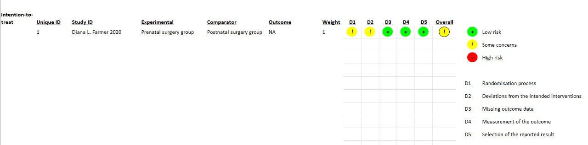

Supplementary Figure 1: Risk of bias assessment for randomized control trial

Study¹ | Selection of cohorts |  |  |  |  | Comparability of cohorts | Outcome |  |  | Power²
 | Representativeness of the exposed cohort | Selection of the non-exposed cohort | Ascertainment of exposure | Demonstration that outcome of interest was not present at start of study |  | Comparability of cohorts on the basis of the design or analysis | Assessment of outcome | Was follow up long enough for outcomes to occur | Adequacy of follow up of cohorts
M. SANZCORTES (2024) | ☆ | ☆ | ☆ | ☆ |  | ☆ | ☆ | ☆ | ☆ | Good quality³
Anita L. Kalluri (2023) | ☆ | ☆ | ☆ | ☆ |  | ☆ | ☆ | ☆ | ☆ | Good Quality
Jacek Zamłyński (2013) | ☆ | ☆ | ☆ | ☆ |  | ☆ | ☆ | ☆ | ☆ | Good Quality

Note

¹ To reduce the risk of bias, each article was assessed by an independent judge, and no discrepancies were found between both reviewers.
² Good quality: 3 or 4 stars in selection domain AND 1 or 2 stars in comparability domain AND 2 or 3 stars in outcome/exposure domain
Fair quality: 2 stars in selection domain AND 1 or 2 stars in comparability domain AND 2 or 3 stars in outcome/exposure domain
Poor quality: 0 or 1 star in selection domain OR 0 stars in comparability domain OR 0 or 1 stars in outcome/exposure domain
³ Low risk of bias = Good and fair quality // High risk of bias = Poor quality
From: Wells, G., Shea, B., O’Connell, D., Peterson, J., Welch, V., Losos, M., & Tugwell, P. (2014). Newcastle-Ottawa quality assessment scale cohort studies. University of Ottawa.

Supplementary Table 1: Quality assessment for observational studies

Summary of findings:
Prenatal repair compared to Postnatal repair for Myelomeningocele
Patient or population: Myelomeningocele
Setting:
Intervention: Prenatal repair
Comparison: Postnatal repair
Outcomes | Anticipated absolute effects* (95% CI) |  | Relative effect  (95% CI) | № of participants  (studies) | Certainty of the evidence  (GRADE) | Comments
Outcomes | Risk with Postnatal repair | Risk with Prenatal repair
Walking independently | 182 per 1,000 | 425 per 1,000  (277 to 647) | RR 2.33  (1.52 to 3.55) | 374  (3 non-randomised studies) | ⨁⨁⨁◯  Moderate^{a,b,c} | Prenatal repair likely results in a large increase in walking independently.
Mortality | 32 per 1,000 | 45 per 1,000  (16 to 130) | RR 1.44  (0.50 to 4.13) | 499  (4 non-randomised studies) | ⨁⨁◯◯  Low^{d,e} | Prenatal repair may result in a large increase in mortality.
Motor function | 169 per 1,000 | 413 per 1,000  (290 to 585) | RR 2.45  (1.72 to 3.47) | 380  (3 non-randomised studies) | ⨁⨁⨁◯  Moderate^{f} | Prenatal repair probably results in a large increase in motor function.
VP shunt | 529 per 1,000 | 275 per 1,000  (137 to 539) | RR 0.52  (0.26 to 1.02) | 291  (3 non-randomised studies) | ⨁◯◯◯  Very low^{g,h} | Prenatal repair may reduce/have little to no effect on VP shunt but the evidence is very uncertain.
*The risk in the intervention group (and its 95% confidence interval) is based on the assumed risk in the comparison group and the relative effect of the intervention (and its 95% CI).
CI: confidence interval; RR: risk ratio
GRADE Working Group grades of evidence
High certainty: we are very confident that the true effect lies close to that of the estimate of the effect.
Moderate certainty: we are moderately confident in the effect estimate: the true effect is likely to be close to the estimate of the effect, but there is a possibility that it is substantially different.
Low certainty: our confidence in the effect estimate is limited: the true effect may be substantially different from the estimate of the effect.
Very low certainty: we have very little confidence in the effect estimate: the true effect is likely to be substantially different from the estimate of effect.

Explanations
a. Low heterogeneity (I² = 13%, p = 0.32), meaning the results are consistent across studies.
b. Population, intervention, and outcome all directly address the clinical question.
c. The pooled effect (RR = 2.33 [1.52–3.55]) has a narrow confidence interval that does not cross 1.
d. Low heterogeneity: I² = 1%, Tau² = 0.01, P = 0.39.
e. Wide 95% CIs across studies (e.g., [0.05, 4.48] and [0.47, 135.37]), with few total events (22 deaths); overall RR = 1.44 [0.50, 4.13] is very imprecise.
f. Very low heterogeneity (I² = 0%, Chi² p = 0.96); consistent direction and magnitude of effect.
g. Substantial heterogeneity: I² = 69%, Tau² = 0.25, P = 0.04. Effect sizes range widely (RR 0.35 to 0.82).
h. 95% CIs for pooled effect cross null (RR=1) and are wide (e.g., 0.13-0.94). Total events = 112, but optimal information size not met.

Supplementary Table 2: Uncertainty of evidence

