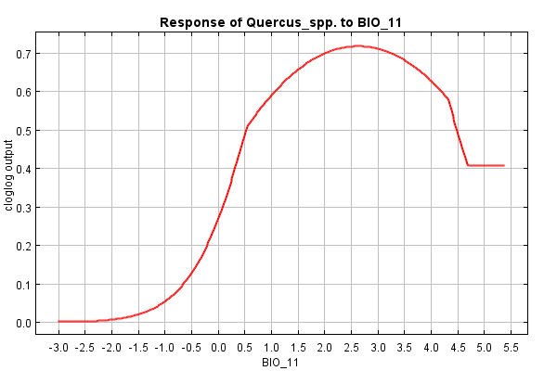 | 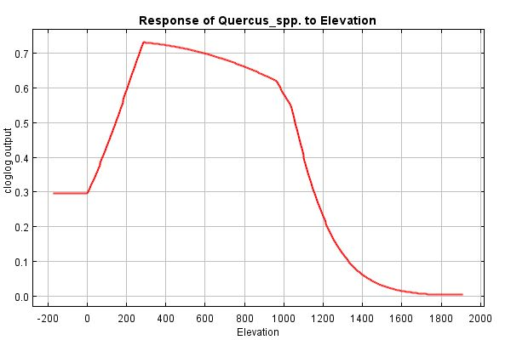
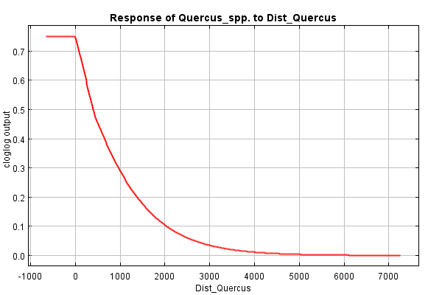
Fig. S1. Response curves of major bioclimatic and environmental variables as derived by MaxEnt modelling, indicating FT1 probability (cloglog) of occurrence in RMNP, created using only each of the corresponding variable (distance values in m. and BIO11 values in ºC)

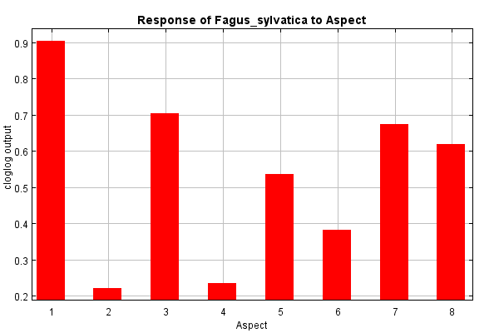 | 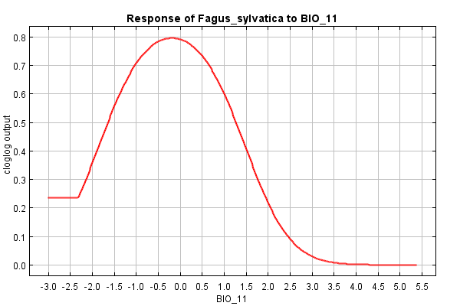
Fig. S2. Response curves of major bioclimatic and environmental variables as derived by MaxEnt modelling, indicating FT2 probability (cloglog) of occurrence in RMNP, created using only each of the corresponding variable (distance values in m., BIO11 values in ºC and Aspect categories as described in 2.3-Data processing and analysis)

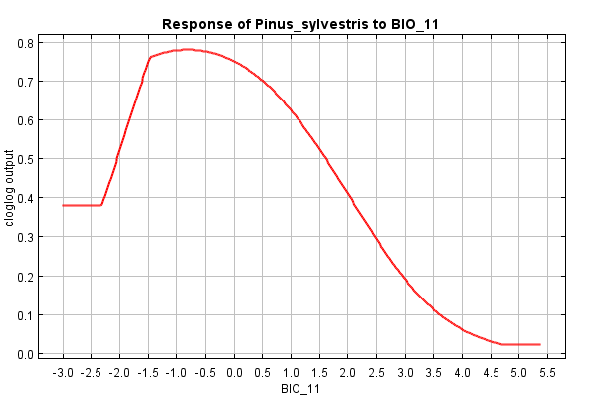 | 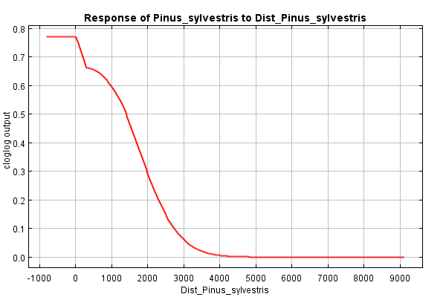
Fig. S3. Response curves of major bioclimatic and environmental variables as derived by MaxEnt modelling, indicating FT3 probability (cloglog) of occurrence in RMNP, created using only each of the corresponding variable (distance values in m., BIO11 values in ºC)

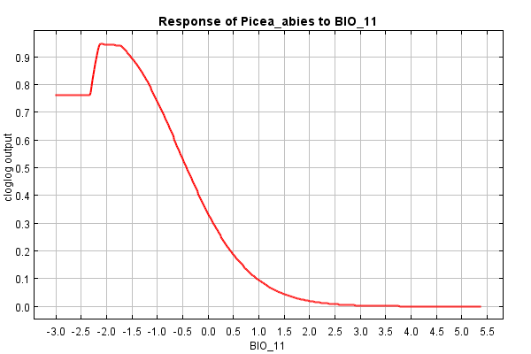 | 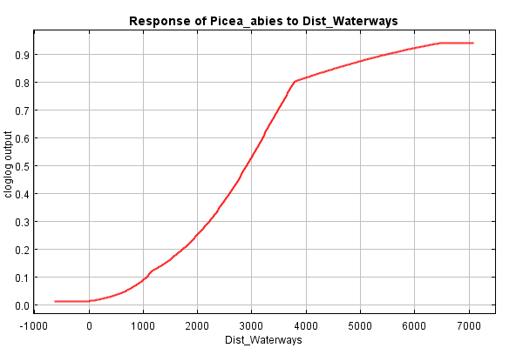
Fig. S4. Response curves of major bioclimatic and environmental variables as derived by MaxEnt modelling, indicating FT4 probability (cloglog) of occurrence in RMNP, created using only each of the corresponding variables (BIO11 values in ºC, distance values in m.)

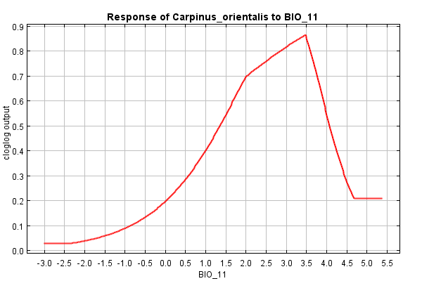 | 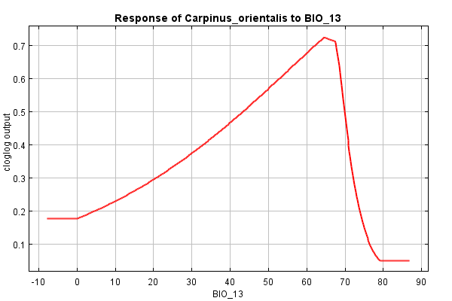
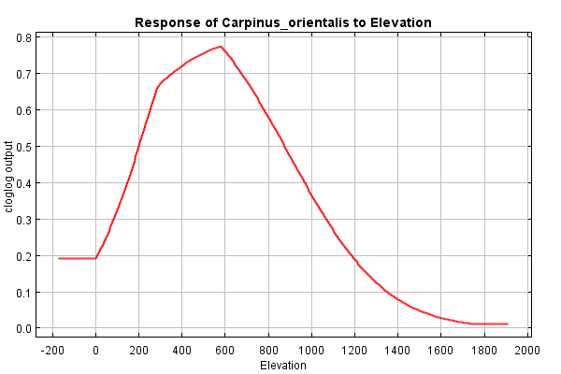
Fig. S5. Response curves of major bioclimatic and environmental variables as derived by MaxEnt modelling, indicating FT5 probability (cloglog) of occurrence in RMNP, created using only each of the corresponding variables (elevation values in m., BIO11 values in ºC, BIO13 values in mm/month)

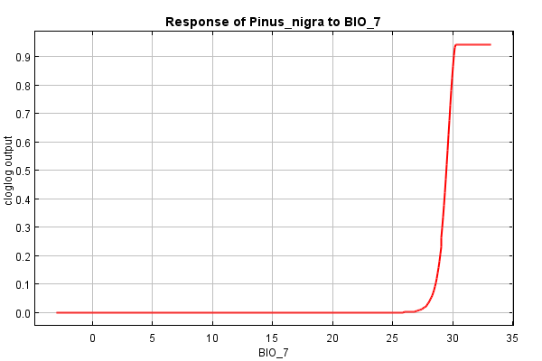 | 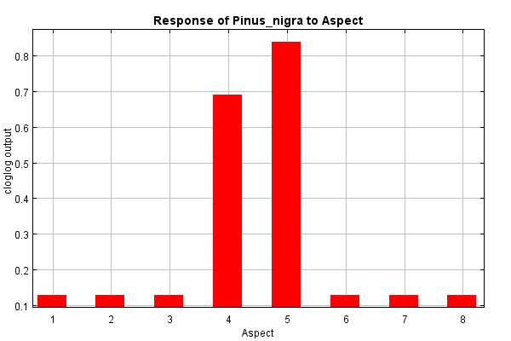
Fig. S6. Response curves of major bioclimatic and environmental variables as derived by MaxEnt modelling, indicating FT6 probability (cloglog) of occurrence in RMNP, created using only each of the corresponding variables (BIO7 values in ºC and Aspect categories as described in 2.3-Data processing and analysis).

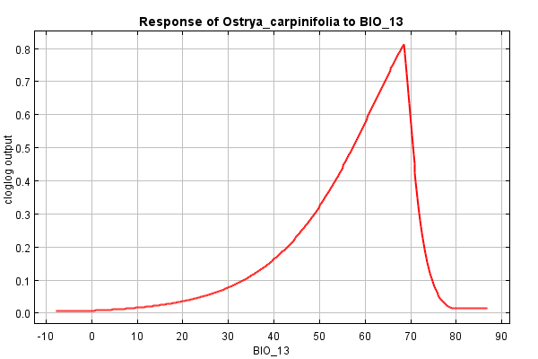 | 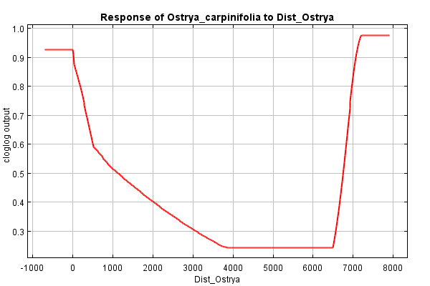
Fig. S7. Response curves of major bioclimatic and environmental variables as derived by MaxEnt modelling, indicating FT7 probability (cloglog) of occurrence in RMNP, created using only each of the corresponding variables (BIO13 values in mm/month and distance in meters).

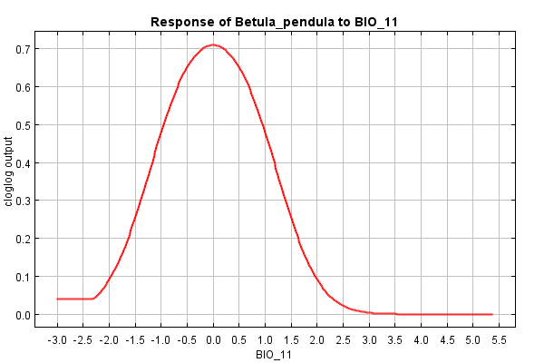 | 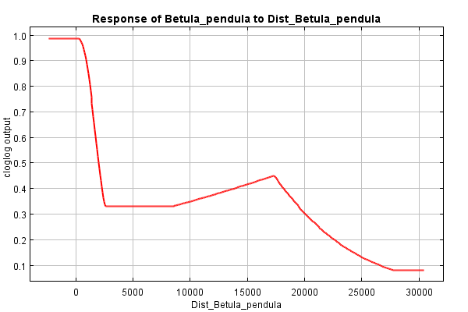
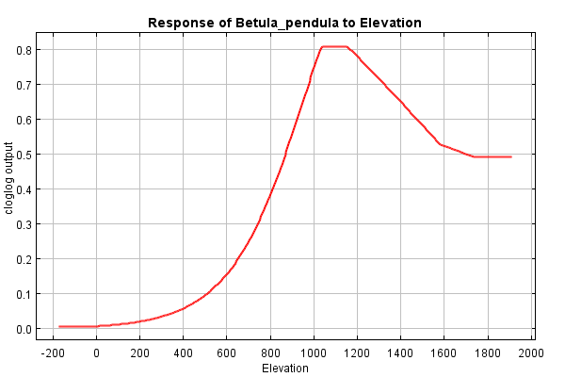
Fig. S8. Response curves of major bioclimatic and environmental variables as derived by MaxEnt modelling, indicating FT8 probability (cloglog) of occurrence in RMNP, created using only each of the corresponding variables (BIO11 values in ºC, distance and elevation in meters).

