Supplementary file

Combination of a pesco-vegetarian diet with non-steroidal anti-inflammatory drugs for colorectal cancer prevention: tumour suppression and gut microbiota modulation in Apc- mutated PIRC rats

Sofia Chioccioli¹†, Niccolò Meriggi²†, Mariela Mejia Monroy^{3,2}, Sonia Renzi⁴, Benedetta Cerasuolo⁴, Giovanna Caderni¹, Carlotta De Filippo²*

¹ Department of Neurosciences, Psychology, Drug Research and Child Health (NEUROFARBA), University of Florence, Florence, Italy.
² Institute of Agricultural Biology and Biotechnology (IBBA), National Research Council (CNR), Pisa, Italy
³ Department of Molecular and Developmental Medicine (DMMS), University of Siena, Siena, Italy.
⁴ Department of Biology, University of Florence, Florence, Italy.

† Authors who contributed equally to this work
* Corresponding author: Carlotta De Filippo
e-mail: carlotta.defilippo@cnr.it

Table S1. Type II ANOVA table reports the effect of diet and pharmacological treatment variables with their interaction effect on the body weight of rats at the end of experiment.
Factor | Sum Sq | Df | F value | Pr(>F) | Sign
Diet | 395.1 | 1 | 1.5562 | 0.215729
Treatment | 4684.8 | 3 | 6.1511 | 0.000791 | ***
Diet: Treatment | 1336.9 | 3 | 1.7554 | 0.162080
Residuals | 21071.4 | 83

Table S2. The table reports the mean body weight in grams and the related standard deviation within brackets of each experimental group. For each group the number of observations (n) is also reported *: significantly different (p<0.05) compared with the NT and ASA1 of the same dietary group (FDR adjusted Wilcoxon rank sum test).
Group | CTR | PVD
NT | 320 (20.1) | n=12 | 330 (18.0) | n=12
SU | 314 (11.6) | n=10 | 305 (21.8) * | n=10
ASA1 | 321 (8.5) | n=12 | 332 (15.0) | n=12
ASA2 | 317 (13.0) | n=12 | 327 (16.8) | n =11

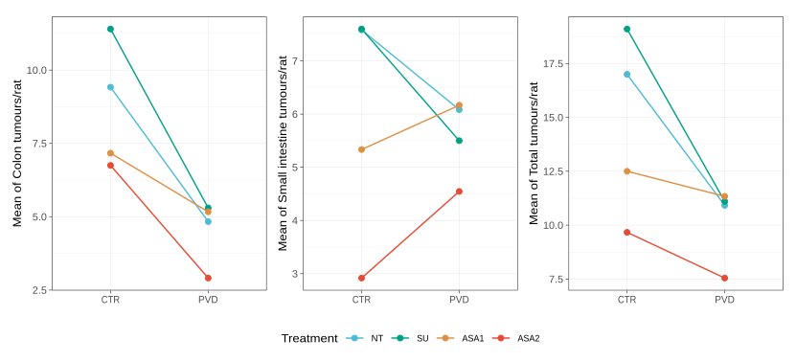
Figure S1. The line chart shows the trend in the mean number of tumours per rat in the CTR and PVD groups for each treatment category (indicated by colour pattern) at the end of the experiment. The three panels (from left to right) represent the mean number of tumours in the colon, in the small intestine, and in both intestinal tracts.

Table S3. Type III ANOVA table reports the effect of diet and pharmacological treatment variables with their interaction effect on the number of tumours per rat tested for different intestinal tracts. Colon: tumours in the colon tract, SI: tumours in the Small Intestine, Total: tumours in the entire intestinal tract (Colon and small intestine).

Tissue | Factor | Sum Sq | Df | F value | Pr(>F) | Sign
Colon | Diet | 126.04 | 1 | 12.343 | 0.0007 | ***
Colon | Treatment | 152.07 | 3 | 4.964 | 0.0032 | **
Colon | Diet/Treatment | 48.18 | 3 | 1.573 | 0.2021
Colon | Residuals | 847.58 | 83
SI | Diet | 13.5 | 1 | 0.936 | 0.336
SI | Treatment | 172.93 | 3 | 3.998 | 0.0104 | *
SI | Diet/Treatment | 53.77 | 3 | 1.243 | 0.2994
SI | Residuals | 1196.71 | 83
Total | Diet | 222 |  | 6.568 | 0.0122 | *
Total | Treatment | 614.2 |  | 6.056 | 0.0009 | ***
Total | Diet/Treatment | 173.5 |  | 1.711 | 0.1711
Total | Residuals | 2805.8

Table S4. Dunnett’s test table reports the effect of comparison in mean levels of all group combinations of diet and pharmacological treatment variables groups against the NT-CTR group, designed as control level. Colon: tumours in colon tract, SI: tumours in Small Intestine, Total: tumours in the entire intestinal tract.

Tissue | Contrast | Diff | Lwr-ci | Upr-ci | P-value | Sign
Colon | NT-CTR vs ASA1-CTR | -2.250000 | -5.736816 | 1.2368164 | 0.3683
Colon | NT-CTR vs ASA2-CTR | -2.666667 | -6.153483 | 0.8201498 | 0.2070
Colon | NT-CTR vs SU-CTR | 1.983333 | -1.673671 | 5.6403373 | 0.5534
Colon | NT-PVD vs NT-CTR | -4.583333 | -8.070150 | -1.0965169 | 0.0045 | **
Colon | ASA1-PVD vs NT-CTR | -4.250000 | -7.736816 | -0.7631836 | 0.0099 | **
Colon | ASA2-PVD vs NT-CTR | -6.507576 | -10.072757 | -2.9423941 | 3.2e-05 | ***
Colon | SU-PVD vs NT-CTR | -4.116667 | -7.773671 | -0.4596627 | 0.0204 | *
SI | NT-CTR vs ASA1-CTR | -2.25000000 | -6.393186 | 1.893186 | 0.5520
SI | NT-CTR vs ASA2-CTR | -4.66666667 | -8.809852 | -0.523481 | 0.0202 | *
SI | NT-CTR vs SU-CTR | 0.01666667 | -4.328743 | 4.362076 | 1.0000
SI | NT-PVD vs NT-CTR | -1.50000000 | -5.643186 | 2.643186 | 0.8791
SI | ASA1-PVD vs NT-CTR | -1.41666667 | -5.559852 | 2.726519 | 0.9050
SI | ASA2-PVD vs NT-CTR | -3.03787879 | -7.274181 | 1.198424 | 0.2638
SI | SU-PVD vs NT-CTR | -2.08333333 | -6.428743 | 2.262076 | 0.6766
Total | NT-CTR vs ASA1-CTR | -4.500000 | -10.844047 | 1.8440474 | 0.2739
Total | NT-CTR vs ASA2-CTR | -7.333333 | -13.677381 | -0.9892859 | 0.0162 | *
Total | NT-CTR vs SU-CTR | 2.100000 | -4.553693 | 8.7536930 | 0.9336
Total | NT-PVD vs NT-CTR | -6.083333 | -12.427381 | 0.2607141 | 0.0658
Total | ASA1-PVD vs NT-CTR | -5.666667 | -12.010714 | 0.6773807 | 0.0996
Total | ASA2-PVD vs NT-CTR | -9.454545 | -15.941174 | -2.9679174 | 0.0013 | **
Total | SU-PVD vs NT-CTR | -5.900000 | -12.553693 | 0.7536930 | 0.1038

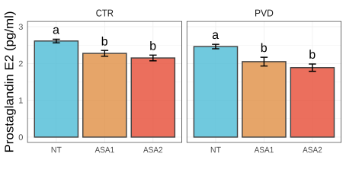

Figure S2. Barplot reports the comparisons of circulating prostaglandin E2 concentration between pharmacological treated groups within the two dietary interventions (CTR, PVD). Differences in variance are tested by using Anova test (p < 0.001), then pairwise comparison was carried out by using Tukey HSD test. Significant comparisons are highlighted using lowercase letters on top of each box: if two means were significantly different, all letters on top of the two boxes are different while if two means were equal, at least one letter is the same.

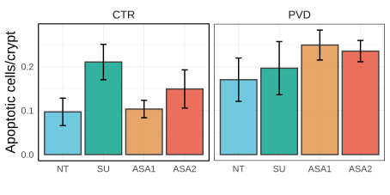

Figure S3. Barplot reports the comparisons of apoptotic cells per crypt in normal mucosa between pharmacological treated groups within the two dietary interventions (CTR, PVD). Differences in variance are tested by using Anova test (p > 0.05), then pairwise comparison was carried out by using Tukey HSD test (no significant comparisons are depicted).

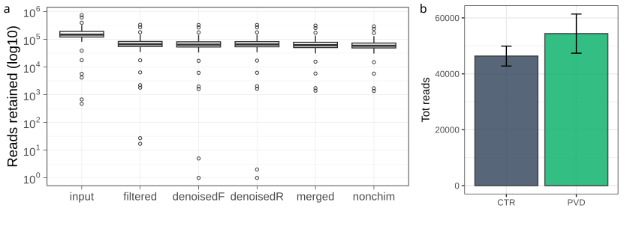

Figure S4. (a) Boxplot reports the logarithm of the number of reads retained after each dada2 quality filtering step. (b) Barplot reports the differences in the total number of reads after chloroplast, mitochondrial and unknown sequences removal after dada2 pipeline, between the two dietary treated cohorts (Kruskal-Wallis test, p = 0.88).

Table S5. Result’s table of the environmental fitting analysis (envfit of “vegan” package) performed between bacterial diversity (ASVs level) and tumours rate in the entire dataset. Colon: tumours in colon tract, SI: tumours in Small Intestine, Total: tumours in the entire intestinal tract.

Marker | R2 | P-value | P-adj | Sign
Colon | 0.2138 | 0.002997 | 0.0090 | **
SI | 0.0150 | 0.612388 | 1
Total | 0.0449 | 0.236763 | 0.7103

Table S6. Result’s table of the environmental fitting analysis (envfit of “vegan” package) performed between bacterial diversity (ASV level) and tumours rate accounted in different tissues performed for each treatment -related dataset. Colon: tumours in colon tract, SI: tumours in Small Intestine, Total: tumours in the entire intestinal tract.

Treatment | Marker | R2 | P-value | P-adj | Sign
NT | Colon | 0.3033 | 0.1149 | 0.3027
NT | SI | 0.0274 | 0.8362 | 1
NT | Total | 0.2403 | 0.1948 | 0.5395
SU | Colon | 0.5091 | 0.0050 | 0.0150 | *
SU | SI | 0.3143 | 0.0809 | 0.2428
SU | Total | 0.3679 | 0.0260 | 0.0780
ASA1 | Colon | 0.1262 | 0.4006 | 1
ASA1 | SI | 0.0200 | 0.9091 | 1
ASA1 | Total | 0.0078 | 0.9431 | 1
ASA2 | Colon | 0.6688 | 0.0030 | 0.0090 | **
ASA2 | SI | 0.4481 | 0.0370 | 0.1109
ASA2 | Total | 0.3810 | 0.0660 | 0.1978

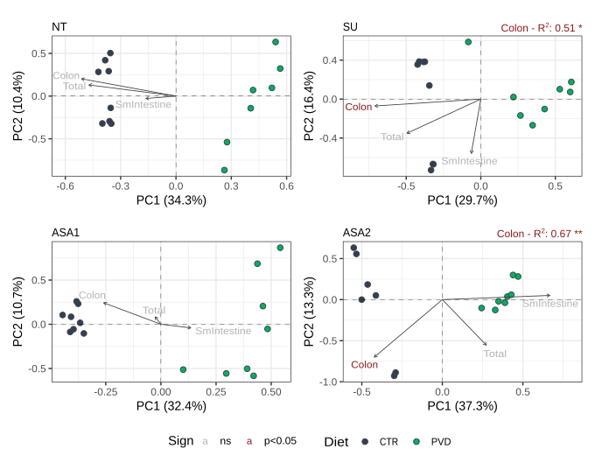

Figure S5. PCA (Hellinger) reports the sample distributions produced by the variation in bacterial ASVs composition in relationships to the associated tumours rate associated to each intestinal tract in each treatment -related dataset. Colon: tumours in colon tract, Sm.Intestine: tumours in small intestine, Total: tumours in the entire intestinal tract. Samples are represented according to diet (colour pattern) variable while arrows indicate direction and magnitude of the linear relationship between tumours rate and the gradient of bacterial ASVs composition depicted by PCA (envfit function). The R-squared value of a significant correlated variable is reported on top of the panel and significance is highlighted using asterisks (*, p<0.05; **, p<0.01).

Table S7. Result’s table reporting the ASVs with related taxonomic assignment, significantly influenced by diet in each treatment -related dataset selected by using Wald’s test (Wald test of DESeq2).
(see .csv file)

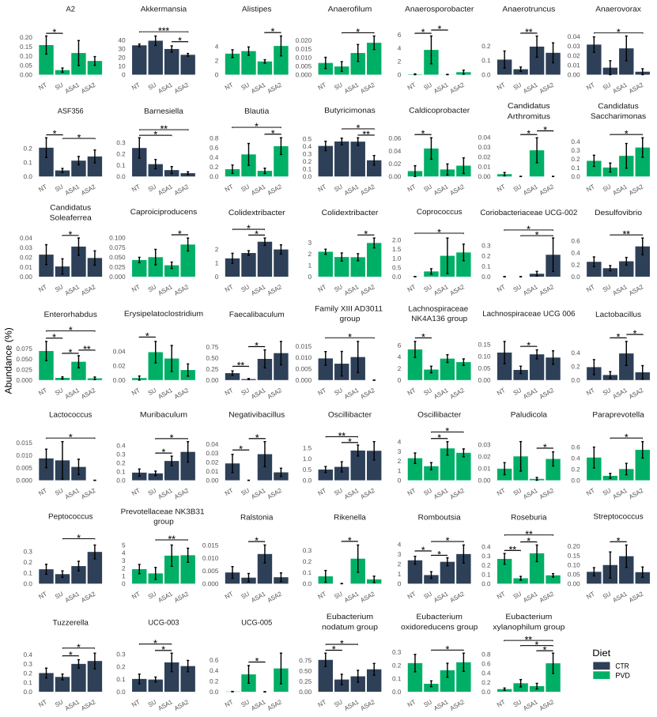

Figure S6. Barplot reports the relative abundance percentage of the main bacterial genera (genera present in less than 5% of samples within the dataset are removed) in each treatment group. Differences between treatment groups are tested by using Wilcoxon rank sum test and significant comparisons are highlighted using asterisks (*, p<0.05; **, p<0.01; ***, p<0.001).

Table S8. Table reports the results of Wilcoxon rank sum test performed to assess differences in the main bacterial genera (genera present in less than 5% of samples within the dataset are removed) among different Aspirin dosage. The bacterial genera included in the analysis are previously selected by using Kruskal-Wallis test (p < 0.05).
Diet | Genus | Group 1 | Group 2 | P-value | Sign
CTR | Akkermansia | 800 | 1600 | 0.0289 | *
CTR | Akkermansia | 0 | 1600 | 0.0003 | ***
CTR | Lactobacillus | 800 | 1600 | 0.0317 | *
CTR | UCG-003 | 0 | 800 | 0.0379 | *
CTR | Colidextribacter | 0 | 800 | 0.0281 | *
CTR | Barnesiella | 0 | 800 | 0.0180 | *
CTR | Barnesiella | 0 | 1600 | 0.0044 | **
CTR | Eubacterium nodatum group | 0 | 800 | 0.0207 | *
CTR | Lactococcus | 0 | 1600 | 0.0192 | *
CTR | Coriobacteriaceae UCG-002 | 0 | 1600 | 0.0213 | *
CTR | Family XIII AD3011 group | 0 | 1600 | 0.0192 | *
CTR | Anaerovorax | 0 | 1600 | 0.0202 | *
CTR | Oscillibacter | 0 | 800 | 0.0030 | **
CTR | Butyricimonas | 800 | 1600 | 0.0065 | **
PVD | Coprococcus | 0 | 1600 | 0.0144 | *
PVD | Alistipes | 800 | 1600 | 0.0379 | *
PVD | Blautia | 0 | 1600 | 0.0321 | *
PVD | Blautia | 800 | 1600 | 0.0100 | *
PVD | Colidextribacter | 800 | 1600 | 0.0379 | *
PVD | Caproiciproducens | 800 | 1600 | 0.0238 | *
PVD | Eubacterium xylanophilum group | 800 | 1600 | 0.0178 | *
PVD | Eubacterium xylanophilum group | 0 | 1600 | 0.0065 | **
PVD | Eisenbergiella | 0 | 800 | 0.0383 | *
PVD | Paludicola | 800 | 1600 | 0.0298 | *
PVD | Enterorhabdus | 0 | 1600 | 0.0121 | *
PVD | Enterorhabdus | 800 | 1600 | 0.0097 | **
PVD | Candidatus Arthromitus | 800 | 1600 | 0.0325 | *
PVD | Roseburia | 0 | 1600 | 0.0059 | **

