Supplementary Information for

Assessment of the IITM Decadal Climate Prediction System for Interannual to Decadal Climate Variability and Indian Summer Monsoon Teleconnections
P. V. Rajesh¹, Rosimitha Panda¹, Rahul Pai¹, Rashmi Kakatkar¹, Darshana Patekar¹, J.S. Deepa¹, C. Gnanaseelan¹,*, A.G. Prajeesh^{1,2}, Amit Kumar Sharma¹, T.S. Fousiya^{1,3}, Subrota Halder^{1,4}, Sebastian Anila¹, Anant Parekh¹

¹Indian Institute of Tropical Meteorology, Pune-411008
²King Abdullah University of Science and Technology
³Meteo-France Toulouse
⁴New York University Abu Dhabi
*seelan@tropmet.res.in
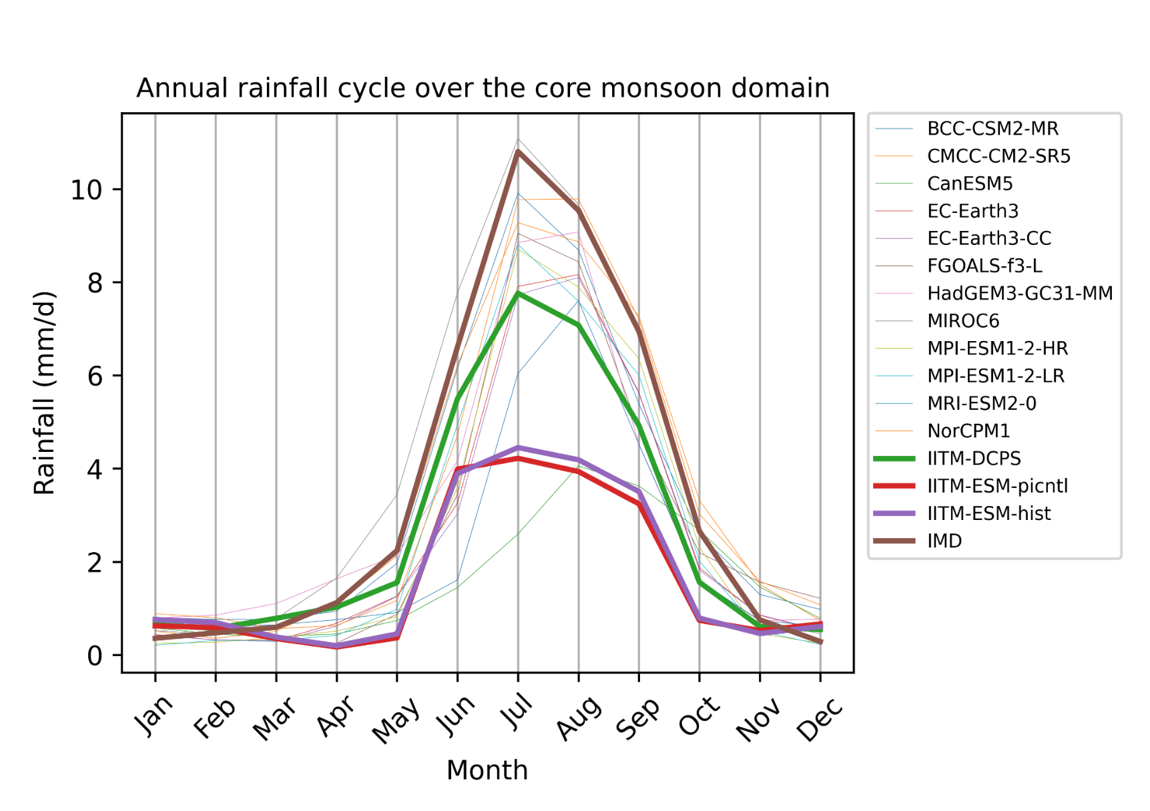
Figure S1a: Bias of 2m temperature (first column), precipitation (second column) and SST (third column), for 200 years of the pi-control from 13 Earth system models (ESMs) participating in CMIP6-DCPP, and IITM-DCPS compared to the observed climatology data. The observed climatological temperature is derived from ERA5, precipitation from GPCP and COBE SST . Each row represents the mean bias for the same model, with units of T2 in degC, precipitation in mm day-1 and SST in K.
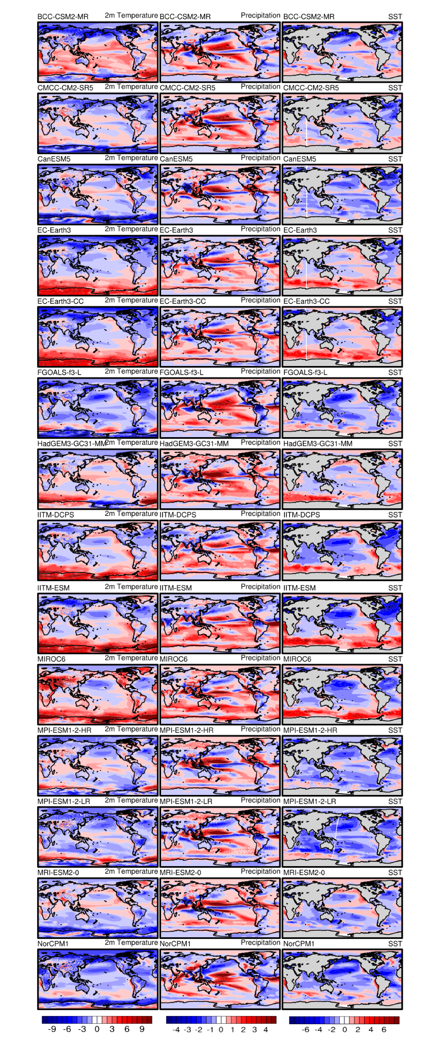
Figure S1b: Comparison of the seasonal cycle of rainfall from IITM-DCPS (green), IITM-ESM historical (purple), and IITM-ESM-PI (magenta) with various CMIP6 models’ PI-control runs participating in the Decadal Climate Prediction Project (DCPP), validated against IMD rainfall observations.
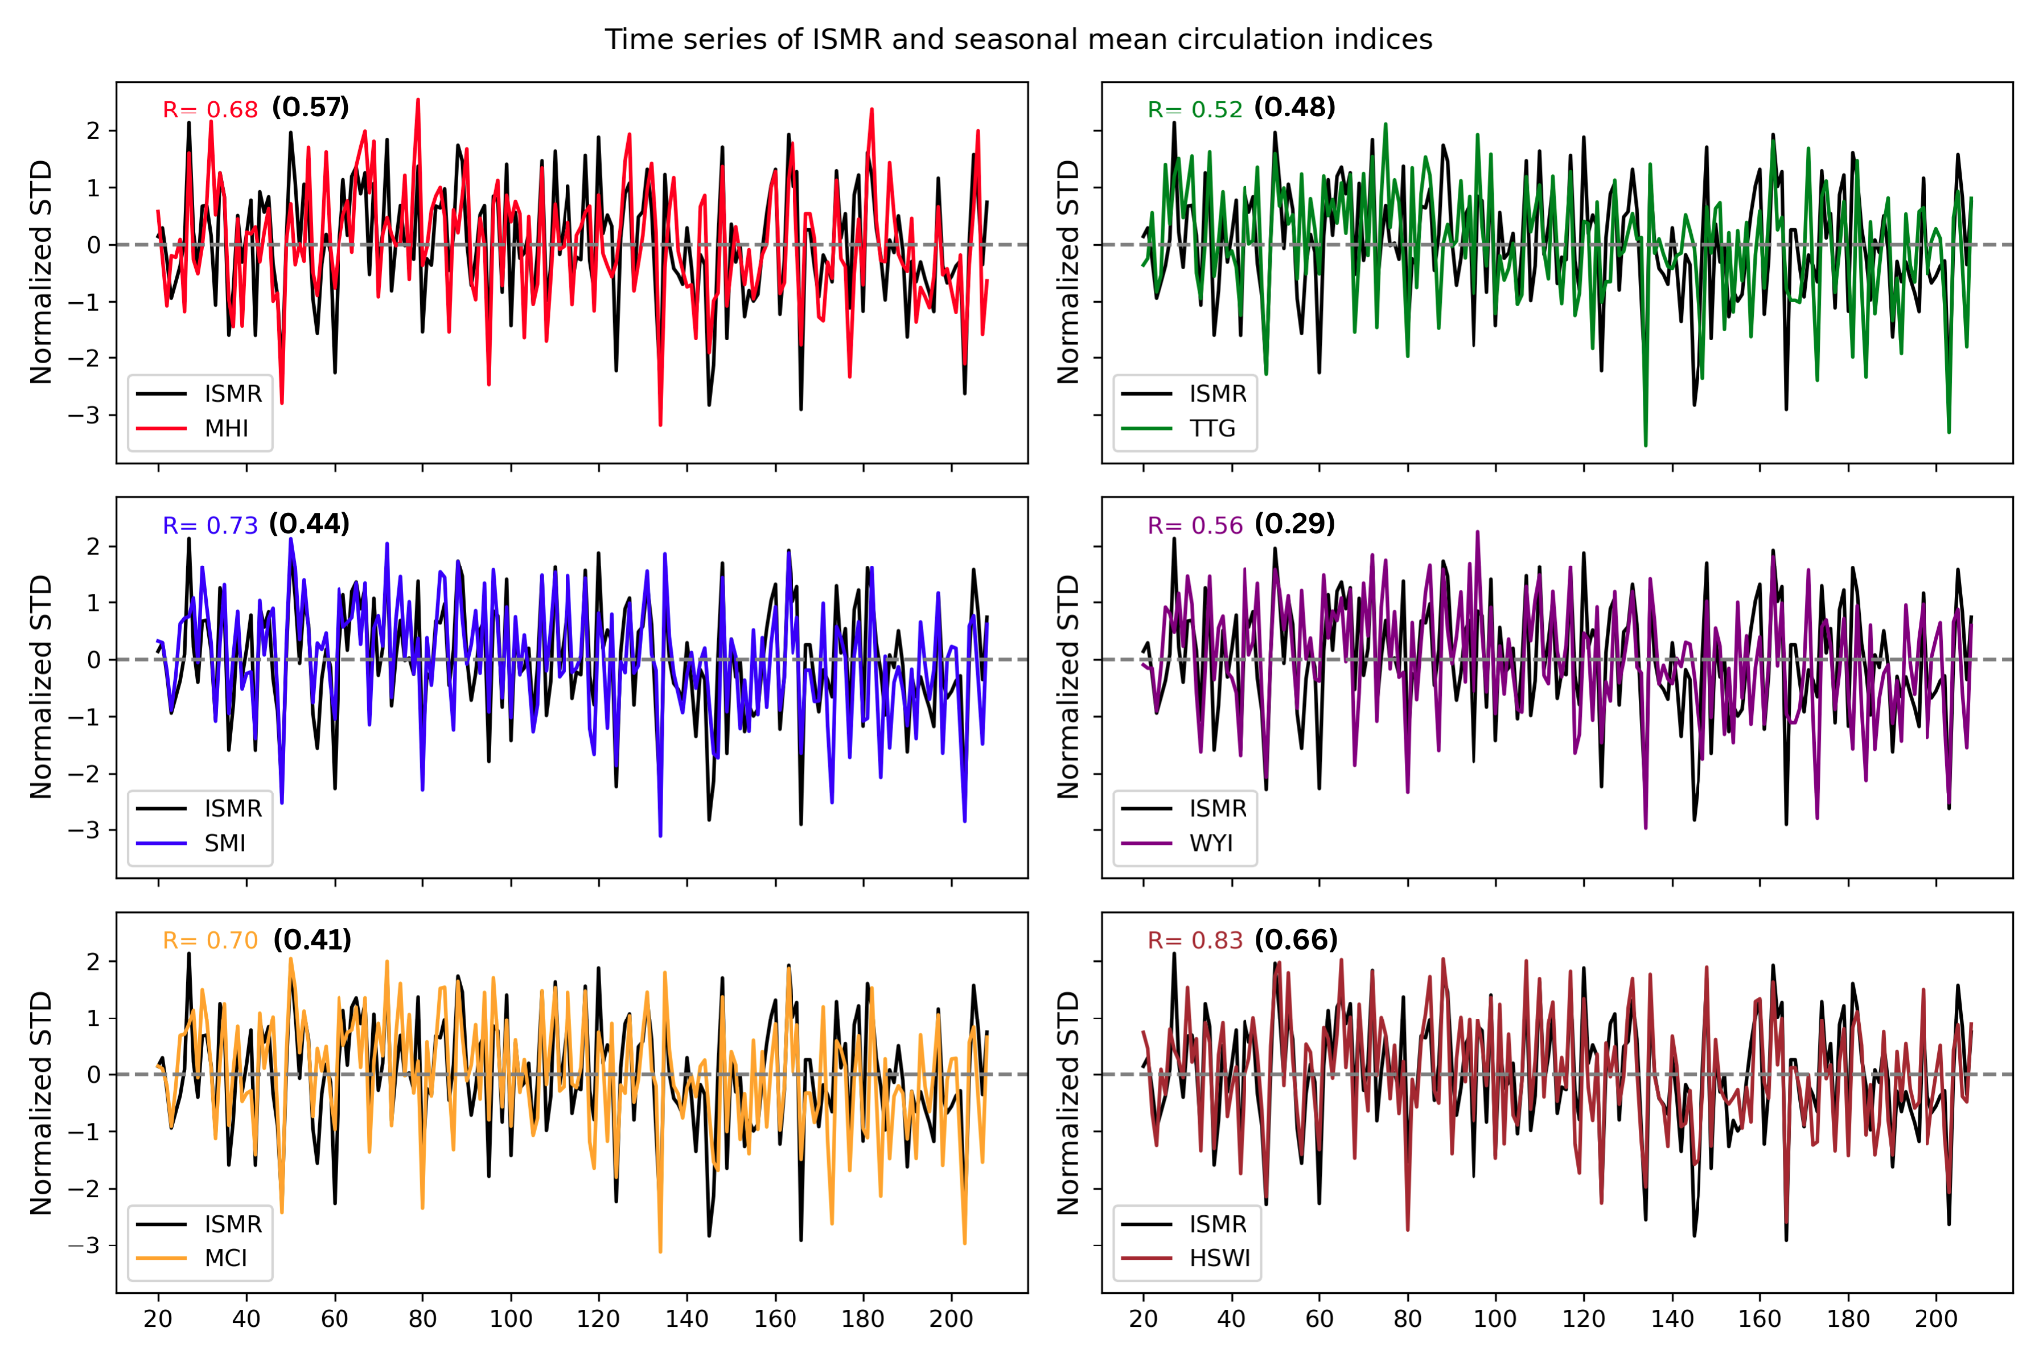
Figure S2: Time series of simulated ISMR and seasonal mean circulation indices (MHI, TTG, SMI, WYI, MCI and HWSI) normalized by their own interannual standard deviation for the period of 200 years and the observation values for correlation coefficient (R) given in black colour.
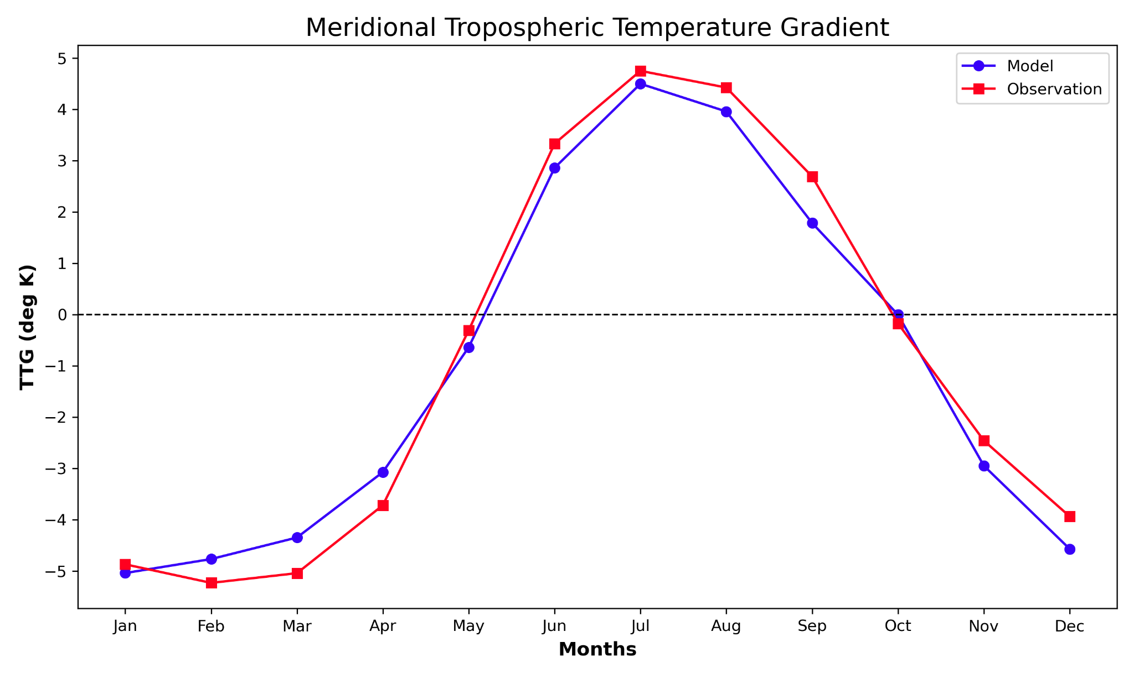
Figure S3: Comparison of annual cycle of meridional Tropospheric Temperature Gradient (TTG) (deg K) between IITM-DCPS (model) and observation over the period of 200 years. TTG is calculated by averaging the air temperature over the column 600-200 hPa and taking the difference between the Indian monsoon domain (60–100°E, 20–30°N) and the equatorial region (60–100°E, 5°S–5°N).
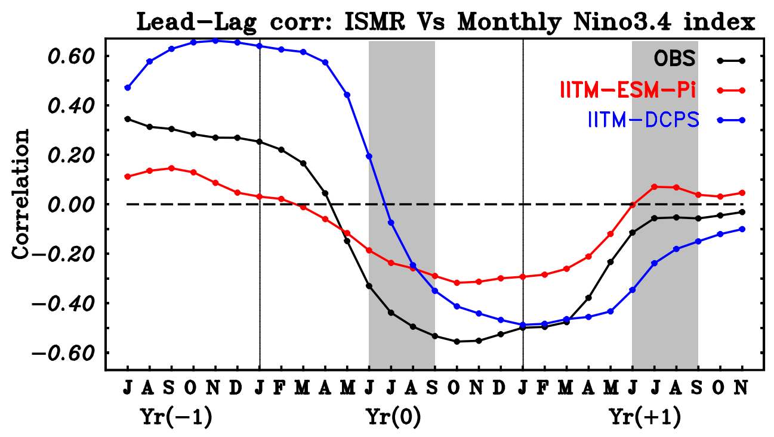

Figure S4: Lead-lag correlations between Indian monsoon rainfall (JJAS mean) time series (IITM) and monthly Niño-3.4 SST (ERSSTv5) from the previous year (year −1) to the following year of the monsoon (year +1) (Black line). The blue line represents the same analysis using the IITM-DCPS control run, while the red line corresponds to the IITM-ESM-picontrol run. IITM Historical may be added, Jastis might have done with CMIP, you may add those results about CMIP models status.
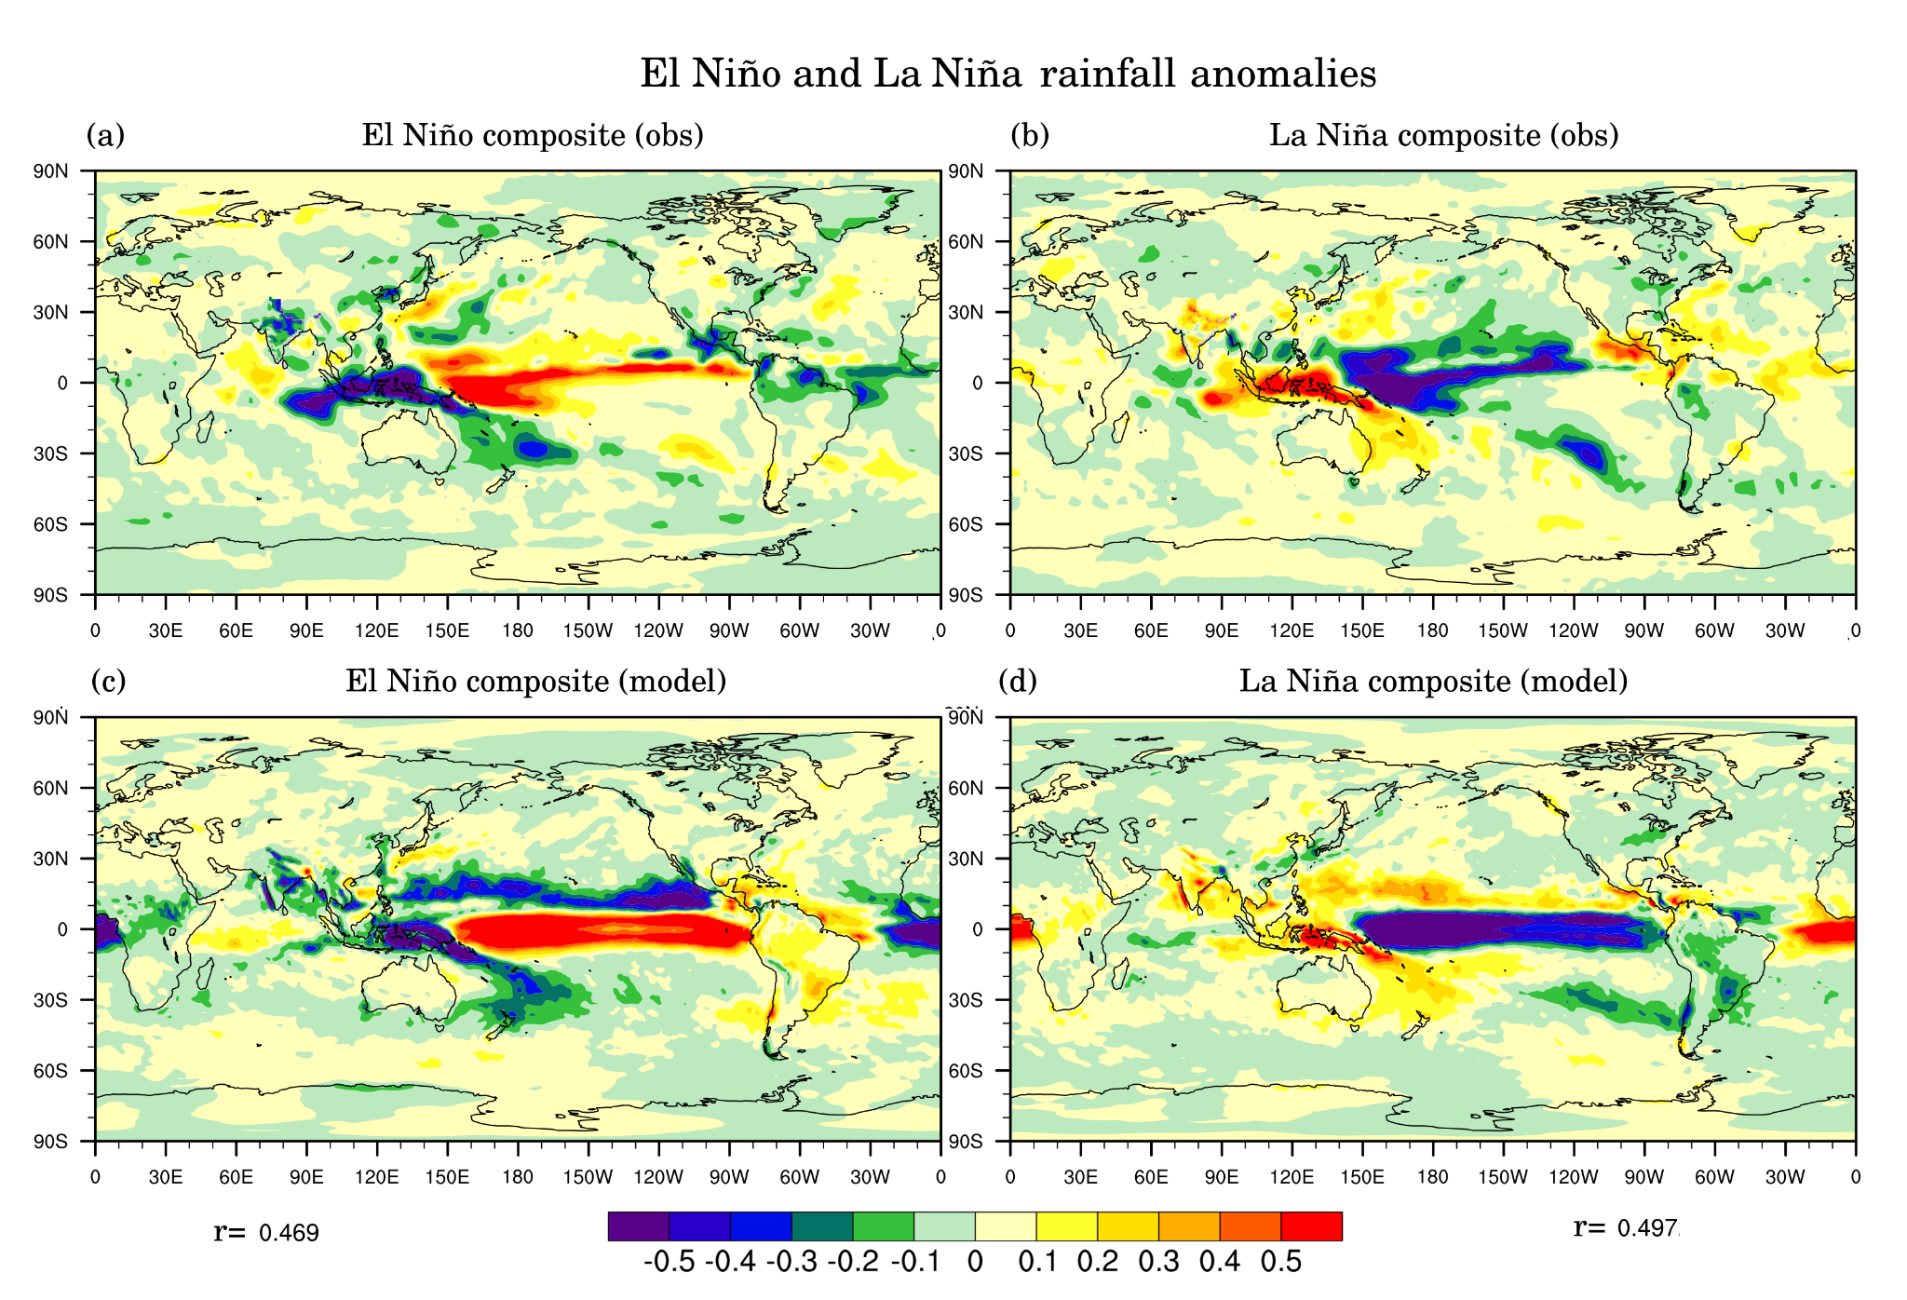
Figure S5: June–September rainfall anomaly composites of (a) observed El Niño events and (b) observed La Niña events for those years as used as in above Figure 6. (c, d), are the same as above, but for IITM-DCPS (model).
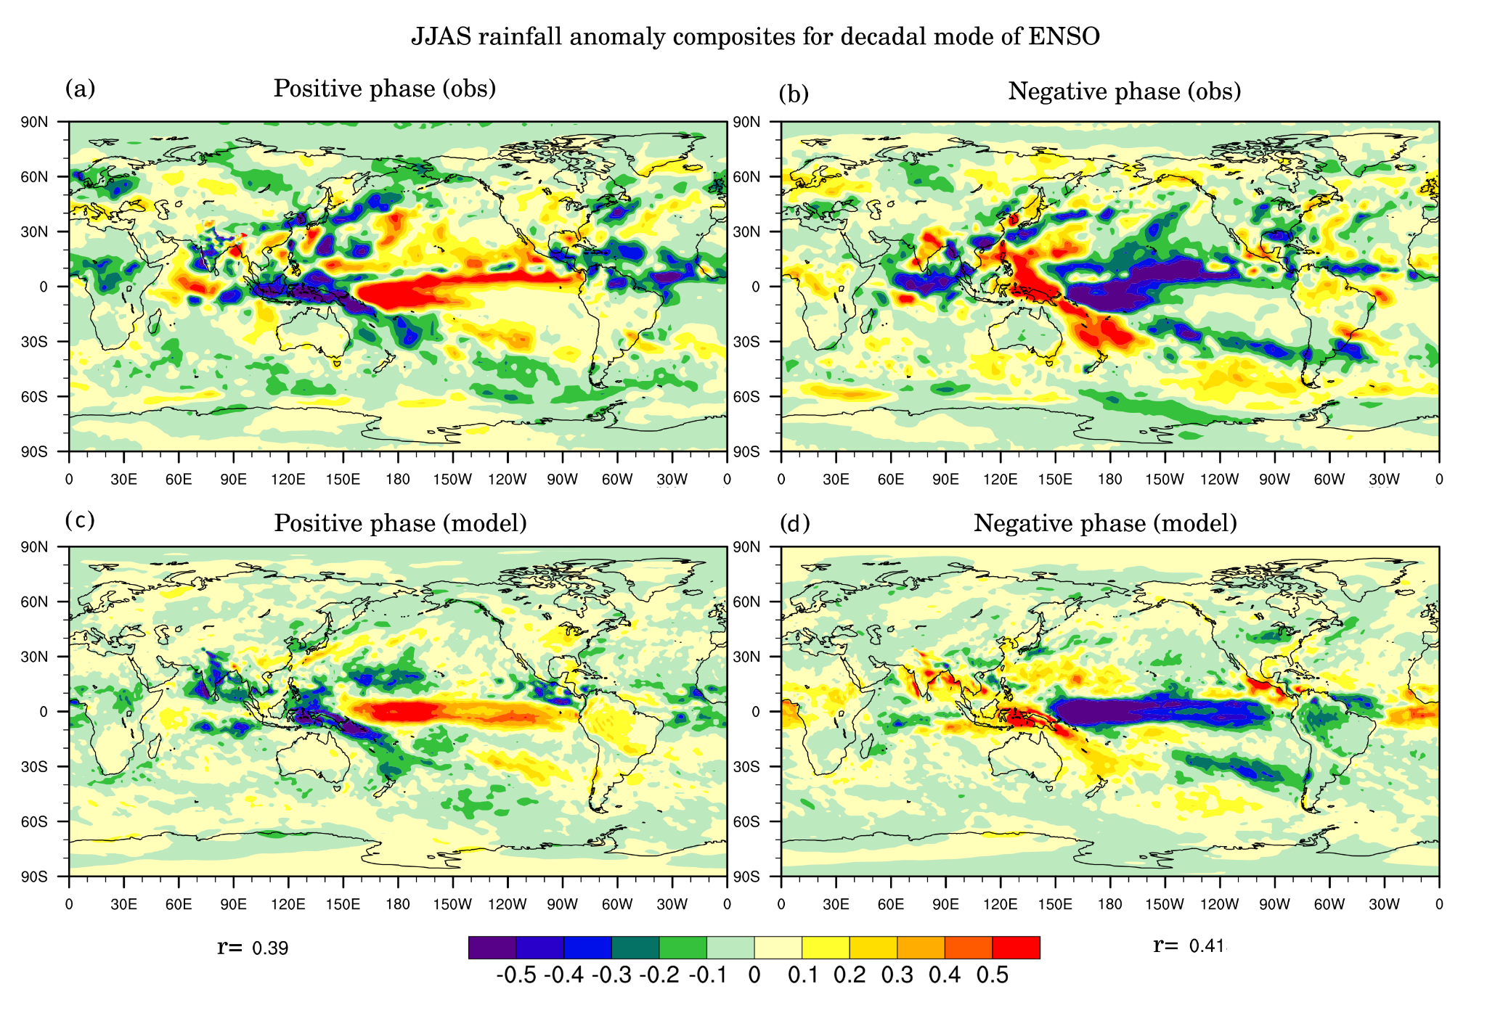
Figure S6: (a) June–September rainfall anomaly composite for the positive decadal modes of ENSO and (b) for negative decadal modes of ENSO, extracted for the same epochs as illustrated in Figure 8. Similarly, (c, d) present the same analysis for IITM-DCPS. What about pi and historical. Color bar may be reversed
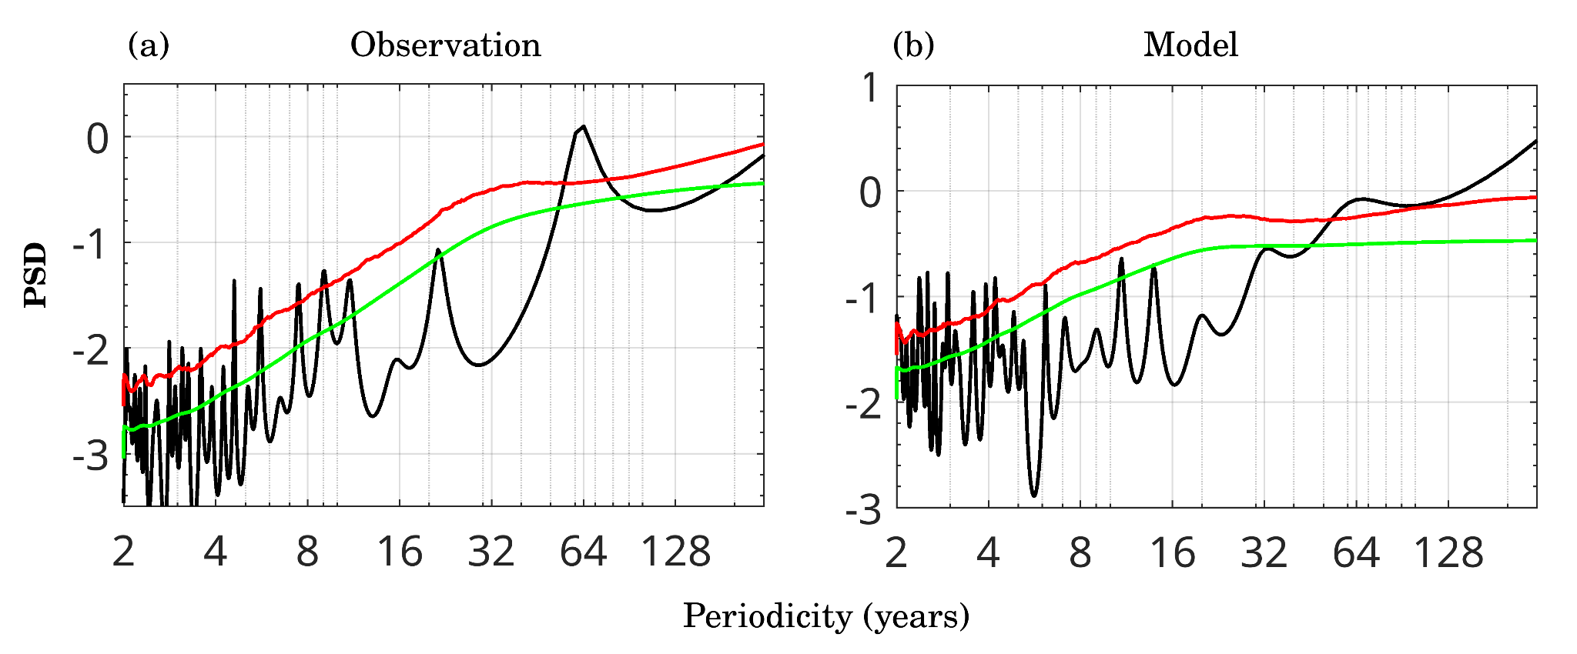
Figure S7: Power spectra of the AMO index from (a) observations and (b) IITM-DCPS, both derived from the raw non-detrended time series obtained as the domain average sea surface temperature (SST) values over the North Atlantic (NA) domain during boreal summer season, where the maximum SST loading is observed (290°E–360°E, 30°N–65°N).What about pi and historical. What is red and green line.
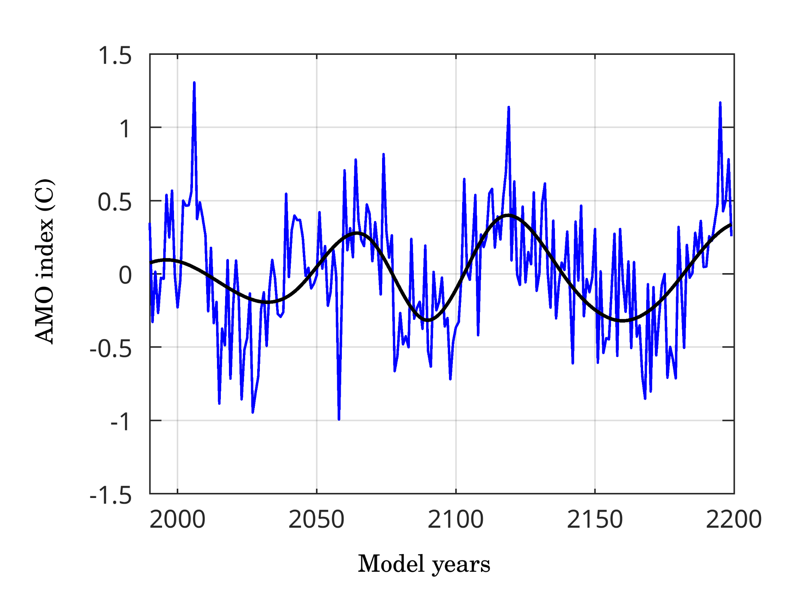

Figure S8: The detrended anomaly time series of the AMO index (blue) from IITM-DCPS for the duration of the last 200 years. The background AMO signal, overlaid on its interannual variability, is decomposed using empirical mode decomposition, shown as the black line
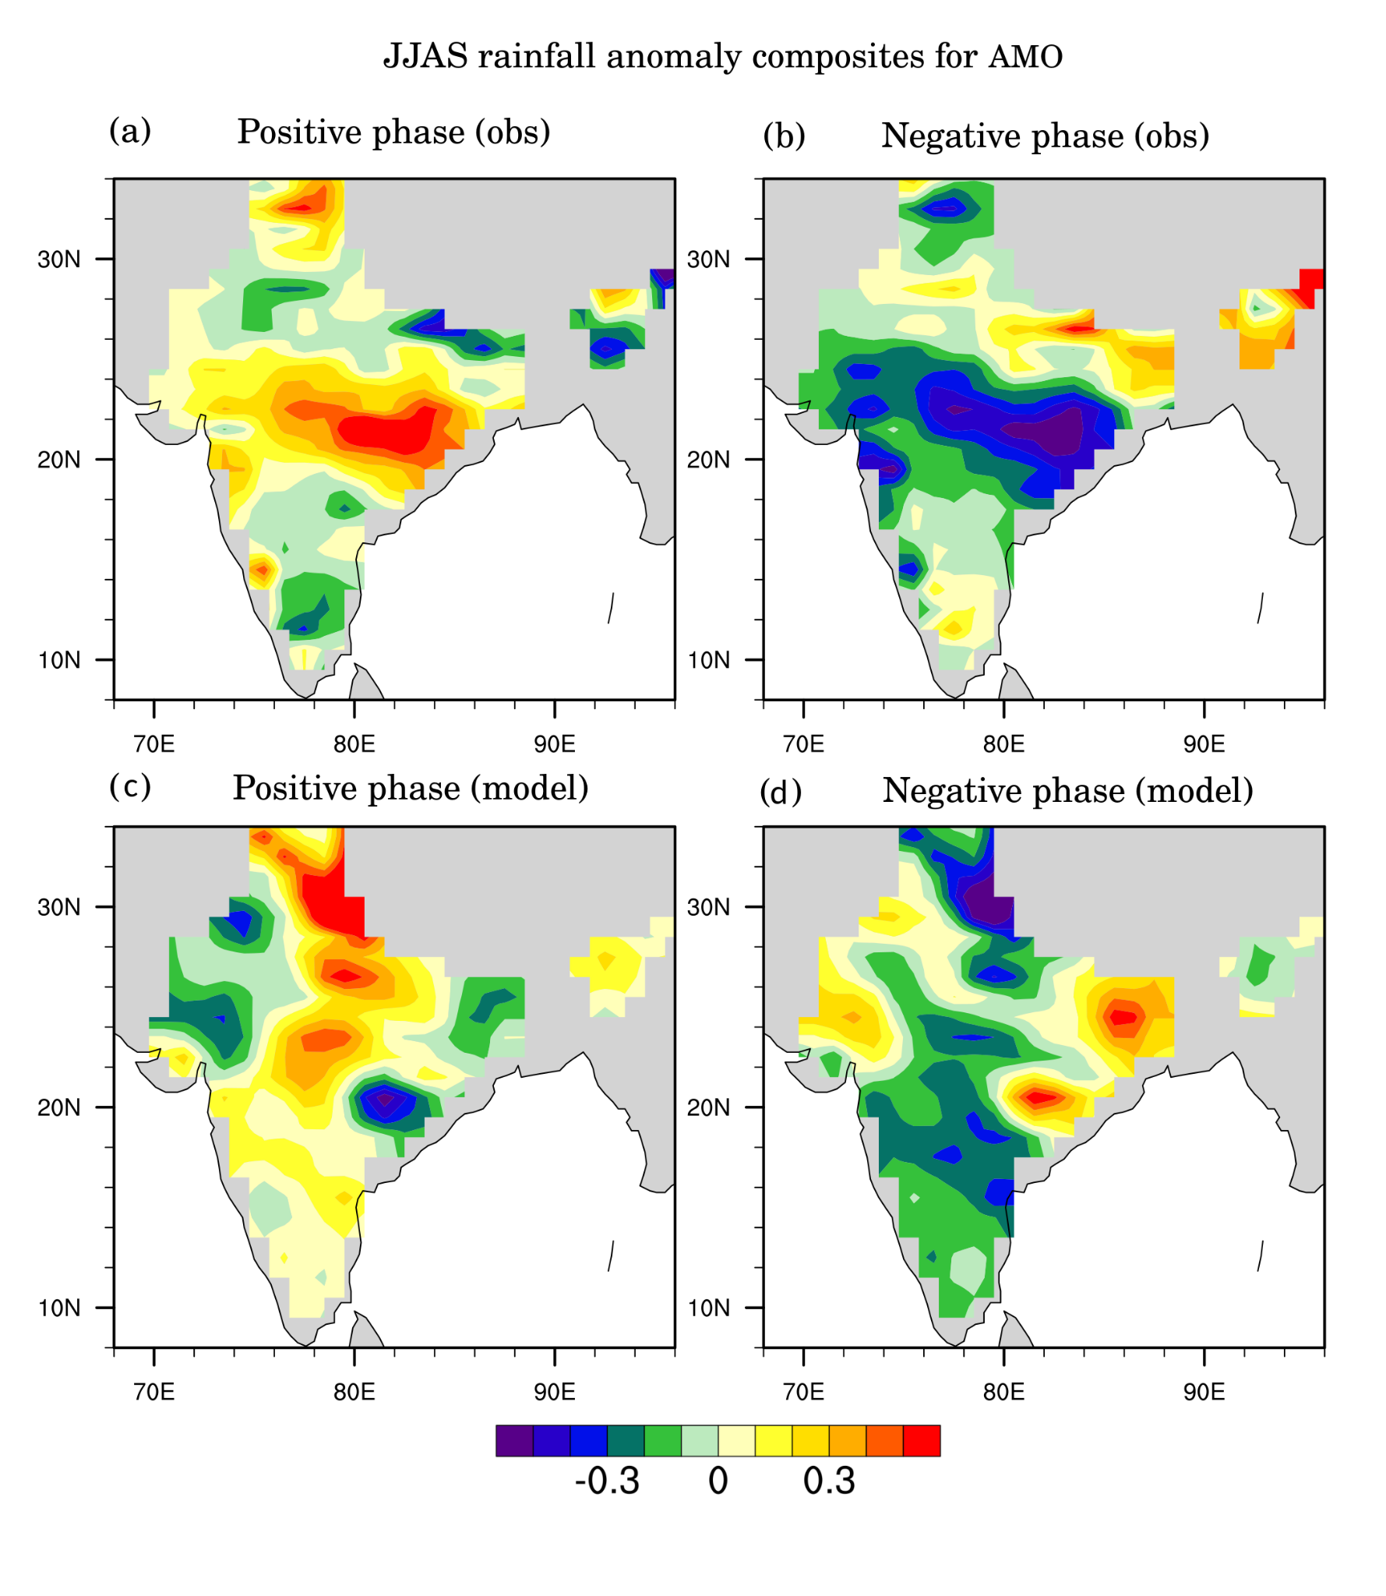
Figure S9: (a) June–September rainfall Indian monsoon rainfall anomaly composites of (a) positive AMO phases and (b) observed negative AMO phases for those years as used as in above Figure 6. (C, d), are same as above, but for IITM-DCPS
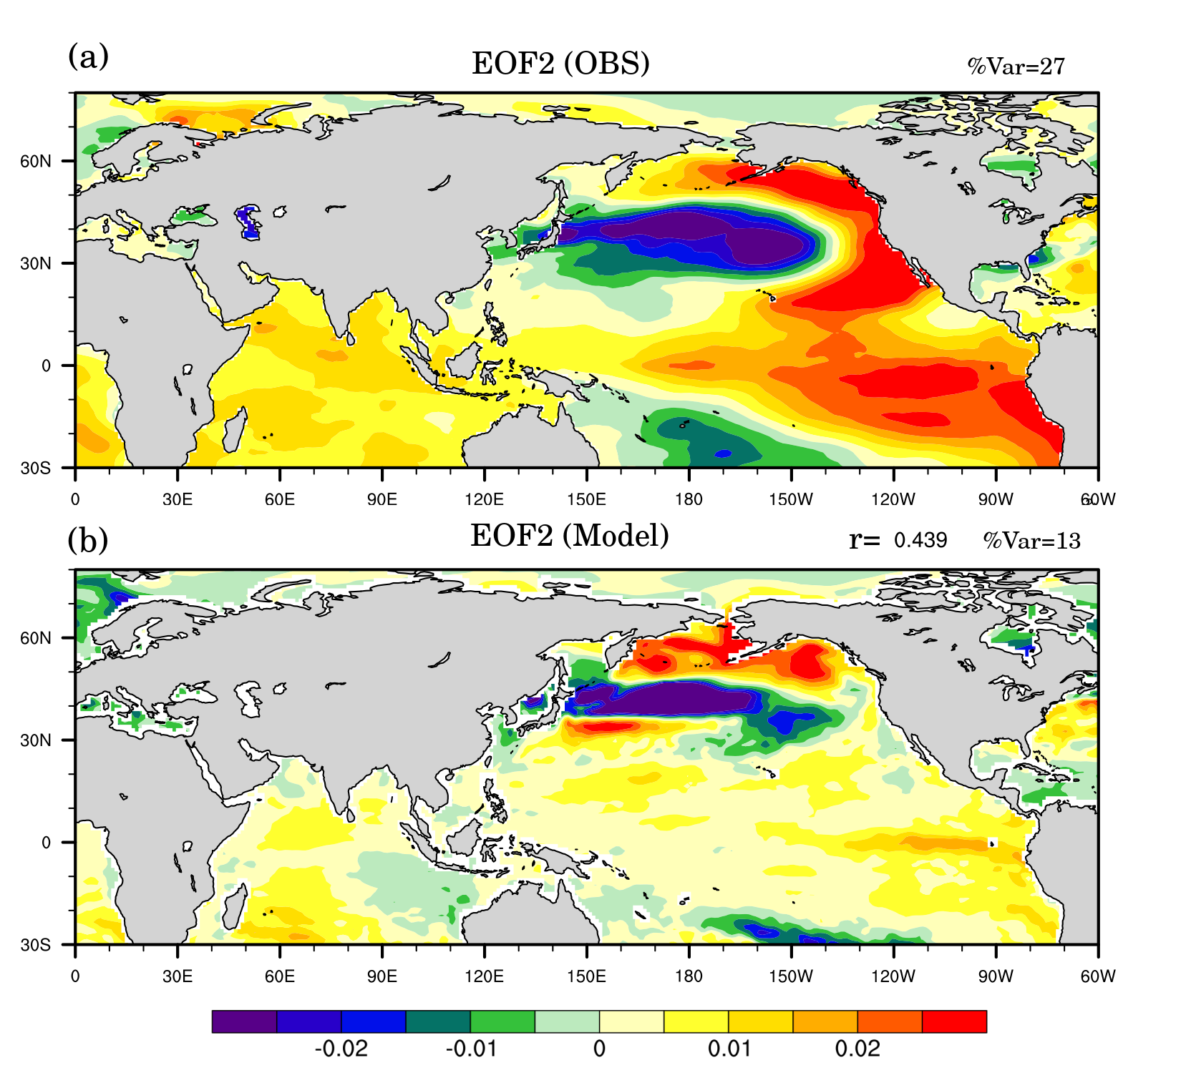
Figure S10: Pattern correlations from projecting the smoothed IPO index onto the SST of (a) observation and (b) IITM-DCPS, referred to as the decadal component of the IPO. The decadal component of the IPO is defined as the 13-year low-pass filtered anomaly of the second EOF of NP SST, following the method from Meehl et al., 2016.

